LEARNING IN THE DIGITAL ERA
Muhammad Imran
Student ID 2424560

Table of Contents
Task 1: Written summary 3
1. Introduction 3
2. Essential Skills for Study & Employment 3
3. Importance for Future Career 4
4. Reflection on Turnitin & Self-Assessment 5
Task 2 – Mind Map & Academic poster 5
Mind Map 5
Academic poster 7
Task 3: Automatic Referencing tool 11
Overview of Virtual Collaboration 12
Tools and Technologies 12
Benefits of Virtual Collaboration 12
Challenges of Virtual Collaboration 13
Best Practices for Effective Virtual Collaboration 13
Use of RefWorks 13
Task 4 – E-Portfolio Creation and Review 14
References 17

Task 1: Written summary

1. Introduction
The chosen profession in this study is software development, a rapidly expanding profession in the wider information technology sector. Experts in this profession should possess a combination of academic and practical skills to become successful. In preparing individuals to venture into higher education and in employment, academic and employment skills play pivotal roles. These skills are not only helpful in the learning process but also enhance employability since they enable individuals to adapt to the changing technologies and workplaces. These competencies developed at the early stages will help graduates to be well placed to meet the expectations of the industry and contribute considerably to organisational performance.

2. Essential Skills for Study & Employment
Technical Skills
Technical skills are essential in the success of software development and other related fields. They include knowledge of programming languages such as Python, Java, or C++, knowledge of development tools, frameworks, and version control systems. In addition, it is necessary to be familiar with data analysis, data management, and algorithms [1]. The set of competencies enables individuals to model, design, and maintain software applications. Technical skills help to complete assignments, projects and research assignments in a school set up. They define the core competencies required in work to solve practical problems, offer valuable and reliable solutions.
Communication Skills
Communication plays an important role in education and career development. Written communication skills are reporting writing, documentation, and email writing, which are clear and structured [2]. The verbal communicative competencies will also be applicable in the presentation, discussions and group work. In the workplace, professionals are supposed to be able to convey technical ideas to non-technical stakeholders in a way that they comprehend. Teamwork is encouraged by effective communication, and it helps reduce misunderstanding and increase the clarity of shared objectives. Ultimately, good communication of ideas enhances individual performance and work group production [3].
Teamwork & Collaboration
Teamwork is also one of the aspects of school projects and working places. Software development often requires teams to build complex systems, which require coordination and cooperation. Cooperation entails communicating, exchanging ideas, valuing the varying opinions, and giving towards group objectives [4]. Flexibility is also an important factor; the team members must be capable of responding to the changing requirements and feedback. There are improved problem-solving and innovation with teamwork since different views will give better outcomes. Learning these skills on the academic level equips them with the situations of teamwork in the professional life [1].
Problem-Solving & Critical Thinking
Problem-solving and critical thinking are important competencies enabling individuals to analyze a situation and devise effective solutions. Problems are often encountered when software developers face them as they find it difficult to fix bugs, performance-tune their systems and to develop effective systems. Critical thinking is an assessment of different approaches and the selection of the best solution to a problem based on evidence and reason [2]. These skills are also applicable in academic contexts whereby students are required to develop a capacity to interpret information, research and apply theoretical facts. Effective problem solving competencies enhance decision-making and enable one to solve complex tasks with precision and comfort [5].

3. Importance for Future Career
Development of essential academic and work skills is critical in the future career achievement. Technical skills enhance employability since they ensure that people possess the practical knowledge required by the industry, hence qualitative in most jobs. The skills of communication enable the specialists to deliver their ideas in a clear manner and work as a team, as well as interact with clients and stakeholders [1]. Teamwork and flexibility are also essential as both modern working environments require individuals to work on diverse teams and respond to dynamism of the requirements. Further, critical thinking and problem-solving skills help the professionals to analyze complicated situations and make sufficient decisions. These are not mere competencies that enable people to secure jobs, but also aid in career progressions in the long run. The development of these skills on a regular basis enables one to optimize their performance, adapt to emerging demands and achieve long term growth in the field of software development [3].

4. Reflection on Turnitin & Self-Assessment
Turnitin similarity score of this work demonstrates the level of novelty and adequate paraphrasing. The moderate similarity score is an indication that there may be some common phrases and most of the material is written independently. To improve the next submissions more emphasis will be given to the paraphrasing, the synthesising of information will be done better, the ideas must be stated in a personal manner. In addition, reference practice will also be promoted in order to have a clear distinction between original and sourced work. Self- Admiral assessment mark of 75 per cent. will be appropriate on the content, structure and clarity of writing. It demonstrates adequate understanding of the topic and well-structured work, and the awareness of what may be improved, such as a stricter critique and more advanced writing.

Task 2 – Mind Map & Academic poster

Mind Map
Effective Teamwork
Teamwork is a very critical aspect of academic and professional development and most particularly in the area of software development. Teamwork is a notion, and it involves the work of people collaborating towards a shared goal through their different strengths and perspectives [6]. Some of the key components that ensure team work is successful as indicated in the mind map include communication, collaboration, leadership, time management, conflict management, and application of appropriate tools and technology.
Communication is one of the most important things of the teamwork. A clear message ensures that everybody knows their roles and responsibilities and active listening helps people to listen to the ideas of others. Positive criticism can also be used to enhance team performance through continuous improvement and reduction of misunderstandings [7].
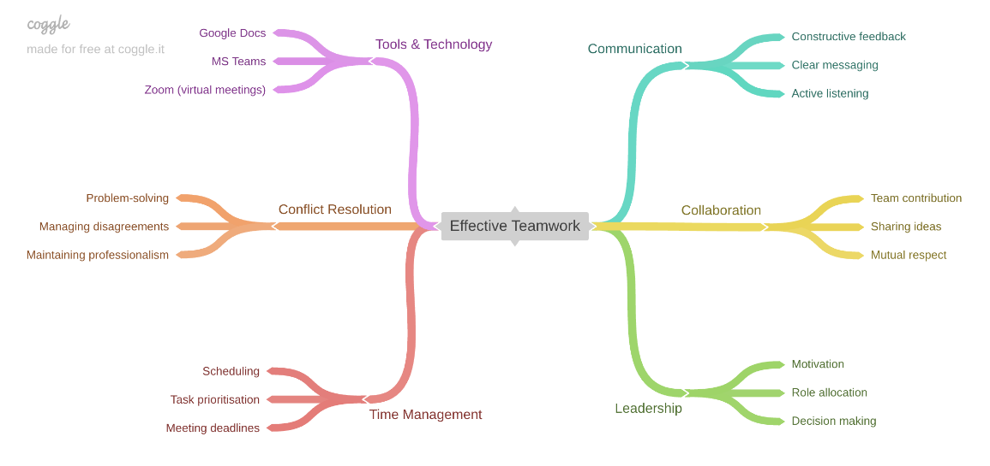
Figure 1: Mind Map
Teamwork is also intertwined with communication and involves the successful exchange of ideas and mutual respect among its members. Since individuals are included in the process and ready to listen to one another, it will lead to more innovative solutions and improved results [8]. The team input will be required as well since it will ensure that all members are active and pulling in the same direction.
Leadership plays a role in assisting to guide the team and to be on track. Effective leaders delegate responsibilities based on individual abilities, make good choices, and motivate the team members to perform optimally. Good leadership offers the team focus and productivity [9].
Time management is another critical problem in teamwork. Prioritisation of tasks and adherence to deadlines, timely scheduling may help the teams to complete the projects successfully. The lack of time management may impair the presentation of the goals despite well coordinated teams [10].
Conflicts of disagreement that may arise throughout the teamwork must be solved by conflict management. Problem solving and professionalism in turn make teams prevent the further development of the conflicts and maintain the working environment positive [11].
Finally, such tools and technology as Google Docs, MS Teams, and Zoom facilitate and support virtual collaboration. These efforts enable the teams to be competent, regardless of where they may be located [12]. In sum, teamwork will be efficient in case of a combination of interpersonal, organisational and technical abilities. These are key skills that should be put into consideration to ensure one succeeds in school and is ready to work in future.

Academic poster
Life is a Team Sport: The Importance of Teamwork for Academic and Career Success
Introduction
The concept of “Life is a Team Sport” gives much importance to the role of cooperation and teamwork in achieving success. Teams play a vital role in completing multi-faceted work and achieving the shared goal in academic and work environments, particularly in software development. Teamwork skills make people work well with others, adjust to new situations, and contribute meaningfully to team success.
Effective Communication
Effective collaboration involves the aspect of communication. Every team member should be defined through effective communication in terms of roles, responsibilities and goals [1]. Listening will allow individuals to hear the other point of view and constructive feedback will promote continuous development. Communication assists in the facilitation of group projects and presentation in academics and easy interaction between the team members and the stakeholders at work.
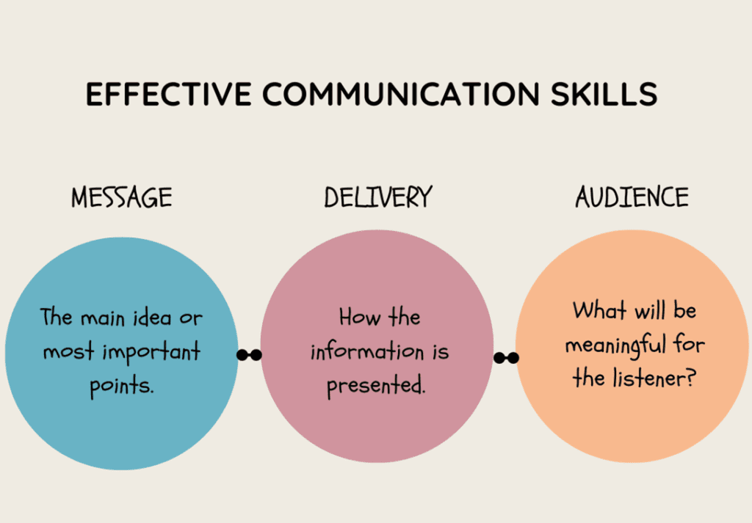
Figure 2: Effective Communication Skills
Collaboration and Team Contribution
Collaboration consists of working on issues cooperatively so as to gather ideas and achieve shared goals. Teamwork involves respect and engagement [2]. It can occur when team members make equal contribution and they appreciate the contribution of others and this generates superior decision making and creative solutions. Software development requires collaboration because projects can attract contribution of different people, who possess different skills and expertise.
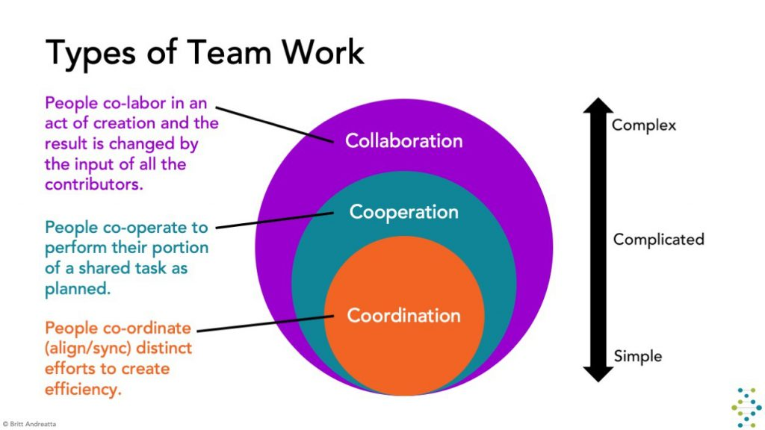
Figure 3: The Types of Teamwork
Leadership and Responsibility
Leadership plays a center stage in assisting teams to excel. Effective leaders can allocate tasks based on individual strengths, make good judgments, and motivate others. Leadership is not a characteristic of a specific person, anyone could be a leader through willingness to be answerable as well as through assisting others [3]. Great leadership in both college and workplace has kept the teams in control and focused towards achieving their objectives.
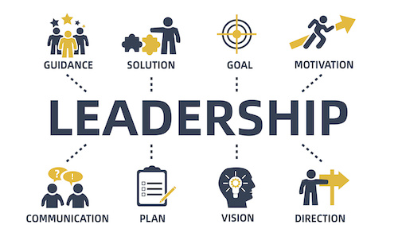
Figure 4: Responsible Leadership
Time Management and Organisation
Time management has been an important factor in meeting activities and deadlines. Time management and planning of work can help maintain a well-organised and productive team when approached properly. Time management results in doing assignments on time in the academic group work and project success and organisational efficiency in the professional setting [4].
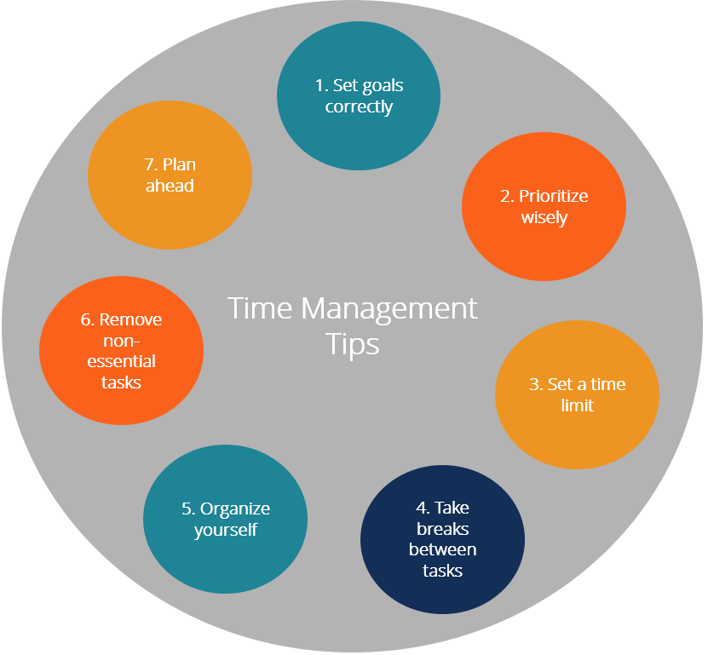
Figure 5: Time Management Tips
Conflict Resolution and Professionalism
Conflicts can be described as a feature of team work, yet they can be resolved successfully through problem solving and being a professional. Peaceful and dignified manner of approaching conflicts can help in ensuring that one enjoys a healthy work environment [5]. Concrete conflict management addresses the conflict and strengthens bonds within a team to ensure that issues do not stagnate the growth.
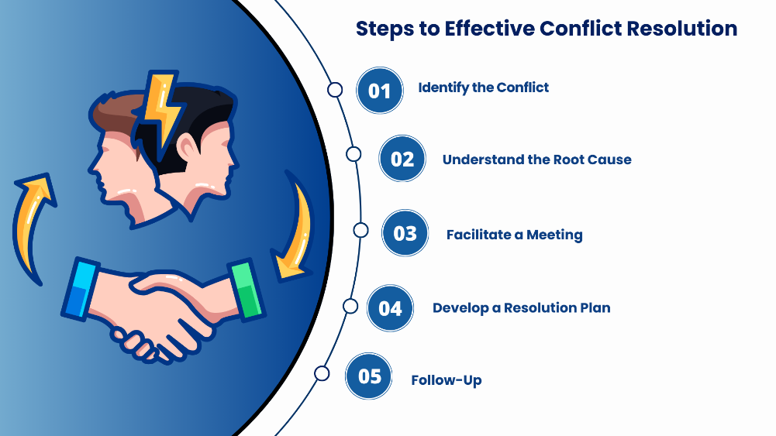
Figure 6: Steps of Effective Conflict Resolution
Use of Tools and Technology
Modern tools that support teamwork include Google Docs, MS Teams, and Zoom. These technologies enable sharing, communication, and collaboration as well as sharing of files especially in virtual worlds [6]. They play a crucial role in enhancing productivity and ensuring that the performances of the team run smoothly.
Conclusion
In conclusion, the concept of “Life is a Team Sport” emphasizes the importance of teamwork in being an effective student and a successful professional. Being a good team leader demands the ability to communicate, collaborate, lead, manage time and resolve conflicts [7]. The excelling of these skills trains them to excel in school and workplace particularly in the dynamic software development world. Task 3: Automatic Referencing tool.

Task 3: Automatic Referencing tool
Introduction
Virtual collaboration has become an indivisible component of the academic and professional world, particularly, the world of software development. With the evolution of the digital technologies, people do not need to be physically present to cooperate effectively with one another. Virtual collaboration is the action of engaging online applications and platforms to assist individuals or their teams to communicate, share information, and work remotely. This has transformed the way teams will work hence the possibility of working in different locations and time zones and still emerge productive and efficient.

Overview of Virtual Collaboration
Virtual collaboration is the process individuals engage with each other through digital process in an attempt to achieve some common objectives. It is highly reliant on the information-sharing, coordination and communication that is heavily dependent on the internet-based tools [8]. Academic settings use virtual collaboration tools to enable students to complete their group projects, discuss, and share materials. They are also used in professional settings, where organisations use them to manage projects, conduct meetings, and coordinate work among employees who work in remote location.

Tools and Technologies
There exist several tools that contribute to virtual collaboration, and each of them has its purpose. Video conferencing platforms are communications tools that enable real-time communication, which enable team members to conduct meetings and discussions. Messaging systems are quick and effective, and collaborative systems support sharing and editing documents in real-time [9]. Such software as Microsoft Teams, Zoom, or Google Docs has become popular as a way of reinforcing the spirit of a team and giving it a smooth working process. These technologies are highly essential because they might be used to ensure efficiency and assist the teams to work together, regardless of their physical location.

Benefits of Virtual Collaboration
Virtual cooperation has several advantages. One of the significant benefits is flexibility, since individuals can work at different locations and manage their time more efficiently. It also enables organisations to access a global talent pool where different people with varying skills and worldviews are pooled [10]. Furthermore, the cost of transporting and physical facilities may be saved through the use of online teamwork. It is also a productivity enhancing practice because teams may embrace digital tools that improve effective communication and organization of tasks.

Challenges of Virtual Collaboration
Despite the benefits, virtual collaboration also faces several challenges. The lack of a face-to-face communication can pose communication impediments and misunderstandings. Meetings can also be difficult to organize due to time difference especially in a global team [11]. Even work can be interfered with by other technical issues such as poor internet connection or software inefficiency. In addition, maintaining a team that is engaged and motivated may not be an easy task in a virtual world since individuals may feel isolated or non-member.

Best Practices for Effective Virtual Collaboration
These challenges should be overcome by adopting effective strategies. Communication should be good and everyone must know their roles and responsibilities. It is known that there are frequent updates and meetings that help to keep the coordination and accountability tracked [12]. Proper tools may be more effective to deal with some particular tasks, and clear deadlines can be used to ensure that the work is complete on time. A positive and productive virtual working environment also involves the development of trust and active participation.

Use of RefWorks
RefWorks is an automatic reference application which strives to simplify the handling of academic references and the generation of citations. It enables users to store, arrange and form references efficiently and in a well-organised manner. This was achieved through RefWorks in order to locate the necessary scholarly materials and create a properly structured reference list. The tool also helped to easily add citations into the document, which means that it is consistent and reduces the chances of errors [6]. The user-friendly interface was able to handle a number of sources and organize them in folders. Moreso, RefWorks is compatible with numerous referencing styles hence is versatile to diverse academic requirements. To demonstrate key functions such as addition of reference, sorting of the sources and citing, screenshots were taken. Usually, RefWorks has been instrumental in the academic writing process since it has helped to improve accuracy, organisation, and efficiency.

Task 4 – E-Portfolio Creation and Review
The present e-portfolio has been created in Wix which is an online web developer that enables users to create and publish websites without necessarily being required to possess advanced technical skills. Wix was selected due to its user-friendly interface and the drag and drop option, which enables it to organise the information in a systematically comprehensible and easy to understand way, text, pictures, and screenshots [13].
Wix is free, and this is one of the reasons why it has been selected. The platform will facilitate online publication of portfolio and sharing of the portfolio through a direct link so that the tutor can easily access the portfolio and evaluate it. In addition, Wix provides numerous templates and design possibilities, which lead to the creation of an attractive and professional portfolio with a visual interest [14].
In most cases, Wix should be considered as a good option when creating an e-portfolio since this tool is versatile and simple to operate as well as allows an individual to present academic work in a well-structured and engaging manner.
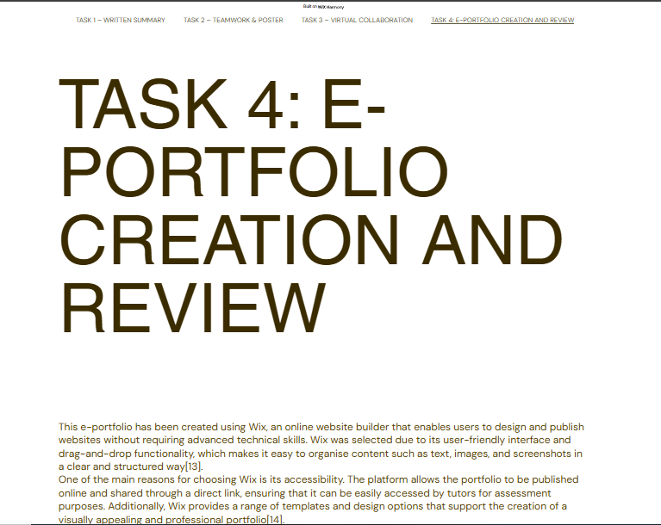
Figure 7: Task 4 Page
(Source:Wix)
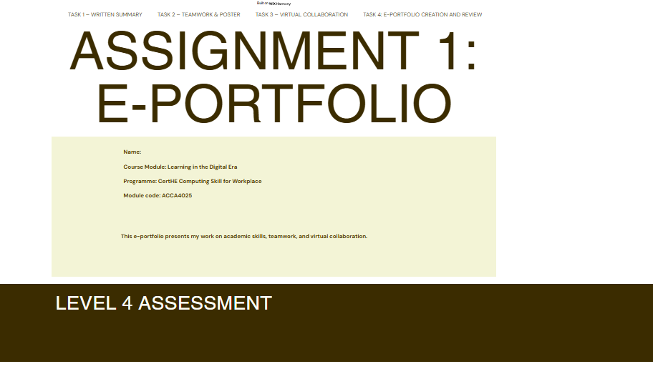
Figure 8: Home Page
(Source:Wix)
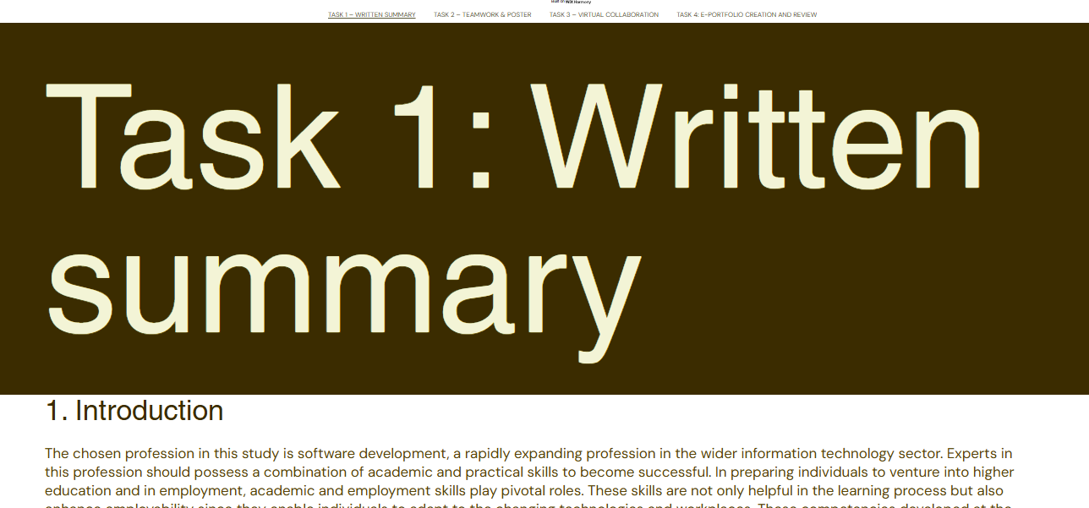
Figure 9: Task 1 page
(Source:Wix)
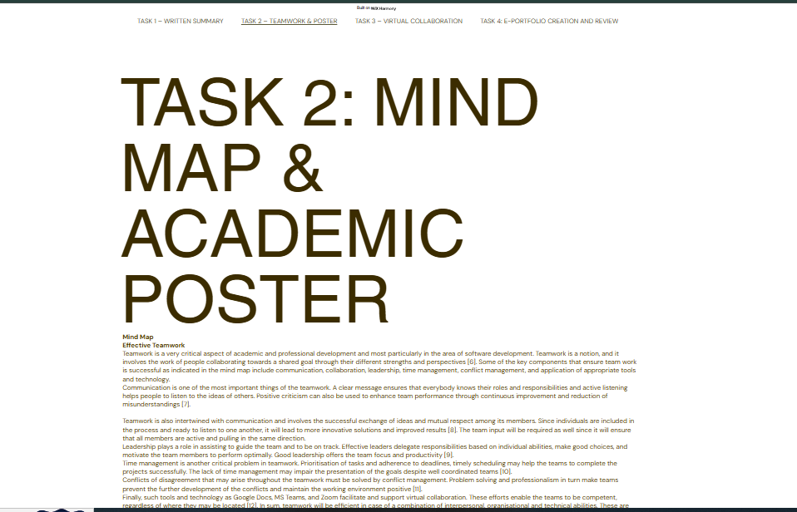
Figure 10: Task 2 page
(Source:Wix)
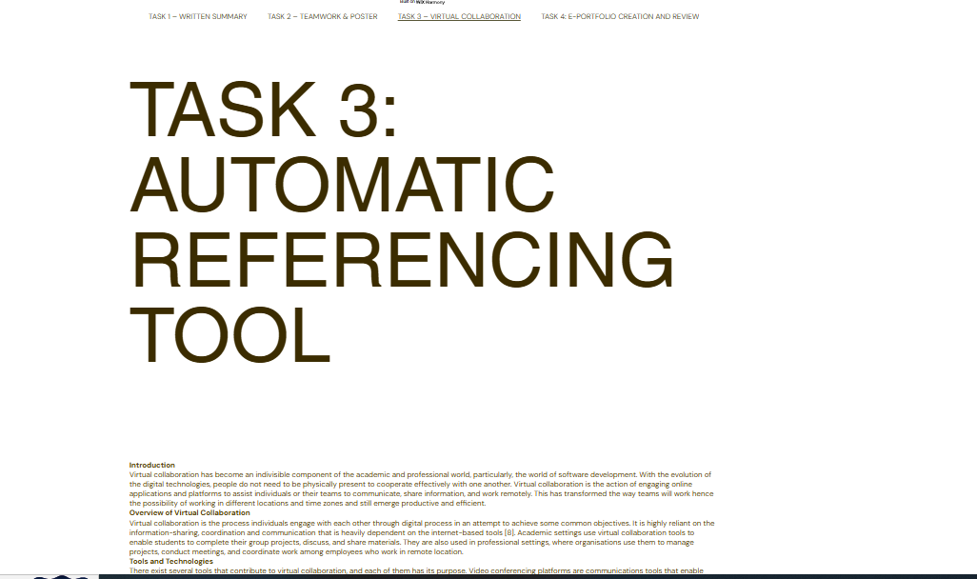
Figure 11: Task 3 page
(Source:Wix)

References
- Shuhaiber, A., Alkuwaiti, A., Alremeithi, M. and Almenhali, H., 2023, July. The Development of Smart E-Portfolio Generator System for University students: An SDLC Approach. In 2023 International Conference on Smart Applications, Communications and Networking (SmartNets) (pp. 1-8). IEEE.
- Roy, D., 2022, April. Developing an e-Portfolio Design Framework for a 3D Printing Design and Analysis Project. In 2022 10th International Conference on Information and Education Technology (ICIET) (pp. 177-183). IEEE.
- Saidova, F., Zakirova, F., Eminov, A. and Otamurodov, G., 2022, March. Multilevel E-portfolio Model in the System of Advanced Training of Academic Staff in Uzbekistan. In 2022 IEEE European Technology and Engineering Management Summit (E-TEMS) (pp. 78-82). IEEE.
- Ford, J.D. and Crawford, D., 2024. Integrating professional preparedness ePortfolios within an undergraduate engineering curriculum. IEEE Transactions on Professional Communication, 67(2), pp.246-259.
- Gantikow, A., Isking, A., Libbrecht, P., Müller, W. and Rebholz, S., 2023, December. On the creation of classifiers to support assessment of E-portfolios. In 2023 IEEE International Symposium on Multimedia (ISM) (pp. 297-302). IEEE.
- Yan, J.Y., Hsieh, Y.H. and Yuan, S.M., 2023, August. Blockchain based E-portfolio ecosystem. In 2023 IEEE 6th International Conference on Knowledge Innovation and Invention (ICKII) (pp. 264-269). IEEE.
- Lonappan, A.M., Viswambaran, V., Shijumon, S. and Amma, L.V., 2025, September. Enhancing Student Engagement in Vocational Education Through Staged E-Portfolio Submissions and Automated Reminders: An Action Research. In 2025 IEEE 14th International Conference on Engineering Education (ICEED) (pp. 108-113). IEEE.
- Merlec, M.M., Sinai, N.K. and In, H.P., 2023, October. A blockchain-based trustworthy and secure review system for decentralized e-portfolio platforms. In 2023 14th International Conference on Information and Communication Technology Convergence (ICTC) (pp. 675-680). IEEE.
- Khwankaew, A., Ratanaolarn, T. and Morris, J., 2025, April. Effectiveness of an e-Portfolio to Enhance Self-Regulated Learning. In 2025 16th International Conference on E-Education, E-Business, E-Management and E-Learning (IC4e) (pp. 1-5). IEEE.
- Kiryakova, O.A. and Menshikova, L.V., 2023, June. The Use of Web-Portfolio Technology for Professional Foreign Language Training of Students in Electronic Educational Environment of Higher Education Institutions. In 2023 IEEE 24th International Conference of Young Professionals in Electron Devices and Materials (EDM) (pp. 1950-1953). IEEE.
- Zunaidah, A., 2022, October. Meaningful online learning with e-portfolio: University students’ perspectives. In 2022 8th International Conference on Education and Technology (ICET) (pp. 228-232). IEEE.
- Luna, M.E.O. and Arce, J.O., 2021, November. Competencies e-portfolio construction and defense influence on STEM career choice. In 2021 6th International STEM Education Conference (iSTEM-Ed) (pp. 1-4). IEEE.
- Wix, “Wix.com,” Wix.com, 2023. https://www.wix.com/
- S. L. Chang and M. K. Kabilan, “Using social media as e-Portfolios to support learning in higher education: a literature analysis,” Journal of Computing in Higher Education, Nov. 2022, doi: https://doi.org/10.1007/s12528-022-09344-z.

