
University of Wales Trinity Saint David

Module Title: Quality Assurance and Service Improvements
Module Code: LCHS7006
Assignment Title: Component 2: Service Improvement Report
Case Study Focus: Mid Staffordshire NHS Foundation Trust

Student Name: Mahir Al Asif Masrur
Student ID: 2436075
Word Count: 3,228 (As per Requirement 3000+- 10%)

Table of Contents
1.0 Introduction 3
2.0 Main Body 5
2.1 Donabedian Model: Structure, Process and Outcome Failures 5
2.2 SWOT Analysis and Impact on Quality, Efficiency and Equity 6
2.3 Swiss Cheese Model Analysis 6
2.4 Fishbone Analysis: Unsafe Care root causes 7
2.5 Five Whys Analysis 8
2.6 Critical Justification of the Selected Frameworks 9
3.0 Recommendations and Implementation Strategy 11
3.1 Reliability of safe staffing and basic care with PDSA 11
3.2 Learning to open reporting and complaints with the use of PDCA 11
3.3 Quality Dashboard and Lean Governance of the Board 12
3.4 Culture Change/Asset-Based Improvement 12
4.0 Conclusion 13
Reference List 14

1.0 Introduction
This report examines the service improvement lessons from Mid Staffordshire NHS Foundation Trust, where serious failures in care occurred between 2005 and 2009. The chosen quality issue is the inability to ensure the safety of patients against unsafe, undignified and poor basic care. The Francis Inquiry established that the Trust Board failed to listen to patients and staff enough, failed to address known shortcomings and permitted a negative culture where poor standards were accepted (Francis, 2013). This was not a unique clinical issue. It was a system-wide malfunction that concerned governance and staffing, patient safety culture, regulation, leadership and accountability (Dixon-Woods et al., 2014). Thus, the case can fit a service improvement report as it demonstrates how poorly built structures and processes can harm the quality, safety, efficiency and public trust.
This issue was especially critical as a lot of patients were vulnerable, frail, older, or incapable of representing themselves strongly. In the Inquiry, there were reports of inadequate basic care, such as assistance with feeding, water not within reach, slow toileting assistance, poor hygiene, loss of dignity and lack of empathy towards patients and family members (Francis, 2013). Such failures are opposing the key objectives of health and social care, in which quality denotes safe, efficient, person-centred, timely, and equitable care (Institute of Medicine, 2001; WHO, 2020). In the case of Mid Staffordshire, the Trust seemed to meet some of the external performance metrics, as patient experience and safety were deteriorating (Francis, 2013). It demonstrates the reason why improvement of services should not be focused on targets but should also look at the experience of individuals receiving care (Berwick, 2013).
To a present-day NHS organisation, this situation is also a lesson that improvement should be an ongoing process. Policies, regulators and reports may be in place in a hospital, but patients can only be safeguarded when everyday ward behaviour is transformed through these controls. This report thus connects all the recommendations with a quantifiable patient safety outcome, as opposed to abstract compliance alone.
In this report, the case has been developed based on Component 1, which found the case to be a governance, leadership and patient safety and clinical accountability failure. It relies on a practical approach as opposed to a theoretical discussion. The model of failed structure, unsafe process and harmful outcomes is linked with the Donabedian Model (Donabedian, 1988; Ayanian and Markel, 2016). The root causes are detected with the help of fishbone analysis and the 5 Whys, and SWOT analysis aids in strategic planning. The organisation culture theory, Results Pyramid, the Kotter model of change and improvement based on assets, are also applied since the class materials highlight culture, leadership, root cause analysis, PDSA, Lean and co-production as the most important strategies to improve the services (Kotter, 1996; Rippon and Hopkins, 2015). The report then offers effective recommendations based on the PDSA, PDCA, Lean and safety dashboard strategies. The objective is to demonstrate that failure of the Mid Staffordshire type could be avoided by enhanced staffing, open reporting, quality control at the Board level and a change of the culture towards patient-centred.

2.0 Main Body
The key quality issue at Mid Staffordshire was the unsafe and undignified care due to the poor-quality assurance system. Francis (2013) discovered that the Trust aimed at targets of national access, financial balance and Foundation Trust status, but acceptable standards of care were not safeguarded. It is important since quality assurance must actively monitor the compliance of care with the necessary standards, and quality improvement must redesign ineffective systems to enhance the results (Spath, 2018; Health Foundation, 2021). At Mid Staffordshire, the two functions did not work. The organisation gathered data, yet the data that was most valuable to it, such as complaints, mortality issues and patient experience, did not result in an immediate improvement (Francis, 2013; Keogh, 2013). The case thus demonstrates that the performance measurement is unsafe when it places more value on positive organisational data than on patient harm signals (Mannion and Davies, 2018).

2.1 Donabedian Model: Structure, Process and Outcome Failures
The structure-process-outcome model by Donabedian is beneficial as it provides explanations as to how organisational conditions affect the delivery of care and patient outcomes (Donabedian, 1988). Mid Staffordshire had the worst structural failures. There was a lack of staffing, weak leadership, ineffective clinical governance and the Board failed to perform as a patient-safety protector (Francis, 2013). This argument is backed by research that demonstrates that low staffing of registered nurses is linked to increased risk of care omissions and avoidable injuries (Dall’Ora et al., 2022; Griffiths et al., 2016). The financial pressure turned into a structural risk as well, as the motivation behind the Foundation Trust status pushed the Board to consider targets and budgets rather than primary care (Dixon-Woods et al., 2014; Vindrola-Padros et al., 2022).
These poor structures were followed by process failures. Nutrition, hydration, toileting, pain management and monitoring of the patient were not always assisted (Francis, 2013). The reporting of incidents and complaints was also not effective since employees were afraid to voice any concerns, and patients were not heard (Mannion and Davies, 2018). The result was preventable pain, loss of respect, outrage among people, regulatory scrutiny and loss of trust in the organisation (Francis, 2013; Berwick, 2013). The good thing about Donabedian is that it exposes the chain of causation. But it has a weakness; it can be too linear. Mid Staffordshire represented not just a mere transition of structure to process to outcome but was also culturally and regulated, with pressures of policy and professional silence (Braithwaite et al., 2017). So, the other tools are required in addition to Donabedian.

2.2 SWOT Analysis and Impact on Quality, Efficiency and Equity
Table 1: SWOT Analysis of Mid Staffordshire NHS Foundation Trust Service Failure (Francis, 2013; Dixon-Woods et al., 2014; Mannion and Davies, 2018; NHS England, 2022; Rippon and Hopkins, 2015)
SWOT area | Case-focused points for Mid Staffordshire NHS Foundation Trust
Strengths | The NHS had strong public-service values, committed staff, professional standards, existing regulators, incident systems and national quality frameworks. Patient and family voices also became important strengths because they eventually exposed the seriousness of poor care (Francis, 2013).
Weaknesses | Weak Board governance, poor staffing, poor clinical supervision, ignored complaints, poor transparency, weak safety culture, poor basic care, and over-reliance on targets and financial performance instead of patient experience (Francis, 2013; Dixon-Woods et al., 2014).
Opportunities | Use PDSA/PDCA cycles, Board-level quality dashboards, safer staffing reviews, open reporting, duty of candour, patient stories, asset-based improvement and co-produced service redesign (NHS England, 2022; Rippon and Hopkins, 2015).
Threats | Financial pressure, workforce shortages, target-driven culture, regulatory gaps, poor morale, public mistrust, and the risk that dashboards become another compliance exercise rather than real learning (Mannion and Davies, 2018; CQC, 2023).

2.3 Swiss Cheese Model Analysis
The Swiss Cheese Model describes patient injuries as the outcome of a combination of multiple, rather than a single, weak safety barrier converging (Reason, 2000). When applied to the Mid Staffordshire NHS Foundation Trust, the model reveals that all the failures at once produce harm due to the malfunction of the ward care, clinical supervision, governance, complaints handling and external regulation. The frontline care was unsafe at the first level: the patients were not always assisted with feeding, hydration, toileting, hygiene or pain management, and demonstrated direct lapses in the primary nursing operations (Francis, 2013). The second level, ward-level oversight, was ineffective as poor observation, ineffective escalation and staffing resulted in the continuation of missed care without remedy (Griffiths et al., 2016; Dall’Ora et al., 2022). On the third level, the organisational governance was ineffective due to the Trust Board prioritising finance, targets and Foundation Trust status over patient experience as a fundamental safety indicator (Francis, 2013; Dixon-Woods et al., 2014).
The fourth was the cultural layer. The voices of staff and patients were not addressed properly, and there was a culture of fear, which did not allow them to report openly (Mannion and Davies, 2018). This implied that there was no conversion of warning signs into learning opportunities. The fifth layer was external control. Even though mortality issues, complaints and testimonies of patients were evident, regulators, commissioners and scrutiny agencies could not recognise the extent of seriousness of poor care early enough (Francis, 2013; Keogh, 2013). Thus, the gaps in each layer fitted: inadequate staffing, ineffective processes, ineffective leadership, ignored complaints, and poor regulation were all combined and were used to put patients at risk.
Figure 1: Swiss Cheese Model Analysis of Unsafe and Undignified Care at Mid Staffordshire NHS Foundation Trust (Self-made and adapted from: Reason, 2000; Francis, 2013; Keogh, 2013)
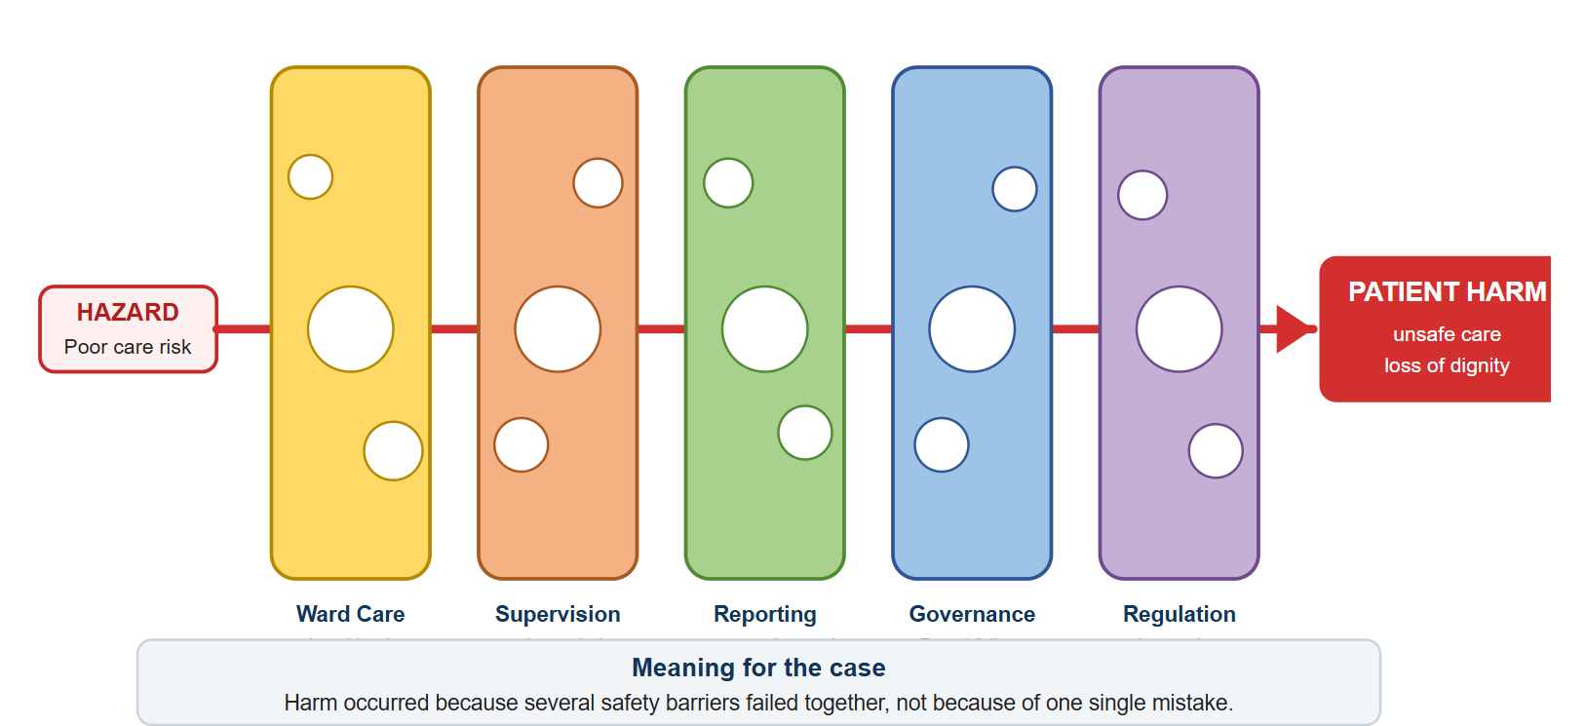
The model is useful in that it does not solely blame frontline staff, but emphasises the responsibility of the system (Reason, 2000). But its weakness is that it describes how the barriers did not work, but not entirely why leaders accepted low standards. Consequently, it ought to be integrated with cultural analysis and the structure-process-outcome model of Donabedian (Donabedian, 1988; Ayanian and Markel, 2016) and maintained responsibility in practice.

2.4 Fishbone Analysis: Unsafe Care root causes
Fishbone analysis assists in the organisation of various causes instead of blaming people (Ishikawa, 1985). In the case of Mid Staffordshire, the causes of low morale, poor supervision, lack of fear to speak up and weak leadership were all the causes of the people (Francis, 2013; Mannion and Davies, 2018). The causes of poor clinical audit, weak escalation, poor complaints handling and unreliable observation systems were included in the list of causes (NHS England, 2022). Some of the causes of the policy were the pressure to become a Foundation Trust, targets on financial balance and national access (Dixon-Woods et al., 2014). Some of the causes that were related to the environment were the poor conditions in the ward, poor dignity, and normalising of callous behaviour (Francis, 2013). Causes of measurement involved the use of reports and statistics, instead of patient experience, and causes of management involved the distance of the Board from frontline reality (Francis, 2013; Keogh, 2013).
Figure 2: Fishbone Analysis of Root Causes of Unsafe Care at Mid Staffordshire NHS Foundation Trust (Self-made and adapted from: Ishikawa, 1985; Francis, 2013; Dixon-Woods et al., 2014)
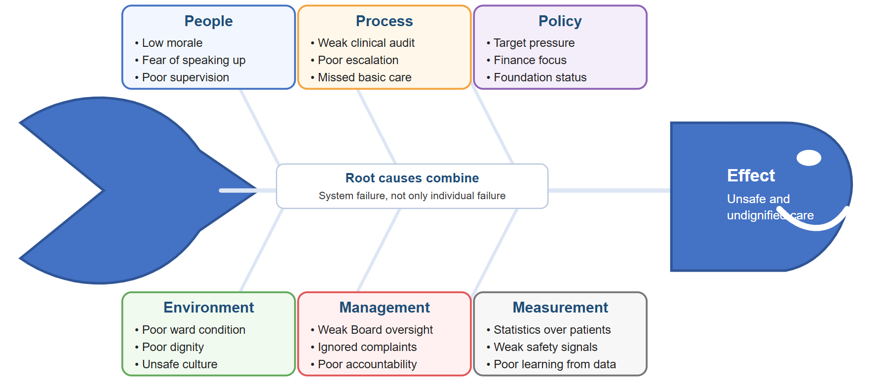
The Fishbone analysis shows that Mid Staffordshire was a multi-cause system failure. It has the advantage of being an attempt to refute a close-minded disciplinary reaction to the individual nurses. Nonetheless, Fishbone can be transformed into a descriptive list when it is not associated with evidence and action (Spath, 2018). In this instance, the evidence indicates that the most profound causes were governance and culture since they permitted the staffing, process, reporting and dignity failures to persist (Dixon-Woods et al., 2014; Francis, 2013).

2.5 Five Whys Analysis
The 5 Whys approach finds out more profound reasons by continuously posing the question of why something happened (Serrat, 2017). The issue was insecure and inhumane fundamental care. Why did it occur? Due to the lack of such basic needs like hydration, nutrition, hygiene and toileting (Francis, 2013). Why did they get lost? Due to the unreliability of the staffing, supervision, and ward processes (Dall’Ora et al., 2022). Can you explain why these weaknesses were not addressed? Complaints, incident reports, and patient experience were not considered urgent safety intelligence (Mannion and Davies, 2018). Why was this not prohibited? Due to a focus on finance, targets and organisational position by the Board, rather than the obvious patient suffering (Francis, 2013). Why was the culture able to allow this? Since this system was more rewarding for compliance with organisational goals than compassion, candour and learning (Berwick, 2013; Dixon-Woods et al., 2014).
Figure 3: Whys Root Cause Analysis of Unsafe Basic Care at Mid Staffordshire NHS Foundation Trust (Self-made and adapted from: Serrat, 2017; Francis, 2013; Mannion and Davies, 2018)
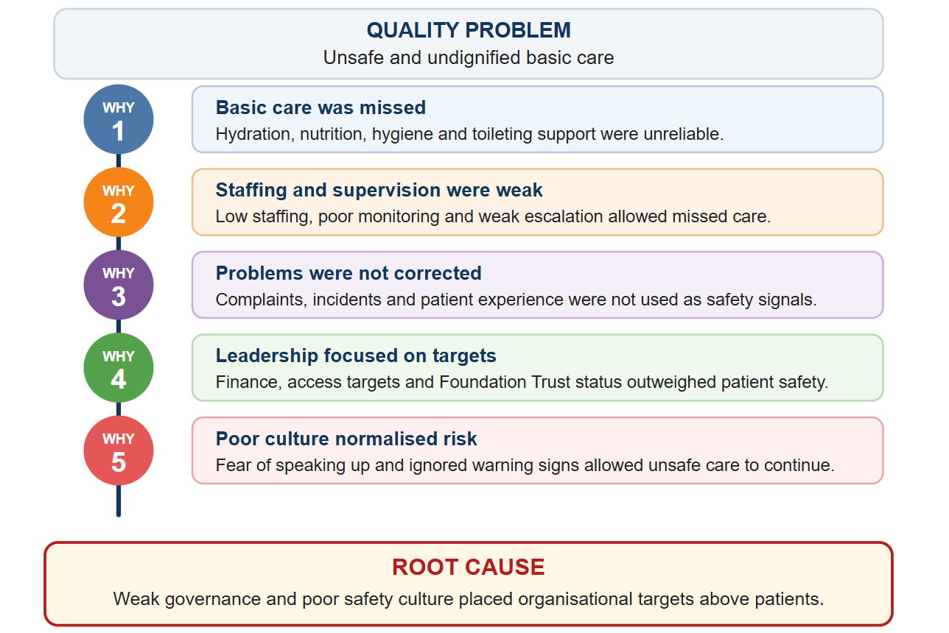
This was caused by a failure in the root cause of leadership and governance culture that did not prioritise patients (Francis, 2013).

2.6 Critical Justification of the Selected Frameworks
The chosen frames are suitable since each of them provides responses to various practical questions. Donabedian poses the question of the whereabouts of quality in terms of structure, process and outcome (Ayanian and Markel, 2016). Fishbone enquires what types of causes created the issue (Ishikawa, 1985). The 5 Whys poses, what underlying assumptions enabled such causes to go untreated (Serrat, 2017). SWOT poses the question of what the organisation can and needs to utilise or manage in the process of improvement (Gürel and Tat, 2017). The two of them have the effect of minimising the risk of a one-sided explanation. One model may put the blame on the staffing, culture or regulation, but as Mid Staffordshire demonstrates, it was all the factors that interacted (Francis, 2013).
The restrictions should also be identified. These models have the potential to make a complicated case in history simpler, in particular where not all the data are available or influenced by the evidence of retrospective inquiry (Francis, 2013). They are also not necessarily change-generating; leaders need to make an analysis into routines, resources and accountability (Batalden and Davidoff, 2007). To this end, the recommendations integrate both technical and cultural tools, i.e., PDSA and Lean and Kotter, the Results Pyramid and asset-based co-production.

3.0 Recommendations and Implementation Strategy

3.1 Reliability of safe staffing and basic care with PDSA
The initial suggestion is to implement a safe staffing and basic care reliability bundle. This should contain acuity-based staffing review, secure hydration and nutrition rounding, call-bell response, dignity checks and senior nurse safety huddles. The reason is obvious: when the structure of Mid Staffordshire was weak, insufficiently staffed, and poorly supervised, the wards, basic care could not be secured (Francis, 2013), and, according to staffing research, the availability of registered nurses correlates with patient outcomes (Dall’Ora et al., 2022). With PDSA, the Trust would design a pilot involving two wards, daily safety huddles and care-round checklists, missed care exploration, complaints and patient feedback, and respond by scaling the intervention in case of improvement of indicators (Taylor et al., 2014). The important measures must involve staffing fill rate, number of missed care episodes, documentation of hydration, rate of pressure ulcers, call-bell response time and patient dignity score. The drawback of this suggestion is the cost, since additional personnel and supervision will need to be invested in. Nevertheless, a probable positive effect is increased safety, decreased complaints and harm-related waste (Ham, Berwick and Dixon, 2016).

3.2 Learning to open reporting and complaints with the use of PDCA
The second suggestion is to establish an open reporting or complaints learning system. This goes directly to the issue of fear, secrecy and poor complaints management that existed at Mid Staffordshire (Francis, 2013). The system must be equipped with non-punitive incident reporting, weekly review of complaints, feedback on patients, review of patient stories by the Board, and freedom-to-speak-up protection by the staff. The Trust would design a clear reporting pathway, conduct staff training and patient communication changes, monthly checks of themes, and take action by changing policies, staffing or training where recurring risks are observed under PDCA (NHS England, 2022). This corresponds to PSIRF since patient safety in the modern world should be aimed at learning and improving the systems rather than blame (NHS England, 2022). The measures should encompass the rates of incident reporting, the response time to complaints, repetition of complaints topic, the staff safety culture scores and the demonstration of learning implemented. The potential limitation is that reporting numbers might increase initially, but this is to be viewed as enhanced openness as opposed to deterioration in safety (Mannion and Davies, 2018).

3.3 Quality Dashboard and Lean Governance of the Board
The third suggestion is to decouple quality intelligence from strictly financial performance and develop a Board Quality and Safety Dashboard. It should feature the staffing, mortality warnings, complaints, patient experience, falls, infection, pressure ulcer, safeguarding, theme of incident and action completion. Francis (2013) demonstrated that the Board did not listen, and it did not rectify the shortcomings; hence, quality information should be visible, triangulated and implemented. Lean thinking has the potential to eliminate wasteful reporting by targeting a few safety-critical measures that lead to escalation (Womack and Jones, 2003; Health Foundation, 2021). Directors should be able to test the dashboard data with frontline experience by conducting monthly ward walks around. These measures should be action completion rate, overdue risks, mortality review completion, staffing escalation response and patient-story review. The danger here is that dashboards might be another compliance exercise. To ensure this is not the case, every red indicator should have an owner, a deadline and follow-up review (Berwick, 2013).

3.4 Culture Change/Asset-Based Improvement
The fourth suggestion is to adopt a patient-centred culture change. The Week 8 culture lecture is pertinent as organisational culture encompasses values, roles, communication, attitudes and assumptions; Mid Staffordshire did not work out since these factors favoured targets over compassionate care. The model by Kotter ought to build urgency through patient narratives, establish a guiding coalition of clinical leaders and patient representatives, communicate a patient-first vision, eliminate barriers to speaking up, build short-term wins and sustain change (Kotter, 1996). Results Pyramid proves to be helpful since new staff experiences, like managers appreciating staff who have raised concerns, can establish beliefs that openness is safe and actions that enhance reporting (Connors and Smith, 2011). A staff champion, a patient advocate, family networks and community partners should be identified by an asset-based approach to enable improvement to be co-produced, not imposed (Rippon and Hopkins, 2015). These should be measures of engagement of staff, confidence in speaking up, patient experience, completion of training and evidence of changes in services produced co-produced. Culture change is challenging and slow, yet it is necessary as technical fixes might fail to work due to the recreation of the same risks by the same behaviours (Braithwaite et al., 2017).

4.0 Conclusion
Mid Staffordshire NHS Foundation Trust reveals the ways in which a healthcare organisation may fail when governance, culture, staffing, measurement and regulation fail to safeguard the patients. The issue of poor individual practice was not the main quality issue, but a system that permitted the continuance of unsafe and undignified basic care and the organisation prioritised targets, finance and Foundation Trust status. The Model presented by Donabedian demonstrated the unreliability of processes and the adverse consequences of weak structures. Fishbone analysis determined people, process, policy, environment, management and measurement causes and the 5 Whys demonstrated that the most fundamental cause was a culture of leadership in which the patients were not the priority. The Swiss Cheese Model demonstrated that the injuries were as a result of failure of multiple safety barriers. This was followed by a SWOT analysis, which indicated the risks and the assets that can be used to improve.
The recommendations are thus aimed at actual, achievable enhancement. The structure of care would be reestablished by safe staffing and the basic care reliability. The processes and organisational learning would be enhanced with open reporting and complaints learning. A quality dashboard on the Board level would enhance accountability and eliminate the possibility of safety information being swept under the carpet behind the financial performance. Sustained patient-centred practice would be facilitated by culture change and asset-based improvement. In general, the key takeaway is that quality assurance cannot be a form on paper. Evidence, compassion, patient voice, transparent measurement and responsible leadership must all be used to create sustainable service improvement.

Reference List
Ayanian, J.Z. and Markel, H. (2016) ‘Donabedian’s lasting framework for health care quality’, New England Journal of Medicine, 375(3), pp.205–207. Available at: https://doi.org/10.1056/NEJMp1605101
Batalden, P.B. and Davidoff, F. (2007) ‘What is “quality improvement” and how can it transform healthcare?’, Quality and Safety in Health Care, 16(1), pp.2–3. Available at: https://doi.org/10.1136/qshc.2006.022046
Berwick, D. (2013) A promise to learn – a commitment to act: improving the safety of patients in England. London: Department of Health. Available at: https://www.gov.uk/government/publications/berwick-review-into-patient-safety
Braithwaite, J., Herkes, J., Ludlow, K., Testa, L. and Lamprell, G. (2017) ‘Association between organisational and workplace cultures, and patient outcomes: systematic review’, BMJ Open, 7(11), e017708. Available at: https://doi.org/10.1136/bmjopen-2017-017708
Care Quality Commission (2023) State of Care 2022/23. Newcastle upon Tyne: CQC. Available at: https://www.cqc.org.uk/publications/major-report/state-care
Connors, R. and Smith, T. (2011) Change the Culture, Change the Game. New York: Portfolio.
Dall’Ora, C., Saville, C., Rubbo, B., Turner, L., Jones, J. and Griffiths, P. (2022) ‘Nurse staffing levels and patient outcomes: a systematic review of longitudinal studies’, International Journal of Nursing Studies, 134, 104311. Available at: https://doi.org/10.1016/j.ijnurstu.2022.104311
Dixon-Woods, M., Baker, R., Charles, K., Dawson, J., Jerzembek, G., Martin, G., McCarthy, I., McKee, L., Minion, J., Ozieranski, P., Willars, J., Wilkie, P. and West, M. (2014) ‘Culture and behaviour in the English National Health Service: overview of lessons from a large multimethod study’, BMJ Quality & Safety, 23(2), pp.106–115. Available at: https://doi.org/10.1136/bmjqs-2013-001947
Donabedian, A. (1988) ‘The quality of care: how can it be assessed?’, JAMA, 260(12), pp.1743–1748. Available at: https://doi.org/10.1001/jama.1988.03410120089033
Francis, R. (2013) Report of the Mid Staffordshire NHS Foundation Trust Public Inquiry: Executive Summary. London: The Stationery Office. Available at: https://www.gov.uk/government/publications/report-of-the-mid-staffordshire-nhs-foundation-trust-public-inquiry
Griffiths, P., Ball, J., Drennan, J., Dall’Ora, C., Jones, J., Maruotti, A., Pope, C., Recio Saucedo, A. and Simon, M. (2016) ‘Nurse staffing and patient outcomes’, International Journal of Nursing Studies, 63, pp.213–225. Available at: https://doi.org/10.1016/j.ijnurstu.2016.03.012
Gürel, E. and Tat, M. (2017) ‘SWOT analysis: a theoretical review’, Journal of International Social Research, 10(51), pp.994–1006. Available at: https://doi.org/10.17719/jisr.2017.1832
Ham, C., Berwick, D. and Dixon, J. (2016) Improving quality in the English NHS. London: The King’s Fund. Available at: https://www.kingsfund.org.uk/insight-and-analysis/reports/improving-quality-english-nhs
Health Foundation (2021) Quality improvement made simple. London: The Health Foundation. Available at: https://www.health.org.uk/publications/quality-improvement-made-simple
Institute of Medicine (2001) Crossing the Quality Chasm: A New Health System for the 21st Century. Washington, DC: National Academies Press. Available at: https://doi.org/10.17226/10027
Ishikawa, K. (1985) What is Total Quality Control? The Japanese Way. Englewood Cliffs: Prentice-Hall.
Keogh, B. (2013) Review into the quality of care and treatment provided by 14 hospital trusts in England. London: NHS England. Available at: https://www.nhs.uk/nhsengland/bruce-keogh-review
Kotter, J.P. (1996) Leading Change. Boston: Harvard Business School Press.
Mannion, R. and Davies, H. (2018) ‘Understanding organisational culture for healthcare quality improvement’, BMJ, 363, k4907. Available at: https://doi.org/10.1136/bmj.k4907
Mosadeghrad, A.M. (2014) ‘Factors influencing healthcare service quality’, International Journal of Health Policy and Management, 3(2), pp.77–89. Available at: https://doi.org/10.15171/ijhpm.2014.65
NHS England (2019) The NHS Patient Safety Strategy. London: NHS England. Available at: https://www.england.nhs.uk/patient-safety/the-nhs-patient-safety-strategy
NHS England (2022) Patient Safety Incident Response Framework. London: NHS England. Available at: https://www.england.nhs.uk/patient-safety/patient-safety-insight/incident-response-framework
NICE (2014) Safe staffing for nursing in adult inpatient wards in acute hospitals. London: NICE. Available at: https://www.nice.org.uk/guidance/sg1
NICE (2021) Shared decision making. London: NICE. Available at: https://www.nice.org.uk/guidance/ng197
Reason, J. (2000) ‘Human error: models and management’, BMJ, 320(7237), pp.768–770. Available at: https://doi.org/10.1136/bmj.320.7237.768
Rippon, S. and Hopkins, T. (2015) Head, hands and heart: asset-based approaches in health care. London: The Health Foundation. Available at: https://www.health.org.uk/publications/head-hands-and-heart-asset-based-approaches-in-health-care
Serrat, O. (2017) ‘The Five Whys Technique’, in Knowledge Solutions. Singapore: Springer, pp.307–310. Available at: https://doi.org/10.1007/978-981-10-0983-9_32
Spath, P. (2018) Introduction to Healthcare Quality Management. 3rd edn. Chicago: Health Administration Press.
Taylor, M.J., McNicholas, C., Nicolay, C., Darzi, A., Bell, D. and Reed, J.E. (2014) ‘Systematic review of the application of the plan–do–study–act method to improve quality in healthcare’, BMJ Quality & Safety, 23(4), pp.290–298. Available at: https://doi.org/10.1136/bmjqs-2013-001862
Vindrola-Padros, C., Ledger, J., Hill, M., Tomini, S., Spencer, J. and Fulop, N.J. (2022) ‘The special measures for quality and challenged provider regimes in the English NHS’, International Journal of Health Policy and Management, 11(12), pp.2914–2924. Available at: https://doi.org/10.34172/ijhpm.2022.6619
Womack, J.P. and Jones, D.T. (2003) Lean Thinking: Banish Waste and Create Wealth in Your Corporation. 2nd edn. London: Free Press.
World Health Organization (2020) Quality of care. Geneva: WHO. Available at: https://www.who.int/health-topics/quality-of-care
World Health Organization (2021) Global patient safety action plan 2021–2030. Geneva: WHO. Available at: https://www.who.int/publications/i/item/9789240032705

