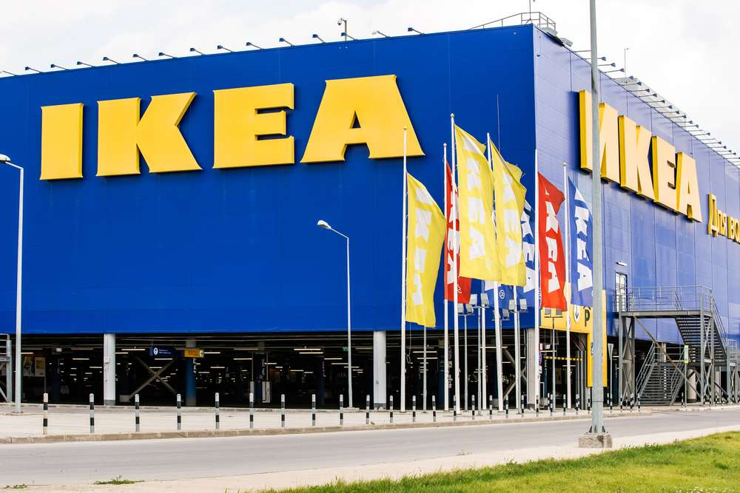

Consultancy Project Report

Analysis of IKEA Retail in the UK

COURSE NAME: ORGANISATIONAL CONSULTANCY
STUDENT NAME: JIAAI CAO
STUDENT NUMBER: 1904715

Table of Contents
1.0 Introduction 1
1.1 Introduction to the organization 1
1.2 Aims and Objectives of the Project 2
1.3 Project Justification 2
2.0 Environmental Analysis 4
2.1 PESTEL Analysis 4
2.2 SWOT Analysis 7
3.0 Research Methodology 9
3.1 Primary Research 9
3.1.1 Pilot Study 9
3.1.2 Ethical Consideration 10
3.2 Secondary Research 10
4.0 Findings and Analysis 12
4.1 Primary research findings and analysis 12
4.2 Secondary research findings and analysis 13
4.3 Limitation of the research 14
5.0 Recommendations and Implementation Plan 15
5.1 Recommendations 15
5.2 Implementation Plan 16
6.0 Conclusions 17
7.0 References 18
8.0 Appendix 23
8.1 Ethics Approval Form 23
8.2 Questionnaire 28
8.3 Pilot study 33
8.4 PESTEL and SWOT analysis 35
8.4.1 PESTEL analysis 35
8.4.2 SWOT analysis 36

List of Figures
Figure 4 Clothing items declined dramatically in March 2020 at negative 28.4% in comparison with a moderate increase of 3.3% in March 2019……………………….5

Figure 5 Implementation Plan………………………………………………………...16

Executive Summary
This report aims to give IKEA UK an analysis of its retailers to aid decision-making about retailing transformation. IKEA is a Swedish furnishing company whose business has gone international. Currently, it has 22 physical IKEA stores in the UK. Through secondary research, it is found that online sales of IKEA boost by 43% while some physical stores face financial crisis and the one in Coventry is to be shut down this summer. Also, through primary research, it is found that customers are not very clear about planning studios and small outlets of IKEA and there is room for IKEA retailers to improve their customers’ shopping experience.

Some recommendations are developed with an implementation plan based on the pandemic situation. Currently, where the UK is in the stage between Insecurity and Transition, the company needs to focus on the capability of e-commerce and build loyalty with customers. When the Transition stage comes, the company can do some marketing programmes to increase the awareness of its new physical store types and to adjust the layout and number of its physical stores for a small group. Then when the UK comes to the Recovering Stage, IKEA can design a series of activities to improve customers’ hedonic and social value when shopping.

1.0 Introduction

1.1 Introduction to the organization
IKEA is a global furnishing organization that offers products in various categories “including textiles, living room and workspace, bedroom and bathroom, kitchen and dining, lighting and home smart, cooking, eating and decoration and food among others” (MarketLine, 2020). The first IKEA company was founded by Ingvar Kamprad in 1943, in Småland, southern Sweden. Now it has 433 IKEA stores in more than 50 markets (IKEA, 2019), with 22 stores in the UK (BBC News, 2020).

The IKEA vision is “to create a better everyday life for the many people”. It guides everything the organisation does, from little things like what raw materials IKEA uses to big strategies like sustainability. To achieve this vision, IKEA has developed its business idea: “to offer a wide range of well-designed, functional home furnishing products at prices so low that as many people as possible will be able to afford them” (IKEA, 2020).

IKEA values were developed from earlier harsh days in Sweden, where people then became more pragmatic and mindful about the resources. The key values of IKEA are concluded into 8 points: Togetherness, Caring for people and planet, Cost-consciousness, Simplicity, Renew and improve, Different with a meaning, Give and take responsibility, Lead by example. In general, IKEA is “constantly trying to find better ways to get things done and to bring out the best in ourselves and others” (IKEA, 2020). Although the world is changing rapidly and IKEA is also changing its way of doing business, the organisation will never change the commitment to live their values.

At present, IKEA is operated by two groups: one is Ingka Group; the other is Inter IKEA Group. Ingka Group was set up by the founder of IKEA, Ingvar Kamprad in 1990s. It has helped spread the IKEA brand to 30 markets by three business areas. The first one is IKEA Retail, which is the core business of Ingka Group, representing over 90% of total IKEA sales (INGKA, 2020). The rest business areas are Ingka Centres and Ingka Investments, which aid the expansion of the organisation. As for Inter IKEA Group, it owns the intellectual property of IKEA and controls worldwide IKEA franchisor by its subsidiary Inter IKEA Systems B.V. (IKEA, 2020).

1.2 Aims and Objectives of the Project
This consulting project aims to give IKEA UK an analysis of its retailers to aid decision-making about retailing transformation. To realise the aim, the following objectives are developed:
- Analyse the business environment using the PESTEL model;
- Explore the changes of current retailing as well as furnishing industry;
- Make a SWOT analysis of IKEA Retail in the UK;
- Produce a questionnaire to identify consumers’ attitudes and behaviours about IKEA Retail in the UK;
- Critically analyse the conditions of IKEA Retail in the UK with primary and secondary research results;
- Provide recommendations for IKEA Retail in the UK to aid their retailing transformation.

1.3 Project Justification
IKEA, the Swedish retail giant announced the shut-down of its Coventry retail store this February, making it the first big closure of a UK IKEA outlet (BBC News, 2020). MarketLine (2019) said that online sales accounted for 11% of total revenues after sales hit a record EUR40bn. Also, according to IKEA Sustainability Report FY19, although there were more than 1 billion visits to IKEA stores in 2019, the number of visits to IKEA websites was 2.8 billion, and e-commerce sales have been boosted by 43% (IKEA, 2019).

The whole retailing in the west faces the same crisis. According to the Centre for Retail Research (2020) which provides authoritative retail data across the UK, Europe and North America, the number of total store closures in 2019 was 16,073, 10% higher than the figure in 2018; the number of total job losses also rose from 117,425 to 143,128 between 2018 and 2019. Furthermore, the effect of coronavirus lockdown will jeopardise even greater on retailers this year.

As a retail giant with Britain being its fourth-largest market (Bridge, 2019), IKEA must act quickly and properly to respond to the testing time. This project will help IKEA to reshape its retail business in the UK to not only go through current lockdown but also gain a promising future.

2.0 Environmental Analysis

2.1 PESTEL Analysis
Here are political, economic, social, technological, environmental and legal factors affecting IKEA retailers in the UK.

- Political
Coronavirus has become a pandemic affecting nearly all countries across the globe these months. The UK is one of the countries most affected by the pandemic. Gov.uk (2020) indicates that the risk to the UK has been raised to high. As a result, the UK government has adopted lockdown measures in which people are advised to stay at home as much as possible (Gov.uk, 2020). A large number of retailers have been closed, including IKEA retailers in the UK. Although most retailers can get business rates relief from the government (Gov.uk, 2020), they are still struggling to survive.
Besides, the UK has left the European Union on January 31st this year and is now experiencing its transition period. At present, not much has changed. However, when the transition period ends, the UK can adopt "no-deal Brexit". If this is the case, "the UK could face higher food prices and disruption to medicines and other goods" due to tariffs (BBC News, 2020).

- Economic
Office for National Statistics (2020) published retail sales data in the UK this April. It shows that “in March 2020, the monthly retail sales volume fell sharply by 5.1%”, while “online sales as a proportion of all retailing reached a record high of 22.3% in March 2020 as consumers switched to online purchasing following the pandemic”. For furniture industry, although the pandemic does damage to the furniture retailers in the short term, it also provides great market opportunities for smart home and home office business since people are more concerned about their home life and many people have to work at home (Dandan, 2020). In fact, Office for National Statistics (2020) shows that in March 2020, the value for household goods increased sales on the month by 18.0%, a 1.0% growth compared with the previous year.
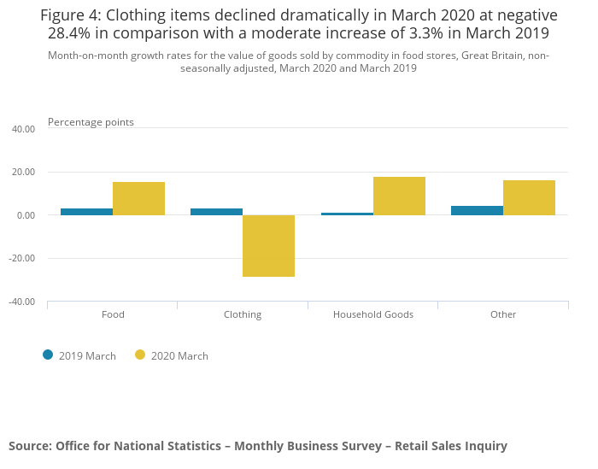

- Social
The different generation has different consumption behaviours. For instance, Generation Y just takes furniture as temporary products whereas their parents and grandparents are willing to invest to choose the right furniture to use for a very long time (McLoughlin, 2020). Therefore, millennials’ shopping frequency for household items tend to be higher and convenience is the case for the group. Some experts also say today's labour force prefers to live in urban areas and they want more convenient shopping experience by walking or taking public transportation rather than a drive to “big box” stores in suburban areas (Stern, 2020).

- Technological
Ecommerce is becoming more and more popular in the UK. The share of online retail sales in 2018 was 17.8% in the UK, a 1.0% higher than that in 2017, and it is expected to grow to 19.0% in 2019 (Centre for Retail Research, 2020). Centre for Retail Research (2020) also shows that 43.0% of online retailing in the UK is carried out via smartphones and tablets, with 60% of mobile retailing done on smartphones.
Apart from digital growth, the recent appearance of technologies like AR and VR is also noticeable. For example, a smart mirror using virtual reality (VR) technology could show the customer what the garment looks like on him/her without changing the clothes (Lifelong Learners, 2017). Although these technologies are costly, with mass production the costs tend to fall.

- Environmental
The environment is worsening due to human behaviours but also gaining concern. In October 2018, an alarming special report published by the Intergovernmental Panel on Climate Change (IPCC) indicated that “global warming is likely to reach 1.5℃ between 2030 and 2052 if it continues to increase at the current rate” (IPCC,2018). In urgent circumstances, young generations are especially active to save the planet and their future. For example, the 16-year-old climate activist, Greta Thunberg, not only persuaded her parents to change lifestyles to reduce their carbon footprint but also influenced millions of people by leading strikes and giving speeches on international stages like the 2019 UN Climate Action Summit (Alter, Haynes and Worland, 2019).

- Legal
The legal issues of a furnishing company lie in not only the adherence of the labour law but also the welfare of customers. Recently, “IKEA is recalling 800,000 dressers that it says could tip over and injure small children, possibly fatally” (Morris, 2020), showing the importance of safety management. Otherwise, monetary loss, as well as reputation damage, will occur according to legal punishment.

2.2 SWOT Analysis
- Strength
1. The broad product range meets diversified customers' needs.
The organisation provides “a variety of furniture for living room, bedroom, kitchen, dining and children’s room” (MarketLine, 2016), ranging from sofas, chairs, lighting, floorings to plant pots and plenty of decorations like candles and mirrors. In addition to furniture for home of living, the organisation also provides one for offices, retail stores and hospitality.
2. Multi-channel retailing enhance customer base.
Currently, IKEA has integrated its physical stores, online stores and mobile apps to provide a seamless shopping experience for customers. The number of visits to IKEA stores also rises from 957 million (IKEA, 2018) to more than 1 billion (IKEA, 2019) between FY18 and FY19. Customers can also shop at www.ikea.com, the e-commerce sales of which increase by 43%, with 2.8 billion visits to IKEA websites (IKEA, 2019). For the IKEA mobile app, it has updated to sync up everything from the user’s website to its devices and can be downloaded both from iOS and Android (IKEA, 2020).
3. Endeavour to sustainability increases IKEA’s goodwill and strengthen the brand’s value.
“IKEA has been working towards sustainability since 1990 when the group developed its first environmental policy” (MarketLine, 2016), and FY19 has seen huge achievements of IKEA on sustainability. For instance, the climate footprint of IKEA value chain reduced by 4.3% and is now the same as the baseline FY16; More plant-based food is offered, including vegan strawberry soft ice introduced in April 2019 (IKEA, 2019).

- Weakness
1. Product recalls may impair the image of the organisation.
The recalling of risky products has always been an issue for IKEA. In 2016 only, there were more than four times of big recalling (MarketLine, 2016). And in March this year, IKEA is recalling 800,000 children’s dressers for risk of tipping over. The dressers were reported to have already caused two minor injuries (Morris, 2020). The recalling of products can not only impair the image of IKEA but also result in loss of sales.

- Opportunity
1. The United Kingdom furniture & floor coverings market is growing.
The United Kingdom furniture & floor coverings market increased by 0.2% in 2018 to reach a value of $17,896.9 million, and it is forecast to rise to $19,168.5 million in 2023 (MarketLine, 2020).
2. Current pandemic increases people's awareness of household items.
Covid-19 imposes UK citizens to stay at home as much as possible. People will pay more attention to household items to make their life and even work at home more convenient and comfortable. It is an opportunity for IKEA retailers to increase sales.

- Threat
1. Lockdown of physical stores put pressure on IKEA retailers.
According to the lockdown policy of the UK government, IKEA physical stores in the UK have been closed since March 20th (IKEA, 2020). This will have a negative impact on the profits of IKEA retailers as costs like employees’ salary are still on without sales in.
2. There is intense competition in the furnishing industry.
The household furniture market is fragmented. IKEA not only faces competition from furnishing companies like Stanley Furniture Company and Ashley Furniture Industries but also mass-market retailers like Tesco and ASDA stores, among others (MarketLine, 2016).

3.0 Research Methodology
There are two main research methods. One is primary research, which is conducted directly by the researchers to “explore the nature of individual needs, buying and product selection” (Wickham and Wilcock, 2012, p.150). The other is secondary research, to collect already published information, which varies enormously in its relevance but it is cost-effective and can be very useful (Wickham and Wilcock, 2012, p.148). This report uses both methods to search for both original sources and wide-ranging published sources as sound evidence to back the findings.

3.1 Primary Research
This report adopts the email survey approach. It is a questionnaire aiming to find out consumers’ attitudes and behaviours on IKEA retailers. Due to the lockdown in the UK and the low-cost benefit, it has become the priority of choices to send questionnaires online, specifically via email and WeChat in this research. The questionnaire consists of three sections. The first section asks about the participants’ demographic characteristics, including gender, age, and employment status. Then based on the responses whether the participants have had experiences of going to IKEA retailers, the positive ones go to the second section where their behaviours towards IKEA retailers are examined, while the negative ones turn to the third section directly to answer questions about attitudes towards IKEA retailers. The expected number of participants is 50.

3.1.1 Pilot Study
Before sending out the questionnaire, a pilot study has done carefully with the module tutor. Under his guidance, an Ethics Approval Form has been updated, and several amendments have been made towards the questions. For example, a “Prefer not to answer” choice has been added to many questions to improve the inclusiveness of the questionnaire, and the means of a “Likert scale” has replaced some clicking the choice, since the former one can quantify the participants’ attitudes more clearly. More details can be seen in the appendix.

3.1.2 Ethical Consideration
Ethical consideration is important to protect the rights and interests of participants, researchers and the university. First of all, the questionnaire puts forward a statement in the front to obtain consent from participants. They are told that their participation is completely voluntary and they can leave the questionnaire page at any time. Also, their responses are anonymous and protected for only academic use. To protect the privacy of the researcher, the questionnaire is sent to mostly the researcher’s friends, classmates and teachers via e-mails and WeChat. Additionally, to minimise the reputation risk of the university, the questionnaire ensures its clarity, relevance and inclusiveness before it is sent out by strict check and revision with the tutor. A copy of the ethics approval form can be found in the appendix.

3.2 Secondary Research
Thematic research is used to group the secondary resources into two categories: One is the research into the retail industry and furniture industry to explore their current status and future trends; the other is the research about IKEA organisation, especially its retailing conditions and strategies.
The following activities have been conducted:
- To use the University of Wales Trinity Saint David (UWTSD) Library for reliable sources: one Management Consulting book has been lent two months ago to guide for this project; also, easy access to databases such as MarketLine, ABI/INFORM Collection and Business Source Complete provides wide-ranging academic sources.
- To investigate the organisation’s official website, including https://www.ikea.com/gb/en/, https://about.ikea.com/en, https://newsroom.inter.ikea.com/ and its parental group website https://www.ingka.com/. This helps to look in-depth into IKEA to know exactly what they have done and the statistics.
- To search for academic and governmental websites to acquire authoritative information. These include news websites like BBC news and the guardian, industry websites like Centre for Retail Research, magazine websites like the Forbes, the Fortune, Harvard Business Review and Marketing Week, as well as governmental websites like the Gov.uk and IPCC.

4.0 Findings and Analysis

4.1 Primary research findings and analysis
The result of the questionnaire can be seen in the form of bar charts and pie charts in the appendix on this report.

The questionnaire has received a total number of 51 results, in which females account for 64.7%, 76.5% of the participants are between 18 and 24 years old and 76.5% of participants are students. Therefore, this questionnaire mainly reflects generation Z’s attitudes and behaviours towards IKEA retailers. In the first part, the questionnaire asks the preference between shopping in retail stores and shopping online in terms of household items and there are 29 participants choose 4 and 5, which shows the high preference of shopping in retail stores. This is good news for IKEA physical stores. However, there are 29.4% of participants hold a neutral view, while 11.8% of them have an opposite preference, so e-commerce is also a big market that IKEA retailers cannot omit.

In the second part, the questionnaire discusses behaviours of participants who have been to IKEA retailers. It is found that the majority (62.8%) of participants usually drive to IKEA retailers, while some (37.2%) choose to take public transportation. In terms of companions, most participants go to IKEA retailers with families and friends, and only three participants choose usually go there alone. Most participants (67.5%) spend longer than 1 hour in IKEA retailers, while only 7% of them spend less than half an hour. When it comes to the sharing will of the experience of IKEA retailers, 67.4% of the participants choose they will share and definitely share the experience. However, there are still four participants think they will not share the experience, with one responding “Nothing”.

The third part investigates the attitudes of participants towards IKEA retailers. Most people agree (58%) and very agree (16%) that shopping in IKEA retailers is a happy experience, while there are still 2% of participants disagree and 6% of them strongly disagree. In terms of the convenience, 51% agree and 12.2% very agree on the convenience. However, 26.5% of the participants hold a neutral view and 10.2% of participants disagree and strongly disagree with the view. Next two questions are preference choices between big IKEA stores, small outlets of IKEA and Planning Studios. In terms of the former two, more participants (60%) prefer big IKEA stores while there are 30% of participants hold a neutral view. In terms of the latter two, 49% of the participants choose a neutral attitude and the preference number is nearly equal between the two sides.

After analysing the results, it is found that there is room for IKEA retailers to improve the experience of customers and more participants show a neutral view when it comes to the different physical store types. This indicates that more participants either do not understand fully about the question, do not have adequate information about the different physical store types or think it depends on different situations (TNS Employee Insights, 2011).

4.2 Secondary research findings and analysis
Apart from retailing trend and macro environment which have been discussed in former sections, secondary research has also looked into the current conditions of IKEA retailers and some approach to improving them.

IKEA is to close its Coventry city centre store this summer, which will become the first UK store closure of IKEA, putting 350 jobs at risk. The retailer was hit by a higher cost, including “minimum wages and business rates, and a big shift to online shopping” (Partridge, 2020). However, IKEA has made new types of physical stores open as early as in 2018. It was a planning studio focusing on the bedroom and kitchen, which marked the firm’s shift to city centres. It is 400 square metres and currently, there are two planning studios in the UK: one in central London’s Tottenham Court Road, and the other in Bromley, south-east London (Wood, 2018). This year, IKEA has bought the west London shopping mall to open new stores in city centres. Unlike planning studios, these outlets will store more than 2000 household items and can be taken away right from the stores (Butler, 2020).

To catch up with the digital trend and improve the shopping experience, the retailing has developed an omnichannel strategy. It is to fully integrate all customer touchpoints including physical stores, websites, mobile apps, social media etc. to provide a seamless experience for customers (Chaffey, Hemphill and Edmundson-Bird, 2018, p.43). Unlike the multichannel strategy, the omnichannel strategy focuses on the whole brand rather than each channel, and customers use channels simultaneously rather than in parallel. In research of omnichannel shopping value (SV), the results show that the hedonic dimension contributes to every channel SV observed, the social dimension promotes dramatically to online and offline touchpoint SV, the joint utilitarian and social dimension has positive effects on mobile touchpoint SV, and the utilitarian dimension facilitates to online touchpoint SV only (Huré, Picot-Coupey and Ackermann, 2017). Therefore, it is significant for IKEA retailers to add hedonic, social and utilitarian shopping value to their customers.

4.3 Limitation of the research
The limitation mainly lies in primary research. First of all, the number of 51 is not enough to back up all citizens in the UK. Second, the ratio of genders and ages is not balanced, so the results of the research may only represent a certain group's ideas. Last but not least, a lack of field investigation or interview of related IKEA staff may result in some misunderstanding of IKEA retailers in the UK.

5.0 Recommendations and Implementation Plan

5.1 Recommendations
Based on the findings and analysis above, there are four recommendations for IKEA retailers in the UK.

1) To improve hedonic and social shopping value in all touchpoints. The study of Högberg et al. (2019) shows that gamified experience could increase the hedonic value of customers. And according to the primary research, most customers go to the IKEA retailers with families and friends, so IKEA could design some relaxing games for a group of customers to enjoy, which could not only make customers happy but also improve their social connections with each other. For example, if customers take selfies in the appointed places and upload them on Facebook or Instagram with tags, then they can get a discount.

2) To improve public perceptions about small outlets and planning studios. The primary research shows that the two new physical store types are not very familiar to the public, so there is a need for IKEA retailers to do some marketing for them. One approach to attracting young customers is to cooperate with influencers by making and uploading Vlogs about small outlets and planning studios.

3) The open and closure of physical stores need to start with a small group. According to the primary research, more customers still prefer large IKEA stores, and people are naturally afraid of changes, so it is not wise to close many large stores and open many small new ones this year.

4) Improve e-commerce capability and build loyalty. Due to the coronavirus, physical stores are shut at present and online sales are increasing rapidly. It is vital at this stage to maintain the smoothness of storage, logistics and services. And it is a chance to build customer loyalty, for example, to delay or cancel the expiry date of the voucher.

5.2 Implementation Plan
The pandemic can be defined by three key stages: Insecurity, Transition and Recovery, and currently the UK is around somewhere between Insecurity and Transition (dunnhumby, 2020). The following figure is the outline of the implementation plan under the impact of the pandemic.
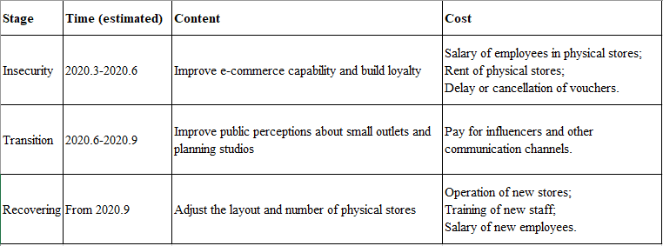
Figure 5 Implementation Plan

6.0 Conclusions
This project report has done a thorough analysis of IKEA retailers, the retail industry and furnishing industry in the UK, using both primary research and secondary research. It is recommended to improve e-commerce capability and build loyalty during the pandemic, and then a small group of physical store adjustment can be done with increased awareness of planning studios and small outlets as well as increased shopping value.

7.0 References
Alter, C. Haynes, S. and Worland, J. (2019) TIME 2019 PERSON OF THE YEAR – GRETA THUNBERG. Available at: https://time.com/person-of-the-year-2019-greta-thunberg/ (Accessed: 26 April 2020).

BBC News (2020) Ikea announces first big UK store closure. Available at: https://www.bbc.co.uk/news/business-51369413 (Accessed: 5 February 2020).

BBC News (2020) Brexit: The UK has officially left the EU - what happens next? Available at: https://www.bbc.co.uk/news/world-europe-51307874 (Accessed: 25 April 2020).

Butler, S. (2020) Ikea buys west London shopping mall in city centre push. Available at: https://www.theguardian.com/business/2020/jan/09/ikea-buys-west-london-shopping-mall-for-170m-in-city-centre-push (Accessed: 12 April 2020).

Bridge, S. (2019) Rising sales can't stop Ikea UK slump as weak pound and new store openings sees it swing to a loss. Available at: https://www.thisismoney.co.uk/money/markets/article-7098801/Rising-sales-stop-Ikea-UK-slump-weak-pound-new-store-openings-sees-swing-loss.html (Accessed: 25 February 2020).

Centre for Retail Research (2020) Online: UK, Europe & N. America. Available at: https://www.retailresearch.org/online-retail.html (Accessed: 25 April 2020).

Centre for Retail Research (2020) Mobile Retailing. Available at: https://www.retailresearch.org/mobile-retailing.html (Accessed: 25 April 2020).

Centre for Retail Research (2020) The Crisis in Retailing: Closures and Job Losses. Available at: https://www.retailresearch.org/retail-crisis.html (Accessed: 16 February 2020).

Chaffey, D., Hemphill, T., and Edmundson-Bird, D. (2018) Digital Business and E-Commerce Management. 7th edn. Harlow: Pearson Education Limited.

Dandan (2020) ‘FT China exclusive: How China's furniture industry is coping with coronavirus’, Furniture Today, 44(26), pp.24. Available at: https://web-b-ebscohost-com.ezproxy.uwtsd.ac.uk/bsi/pdfviewer/pdfviewer?vid=20&sid=b5a8225c-1eb1-4276-8e6a-dba65bf58ac5%40pdc-v-sessmgr02 (Accessed: 9 April 2020).

dunnhumby (2020) What can Customers tell Retailers about how to plan ahead right now? Available at: https://www.dunnhumby.com/resources/blog/en/What-can-Customers-tell-Retailers-about-how-to-plan-ahead-right-now (Accessed: 4 May 2020).

Gov.uk (2020) Business rates: expanded retail discount – guidance. Available at: https://www.gov.uk/government/publications/business-rates-retail-discount-guidance (Accessed: 26 April 2020).

Gov.uk (2020) Number of coronavirus (COVID-19) cases and risk in the UK. Available at: https://www.gov.uk/guidance/coronavirus-covid-19-information-for-the-public (Accessed: 26 April 2020).

Gov.uk (2020) Coronavirus (COVID-19): what you need to do. Available at: https://www.gov.uk/coronavirus (Accessed: 26 April 2020).

Högberg, J. et al. (2019) ‘Creating brand engagement through in-store gamified customer experiences’, Journal of Retailing and Consumer Services, 50(2019), pp.122-130.

Huré, E., Picot-Coupey, K. and Ackermann, C. (2017) ‘Understanding omni-channel shopping value: A mixed-method study’, Journal of Retailing and Consumer Services, 39(2017), pp. 314-330.

IKEA (2020) IKEA culture and values. Available at: https://about.ikea.com/en/who-we-are/our-roots/ikea-culture-and-values (Accessed: 20 April 2020).

IKEA (2020) The IKEA vision and business idea. Available at: https://about.ikea.com/en/who-we-are/our-roots/the-ikea-vision-and-business-idea (Accessed: 20 April 2020).

IKEA (2020) One brand – many companies. Available at: https://www.ikea.com/gb/en/this-is-ikea/about-us/one-brand-many-companies-pub07af8e71 (Accessed: 20 April 2020).

IKEA (2020) IKEA mobile apps. Available at: https://www.ikea.com/gb/en/customer-service/mobile-apps/ (Accessed: 29 April 2020).

INGKA (2020) We bring IKEA into people’s lives. Available at: https://www.ingka.com/ (Accessed: 20 April 2020).

IKEA (2019) IKEA Sustainability Report FY19. Available at: https://gbl-sc9u2-prd-cdn.azureedge.net/-/media/aboutikea/pdfs/ikea-sustainability-reports/ikea-sustainability-report-fy19_.pdf?la=en&rev=17f025ae6d35420facf7a40d50d4e5a6&hash=4A185424A2EE8D9671F382D833D82EF4 (Accessed: 20 April 2020).

IKEA (2018) IKEA Sustainability Report FY18. Available at: https://preview.thenewsmarket.com/Previews/IKEA/DocumentAssets/535135.pdf (Accessed: 29 April 2020).

IPCC (2018) SPECIAL REPORT | Global Warming of 1.5 ºC. Available at: https://www.ipcc.ch/sr15/ (Accessed: 24 April 2020).

Lifelong Learners (2017) Retail 2020 | 5 Technologies that will change the way you shop [video]. Available at: https://www.youtube.com/watch?time_continue=297&v=iRvaWHk3A8k&feature=emb_logo (Accessed: 23 February 2020).

MarketLine (2020) Furniture & Floor Coverings in the United Kingdom. Available at: https://advantage-marketline-com.ezproxy.uwtsd.ac.uk/Analysis/ViewasPDF/united-kingdom-furniture-floor-coverings-92811 (Accessed: 26 February 2020).

MarketLine (2019) Ikea boosted by online sales. Available at: https://advantage-marketline-com.ezproxy.uwtsd.ac.uk/News/ikea-boosted-by-online-sales (Accessed: 26 February 2020).

McLoughlin (2020) ‘Can the furniture industry afford a 'more affordable' Ikea?’, Furniture Today, 44(25), pp.2. Available at: https://web-b-ebscohost-com.ezproxy.uwtsd.ac.uk/bsi/pdfviewer/pdfviewer?vid=23&sid=b5a8225c-1eb1-4276-8e6a-dba65bf58ac5%40pdc-v-sessmgr02 (Accessed: 9 April 2020).

Morris, C. (2020) Ikea recalls 800,000 children’s dressers for risk of tipping over. Available at: https://fortune.com/2020/03/04/ikea-recalls-childrens-dressers-tipping/ (Accessed: 26 April 2020).

MarketLine (2016) Ikea Group MarketLine Company Profile. Available at: http://www.marketline.com.ezproxy.uwtsd.ac.uk/ (Accessed: 25 February 2020).

Office for National Statistics (2020) Retail sales, Great Britain: March 2020. Available at: https://www.ons.gov.uk/businessindustryandtrade/retailindustry/bulletins/retailsales/march2020 (Accessed: 25 April 2020).

Partridge, J. (2020) Ikea to close first big UK store, putting 350 jobs at risk. Available at: https://www.theguardian.com/business/2020/feb/04/ikea-close-store-jobs-coventry-city-centre (Accessed: 25 February 2020).

Stern, M. (2020) IKEA Tests Parking Lot-Free Stores. Available at: https://www.forbes.com/sites/retailwire/2020/01/29/ikea-tests-parking-lot-free-stores/#6e7daabc4924 (Accessed: 25 February 2020).

TNS Employee Insights. (2011). THE RESULTS ARE IN, NOW WHAT? Turning employee surveys into agents of change. TNS .

Wood, Z. (2018) Mini Ikea spin-off store opens in central London. Available at: https://www.theguardian.com/business/2018/oct/11/mini-ikea-planning-studio-spin-off-store-opens-central-london (Accessed: 12 April 2020).

Wickham, L. and Wilcock, J. (2012) Management Consulting. 4th edn. Harlow: Pearson.

8.0 Appendix

8.1 Ethics Approval Form
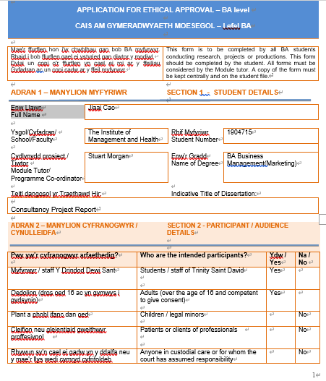
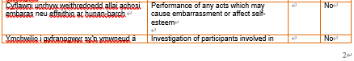
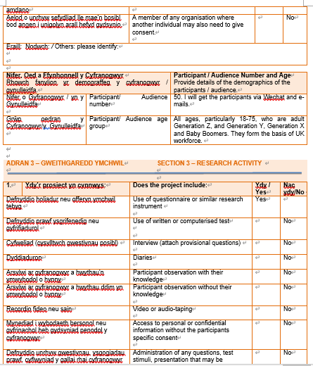
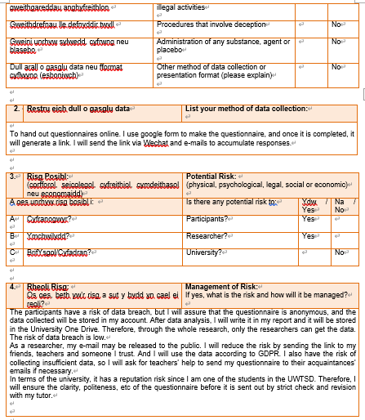
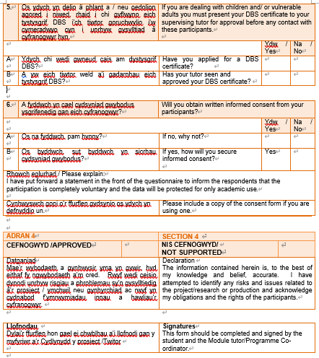
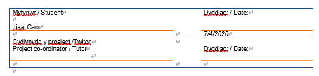
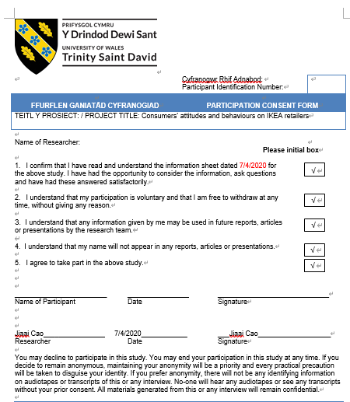
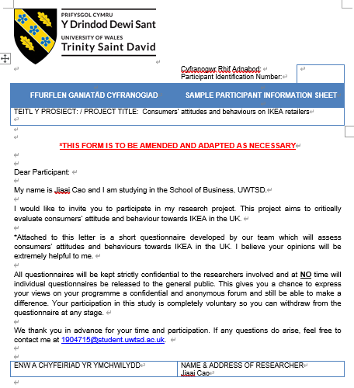

8.2 Questionnaire
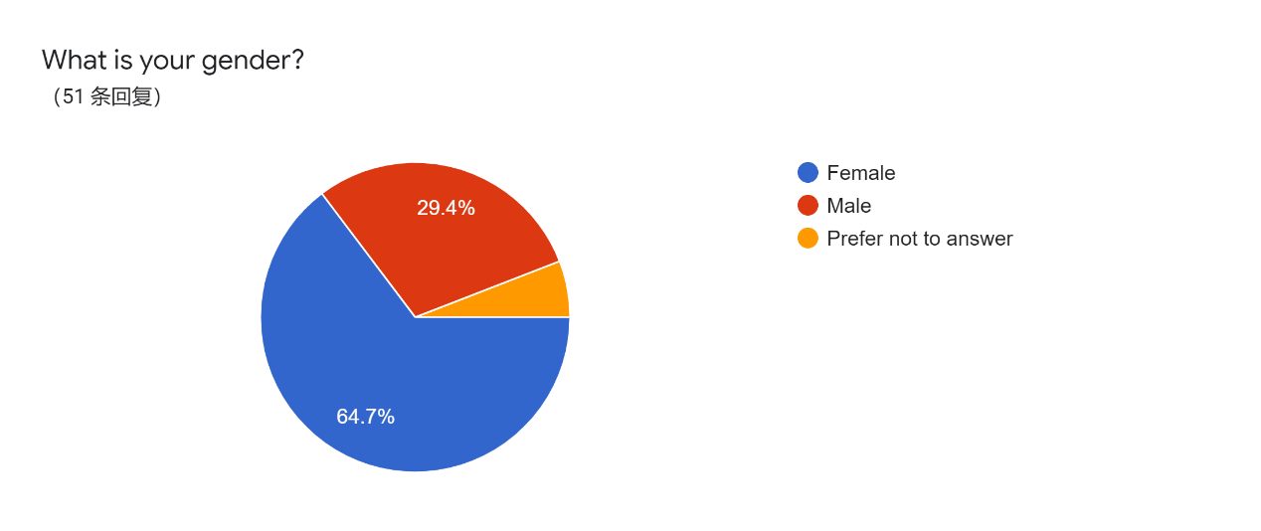
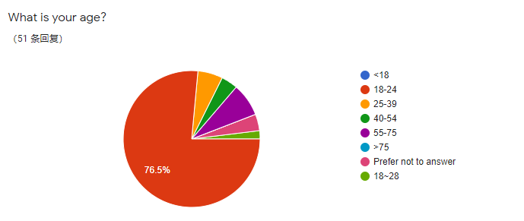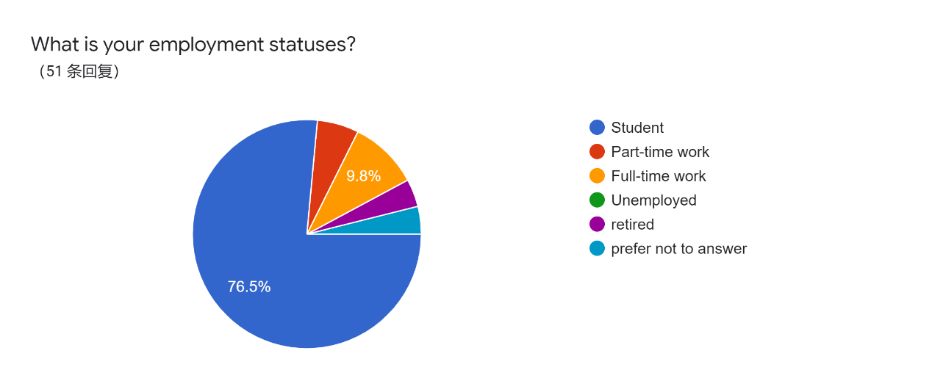
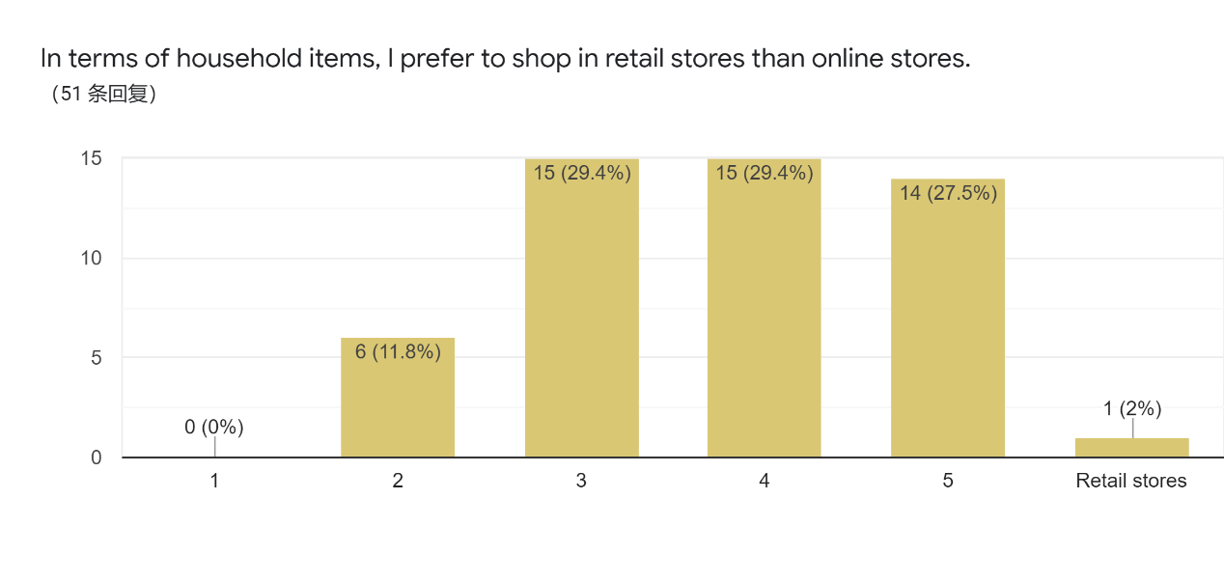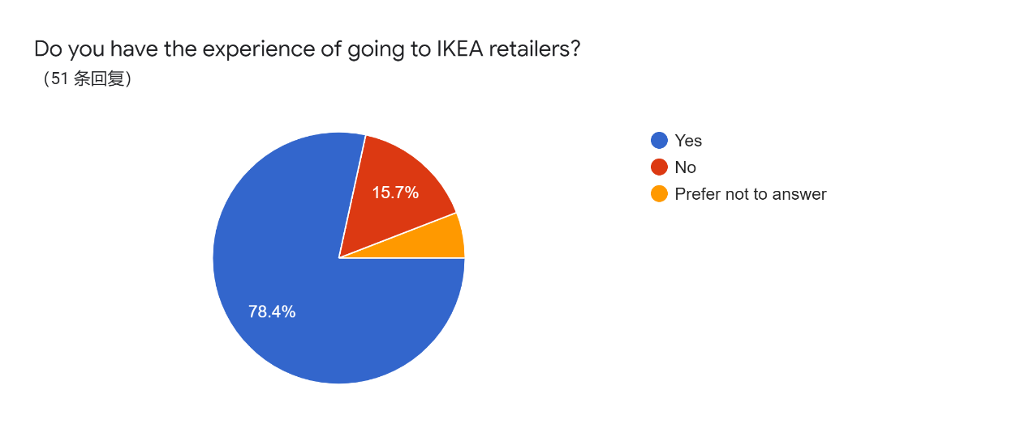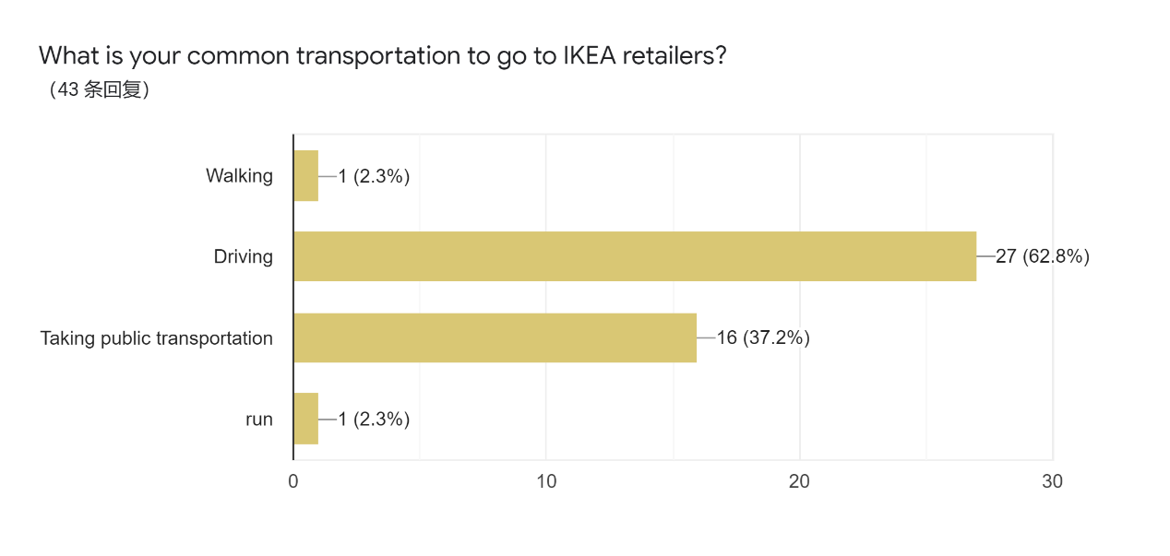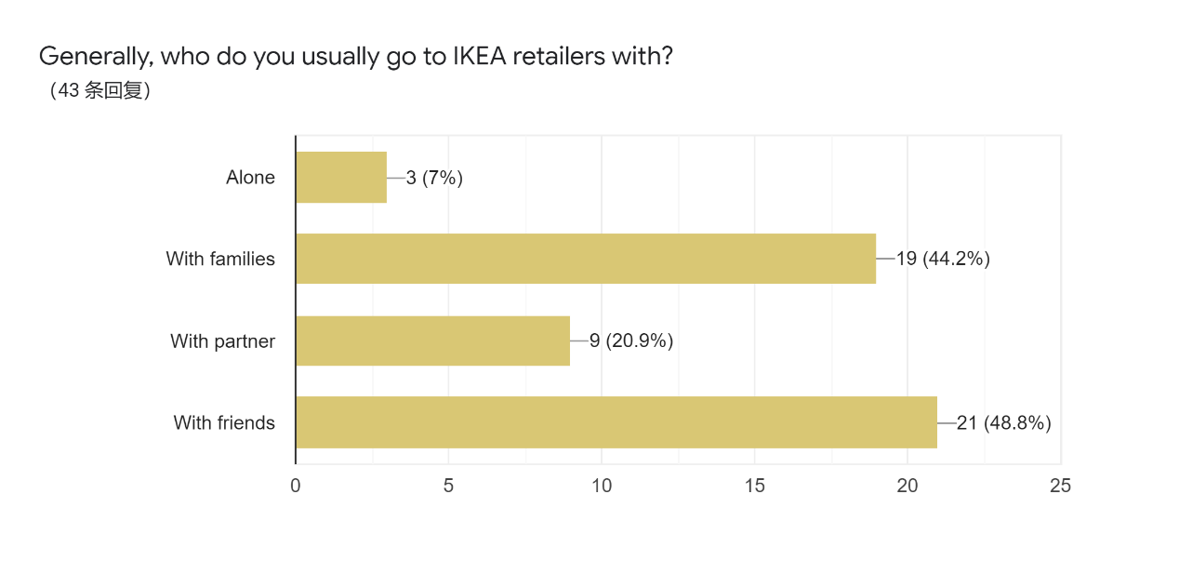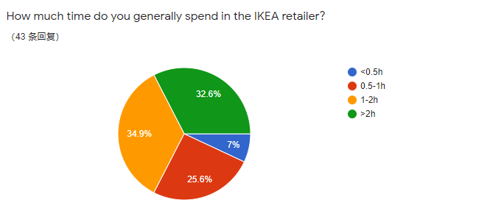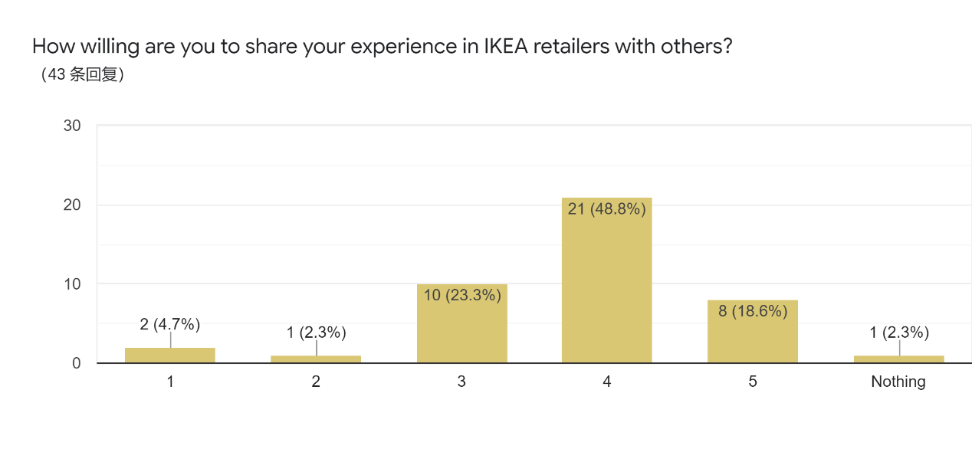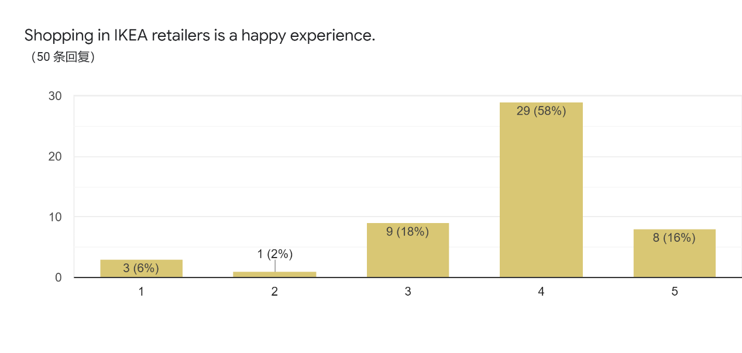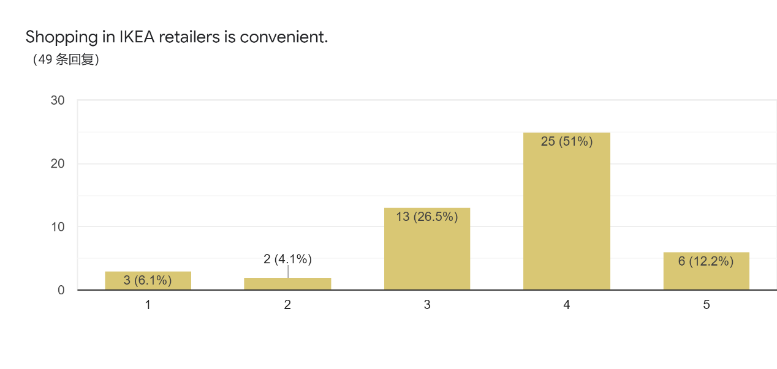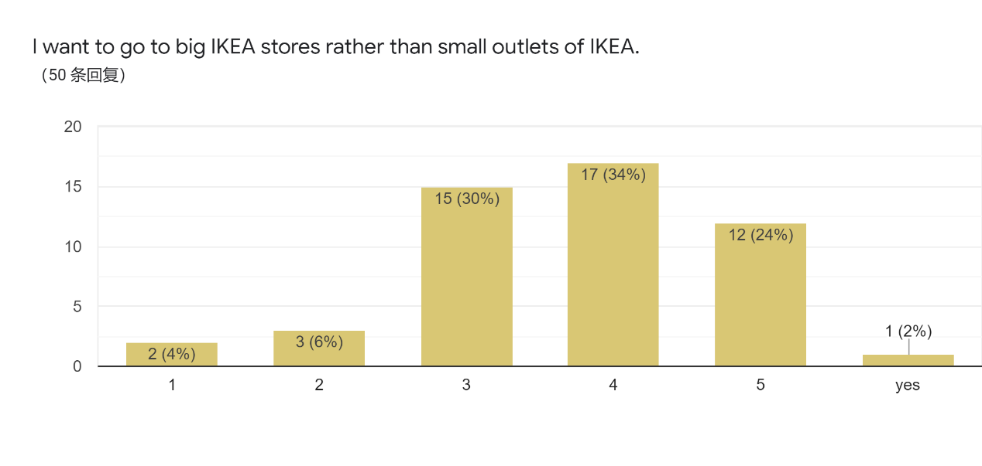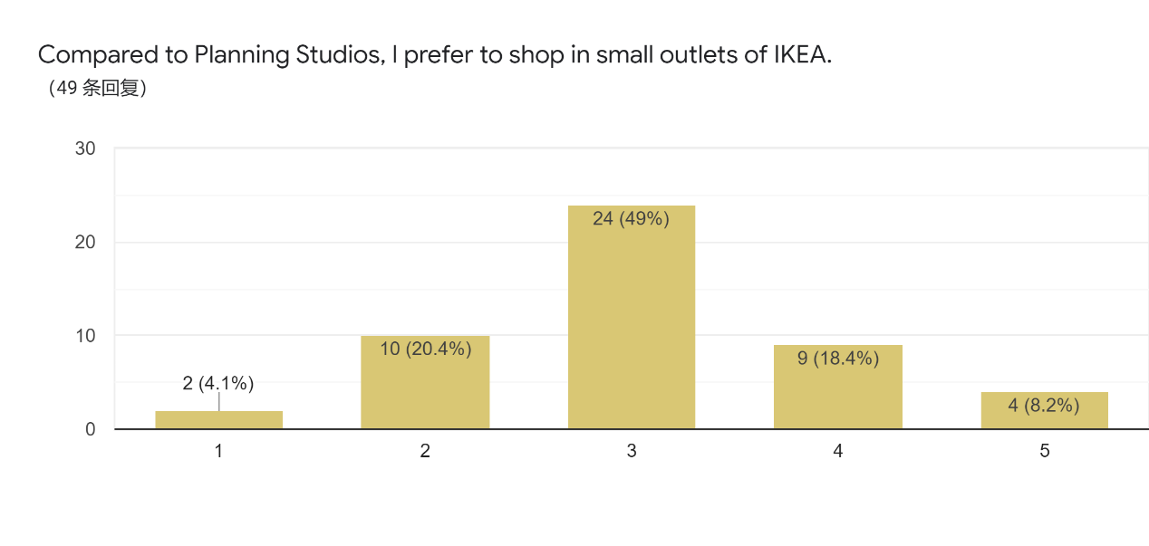

8.3 Pilot study
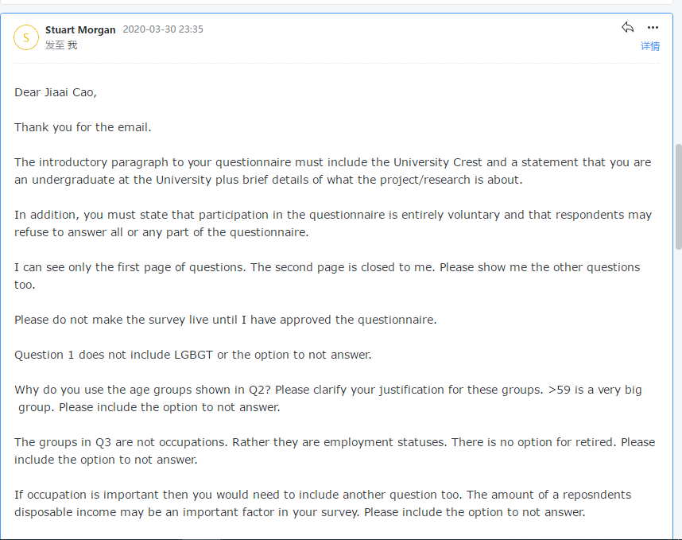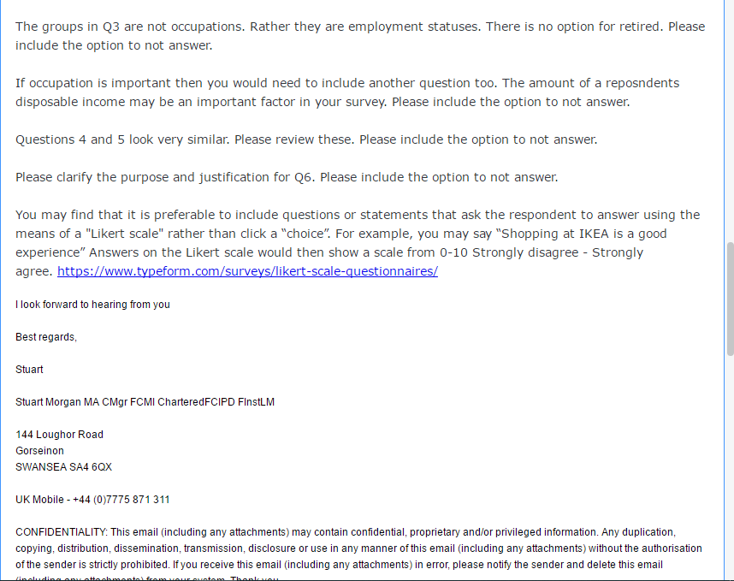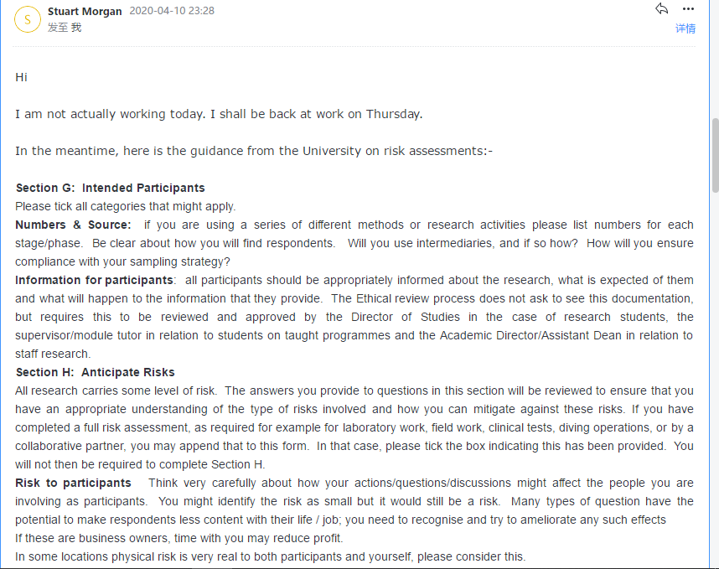

8.4 PESTEL and SWOT analysis

8.4.1 PESTEL analysis
Political:
The UK is hit by coronavirus and is experiencing lockdown;
The UK has left the EU.
Legal:
Recent tipping over and injury cases should raise concern.
Environmental:
The environment is worsening due to human behaviours;
People especially young generations are more concerned about the environment.

Technological:
E-commerce is becoming more and more popular in the UK;
The recent appearance of technologies like AR and VR is also noticeable.

Social:
Generation Y has a more temporary attitude towards furniture products compared to their parents and grandparents;
Today’s labour force tends to live in the city centre and prefers a convenient shopping experience.

Economical:
The retail sales volume in the UK fell sharply while online sales as a proportion of all retailing have reached a record high in March.

8.4.2 SWOT analysis
Threat:
Lockdown of physical stores put pressure on IKEA retailers.
There is intense competition in the furnishing industry.

Opportunity:
The United Kingdom furniture & floor coverings market is growing.
Current pandemic increases people's awareness of household items.

Weakness:
Product recalls may impair the image of the organisation.

Strength:
The broad product range meets diversified customers' needs;
Multi-channel retailing enhance customer base.
Endeavour to sustainability increases IKEA’s goodwill and strengthen the brand’s value.

