The owner of a successful catering business located in central Swansea, supply catering service to local businesses and organizations. As they have expanded, they wish to upgrade their entire data processing provision to help them with the running of their catering services and finances.
They had a very basic customer invoicing system and I will develop it more so they can record customer details, information of any catering services and events that the customer’s request, and to record purchases as well as sales.
First I will start with the entity relationship diagram as follows:
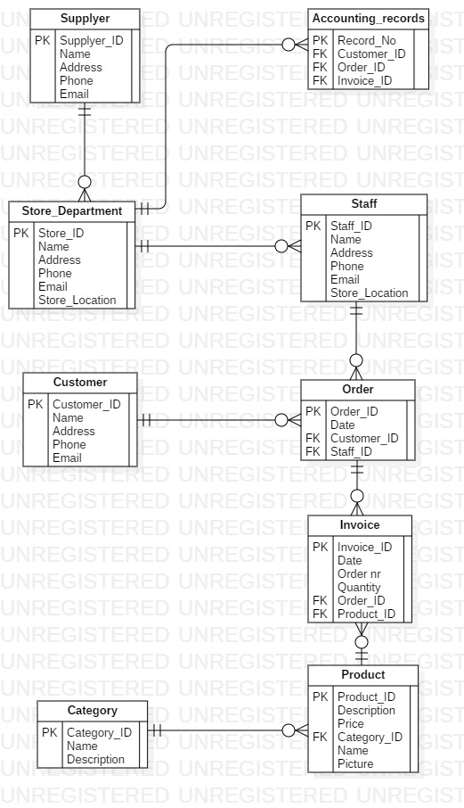
The customer is placing an order or is requesting for an event. After giving all the details needed, the staff will make an invoice for him. When done, the records will be kept in the Accounting_records database.
Use case diagram will be as follows:
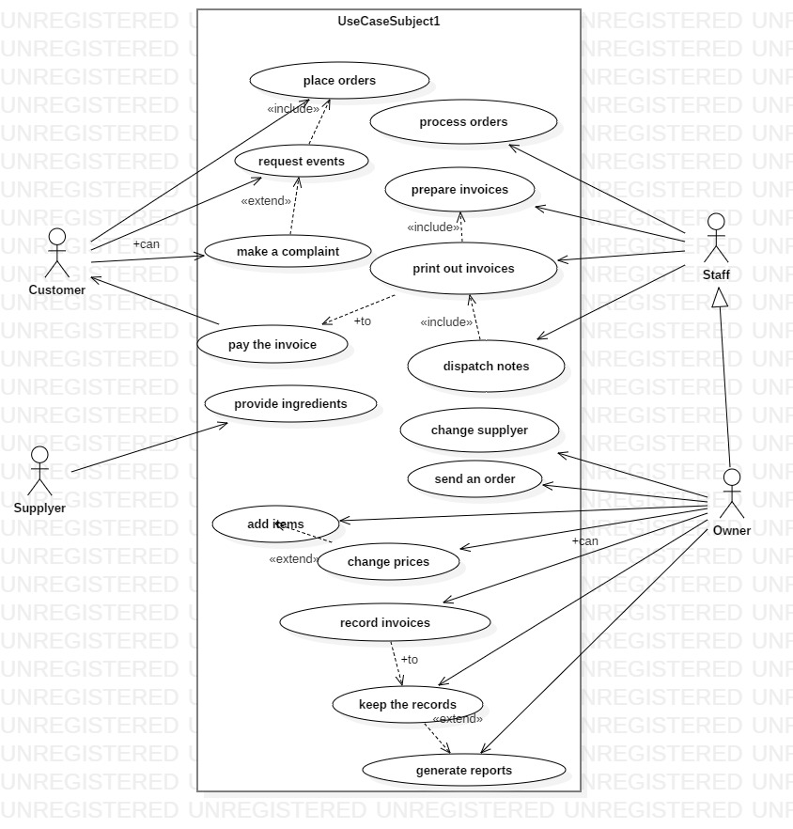
Where you can see a detailed scheme of the processes involved.
The next one will be the Data flow diagram:
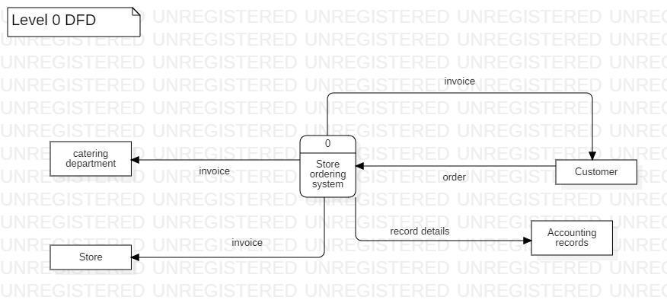
In this level 0 we can see a basic diagram with the processes barely detailed. The customer is placing one order, he get the invoice confirmation from the store ordering system. The system will lately send the records to the database.

In a more detailed way, here is the level 1 of the diagram:


