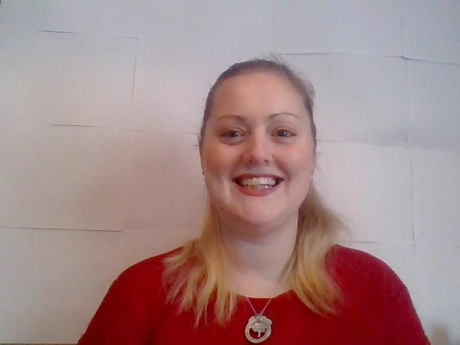
A PROPOSED
INTERVENTION
By Miss Gowen, Year 6 teacher,
Health and Well
-
being officer
Why?
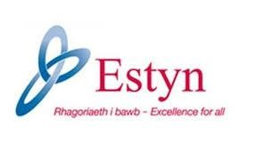
2014
Well-being – Adequate.

2017 onwards
Well-being and attitude of learners

Donaldson (2015)
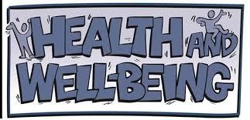
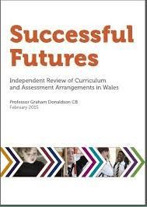
Children and young people need to experience social, emotional and physical well-being to thrive and engage successfully with their education. The Health and well-being Area of Learning and Experience will help them to build the knowledge, understanding and skills that will enable them to develop positive and appropriate relationships, deal with the difficult issues and decisions they will face and learn to live independently.
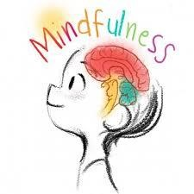
What is mindfulness?
■
Skill of training the attention
by attending to and focusing
on what is happening
■
Helping us address worries
■
For children and young people
it can help them to work
skilfully with the stresses and
strains of childhood and
adolescence

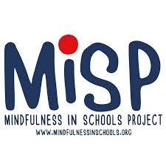
Benefits 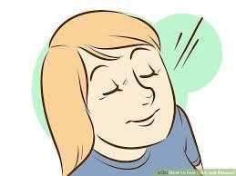 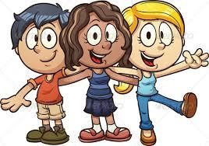
_{Feel calmer} Get on better with others
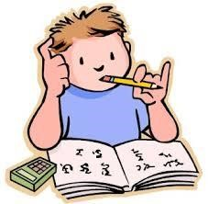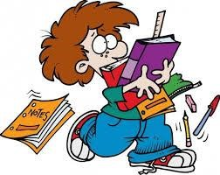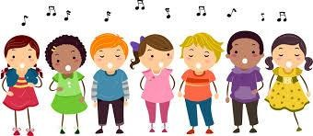
Concentrate better Manage stress Manage performance
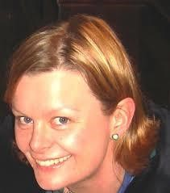
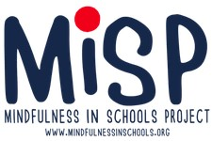
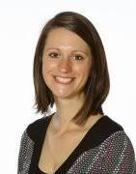
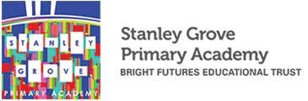

Claire Kelly – Director of
training and content
Amy Footman
–
Headteacher

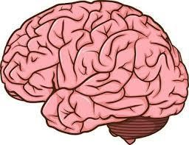
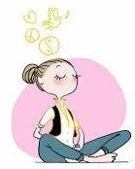

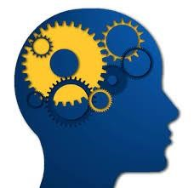

Outside agencies
2009
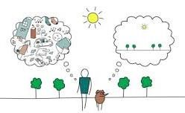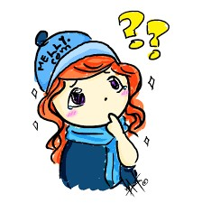

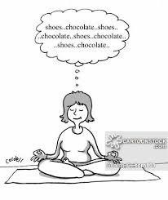
Attention-training Mega-cognitive
Emotions +Thoughts

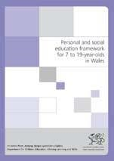


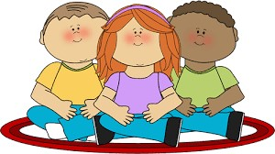
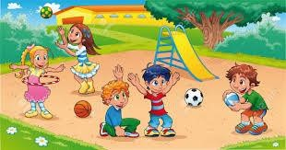
or
6
= 1 hour sessions
12 = 30 minute sessions
+ 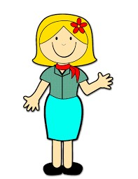 = £1000 approx.
Three-day course
Above average for Free School Meals (FSM)
Our school – 35% FSM
Average in Wales 21%

months – 1 year
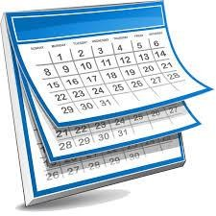
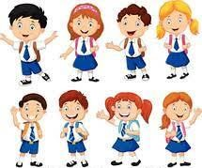



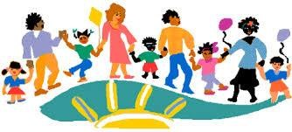


Who?
Whole school
approach

Monitor/Review
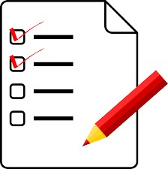
Self-report questionnaires at:
- baseline
- post-training
- 3 months follow up

Informant reports from teachers and parents at: - baseline
- follow-up

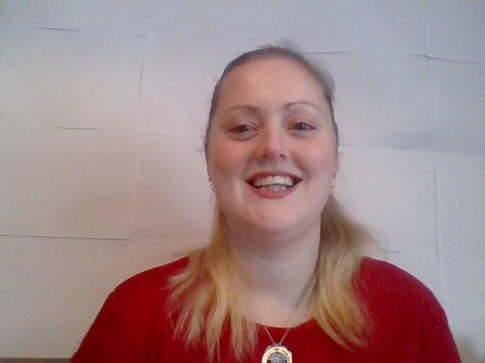
Thank you
 Diolch
Script
Croeso, Welcome, children, teachers, support staff, governors, parents and carers. My name is Miss Gowen and I am the year 6 teacher here at this primary. I am also the health and well-being officer for the whole school and work closely with staff from our Secondary school during transitional periods. Thank you for the opportunity to propose an intervention to you today. It will not only help children with progression and transition but will improve children’s well-being.
Why?
In our last Estyn report in 2014 for Well-being we received an adequate. This is something we need to work on as a school and is in our self-evaluation of our school development plan. Estyn’s inspections have now changed. From September 2017 their area for well-being is now well-being and attitudes of learners. As we are due to get inspected anytime within the next 2 years we must not only look at the well-being of our pupils but their attitudes to learning, how are they developing the key attitudes and behaviours that will help them learn throughout their lives (Estyn, 2018).
Donaldson (2015) has identified six Areas of Learning and Experience for the new curriculum, one of which is Health and Well-being. He says Children and young people need to experience social, emotional and physical well-being to thrive and engage successfully with their education. This area of learning will help children to build the knowledge, understanding and skills that will enable them to develop positive and appropriate relationships, deal with difficult issues and decisions they will face and learn to live independently. I would like to concentrate on the emotional side of things and in particular the ’being able to deal with difficult issues and decisions’. An approach I use myself and is used by counsellors to help with this is called mindfulness.
What?
Mindfulness equips you with the skill of training the attention by attending to and focusing on whatever is happening at any given moment. It is a way of helping us address the kind of worries that we all experience. For children and young people, it can help them learn how to work skilfully with the stresses and strains of childhood and adolescence. These coping skills then remain with them into adulthood.
Benefits
In adults it has been proven to help with stress, anxiety, depression and a range of chronic physical conditions. It has been recommended by the National Institute for Health and Care Excellence for use with recurring depression. It may be beneficial for parents also.
Although mindfulness studies are based on adults, the Mindfulness in School Project (MiSP) research has found it helps children: feel calmer and more fulfilled, get on better with others, concentrate better, are able to manage their stress and anxiety and manage performance more effectively in areas such as sport, music and drama.
Claire Kelly, director of training and content at the MiSP says initial research suggests mindfulness has a positive impact on academic skills and performance, as well as general well-being. Teachers who work with children who have special educational needs (SEN) including autism spectrum disorders (ASD) and attention deficit disorders (ADD) have had great success in teaching mindfulness skills. It helps the children manage their own behaviour by giving them a moment to pause and think before reacting to a situation. But it does not just help those children with emotional issues or those having a difficult time, mindfulness is for all children.
Amy Footman, headteacher of Stanley Grove Primary Academy in Manchester talked on the BBC breakfast show about how she teaches mindfulness as a whole class as part of the PSHE curriculum and even practises mindfulness herself every day. She says it helps children in her school to calm themselves, when they have difficulties, before they take a test and even with their fears. It helps children focus their attention and think before they act in difficult situations. Research has been done in her school with results that mindfulness improves attention and concentration, focus on tasks and behaviour in learning. However, she does go on to say mindfulness does not work for all teachers and students.
Outside agencies
Mindfulness in Schools Project (MiSP) is one option we could use to introduce mindfulness within the school. It is a national, not-for-profit charity for young people and schools. It was established in 2009 to bring the benefits of secular mindfulness to the classroom and is now the leading provider of school-based mindfulness. It has programmes to train teachers, so they can teach mindfulness in their school. However, the programmes are expected to be taught only by those who regularly practise mindfulness themselves so if teachers are interested it has programmes for beginners too.
Paws b programme is one of MiSP’s programmes, which is designed for key stage two children aged seven to eleven. It has PowerPoint presentations, worksheets and discussions as well as mindfulness practice. There are also exercises to do at home. Through this programme children learn the neuroscience of mindfulness and how it affects the brain, how to ground themselves when their mind or body is overly busy or out of balance, how to respond rather than react to difficult situations, how their thinking processes impact on them emotionally and physically and how mindfulness can support them in daily activities and relationships.
Mindfulness practice itself involves activities such as attention-training and meta-cognitive tasks that help children focus on the present moment and work skilfully with their thoughts and emotions. It doesn’t necessarily come easily; the mind often wanders at first. But with practice, children become more able to focus their attention.
How?
The Paws b programme can be taught as part of the PSHE curriculum, although some schools are starting to introduce it into other aspects of school life. It can be delivered as six-hour long sessions or 12 half hour sessions. Some schools do a session a week, some have even started using mindfulness as part of morning registration, to help children settle before they start learning, after lunch, to help calm them down after playing outside and even as part of assembly. I have witnessed something similar in a different school, where soothing music is playing as the children have entered before morning registration. It helps calm the children before learning begins.
Cost
For one member of staff to attend the three-day training on the paws b programme and for cover, the cost will be approximately £1000. However, MiSP offers supported places to teachers in UK schools with above average numbers of pupils receiving free school meals (FSM), which is our school, as 35% of our children receive FSM and the average in Wales is 21%. The discount offered can range from 25% to 100%.
Timeline
To fully implement this and see results we are looking at a minimum of 6 months to 1 year. This involves time for teachers to go on the course, start teaching the paws b programme to our pupils and have time to review the results.
Who?
For this to be a success we need training from MiSP and a whole school approach, that’s everybody, learners, teachers, headteachers, teaching assistants, support staff, governors, parents/carers to help and support this intervention.
Monitor/Review
We can monitor emotional well-being of the children who use mindfulness by using self-report questionnaires (using Sterling Children’s Well-being Scale, SCWBS, Liddle and Carter, 2010) at baseline, post-training and 3 months follow-up and informant reports (using Behavior Rating Inventory of Executive Function – Teacher and Parent Versions, BRIEF-T and BRIEF-P; Gioia et al., 2000) from teachers and parents at baseline and follow-up. We can then review the results to see if it is benefiting children’s overall well-being.
Thank you for listening to my proposal today. I hope you are excited as I am to get started. I am eager to hear your thoughts and questions and look forward to our next meeting. Diolch.

Bibliography
‘Amy Footman’ (2015) BBC Breakfast Show. BBC1, 23 October. Available at: https://youtu.be/mKJlshHiEyA (Accessed: 12th November 2018)
Cefn Hengoed (2018) School Based Staff. Available at: http://www.cefnhengoed.net/index.php/who-we-are/school-based-staff (Accessed: 9th November 2018)
Children’s Commissioner for Wales (2004) Clywch Report. Available at: https://www.childcomwales.org.uk/wp-content/uploads/2016/04/Clywch.pdf (Accessed: 9th November 2018)
Department for Children, Education, Lifelong Learning and Skills (2008) School-based Counselling Services in Wales: a National Strategy. Available at: http://dera.ioe.ac.uk/543/1/counsellingstrategy-e.pdf%3Flang%3Den (Accessed: 9th November 2018)
DfTE (2005) Transition from Primary to Secondary school: Summary of Consultation Responses. Available at: http://dera.ioe.ac.uk/5793/1/primary-to-secondary-school-e.pdf (Accessed: 9th November 2018)
Donaldson, G. (2015) Successful Futures: Independent Review of Curriculum and Assessment Arrangements in Wales. Available at: http://dera.ioe.ac.uk/22165/2/150225-successful-futures-en_Redacted.pdf (Accessed: 9th November 2018)
Estyn (2004) Moving On… Effective Transition from Key Stage 2 to Key Stage 3. Available at: http://dera.ioe.ac.uk/5204/1/moving-on-effective-transit1.pdf%3Flang%3Den (Accessed: 9th November 2018)
Estyn (2010) Transition plans and grant: An evaluation of the impact of transition plans and grant on primary and secondary school partnerships at key stage 2 and key stage 3. Available at: http://dera.ioe.ac.uk/917/1/Transition_plans_and_grants_March_2010%5B1%5D.pdf (Accessed: 9th November 2018)
Estyn (2013) Effective transition from primary to secondary school. Available at: https://www.estyn.gov.wales/effective-practice/effective-transition-primary-secondary-school (Accessed: 9th November 2018)
Estyn (2018) Guidance handbook for the inspection of primary schools. Available at: https://www.estyn.gov.wales/sites/default/files/documents/Guidance%20handbook%20for%20the%20inspection%20of%20primary%20schools%20-%202018.pdf (Accessed: 9th November 2018)
General Assembly Resolution (1989) The United Nations Convention on the Rights of the Child. Available at: https://downloads.unicef.org.uk/wp-content/uploads/2010/05/UNCRC_united_nations_convention_on_the_rights_of_the_child.pdf (Accessed: 9th November 2018)
Google Images (Accessed: 9th November 2018)
Henriques, G (2015) What is Mindfulness and How Does It Work. Available at: https://www.psychologytoday.com/us/blog/theory-knowledge/201502/what-is-mindfulness-and-how-does-it-work (Accessed: 9th November 2018)
McLellan, R. and Galton, M. (2015) The Impact of Primary-Secondary Transition on Students Well-being. University of Cambridge. Available at: https://www.educ.cam.ac.uk/people/staff/mclellan/Final-Report-June-2015.pdf (Accessed: 9th November 2018)
Mindfulness in Schools Project, MiSP (2018) Bringing Mindfulness to Schools. Available at: https://mindfulnessinschools.org/ (Accessed: 9th November 2018)
NFER (2006) Transition from Primary to Secondary School: Current Arrangements and Good Practice in Wales. Avalable at: https://www.nfer.ac.uk/publications/WTN01/WTN01.pdf (Accessed: 9th November 2018)
NFER (2011) Report: Developing school counselling services for children and young people in Wales. Available at: https://nfer.ac.uk/publications/WPV01/WPV01.pdf (Accessed: 9th November 2018)
Rechtschaffen, D. (2014) The Way of Mindful Education: Cultivating Well-being in Teachers and Students. New York: W. W. Norton & Company, Inc.
School Standards and Organisation (Wales) Act 2013. Available at: file:///C:/Users/thecr/Desktop/anaw_20130001_en.pdf (Accessed: 12th November 2018)
Siegel, D (2011) The Healthy Mind Platter. Available at: https://www.drdansiegel.com/resources/healthy_mind_platter/ (Accessed: 9th November 2018)
St Thomas Community Primary School (2012) School Information. Available at: http://stthomascommunityprimary.wales/info/ (Accessed: 9th November 2018)
The School Run (2018) Mindfulness in primary schools explained. Available at: https://www.theschoolrun.com/mindfulness-in-schools (Accessed 9th November 2018)
Vickery, C. E. and Dorjee, D. (2016) Mindfulness Training in Primary Schools Decreases Negative Affect and Increases Meta-Cognition in Children. Available at: https://www.frontiersin.org/articles/10.3389/fpsyg.2015.02025/full?utm_source=Email_to_authors_&utm_medium=Email&utm_content=T1_11.5e1_author&utm_campaign=Email_publication&field=&journalName=Frontiers_in_Psychology&id=154489#B28 (Accessed: 9th November 2018)
Welsh Government (2014) School development plans: Guidance. Available at: https://beta.gov.wales/sites/default/files/publications/2018-03/school-development-plans.pdf (Accessed: 9th November 2018)
Welsh Government (2016) Collaborative working between CAMHS and the counselling service: Guidance. Available at: https://beta.gov.wales/sites/default/files/publications/2018-03/collaborative-working-between-child-and-adolescent-mental-health-services-and-the-counselling-service.pdf (Accessed: 9th November 2018)

