Programs in C and Documentation

Course: Software Development
Module Code: ACCA4017

Author: Jessica Williams
Date: 29/04/2019
Student Number: 1809781

TABLE OF CONTENTS
1 Introduction 3
2 Part C: Card Matching Game: 4
2.1 Problem and Solutions 4
2.2 Code 7
2.3 Testing 10
2.3.1 Scenario One 10
2.3.2 Scenario Two 11
2.3.3 Scenario Three 12
2.3.4 Scenario Four 13
2.3.5 Scenario Five 14

Introduction
This document will identify the understanding and implementation of the programming language of C. The document is aimed at Part C of the software development assignment.
A coded program is going to be identified and explained for the popular card matching game. The problems and solutions for the code will be described. The pseudocode will be identified along with the code and testing outcome for the solutions.

Part C: Card Matching Game:

Problem and Solutions
The problem in part C exercise describes the requirement to allow the user to play the popular card matching game of pairs. The requirements for the game are as follow:
- Display the rules to the user.
- Use a function to display the cards to be visually pleasing for the user.
- Option to start the game.
- Randomise the numbers in an array.
- Display outcome- if the user has a match or doesn’t have a match.
- User is unable to pick the same card twice.
- User is unable to pick a matched card.
- Display final score once all pairs have been matched.
- Option to end the game or play again.

The following pseudocode is identified for the solution of the problem:

Define libraries

Enter main
{
choice1, choice2, score=0, matchCount=0, i, temp;
choice
rand1,rand2;
low= define number
high= define number
srand (time(NULL)
shuffle = 1

PF “Welcome user to game”
PF “Insert rules”
PF “Cards are displayed below”
printcards function;

PF “Would you like to play the game?”
SF choice
Pairs array

While choice = y or Y
{

Shuffle and randomise cards

PF “Enter your first card”
SF choice1

choice2= choice1

While choice1= choice2
{
PF “Enter your second card”
SF choice2
}

If pairs choice1 = pairs choice2
{
PF “It’s a match”
matchCount +1
pairs choice1=7
pairs choice2 = 7
}

Else
{
PF “No match”
}

Score+1
Printcards function

If matchcount=6
{
PF “Your final score is: display score”
PF “Would you like to play again?”
SF choice

If choice Y or y
{
matchCount= 0
score=0
shuffle = 1
}
}
}
printf("End of game");
}

Printcards function
{
i, j, count =0

for (i = 0;i < 3;i++)
{
for (j = 0;j < 4;j++)
{
if (pairs[count] = 7)
{
PF “| |”
}
else
{
PF “count”
}
count++
}
PF “Space”
}
}

Code
#include <stdio.h>
#include <stdlib.h>
#include <time.h>

void printcards(int pairs[12]);// function

int main()
{
int choice1, choice2, score = 0, matchCount = 0, i, temp;
char choice;

int rand1, rand2;
int low = 0;//lowest range
int high = 11;//highest range
int count = 0, start;
int shuffle = 1;
srand(time(NULL));

printf("Hello and welcome to the matching game.\nThe rules are as follow:\n");
printf("* Select your first number between 0 and 11 and then select your second number between 0 and 11.\n* Do not pick the same numbers for your first and second choice as it will not let you continue with the game.\n* Once a match has been made the numbers will be removed from the selection.\n* Once all numbers have been matched your final score will be displayed.\n* You will then have the option to play the game again. \n");//display rules
printf("The cards will be displayed below:\n");

printf("Would you like to play the game? Y/N");// option to start game
scanf(" %c", &choice);

int pairs[12];

while (choice == 'y' || choice == 'Y')
{

if (shuffle == 1)
{
pairs[0] = 1;
pairs[1] = 1;
pairs[2] = 2;
pairs[3] = 2;
pairs[4] = 3;
pairs[5] = 3;
pairs[6] = 4;
pairs[7] = 4;
pairs[8] = 5;
pairs[9] = 5;
pairs[10] = 6;
pairs[11] = 6;

for (i = 0; i < 100; i++)// randomising numbers
{
rand1 = rand() % (high - low + 1) + low;
rand2 = rand() % (high - low + 1) + low;

temp = pairs[rand1];
pairs[rand1] = pairs[rand2];
pairs[rand2] = temp;
}
shuffle = 0;
printcards(pairs);
}
printf("Enter the number of your first card: ");
scanf("%d", &choice1);
while(pairs[choice1] == 7)
{
printf("You have already matched this card\n");// user is unable to pick a matched card
printf("Enter the number of your first card: ");
scanf("%d", &choice1);
}

choice2 = choice1;

while (choice1 == choice2)// user is unable to pick the same card
{
printf("Enter the number for your second card: ");
scanf("%d", &choice2);
while (pairs[choice2] == 7)
{
printf("You have already matched this card\n");// user is unable to pick a matched card

printf("Enter the number of your second card: ");
scanf("%d", &choice2);
}
}

if (pairs[choice1] == pairs[choice2])//display outcome
{
printf("You have a match\n\n");
matchCount = matchCount + 1;
pairs[choice1] = 7;// taking out matching cards
pairs[choice2] = 7;

}
else
{
printf("Sorry no match this time\n\n");// display outcome
}
score = score + 1;

printcards(pairs);

if (matchCount == 6)
{
printf("Your final score is: %d\n", score);//display final score
printf("The game has finished\n");
printf("Would you like to play again? Y/N");// option to end or play again
scanf(" %c", &choice);

if (choice == 'y' || choice == 'Y')
{
matchCount = 0;
score = 0;
shuffle = 1;

}
}
}

printf("End of game");
}

void printcards(int pairs[12])// using a function and calling pairs
{
int i, j, count = 0;

for (i = 0;i < 3;i++)//display rows
{
for (j = 0;j < 4;j++)//display columns
{
if (pairs[count] == 7)
{
printf("| | ");
}
else
{
printf("|%d | ", count);
}
count++;
}

printf("\n\n");
}
}

Testing

For testing purposes the following five scenarios have been tested.

Scenario One
If the user selects “y” or “Y” the game will start if ‘n’ is selected the game will end. If an invalid character is inserted the game will end.

Start game with input of “Y”.
Expected outcome: Game starts- PASS
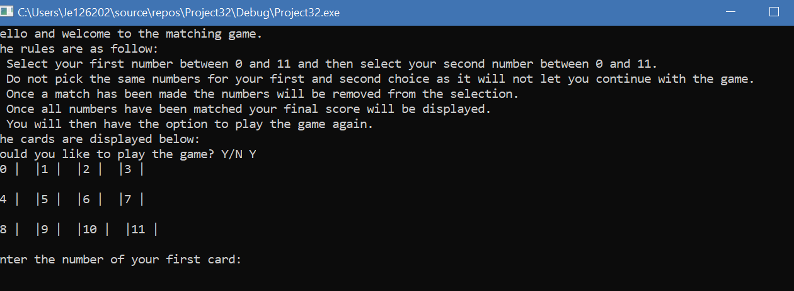

Start second round of game with input of “y”.
Expected outcome: Game starts again- PASS
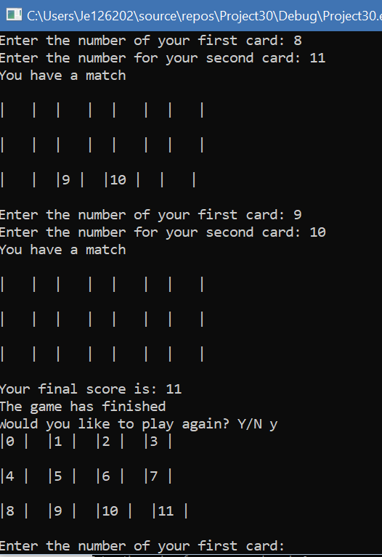

End second round of the game with input of “n”.
Expected outcome: ‘End of game’ is displayed- PASS
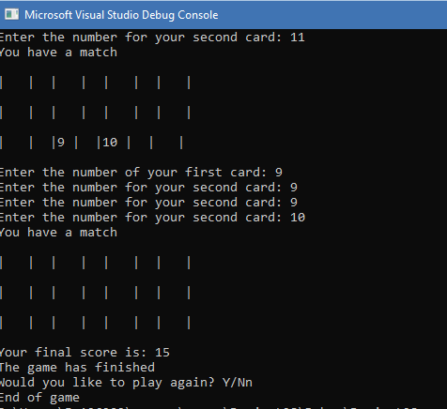

Insert an invalid character to start the game again.
Expected outcome: ‘End of game’ is displayed- PASS
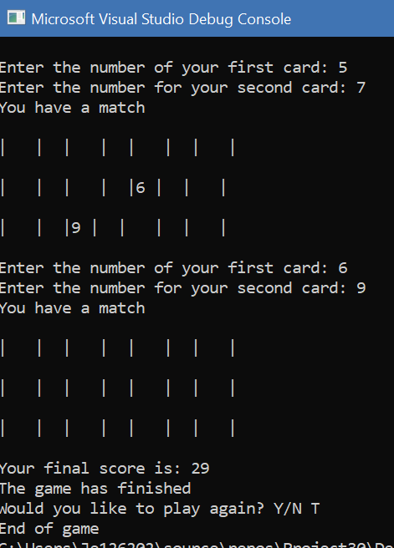

Scenario Two

If the user inserts the same number as their first choice.
Expected outcome:
‘Enter the number of your second card:’ until the user enters a valid number- PASS
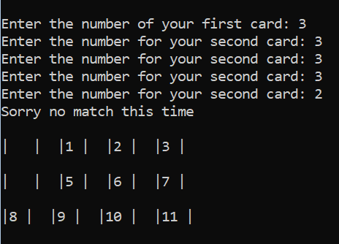

Scenario Three
Randomising numbers
Expected outcome: numbers are randomised every time the game is run-
Number 5 is paired with number 9 for the first round of the game. The game was played again and number 5 was paired with number 4 - PASS

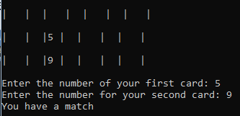

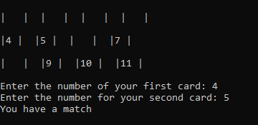

Scenario Four
If the user has an invalid match, a matching pair and once all matches have been made

No matching cards.
Expected outcome: ‘Sorry no match this time’ is displayed- PASS

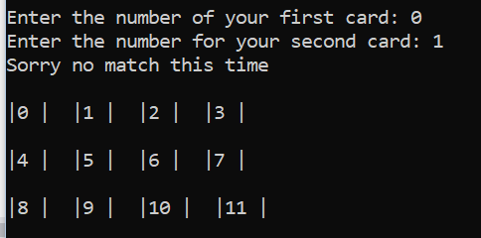

Matching card and all matches made to display final total.
Expected outcome:
If a match has been made user is displayed with ‘You have a match’- PASS
Once all matches have been made display ‘Your final score is: *’ the score will be dependent on how many goes the user has taken to match the randomised cards in the game- PASS

Scenario Five

Selection of the same matched numbers after a match has been found.

After a match the user selects the same numbers for a match again.
Expected outcome:
‘You have already matched this card. Enter the number of your first card:’- FAIL user is able to reselect already matched cards.
‘You have already matched this card. Enter the number of your second card:’- FAIL user is able to reselect already matched cards.

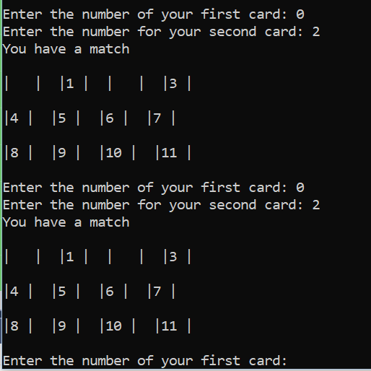

This outcome should not be valid as it will count towards the users end score. The game has been formatted that once a match has been made the numbers disappear from the grid. If the user follows the grid to select their next choice they will not see the already matched numbers. However there is no validation on the users input for a matched number.

Reflection of code:
Once the user has a pair the count pairs count is = 7. The idea is a while statement could be used that when the user selects a matched number the count of 7 won’t let them choose the matched number again.

Example:
while(pairs[choice1] == 7)
{
printf("You have already matched this card\n");
printf("Enter the number of your first card: ");
scanf("%d", &choice1);
}

This has been added to the final code in section 3.1.2 for choice 1 and choice 2 of the users input.

Re- executing the test again:

After a match the user selects the same numbers for a match again.
Expected outcome:
‘You have already matched this card. Enter the number of your first card:’- PASS user is not able to reselect matched numbers.
‘You have already matched this card. Enter the number of your second card:’- PASS user is not able to reselect matched numbers.

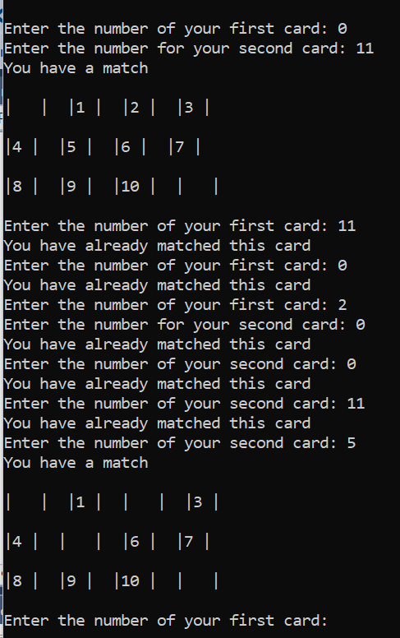

Additional test: Ensure a user is unable to select a matched number and select the same number for their first and second choice- PASS



