BA Leadership and Management
BMSW5105
Individual written report & oral performance

Workplace culture and its impact on organisational efficiecy

Lecturer: Abdi Rahman
Student: Nicoleta Damian (2120244)

Table of contents
Summary 3
Introduction 4
Importance of culture in a company 7
Pandora and its workplace culture 7
Impact of the environmental factors 9
Ethical behaviours and appropriate frameworks 10
Barriers to the effective functioning of Pandora and recommendations 14
Conclusion 16
Reference list 18

Summary
This report emphasizes the barriers to effective functioning of Pandora's culture and provides recommendations for enhancing the workplace culture. The identified barriers include poor communication, inadequate training and development opportunities, inconsistent leadership practices, and a lack of recognition and rewards for ethical behavior.
The recommendations provided in this report will positively impact organizational efficiency by aligning employees with Pandora's values and goals.
By addressing these barriers and implementing the suggested recommendations, Pandora can create a robust and positive workplace culture. This will lead to improved organizational efficiency, customer satisfaction, and overall success.

Introduction
This report examines the workplace culture of Pandora stores, focusing on the importance of effective organization and identifying and addressing potential barriers to creating a positive and thriving environment. To provide a comprehensive understanding, this report will begin by providing background information on Pandora, highlighting its history and significance in the jewelry industry. It will then delve into the significance of an effective organizational culture and explore potential barriers that may hinder the desired workplace culture at Pandora. To ensure the reliability and credibility of the analysis and recommendations, trustable references and citations from reputable sources will be utilized throughout the report.

Founded in 1982 in Copenhagen, Denmark, Pandora has grown to become a globally recognized jewelry retailer. Renowned for its customizable charm bracelets, the company demonstrates a commitment to excellence in craftsmanship, sustainable sourcing, and responsible business practices. With a diverse range of products and a strong presence in the market, Pandora has established itself as one of the leading jewelry brands worldwide. More than 6,500 points of sale, including more than 2,500 concept shops, sell Pandora products in more than 100 countries.
Pandora, which has its global headquarters in Copenhagen, employs 32,000 people and produces its products in two LEED-certified factories in Thailand that mainly utilise reused metals such as gold and silver.
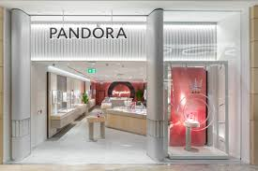
By 2030, Pandora plans to cut emissions of greenhouse gases by 50% throughout its individual activities and supply chain as part of its commitment to leadership in sustainable development.
The business, which is traded on the Nasdaq Copenhagen stock platform, brought in 3.6 billion euros in revenue in 2022.
One of their 2500 stores is Pandora Birmingham store, this branch being the organisation of which workplace culture and its organisational efficiency is being analysed in this report.
As Pandora has numerous stores located in Birmingham, is important to mention that the report is based on Pandora Birmingham Bullring, which address is located at Unit SU325, Lower Mall Bullring

Central to the success of any organization is an effective workplace culture. Workplace culture encompasses the shared values, beliefs, assumptions, and practices that shape the behavior of individuals within an organization. A positive and well-defined workplace culture promotes employee engagement, satisfaction, and productivity, ultimately contributing to the overall success of the organization.

This report seeks to analyze and evaluate the workplace culture at Pandora stores, with a particular focus on factors that may hinder the creation of the desired culture. Potential barriers may include challenges related to communication, lack of training and development opportunities, inconsistent leadership practices, and a failure to recognize and reward ethical behavior within the organization. By adopting a systematic approach, this report aims to identify and address these barriers to foster a more favorable workplace culture at Pandora.

Academic articles, reputable industry reports, and expert opinions from renowned publications will be used to support and validate the analysis and recommendations presented in this report. By utilizing these reliable sources, this report aims to provide an evidence-based and well-informed analysis of Pandora's workplace culture.
Leadership's foundation is structure since without effective organisation, no leadership can carry out its duties with ease. This organisation functions as an additional stage in the managerial procedure, attempting to coordinate diverse company operations in order to achieve established goals.( Allaire and Firsirotu, 1984)
It constitutes a formalised set of obligations that employees must fulfil in order to carry out a variety of tasks and advance company objectives.
In other phrases, an organisation is just a group of people cooperating to achieve a shared goal. Schein (1992), Deal and Kennedy (2000), and Kotter (1992) believed it is a collection of individuals who come together or congregate in one location and work together to accomplish an objective that they share.
The combination of beliefs, principles, perceptions, structures, and norms that direct and shape worker behaviour within a company is referred to as organisational culture.(Ravasi and Schultz, 2006) This culture represents how participants, including staff, clients, suppliers, and clients, view the company and its image in the marketplace.
Despite the fact that they can assist establish it, organisational goals and a statement of purpose should not be confused with a culture. Releases of information or policy statements don't build culture; uniform and genuine behaviour does. Once you observe the way a CEO handles a difficult situation, how a team adjusts to changing client needs, or the manner in which a management stabilises a staff member who does the wrong choice, you can observe business culture in practise.

Importance of culture in a company

Every facet of your company are impacted by organisational culture, from contract terms and benefits for workers to timeliness and attitude. The workforce is more inclined to feel at ease, recognised, and appreciated whenever the atmosphere at work matches their preferences. Organisations with a great emphasis on culture are better able to withstand challenging times as well as modifications in the company's climate.
Whenever it involves luring people and exceeding the rivals, the culture has a crucial edge. Almost half employees intend to leave their present employer for a position with fewer benefits at a business with a more favourable environment, and 77 percent of job seekers think about the culture of an employer prior registering.
Nearly two-thirds (65%) of staff members remain at their jobs for different causes, with one of the most important markers of employee happiness is the culture of an organisation.

Pandora and its workplace culture

Pandora, as a company, upholds three key values: pride, passion, and performance. These values play a fundamental role in shaping Pandora's workplace culture and driving organizational success.

Firstly, pride is a crucial value within Pandora's workplace culture. It encourages employees to take ownership of their work and to feel a sense of accomplishment in delivering high-quality products and services. By instilling a sense of pride in their work, Pandora can foster a culture of excellence and attention to detail, ultimately resulting in satisfied customers and continued business growth.

Secondly, passion is an essential value that drives innovation and creativity within Pandora's workplace culture. Passionate employees are more likely to go above and beyond their duties, as they are intrinsically motivated to excel in their roles. This enthusiasm and dedication can lead to the introduction of new ideas, improved processes, and a continuous drive for success. By cultivating a culture of passion, Pandora ensures that its employees feel inspired and empowered to contribute their best efforts, ultimately enhancing the company's competitiveness in the marketplace.

Lastly, performance is a value that aligns closely with Pandora's commitment to excellence. The company places great emphasis on measuring and evaluating performance, providing clear goals and expectations, and recognizing and rewarding outstanding achievements. By prioritizing performance, Pandora fosters a results-driven culture where employees are continuously motivated to reach their full potential. This focus on performance not only contributes to individual growth and career development but also drives the overall success and profitability of the organization.

The importance of these three key values, pride, passion, and performance, in Pandora's workplace culture cannot be overstated. They form the bedrock of employee engagement, productivity, and satisfaction. When employees take pride in their work, are passionate about what they do, and consistently perform at a high level, it creates a positive and inspiring work environment. This, in turn, leads to increased employee morale, enhanced customer experiences, and ultimately, business success. By upholding these values, Pandora ensures that its workplace culture remains vibrant, energizing, and dynamic, attracting and retaining top talent while maintaining its position as a leader in the jewelry industry.
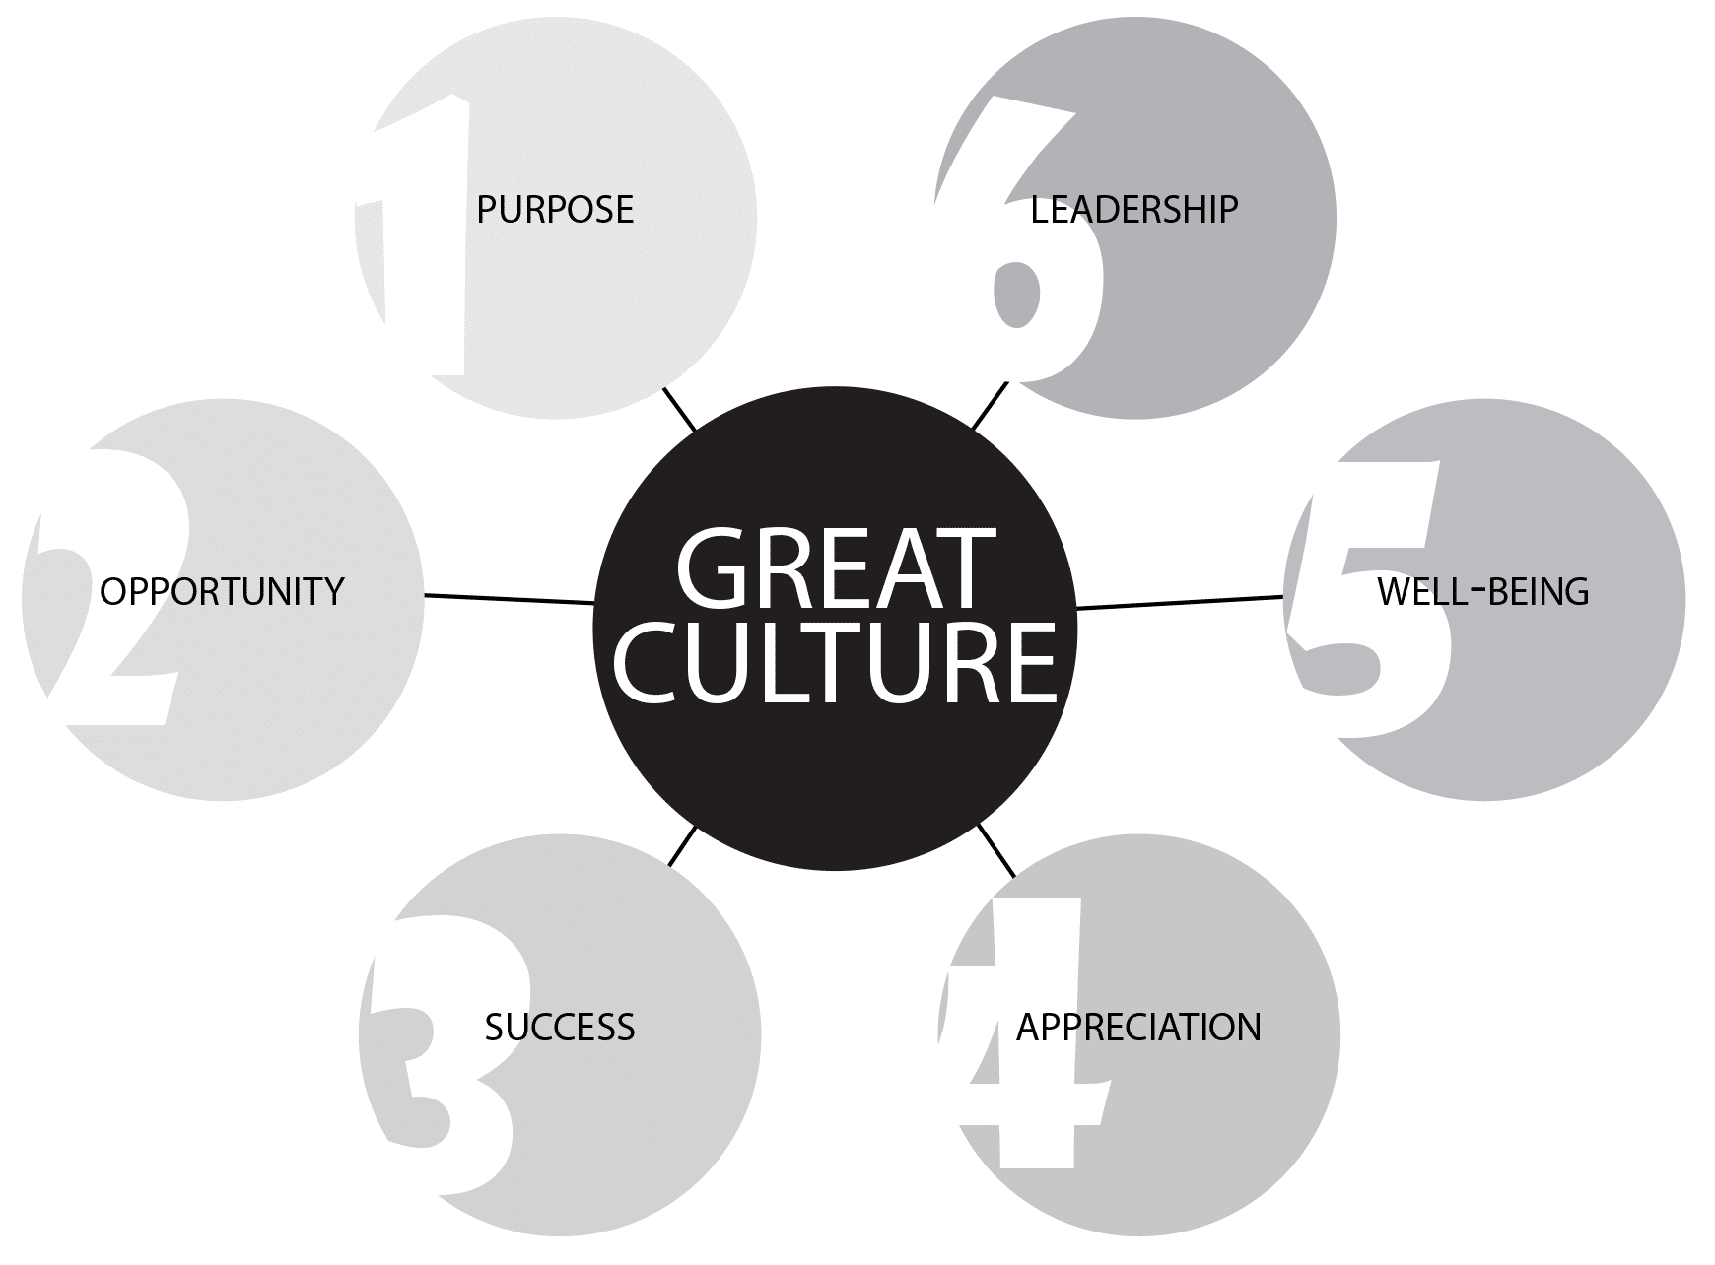

Impact of the environmental factors
Employees gain from controlling the entire value chain and continue to enhance the efficacy at all stages by resolving issues quickly, moving on, and learning from failures.
Environmental factors can have a significant impact on the culture of an organization like Pandora. These factors include the external influences and conditions that surround the company and can affect its operations, strategic decisions, and overall culture. Let's critically assess the impact of environmental factors on the culture of Pandora.

Sustainability and responsible sourcing: One major environmental factor that strongly influences Pandora's culture is its commitment to sustainability and responsible sourcing. Pandora places a high value on ethical practices and social responsibility, and this is deeply ingrained in its culture. The company has implemented rigorous supply chain processes to ensure that its materials are sourced responsibly, and it actively promotes recycling and reducing waste. This environmental factor shapes Pandora's culture by fostering a sense of responsibility, innovation, and consciousness about their impact on the environment.

Consumer preferences: Another significant environmental factor that affects Pandora's culture is changing consumer preferences. As consumer awareness of sustainable practices and ethical sourcing grows, so does the demand for eco-friendly products. Pandora's culture is influenced by these shifting consumer preferences, as the company continuously strives to meet market demands and align its products and practices with customer values. This means Pandora must adapt to changing trends and invest in research and development to maintain its competitive edge, shaping its innovation-driven and customer-oriented culture.

Competitive landscape: The competitive landscape within the jewelry industry is also an important environmental factor that affects Pandora's culture. The company faces fierce competition from other well-established brands, both in traditional jewelry retail and customizable jewelry spaces. This forces Pandora to continuously differentiate itself and strive for excellence in design, quality, and customer experience – elements that are deeply embedded in the company's culture. The need to stay ahead in a highly competitive environment influences Pandora's culture by fostering a sense of urgency, innovation, and a drive for continuous improvement.

Globalization and market expansion: Globalization and the expansion of markets present both opportunities and challenges for Pandora's culture. With a presence in multiple countries, Pandora needs to adapt its culture to various cultural contexts, regulatory environments, and consumer behaviors. This requires the company to be culturally sensitive, adaptive, and inclusive in its practices, fostering a diverse and inclusive culture. At the same time, globalization enables Pandora to tap into new markets and growth opportunities, influencing its culture by fostering a dynamic, outward-looking, and entrepreneurial mindset.

Technological advancements: Technological advancements not only impact the jewelry industry but also influence Pandora's culture. As consumers increasingly embrace digital platforms and ecommerce, Pandora has had to adapt by investing in online channels, digital marketing, and personalized experiences. Embracing technology shapes Pandora's culture by promoting innovation, agility, and an emphasis on leveraging data and analytics to enhance customer engagement and experience.

Assessing the culture of a specific Pandora store, such as the Pandora Birmingham store, requires an understanding of the core values and ethical commitments of the organization as a whole, along with an examination of specific practices and behaviors at the store level. In order to evaluate critically Pandora Birmingham store’s workplace culture is being used an overarching framework to evaluate its culture and discuss a common ethical dilemma that this jewelry store faces .

Ethical behaviours and appropriate frameworks

One framework that can be used to assess the ethical culture of an organization is the "Four Component Model" developed by Trevino, Weaver, and Brown. This model identifies four components that contribute to an organization's ethical culture: ethical sensitivity, ethical judgment, ethical motivation, and ethical behavior.

1. Ethical sensitivity: This component refers to an individual's ability to recognize and interpret ethical issues in the workplace. It involves considering the impact of actions on various stakeholders, such as customers, employees, and the broader community. Ethical sensitivity can be influenced by factors such as training, leadership, and organizational values. To evaluate the ethical sensitivity of the Pandora Birmingham store, it would be necessary to examine whether employees are trained to identify and respond to ethical issues, and if they are encouraged to voice concerns.

2. Ethical judgment: Ethical judgment involves evaluating potential courses of action and deciding what is morally right or wrong. It requires employees to understand and apply ethical principles and values. In the context of a jewelry store like Pandora, ethical judgment could include decisions regarding responsible sourcing of materials, accurate product information, and fair pricing. Assessing the ethical judgment of the Pandora Birmingham store would involve considering whether employees are equipped with the tools and guidance to make ethical decisions.

3. Ethical motivation: Ethical motivation refers to an individual's internal drive to act ethically. It entails aligning personal values with the organization's ethical standards. For the Pandora Birmingham store, evaluating ethical motivation would involve determining whether employees are motivated to act in an ethical manner, beyond mere compliance with rules and regulations. A positive ethical culture would likely foster a sense of pride and commitment to ethical behavior among employees.

4. Ethical behavior: Ethical behavior is the observable actions that demonstrate ethical conduct. This includes honesty, integrity, fairness, and respect. To evaluate the ethical behavior of the Pandora Birmingham store, one would need to examine whether employees consistently display these traits in their interactions with customers, suppliers, and colleagues.

Considering the broader jewelry industry, an example of an ethical dilemma that could influence the culture of the Pandora Birmingham store is the issue of responsible sourcing of gemstones and metals. Many jewelry retailers face challenges in ensuring that the materials they use are not connected to human rights abuses, environmental damage, or unethical mining practices. The Pandora brand has made commitments to responsible sourcing, and it would be important to assess whether the Birmingham store upholds these standards in their sourcing and supply chain practices.
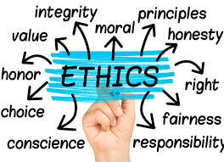

In this report we will examine Pandora's workplace culture and analyze it using Porter's Five Forces framework.
Porter's Five Forces is a strategic management tool that helps to analyze the competitive environment of a company. It identifies five key forces that shape the competitive landscape, including the threat of new entrants, the bargaining power of buyers, the bargaining power of suppliers, the threat of substitute products or services, and the intensity of competitive rivalry. Let's explore how these forces apply to Pandora's workplace culture.

Firstly, the threat of new entrants for Pandora's workplace culture is relatively low. Pandora has established itself as a leading brand in the jewelry industry, known for its quality craftsmanship and innovative designs. The company has built a strong reputation and customer loyalty over the years, making it difficult for new competitors to enter the market and replicate Pandora's workplace culture.

Secondly, the bargaining power of buyers is moderate in Pandora's workplace culture. While customers have options to choose from various jewelry brands, Pandora's unique customizable approach sets it apart. This uniqueness gives Pandora some leverage in the market, as customers value the ability to personalize their jewelry. However, the company must continually focus on meeting customer demands and preferences to maintain its competitive edge.

Thirdly, the bargaining power of suppliers is crucial but somewhat low for Pandora's workplace culture. The company relies on a global network of suppliers to source its materials, such as gemstones and metals. However, there is a relatively large number of suppliers available in the market, giving Pandora some flexibility in negotiating favorable terms. Moreover, Pandora's commitment to responsible sourcing and sustainability also provides them with an advantage in supplier relationships.

Fourthly, the threat of substitute products or services in Pandora's workplace culture is moderate. While the main focus is on customizable jewelry, customers always have alternative options to consider, such as traditional jewelry retailers or other customizable jewelry brands. Pandora must continue to innovate and offer unique designs and personalized experiences to differentiate itself from competitors and reduce the threat of substitutes.


Lastly, the intensity of competitive rivalry in Pandora's workplace culture is high. The jewelry industry is highly competitive, with several established brands vying for market share and customer attention. Competitors such as Tiffany & Co., Swarovski, and Alex and Ani pose a challenge to Pandora. To stay ahead, Pandora must continually invest in research and development, design innovation, and effective marketing strategies to differentiate itself and maintain its competitive advantage.

Barriers to the effective functioning of Pandora and recommendations

To identify barriers to effective functioning of Pandora's culture and offer recommendations for enhancing the workplace culture, it is important to consider potential challenges and ways to address them. Given the lack of extrimely specific information about Pandora's Birmingham store, the recommendations will be more general in nature.

1. Lack of Communication: Poor communication can act as a barrier to effective functioning of any organization's culture. In the case of Pandora, this could manifest as a breakdown in conveying the company's values, goals, or updates on ethical practices to employees. To address this, Pandora can implement regular communication channels such as town hall meetings, newsletters, or intranet platforms to ensure transparency and promote a culture of open dialogue.

Positive impact on organizational efficiency: Improved communication ensures employees are well-informed about Pandora's expectations, core values, and ethical practices. This clarity can lead to enhanced alignment and understanding of desired behaviors, fostering a more efficient organizational culture.

2. Lack of Training and Development: Insufficient training and development opportunities for employees can hinder the effective functioning of Pandora's culture. Without proper training, employees may lack the necessary skills, knowledge, and ethical awareness to contribute fully to the organization’s ethical practices and goals. Offering training programs related to ethics, responsible sourcing, customer service, and efficient retail practices would be beneficial.

Positive impact on organizational efficiency: Investing in comprehensive training and development programs can equip employees with the skills and knowledge required to perform their roles effectively. This can lead to improved customer satisfaction, increased employee motivation, and higher productivity, thereby positively impacting organizational efficiency.

3. Inconsistent Leadership: Inconsistent leadership practices, such as a lack of role modeling ethical behavior or a failure to hold employees accountable for ethical violations, can undermine the desired culture of Pandora. Leaders must set the tone for ethical conduct, actively promote ethical decision-making, and reinforce the company's core values.

Positive impact on organizational efficiency: Consistent and ethical leadership encourages employees to align their behaviors with Pandora's values. This creates a culture of trust, motivation, and accountability, which in turn positively impacts organizational efficiency by reducing conflicts, improving teamwork, and increasing employee engagement.(Kidder, 1995)

4. Lack of Recognition and Rewards: Failing to recognize and reward ethical behavior can demotivate employees and hinder the effective functioning of Pandora's culture. It is crucial to acknowledge and appreciate employees who consistently demonstrate ethical conduct and contribute to responsible business practices.

Positive impact on organizational efficiency: Recognizing and rewarding ethical behavior reinforces desired actions and creates a positive work environment. Employees who feel valued and appreciated are more likely to be motivated, engaged, and committed to their work. This enhances productivity and efficiency within the organization.

In addition, by addressing the barriers mentioned above through enhanced communication, training and development, consistent leadership, and recognition and rewards, Pandora can create a more robust and positive workplace culture. These improvements will positively impact organizational efficiency by fostering alignment, motivation, engagement, and ethical behavior among employees, ultimately leading to improved productivity, customer satisfaction, and overall performance.
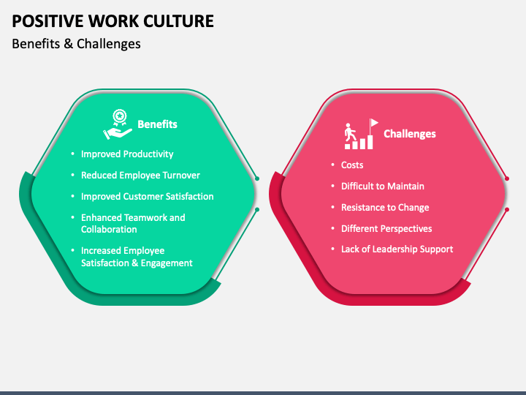

Conclusion
In conclusion, environmental factors have a significant impact on the culture of Pandora. Sustainability and responsible sourcing, consumer preferences, the competitive landscape, globalization, and technological advancements all shape the company's culture. Pandora's culture reflects its commitment to ethics, sustainability, innovation, customer value, diversity, and adaptability. By embracing these environmental factors and aligning its culture with market dynamics, Pandora can sustain its success in an ever-evolving industry.
Pandora's workplace culture is shaped by various factors that can be analyzed using Porter's Five Forces framework. While the threat of new entrants and bargaining power of buyers are relatively low, the bargaining power of suppliers is moderate. The threat of substitute products or services is also moderate, and the intensity of competitive rivalry is high. By understanding and addressing these forces, Pandora can continue to foster a strong workplace culture, innovate, and sustain its success in the dynamic and competitive jewelry industry.
In conclusion, without more specific information about the Pandora Birmingham store, it is challenging to provide a detailed assessment of its culture with absolute certainty. However, using the Four Component Model and focusing on ethical sensitivity, judgment, motivation, and behavior, one can evaluate the general ethical culture of the store. Additionally, a common ethical dilemma in the jewelry industry, such as responsible sourcing of materials, can significantly influence the ethical culture of the organization. Further research or information specific to the Pandora Birmingham store would be necessary for a comprehensive evaluation.

Reference list
Pandora A/S. (n.d.). Our Values. Retrieved from https://www.pandoragroup.com/sustainability/explore/society/our-values
Armstrong, M. (2012). Armstrong's Handbook of Performance Management: An Evidence-Based Guide to Delivering High Performance. Kogan Page. (Accessed: 2 July 2023)
Allaire, Yvan; Firsirotu, Mihaela E. (July 1984). "Theories of Organizational Culture". Organization Studies. 5 (3): 193–226. (Accessed: 4 July 2023)
Brownell, E. (2000). How to create organizational trust. Manage, 52(2), 10–11. (Accessed: 4 July 2023)
Brown, M., Treviño, L. K., & Harrison, D. 2005. Ethical leadership: A social learning perspective for construct development and testing. Organizational Behavior and Human Decision Processes, 97: 117-134. (Accessed:5 July 2023)
Deal T. E. and Kennedy, A. A. (1982, 2000) Corporate Cultures: The Rites and Rituals of Corporate Life, Harmondsworth, Penguin Books, 1982; reissue Perseus Books, 2000
Gallup. (2017). Employee Engagement. Retrieved from https://www.gallup.com/workplace/238079/state-global-workplace-2017.aspx (Accessed: 2 July 2023)
Goleman, D., Boyatzis, R., & McKee, A. (2002). Primal Leadership: Realizing the Power of Emotional Intelligence. Harvard Business Review Press. (Accessed: 28 June 2023)
Lockwood, N. (2007). Leveraging Workplace Culture to Drive Business Results: How Coca-Cola Enterprises Does It. Retrieved from https://www.shrm.org/hr-today/news/hr-magazine/Pages/0207cover.aspx (Accessed: 4 July 2023)
Kotter, J. P.; Heskett, James L. (1992). Corporate Culture and Performance. New York: The Free Press. (Accessed: 1 July 2023)
Kidder, R. (1995). How good people make tough choices. New York: William Morrow and Company, Inc. (Accessed:2 July 2023)
Pandora A/S. (n.d.). About Pandora. Retrieved from https://corporate.pandora.net/en/about-us/about-pandora/ (Accessed: 28 June 2023)
Porter ME, 1979 Mar/Apr, 'How competitive forces shape strategy', Harvard Business Review. (Accessed:6 July 2023)
Porter ME, 1980, "Competitive Strategy: Techniques for Analysing Industries and Competitors". The Free Press. (Accessed:6 July 2023)
Porter ME, "Towards a Dynamic Theory of Strategy", Strategic Management Journal 1991, vol. 12, 95-117. (Accessed:6 July 2023)
Ravasi, D.; Schultz, M. (2006). "Responding to organizational identity threats: Exploring the role of organizational culture". Academy of Management Journal. 49 (3): 433–458. (Accessed:2 July 2023)
Pandora A/S. (n.d.). Sustainability Report 2019. Retrieved from https://investor.pandoragroup.com/shared/download.aspx?sid=176706&aid=0&fileid=21749
(Accessed:5 July 2023)
Schein, Edgar H. (1990). "Organizational culture". American Psychologist. 45 (2): 109–119. (Accessed: 6 July 2023)
Schein, Edgar (1992). Organizational Culture and Leadership: A Dynamic View. San Francisco, CA: Jossey-Bass. pp. 9 (Accessed: 2 July 2023)
Schein, E. H. (2016). Organizational Culture and Leadership. John Wiley & Sons. (Accessed: 29 June 2023)
Toegel, G., & Barsoux, J. L. (2012). How to Become a Better Leader. Harvard Business Review. Retrieved from https://hbr.org/2012/09/how-to-become-a-better-leader (Accessed: 2 July 2023)
Treviño, L. K., & Weaver, G. R. 2003. Managing ethics in business organizations. Stanford, CA: Stanford Business Books. (Accessed:5 July 2023)

