The relationship between the Ionian Islands internally and their position within the wider trade network in the Bronze Age.
Although geographically designated as the ‘Ionian Islands’ there is no one unified culture that combines the islands to each other. Therefore, this essay will discuss the interactions between the islands internally and whether these interactions can be found within the archaeological record. It will then place the islands within the wider Bronze Age world system of the Mediterranean and try to determine the role that the islands played while supposedly on the periphery of this large trading network. It will be argued that the Ionian islands played a larger role in the overall trading network than they are given credit for.
Excavations on the Ionian Islands have been limited, with the majority of early excavations having focused on the search for Homer’s home of Odysseus in Ithaca. This type of archaeology, the search for a specific answer, can mean there are issues with the interpretation of finds. Later archaeological investigations have been more revealing, especially with new views discussing the islands role in the wider trade networks, along with investigations into the islands themselves, and determining the occupation history of each island.
Patton presents the idea of ‘Island insularity’ that as islands are small land spaces cut off from other communities, they develop specific features which set them apart from land based communities and cause cultural effects. This idea is based on Evans’ theory of ‘Island Laboratory’, in which limited resources mean islands adapt to what is available, but also seek external contact which influences their culture.
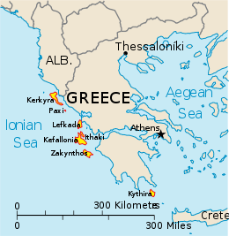
Despite their overarching title, each island has its own discrete culture mostly unrelated to its fellow islands. This is due to groups of farmers who originally settled on the islands who may have come from different parts of the mainland; the northern islands being settled by those from Dalmatia, and the southern islands by people from the Peloponnese. Geographically, this would be logical as the islands closest contacts are the mainland and not each other.
Figure 1 Location map of the Ionian islands
From: Wikipedia
Haywood completely dismisses Kythira from her discussion due to its southerly position being completely separated from the other islands not even being in the Ionian sea, and also draws a distinction between Kerkyra/Corfu and the other islands as it is the furthest north and has a distinct culture. There is also a north-south division within the closest grouped islands in the Middle Bronze Age with Ithaca and Kefallonia having no clear pottery influence from South of the Corinthian Gulf whereas there is evidence for this pottery on Lefkada. Patton shows that the islands further north, Lefkada and Meganisi, were the earliest occupied in the 5th and 4th Millennium BC followed by Ithaca and Kefallonia in the 3rd and finally Zakynthos, the furthest south, in the 2nd.
Kerkyra/Corfu was the northern most island and was not Aegean in character, it is the closest to Italy, but also closer to Bronze Age Albania than Greece. Hammond suggests that this is because it was first settled by a population defined by their Scratched Ware pottery type, before an immigration of people likely to be of Macedonian origin having come through the Epirus region introducing Red Ware pottery. There is limited evidence of Mycenaean interaction, though there is some pottery found, it is suggested that the contact was much less significant than that of the rest of the Ionian islands, and likely happened through the islands instead of a direct contact.
Through the Ionian islands geographical position, they became involved in the larger trading network at the time, but to gain produce they would also have needed something to trade with. However, not all traded materials would have survived in the archaeological record, especially foodstuffs, wood, and textiles. Today the islands produce crops such as the olive, currant vine, fruit and nut trees, and other crops, it is also likely that they would have had a larger amount of wood. Food resources could have been a possible trading item, especially if the harbours were open to ships stopping on a longer journey from the Eastern or Western Mediterranean and needed supplies.
Geographically there is also a division within the islands themselves because they are positioned on the constructive boundary between two tectonic plates, so most of the islands are divided by a mountain range. This could cause isolation between communities on the same island but potentially increase communication with communities within sight across the water, especially between northern Kefallonia and Ithaca. Despite Haywood‘s assertion that interactions between the islands would have been eased due to the absence of the meltemia, the northern wind that affects the Aegean in the summer months, what may have been more influential on the islands could have been the mistral winds which happen daily from spring to autumn coming from the northwest, but lessen in the summer making this is the best time for sailing.
Trading seasons across the Mediterranean were affected by the other winds, weather and currents, but to be part of the larger trading routes the rest of the Mediterranean weather would need to be taken into account. It is clear from the water currents that the summer months are when it is easiest to move in a northerly direction across the west coast of Greece (Figure 3). It would also have been possible for sailors from the Aegean to reach the islands at this time.

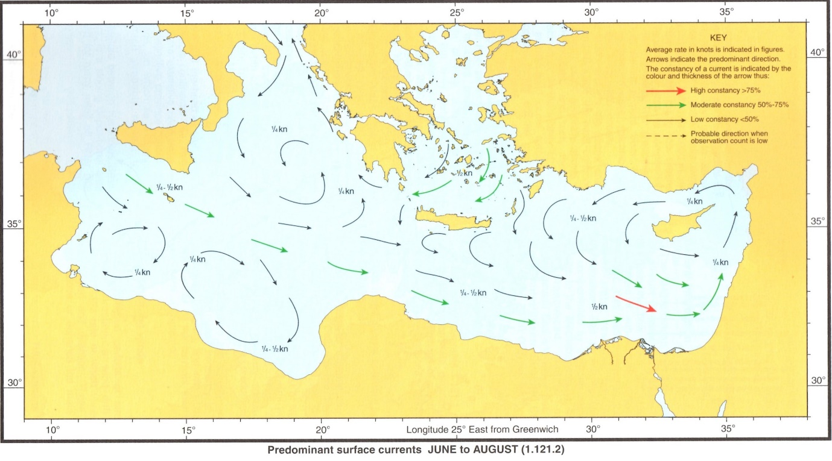
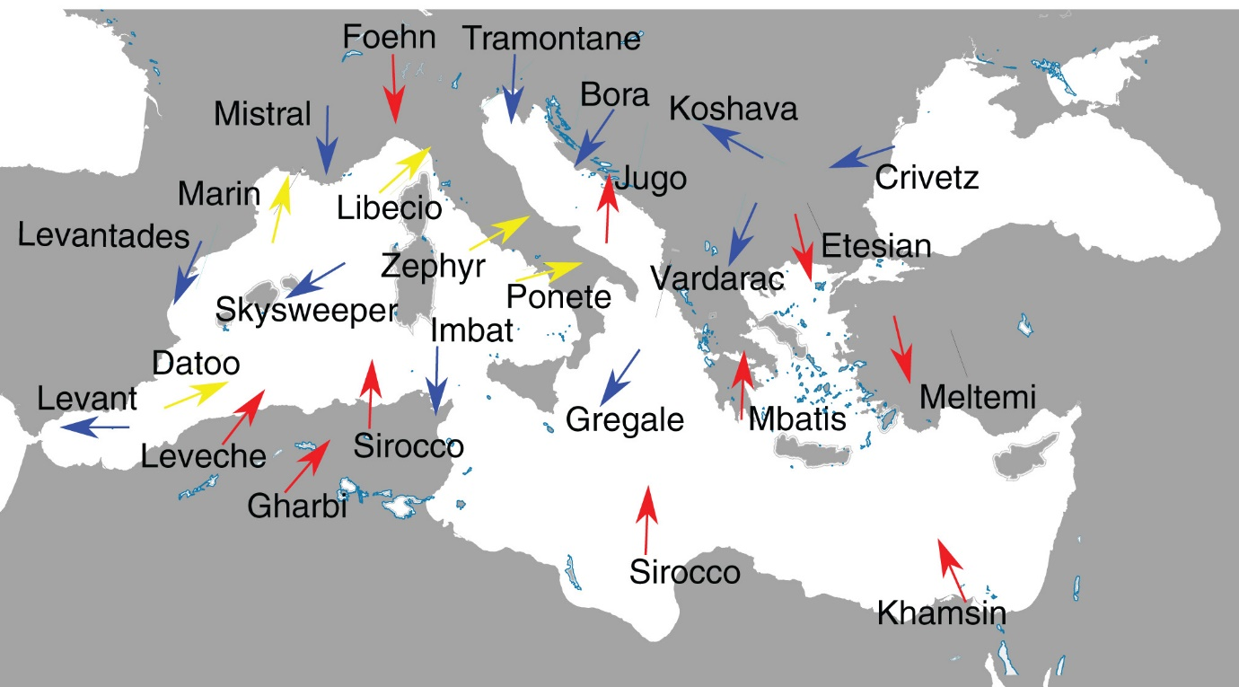
It is clear that strong winds in August would have made sailing difficult (Figure 5). Although there are still fairly strong winds in May (Figure 4) they are not as ferocious as those in August, so it would appear that May would be the best season for trading. Even so, it would have been difficult to get from the Levant and Eastern Mediterranean to the Adriatic trading route, given that the winds pull in an easterly direction. Perhaps this is why there is a division in interactions between the western and eastern Mediterranean.
Figure 3 Map of June to August Surface Currents on the Mediterranean. From: UK Hydrographic Office, 2016, p. 19.
Figure 2 Map of the winds of the Mediterranean. From: Romanic, 2018, p. 2.

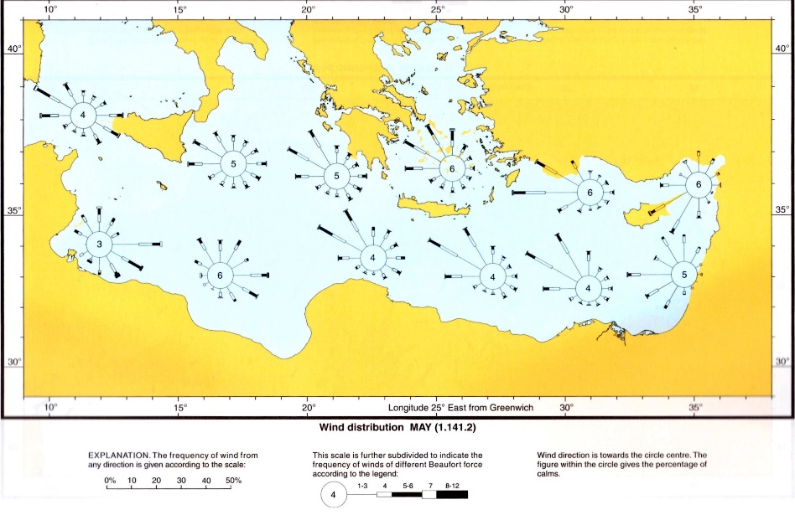
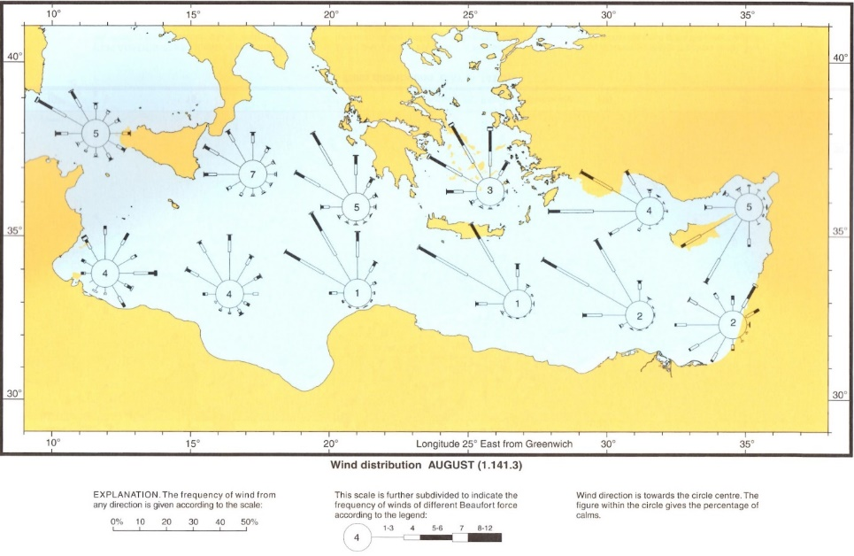
Haywood presents an image of the islands being isolated from the wider Mediterranean exchange, especially culturally, except for the island of Zakynthos which appears to have some form of LH I occupation. It seems that in the MM IB period, even when contacts increased between the mainland, Crete and the Cyclades, the Ionian islands on the western and therefore opposite coast of the interactions seem not to have benefitted from these increasing contacts.
Figure 4 Map of the May Wind Distribution of the Mediterranean. From: UK Hydrographic Office, 2016, p. 33.
Figure 5 Map of the August Wind Distribution of the Mediterranean. From: UK Hydrographic Office, 2016, p. 34.
Therefore, the focus of interaction shifts towards the more logical trade route, with the Ionian islands participating in the trade network between Greece and the East, to Southern Italy and the Adriatic (see figure 2). There is evidence for trade between the Mycenaeans and Bronze Age Italians through pottery, weapon remains, and purple-dying. Italy was emerging as a trading periphery during the Bronze Age in the Mediterranean, and was useful for its raw materials of copper and amber. However, when focusing on the Eastern Mediterranean World System Italy does not appear to have a major role. Although it was a producer of copper most artefacts found in Greece are produced from Cypriot copper suggesting a much larger trading network with Cyprus than with Italy.
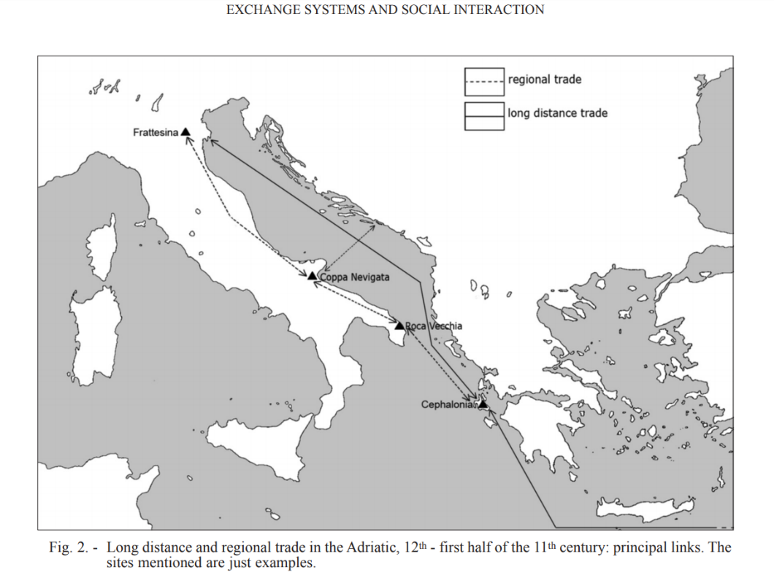
It is difficult to determine whether there was a circulation of finished products or raw materials across the Adriatic. A main example of this debate is the Naue II type swords, which have been found across Mycenaean Greece but also in Bronze-Age Albania, and were clearly introduced into the Aegean by the Adriatic sea route just before the collapse of the Mycenaeans in the 13th century BC. Analysis of the copper of the swords links it with Italian objects made in the Veneto and Lombardy areas of northern Italy, but there is also a possibility that bronze workshops in southern Italy had imported the bronze and copper from northern Italy. This proves a comprehensive trading network across the Adriatic, showing that Mycenaean trade could also have occurred in northern Italy and Albania, as well as in southern Italy.
Figure 6 Trade in the Adriatic, 12th-11th century
From: Cazzella, 2010.
Cazzella and Recchia, as well as Sherratt, all argue that amber increased the eastern trading connections with Italy. Sherratt discusses this idea as integral to his Bronze-Age World System theory, where he places Italy as part of the periphery of the Mycenaean trading world, because it becomes an active part of the trade network.
Although Italy is the periphery of the Eastern Mediterranean world, it could perhaps be seen as the ‘core’ of its own trading network, as it controls the transport from the east to the west as well as to the north. Italy is not a marginal state in the World System because without it there would be a larger effect on the overall trading network and a significant alteration in trading would be necessary, whereas a marginal area if disconnected would not affect the larger trading network.
Sherratt admits that there are multiple ‘cores’ within a world system, and it appears that Italy becomes a ‘core’ as part of the amber trading network. The amber in this trading network is not from Italy, but is being transported from the north/Scandinavia through Italy as is evident by the same amber being present in tombs at Apulia and Basilicata. With the exchange of Amber going south, there must also be trade going north, which has been suggested as folding stools – but it is admitted that perhaps this is not a regular transfer. This interaction is not limited to Italy, there would also have been connections across the rest of the Adriatic, stretching between Italy and also bronze-age Albania, as well as northern Greece such as Epirus.
It is important to see not just the macro-perspectives, the whole of Bronze Age Mediterranean as a trade system, but also in this case the rest of Europe interacting as well; there are also micro-perspectives, in this case the Ionian islands, within the wider system. Zakynthos, Lefkada, and Kefallonia in particular would have acted as marginal states within the wider trading network. If they stopped trading it would not have affected the overall supply network, whereas the other islands would not have been part of the model at all. This shows the limited importance of the islands within the trade network, and also the lack of economic and cultural coherence between the islands.
The most predominant evidence of Mycenaean trade in Italy is the remains of Mycenaean pottery. This is predominantly found in the Apennine region of Italy, in Coppa Nevigata especially (see figure 2) there is evidence for local production of pottery that seems to be inspired by the Mycenaean pottery, suggesting at least either indirect or direct contact. This Italian-made pottery that mimics the Mycenaean style is also found further north in Italy in the Po Valley region where analysis of the shards shows them to be Italo-Mycenaean products instead of Aegean imports. This indicates that they must have had access to Mycenaean pottery, which they then copied and adapted to make themselves at a local level, showing some sort of cultural transference.
Cazzella argues that the trade network that developed with the Mycenaeans did not diminish with their collapse but seemed to increase, this is also when the role of the Ionian islands within this trading network increased. This may because of an influx of traders from the Eastern Mediterranean wanting access to amber without having the Mycenaeans as intermediaries, (although the Phoenicians had been traversing the western Mediterranean much earlier). Seafarers from the Eastern Mediterranean were now going directly to Italy for the raw materials that could be found there, including amber and tin. The southern Ionian Islands (Kefallonia, Ithaca and Zakynthos) therefore became a stopping point during these expeditions. Presumably this is where sailors would stop to restock supplies or pull into harbour after a long journey; perhaps even repair work on ships may have taken place as surely the islands would have needed these skills as boats would have been their main form of transport. It is evident that some form of trading took place on the islands as a large number of amber beads, similar to the Tiryns type, were found in Kefallonia. These beads would have been produced in north-east Italy and then traded in the Eastern Mediterranean.
Kristiansen raises an important question on the type of interactions that were happening alongside the trade. With the movement of goods comes the movement of people, which in turn leads to the movement of ideas, beliefs and cultures. There is debate on the extent of the trading network between Bronze Age Greece and Italy as to whether trade was organised by a centralised government, small private traders, or family traders. Due to the discovery of Italian objects in the graves at Mycenae current consensus would lean towards there being a larger state-organised trade network, especially with the importing of high-value goods such as amber. There is also speculation on whether with the movement of people, came the settlement of people, particularly Mycenaeans in Italy with the beginning of local production of their pottery types.
Kristiansen states that there would have been a commercial aspect of trade. Cazzella & Recchia speculate that the Eastern seafarers may have seen themselves as superior to the locals they were trading with but had to establish cordial relationships for trade. If local elites existed in Bronze Age Italy, then it is likely that they treated the Mycenaean elites as their equal and would have mediated a non-trading relationship through gift exchange. However, this relationship cannot be confirmed by the archaeological record, especially as the existence of the Bronze Age Italian elites existing is still being questioned.
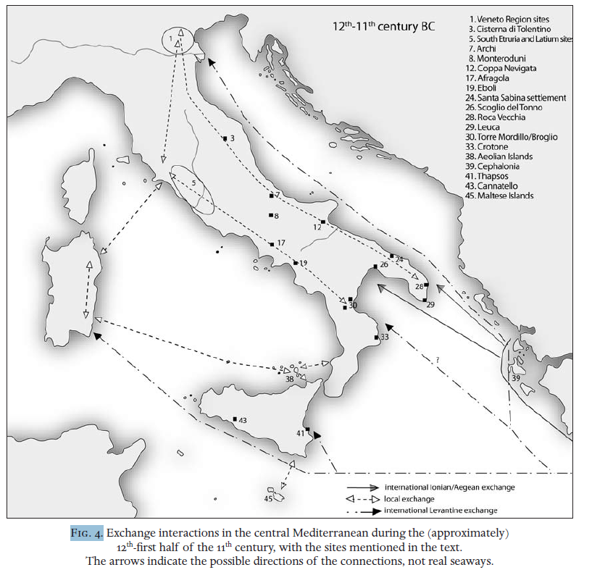
Cazzella extends the argument that a long-distance trade network was established between the eastern Mediterranean and north-eastern Italy during the 12th/11th century BC, incorporating a stopping point at the Ionian islands. This trade network then remained and possibly increased after the fall of the Mycenaean world, due to eastern traders being unable to exchange within Greece, notably as Italy became more prominent in the eastern Mediterranean during the Iron Age. However, despite the existence of this trade network and the transfer of culture, there was not necessarily a permanent presence of settlement of eastern foreigners in Italy and the northern Adriatic.
Figure 7 Exchange interactions in the central Mediterranean during the (approximately) 12th first half of the 11th century, with the sites mentioned in the text.
The arrows indicate the possible directions of the connections, not real seaways.
From: Cazzella & Recchia, 2009, p. 37.
The extent of the Ionian Islands trading status remains questionable, but the islanders went from being bystanders in the trade between Mycenaean Greece and Italy in the Bronze Age to becoming participants in the main trading system after the fall of Mycenae, when eastern traders created a route that bypassed Greece. Their status appears to have increased from that of a marginalised state to a semi-peripheral state, potentially taking the place that Mycenaean Greece once had as a periphery state before its fall. Evidence for this is limited to some amber products in Kefallonia, and to make the argument more substantial other forms of evidence from the rest of the Ionian Islands is required. Word Count: 2481

Bibliography
Cazzella, A., 2010. Exchange System and Social Interaction during the Late Bronze Age in the Southern Adriatic. In: P. C. G. E. Borgna, ed. Dall’Egeo all’Adriatico: organizzazioni sociali, modi di scambio e interazione in età postpalaziale . Udine: Atti del Seminario internazionale, pp. 159-170.
Cazzella, A. & Recchia, G., 2009. The ‘Mycenaeans’ in the Central Mediterranean: a Comparison between the Adriatic and the Tyrrhenian Seaways. In: Pasiphae: Rivista di Filologia e Antichita Egee III. Pisa; Roma: Fabrizio Serra Editore, pp. 27-40.
Chirarantini, L. et al., 2018. Copper metallurgy in ancient Etruria (southern Tuscany, Italy) at the Bronze-Iron Age transition: a lead isotope provenance study. Journal of Archaeological Science: Reports, Volume 19, pp. 11-23.
Dn Nautica, 2015. Winds on the Adriatic. [Online]
Available at: http://www.dn-nautica.com/sailing-in-croatia/tips/winds-on-the-adriatic
[Accessed 20 April 2020].
Evans, J. D., 1973. Islands as Laboratories for the Study of Culture Process. In: A. C. Renfrew, ed. The Explanation of Culture Change: Models in Prehistory. London: Duckworth, p. 517–520.
Gleba, M., 2017. Tracing textile cultures of Italy and Greece in the early first millennium BC. Antiquity, 91(359), pp. 1205-1222.
Hammond, N., 1992. The Relations of Illyrian Albania with the Greeks and the Romans. In: T. Winnifrith, ed. Perspectives on Albania. New York: Palgrave Macmillan, pp. 29-39.
Harding, A., 1992. The Prehistoric Background of Illyrian Albania. In: T. Winnifrith, ed. Perspectives on Albania. New York: Palgrave Macmillan, pp. 14-28.
Haywood, C. S., 1999. The Ionian Islands in the Bronze Age and Early Iron Age. Liverpool: Liverpool University Press.
Hodos, T., 2009. Colonial Engaagements in the Global Mediterranean Iron Age. Cambridge Archaeological Journal, 19(1), pp. 221-41.
Jung, R. & Mehofer, M., 2013. Mycenaean Greece and Bronze Age Italy: Cooperation, Trade or War?. Archaologisches Korrespondenzblatt, Volume 4, pp. 175-193.
Koui, M. et al., 2006. Study of Bronze Age Copper-Based Swords of Type Naue II and Spearheads from Greece and Albania. Mediterranean Archaeology and Archaeometry, 6(1), pp. 49-59.
Kristiansen, K., 2018. Theorizing Trade and Civilization. In: K. Kristiansen, T. Lindkvist & J. and Myrdal, eds. Trade and Civilisation: Economic Networks and Cultural Ties, from Prehistory to the Early Modern Era. Cambridge: Cambridge University Press, pp. 1-24.
Patton, M., 1996. Islands in Time: Island sociogeography and Mediterranean prehistory. London; New York: Routledge.
Pavel, C., n.d. Homer and Archaeology: Perspectives from the East Aegean - West Anatolian Interface. In: V. Faranton & M. Mazoyer, eds. Homere et l'anatolie 2. Paris: L'Harmattan, pp. 9-70.
Romanic, D., 2018. Review: Local winds of Balkan Peninsula. International Journal of Climatology, Volume 39, pp. 1-17.
Schon, R., 2006. Diachronic Frontiers: Landscape Archaeology in Highland Albania. Journal of World-Systems Research, 12(2), pp. 231-262.
Sherratt, A., 1993. What would a Bronze-Age World System look like? Relations between temperate Europe and the Meditteranean in later prehistory. Journal of European Archaeology, 1(2), pp. 1-58.
UK Hydrographic Office, 2016. Admiralty Sailing Directions: Mediterranean Pilot. Volume 5.. 13th ed. Taunton: UK Hydrographic Office.

Pavel, n.d.
Haywood, 1999.
Patton, 1996, p. 2.
Evans, 1973 in Patton, 1996, p. 2.
Patton, 1996, p. 7.
Patton, 1996, p. 7.
Haywood, 1999, p. 3.
Haywood, 1999, p. 136.
Patton, 1996, pp. 12-18.
Hammond in Haywood, 1999, p. 13; although Hammond’s work is often too focused on Macedonia.
Haywood, 1999, p. 13.
Haywood, 1999, p. 5.
Patton, 1996, p. 18.
Haywood, 1999, p. 5; Patton, 1996, p. 18.
Haywood, 1999, p. 5.
Dn Nautica, 2015.
Haywood, 1999, p. 136.
Haywood, 1999, p. 136.
Cazzella, 2010, p. 161.
Jung & Mehofer, 2013; Cazzella & Recchia, 2009, p. 30.
Cazzella & Recchia, 2009, p. 29.
Jung & Mehofer, 2013, pp. 178-9.
Jung & Mehofer, 2013, p. 178.
Koui, et al., 2006, p. 50.
Jung & Mehofer, 2013, p. 178.
Cazzella & Recchia, 2009; Sherratt, 1993.
Sherratt, 1993, p. 31.
For example, the possible interactions with Wessex see: Kristiansen, 2018, pp. 10-1; Sherratt, 1993, p. 33.
Sherratt, 1993, pp. 3-5.
Sherratt, 1993, p. 4.
Cazzella & Recchia, 2009, p. 33; Sherratt, 1993, p. 4.
Sherratt, 1993, pp. 32-3.
Schon, 2006; Harding, 1992; Hammond, 1992.
Kristiansen, 2018, p. 18.
Jung & Mehofer, 2013, p. 180.
Jung & Mehofer, 2013, p. 180.
Cazzella, 2010, p. 162.
Jung & Mehofer, 2013, p. 180.
Cazzella, 2010, p. 161.
Cazzella & Recchia, 2009, p. 37.
Cazzella, 2010, pp. 162-3; Cazzella & Recchia, 2009, p. 37.
Kristiansen, 2018, p. 9.
Kristiansen, 2018, p. 9.
Kristiansen, 2018, p. 9; Cazzella, 2010, p. 162.
Kristiansen, 2018, p. 12.
Cazzella & Recchia, 2009, p. 39.
Cazzella & Recchia, 2009, p. 39.
Cazzella, 2010, p. 164.
Cazzella, 2010, p. 164.
For more information on Iron Age Italy and Elba see: Chirarantini, et al., 2018; Hodos, 2009; Gleba, 2017.
Cazzella, 2010, p. 165.

