

Module Code: LCBB6002
Assignment Title: Assignment 1
Module Lecturer’s Name: Thomas Adeyemi
Student Name: Diana Paula Stratulat

Student ID: 2024156

Table of Contents
Introduction 2
Dividend Distribution Policy of British Petroleum 2
Analysis and Evaluation 2
Efficient Market Hypothesis Theory in the Context of the BP Plc 4
Critical Analysis 4
Appraising Projects 5
Methods and Evaluation of BP Plc 5
Challenges Faced by BP Plc in Different IFM 6
Conclusions 7
References 8

Introduction
British Petroleum has been chosen as a multinational company for this report. British Petroleum, or BP for short, is a massive oil and gas company based in London, UK. It all started way back in 1909 when the company was known as the Anglo-Persian Oil Company. Today, BP has operations in over 70 different countries and is one of the biggest players in the oil and gas industry. They're involved in all sorts of businesses, including exploring and producing oil and gas, refining and marketing petroleum products, and making petrochemicals (Abdelrehim, Maltby and Toms, 2015). They sell everything from gasoline to motor oils, and they're even starting to dabble in renewable energy. International Financial Management (IFM) is crucial to BP due to its global operations. As a multinational company, BP has to deal with various challenges related to currency exchange rates, country-specific tax regulations, and international trade laws. BP has to manage its financial resources efficiently to maintain its global operations and fund its growth strategies. Hence, IFM is vital for BP to ensure optimal use of its financial resources and mitigate risks in different international financial markets of the world.

Dividend Distribution Policy of British Petroleum

Analysis and Evaluation
BP has a well-established dividend distribution policy that is attractive to investors. The company has a history of paying dividends consistently, and its dividends have been stable or increasing over the years. BP's dividend distribution policy reflects its strong cash flow and a commitment to returning value to its shareholders (Chaplinsky, Lynch andDoherty, 2017). In 2021, BP announced a dividend of 5.46 cents per share for Q2, marking a 4% increase from the previous quarter. The company aims to return at least 60% of its surplus cash flow to shareholders through dividends and share buybacks. BP's dividend yield as of September 2021 was around 4.8%, which is higher than the industry average.
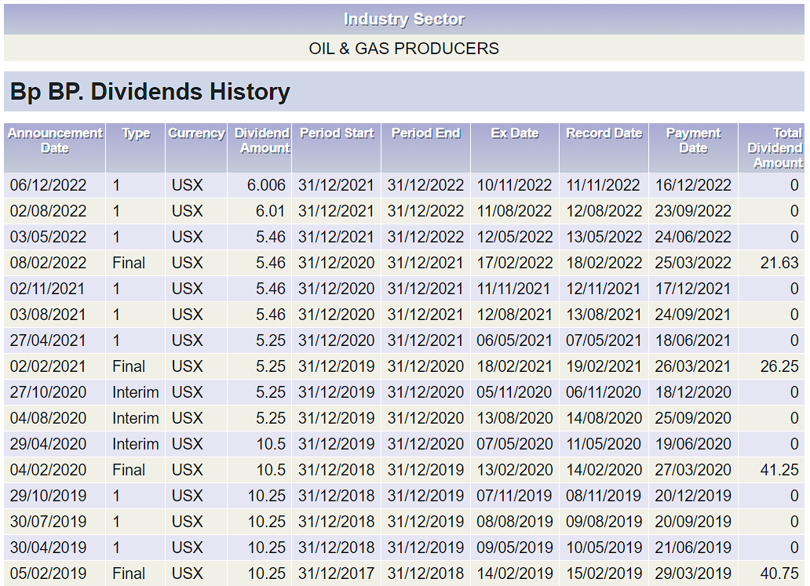
Figure 01: Dividends payout history of BP Plc. Source: (BP, 2022)
However, as the above graph shows, the COVID-19 pandemic has affected BP's financial performance, leading to a decrease in its dividend payments. In 2020, BP reduced its dividend payments by 50% in response to the challenging market conditions. The company also announced a plan to shift towards renewable energy, which could impact its dividend policy in the long run. BP's dividend distribution policy is essential for attracting and retaining investors. The company's dividend payments have a significant impact on its share price, and hence, it is essential to maintain a stable and attractive dividend distribution policy (Wereley, 2020). Overall, BP's dividend distribution policy is reflective of its financial strength and commitment to shareholder value, but it is also subject to external factors such as market conditions and industry trends.

Efficient Market Hypothesis Theory in the Context of the BP Plc

Critical Analysis
The Efficient Market Hypothesis (EMH) theory basically says that financial markets are really good at incorporating all the available information about a particular asset into its price. So, if there's any news or information about a company that might affect its stock price, that information is quickly reflected in the stock's current price (Ţiţan, 2015). In other words, it is not possible to consistently achieve superior returns in an efficient market because any new information that becomes available is immediately reflected in the asset prices, leaving no room for arbitrage. In the context of BP plc, EMH theory can be applied to evaluate the efficiency of the stock market in reflecting the company's fundamental value (Umoru et al., 2020). Therefore, if the EMH holds true, the stock price of BP should reflect all available information related to the company and its industry, making it impossible to outperform the market consistently.
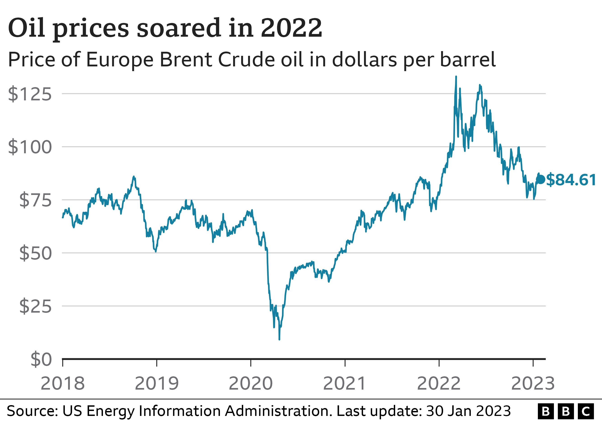
Figure 02: increased profit of BP Plc. Source: (Nick Edser, 2023)
The company had a great increase in the profit in 2022 as shown in the figure above. However, some researchers have criticized the EMH theory for oversimplifying the complex nature of financial markets. They argue that the theory fails to account for the impact of behavioral biases and the imperfect flow of information in financial markets. These factors can result in the mispricing of assets, creating opportunities for investors to generate abnormal returns. In the case of BP, the stock price has shown significant fluctuations over the years due to various factors, including oil price volatility and geopolitical risks. This suggests that the stock price of BP may not always reflect all available information and that there may be opportunities for investors to generate abnormal returns.
In summary, while the efficient market hypothesis provides a useful framework for understanding financial markets, it may not always hold due to market inefficiencies, limited information, behavioral biases, and technical and fundamental analysis.

Appraising Projects

Methods and Evaluation of BP Plc
BP Plc has a long history of investing in various projects globally, ranging from upstream exploration and production to downstream refining and marketing. In evaluating potential projects, BP utilizes various methods to assess their feasibility and profitability. One method used by BP to appraise projects is the Net Present Value (NPV) technique. In simple terms, when BP is considering a project, they use a method called NPV to figure out if it will be profitable. This means they look at how much money the project is expected to make over its lifetime, and then they subtract the initial investment (Malone, 2019). If the number is positive, it's considered a good investment. Another method BP uses is called IRR, which basically calculates the rate of return a project is expected to generate based on the initial investment and expected cash flows over its lifetime. If the IRR is higher than the required rate of return, the project is considered a financially feasible option. To sum it up, BP uses NPV and IRR methods to determine if a project is worth investing in.
BP also evaluates projects based on their strategic fit with the company's overall goals and objectives. Projects that align with BP's strategic priorities, such as reducing emissions and transitioning to renewable energy sources, are given priority. In recent years, BP has been investing heavily in renewable energy projects, including wind and solar power. In 2021, BP announced plans to increase its annual investment in low-carbon projects to $2-3 billion by 2030.
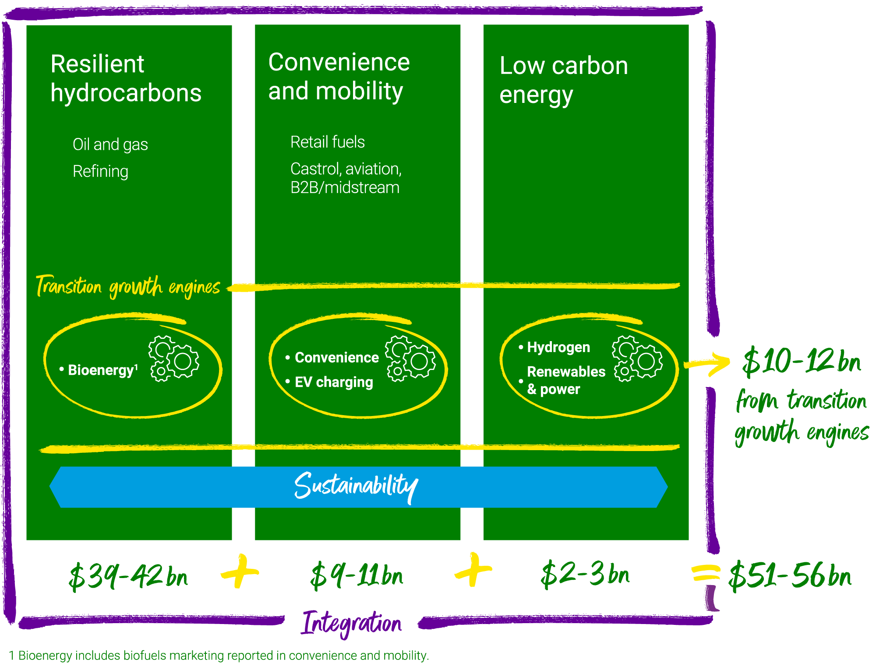
Figure 03: Low-carbon energy investment of BP Plc. Source: (BP global, 2023)
However, BP has also faced challenges with some of its projects, such as the Deepwater Horizon oil spill in 2010, which resulted in significant financial and reputational damage to the company. BP utilizes various methods to appraise potential projects, including the NPV and IRR techniques, as well as strategic alignment with the company's overall goals.

Challenges Faced by BP Plc in Different IFM
BP Plc, as a multinational corporation, faces various challenges in different international financial markets, including:
- Fluctuating oil prices: As a global oil and gas company, BP's financial performance is heavily influenced by fluctuations in oil and gas prices, which can impact its revenue and profitability. The company's exposure to oil price volatility makes it challenging to predict future revenue and plan for long-term investments.
- Geopolitical risks: BP operates in various regions globally, including politically unstable regions, where there is a risk of disruptions to operations due to changes in government policies, regulatory frameworks, and civil unrest.
- Currency risk: BP generates revenue in various currencies, and fluctuations in exchange rates can impact its profitability. Changes in currency exchange rates can also impact the value of the company's assets and liabilities, creating challenges in managing its financial position.
- Regulatory compliance: BP is subject to various regulations in different countries where it operates, ranging from environmental regulations to tax laws.
- Access to capital: BP requires significant capital investments to finance its operations and growth initiatives. Access to capital can be challenging in certain international financial markets, where investors may have limited appetite for risk.

Conclusions
In conclusion, British Petroleum (BP) is a multinational corporation that faces various challenges in different international financial markets. The company's dividend distribution policy is based on its financial performance and cash flow position. The efficient market hypothesis theory suggests that the UK stock market, including BP's stock, is semi-strong efficient, making it challenging to gain a competitive advantage by using past information to make future investment decisions. BP uses various project appraisal methods, such as NPV, IRR, and strategic alignment, to evaluate potential projects.

References
Abdelrehim, N., Maltby, J. and Toms, S., 2015. Narrative reporting and crises: British Petroleum and Shell, 1950–1958. Accounting History, 20(2), pp.138-157.
BP global. 2023. Why invest in BP: Investors: Home Available at: https://www.bp.com/en/global/corporate/investors/why-invest-in-bp.html (Accessed: April 5, 2023).
BP. 2022. share price ADVFN. Available at: https://uk.advfn.com/stock-market/london/bp-BP./dividends (Accessed: April 5, 2023).
Chaplinsky, S., Lynch, L.J. and Doherty, P., 2017. British Petroleum, Ltd. Darden Business Publishing Cases, pp.1-28.
Malone, R., 2019. Driving value through standardization. British petroleum.
Nick Edser, D.T 2023. BP scales back climate targets as profits hit record. Available at: https://www.bbc.com/news/business-64544110 (Accessed: April 5, 2023).
Ţiţan, A.G., 2015. The efficient market hypothesis: Review of specialized literature and empirical research. Procedia Economics and Finance, 32, pp.442-449.
Umoru, B., Udobi-Owoloja, P.I., Nzekwe, G.U., Iyiegbuniwe, W.C. and Eziker, J.E., 2020. Are stock returns predictable? The myth of efficient market hypothesis and random walk theory using Nigerian market data. International Journal of Economics, Business and Management Research, 4(7), pp.115-130.
Wereley, I., 2020. Advertising an empire of oil: The British Petroleum Company and the Persian Khan exhibit of 1924–1925. MediaTropes, 7(2), pp.19-39.

