Business Issues and the Contexts of Human Resources

Name: Agnieszka Grabowska-Phillips

CIPD Membership Number: 48812683

Date: 27/12/2017

Word count (approx.: 3900 words)

I declare that this assignment is my own work and that any information obtained from books and other sources have been appropriately referenced.

Signed......................................................... Date...............................................

The evolving role of HR
in the contemporary business world

Table of Contents

1. Introduction 4
2. Key forces shaping the HR agenda 5
2.1 Models of the HR function 5
2.2 HR Strategies 7
2.3 Insights and solutions to support business performance 7
2.4 Business ethics and accountability 8
3. Tools for analysing the business environment 9
3.1 Internal and External Factors 9
3.2 SWOT 9
3.3 PRIMO-F 10
3.4 PESTLE 10
4. Factors that have impact on an organisation’s business and its HR function 11
4.1 Size of organisation (SWOT - strength) 11
4.2 Organisation’s workforce (PRIMO-F - people factor) 11
4.3 New technology (PESTLE - technological factor) 11
4.4 National economy (PESTLE - economic factor) 12
5. Key stages in strategy formulation and implementation 13
5.1 Strategy Formulation 13
5.2 HR’s contribution to business ethics and accountability 14
6. Evaluation of business performance 16
6.1 Business Performance 16
6.2 Business Planning and Change Management 16
7. The use of business and contextual data 19
7.1 Internal Information 19
7.3 Competitive Information 19
7.4 Government Information 19
8. Conclusion 20
References 21
Appendices…………………………………………………………………………………………..26

1. Introduction

HRM plays a significant role in organisation by providing flexibility and adaptability (Khatri, 1999). It feeds directly into organisation’s success (Marchington & Wilkinson, 2008) by ensuring that the human side of lean management creates lasting value (Frackleton, et al., 2014). This paper has been produced for inclusion in the CIPD delegate pack as a part of discussion on the evolving role of HR in the contemporary business world.
The term ‘social justice’ is often used to describe the evolution of HRM in nineteenth-century Britain (Torrington, et al., 2008). It originated from industrial welfare, initiated by a small number of progressive employers, who spoke up for improved working conditions (Farnham, 2015). In 1831, a strong humanitarian campaign led by the MPs Anthony Ashley-Cooper and Michael Sadler, and by textile manufacturers of Lancashire and Yorkshire resulted in a Factory Act being passed. Two years later, UK Parliament approved a new Factory Act, this time also establishing a system to ensure that new regulations were followed. The teams of four inspectors were introduced in factories marking the beginning of HR (Parliament, 2017).
The first officially recognised personnel department has been set up in the US in early 1900s at the National Cash Register Co. to handle grievances, discharges and safety (Fig.1). The trend spread and by 1920s, the role of personnel departments became much more defined. Yet still focusing mostly on recruitment, evaluation and training. It was not until 1970's, when that role expanded into advisory function when the evolving employment legislation forced personnel departments to focus on preventing managers violating the law (Kumar, 2015).

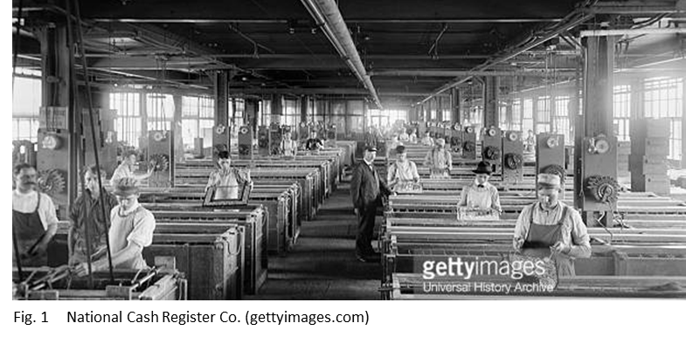

2. Key forces shaping the HR agenda

2.1 Models of the HR function
The next major shift in HR happened in the 1980’s and 1990's in response to globalisation and neoliberal economic policies (Farnham, 2015). The employers started gradually seeking greater flexibility in their arrangements - the workforce and patterns of work became more diverse and the number of part-time and temporary contracts increased. Internet era that followed initiated surge in number of employees working from home and HR’s traditional role yet again became outdated (Kumar, 2015).
The number of HR models has been proposed in response to changes. The Harvard Model (Fig.2) recognised that stakeholders’ interests and situational factors affect the HR policy choices of an organisation in terms of shaping employee influence, human resource flow, reward systems and work systems (Boselie, 2015).
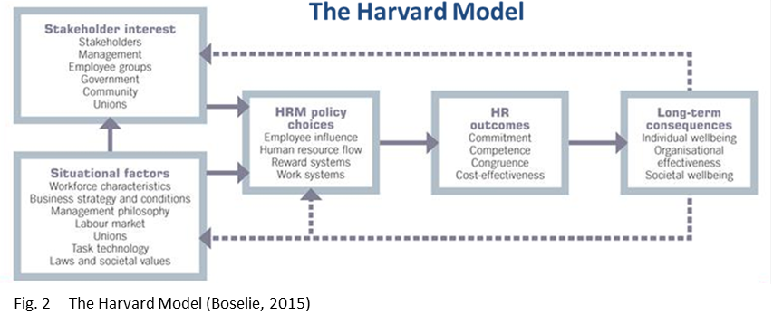

Ulrich’s HR Model separated the policy making, administration and business partner roles at the same time defining HR’s new roles and responsibilities (Fig.3). The goal was to shift the role of HR from administration to strategy (Foster, 2015).
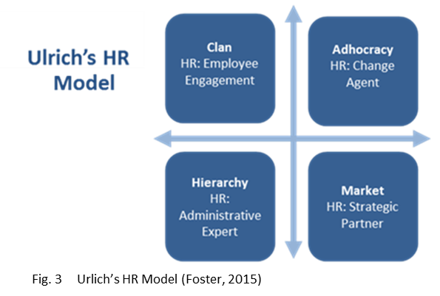

Recently another shift in HR practice has been observed. Today’s HR is all about the business, creating value for others, managing talent, leadership and culture. First and foremost, HR strategy must be aligned to the broader business strategy to be effective (CIPD, 2017a). In the past, HR role was limited to making sure that employees are competent, have good experience and wellbeing. Nowadays, the employees are put in the business context forcing HR to concentrate on their connection to customers and investors outside the organisation (Gyton, 2017).
HR can create value for their stakeholders by addressing proactively complex talent and business needs. It can improve the company’s profit margins, positively impact the cost of goods sold, lower the day’s sales outstanding, and increase the price / earnings ratio while liquidating overhead costs to the business (Gregory, 2017).
Framework for Value Creation highlights HR practices required to create value through ‘Talent’, ‘Leadership’ and ‘Organisational Capital’ (Fig.4). The aim is to achieve a clear line of sight between recruiting the talent, the organisational culture, capability and the stakeholder value (Ulrich, et al., 2017).

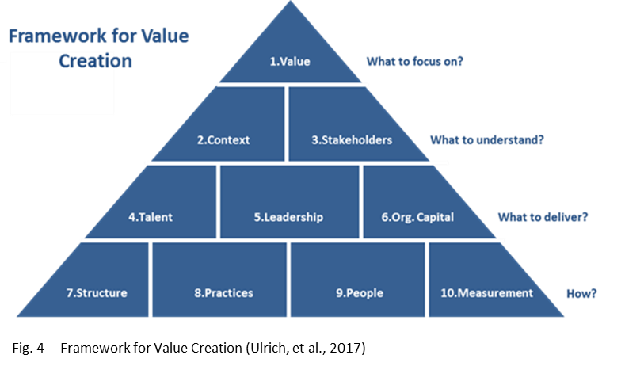

2.2 HR Strategies
HR strategies need to be integrated into the business strategy to bring about the best deployment and management of the human capital. Private, public and voluntary sectors have each different business context and therefore require different approach to HR (Taylor & Wilkinson, 2016). For instance, one of the main issues HR faces in voluntary sector is an employee engagement - the staff often see their jobs as ‘paid volunteering’ and find it difficult to focus on more challenging and mundane aspects of their work. Also, when it comes to financial incentives, there is much more room for manoeuvre in private sector. Reward management and motivation practices in public and third sectors are therefore much more limited. The other examples of unique features are ambiguity and pace. Unlike in the private sector, the complexity of stakeholder engagement and changes in government can sometimes make the decision-making structure quite unclear in the public sector. And while in the private sector the business tends to be fast-paced and outcome-driven, in the third sector the pace of decision-making is often very different (Roper, 2017).
Organisational response to development and business environment is always critical (Taylor & Wilkinson, 2016). The increasing number of competitors will inevitably force the organisation to embrace new business strategies and HR practices (Armstrong & Sappington, 2006). For example, the extent to which the competition affects organisation’s ability to recruit qualified workers would influence company’s recruitment strategy. In the similar way, HR may be forced to develop programs and incentives to retain key employees (Benjamin, 2017).
Another major factor that may affect HR strategy is globalisation. The current wave is driven by ideological change and technological revolution (Gupta, et al., 2008). Increasing emphasis on knowledge-based competitiveness accelerated the importance of human capital; staying abreast of new strategies is now necessary for finding and attracting talent (Wan, et al., 2002).

2.3 Insights and solutions to support business performance
The ‘best practice’ approach is a set of HRM practices designed to support business performance. It is often regarded as universal as it can be adopted in any situation (Armstrong, 2016) for instance employment security, selective hiring, self-managed teams, high compensation contingent on performance, training, reduction of status differentials and sharing information (Pfeffer, 1994). The ‘best fit’ approach is based on the idea that organisation’s HR strategies should be linked to the type of organisation and its circumstances. The aim is to achieve competitive advantage (Armstrong, 2016). These criteria can be fulfilled via innovation (unique products/services), quality (high-standard products/services) and cost leadership (minimising expenses) (Porter, 1985).

2.4 Business ethics and accountability
There is a considerable overlap between ethics and the law; nonetheless the two are not equivalent. The business ethics often begins where the law ends, as while the law defines the minimum acceptable standards of behaviour, it doesn’t cover every possible ethical issue in business (Crane, 2016). When setting up HR agenda, the organisation should always take into account the ethical considerations. They include interests of stakeholders of the organisations (employees and employers) as well as the wider community and the society in general (Armstrong, 2016).
Organisational codes of ethics and professional codes of conduct provide framework to determine what is important to consider (Biech, 2007). There are a strict set of rules that all members of CIPD are required to adhere to (see Appendix A). These obligations form a Code of Personal Conduct (CIPD, 2017b).
As well as having a personal responsibility for ethical decision-making, HR professionals are responsible for promoting ethical behaviour within the organisation. This can be achieved by development or adoption of corporate code of practice. M&S Code of Practice is one such example. The Code obliges all suppliers to ensure their product meets minimum labour standards, the national law and the Global Sourcing Principles (M&S, 2016). Ethical trade means that retailers, brands and their suppliers take responsibility for improving the working conditions of the people who make the products they sell. The Ethical Trading Initiative (ETI) is a leading alliance of companies, trade unions and NGOs that promotes respect for workers' rights around the globe (Fig.5). Their vision is “a world where all workers are free from exploitation and discrimination, and enjoy conditions of freedom, security and equity” (ETI, 2017).



3. Tools for analysing the business environment

3.1 Internal and External Factors
To be effective, HR strategy must be aligned to the broader business strategy. HR must focus on the forces that affect organisation’s performance and it is critical that some basic elements are not overlooked or ignored during this process (CIPD, 2017a). There are numerous external and internal factors affecting HR practices and shaping the HR agenda and they differ significantly across countries (Ozutku & Ozturkler, 2009).
The external factors that affect HR practices can be defined as the elements that cannot be controlled and changed as per organisation needs (Kane & Palmer, 1995). Their understanding will have a positive effect on broader business policy as well as workforce planning, organisational change and many other HR related areas (CIPD, 2017a); for instance, the government policies will affect any strategic training and development activities (Mabey & Salaman, 1995).
The internal factors are organisational characteristics that are related to HR practices (Milkovich & Boudreau, 1991). For instance, various HR practices at small and medium enterprises are influenced by ownership, age and size of firms (Zheng & Morrison, 2009).
One of the most commonly used tools for analysing the business environment is SWOT analysis. It identifies the strengths, weaknesses, opportunities and threats relating to a project or business (Gregory, 2017). The value of a SWOT analysis can be enhanced when used with other analysis tools such as PESTLE and PRIMO-F (CIPD, 2015a).

3.2 SWOT
SWOT analysis examines the internal and external factors that are either supportive or unfavourable to achieving organisation’s objective (see Appendix B). The internal factors (strengths and weaknesses) are relative to competitive forces, while the external factors (opportunities and threats) emerge as a result of the competitive dynamics caused by future gaps in the market (CIPD, 2015a).
The main advantages of SWOT analysis are its flexibility and a simple framework that encourages strategic thinking. SWOT analysis is an extremely useful tool as it enables an understanding of the strengths and weaknesses of the organisation. It also helps to anticipate future threats and therefore avoid or minimise their impact. Finally, it helps the organisation to spot and exploit business opportunities (CIPD, 2015a).
The simple framework of SWOT can however be also seen as a disadvantage, as a lack of detailed structure may lead to key elements getting missed. Furthermore, to be effective, the analysis needs to be undertaken on a regular basis and the involvement of different people is required to achieve different perspectives. The other disadvantages are the fact that it is easy to over-simplify data and the possibility of replacing factual data with assumptions. Finally, too much data might be overwhelming and end up with misleading results (CIPD, 2015a).

3.3 PRIMO-F
PRIMO-F analysis provides consistent framework to examine the internal factors (people, resources, innovation, marketing, operations and finance) (CIPD, 2015a). It is a simplified way of showing strengths and weaknesses in these areas (Morrison, 2010).
The advantage of PRIMO-F is that it provides a consistent framework for comparison and benchmarking either from within the organisation or to benchmark against a previous analysis or benchmark against other organisations (Morrison, 2010).
However, PRIMO-F is not in itself a solution. It was designed to be used alongside the SWOT analysis, enabling it to work more effectively (Morrison, 2010).

3.4 PESTLE
PESTLE analysis helps to identify external factors (political, economic, sociological, technological, legal and environmental) that may impact organisation’s strategy and business decisions. The organisation itself cannot influence them, yet their understanding can maximise opportunities and minimise threats. Examining these risks will allow HR and senior managers making informed decisions and highlight potential for additional costs (CIPD, 2017a).
PESTLE’s main advantage is its simple framework facilitating an understanding of the wider business environment. The analysis encourages the development of external and strategic thinking. It can enable an organisation to anticipate future business threats and take action to avoid or minimise their impact. It also helps to spot business opportunities and exploit them fully (CIPD, 2017a).
The main disadvantage of PESTLE is the pace of change in external factors that makes it increasingly difficult to anticipate developments that may affect an organisation in the future. Similarly to SWOT analysis, PESTLE needs to be undertaken on a regular basis to be effective. Likewise, some users may oversimplify the amount of data used or base their decisions on assumptions that subsequently prove to be unfounded (CIPD, 2017a).

4. Factors that have impact on an organisation’s business and its HR function

The flexibility of SWOT, simplicity of PESTLE and consistency of PRIMO-F make them extremely useful tools. However, they do have their disadvantages and therefore it is best to use them together (CIPD, 2015a):

4.1 Size of organisation (SWOT - strength)
The size of organisation plays an important role in the intensity and type of HR practices (Garavan, et al., 2008). HR challenges will differ depending on the size of a company, for instance, the organisations may have to alter HR practices because of the different legal requirements. The main difference between small and large organisations is however in terms of resources, money, and time. Budgetary and time constraints that are more typical to smaller companies, will limit their recruitment efforts. The larger organisations usually have a wider range of recruitment processes and use a greater number of selection procedures. For example, larger firms are more likely to advertise through national newspapers, trade magazines, and other media sources. The smaller firms tent to use internal job postings, advertisement in local newspapers and social networks. Time and resource restrictions will also affect the selection of qualified individuals. While larger companies can afford to use more sophisticated and lengthy testing such as intelligence or personality tests, smaller companies are more likely to focus on the use of performance tests instead (Kerin, 2015).

4.2 Organisation’s workforce (PRIMO-F - people factor)
Investing in people’s skills has positive impact on productivity and other business outcomes. The research showed that this influence can be greater than impact of investment in IT, in machinery, or in R&D; the more highly qualified and educated workforce is the greater productivity, innovation and higher quality products or services can be achieved (Tamkin, 2005). Yet, while skills can be taught, attitude cannot be coached. Less-experienced employees with positive attitude are more beneficial than the experienced ones who refuse to assimilate and share in a company’s success. The stories of positive work culture spread fast and the enthusiasm is one of the best drivers of recruitment. Another benefit of good culture is employee engagement that leads to low turnover and increased retention rates (Fermin, 2015).

4.3 New technology (PESTLE - technological factor)
New technology allows access to larger than ever amount of data. It impacts the way businesses understand their customers, market to new audiences, and communicate with existing and prospective employees. HR needs to embrace and build on technological advancements to meet both employee expectations and business requirements (Biro, 2017). The two most prominent areas of technology that affect HR are HR software and the social media. Social networking plays an important role in HR, particularly when it comes to recruitment. According to a survey, almost a quarter of employers are regularly using sites such as Facebook and LinkedIn to recruit staff. HR software is currently shifting towards on-demand option and the move towards unified talent management systems can be observed. Furthermore, the design of HR software is also changing. The new trend is to include broader business user such as line managers and employees within the organisation (Christie, 2009).

4.4 National economy (PESTLE - economic factor)
There is a significant interference of national economy on HR policies (Rosman, et al., 2013) and economic trends, such as unemployment rate, have big influence on organisations’ HR agenda (Mello, 2006). The shape of the current economy not only affects the talent pool, but it might affect organisation’s ability to hire anyone at all. One of the biggest ways to prepare against economic conditions is to not only know what is happening in the world, but also create a plan for when there is an economic downturn (Onsarigo, 2016).

5. Key stages in strategy formulation and implementation

5.1 Strategy Formulation
There are three main elements in design of strategy: the goals to be achieved, policy guidelines for action and programmes to accomplish them (Quinn, 1980). Numerous models that focus on formulation, implementation and evaluation have been introduced. David’s Model of Strategic Management Process (David, 2009) indicates all major steps that must be met and illustrates the process as a continuous activity (Fig.6) (Jurevicius, 2013).
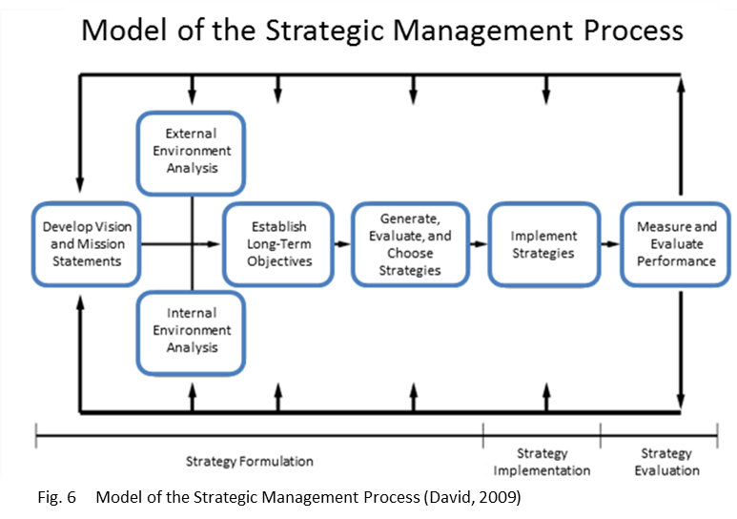

HR strategies are driven by company’s goals and objectives that derive from organisation's mission, vision and values. To ensure the link, they need to have external fit with business strategies and be vertically integrated with them. Furthermore, there needs to be horizontal integration with all aspects of HR strategy i.e. internal fit that allows the strategies to support each other ensuring that all strategies work together and are not in competition. The greater the degree of vertical and horizontal integration within an organisation, the more effective HR strategy. Finally, operational alignment of strategies ensures that the work will be actually be completed (Richards, 2017).

5.2 HR’s contribution to business ethics and accountability
The management of human resources is often seen as an ethical problem between rights and duties. From an ethical perspective, the employees should never be treated as a means only and accepting the responsibility to act in the best interest of the organisation and its workforce is essential (Crane, 2016).
There are distinct two aspects of business ethics: ‘specific situations in which ethical controversy arises’ and ‘the principals of behaviour by which it is appropriate to abide’ that include ethics of employment (pay, unions, worker’s rights, equal opportunities, non-discrimination, whistle-blowing), ethics of accounting (finance, restructuring and investing) and ethics of information (Chryssides & Kaler, 1993).
Winstanley et al (1996) recommended a framework for analysing HRM (Fig.7). To bring the greatest benefit to organisation, HR role should cover employment charters, legal regulation, innovation in good practice, challenge inevitability of demise of job security (Winstanley, et al., 1996).
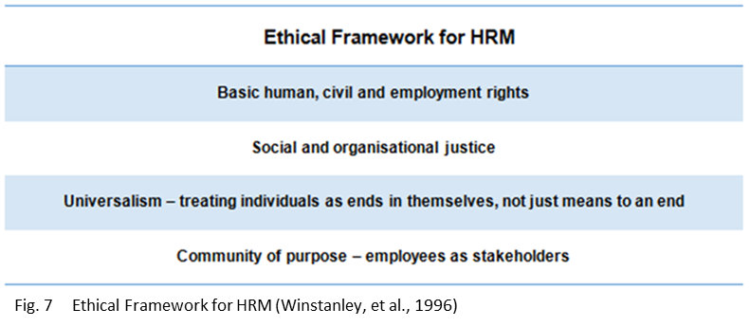
Specific workplace situations require decision makers to decide which choice is right for them. CIPD identified eight ethical perspectives for navigating workplace dilemmas to assist HR professionals in making the right choice (Fig.8) (CIPD, 2015b):
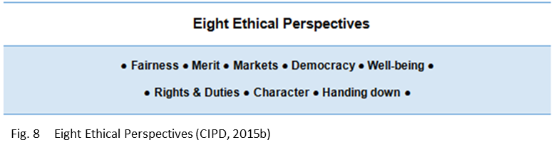

These lenses aren’t necessarily mutually exclusive. Some like democracy and human rights might support one another; others might co-exist but be appropriate to different kinds of decision or situation. Some are easy to combine, but there are potential confusions between others and they can’t be applied simultaneously. Finally, they can give very different advice once distinguished for example merit versus markets (CIPD, 2015b).

6. Evaluation of business performance

6.1 Business Performance
Traditional HR evaluation focused on the efficiency and effectiveness of the range of practices it covered. The most commonly used evaluation tools included HR statistics, KPIs and Balanced Scorecard. ‘HR Statistics’ are for instance the number of job applicants, turnover, and training hours per employee. Gathered together are very useful in terms of internal or external benchmarking. ‘KPIs’ (Key Performance Indicators) involve setting targets for activities that are critical for achieving business objectives and assessing performance against them. ‘Balanced Scorecard’ lists agreed set of performance and the strategic objectives (Wilkinson & Taylor, 2016).
The evolution from people-performance to organisational-performance orientated function lead to new requirement for self-evaluation based on ‘three savvies’. The new requirement is for the professional to be ‘contextual’, ‘organisational’ and ‘business’ savvy. The first ability involves being alert to external factors and macro trends affecting the organisation at present and in future. The second is having a sophisticated understanding of people and culture of organisation. Finally, HR professional should understand the business side of operations including the way company makes money and what matters most when it comes to its commercial health (Wilkinson & Taylor, 2016).

6.2 Business Planning and Change Management
Alignment of HR strategy with the business objectives focuses on two areas. At first, HR should compare its agenda with business strategy to ensure the top priorities match up. Secondly, HR should create a plan to meet the business strategy. Action plans and measurement are needed to turn strategy into outcomes (PersonnelToday, 2002). The objectives would include achieving effective resourcing, reward management, employee engagement and ensuring that training and development satisfy the needs of the organisation as well as the individual (Turner, 2002).
The organisational change can be driven by many different forces and a failure to introduce it effectively can have a negative impact on market position, stakeholder credibility, employee engagement and other elements crucial to company’s success (CIPD, 2017c). The first basic mechanism for managing change was Lewin’s Three Steps Change Process that defined change as moving from one static state via a state of activity to another static state. It involved three steps: ‘unfreezing’, ‘changing’ and ‘refreezing’ (Lewin, 1947).
Six Steps to Effective Change model focuses on the process to achieve effective change. It is based on the notion that changes in attitudes lead to changes in behaviour (Beer, et al., 1990). HR’s contribution in each phase is crucial (Kew & Stredwick, 2010) (Fig.9).

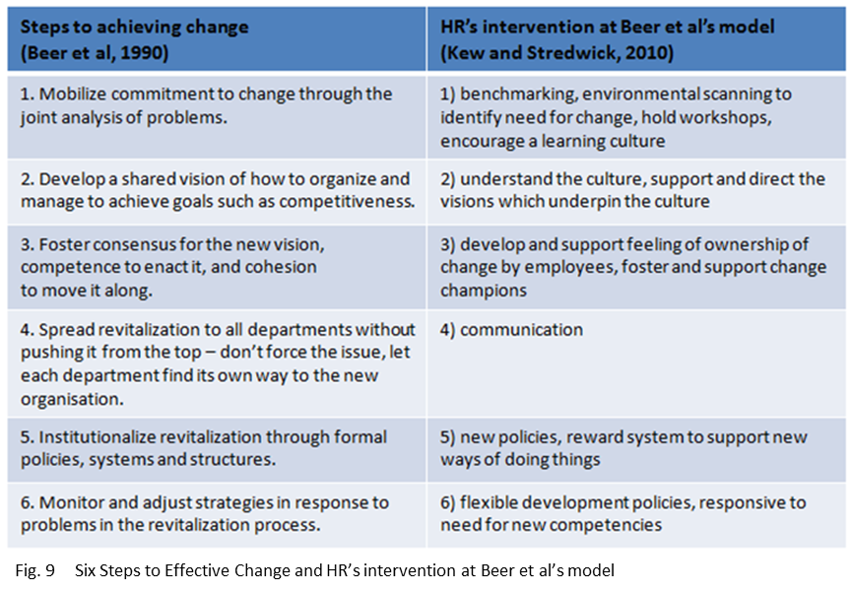

HR has a significant role to play in any change management process, because it concerns both controllable (business processes) and the uncontrollable (people).
The HR contribution to the controllable - The contribution to developing change process may include for instance harmonising short-term goals with strategic needs, but also identifying skills gaps and advising on training and working practices. It is because change often requires adopting new behaviours and acquiring different skills, and HR can organise the learning and development programmes required to do this (Wilkinson & Taylor, 2016).
The HR contribution to the uncontrollable - HR can deal with uncontrollable by being aware of potential reactions to change and offering faster and more efficient response as a result (Wilkinson & Taylor, 2016). Kübler-Ross (1973) defined a psychological process by which humans respond to change. Its redefined model popularly referred to as ‘The DREC Cycle’ (Fig.10), explains a four-step process for adopting new patterns of behaviour or working practices: denial, resistance, exploration, commitment (Platt, 2015).
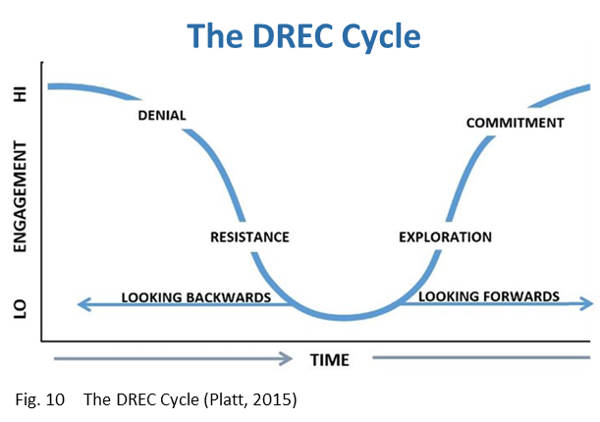
When managing uncontrollable, in addition to management of expectation and conflict, HR should focus on appropriate communication and creating change-ready culture to ensure employees participation in change. A clear vision of future will lead to less confusion and less resistance. The understanding of existing culture can be achieved by interviews, focus groups or satisfaction surveys (Wilkinson & Taylor, 2016).

7. The use of business and contextual data

7.1 Internal Information
There are several different sources of business and contextual data that can be assessed and utilised for planning purposes. Internal information is the one most frequently used. It involves an analysis of quantitative and qualitative HR data ranging from head count and costs to information about culture. Well-designed HR plan highlights head count changes that flow from the business strategy, cover the practicalities of staff supply and demand, and organisational development techniques. However, it should also address measures such as return on investment, increase in sales, and improvements to productivity (PersonnelToday, 2002).
7.2 Industry Information
The employees are the most valuable asset for any organisation and therefore it is very important for HR to develop strategies that improve their experience and engagement. The understanding of industry helps to identify areas of weaknesses, areas that need improvements, training needs and employee satisfaction levels as well as current industry trends (Bhatia, 2017).

7.3 Competitive Information
Gathering and analysing information about competitors’ activities and business trends allows to further organisation’s goals. Firstly, it helps to anticipate events that impact HR by providing insight into competitors’ strategic HR decisions. Secondly, the decisions made with competitive information can positively impact company’s competitive advantage. For instance, gaining knowledge of innovative HR tools and practices used by competition allows developing a counter-strategy. Finally, competitive information helps to identify and track new competitors (Gill, 2003).

7.4 Government Information
Governments Information provides countless opportunities for economic, political, scientific, and social initiatives and innovation (Janssen, et al., 2017). Many governments around the world are increasingly committing to make their vast reams of data both accessible and usable. UK government continue to lead the way, with others keen to follow suit (Beardmore, 2017).

8. Conclusion

HRM evolved from industrial welfare and the HR models changed and advanced. Today, the HR component of the organisation is thought about as a strategic contributor to business success. The aim is to achieve a clear line of sight between recruiting the talent, the organisational culture, capability and the stakeholder value (Ulrich, et al., 2017).
The best deployment and management of the human capital depends on effective integration of HR strategies into the business strategy. This paper assessed the factors which impact on an organisation’s business and its HR function, and provided the tools for analysing the business environment.
The role of HR in strategy formulation and business planning has is critical and the number of different sources of business and contextual data can be utilised for planning purposes.
Finally, when setting up HR agenda, the organisation should always take into account the ethical considerations. Corporate codes of ethics and professional codes of conduct can provide framework to determine what is important to consider (Biech, 2007).

References

Armstrong, M., 2016. Armstrong's Handbook of Strategic Human Resource Management. 6 ed. Philadelphia: Kogan-Page.
Armstrong, M. & Sappington, D., 2006. Regulation, Competition and Liberalization. Journal of Economic Literature, 154(6), pp. 325-366.
Beardmore, D., 2017. The value of open data for the private sector. [Online]
Available at: https://theodi.org/blog/the-value-of-open-data-for-the-private-sector
[Accessed 27 12 2017].
Beer, M., Eisenstat, R. & Spector, B., 1990. Why change programs don’t produce change. Harvard Business Review, 68(6), pp. 158-166.
Benjamin, T., 2017. External & Internal Environmental Factors Influencing HR Activities. [Online]
Available at: http://smallbusiness.chron.com/external-internal-environmental-factors-influencing-hr-activities-34745.html
[Accessed 22 12 2017].
Bhatia, T., 2017. HR Statistics For Human Resource Management. [Online]
Available at: https://empxtrack.com/blog/statistics-for-human-resource-management/
[Accessed 20 12 2017].
Biech, E., 2007. Thriving Through Change: A Leader's Practical Guide to Change Mastery. 1 ed. Danvers: ASTD Press.
Biro, M., 2017. The Impact of Technology on HR and What’s Ahead. [Online]
Available at: https://www.huffingtonpost.com/meghan-m-biro-/the-impact-of-technology-_1_b_9294208.html
[Accessed 21 12 2017].
Boselie, P., 2015. Covering all the bases: multi-stakeholder HR. [Online]
Available at: http://www.hrmagazine.co.uk/hr-most-influential/profile/covering-all-the-bases-multi-stakeholder-hr
[Accessed 23 12 2017].
Christie, J., 2009. HR in the future: The impact of technology. [Online]
Available at: https://www.hrzone.com/talent/development/hr-in-the-future-the-impact-of-technology
[Accessed 21 12 2017].
Chryssides, G. & Kaler, J., 1993. An Introduction to Business Ethics. 1 ed. London: Cengage Learning EMEA.
CIPD, 2015a. SWOT analysis. [Online]
Available at: https://www.cipd.co.uk/knowledge/strategy/organisational-development/swot-analysis-factsheet
[Accessed 22 12 2017].
CIPD, 2015b. Ethical decision-making: eight perspectives on workplace dilemmas. [Online]
Available at: https://www.cipd.co.uk/knowledge/culture/ethics/workplace-decisions-report
[Accessed 20 12 2017].
CIPD, 2017a. PESTLE Factsheet. [Online]
Available at: https://www.cipd.co.uk/knowledge/strategy/organisational-development/pestle-analysis-factsheet
[Accessed 23 12 2017].
CIPD, 2017b. Code of Professional Conduct. [Online]
Available at: https://www.cipd.co.uk/about/what-we-do/professional-standards/code
[Accessed 2017].
CIPD, 2017c. Change management. [Online]
Available at: https://www.cipd.co.uk/knowledge/strategy/change/management-factsheet
[Accessed 20 12 2017].
Crane, A., 2016. Business Ethics: Managing Corporate Citizenship and Sustainability in the Age of Globalization. 4 ed. Oxford: Oxford University Press.
David, F., 2009. Strategic Management: Concepts and Cases. 12 ed. New Jersey: Prentice Hall .
ETI, 2017. Ethical Trading Initiative. [Online]
Available at: https://www.ethicaltrade.org/
[Accessed 22 12 2017].
Farnham, D., 2015. Human Resource Management in Context. 4 ed. London: CIPD.
Fermin, J., 2015. How Company Culture Affects Human Resources. [Online]
Available at: https://www.digitalistmag.com/lob/human-resources/2015/06/05/company-culture-affects-human-resources-02840319
[Accessed 21 12 2017].
Foster, S., 2015. The Ulrich Model: 18 years old, but is it working?. [Online]
Available at: https://www.ngahr.com/blog/ulrich-model-18-years-old-it-working
[Accessed 23 12 2017].
Frackleton, E., Girbig, R., Jacquemont, D. & Singh, A., 2014. Guiding the people transformation: The role of HR in lean management. The Lean Management Enterprise, pp. 7-88.
Garavan, T., Wilson, J. & Carbery, R., 2008. Mapping The context and Practice of Training, Development Human Resource Management Practices: A Comprehensive Review and HRD IN European Call Centres. Journal of European industrial Training, 32(8), pp. 612-728.
Gill, E., 2003. Competitive Intelligence From the HR Vantage Point. [Online]
Available at: https://www.ere.net/competitive-intelligence-from-the-hr-vantage-point/
[Accessed 27 12 2017].
Gregory, A., 2017. How to Conduct a SWOT Analysis for Your Small Business. [Online]
Available at: https://www.thebalance.com/swot-analysis-for-small-business-2951706
[Accessed 23 12 2017].
Gupta, A., Govindarajan, V. & Wang, H., 2008. The Quest for Global Dominance: Transforming Global Presence into Global Competitive Advantage. 2 ed. Chichester: John Wiley & Sons.
Gyton, G., 2017. Q&A: Dave Ulrich. [Online]
Available at: http://www2.cipd.co.uk/pm/peoplemanagement/b/weblog/archive/2017/03/28/q-amp-a-dave-ulrich.aspx
[Accessed 23 12 2017].
Janssen, M., Konopnicki, D., Snowdon, J. & Ojo, A., 2017. Driving public sector innovation using big and open linked data (BOLD). Information Systems Frontiers, 19(2), pp. 189-195.
Jurevicius, O., 2013. Strategic Management & Strategic Planning Process. [Online]
Available at: https://www.strategicmanagementinsight.com/topics/strategic-planning-process.html
[Accessed 20 12 2017].
Kane, B. & Palmer, I., 1995. Strategic HRM or Managing the Employment Relationship. International Journal of Manpower, 16(5), pp. 6-21.
Kerin, M., 2015. Understanding the Differences Between Human Resources for Small and Large Companies. [Online]
Available at: https://www.linkedin.com/pulse/understanding-differences-between-human-resources-small-kerin-mba/
[Accessed 21 12 2017].
Kew, J. & Stredwick, J., 2010. Human Resource Management in Context. 3 ed. London: CIPD.
Khatri, N., 1999. Emerging issues in Strategic HRM. Singapore International Journal of Manpower, 20(8), pp. 516-529.
Kumar, V., 2015. The Historical Background Of Human Resource Management. [Online]
Available at: https://www.linkedin.com/pulse/historical-background-human-resource-management-vinaykumar-s
[Accessed 23 12 2017].
Lewin, K., 1947. Frontiers in group dynamics II. Channels of group life; social planning and action research. Human relations, 1(3), pp. 143-153.
M&S, 2016. Marks and Spencer Code of Practice - Ethical Trading. [Online]
Available at: https://corporate.marksandspencer.com/file.axd?pointerid=22e10bb0c7ea4457858fdd030ab6f5d5
[Accessed 11 11 2017].
Mabey, C. & Salaman, G., 1995. Strategic Human Resource Management. 1 ed. Oxford: Wiley-Blackwell.
Marchington, M. & Wilkinson, A., 2008. Human Resource Management at Work: People Management and Development. 4 ed. London: CIPD.
Mello, J., 2006. Strategic Human Resource Management. 2 ed. Ohio: Thompson, South-Western.
Milkovich, G. & Boudreau, J., 1991. Human Resource Management. 6 ed. New York: McGraw-Hill.
Morrison, M., 2010. PRIMO-F Model for Business Development. [Online]
Available at: https://rapidbi.com/primo-f-model-for-business-development/
[Accessed 21 12 2017].
Onsarigo, I., 2016. Factors Affecting Human Resource Practices. [Online]
Available at: https://www.linkedin.com/pulse/factors-affecting-human-resource-practices-isaac-onsarigo/
[Accessed 21 12 2017].
Ozutku, H. & Ozturkler, H., 2009. The Determinants of Human Resource Practices: An Empirical Investigation in the Turkish Manufacturing Industry. Ege Academic Review, 9(1), pp. 73-93.
Parliament, 2017. Living Heritage - Reforming society in the 19th century. [Online]
Available at: http://www.parliament.uk/about/living-heritage/transformingsociety/livinglearning/19thcentury/overview/factoryact/
[Accessed 23 12 2017].
PersonnelToday, 2002. Developing HR strategy: Aligning HR to the business. [Online]
Available at: https://www.personneltoday.com/hr/developing-hr-strategy-aligning-hr-to-the-business/
[Accessed 20 12 2017].
Pfeffer, J., 1994. Competitive advantage through people: unleashing the power of the work force. 18 ed. Boston: Harvard Business School Press.
Platt, G., 2015. 'Why' Should We Manage Change?. [Online]
Available at: https://www.linkedin.com/pulse/why-should-we-manage-change-garry-platt/
[Accessed 20 12 2017].
Porter, M., 1985. The Competitive Advantage: Creating and Sustaining Superior Performance. 1 ed. New York: Free Press.
Quinn, J., 1980. Strategies for Change: Logical Incrementalism. 1 ed. New York: McGraw-Hill.
Richards, L., 2017. Alignment of Strategies. [Online]
Available at: http://smallbusiness.chron.com/alignment-strategies-4649.html
[Accessed 21 12 2017].
Roper, J., 2017. Public vs. private vs. third sector HR: The unique challenges. [Online]
Available at: http://www.hrmagazine.co.uk/article-details/public-vs-private-vs-third-sector-hr-the-unique-challenges
[Accessed 22 12 2017].
Rosman, M., Shah, F., Hussain, J. & Hussain, A., 2013. Factors Affecting the Role of Human Resource Department in Private Healthcare Sector in Pakistan: A Case Study of Rehman Medical Institute (RMI). Research Journal of Recent Studies, 2(1), pp. 84-90.
SHRM, 2017. What's Next - Future Global Trends Affecting Your Organization. [Online]
Available at: http://futurehrtrends.eiu.com/report-2015/challenges-for-human-resource-management-and-global-business-strategy/
[Accessed 23 12 2017].
Tamkin, P., 2005. Measuring the Contribution of Skills to Business Performance - A Summary for Employers. 1 ed. Brighton: Institute for Employment Studies.
Taylor, S. & Wilkinson, K., 2016. Business Issues and the Context of Human Resources. In: S. Taylor & C. Woodhams, eds. Studying Human Resource Managemnet. London: CIPD, pp. 3-66.
Torrington, D., Hall, L. & Taylor, S., 2008. Fundamentals of Human Resource Management : Managing People at Work. 1 ed. Harlow: Pearson Education Limited.
Turner, P., 2002. How to do HR forecasting and planning. [Online]
Available at: http://www2.cipd.co.uk/pm/peoplemanagement/b/weblog/archive/2013/01/29/6487a-2002-03.aspx
[Accessed 20 12 2017].
Ulrich, D., Kryscynski, D., Brockbank, W. & Ulrich, M., 2017. Victory Through Organization: Why the War for Talent is Failing Your Company and What You Can Do About It. 1 ed. New York: McGraw-Hill.
Wan, D., Kok, V. & Ong, C., 2002. Strategic Human Resource Management and Organizational Performance in Singapore. Sage Journals, Volume online.
Wilkinson, K. & Taylor, S., 2016. Managing and Co-ordinating the HR Function. In: S. Taylor & C. Woodhams, eds. Studying Human Resource Management. London: CIPD, pp. 21-41.
Winstanley, D., Woodall, J. & Heery, E., 1996. Business ethics and human resource management: Themes and issues. Personnel Review, 25(6), pp. 5-12.
Zheng, G. & Morrison, M., 2009. Enhancing Chinese SME performance through innovative HR practices. Personnel Review, 38(2), pp. 175-194.

Appendix A

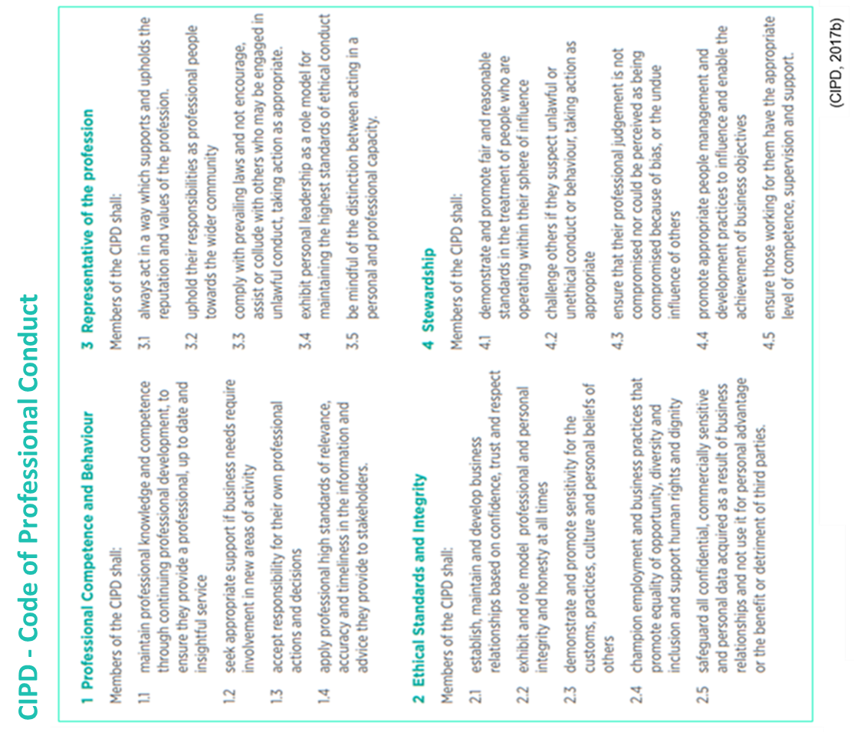

Appendix B


