

LOCATION: Home | LLEOLIAD:
LEVEL 4 | LEFEL 4
EXAMINATION PERIOD | CYFNOD ARHOLIADAU
may 2020 | mai 2020

MODULE CODE: ACDB4002 / ACDA4006
Electrical & Electronic Principles
TIME: 2 HOURS + 30 MINS UPLOAD TIME AND 3o minutes (additional needs)
EXAM: MOCK
RESOURCES: OPEN BOOK

- An oscilloscope display shows the above voltage waveform. The oscilloscope settings are shown in the box next to the waveform.

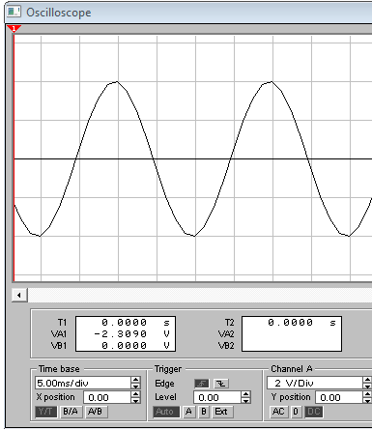
Oscilloscope settings:
5V/div
25ms/div

- Estimate the period of the waveform
100ms = 4 squares 200ms= 8 squares
- From the estimated period, determine its frequency
0.01Hz
- Determine its peak to peak amplitude
4 peak to peak = 4*5 = 20v
- Determine the RMS value of the waveform
10*0.7071=7.071

The discharging equation for a series resistor/capacitor network is given by:
$$V_{C}=V_{0}\left(e^{{-t}/τ}\right)$$
Where V_{c} is the voltage across the capacitor and V₀ is the initial capacitor voltage.
Assuming the following: R = 80k, C = 10µF and V₀ = 10V:
- Calculate V_{c} at time t = 1.6 seconds.
$V_{C}=10\left(e^{-1.6/80,000}\right)$=9.9V

- Sketch a labelled graph that would represent the discharging curve.
?
- What is the stored energy within the capacitor before it is discharged?
½ *c*v² = ½*10uf*12²=7.2x10⁻⁴
- Calculate the time taken for the stored energy within the capacitor to reach 0.1mJ
?

Design a logic circuit to fulfil the behaviour shown in the truth table in Fig Q3
A | B | C | X
0 | 0 | 0 | 1
0 | 0 | 1 | 0
0 | 1 | 0 | 1
0 | 1 | 1 | 1
1 | 0 | 0 | 1
1 | 0 | 1 | 0
1 | 1 | 0 | 0
1 | 1 | 1 | 1

Fig Q3
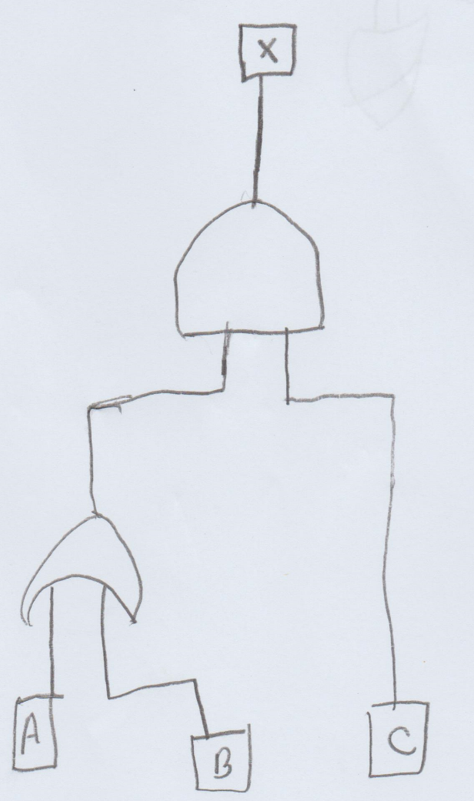
AND GATE, OR GATE

For the circuit shown in Fig Q4. Determine the following:
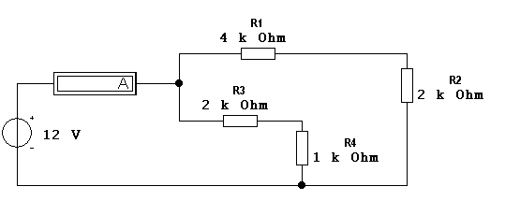
Fig. Q4

  - Total circuit resistance
RA=R1+R2 = 6kohm
RB=R3+R3= 3kohm
1/R_{T} = 1/RA+ 1/RB
1/R_{T} = 1/6k + 1/3k=2kohm

  - Total circuit current
I=V/R =12/2000=6mA

  - Current flowing through R4
I=2k*6mA=12mA

  - Total power delivered by the battery
6167 mAh *12v * 3.6 = 266414.4J
  - Power dissipated by R1

I =V/R= 12/1000=0.012
P = I²*R= 1.44x10⁻⁴*1000=1.44mW

  - R4 is replaced by a wire link. What is the new circuit current?
?

