
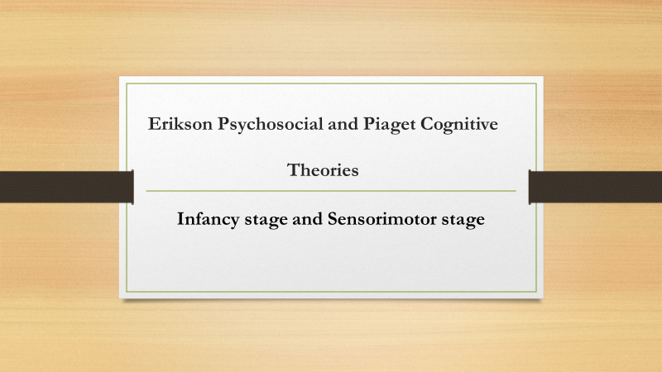

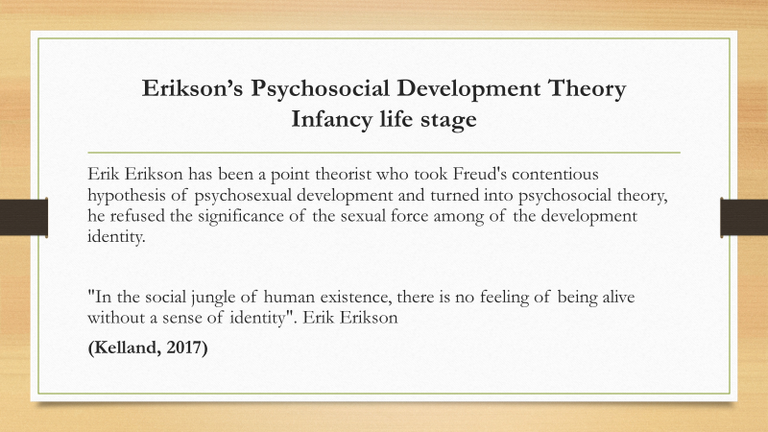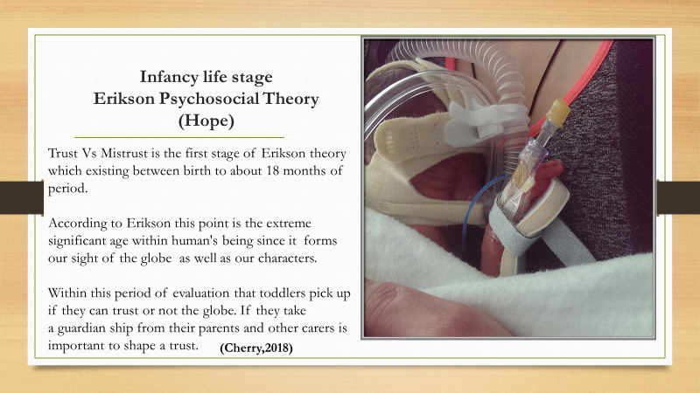

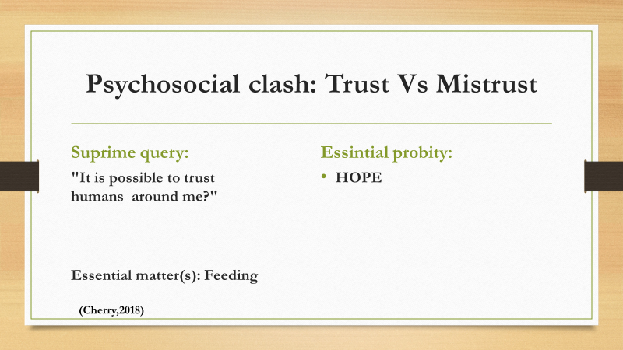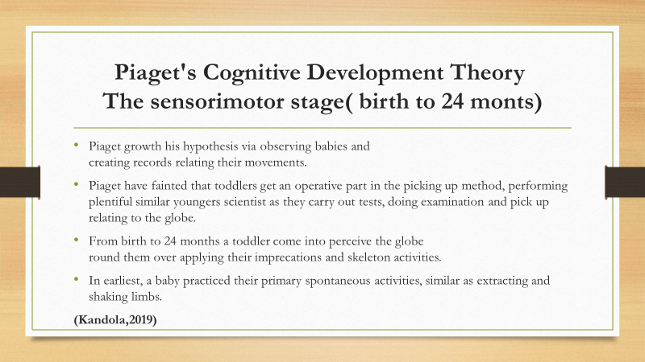
Ì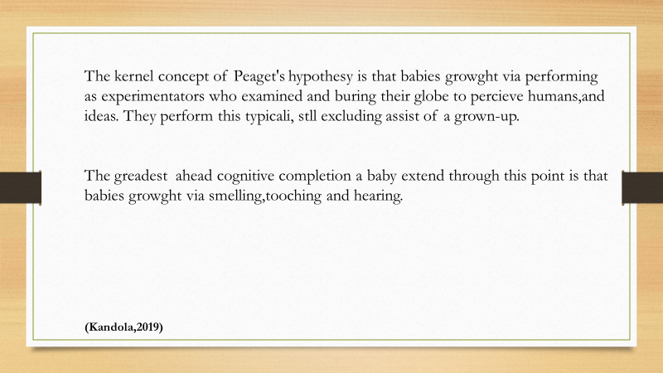
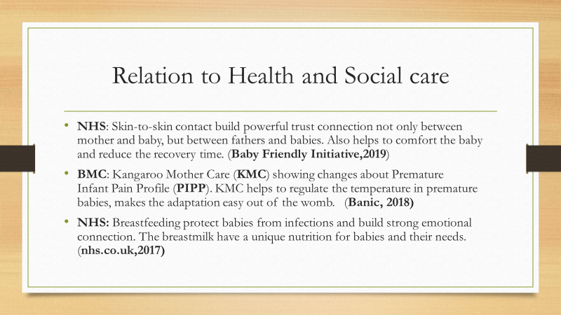

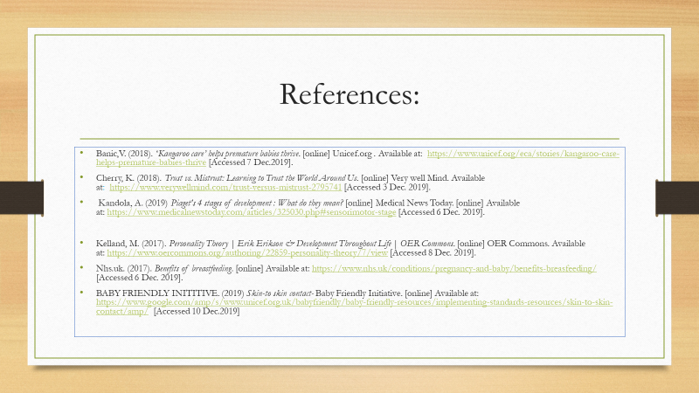
STUDENT NAME: | ANDREA MILEVA
STUDENT ID: | 1812394
MODULE NAME: | BMHP
MODULE ID: | 4003
LECTURER NAME: | DR. GULNAR ALI

Table of Contents
ERIKSON’S THEORY 8
PIAGET’S THEORY: 9
HUMAN COGNITION,EMOTIONS AND BEHAVIOR PATTERNS IDENTIFIELD INFANCY STAGE 10
HOW THIS THEORIES RELATE TO HELATH AND SOCIAL CARE? 11
CONCLUSION 12
REFERENCES 13

ERIKSON’S PSYCHOSOCIAL AND PIAGET’S COGNITIVE
THEORIES
INFANCY STAGE AND SENSORIMOTOR STAGE

ERIKSON’S THEORY: Erik Erikson has been a point theorist who took Freud's contentious hypothesis of psychosexual development and turned into psychosocial theory, he refused the significance of the sexual force among of the development identity. (Kelland,2017)

According to Erikson every person goes throw to 8 crises for whole life. Infancy is the first and most important crisis which every person has goes throw from the beginning of his life. If this crisis is complete by success every next will be successes.

Trust vs. mistrust is that the initial psychological crisis to be resolved by the individual and focuses on age zero to one year recent. This initial stage centres round the infant’s basic desires being met by the oldsters because it depends on them, particularly the mother for food, sustenance, and luxury. The infant’s relative understanding of society comes from the oldsters and their interaction with the kid. If the kid is exposed to heat, regularity, and dependable affectionateness, the infant’s read of the globe are going to be one in all trust. If this does not happen, and therefore the caregivers fail to produce secure surroundings, a way of mistrust can result. Erikson believed the foremost biological process task in infancy to be learning whether or not people, particularly primary caregivers, often satisfy basic desires. If caregivers are consistent sources of food, comfort, and affectionateness, associate degree baby learns trust – that otherward dependable and reliable. If they’re neglectful, or even perhaps abusive, the baby instead learns mistrust – that the globe is in associate degree undependable, unpredictable, and presumably dangerous place.
This early stage in development sets the pace for future ‘victories’ in development across the period of time.
(Cherry,2018)

Trust Vs Mistrust is the first stage of Erikson theory which existing between birth to about 18 months of period.
According to Erikson this point is the extreme significant age within human's being since it forms our sight of the globe as well as our characters.
Whiting this period of evaluation that toddlers pick up if they can trust or not the globe. If they take a guardian ship from their parents and other cares is important to shape a trust. (Cherry,2018)

PIAGET’S THEORY: Piaget growth his hypothesis via observing babies and creating records relating their movements.
Piaget have fainted that toddlers get an operative part in the picking up method, performing plentiful similar youngers scientist as they carry out tests, doing examination and pick up relating to the globe.
From birth to 24 months a toddler come into perceive the globe round them over applying their imprecations and skeleton activities.
In earliest, a baby practiced their primary spontaneous activities, similar as extracting and shaking limbs. The kernel concept of Piaget's hypothesis is that baby’s growth via performing as experimenters who examined and burring their globe to perceive humans, and ideas. They perform this typical, still excluding assist of a grown-up.
The greatest ahead cognitive completion a baby extend through this point is that babies’ growth via smelling, touching and hearing.
(Kandola,2019)

HUMAN COGNITION, EMOTIONS AND BEHAVIOR PATTERNS IDENTIFIELD INFANCY STAGE

Infancy could be a vital biological process amount involving institution of the neurologic underpinnings of psychological, affectional and relative functioning. the mixing of findings from biological process and attachment theories and neurodevelopment has contributed to bigger understanding of the importance of early relationships and therefore the biological process impact of reciprocal disturbance.

The babe brain develops inside associate degree social context, wherever structural and practical networks area unit formed by the character and quality of early caregiver–infant interactions. This ‘experience-dependent’ nature of brain development has systematically been illustrated in studies of teams of youngsters United Nations agency were exposed to early aberrant, caregiving environments. for example, early disruptions to early caregiver–child relationships are found to end in alterations of specific brain regions concerned in emotional regulation.

(SIVARATMEN AND KOMITRI,2015)

HOW THIS THEORIES RELATE TO HELATH AND SOCIAL CARE?

SKIN-TO-SKIN CONTACT: According to research of Baby Friendly Initiative (2019), this contact is extremely important for building a powerful trust connection between mother and baby. When a mother holds her baby in skin to skin contact once birth it initiates sturdy self-generated behaviors in each. The mother can expertise a surge of material hormones and start to smell, stroke and have interaction together with her baby.
Skin-to-skin it helps both mother and babies to feel less pain.
This contact in Neonatology is called Kangaroo Care which is important act for premature babies. The Kangaroo Care have many benefits to preterm babies such as easy temperature regulation, less amount of O2 also helps with the easy adaptation out of womb.
Kangaroo care can be given by the fathers. (Baby Friendly Initiative,2019)

BREASTFEEDING: The researches found that the breast milk is unique and design to meet the baby needs of nutrition.
The breastmilk helps with prevents of infections, less pain, also have enough vitamins and minerals.
During the breastfeeding mother and babies built physical and emotional connection.
(Nhs.uk,2017)

PEDIATRIC PFYSIOTHERAPY: A primary goal of early intervention is to advance psychological feature and readiness to find out for infants and youngsters with special wants. Achieving this goal needs associate through empirical observation supported model for the way these skills emerge. within the twentieth century, psychological feature was preponderantly viewed as a method occurring severally of the body, surroundings, and others.8Perceptualdata served as input and behaviour resulted as output from a psychological feature system that was separate and unaffected by perceptual-motor expertise.
(ZENG et al,2017)

CONCLUSION:
In both theories the first stage is important to build behaviour and characters in every human. If the human built strong trust connection between parent and carers, he or she will be built social connections when growth up.
For people who will work with children in future Erikson theory will help to understand why some child have strong emotional connection with mothers than the fathers or to grand parent than the parents.

REFERENCES:
- BABY FRIENDLY INITITIVE. (2019) Skin-to skin contact- Baby Friendly Initiative. [online] Available at: https://www.google.com/amp/s/www.unicef.org.uk/babyfriendly/baby-friendly-resources/implementing-standards-resources/skin-to-skin-contact/amp/ [Accessed 10 Dec.2019]

- Cherry, K. (2018). Trust vs. Mistrust: Learning to Trust the World Around Us. [online] Very well Mind. Available at: https://www.verywellmind.com/trust-versus-mistrust-2795741 [Accessed 3 Dec. 2019].
- Kandola, A. (2019) Piaget's 4 stages of development : What do they mean? [online] Medical News Today. [online] Available at: https://www.medicalnewstoday.com/articles/325030.php#sensorimotor-stage [Accessed 6 Dec. 2019].
- Kelland, M. (2017). Personality Theory | Erik Erikson & Development Throughout Life | OER Commons. [online] OER Commons. Available at: https://www.eorcommons.org/authoring/22859-personality-theory/7/view [Accessed 8 Dec. 2019].
- Nhs.uk. (2017). Benefits of breastfeeding. [online] Available at: https://www.nhs.uk/conditions/pregnancy-and-baby/benefits-breastfeeding/ [Accessed 6 Dec. 2019].
- Sivaratnam, C. and Komitri, A. (2015) Attachment and early brain development-neuroprotective interventions in infant-caregiver therapy. [Online] Taylor and Francis. Available at: https://www.tandfonline.com/doi/full/10.3402/tdp.v3.28647 [Accessed 17 Dec. 2019]

Zeng, N., Ayyub, M., Sun, H., Wen, X., Xiang. P. and Gao, Z. (2017) Effect of Physical Activity and Cognitive Development in Early Childhood: A Systematic Review. BioMed Research international,2017, pp.1-13.

