Leadership, Management Theory and Practice (LCBB6003)  Leadership, Management Theory and Practice  (LCBB6003)  INDIVIDUAL REPORT | 

Anca Mirela Dula 2112863
University of Wales trinity saint David
Lecturer: Dr. Laila Maazous

Lesson Learned Report: Leadership Lessons from Four Business Leaders

By examining the traits and methodologies of esteemed corporate figures like Samuel Walton, Henry Ford, Steve Jobs, and Indra Nooyi, several essential leadership lessons become apparent. These people have made lasting impressions on their specific fields and have become iconic characters in the domain of leadership. By conducting a comprehensive analysis of their characteristics, tactics, and methods, I have obtained valuable knowledge on successful leadership, using pertinent ideas, concepts, and models.


Visionary Leaderships
There are several traits that are shared by all four of the leaders, and one of those features is the visionary approach that each of them takes. If we take Steve Jobs as an example, he is well-known for his ability to think of products that buyers did not even understand they wanted. According to the concept of transformational leadership, which puts a focus on the practitioner's ability to articulate a compelling vision and encourage followers to work towards reaching that objective, this is congruent with the philosophy. The uncompromising drive to excellence that Jobs displayed, together with his persistent pursuit of innovation, exemplifies the value of visionary leadership in the process of driving the success of an organisation. (Bass, 1895).

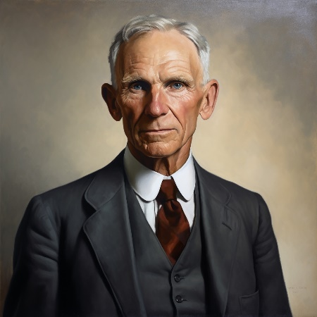

Adaptability and Innovation

Through the implementation of his revolutionary assembly line manufacturing technique, Henry Ford brought about a revolution in the automobile industry. The very definition of adaptive leadership is shown by his capacity to adjust to shifting market conditions and to pioneer innovative production practices. To successfully navigate complicated corporate situations, it is essential to be flexible and forward-thinking. Ford's willingness to reject traditional wisdom and embrace innovation exemplifies this significance (Heifetz & Laurie, 1997).
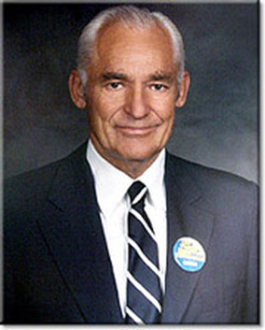

Empowering Others
Samuel Walton's approach to leadership was distinguished by the fact that he placed a strong focus on staff empowerment and the cultivation of a culture that encouraged cooperation. The practice of Walton, which involves requesting input from frontline workers and incorporating them in decision-making processes, is consistent with the concepts of servant leadership, which place an emphasis on the well-being and growth of employees. A workforce that is motivated, engaged, and capable of driving organisational success may be cultivated by leaders who demonstrate the ability to empower others and inspire a sense of ownership in their employees (Greenleaf, 1970).


Strategic Acumen
Indra Nooyi's stint as CEO of PepsiCo was distinguished by her great commercial acumen and strategic vision while her tenure. A strategic leadership strategy that is geared at long-term sustainability is seen in Nooyi's emphasis on diversification and development into healthier product categories. This demonstrates the significance of strategic thinking in generating organisational development and competitiveness, as shown by Nooyi's ability to forecast market trends, capitalise on new opportunities, and traverse complex global difficulties (Nohria & Khurana, 2010).

Conclusion
In conclusion, the analysis of the leadership qualities shown by notable figures such as Samuel Walton, Henry Ford, Steve Jobs, and Indra Nooyi has yielded a wealth of information that is very helpful in understanding the fundamentals of successful leadership. Every leader embodies important ideas and practices that are essential to the success of an organisation. These include the capacity to empower others, flexibility, visionary leadership, and strategic acumen. I have obtained a greater grasp of the complex nature of leadership and its transforming influence on people, organisations, and society by applying pertinent theories, ideas, and models of leadership. This has allowed me to get some insight into the nature of leadership.

References

Bass, B. (1998). Transformational Leadership: Industrial, Military, and Educational Impact. 1 ed. New York: Sage Publication.
Hobson, N. (2023). Steve Jobs Said What Separates a Leader From a Follower Really Comes Down to This Mindset. [Online] Available at: https://www.inc.com/nick-hobson/steve-jobs-said-what-separates-a-leader-from-a-follower-really-comes-down-to-this-mindset.html[Accessed 26 03 2024].
Isaacson, W. (2012). The Real Leadership Lessons of Steve Jobs. [Online] Available at: https://hbr.org/2012/04/the-real-leadership-lessons-of-steve-jobs[Accessed 26 03 2024].
Levy, S. (2024). Steave Jobs- American Businessman. [Online] Available at:https://www.britannica.com/biography/Steve-Jobs[Accessed 26 03 2024].
Ziegler, J. A. (2014). “Transformational Leader”:. Journal of Leadership Education , 13(2), pp. 54-57.
Bass, B. M. (1985). Leadership and performance beyond expectations. Free Press.
Greenleaf, R. K. (1970). The servant as leader. Robert K. Greenleaf Center.
Heifetz, R. A., & Laurie, D. L. (1997). The work of leadership. Harvard Business Review, 75(1), 124-134.
Nohria, N., & Khurana, R. (2010). Handbook of leadership theory and practice. Harvard Business Press.

