
Skills for the Workplace
Module Assignment Submission
Student Name: | AYODEJI MATHEW AJIBOYE
Student Number: | 1813316
Module No: | BMSK4005_LON
Module Title: | PROFESSIONAL CAREER DEVELOPMENT
Lecturer: | ANUPAM MAZUMDAR

Table of Contents

Introduction................................................................................1
Personal lifeline journey.............................................................2
Skills and knowledge contributing to working effectively...........3
Self-Motivation Review ..............................................................4
Self-Motivation quiz....................................................................5
Learning Styles.............................................................................6
Personal development plan.........................................................7
My career ambition and aspirations...........................................8
Review of my understanding and Expectations of world of
Employment ...............................................................................9
Action plan...................................................................................10
Conclusion....................................................................................11
References.....................................................................................12

- Introduction

A journey of a million miles has to begin with a step. Our experiences from the beginning of our life journey has made us who we are today and our reflection from these past experiences will continue to influence us through the future.
There are skills and knowledge that contribute towards working effectively, some of these skills and knowledge are developed throughout our life progression, it is obvious that the labour market is highly competitive, Employers are looking to employ individuals with special Employability skills to enhance the growth if their organizations. Therefore, an employee must be able to demonstrate ranges of employability skills.
Getting ready for employment requires a good plan, which involves our experiences acquired through our lifeline, learning from our past mistakes and a vision of what we want to become and how to work hard to achieve that, by building a strong self-motivation habits, identifying our strength and a weakness. Your strength defines what you can do, which enables you to create ways to develop yourself towards your goals. This writing contains portfolios of evidence that shows how my experiences from my birth has shaped me towards achieving my career goals.

Personal lifeline Journey

My life journey began in 1981, when I was born. My Dad was a chartered accountant and my mum was a business woman who was into buying and selling of readymade clothes. Both my dad and my mum had impacted in my life in other for me to get to where I am today.
When I was 7 years old, every time we were on holiday at school, I was following my mum to her shop where she was selling clothes. Because I was always with my mum in the shop, watching every market strategy she was using to sell her markets, I became very interested in business, this even made me thought then that opening my own business would be one of the careers I would like to ventured into. I became very confident that I was even attending to customers. Having the opportunity to speak to different types of customers made it look like I was in control and even jokingly, my people had branded me the manager of my mum’ business. But my Dad who was an accountant was very good at mathematics, would make me study every day and most time Mathematics. He used to teach and revise with me every night before any of my exam days. I became very good at Math’s and this prompted me to study courses that involves calculations at the university.
I loved to play football, at 15 years old, because I have gained so much confidence and had the attribute of managing people, this brought out the leadership ability in me and this made me to be appointed as the captain of my football team. And I was also appointed as the school head prefects at 17 years old. I passed my Senior school living certificate exam at 19 years old and gained admission into the university to study physic and electronics. My first job was as an apprentice during my university years at electronics shop, where I was working within a group of individuals as a team to repair broken electronics. At 20 years my dad lost his job, things became very difficult for the family and we had to rely my mum's business to survive. This created lots of pressure on my mum as result of too much thinking, she developed a high blood pressure and she became ill. Her illness became on and off.
I was 23years old when I lost my mum to the illness, it was a devastating year for me. This lost propelled me to have my own business like my mum. In 2005 at 24years, I had my own game shop Business with the help of my dad. At 25years i graduated from the university with a degree in physics and electronics. I was supposed to go for national youth service at 26years but my name was not shortlisted. This was a turned down for me because all my graduate’s mates went for the service that year. I went for a compulsory national youth service corps in 2008 at 27years which lasted for 1 year.
At 32years, my dad sponsored my traveling to United Kingdom, in United Kingdom, I registered with a cleaning agency called Atom in 2012, and I started working for a cleaning company known as ISS cleaning facility company. At 33years I met my wife and got married. During this year I became a permanent staff of ISS and I was promoted to a position of a team leader. At 37 years, I had my baby boy. During this year ISS lost the contract to another company called ABM, and all the staffs were tupe over to ABM. I still remained the team leader with the new contractor until my supervisor has to step down due to personal reasons and I was appointed as the supervisor by the company.
I was an ordinary cleaning operative, but my qualities and skills took me from being an operative, to a team leader and finally to a position of a supervisor. My career goal is to be a manger, an while I was deliberating on what to do to achieve my goal, I met a coworker who happened to be a student of University of Wales trinity saint David. He spoke to me about this course, Higher certificate in skills in workplace, which I found to be very useful in other to achieve my career goals. I went online and applied and I was shortlisted for an interview, which I was lucky to be the only among group to be admitted. Bellow is my lifeline journey diagram.
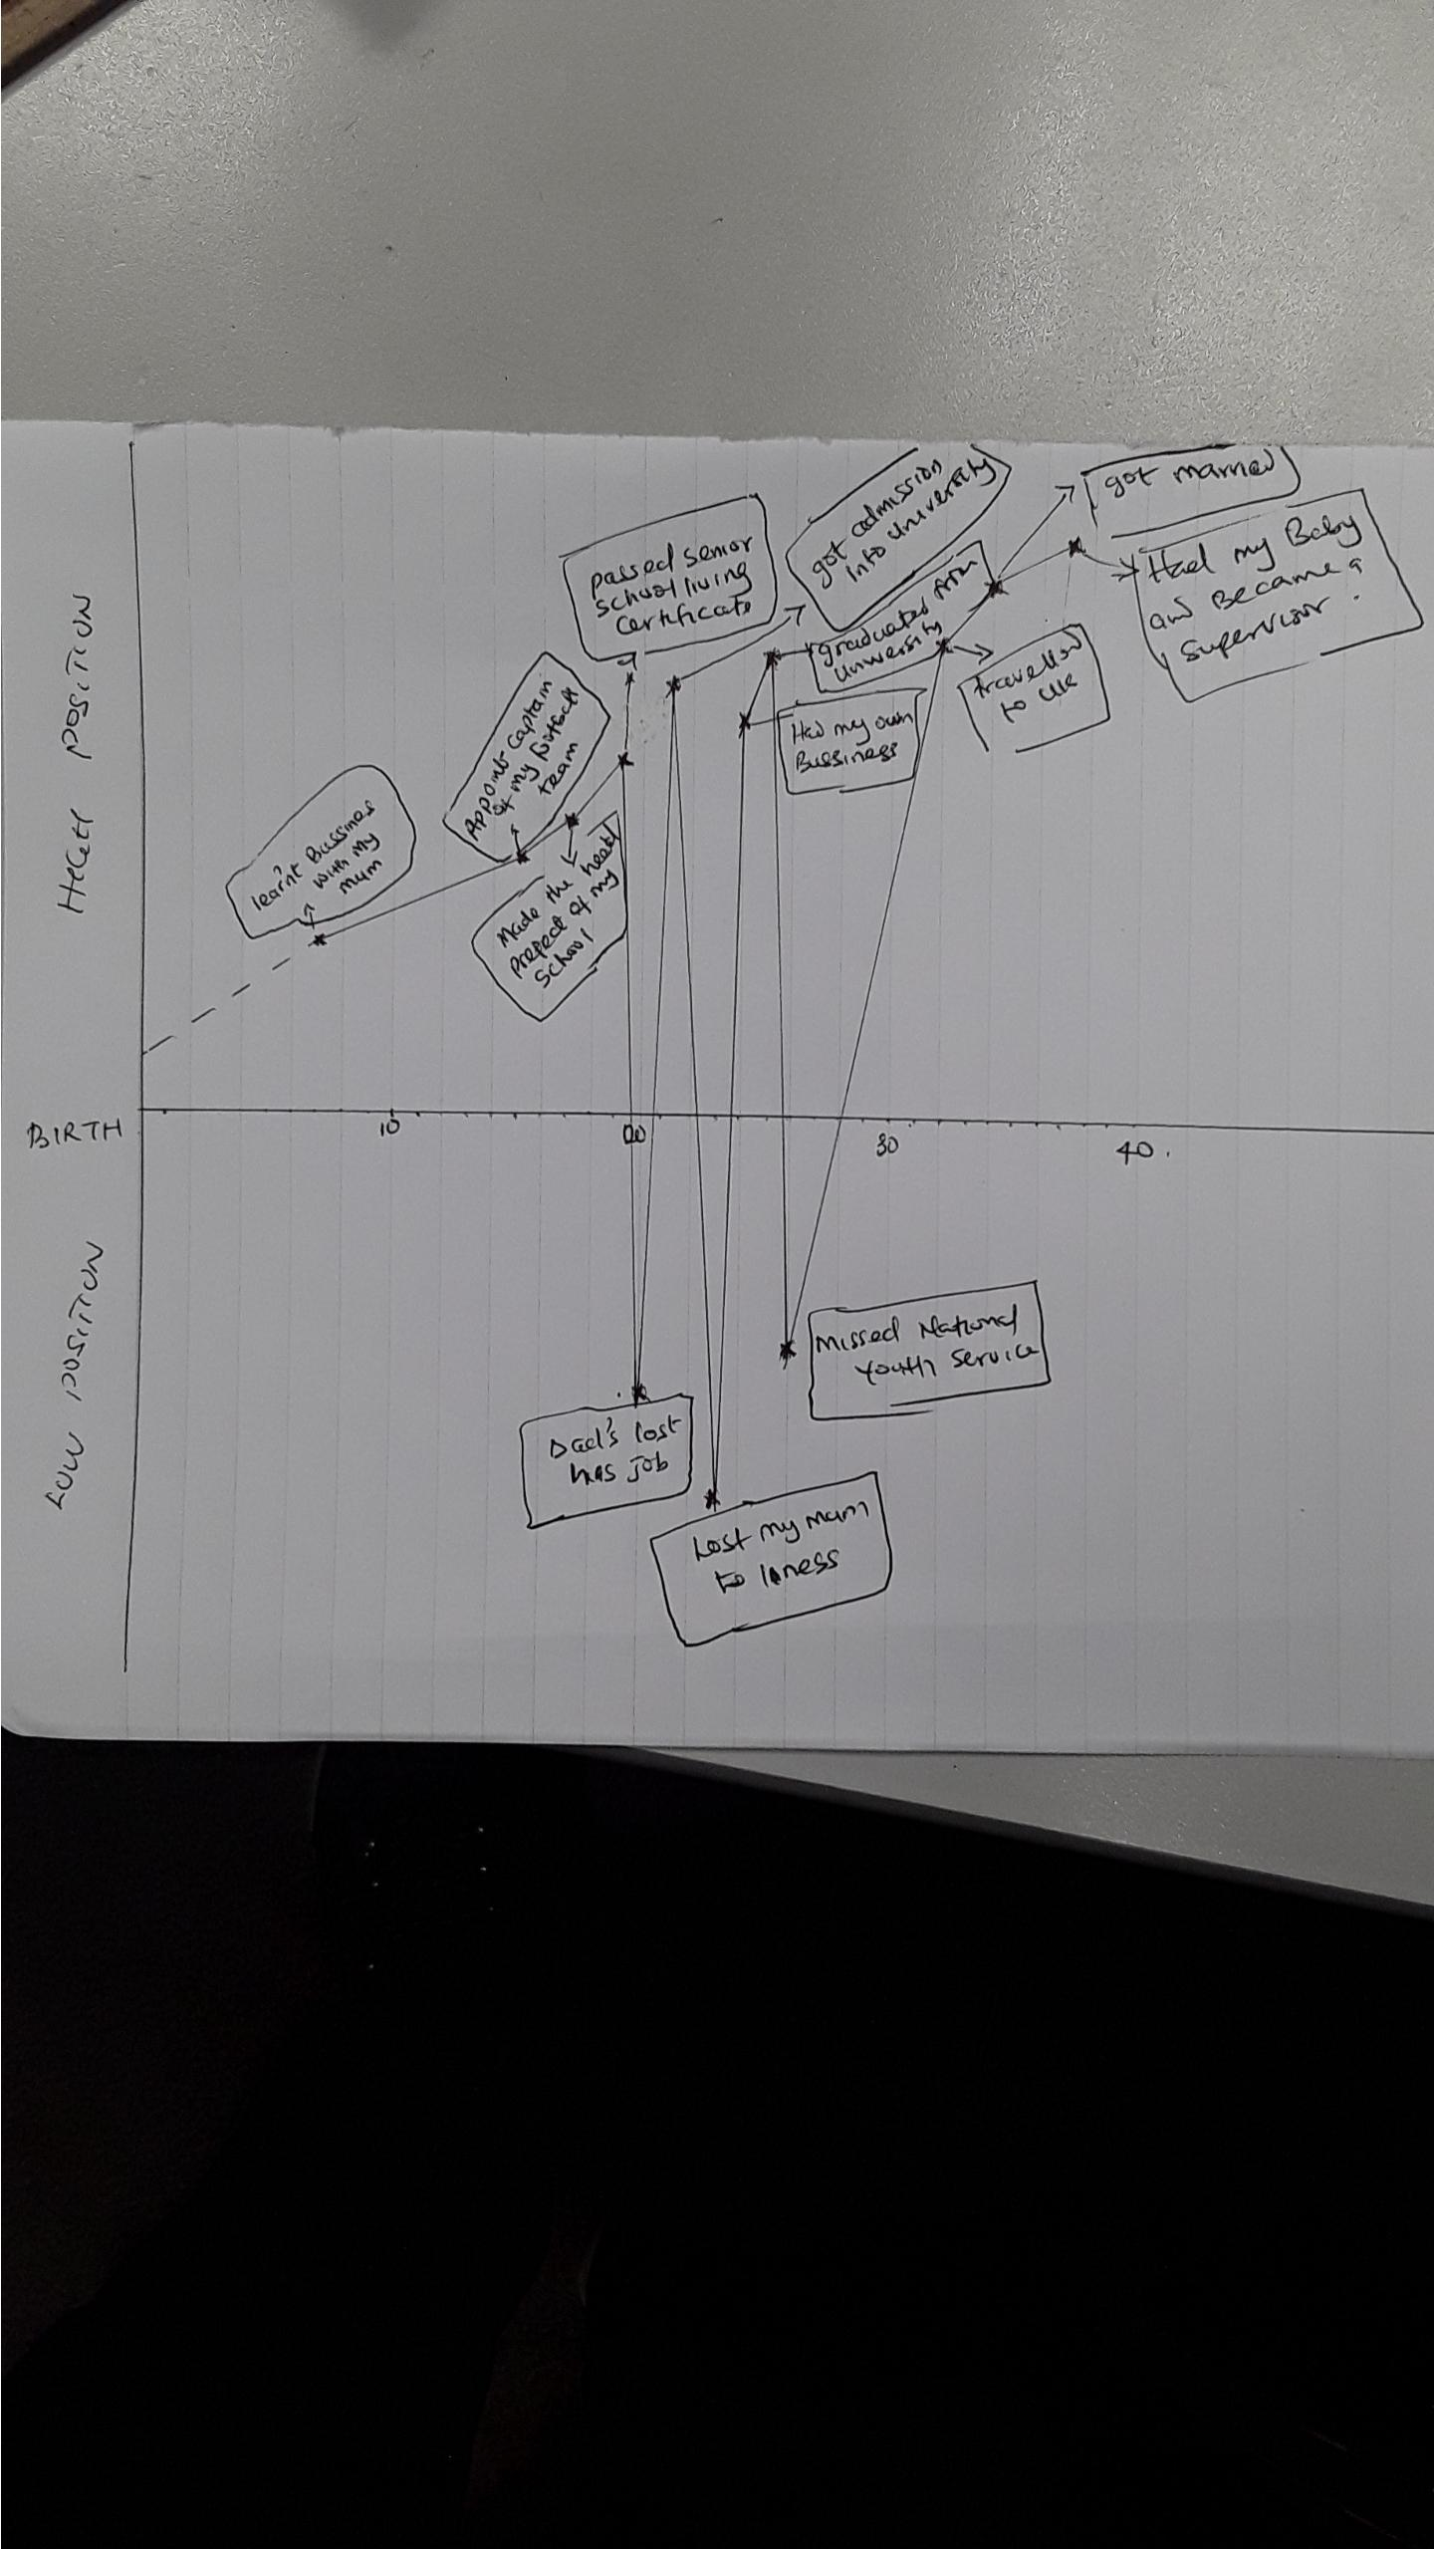

3. Skills and knowledge contributing to working effectively

“The main barriers to higher Education graduates in entering the world of work are the gap between the graduate’s job skills and the skills needed in the workplace” (Suarta et al., 2017).
This skill can be defined as the transferable skills needed by an individual to make them employable. But it is very important that individuals should develop and improve in their skills throughout their working life in other to be able to maintain working effectively. Working effectively depends on individual’s knowledge, skills and attitude. This skills and knowledge equip individuals to carry out their roles effectively to the best of their ability. These important and highly sorted skills are:
- Communication skills: This is a very important skills needed within the workplace. “For example; oral communication and interpersonal skills are often cited as the most important criteria in evaluating job candidates” (Maud, Schriek & Tinker,2017). According to Morgan (2017), “Unless we are brand-new manager taking over a local business or a new student who has just enrolled on a course, most communication will take place in the context of relationship which already exist”. “Communication happens every day in the workplace, such as manager give direction to workers, co-workers communicate to plan a project and employee communicating information to customers” (Suarta et al., 2017). When working within a team setting, to maximize productivity, good communication skills contributes to working effectively. “This is because Tasks are accomplished and relationship managed through interpersonal interaction” (Maud, (Schriek & Tinker, (2017). This skill is required to pass and receive information and also acting upon key information and instruction at work. It gives you the ability to explain what you mean in a clear and concise way through written and spoken means. Your communication skills make you to relate and listen to other people which enhance working effectively.
- Team working: In every organisation, employees are required to work within a team, to save time and also to promote sharing of ideas and vision to promote the organisation. A team is a number of individuals working as one to achieve a particular goal to which they all mutually committed Morgan (2017). But these individuals are of different backgrounds, different disciplines and expertise. According to Maud, Schriek & Tinker (2017), “the few meetings in the life of a team strongly influence its ongoing structure, so planning how to launch a project and how to conduct those first few meetings is an important consideration in developing a effective and efficient team structure”. A good team working skills helps you to work with other people from different backgrounds and disciplines, sharing vision and ideas. Team member must be flexible enough to adapt to cooperative working environment where goals are achieved through collaboration and respect with another team member (Suarta et al., 2017).
- Leadership skills: Individuals should be able to lead when appropriate. Leadership skills is highly sorted Employability skills by organisations. A leader is a good organiser of a team this skill is used to facilitate innovative team work in catalysing the transformation of the organisation. Leadership skills involves speaking for people, judging risk, innovating and contributing to the whole organisation.
- Time management skills: Time management is the ability to, manage and use your time effectively. According to Kapur (2018) “time management is considered to be a skill that whole be mastered by all individuals at all level and in all walk of life”. In every organisation, employees can be given multiple tasks which has to be completed within a time frame. It is important to have this skill to be able to organise tasks in order of urgency and important. “An individual should organise all his tasks and duties in accordance with timing; when an individual, no matter what age group he is, no matter what job he is engaged into implement all his functions in accordance with time that makes him more discipline and well organised” kapur (2018).
Within the workplace, time, management skills help you to complete tasks in timely manner without the need of rushing to meet deadline and feeling under pressure.

4 Self-Motivation Review

“Motivation is a theoretical concept utilized to clarify human behaviour” (Gapalan et., (2017). It is the drive that pushes us towards our goals. The ability to push yourself towards achieving your goals is called self-motivation. People with self-motivation can find a reason and strength to complete a task even when challenging, without giving up or needing another person to encourage them.
Aiming towards your career goals, you will need a self-motivation. Focus and hard work are very essential for achieving your career goal. I have self-motivated myself by believing in my abilities, to push on during difficult times, when I was young, I remember using self-motivation to push myself so hard into saving as much as little for my pocket money given to me to eat to be able to buy a video game. Working towards my career goals, am using some self-evaluation techniques to analyse my skills and ability to enable be achieve my career aim.

Self-Motivation quiz

I have used a self-motivation quiz to determine my level of motivation towards my goals. My score was wonderful, it really showed how determined I am to achieving my goals . Having self-confidence positive thinking and focus are drives behind my motivation. Bellow is the result of my self motivating quiz.
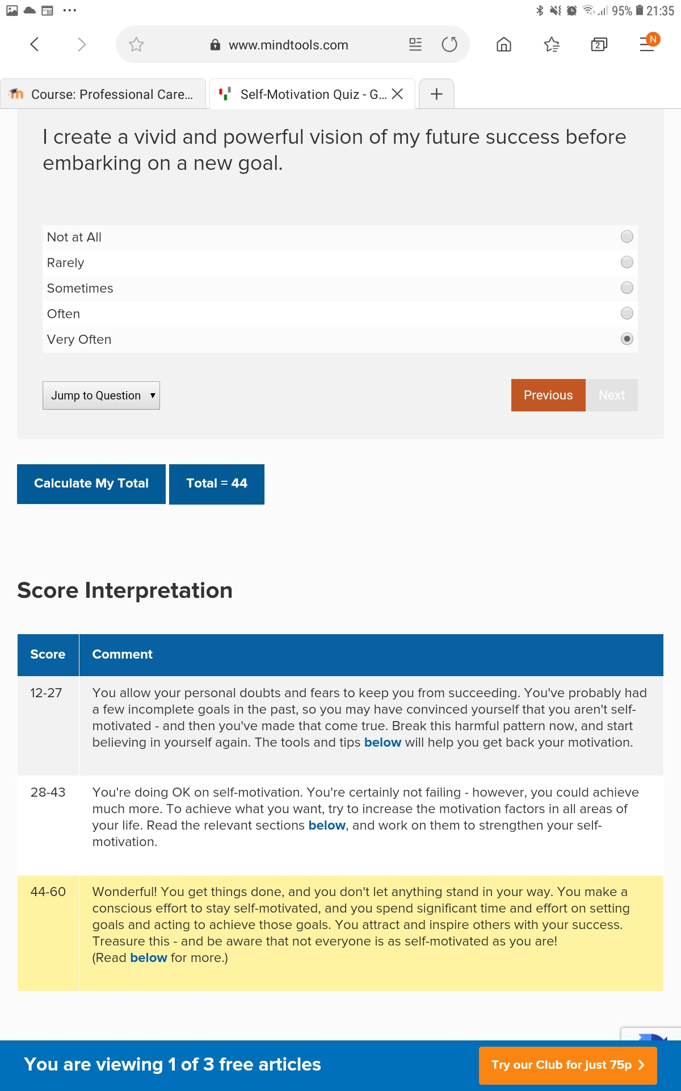

Learning Styles

VAK learning styles : People can be classified into one of three preferred learning styles . Bellow are the three categories of leaning styles .
Visual leaner: this is when people learn by visualising things. They people with “show men type of learning . By seeing or observing things. Things like pictures .
Auditory leaner: this learning style involves learning through listening. This are “tell me” style of learning.
Kinaesthetic leaner: This is a learning style through moving, doing and touching.
To be able to ascertain my preferred learning style, i have used VAK Learning Style Self Assessment Questionnaire, which contains questions and answer that most represent how i generally behave. The result below shows the outcome of my test.
VISUAL = 13
AUDITORY = 8
KINESTHETIC = 9
With this result it confirmed that I am visual learner . I like visualising things in other for me to understand. Sometime I like to analyse things by drawing them down for better understanding.
Kolb learning Styles: This learning styles is based on your concrete experience on a particular situation, observation and reflection on your experience, formation of abstract concept based on the reflections and also testing the new concept followed by repetition of these four steps. Kolb four types of learning Styles.
- Diverging
- Assimilating
- Converging
- Accommodating.
Each of this learning styles is made up of at least two of the below components.
Concrete Experimentation (CE): This is the beginning of learning how to do something, making some researches, expecting feedback and prone to mistakes
Reflective Observation (RO): When you reflect on the process, when you ask yourself questions like what’s the end result? what’s the reaction of others, is the process or concept clear in your mind?
Abstract Conceptualization (AC): This is when you can analyse and decide on what you like or dislike about the process. What can be changed and what other method can you use.
Active Experimentation (AE): This when you do everything in a new way, with a desire to try the process again and come out with a better result

- Diverging learning style: consist of concrete Experimentation and Reflective Observation.
People with the learning style views situations in different
perspective, they are group orientated as well feeling oriented and also care about diverse culture.

- Assimilating learning Styles: Combination of Abstract conceptualization and reflective Observation.
People with tis learning style tend to perform their own research, likes to work by themselves. Prefers reason and logic over working in groups.

- Converging learning style: Consists of combination of Abstracts Conceptualization and Active Experimentation.
This people are ideal problem solver, enjoy decision making process and making decision. They Al’s prefer technical problem and tend to work alone.

- Accommodating learning style : Consist of Concrete Experimentation and active Experimentation.
People with this learning style are good at trial and error problem, they are very comfortable around people, they use intuition to solve problems and they are very adaptable. Using Kolb’s learning Styles, I am able to establish that I belong to Accommodating learning style group. I like to listen to people’s ideas even though I have my and I always like to build on people already made ideas to make them perfect .

Personal development plan.

Swot Analysis
This is a self-assessment technique to determine my strength, weaknesses, opportunities and threats in other to achieve my career goals.
STRENTH: My strength is my ability to adapt and integrate in any environment or condition that I find myself. Moving to multicultural environment like United Kingdom, and studying at the u university of Wales trinity saint David among students from different part of the world, am able to integrate and learnt so ma y things quickly. This ability will help me in my career development. Labour market comprise of people from different part of the world, organisations employ individuals from different backgrounds and disciplines, therefore my quick adaptation and integrating ability is an advantage. Secondly, my leadership skills, my ability to lead others looks like I was born with it, right from my young age I have been a leader, from being the captain of my school football team, to being the team leader in my place of work. During my first and second term group presentation, I was the group leader of my team. This skill gives me an advantage because of its importance in any managerial career. Finally, my quick-thinking skills, my ability to think my way out of any difficult situation is one of my strength toward my career.
WEAKNESSES: My first weakness is time management. A good manager needs to be able manage his time well. My in ability to manage my time effectively is my biggest weakness. I have so many times found myself under pressure and running against time to be able to meet up with deadline to finish a task. My second weakness is my poor listening skills am not a good listener. In other to communicate effectively, you need to be able to listen to others.
OPPORTUNITIES: My access to student loan is a big opportunity for me. Am able to study and acquire skills and knowledge to propel me towards achieving my career goals without any financial obstacles.
THREAT: Studying and working at the same is very difficult. Sometimes all this had to be done together while also taking care of my family. My work schedule is really affecting my ability to study effectively. My working time has taken almost all the time I need to study and revise my class work. The school times table changes every time, this is having a negative impact on my work schedule because every time this happens, I had to alter my work contract. This is really a big Threat for me.
Having know my threat , am looking to turn my opportunity to my strength by using the availability of student loan for me to go for more study in time management.

JOHARI WINDOW.
This is techniques that will help me to understand myself and my relationship with other. It is a useful tool for self-understanding, awareness, and personal growth. It contain 4 quadrant as shown below.
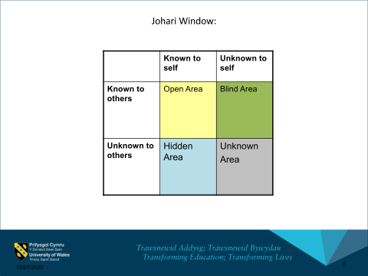

The open area in the area with things that I know about myself and that are also known by others. Like my ability to relate and talk to people, my ability to solve problems and also my leadership ability. So many times, in my place of work I have heard this statement from people, “Mathew is here now, everything will be sorted”
The blind area is the area about me that are known to people but unknown to me. For example, whenever am doing a presentation I have been told that i use my hands a lot. This is not known by me. Another example is the way I argue with others, have been told several times that I do not like to loose argument with people, this part of me is unknown by me.
The hidden area is the area that are known by myself but is u know to others. For example, nobody knows am an emotional person, this is the part of me that I have never shown to anyone.
And the last one is the hidden area; this is the part of me that is unknown to myself and also unknown to others. This particular left for me to find out.

Personal Development Plan
 | Short-Term Time Frame  What do I want to  accomplish in the next  three to six months? | Mid-Term Time Frame  What do I want to  accomplish in the next  six months to two years? | Long-Term Time Frame  What do I want to  accomplish in the next  two to three years?
Section 1 - My Goals | To Achieve my certificate in high education in skills in work place with high grades.  Improve my time management skills and develop my employability skills | To become a manager in my workplace and put to use my acquired skills  Continue my study to acquire Ba in Business management | Be the manager of my own restaurant Business
Section 2 - Skills and Knowledge to be  Learned | Presentation skills , communication skills,  Leadership skills and Time management skills | Put to test my acquired employability skills , Managing my time effectively .  Do a lot of researches on opening restaurant Business and Business plan | Certificates in food management courses
Section 3 - Next Steps  How am I going to acquire the skills and knowledge? | Continue my study in certificate in higher Education in skills in workplace to level 5 and level 6 | Register for time management course ,  Develop more on my employability skills and communication skills by studying more | Put to constant practise my employability skills in my place of work.
Adapted from: http://www.hr.ucdavis.edu/sdps/forms/IDP%20Final%2010.14.11.pdf

 | Short-Term Time Frame  What do I want to  accomplish in the next  three to six months? | Mid-Term Time Frame  What do I want to  accomplish in the next  six months to two years? | Long-Term Time Frame  What do I want to  accomplish in the next  two to three years?
Section 4 - Resources  What resources do I need? | Student finance funding | Free time that will not affect my work schedule | Self commitment and determination
Section 5 - Time Schedule  What is my time schedule? | Weekends and my free time | My day off at work | Mondays to Saturdays.
Adapted from: http://www.hr.ucdavis.edu/sdps/forms/IDP%20Final%2010.14.11.pdf

My career Ambitions and aspiration.

I know I was born to be a leader to be a leader, looking at where I started from and where I am today. My career goal is to become a manager in my place of work , the work has already started , because I started as a cleaner and I became the team leader, not long time i became the supervisor , it will not be long when I will become a manager , am working really hard towards that. And I know I will achieve my goal in the end

Review of my understanding and Expectation of

World of employment.
Developing an Understanding of the recruitment and selection processes is key to understanding how employers develop a selection process and why they use certain tool Morgan (2017).
A job vacancies are always advertised by the company based on the companies preference for a particular vacant position. There is always a different recruit process and how the process will be conducted and also what employers will be looking for every vacant position. In the world of employment, employers follows a recruitment and selection processes .
Recruitment is the process of identifying a number of applications who are willing to apply for a particular job or training programme Morgan,(2017). While Selection processes is the process of comparing information from the applicants with the requirements as specified in the advertisement, and selecting those who meet the essential requirements to move forward in the selection processes Morgan, (2017).
In the world of employment, employer recruitment and selection processes there has to be Job advertisement where an advert is placed for people to apply for a vacant job positions, and also the description of the tasks the job will involve and using the job description and information’s to determine the qualities required from the successful candidates followed by examining the applicants and deciding which candidates to be called for an interview. In the world of employment, companies or organisations are looking for individuals that are proactive in terms of their abilities. They are always looking to for ways to hire exceptional employees. But my expectations are first, to have the knowledge of the business of the organization I want to work with, secondly, employers should have a responsibility to develop the employability skills of their staffs and finally, timely and accurate payment of wages ,sage working environment , and work life balance.

Action plan .

My plane is to use the opportunity that I have ,which is the access to student finance to apply for more training courses in time management and communication skills which is my weakness. After which I will applying for a managerial position in my workplace with my certificate and save money to open my own restaurant Business.

Conclusion.

Your career starts when you were born, we tend to learn what we will become as we grow up. Building yourself towards your career goal takes a lot of determination and it requires a good knowledge and understanding of yourself. World of employment is full of competition; a self-motivation is required to develop all the employability skills needed towards achieving your career goal. There is need for proper personal development plan, to guide us towards achieving our goal.

12. References

- Morgan, P. (2017) The business students guide to study and employability.1st Ed. London: Sage.
- Griffith, B.A and Dunham,E.B.(2015) ‘Communication’ , in Mound, A, Shriek,M and Tinker,P.T (ed.) certificate in higher education:Skils for the workplace student yearbook. London: Sage.
- SkillsYouNeed(2019)Time management.[Online] available at: https://www.skillsyouneed.com/ps/time-management.html (Accessed:12 January 2020).
- OpenLearn(2016)Skills for study.[Online] Available at: http://www.open.edu/openlearn/skills-for-study (Accessed: 13th January 2020).
- Skills for Learning (2018) Guide to time management [online]. Wolverhampton: University of Wolverhampton. [Accessed : 13th January 2020]. Available at: <http://www.wlv.ac.uk/skills>.
- Suerta, I.M.et al.(2017) ‘Employability Skills Require by the 21st Century'. A literature review of Labour Market Demand, 10.2991/ictvt-17.2017.58.
- Kapur, R. (2018) ‘Time management’. A case study
- Gopalan, V.et al.(2017). A review of the Motivation Theories in Learnig, AIP conference Proceeding 1891.

