

Cloud-Based Web Services
ACCA6024
Assignment 2
M. Dacey
Paul Newman 1805454

Contents
Cloud Computing 4
Advantages 5
Disadvantages 5
Scalability 6
Node.JS 7
Docker 8
Containers 9
Web applications 10
Virtual machines 11
Virtual Infrastructure 12
Virtual Machine Components 12
Bibliography 13

Figure 1 Cloud Computing at its most simple [2] 4
Figure 2 Docker Containers [5] 8
Figure 3 Containerized Applications [5] 10
Figure 4 How Virtual Marines work within Docker [5] 11

Cloud Computing

Varied people have different perceptions on cloud computing. Some people use the term "cloud computing" to describe using services that mimic the Internet or a network while accessing applications and storing data there. It appears to others as simply a modernisation of the time-sharing paradigm that was previously used as nothing new. In the 1960s, before the development of comparatively less expensive computing systems, they were commonly used. These advancements ultimately led to the client/server model. time-sharing systems were doomed by the personal computer, which brought massive quantities of processing power to people's desktops. Professor at MIT John McCarthy proposed the idea of computing as a utility similar to electricity in 1961. 1 Another trailblazer who later created the ARPANET's foundation was the Department, J.C.R. Licklider was the creator of the Advanced Research Projects Agency Network, the forerunner to the Internet.
At a time when punched card, batch processing, and mainframe computers were the norm in the 1960s, Licklider promoted concepts at both ARPA and Bolt, Beranek and Newman (BBN), the high-technology research and development corporation. Computing ruled the day. [1]
Cloud computing is a system that manages data and applications using the internet and centralised remote servers. Using applications without installing them, consumers and companies can access their personal files from any computer with an internet connection thanks to cloud computing. This method centralises storage, resulting in significantly more efficient computation, processing, memory, and bandwidth. Cloud computing, in its most basic form, consists of virtualized shared computing resources that can be accessed as a service via an API. Users within a company can execute apps by deploying them to the cloud, which is a virtual data centre. The physical resources may be housed both inside and outside of an organisation in a variety of places, including on local hardware, in an enterprise data centre, or at distant or managed service providers on a pay-per-use basis. A highly scalable, dependable on-demand solution with flexible management capabilities is provided by cloud computing resources that are made available as a service and delivered using IP-based connectivity. [2]

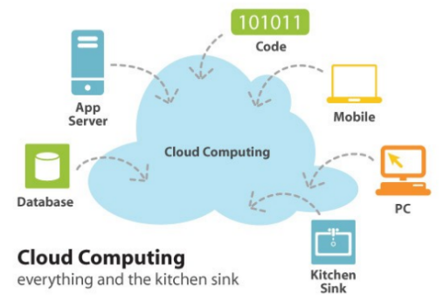
Figure 1 Cloud Computing at its most simple [2]

Advantages
- Reduced Cost Organizations save money with cloud technology since it is paid for progressively.
- Enhanced Storage More data can be stored by organisations than on personal computers.
- High Automation IT staff members are no longer responsible for updating software.
- Be flexible Compared to earlier computer techniques, cloud computing offers a lot more freedom.
- Greater Mobility Employees are not restricted to their desks; they can access information wherever they are.
- Permits IT to Change the Focus Government organisations will be able to focus on innovation without having to worry about ongoing server updates and other computer difficulties. [2]
- Self-service On-demand Users can utilise cloud computing resources as needed thanks to on-demand self-service. without any human interaction between the user and the provider of the cloud service. With on-demand self-service, a customer can plan out their cloud usage. means of controlling the services offered. Both the consumer and the cloud service provider benefit from the efficiency and cost savings that come with this simplicity of use and lack of human involvement [1]. in addition to managing and deploying these services, providing services like compute and storage as required. The self-service interface must be user-friendly and deliver efficient services in order to be successful and acceptable to the consumer.
- Widespread network access.
- Geographical independence.
- Use a network to access apps provided by a cloud software as a service (SaaS) provider.
- Deploy customer-created applications to a cloud using cloud platform as a service (PaaS).
- Rent processing power, storage space, network capacity, and other essential computer resources using cloud infrastructure as a service (IaaS).
- Private cloud—owned or leased by an organisation.
- Shared infrastructure for a specific community: community cloud.
- Mega-scale infrastructure sold to the general public as the public cloud.
- Two or more clouds combined to form a hybrid cloud. [1]

Disadvantages

- Among virtual machines running on the same server, there is data leakage and illegal access.
- A cloud provider's improper handling and protection of sensitive data.
- releasing sensitive information to law enforcement or the government without the client's knowledge or consent.
- Possibility of adhering to compliance and legal standards.
- System failures and crashes that render the cloud service unavailable for a long time.
- Cloud-based client apps are breached by hackers, who then steal and distribute sensitive data.
- The effectiveness of the security measures put in place by the cloud provider.
- The level of compatibility present, allowing a client to migrate apps between different cloud providers without difficulty and prevent "lock-in". [1]
Users of the cloud should be cautious about the long-term availability of their data as well as the possibility that the cloud provider may covertly use sensitive data for its own benefit. Encryption is one mitigating strategy that can be used to safeguard cloud data. Data encryption can shield information from hacker or cloud provider disclosure, but it makes it more difficult to search for or analyse that data. This book clarifies all of these concerns and offers thorough advice on how to work within the cloud computing field to maximise returns on investments without sacrificing information security. [1]

Scalability

Demand—Changes in their environment are a reality for all enterprises. One significant benefit of cloud computing is its capacity to scale up and down. Cloud solutions (both private and public) can adapt to changes if an organisation experiences times where its demands for computing resources are much greater or lower than usual. [1]
- Data centre streamlining: Any firm, regardless of size, will have made a sizable investment in its data centre. This includes purchasing and maintaining the gear and software, offering the spaces where the hardware is kept, and recruiting the staff members responsible for keeping the data centre operational. By utilising internal cloud technologies or by offloading workload to the public, a business can streamline its data centre.
- Enhancing corporate processes: The cloud offers an infrastructure for doing this. In the cloud, an organization's suppliers and partners can exchange data and apps, allowing all parties to concentrate on the business process rather than the infrastructure that supports it.
- lowering initial costs—Cloud computing significantly lowers launch costs for new businesses, businesses operating in emerging markets, and even advanced technology departments within bigger enterprises. The newly formed organisation begins with a ready-made infrastructure.
- whether the cloud is in a public or private location, the time and other resources required to create a data centre are covered by the cloud provider, public or private. [1]
Not Cloud Computing
Utility computing and cloud computing are not the same. Cloud computing can use distributed, virtualized platforms rather than a centralised computer resource, and it is not required to use the metered service price of utility computing.
Is grid computing's counterpart, cloud computing, comparable? Distributed virtual machines are utilised in grid computing, however unlike cloud computing, these computers are frequently devoted to a single, extremely complicated task [1].
Cloud computing is sometimes seen as client/server computing, with the cloud playing the server function. The server, however, is a specific machine at a certain place in the classic client-server architecture. Computations operating in the cloud can be based on computers located anywhere, distributed among computers, and employ virtualized platforms—all of which are hidden from the user. every user knows is that in order to produce outcomes, they are accessing resources, using processing, and storing them somewhere [1].
The use of the cloud is not Software as a Service, or SaaS, is software that businesses may buy, manage, and employ to run on their own or third parties' hardware.
Virtualization is not cloud computing either, despite the fact that it can be used to accomplish cloud computing. Operating system virtualization can be used in a data centre or on the personal computers of an enterprise. not using the cloud. Virtualization can, however, be used with cloud computing resources [1].
The service-oriented architecture (SOA), which enables data interaction between various applications involved in business operations, and cloud computing are not the same. In conclusion, even if the concepts mentioned above are not necessarily related to cloud computing, depending on how they are used, they may be [1].

Node.JS

A cross-platform, open-source runtime environment called Node.js is used to create server-side web applications. Applications for Node.js can be run on a number of operating systems and are written in JavaScript. Node.js was created to maximise an application's throughput and scalability for real-time online applications. It is based on an event-driven architecture and a non-blocking Input/Output API. For a very long time, stateless models served as the foundation for every web development framework that was accessible. In a stateless architecture, the data created during one session—such as details about the user's preferences and recent events—is not stored for use during the user's subsequent session. Maintaining the user's session data between requests required a lot of work. However, with Node.js, web applications now have the ability to establish two-way, real-time connections that allow for unrestricted data exchange between the client and server [3].
Over time, a stateless request-response framework was the foundation for the majority of the apps. In these kinds of apps, it is the developer's responsibility to make sure the proper code was implemented to guarantee that the web session's state was kept while the user interacted with the system. However, real-time collaboration and two-way communication are now possible with Node.js online apps. Both the client and the server can initiate communication while the state is still maintained [3].
Numerous substantial businesses use Node.js. Here is a short list of some of them:
- PayPal Numerous sites within PayPal have begun the switch to Node.js.
- LinkedIn's mobile servers, which run the iPhone, Android, and mobile web products, are powered by Node.js.
- Mozilla To support browser APIs, Mozilla has adopted Node.js, which has received 500 million instals.
- eBay Node.js is used by eBay to host its HTTP API service [3].
Node.js can be used for many applications with different purposes; the only situation in which it shouldn't be utilised is if the application requires lengthy processing times.
Node is designed to run in a single thread. Whenever a programme needs to conduct some lengthy calculations in the background. As a result, the server won't be able to handle any additional requests while performing a calculation. Node.js is ideal when processing requires less devoted CPU time, as was previously discussed [3].

Docker

Docker. Solomon Hykes established Docker Inc. in 2010 as dotCloud Inc. With the goal of minimising the complexity associated with using Linux containers, dotCloud engineers developed abstraction and tooling for Linux Containers and made advantage of cogroups and namespaces in the Linux Kernel. DotCloud altered the focus of their tooling from the PaaS business to containerization and published their tooling open source. DotCloud was sold by Docker Inc. to cloud Control, which ultimately declared bankruptcy. The operating system-level virtualization technology known as containers is called Docker. It is crucial to understand that this is distinct from hardware virtualization. This will be discussed more in the chapter. Within the same physical or virtual system, Docker makes use of the Linux kernel's resource isolation features, including cogroups, kernel namespaces, and Overlay FS. In order to execute numerous apps that are separate and contained from one another, Overlay FS is a union-capable filesystem that combines many files and directories into one [4].
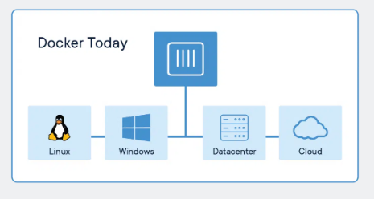
Figure 2 Docker Containers [5]

Containers

Although containerization has gained momentum and become increasingly popular over the past few years, the idea dates back to the 1970s. the same real or virtual machine, all together.
1979: In 1979, Version 7 of UNIX introduced the chroot system call. Chroot was designed with the idea that it would alter the apparent root directory for the currently active process and its offspring. Files outside the designated directory tree cannot be accessed by a process that is started inside a chroot. The chroot jail was the name given to this setting [4].
2000: FreeBSD provided support for a feature that allowed for the partitioning of the FreeBSD system into a number of distinct, isolated systems called jails, expanding on the chroot concept. On the host system, each prison is a virtual environment with its own collection of files, processes, and user accounts. While FreeBSD jails confined operations of the jailed process to the entire system, including the IP addresses that were bound to it, chroot just restricted processes to a view of the filesystem. As a result, FreeBSD jails make it simple to experiment with various configurations of Internet-connected software while preventing changes made inside the prison from affecting the main system outside [4].
2006: Operating system virtualization with OpenCV was quite popular among low-end Virtual Private Server (VPS) providers. OpenCV permitted a physical container, which are several isolated operating system instances, on a single server. All of the containers share a patched Linux kernel that is used by OpenCV. Each container functions independently and contains a virtualized set of files, users, and other resources. process trees, virtual network devices, and groups [4].
2006: Control groups, often known as cogroups, were invented by Google engineers and were first known as process containers. A Linux kernel feature called cogroups separates and restricts the use of resources (such CPU, memory, disc I/O, and network) to a group of processes. Cogroups have undergone numerous redesigns, with each considering the increasing number of use cases and necessary functionality [4].
2008: By combining the Linux kernel's cogroups with support for isolated namespaces to create an isolated environment for applications, LXC offers operating-system level virtualization. LXC was initially employed by Docker to provide [4].
Difference Between Containers and Virtual Machines
Since containers separate the programmes, many people believe they are equivalent to virtual machines. Although it may appear that way at first glance, the main distinction is that containers and hosts share the same kernel.
All containers operate on the same host system, and Docker only isolates a single process (or a collection of processes, depending on how the image is constructed). Operating containers has less of an impact on the host than running virtual machines since the isolation is implemented at the kernel level. The chosen process or set of processes continues to execute on the same host when a container is spun up; no virtualization or emulation is required [4].
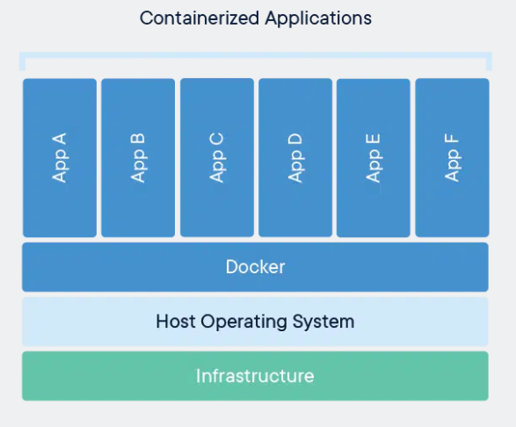
Figure 3 Containerized Applications [5]

Web applications

Virtualisation
In the past, server virtualization was thought of as a way to cut costs. But it has developed to the point where it is now regarded as valuable. In addition to giving users flexibility in how they use resources, cloud computing is made possible by this. Following are some of the main virtualization advantages unique to cloud computing:
- Usage-based billing (utility pricing), as opposed to fixed hardware capacity.
- Quick deployment of new servers.
- Promotion of scale economies.
- Customer separation from actual server locations.
- Using service-level agreements as a guide.
- Supported alternative sources.
- The flexibility of applications between servers and data centres [1].
Customers have some degree of choice thanks to virtualization, and cloud providers benefit from its efficiency and cost-cutting capabilities. In many cases, clients will test out hybrid clouds before making the switch to virtualized clouds. and assess the cloud paradigm in the light of their own corporate needs. Users will use cloud computing more frequently as they get used to it. Having the ability to quickly minimise the number of servers they are utilising when they are not needed, as well as the capacity to have a huge number of servers ready on demand. The development of autonomous computing and the incorporation of change management into the virtual machine model can yield additional benefits. If used appropriately, virtualization can also lead to shorter ramp-up times and shorter development times. and market applications, as well as the quick acquisition or depletion of resources as needed Through the ability to open virtual machines on the resources of the cloud provider as if the virtual instance were running on the customer's hardware, virtualization also offers utility computing. This feature may come in very handy for satisfying both anticipated and unforeseen peak consumer demands. [1].

Virtual machines

A virtual machine is a piece of software that functions as a computer and runs an operating system and programmes. The physical resources of a host serve as the foundation for the virtual machine, which is made up of a number of specification and configuration files. Virtual devices built into each virtual machine offer the same services.
functionality as actual hardware, but are more manageable, portable, and secure.
You will benefit from some basic knowledge, such as the virtual machine lifecycle, components, and VMware Tools, before you begin creating and managing virtual machines.
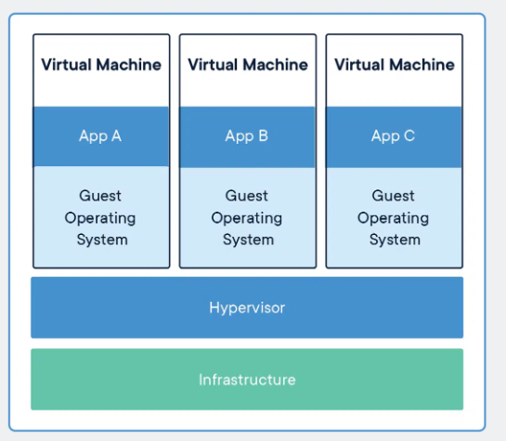
Figure 4 How Virtual Marines work within Docker [5]
The various files that make up a virtual computer are kept on a storage device. The configuration file, virtual disc file, NVRAM setting file, and log file are the important files [6].

Virtual Infrastructure

Virtualization and administration are two of the at least two software layers that make up the infrastructure that supports virtual machines. The virtualization tools that aggregate and display the host hardware to virtual machines as a standardised set of resources are offered by ESXi in vSphere. On ESXi hosts that vCenter Server controls, virtual machines are operated [6].
With the Server, you can efficiently manage and monitor your data centre infrastructure by pooling the resources of several hosts. You may plan tasks, provision virtual machines, manage resources for them, gather statistical logs, make templates, and more.
Virtual machine deployment and creation options are numerous. A single virtual machine can be built, and the guest operating system and VMware Tools can be installed on it. An existing virtual machine can be copied or made into a template. OVF or OVA templates can also be deployed [6].

Virtual Machine Components

An operating system, VMware Tools, virtual resources, and virtual hardware are often present in virtual machines. These components are managed in the same way as those found in a physical computer.
- Operating System
On a virtual machine, you instal a guest operating system in the same way as you the software that controls a real computer. A CD/DVD-ROM or ISO image holding the installation files for an operating system is required [6].
- VMware Tools
A collection of tools called VMware Tools improves management of virtual machines and the performance of the guest operating system. Device drivers and other software necessary for your VM are included. You have additional control over the virtual machine interface with VMware Tools [6].
- Compatibility Setting
Applying a compatibility setting in the vSphere Client allows you to allocate each virtual machine to a compatible ESXi host version, cluster, or datacentre. The virtual machine's hardware features and the ESXi host versions it may run on are both determined by the compatibility setting [6].
- Hardware Devices
Every piece of virtual hardware serves the same purpose for the virtual machine that physical computer hardware does. Each virtual machine has resources for its CPU, memory, and disc. CPU virtualization prioritises performance and, whenever possible, runs on the processor itself. When possible, the underlying physical resources are exploited. To make virtual machines function as though they were running directly on a physical system, the virtualization layer only executes instructions when necessary [6].
Virtual memory is supported by all current operating systems, enabling software to use more memory than the machine actually has. Similar to this, the ESXi hypervisor supports overcommitting virtual machine memory, in which case the total amount of guest memory configured for all virtual machines may exceed the whole amount of physical memory on the host [6].

Bibliography

[1] | R. L. Krutz, “Cloud Security,” in A Comprehensive Guide to Secure Cloud Computing, Wily Publishing inc.
[2] | G. Paliwal, “Cloud Computing,” in What is Cloud Computing , 2010.
[3] | K. Rungta, “Learn NodeJS in 1 Day,” in Learn NodeJS , Krishna Rungta, 2016.
[4] | S. Bhat, “Practical Docker with Python,” in Build, Release and Distribute your Python App with Docker, apress, 2018.
[5] | “docker.com,” 2022 Docker Inc., 2022. [Online]. Available: https://www.docker.com/. [Accessed 9 12 2022].
[6] | “vSphere Virtual Machine Administration,” vmware, 16 OCT 2018.

