7/24/2026
University of Wales Trinity Saint David
London campus
E-Portfolio Link: https://2544584.wixsite.com/diverse-portfolio-so
Module Name: Learning In the Digital Era
Module Code: ACCA 4025

Student Name: Rachel Pereira de Oliveira Almeida
Student ID:2544584
Group:

Lecturer’s Name: Anees Baquir

LDE Assignment 1
E-Portfolio
Table of Contents
Introduction 2
Main Body 2
Task 1: Essential Academic and Employment Skills for the future career Path 2
Task 1 (a): Report on Essential Academic and Employment Skills 2
Task 1 (b): Evaluation of Task 1 (a) based on Similarity report 2
Task 2: Collaborative Mind Map and Individual Poster 2
Mind Map (Collaborative) 2
Poster (Individual) 2
Task 3: Virtual Collaboration and RefWorks 2
Report on Virtual Collaboration 2
Step-by-step process of using RefWorks with visuals 2
Task 4: E-Portfolio Creation and Evaluation 2
Task 4 (a): E-Portfolio Creation 2
Task 4 (b): Illustrative Review of E-Portfolio tool Selection 2
Conclusion 2
References 2
Task 1 References: 2
Task 3 References: 2

Introduction
I am Rachel Pereira de Oliveira Almeida, a specialist in safety and professional growth. Known for resilience and empathy, I am currently attaining a computer degree in London. I am to merge my extensive interpersonal background with high-level technical skills, delivering a unique perspective that integrates human-centric service with modern digital innovation.

Main Body

Task 1: Essential Academic and Employment Skills for the future career Path

Task 1 (a): Report on Essential Academic and Employment Skills

Software and App Developer for driving instructors and learners on the road
Software and app development is a career that combines technical knowledge and professional skills. After graduation from university employers will look for professionals with academia due to appropriate use of digital language and time management ​[1]​.
The skills I will gain such as time management using e-mail Outlook, learning in a digital era, programming, software data and coding skills, Excell are attractive to employers ​[2]​. Moreover, I can also build my own applications to use on the industry I am already familiar with.
First, I can use all my skills mentioned above to work either full time or part-time in many different companies who are looking to employ a newly graduate person to help their company to build security to their computers, or to develop methods using applications to help their workload easier to use on their day-to-day business. As many businesses nowadays are going digital, for their planers, organizations do feel the need to use technology.
Second, I can also build with my own skills and develop software and applications to sell to help others to basic lean to drive or for the Driving Instructors business industry, as this is a topic I already have a wide knowledge skill. I can help learners: Use the app to prepare them with their theory test, then a following up app to help them the basic skills to practical test. I can use the DVSA Rules and Regulations ​[3]​ to guide.
To conclude my thesis, I will use my studies skills gained throughout the university and apply to that employment.
Reflexion on plagiarism
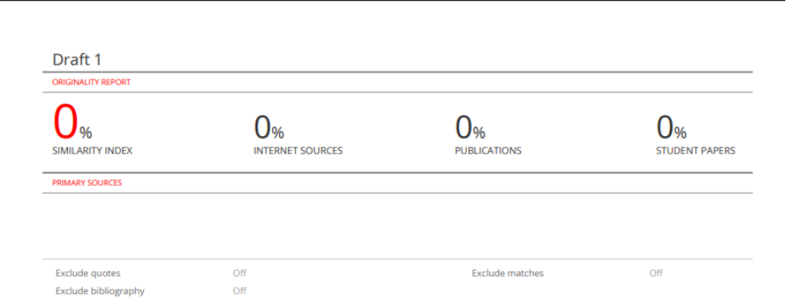
After the

References:

​​[1] D. Vlachopoulos and O. Pachni Tsitiridou, '"Preparing university graduates for the labour market through employability skills development and university–industry collaboration: A systematic review," Education Sciences, vol. 16, no. 3, pp. 426.
​[2] Gov.Uk, '"Digital skills to help your career,", vol. 2026, no. 09/07.
​[3] Gov.UK, '"Driver and Vehicle Standards Agency,", vol. 2026, no. 09/07.​

Task 1 (b): Evaluation of Task 1 (a) based on Similarity report

Generic Assessment criteria/ GAC
Having scored 100% guide state mark on the Generic Assessment criteria, I have only used guidance to help me to write my written summary for the topic of essential skills for study and employment. I ensured that the main content was written in my own words and that all sources were correctly cited using IEEE referencing. If I need to improve in future, I will make sure to improve by paraphrasing with more careful consideration to reduce similarity that is not needed. I have included relevant sources, and appropriate referencing, clear ideas to meet the assignments requirements. I score myself good.

Based on the Generic Assessment Criteria I have come to score myself Good.

Task 2: Collaborative Mind Map and Individual Poster
Mind Map (Collaborative)

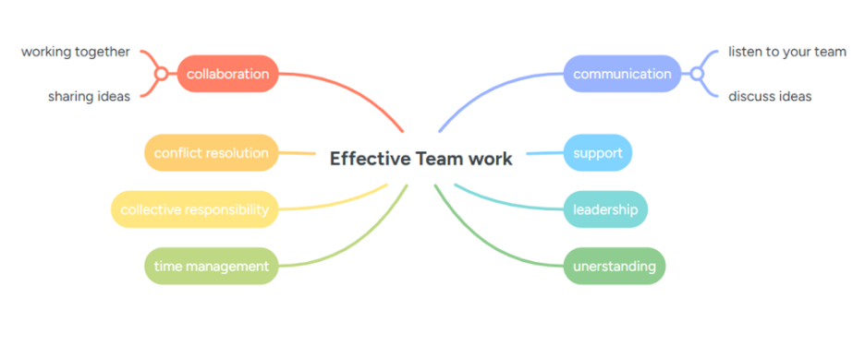

Team member Rachel
Effective Team work is an essential to achieve shared ideas and to achieve goals both in academic and professional environment. Communication is an important skills team members must gain to help support and avoid misunderstandings. It is through communication that team members can resolve problems and find solutions. Collaboration encourages the whole team to get involved and contributes to their knowledge resulting in a better solution and improve creativity. Leadership and understanding help others to keep motivated and to progress in the workspace and to progress with any schedules and deadlines. Time management it is an essential skill that helps to keep tasks and plans in good time for deadlines. Collective responsibility supports each team members to ensure each one is contributing fairly. By developing these skills, students become a better professional in the workplace for their future careers as teamwork is an essential part of majority of projects, including software and app developers.

Team member Cristiane

For this work, we used Microsoft Teams and Google Drive to share files, organize our ideas, and stay connected easily. Our main goal was to build a clear, practical mind map that covers all key parts of effective teamwork from open collaboration to meeting deadlines.
I focused on active listening and respectful dialogue everyone had space to share different views, and we built our ideas together. I also made sure we balanced individual tasks with shared responsibility, so every person contributed fairly. This experience showed me that good teamwork is not just about finishing work it is about supporting each other, learning from different perspectives, and growing together as we move toward our common goals.
this work, we used Microsoft Teams and Google Drive to share files, organize our ideas, a
Team member Javier
I think communication is essential when working in teams because it helps people work effectively with their coworkers and it also allows share ideas and feelings, creating a comfortable and enjoyable work environment to perform at their best. In addition, clear communication helps avoid misunderstanding and prevent mistakes and confusions. To conclude, developing strong communication skill is a positive addition to your personal development not only in your workplace but also in your personal life.
The communications team is in charge to delivered ideas through different platform such as Facebook, E-mails, websites or letters. It helps to maintain to align and help to keep coordinate with the other members team. And a good communication can lead the company to stay on the top of the market.
Good communications also can help to have a good relationship with the clients, that’s important because it helps the clients always keep relief about the money, they are investment. Many companies are always training its personal in good communication skill.

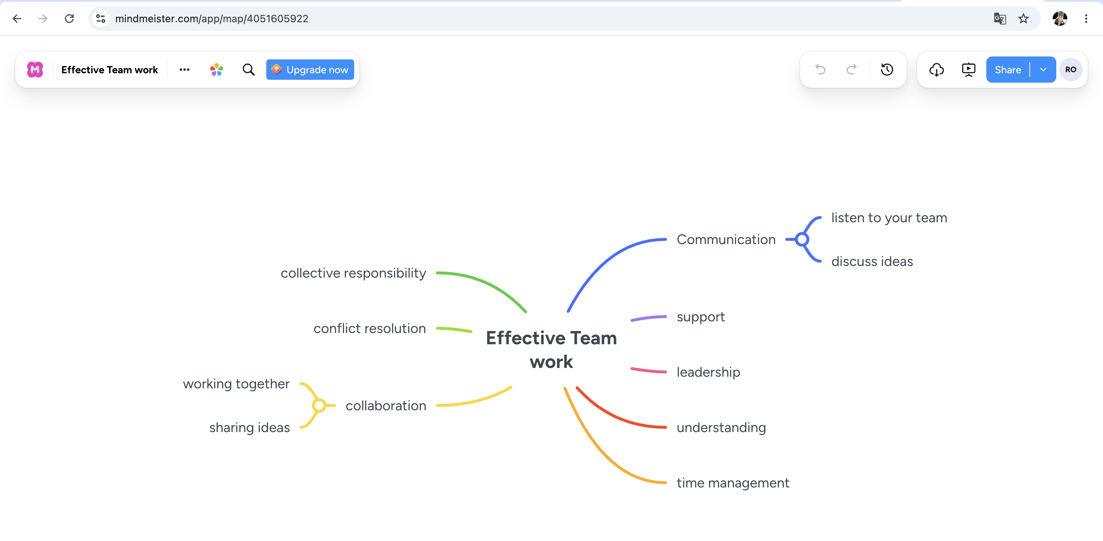

Poster (Individual)

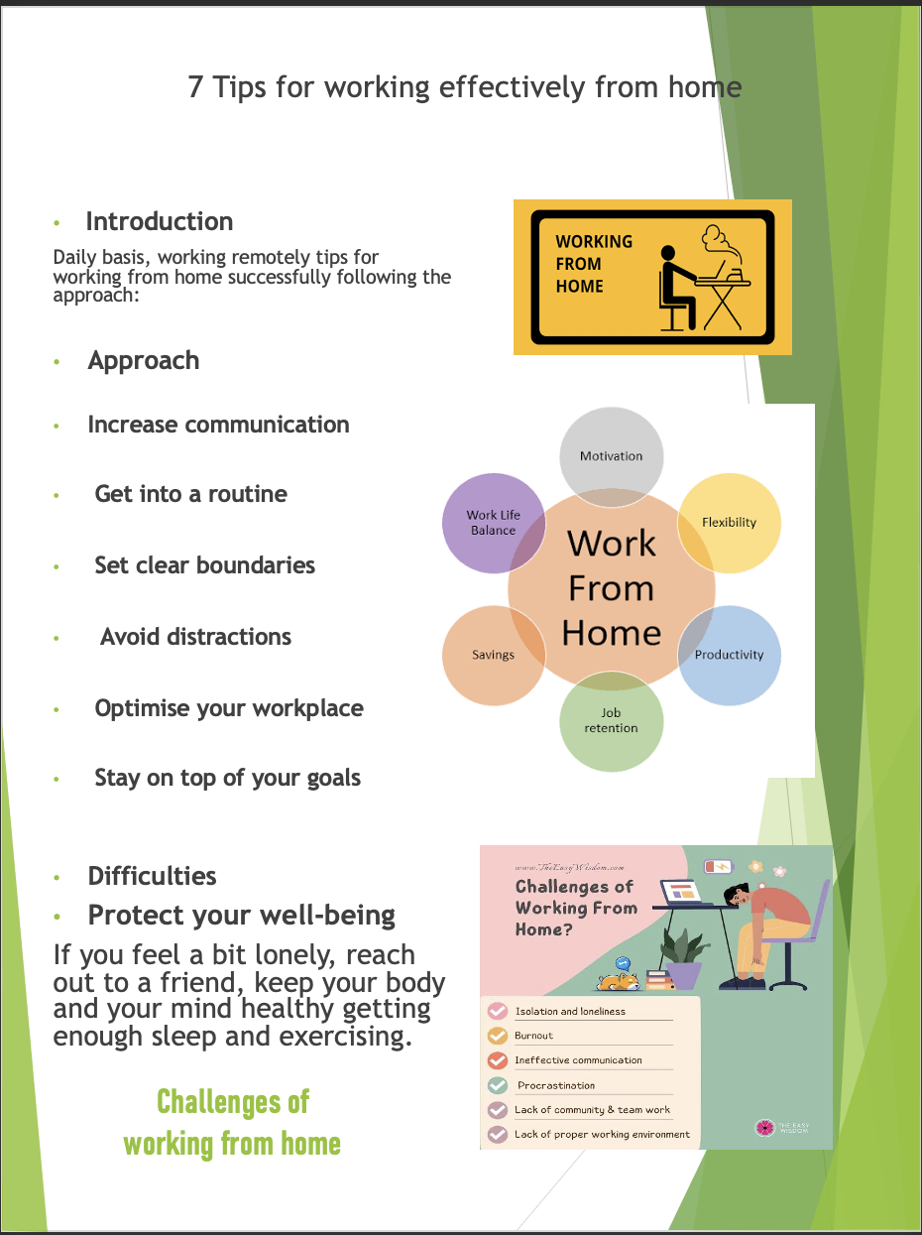

Task 3: Virtual Collaboration and RefWorks

Report on Virtual Collaboration Topic -1 Forming a Team
Virtual Teams dynamics
According to Norman (2013) ​[1]​, is the term used to described how the personal characteristics and interpersonal behaviours of members of a virtual team impact the ways in which they interact, how they communicate and how they share the tasks required to successfully undertake their assigned work.
Tuckman’s ​[2]​model comprised in four stages:
- Forming – effort to get to know each other through communication, involvement or not getting enough involved and not worrying.
- Storming – conflict around personalities.
- Norming – when people start to resolve their differences.
- Performing – achieve goals without
Adjourning – Performing, this is for later in the stage.
Creating a health organization ​[3]​
Trust – is critical in a team. Being very open with each other.
Conflict – is necessary and required. We have trust, it is important to have commitments.
Commitment – is important, because we have trust to keep an open engagement with honest conflict and to commit to the decisions.
Accountability – people need to hold each other accountable. To collect the results of the team we must trust one another and engage in a health conflict, commit to the decisions and hold each other accountable and achieve true collective results.
Build trust is important because the success or failure of the team is based on your relationship with each member. Teamwork requires to build a trusting relationship eg: Asking Open Questions and Avoiding making assumptions.
Introducing yourself and getting to know your team members. How you introduce yourself? This is a question when working in a team we should ask ourselves.
Virtual relationships consist of: ​[4, 5]​
Jealousy of others the way they perceive to be better than oneself.
Shame cannot be on their authentic self.
Anxiety fear what other perceives of them.
Authentic self-important:
- Trust – Promoting trusting in the environment team.
- Morale – Authenticity boost morale with the team.
- Time Management – Projects get completed in a swifty manner.

Network
Profile itself and create a brief bio, including a photograph, skills and expertise and hobbies. Share with the team members. Attain feedback, check if it comes across as authentic.
Forming ​[6]​
FAST Framework.
Frequently discussed – Ambitious – Specific - Transparent. They help the team to work focused and in the right direction and stay on track.

Step-by-step process of using RefWorks with visuals
When referencing using in the browser write Refworks and click login.

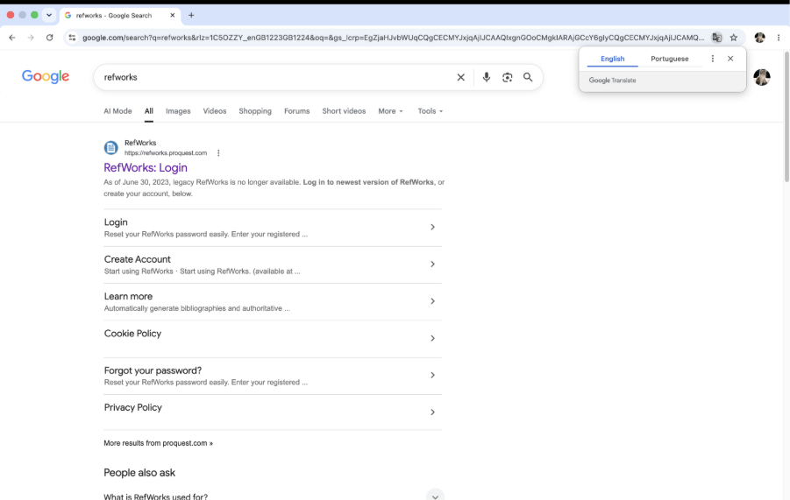

Login using your credentials.
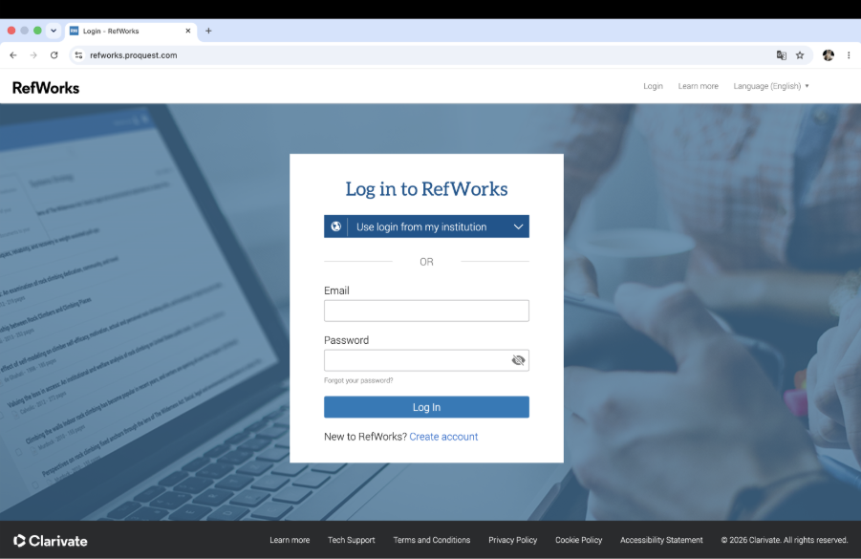

It will come into the last page of your previous references work.
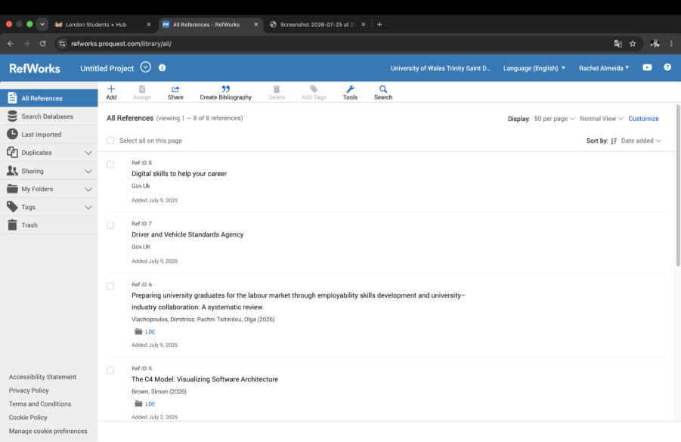

Using the browser type it Google Scholar.
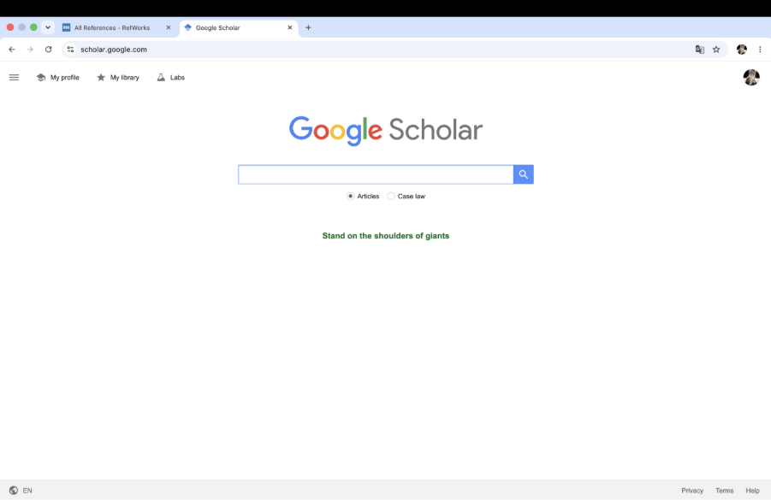

Type the topic you want to cite.

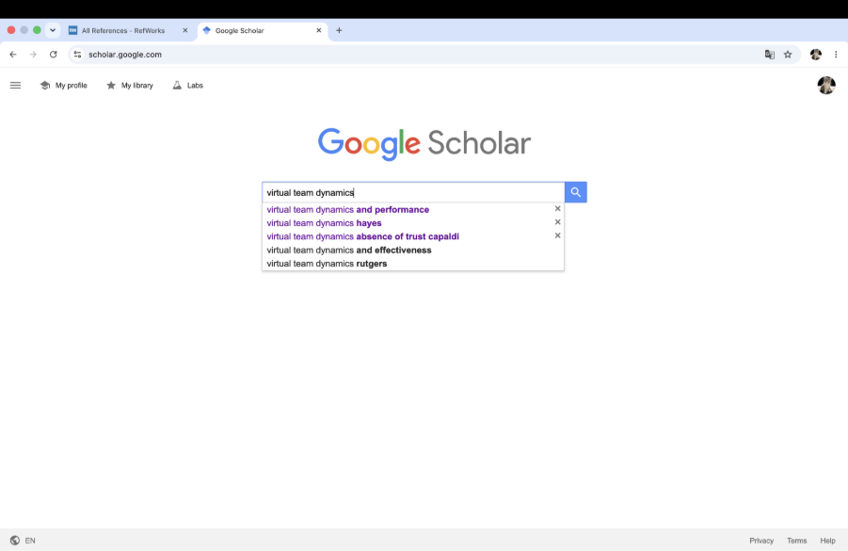

Choose the citation for your work and use the cite icon.

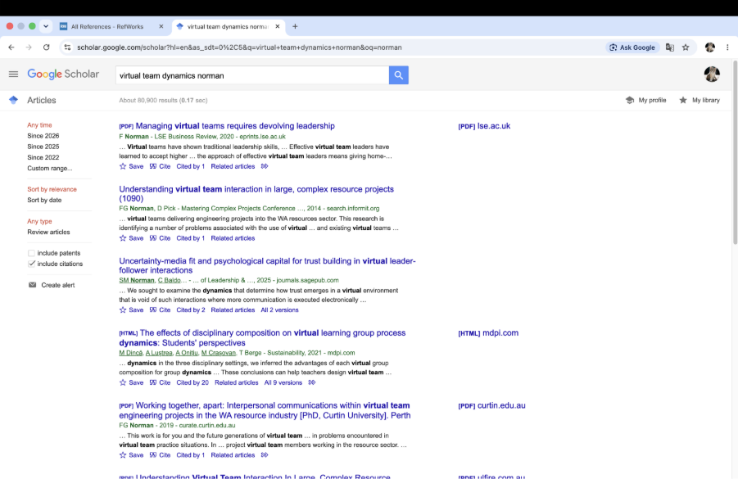

Then press the RefWorks icon.

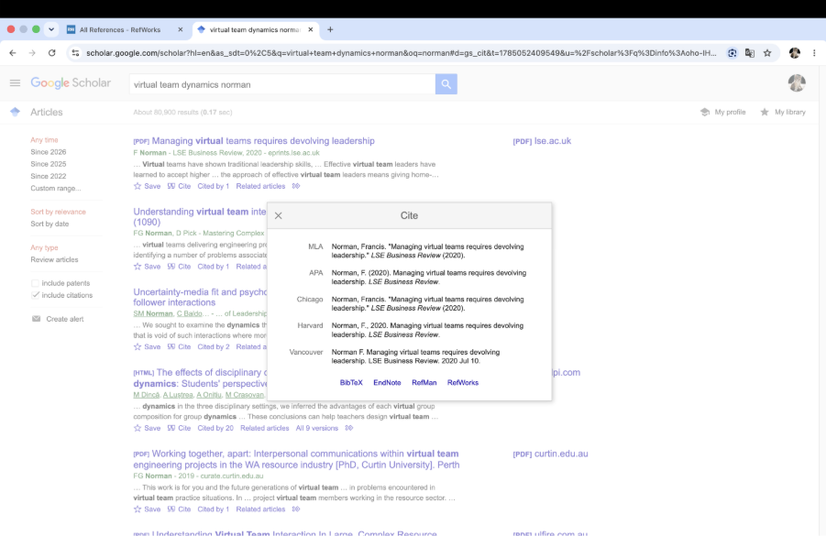

You should import your work. If successful, the import will show complete.

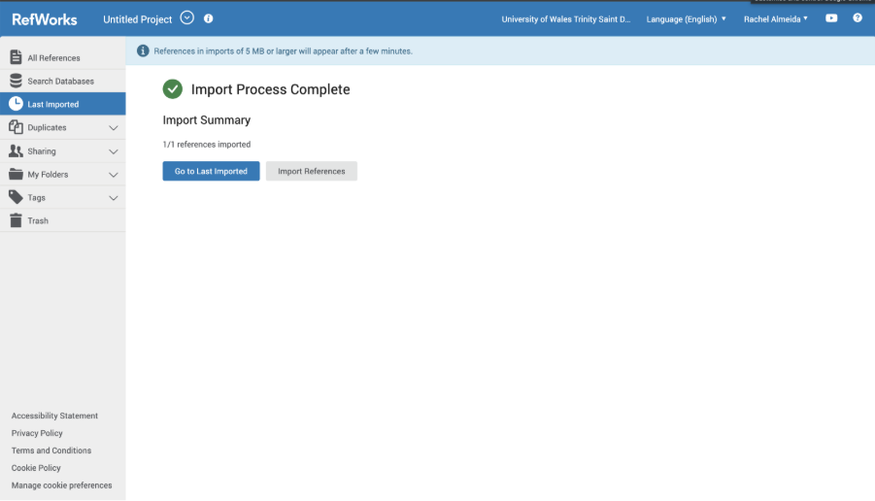

Then you should see all your last imports.
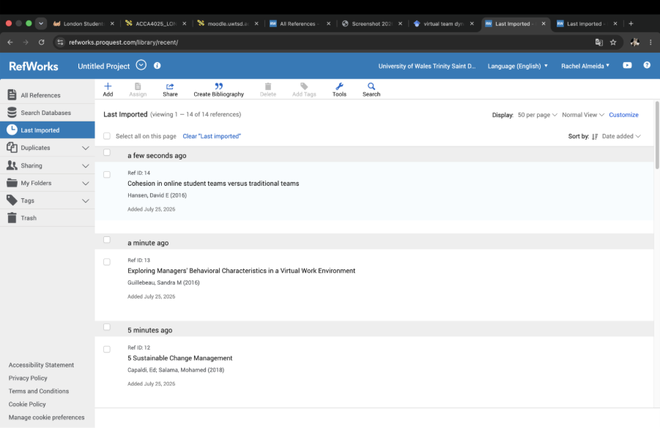
To do your referencing’s you need your RefWorks on your RCM. Press next where you want to cite.
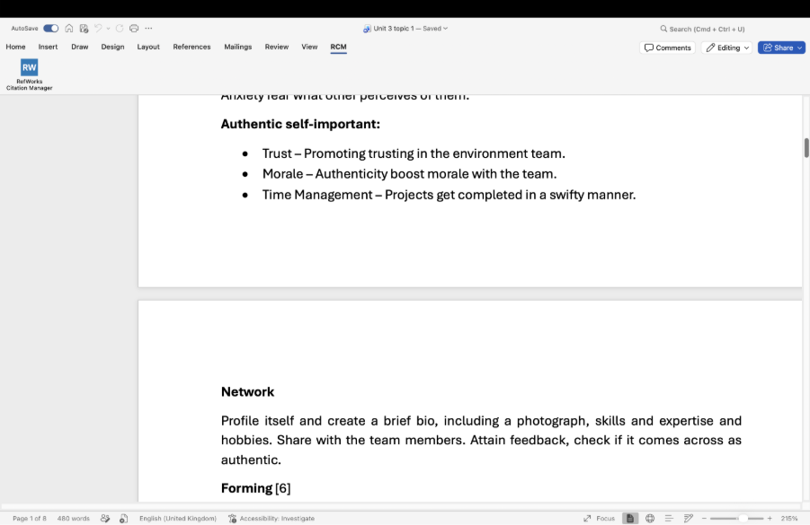

It will show a window next to your work. With your citations.
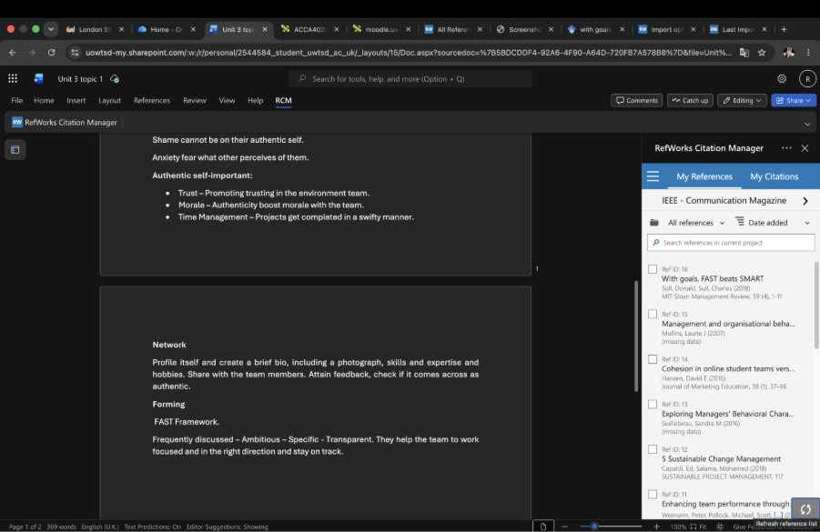
Make sure your settings are all on and you have the correct citation style for your document.
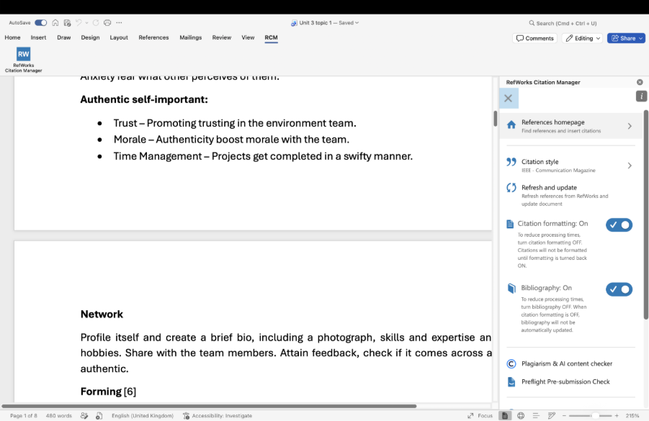

Add your bibliography.

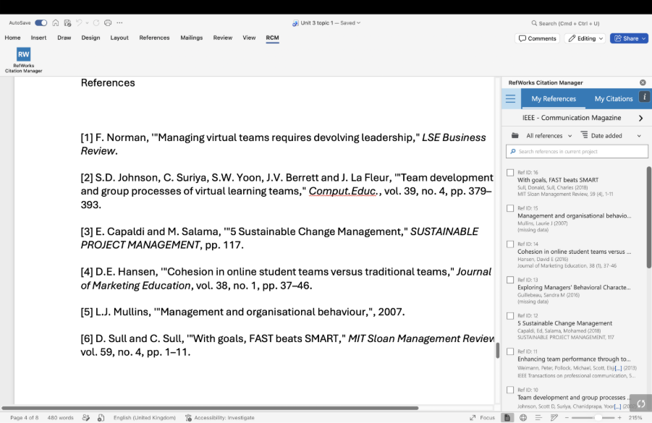

Task 4: E-Portfolio Creation and Evaluation

Task 4 (a): E-Portfolio Creation
I have chosen the free Online Website builder Wix for my e-portfolio.

Task 4 (b): Illustrative Review of E-Portfolio tool Selection

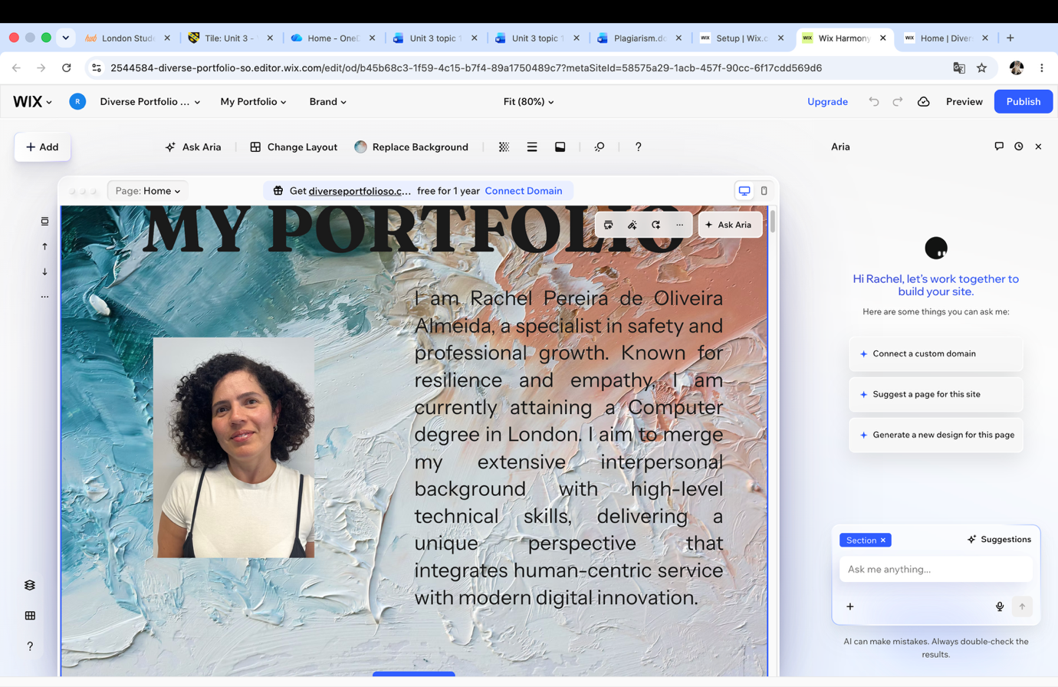

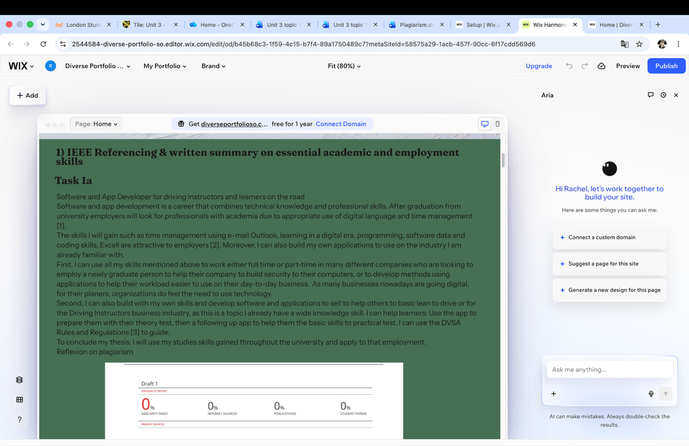

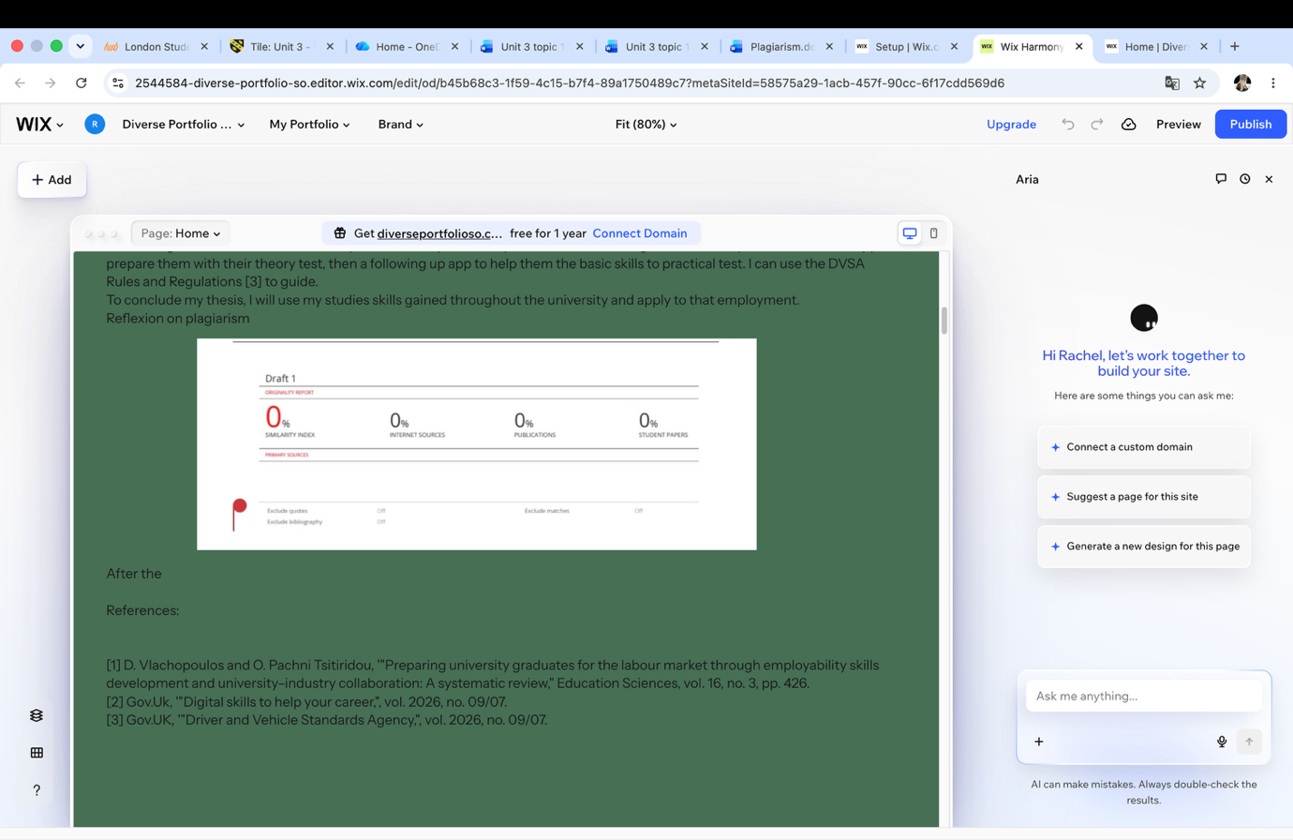

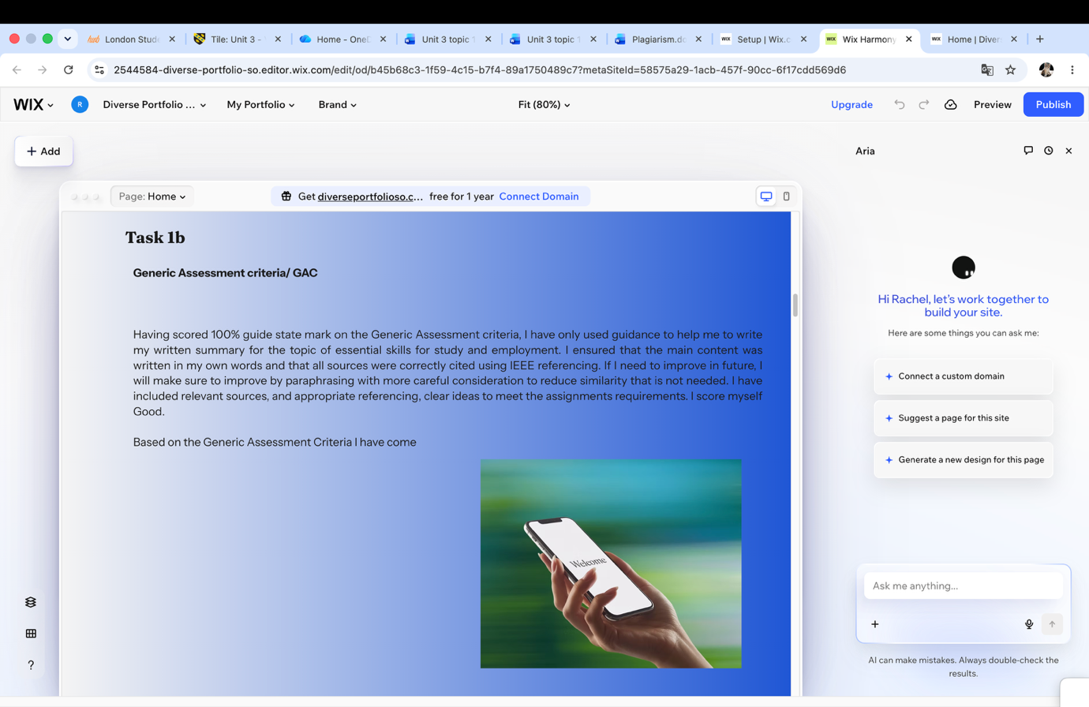

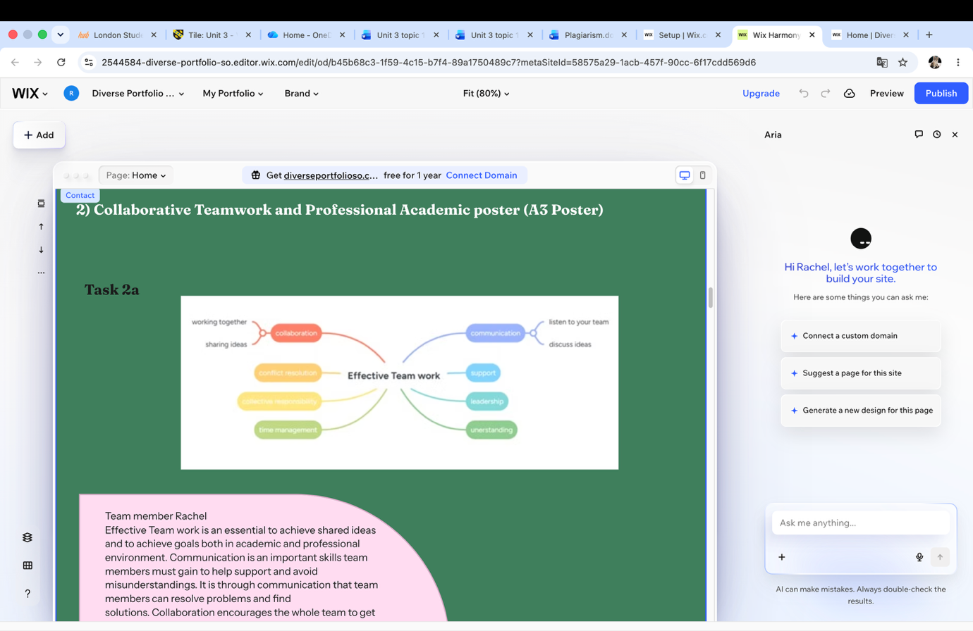

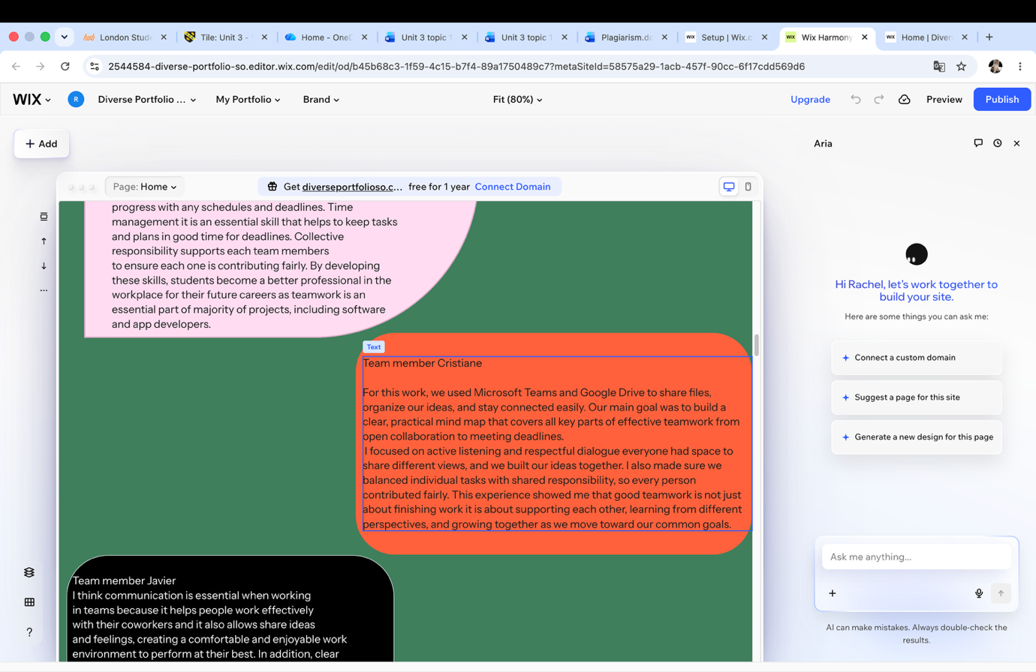

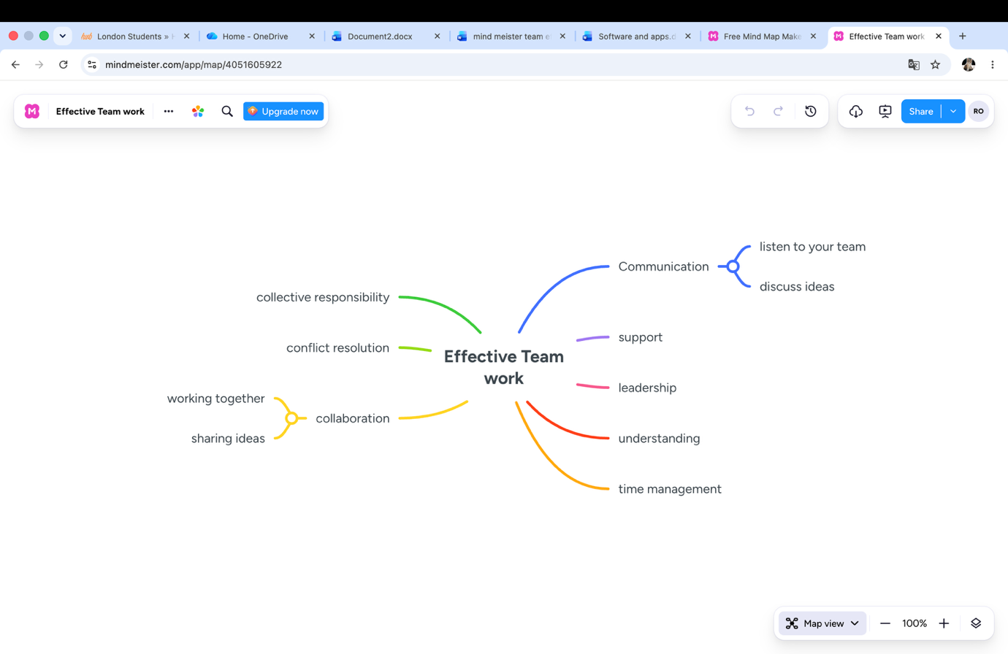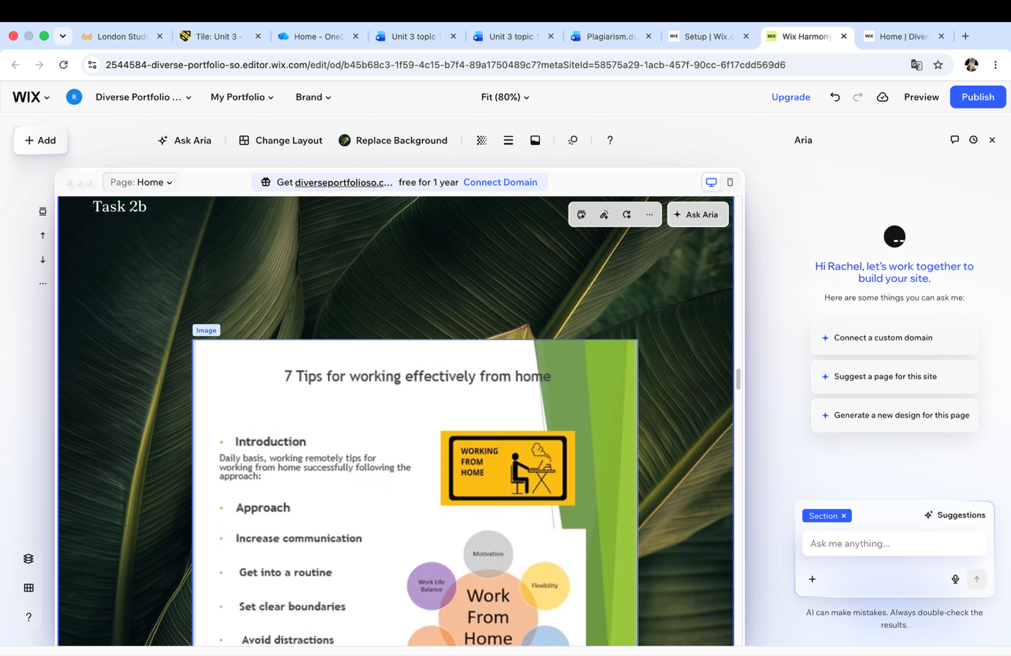

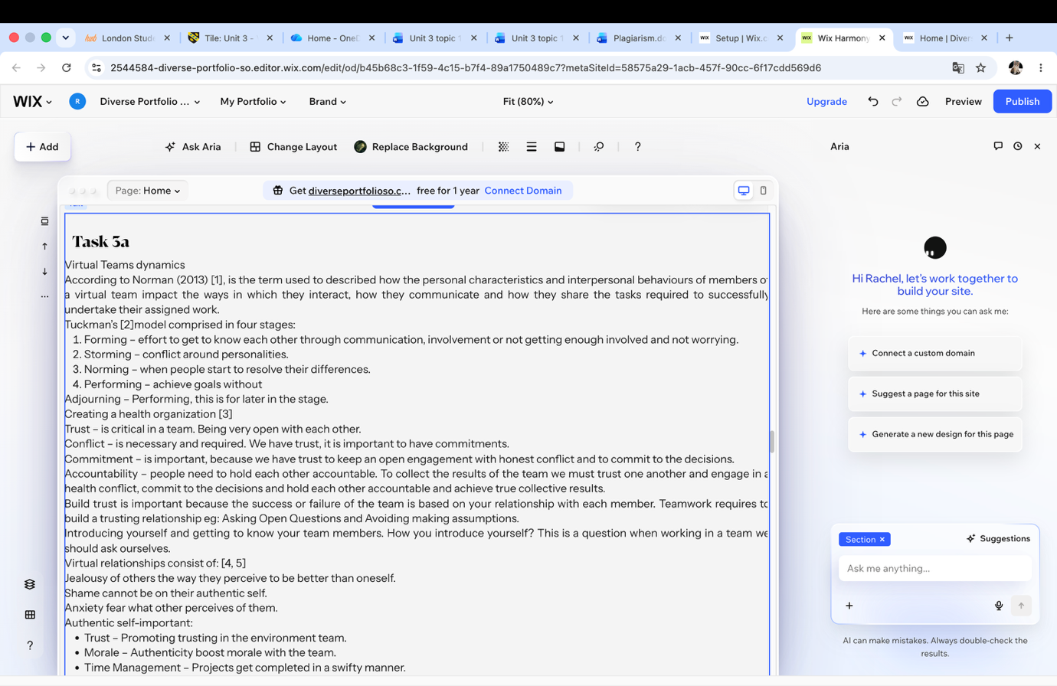

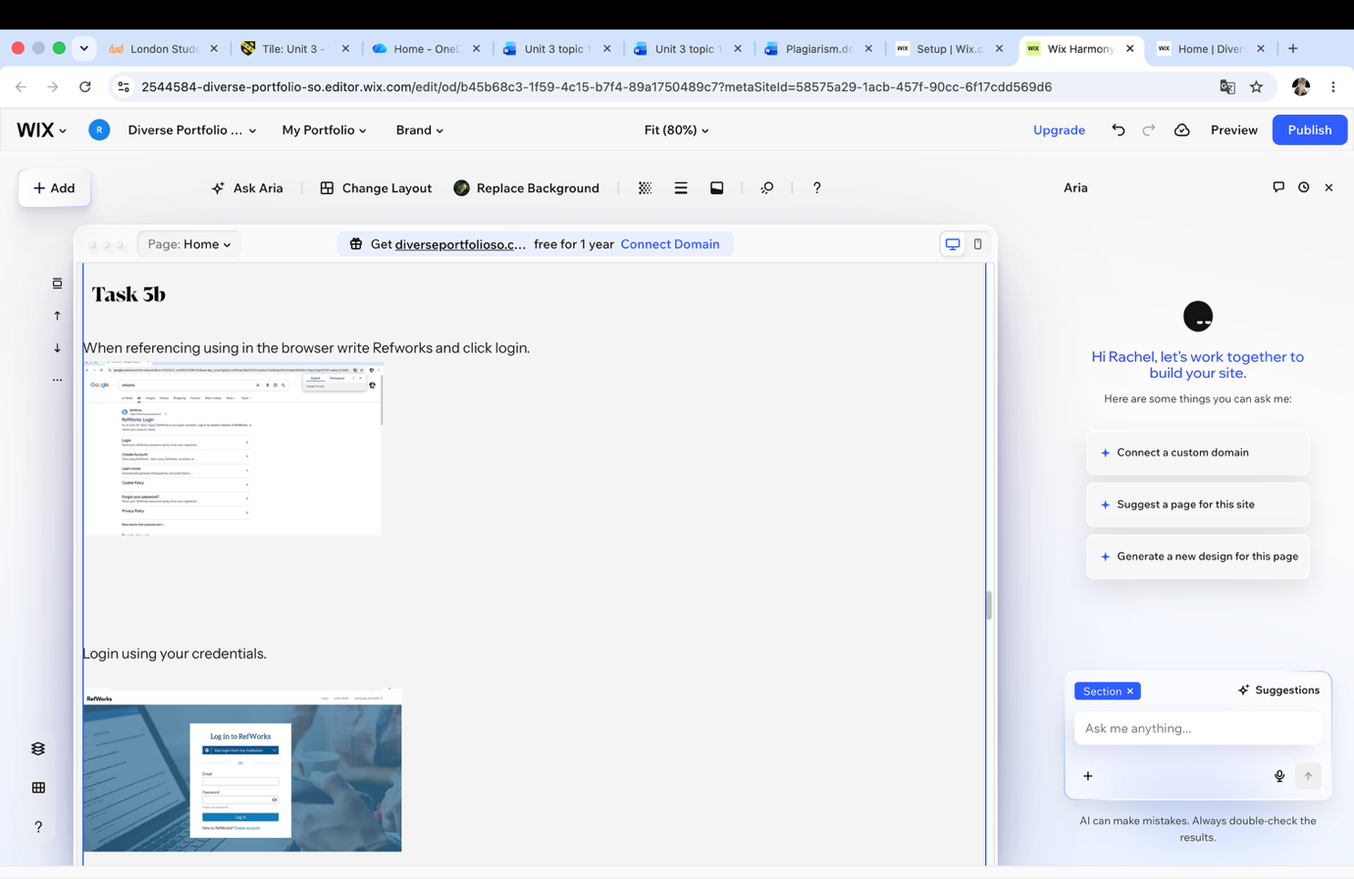

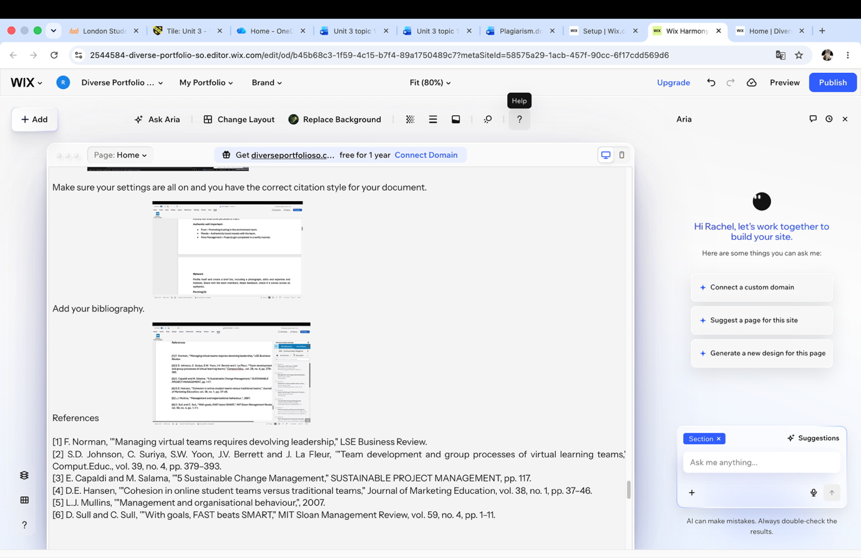

Conclusion
In conclusion that computing in the workplace is an essential skill which requires the ability to understand various tolls provided online. The formation of a teamwork is also necessary so projects can be completed in good time. Overall, good computer skills, good communication, leadership, time management, trust are good professional practice.

References

Task 1 References:
​​[1] D. Vlachopoulos and O. Pachni Tsitiridou, '"Preparing university graduates for the labour market through employability skills development and university–industry collaboration: A systematic review," Education Sciences, vol. 16, no. 3, pp. 426.
​[2] Gov.Uk, '"Digital skills to help your career,", vol. 2026, no. 09/07.
​[3] Gov.UK, '"Driver and Vehicle Standards Agency,", vol. 2026, no. 09/07.​

Task 3 References
​​[1] F. Norman, '"Managing virtual teams requires devolving leadership," LSE Business Review.
​[2] S.D. Johnson, C. Suriya, S.W. Yoon, J.V. Berrett and J. La Fleur, '"Team development and group processes of virtual learning teams," Comput.Educ., vol. 39, no. 4, pp. 379–393.
​[3] E. Capaldi and M. Salama, '"5 Sustainable Change Management," SUSTAINABLE PROJECT MANAGEMENT, pp. 117.
​[4] D.E. Hansen, '"Cohesion in online student teams versus traditional teams," Journal of Marketing Education, vol. 38, no. 1, pp. 37–46.
​[5] L.J. Mullins, '"Management and organisational behaviour,", 2007.
​[6] D. Sull and C. Sull, '"With goals, FAST beats SMART," MIT Sloan Management Review, vol. 59, no. 4, pp. 1–11.

​​

