Introduction
According to Baddeley 1986, working memory has been defined differently by several schools of thought based on the numerous cognitive areas that it incorporates since the notion was first proposed more than 50 years ago. Working memory is thought to be heavily involved in goal-directed behaviours where information must be retained and manipulated to ensure successful tasks. This is the consensus regarding working memory (Baddeley, 1986; Gathercole & Baddeley,1993). The multicomponent working memory model put forth by Baddeley and Hitch was the first competing model to describe the concept of working memory. Two areas of working memory research have received the most attention: verbal and visuospatial. The verbal domain's operation has been well mapped. A substantial amount of research demonstrates that the "phonological loop," a collaboration between processes for speech output and representations of speech phonology, is essential for maintaining verbal information (Baddeley, 1986; Gathercole & Baddeley,1993).
Samantha 2022 suggests the short-term memory for auditory information is controlled by the phonological loop, a region of the brain. Usually, this data is retained verbally in the form of a list of things or a brief narrative. The loop allows individuals to briefly hang on to information so they may alter it, and it is thought to be involved in language processing. To maintain a phone number in their phonological loop, someone can, for instance, repeat it loudly while trying to memorise it. As the loop is believed to have a limited capacity, knowledge that is not practised is frequently lost (Samantha 2022). The working memory contains the phonological loop, which is utilised to process spoken and written words.
According to Samantha 2022 the vocal process, which enables humans to pronounce verbal information repeatedly, and the phonological storage, which stores speech-based information, make up this system. Neurologic of language 2016 suggests the working memory's phonological loop makes a distinction between a phonological store, linked to left frontal activation, and a rehearsal buffer, linked to Broca's area activation. Prefrontal and parietal areas are used by working memory. For verbal/numerical activities, Broca's region and the left frontal areas are active; bilateral activations are more common for nonverbal material (neurologic of language 2016).
The ability to comprehend spoken information makes the phonological loop crucial. Without it, spoken communication would not be possible. Several studies looked at the idea that the length of the words that must be remembered affects the immediate memory span, which is believed to be variable. Short words are frequently more easily remembered on tests of instant recall than longer words. This discovery is frequently explained in terms of the working memory model and the phonological loop's function in immediate recall (Baddeley et al., 1975). The word length effect shows short words are easier to remember quickly than long words. Short words can be spoken more quickly, which explains why more words can be silently spoken before they decay.

Hypothesis
The results indicate that the hypothesis that participants will recall significantly more short words than long words was supported and provides support for the Word length effect.

Methodology

Participants
A convenience sample of thirty-four participants completed both conditions of this study: 2 were male and 32 females. Ages ranged from 18 to 49 years (Median = 25.36, SD = 3.41 years). Participants were all undergraduate students from West Wales who took part in the word length effect test. All participants were naive to the purpose of the experiment.
Design
A related-subjects design was used. There was one independent variable with two conditions: the length of the words presented (long or short). There was one dependent variable: the number of words recalled. Participants took part in both conditions of the experiment.

Materials
15 long words and 15 short words were used. Words included were forgiveness, disorganised, desk and snore. Pen and paper were given. Words were presented on a large screen with a blue background, letters at size 72 arial. Two seconds at a time the words were shown.
Procedure
See appendix 2 for procedure.

Results
The following results present the findings for the word length effect.
The results indicate that the hypothesis that participants will recall significantly more short words than long words was supported and provides support for the Word length effect.
See appendix 4 for SPSS raw data and outputs.

Chart 1
Median scores for long and short words.

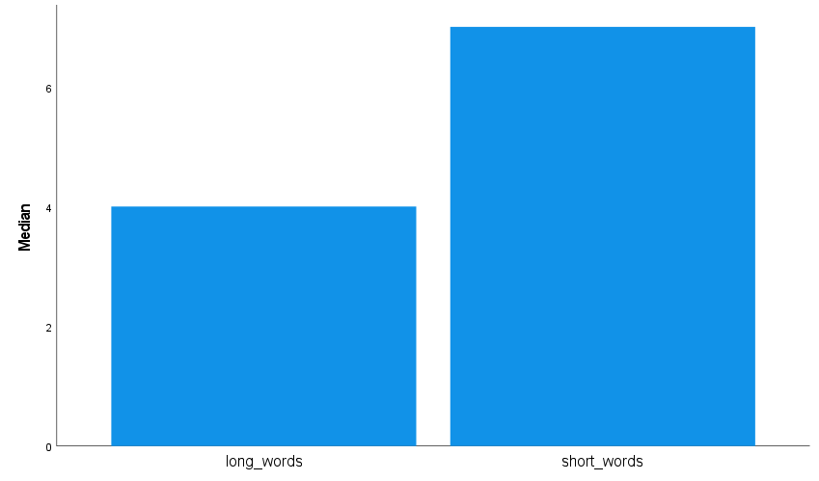

State what the figure in the chart shows (one higher than the other)
In the chart shown above, short words were recalled more than long words.
The median for long words was 4 (SD = 1.35)
The median for short were was 7 (SD= 2.75)

To examine if the median scores for both conditions are significantly different to the probability of .05, the non-parametric Wilcoxon statistical test was carried out.

A Wilcoxon signed-rank test showed a significant difference between the long and short word conditions (Z = -4.98, p<001). Median recall scores for short words were significantly better than for long words (7 and 4 respectively).

Reference list:

Baddeley, A. D. (1986). Working memory. Oxford: Oxford University
Press, Clarendon Press.

Gathercole, S. E., & Baddeley, A. D. (1993). Working memory and
language. Hillsdale, NJ: Erlbaum.

Neurobiology of language (2016). Bradley R. Buchsbaum. (2015),
Rotman Research Institute, Baycrest, University of Toronto, Toronto, ON, Canada. Phonological loop. Retrieved from: Phonological Loop - an overview | ScienceDirect Topics

Samantha, J. (2022). The phonological loop. How it works and what it's responsible for. Retrieved from: The Phonological Loop: How It Works And What It’s Responsible For – ICPHS (icphs2019.org)

WordPress (2015). The phonological loop. Working memory. Retrieved from: The Phonological Loop | Working Memory (wordpress.com)

Appendices

Appendix for long and short words

Table 1 long and short words
Word List Table
Condition 1 – Long Words | Condition 2 – Short Words
Transaction | Desk
Forgiveness | Leap
Physician | Mood
Proximity | Tank
Constitution | Rules
Rationalise | Roof
Interaction | Mend
Deductions | Snap
Representation | Tomb
Impatiently | Slow
Reinstate | Tape
Intimidating | Rack
Disorganised | Snore
Understanding | Lose
Illuminate | Paid

Appendix 2 procedure

Standardised procedures
To ensure that all participants have the same experience, researchers should ensure that they are all tested:
- In the same place, with the same equipment and materials placed in the same way.
- Under the same conditions, so the level of lighting, noise and heat remains the same for all
participants.
- At roughly the same time of day, as people may behave differently if tested at nine o'clock in the morning rather than five o'clock at night.
- Given identical standardised instructions in the same way.

Standardised Instructions: these are given in the chosen location and there may be more than one set for different (IV) conditions of the investigation. The standardised instructions are important, as each participant must receive the same instructions, so they understand what to do in the study. Also, it ensures that each participant is treated the same and should help eliminate experimenter effects. You can read the instructions to the participant(s) or let them read the instructions themselves.

Standardised procedure for the word length effect study
An opportunity sample of students was used. Presumptive consent was gained.
The following instructions were presented verbally:
- Participants were asked to sit quietly facing the projector screen situated on the wall in front of them.
- You will take part in a short memory task.
- Please ensure that you have a pen and paper in front of you.
- Can you all see the screen and text on the power point clearly?
- You will be presented with 2-word lists – consisting of 15 words each.
- Following the first list – you will be asked to write any words remembered from the list (in any order). The next 15 words were presented in the same way.
- Participants received the long words first followed by the short words. They had 90 seconds to recall and write down the words from list one and list two.
- Words were presented in the middle of a blue screen every 2 seconds, for 1 second.
- The font was Arial, white, size 72.
- Participants were thanked for their participation.
- Participants were fully debriefed regarding the aim and hypotheses of the experiment.
Following the making of the accuracy of recalled words, raw data was analysed using a Wilcoxon signed-rank test on SPSS 26.

Appendix 3 raw data

Short words long words
5 2
6 5
5 3
3 1
2 3
6 4
4 1
4 5
8 7
4 3
12 6
9 4
6 2
5 3
9 4
11 5
7 4
8 4
6 2
7 3
10 3
7 4
12 5
9 4
12 5
6 3
4 2
9 5
11 4
6 5
8 4
9 3
11 4
9 5

Table number of words recalled.

Appendix 4 SPSS outputs

NPar Tests

Chart 1

Descriptive Statistics
 | N | Mean | Std. Deviation | Minimum | Maximum | Percentiles
 |  |  |  |  |  | 25th | 50th (Median) | 75th
longwords | 34 | 3.74 | 1.355 | 1 | 7 | 3.00 | 4.00 | 5.00
short words | 34 | 7.35 | 2.751 | 2 | 12 | 5.00 | 7.00 | 9.00

Table 3

Ranks
 |  | N | Mean Rank | Sum of Ranks
short words - longwords | Negative Ranks | 2ª | 3.50 | 7.00
short words - longwords | Positive Ranks | 32^{b} | 18.38 | 588.00
short words - longwords | Ties | 0^{c}
short words - longwords | Total | 34
a. short words < longwords
b. short words > longwords
c. short words = longwords

Table 4

Test Statistics
 | short words - longwords
Z | -4.981^{b}
Asymp. Sig. (2-tailed) | <.001
a. Wilcoxon Signed Ranks Test
b. Based on negative ranks.

Appendix 5 consent form


Centre for Psychology and Counselling

Study Consent Form
I understand that this research study is being carried out by a 1st year Psychology Student for their dissertation, and that taking part in this study will involve an examination on long and short words recalled in the word length effect.
This study will take approximately 10 minutes to complete.
I understand that participation in this study is voluntary, and I am free to withdraw participation during or at the end of the study without giving a reason. I understand that once I leave the study, I will not be able to withdraw my data, as it will be anonymized. I am aware that if I have concerns about the study, I can discuss these concerns with the researcher at any time during or after the study. I understand that I will be provided with the contact details of the research supervisor at the end of the study, should I have any concerns.
I understand that the information provided by me will be held confidentially, with a code assigned in place of my name. These data will be stored indefinitely in accordance with the Data Protection Act.
I also understand that at the end of the study I will be provided with a debrief form and the opportunity to discuss any issues with the researcher.

I, ___________________________________(NAME) consent to participate in the study conducted by Gemma Vaughan, Centre for Psychology and Counselling, University of Wales Trinity Saint David, under the supervision of Charlotte Greenway.

Participant Signature: ________________________________________________
Date: ___________________
Name and signature of researcher taking consent.
___________________________________________________________________

Appendix 6 debrief sheet.

Centre for Psychology and Counselling

Study Debrief Sheet

The word length effect

Thank you for taking part in the study.

The aim of this study was to explore long and short words, We specifically wanted to find out whether more short words were recalled more than long words.

If you wish to withdraw your data from the study, you must tell the researcher now. After this point, all of your data will be anonymised, and we will not be able to trace it back to you.

If taking part in this study has raised any questions, please speak to the researcher on Gemma Vaughan, 2203490@student.uwtsd.ac.uk or contact the academic supervisor Charlotte Greenway, C.Greenway@uwtsd.ac.uk.

Thank you once again for taking time to participate in this study.

Gemma Vaughan
(BSc applied psychology)
University of Wales Trinity Saint David

Appendix 7 information sheet
Centre for Psychology and Counselling

Study Information Sheet
This document provides key information regarding the study and provides details about what will be expected of you as a participant. Therefore, please read this information carefully before providing consent to take part.
During this study you will be required to do the following:
  - Recall several long and short words.
  - The word length effect.
  - Further instructions on how to complete this will be provided at the top of the questionnaire.

- You will then be presented with a list of 30 words on the computer screen.
  - Each word will be presented individually for two seconds, and your task is to simply read the word
  - Whilst the words are being presented, you will be required to look and remember carefully at how many words you can recall.

- Once all the words have been displayed, you will then be given ten minutes to complete as much of the words as possible.
- You will then be required to write down as many of the words as you can remember on the piece of paper provided. You will have two minutes to complete this task. Once the two minutes is up, that will be the end of the study.
At the end of the study, you will be debriefed by the researcher and you will be provided with the study debrief sheet.
If you feel you would be uncomfortable with this study, please retain from taking part.
If you have any questions, please ask the researcher now.
If you are happy to take part in this study, please read and sign the consent form.

