Business Plan for
ENTREPRENEURSHIP BMIH5001
Business Plan for:
Lecturer: | Neil Dyer
Date: | 27.02.2024
Team members: | Beatrice Alexandra Crisan (2208395)  Andreea Loredana Mirica (2028692)  Codruta Daniela Bogatean(2210404)  Marika Henszek (2208214)


Business plan contents
Executive Summary…………………………………………………………………………………………………………….3
1 Executive summary 3
2 Business details 4
3 Key personnel 5
Vision 6
4 The business idea 6
5 Business goals 6
6 What the business does 7
7 What makes the business different 7
8 Legal requirements 7
Marketing 8
9 Market research 8
10 Profiling customers 8
11 Profiling competitors 9
12 Managing market risks 9
13 Pricing 9
14 Promotion and advertising 10
Running the business 11
15 Staff 11
16 Premises 11
17 Suppliers 11
18 Equipment 12
19 Managing operational risks 12
Finance 13
20 Start-up costs 13
21 Profit and loss forecast 15
22 Sourcing finance 16
23 Managing financial risks 16
24 Cash flow forecast 17

1 Executive summary

Vision Forest House, located in Cadnam, Southampton, offers a unique and immersive experience with three bedrooms, a BBQ area, a hot tub, and a play zone against the backdrop of a lush forest. Led by experienced directors in finance, supplies, cleaning, and marketing, Vision aims to achieve a £68,000 turnover in its first year. The business targets diverse customer segments, providing a blend of comfort and nature experiences. With a strategic focus on unique offerings, competitive pricing, and effective marketing, Vision aspires to become an iconic eco-friendly hospitality landmark in the next 3-5 years.

2 Business details

Company name:

The Vision Forest House

Address:

Cadnam
Southampton
SO40 2NG

Primary contact method:

thevision@gmail.com

The business will:

Vision is more than just a place to stay; it's an immersive experience designed to captivate the senses and provide a respite from the ordinary. With three beautifully appointed bedrooms and a range of thoughtful amenities. The meticulously designed backyard features a state-of-the-art BBQ area, an inviting hot tub, and a vibrant play area for children, all set against the backdrop of Cadman’s lush forest. This setting promises an unparalleled stay for families, nature enthusiasts, and anyone looking to escape the hustle and bustle of city life.

3 Key personnel

Details of owner(s):
Name: Henszek Marika
Position/main responsibilities: Director/Finance manager
Experience and knowledge of our industry:
Led financial planning, budgeting, and forecasting processes. Implemented robust financial controls and risk management strategies, ensuring compliance with industry regulations. Oversaw the preparation of monthly, quarterly, and annual financial reports.
Previous employment: Nature Haven Resorts(2018-2022)
Key skills brought to the business: Financial Planning and Analysis, Budgeting and Forecasting, Risk Management, Financial Reporting, Team Leadership, Cost Control, Strategic Financial Planning, Data Analysis, Compliance and Regulation.
Business experience and any training undertaken: 5 years in business
Academic/professional qualifications:
Bachelor’s degree in finance, Accounting, Business Administration/Chartered Financial Analyst (CFA)

Salary expectations £ 0

Name: Codruta-Daniela Bogatean
Position/main responsibilities: Director/ Supplies /Equipment
Experience and knowledge of our industry: Vendor Management ,Inventory Control /Maintenance, and operations
Previous employment: Nature Haven Resorts(2018-2022)
Key skills brought to the business :Proven ability to manage relationships with key suppliers, negotiation skills for securing favourable terms and cost-effective procurement/Management of the lifecycle of various assets, from furniture to specialized amenities, knowledge of maintenance and repair procedures for various equipment
Business experience and any training undertaken: 2 years in suppliers and equipment
Academic/professional qualifications:, Certification in Supply Chain Management, Training in Equipment Maintenance and Technology, Professional Development Courses

Salary expectations £ 0

Name: Beatrice Crisan
Position/main responsibilities: Director/Cleaner
Experience and knowledge of our industry: Operational Excellence, Quality Assurance ,Customer Service
Previous employment: Nature Haven Resorts(2018-2022)
Key skills brought to the business: : Expertise in maintaining high cleanliness standards, time management skills for efficient and effective cleaning operations
Business experience and any training undertaken: 5 years in the cleaning industry
Academic/professional qualifications: Bachelor’s degree in business administration , Professional Development Courses.
Salary expectations £ 0
Name: Andreea Mirica
Position/main responsibilities: Director/Marketing
Experience and knowledge of our industry: Digital Marketing Mastery, Brand Development, Customer Engagement.
Previous employment: Nature Haven Resorts(2018-2022)
Key skills brought to the business: Strategic Branding ,Digital Marketing Expertise , Market Research and Analysis , Innovative Campaign Management
Business experience and any training undertaken: Successfully managed cross-functional teams, collaborating with departments to align marketing strategies with overall business objectives
Academic/professional qualifications: Bachelor’s degree in marketing, Certified Digital Marketing Professional (CDMP) with specialized training in online marketing strategies
Salary expectations £ 0

Vision

4 The business idea

Sum up your business idea:
Based on the BMC (Appendix 1) Vision Airbnb aims to provide a unique and comfortable space for various customer segments, leveraging partnerships, key resources, and customer relationships through online and offline channels, with a diversified revenue stream from both rental and event hosting.

5 Business goals
- What do you want to achieve in your first year of business?
- Vision is an LTD with four shareholders for profit and anticipates a turnover of £68,000 in the first year of operation, driven by a combination of accommodation fees, additional service revenues, and merchandise sales.

- Where do you see your business in 3-5 years’ time?
- In the next 3 to 5 years, we envision Vision as an iconic landmark in eco-friendly hospitality, renowned for its harmonious integration with nature and exceptional guest experiences.

6 What the business does:

Vision is thoughtfully designed to blend seamlessly with the natural surroundings, offering guests a tranquil escape. Unlike traditional accommodations, Vision offers a truly unique and memorable experience, guided forest hikes, wildlife observation, and stargazing, immersing themselves fully in the beauty and serenity of the wilderness.

Product/service | Features | Benefits
- 3 Bed house in the forest | - Privacy and Serenity  - Thoughtful Design  - Comfortable Accommodation | - Escape from Urban Life  - Ultimate Relaxation  - Reconnection with Nature
- Wildlife Observation | - Variety of Trails  - Educational Content | - Exploration and Adventure  - Learning Experience  - Physical Activity

7 What makes the business different (Value Proposition)
Your product/service is unique or different compared with the competition because:
- Special Location: It's in a beautiful forest, so you can escape from city life and enjoy nature.
- Personal Attention: They care about each guest and make them feel welcome and special.
- Taking Care of Nature: we use clean energy and try not to harm the environment.
- Cozy Rooms: The rooms are comfy and nice, perfect for a relaxing stay.
- Nature Adventures: You can go on guided walks and explore the forest.
- Extra Fun: They offer cool activities like tours and spa treatments.
Overall, Vision is a unique place where you can relax, have fun, and connect with nature.

8 Legal requirements
The legal and insurance requirements that apply to your business are:
- We need to obtain necessary permits for operating a hospitality business in a forested area, to adhere to regulations concerning guest safety, food handling, and sanitation standards and to comply with environmental regulations and obtain permits for activities that may impact the surrounding ecosystem.
You will meet your legal and insurance requirements by:
- Safety Regulations involve conducting thorough risk assessments of the property, implementing safety protocols, and ensuring that all structures and amenities meet building codes and safety standards.
- Comply with food handling regulations by implementing proper food safety protocols, and training staff in safe food handling practices.
- Obtain permits for any activities or developments that may impact the surrounding ecosystem, such as trail maintenance, and waste management.
- Through meticulous planning, sustainable practices, and a commitment to guest satisfaction, Vision aims to carve a niche in the hospitality industry by offering a truly transformative forest retreat experience.

Marketing

9 Market research

Trends in your chosen market are:
The latest trends in hospitality marketing are essential for businesses to remain competitive, attract clients, and develop a relationship of trust with their target market. This business plan's trend research will be based on a Pestle analysis(Appendix 4) of Airbnb accommodations.

How you know this:
- AIRBNB's analysis of social trends considers shifts in consumer preferences, demographics, and lifestyle. AIRDNA (2022) reports a growing preference for experiential travel, with Airbnb experiencing substantial growth. This trend is driven by a desire for unique, authentic experiences, such as forest homes, small homes, and farm stays, over traditional hotel alternatives. Tourists choose accommodations with distinctive amenities like hot tubs, panoramic views, barbecue facilities, and outdoor space. (Appendix 2)
- As Paulton Parks and the New Forest region evolve into more popular tourist attractions, there is a greater demand for accommodations, which is driving up the cost of lodging in Cadnam and the adjacent communities around Paulton Parks. Liley, et.al. (2020) stated in a survey that with its distinct recreational options, the New Forest brought in 15.2 million visitor days in 2017 and 17.6 million by 2037.
- Due to the beautiful surroundings and accessibility for outdoor exploration, the Cadnam, New Forest region is seeing a rise in outdoor and adventure travel. According to CRRHOSPITALITY 2024, the adventure tourism market is expected to generate $1.3 trillion in worldwide revenue by 2026, with $683 billion in US expenditure occurring annually.

10 Profiling customers

The customer groups you will be selling to are:
Family search for peace and comfort
- Demographic:35-44 , equal genders , moderate to high incomes
- Interests : Prioritize leisure , family time , comfort
- Behaviour: Invest in spacious, outdoor accommodation near Paulton Theam Park.

Friends on Weekend Getaways:
- Demographic :25-34-year-old ,equal gender distribution.
- Interests: Seek amusements , adventure ,social interaction
- Behaviour: Attracted to shared space, entertainment activities, party organisation.

Business Travelers Seeking Peaceful Workspace
- Demographic: 45-54, male, higher income
- Interests: relaxation, comfort, workspace-friendly facilities.
- Behaviour: fast internet, work area, near conference locations.

Couples Seeking Intimate Retreats
- Demographic: 25-45, equal gender, moderate -high income.
- Interests: Romanticism, privacy
- Behaviour: Spend on romantic lodgings with hot tub and panoramic views

Your customer research has shown what your customers want is:
- According to (2023) research by Airbnb, family travel has increased by 60% because of the company's value, space, and affordability. Additionally, a 2022 Family Travel report highlights the importance of experiences that enhance families' togetherness and well-being while enjoying theme parks and outdoor activities.

- Airbnb statistics reveal a diverse customer base, with 46.43% male and 53.57% female, with 11.78% aged 18-24. The highest age group is 25-34 years, followed by 35-44 years, 17.68% and 11.67% aged 45-55 years, and 55-64 years. The baby bloomers club has 7.46% aged 65 and above, (similar web, 2024).
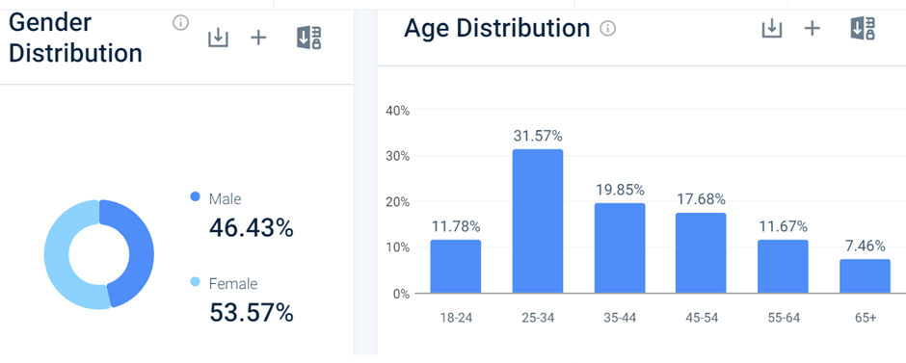
Furthermore, evaluating customer reviews from surrounding houses with poor Wi-Fi (AIRBNB, 2023), less cooking amenities, no hot tub or BBQ, (AIRBNB, 2022) research indicates a significant need for family-friendly lodging close to Paulton's Theme Park ,Vision offers features such large living rooms, private outdoor areas, romantic retreats, communal places, and business-related amenities.

How you know this:
- Targeting clients entails customising marketing strategies, offering valuable services, and providing family-friendly amenities to suit each client's specific demands to maximise occupancy and income potential.

Number of customers you expect to win in each group and what they might pay:
Group | Number of customers | Price they might pay per unit
Families with children | 50% | £200-£250
Groups of friends | 25% | £250-£300
Business Travelers | 10% | £150-£200
Couples Seeking for Romantic Getaways | 15% | £250-£300

11 Profiling competitors

Competitor name | Strengths | Weaknesses
- Twin Oaks Guest House | - Ideal location before a cruise | - Unavailable during the busiest time of the year
- Le Chateau | - Staff friendly | - High price for what they offer
- The Bell Inn, New Forest | - Amazing meal | - Bad customer service
- Bartley Lodge Hotel | - Fantastic venue for events | - Laking employees , requiring investment
- Travelodge Stoney Cross Lyndhurst | - Good price , great location | - Noisy issue, dirty accommodation

How you can improve on their offer and/or price(s) unique offerings:
Vison Forest House strategy to differentiate from competitors is to enhance its offerings and pricing to attract more customers and establish itself as a preferred accommodation choice in the Cadnam area near Paulton Theme Park as follows:

Upgraded Facilities and Services:

- Offer extras like free breakfast,
- Tour guides.
- Having panoramic landscapes,
- Having hot tub amenities.

Targeted Marketing and Promotions:
- Create ads emphasising special attributes such as being close to Paulton's Theme Park,
- Utilise online platforms like Facebook, Instagram, and Twitter

Flexible Pricing Strategies:
- Apply pricing tactics.
- According to consumer demand,
- The seasons,
- Local events.

Attention to excellent customer experiences and customer service.

Stress environmentally friendly and sustainable methods.

Invite famous people to The Vision House for a complimentary lunch and stay in exchange for excellent publicity.

12 Managing market risks

Write down the risks you have identified:
As seen in SWOT (Appendix 3)analysis risks include:
- variations in the weather,
- increased competition,
- negative reviews due to maintenance, cleaning, or customer service.

How will you manage these risks so that they become less of a threat:
- For guests to enjoy during bad weather, The Vision House provides indoor activities. They also, accommodate visitors' requests for refunds or rescheduling by implementing flexible cancellation procedures.

To stand out from the competition, The Vision House is utilising innovative marketing strategies. With a focus on its USPs, the business is improving its marketing initiatives, bringing in new clients with focused advertising, highlighting the advantages of staying at The Vision House, such as its scenic location, amenities, and personalized services. and building enduring ties with clients through customer loyalty plans.

It is important to promptly deal with maintenance concerns, carry out periodic checks, and train staff to cope with difficult situations to avoid bad reviews.

13 Pricing

How you can calculate your prices:
To determine pricing, demand for Airbnb must be analysed in terms of location, facilities, time of year, competitor analysis, customer reviews and the value proposition which considers the unique benefits and futures of the business (Maraga, 2023).

How your prices compare with the competition:
Product/service | Your price(s) | Range of competitor prices (per unit)
Families with children | £200-£250 | £180-£300
Groups of friends | £250-£300 | £200-£350
Business Travelers | £150-£200 | £120-£250
Couples Seeking for Romantic Getaways | £250-£300 | £200-£350

Reasons for the difference between your price(s) and your competitors’ price(s):
- Special features of the property, such a hot tub, stunning views, and grilling facilities, support higher rates.
- Location: The cost is influenced by how close Paulton’s Theme Park and the New Forest region are.
- Service Quality: Superior guest experiences and customer support can lead to higher prices.

14 Promotion and advertising

How and where will you promote your product/service?
Promoting The Vision Forest House, requires a targeted marketing approach to reach potential customers effectively.
1 Online Presence Strategy:
• Establish a professional site that features lodging options, amenities, and reservation details.
• Use social media sites for promotions and images, such as Facebook, Instagram, and Twitter.
• For better publicity and bookings, collaborate with OTAs like Booking.com, Airbnb, and Expedia
2 Strategy for Content Marketing:
• Create interesting blogs, videos,
• Highlight the New Forest region, things to do with kids, and travel advice.
• Collaborate with celebrities to get free lunch and rooms in return for great publicity.

3 Classical Advertising:
• Run posts in local papers, magazines, or travel guides.
• Sponsorship to community events.

4 Reviews and Word-of-mouth:
• Build up positive reviews from visitors on websites like TripAdvisor, Google
• Provide rewards for recommendations to encourage suggestions

Running the business

15 Staff

Role | Total cost | Necessary experience | Specialist skills and/or qualifications
- Cleaner from year 2 | £5000 | - Previous experience preferred but not essential as full training will be provided (Indeed,2024) | - Attention to detail  - Time management  - Self-motivation  - Understanding of Cleaning products and equipment  - Basic maintenance skills

16 Premises

 | Cost £
Premises required at start-up: 3-bed houses inherited | £0
Premises required in the future (if different): 2nd House in Forest of Dean, New Road, Aylburton, Lydney GL15(Zoopla,2024) | £37.678/pa  £3140/month

17 Suppliers

Your key suppliers and their credit terms
Supplier | What you’ll buy from them | - Number of days’ credit
- British Gas/Southern Water/Sky | - Electricity, water, gas, and internet connectivity | - Every month
- Safety | - Smoke and carbon monoxide detectors  - First aid kit | - 1 year
- Proper insurance | - Policy cover | - Every month
- Ikea Business/Way Fair/ Local Furniture Store/Garden trends/ | - Furniture and decor  - Kitchen essentials  - Outdoor furniture/BBQ/  - Kids outdoor toys | - 3-5 years
- Tradepoint/ Cosco/Homebase Trade UK/B&Q Trade | - Kitchen and all-around appliances  - Cleaning supplies | - 3 years
- Dunelm/The White Company/Argos | - Bedding and liens | - 6 months
- Cosco/Booker Wholesale | - Coffee/condensed milk | - monthly
- Out of Eden/Green People | - Eco friendly shampoo, conditioner, shower gel and soap. | - monthly

18 Equipment
Our commitment to providing an unforgettable experience begins with the carefully selected equipment and furnishings that adorn our cosy abode. Sourced from reputable suppliers like Amazon, Argos, Curry’s, Garden Trends, Ikea, Outdoor Toys, The Range, and The White Company, each piece has been chosen to create a harmonious blend of comfort and style.
(Amazon,2024),(Argos,2024),(Currys,2024),(Garden Trends,2024),
(Ikea,2024),(Outdoor Toys,2024),(The Range,2024),(The White Company,2024)

Resource | When | How funded | Cost £ per unit
- Beds | - beginning | - loan | £399
- Mattress | - beginning | - loan | £159
- Bedside tables | - beginning | - loan | £49
- Wardrobes | - beginning | - loan | £277
- Rugs | - beginning | - loan | £37
- Bedding | - beginning | - loan | £63
- Lamps | - beginning | - sales | £64
- Lights | - beginning | - sales | £44
- Curtains | - beginning | - sales | £37
- Linens | - beginning | - loan | £130
- Bathroom cabinet | - Beginning | - loan | £430
- Towels | - beginning | - sales | £10
- Bath robes | - every 3 months | - sales | £70
- Slippers | - every month | - sales | £3
- Paintings | - beginning | - sales | £30
- Sofa | - beginning | - loan | £1.070
- TV stand | - beginning | - loan | £93
- TV | - beginning | - loan | £1699
- Coffee table | - beginning | - loan | £129
- Dressing table | - beginning | - loan | £99
- Mirrors | - beginning | - sales | £10
- Desk | - beginning | - loan | £70
- Dining table | - beginning | - loan | £330
- Chairs | - beginning | - loan | £88
- Cooker | - beginning | - loan | £719
- Fridge/freezer | - beginning | - loan | £999
- Washing machine | - beginning | - loan | £399
- Dryer | - beginning | - loan | £579
- Dishwasher | - beginning | - loan | £519
- Microwave | - beginning | - loan | £209
- Toaster | - beginning | - loan | £40
- Kettle | - beginning | - loan | £35
- Smoke and carbon detector | - beginning | - sales | £53
- Coffee machine | - beginning | - sales | £35
- Kitchen essentials | - beginning | - loan | £300
- First aid kit | - beginning | - sales | £29
- Outdoor furniture | - beginning | - loan | £1.409
- Kids outdoor toys | - beginning | - loan | £1.060
- Hot tube | - beginning | - loan | £499
- BBQ and outdoor fridge | - beginning | - loan | £1.899
- Cloths | - every 6 months | - sales | £15
- Hot tube chemicals | - every 2 months | - sales | £120

19 Managing operational risks
Risk | Solution
Staff  Staff turnover  Lack of Training  Staff Availability | Increase worker retention via competitive compensation, a nice work environment, and training and development. Regular feedback helps resolve issues and boost work satisfaction.  Staff should get rigorous training in customer service, cleanliness, safety, and emergency procedures. Update training materials regularly to reflect operational and regulatory changes.  Create a flexible staffing approach with full-time, part-time, and on-call personnel to meet demand. Contact temp agencies for fast staffing at busy hours.
Suppliers  Supply Chain  Disruptions Quality Issues  Price Volatility | Avoid relying on one provider for essentials by diversifying. Regularly evaluate supplier performance and replenish crucial goods to avoid short-term interruptions.  Conduct extensive due research before hiring new suppliers and setting quality standards in contracts. Make frequent quality inspections on incoming goods and contact suppliers immediately if problems arise.  Use long-term contracts to lock in pricing. Join a purchasing club for critical commodities with variable costs to negotiate better pricing.

Finance

20 Start-up costs

Calculate how much money you need before you start trading.

* Total from here should be used in 22 Sourcing finance below

21 Profit and loss forecast

22 Sourcing finance

There are different approaches available to startup businesses for obtaining funding, each with various benefits and drawbacks of their own. Additionally, major financial institutions provide startup-friendly loans that ease the loan application process by allowing the business to borrow a set amount at a time and make payments on time. Strict eligibility demands, a high rate of interest, and the need for protection, however, may be the source of issues, particularly to new businesses with no previous record of success in running the business (Oranburg, 2020).
According to Kurpjuweit and Wagner (2020) the use of crowdfunding as a more affordable financing option is expanding. Through platforms like Indiegogo or Kickstarter, entrepreneurs can generate money from a large group of supporters. However, sales performance is based upon the success of advertising, which also charges fees. besides that, in exchange for debt, startups with accelerators and incubators provide funding, opportunities for collaboration, and mentorship to help businesses grow faster. Regarding this company strategy, the relevant authority has chosen to begin the venture with the help of an institutional loan in addition to its own contribution.

Total borrowing requirement for the business

23 Managing financial risks (such as, sales are less than forecasted or start-up finance taking three months longer to obtain)

The risks that you have identified for your financial forecast are:
Entrepreneurs operating this Airbnb business should take note of many kinds of aspects to make sure that the financial base is stable to successfully operate The Vision. Considering all the costs and expenses the owners must understand the challenges and unforeseen events that could occur. For example, property–related risks, lack of booking that leads to loss of revenue and not reaching the forecast, natural disasters, or unforeseen events.

How you will minimise their impact:

To eliminate the effect of the identified risks for the financial forecast, particular strategic measures could be adopted. The organisation must conduct an in – depth review of the pricing strategy and the cost structure to increase gross profit margin. This may include optimizing the operational process or for example evaluating product prices to get a higher margin (Eldering, Ende and Hulsink, 2023).

24 Cash flow forecast

25 Conclusion.

Vision Forest House presents a compelling business plan, leveraging its distinctive features, experienced team, and strategic positioning in the hospitality market. By addressing legal requirements, conducting thorough market research, profiling customers, and managing operational and financial risks, Vision aims for sustainable growth. With a commitment to exceptional customer experiences, environmental responsibility, and competitive pricing, Vision Forest House sets out to redefine forest retreat experiences and establish itself as a premier destination in eco-friendly hospitality.

26 References

- AIRBNB (2023) Charming Annex in the New Forest, Brockenhurst.
Available at: https://www.airbnb.co.uk/rooms/26565048?adults=1&children=0&enable_m3_private_room=true&infants=0&pets=0&check_in=2024-03-24&check_out=2024-03-29&source_impression_id=p3_1708287065_ODC%2BEh6%2B5i9VHoKy&previous_page_section_name=1000&federated_search_id=1c72f44b-2397-4b8b-ba8e-fc05115e6789
(Accessed: 20 February 2024).

- AIRBNB (2023) Families find value, more space when traveling on Airbnb. Available at: https://news.airbnb.com/families-find-value-more-space-when-traveling-on-airbnb/
(Accessed: 17 February 2024).

- AIRBNB (2022) Private" Garden" suite, in Cadnam, New Forest. Available at: https://www.airbnb.co.uk/rooms/6921654?adults=1&children=0&enable_m3_private_room=true&infants=0&location=Cadnam%2C%20United%20Kingdom&pets=0&check_in=2024-03-03&check_out=2024-03-08&source_impression_id=p3_1708288420_gQ7h7SG7wNoJWvPm&previous_page_section_name=1001&federated_search_id=de0781a6-573e-4fd1-b68c-26ef002af278
(Accessed: 20 February 2024).

- Airbnb (2021) Report on Travel & Living (2021). Available at:https://news.airbnb.com/wp-content/uploads/sites/4/2021/05/Airbnb-Report-on-Travel-Living.pdf
(Accessed: 21 February 2024).

- AIRDNA (2022) Apartment or A-Frame? Why Unique Airbnbs Outperform the Rest.
Available at: https://www.airdna.co/blog/unique-airbnbs-outperform-the-rest
(Accessed: 12 February 2024).

- Amazon(2024) Equipment, outdoor furniture, first aid kit, smoke, and carbon detector. Available at: https://www.amazon.co.uk/s?k=outdoor+furniture&crid=161CW4GZVW9Z8&sprefix=outdor+furniture%2Caps%2C95&ref=nb_sb_ss_ts-doa-p_1_16 (Accessed: 22 February 2024)

- Argos (2024) Equipment, kitchen appliances. Available at: https://www.argos.co.uk (Accessed: 22 February 2024)

- Bartley Lodge Hotel (2024) Bartley Lodge Hotel. Available at: https://www.google.co.uk/travel/search?q=bartley%20lodge%20hotel%20reviews&g2lb=2502548%2C2503771%2C2503781%2C2504375%2C2504510%2C4258168%2C4284970%2C4291517%2C4814050%2C4874190%2C4893075%2C4965990%2C10208620%2C72277293%2C72302247%2C72317059%2C72406588%2C72414906%2C72421566%2C72430562%2C72458066%2C72462234%2C72469155%2C72470440%2C72470899%2C72471280%2C72472051%2C72473738%2C72473841%2C72476339%2C72483525%2C72484083%2C72484736%2C72485656%2C72486593%2C72494250%2C72496942%2C72498532%2C72505360&hl=en-GB&gl=uk&ssta=1&qs=CAEyE0Nnb0k3Zld6dmJhM3VLMDVFQUU4AkIJCe36rGe74Vo5QgkJ7fqsZ7vhWjk&ap=MAC6AQdyZXZpZXdz&ictx=1&ts=CAESCAoCCAMKAggDGkcKKRInMiUweDQ4NzM4OTU3YmUzNmRkN2I6MHgzOTVhZTFiYjY3YWNmYWVkEhoSFAoHCOgPEAcYGhIHCOgPEAcYHRgDMgIIAioHCgU6A0dCUA&ved=0CAAQ5JsGahcKEwjQo_CPjbaEAxUAAAAAHQAAAAAQVA (Accessed: 21 February 2024).

- Booking.com (2024) Le Chateau .Available at: https://www.booking.com/hotel/gb/le-chateau.en-gb.html?aid=2127493&label=metagha-link-LUGB-hotel-3455759_dev-desktop_los-3_bw-159_dow-Friday_defdate-0_room-0_gstadt-2_rateid-public_aud-0_gacid-_mcid-10_ppa-0_clrid-0_ad-0_gstkid-0_checkin-20240726_ppt-&sid=3a75d88a498a41e9a6f72e78ada58e38&all_sr_blocks=345575904_369588898_2_1_0;checkin=2024-07-26;checkout=2024-07-29;dest_id=-2591492;dest_type=city;dist=0;group_adults=2;group_children=0;hapos=1;highlighted_blocks=345575904_369588898_2_1_0;hpos=1;matching_block_id=345575904_369588898_2_1_0;no_rooms=1;req_adults=2;req_children=0;room1=A%2CA;sb_price_type=total;sr_order=popularity;sr_pri_blocks=345575904_369588898_2_1_0__42000;srepoch=1708298352;srpvid=341ca3f311540063;type=total;ucfs=1&#tab-reviews (Accessed: 21 February 2024).

- Booking.com (2023) The Bell Inn, New Forest. Available at: https://www.booking.com/hotel/gb/the-bell-inn.en-gb.html?aid=311076&label=the-bell-inn-wk9uSUphX9dAnDOiT7_yIAS393065539145%3Apl%3Ata%3Ap1%3Ap2%3Aac%3Aap%3Aneg%3Afi%3Atiaud-2007851543976%3Akwd-11513718668%3Alp9045371%3Ali%3Adec%3Adm%3Appccp%3DUmFuZG9tSVYkc2RlIyh9YVujEjbMrKBVEQO8hCDrg-c&sid=3a75d88a498a41e9a6f72e78ada58e38&all_sr_blocks=3713111_160357300_2_2_0;checkin=2024-07-26;checkout=2024-07-29;dest_id=-2602331;dest_type=city;dist=0;group_adults=2;group_children=0;hapos=1;highlighted_blocks=3713111_160357300_2_2_0;hpos=1;matching_block_id=3713111_160357300_2_2_0;no_rooms=1;req_adults=2;req_children=0;room1=A%2CA;sb_price_type=total;sr_order=popularity;sr_pri_blocks=3713111_160357300_2_2_0__51000;srepoch=1708299327;srpvid=61e2a5dcf01805e5;type=total;ucfs=1&#hotelTmpl (Accessed: 21 February 2024).

- Cox, D.R. and Lewis, P.A.W., 1981. A note on pseudo-likelihood constructed from marginal densities. Biometrika, 68(3), pp.761-762. [online] Available at: https://www.sciencedirect.com/science/article/abs/pii/0160738381900049 (Accessed: 25 February 2024).
- Chen, J. (2022). SWOT Analysis: What It Is and How to Use It. [online] Investopedia. Available at: https://www.investopedia.com/terms/s/swot.asp (Accessed: 25 February 2024).

- Cornelis E., Ende J., Hulsink W. (2023). Why entrepreneur sourcing matters: the effects of entrepreneur sourcing on alternative types of business incubation performance. R&D Management, 53(3), pp.481–502. Available at: doi:https://doi.org/10.1111/radm.12588.

- CRRHOSPITALITY (2024) THE RISE OF OUTDOOR ADVENTURE TOURISM: WHAT IT MEANS FOR CAMPGROUNDS. Available at: https://crrhospitality.com/blog/the-rise-of-outdoor-adventure-tourism-what-it-means-for-campgrounds/ (Accessed: 25 February 2024).

- Currys(2024) Equipment, large kitchen appliances and bedroom technology. Available at: www.currys.co.uk (Accessed: 21 February 2024).

- Eviivo. (n.d.). Legal matters for B&Bs. [online] Available at: https://eviivo.com/trade-secrets/legal-matters-bb/ (Accessed 24 Feb. 2024)

- Family Travel report (2022) Ready to experience the world. Available at:https://recommend.com/wp-content/uploads/2022/04/2022-Family-Travel-Trends-Report.pdf (Accessed: 18 February 2024).

- Gov.UK (2023). Welcome to GOV.UK. Available at: https://www.gov.uk/. (Accessed: 25 February 2024).

- Garden trends(2024) Equipment ,outdoor bbq . Available at : https://www.gardentrends.co.uk/products/ex-display-draco-grills-6-burner-black-outdoor-kitchen-with-stainless-steel-single-fridge-unit (Accessed: 18 February 2024).

- GOV.UK (2023). Income Tax rates and Personal Allowances. GOV.UK. Available at: https://www.gov.uk/income-tax-rates (Accessed: 25 February 2024).

- GUEST READY (2022) Get your Airbnb ‘Business Travel Ready’. Available at: https://www.guestready.com/blog/airbnb-business-travel-ready/ (Accessed: 20 February 2024).

- Ikea(2024)Equipment, bedroom furniture, tables, chairs , bedside tables,. Available at : www.ikea.co.uk (Accessed 23 February 2024)

- Indeed (2024) Airbnb cleaner. Available at : https://uk.indeed.com/jobs?q=airbnb&l=Cadnam%2C+Hampshire&vjk=b92fdf8b552474de (Accessed: 25 February 2024).

- Kurpjuweit, S. and Wagner, S.M., (2020). Startup supplier programs: a new model for managing corporate-startup partnerships. California Management Review, 62(3), pp.64-85.

- Laws, E., 2006. Tourist and visitor accommodation: Planning, building and running hotels, catering and holiday villages. Butterworth-Heinemann. [online] Available at: https://books.google.co.uk/books?hl=en&lr=&id=zGwctkli91sC&oi=fnd&pg=PA3&dq=regulation+for+bed+and+breakfast+in+forest+uk&ots=Q-KqgCpD07&sig=MLoJPwFSHRpz8sGYUkFsMExB5AI&redir_esc=y#v=onepage&q&f=false (Accessed: 25 February 2024).

- Liley,D., Pnter, C., Caals,Z& Saunders,P.(2020) New Forest visitor survey Available at:https://www.newforestnpa.gov.uk/app/uploads/2020/05/New-Forest-Visitor-Survey-report.pdf (Accessed: 16 February 2024).

- Maraga, F (2023) Price: How to Establish a Competitive Rate for Your Airbnb Listing Available at:https://www.linkedin.com/pulse/chapter-6-setting-right-price-how-establish-rate-your-maraga/. (Accessed: 25 February 2024).

- Oranbrug, S.C. (2020). Start up financing. Start-up Creation. 2nd edn. Woodhead Publishing Series in Civil and Structural Engineering 2020, pp. 59-79.

- Outdoor toys(2024) Equipment , outdoor toys . Available at : www.outdoortoys.co.uk Available at: https://www.outdoortoys.com/ ( Accessed : 24 February 2024)

- n Osterwalder, A., Pigneur, Y., Bernarda, G. and Smith, A., 2014. Value proposition design: How to create products and services customers want. John Wiley & Sons. [online] Available at: https://en.wikipedia.org/wiki/Business_Model_Canvas (Accessed: 25 February 2024).

- QuoteSearcher (2024) Quote Searcher. Insurance Quotes for Taxi, Fleet, Courier and Motor Trade. [online] Available at: https://www.quotesearcher.com [Accessed 22 February 2024].

- Real.mtak.hu. (n.d.). The impact of Bed and Breakfast accommodations on regional development: The case of Hungary. [online] Available at: https://real.mtak.hu/186045/ (Accessed: 25 February 2024).
- Seed Digital. (2022). How to: Business Model Canvas explained. [online] Medium. Available at: https://medium.com/seed-digital/how-to-business-model-canvas-explained-ad3676b6fe4a (Accessed: 25 February 2024).

- The Range(2024) Equipment , hot tub . Available at : https://www.therange.co.uk/outdoor-living/pools-and-hot-tubs/spas-and-hot-tubs/lay-z-spa-helsinki-airjet-hot-tub-spa/( Accessed : 24 February 2024)

- The white company(2024)Equipment, bed linen, duvets, pillows bath robes. Available at: The White Company | Luxury Clothing, Homeware and Gifts ( Accessed: 24 February 2024)

- Travelodge (2024) Travelodge Stoney Cross Lyndhurst.Available at: https://www.google.co.uk/travel/search?q=%E2%80%A2%09Travelodge%20Stoney%20Cross%20Lyndhurst&g2lb=2502548%2C2503771%2C2503781%2C2504375%2C2504510%2C4258168%2C4284970%2C4291517%2C4814050%2C4874190%2C4893075%2C4965990%2C10208620%2C72277293%2C72302247%2C72317059%2C72406588%2C72414906%2C72421566%2C72430562%2C72458066%2C72462234%2C72469155%2C72470440%2C72470899%2C72471280%2C72472051%2C72473738%2C72473841%2C72476339%2C72483525%2C72484083%2C72484736%2C72485656%2C72486593%2C72494250%2C72496942%2C72498532%2C72505360&hl=en-GB&gl=uk&ssta=1&ts=CAEaRwopEicyJTB4NDg3MzhlNjY2ODUzNDk1ZjoweGI1YjNmNzAwNGIxOTNhOTYSGhIUCgcI6A8QBxgaEgcI6A8QBxgdGAMyAggC&qs=CAEyFENnc0lsdlhrMklUZ19kbTFBUkFCOAJCCQmWOhlLAPeztUIJCZY6GUsA97O1&ap=ugEHcmV2aWV3cw&ictx=1&ved=0CAAQ5JsGahcKEwjQ557-j7aEAxUAAAAAHQAAAAAQCw (Accessed: 20 February 2024).

- Twinoaks Guesthouse (2024) Twin Oaks Guest House Available at: https://www.twinoaks-guesthouse.co.uk/ (Accessed: 22 February 2024).

- Wayfair(2024)Equipment, living room furniture, lights, curtains. Available at: https://www.wayfair.co.uk/gateway.php?refid=MX79439818521921.Wayfair%20Furniture~be&pcrid=79439818521921&device=c&targetid=kwd-79440042600625:loc-40877&refid=MX79439818521921.Wayfair%20Furniture~be&pcrid=79439818521921&device=c&targetid=kwd-79440042600625:loc-40877&msclkid=5bb28e7bc7cf103cf294eb9e3d6d3ee7 (Accessed on 24 February 2024)

- Zoopla (2024) 4-bed detached house for sale. Available at: https://www.zoopla.co.uk/for-sale/details/65831465/?search_identifier=7eb77303d3600518e9aa5b01e34308d47df95975fac76cf96ce06bc66de2cdeb (Accessed: 25 February 2024).

27 Appendix
(An appendix comes at the end (after the reference list) of a report, research project, or dissertation and contains any additional information such as raw data, tables, and supporting information such as screenshots, and additional evidence. The information in the appendices is relevant but is too long or too detailed to include in the main body of your work.)

Appendix 1
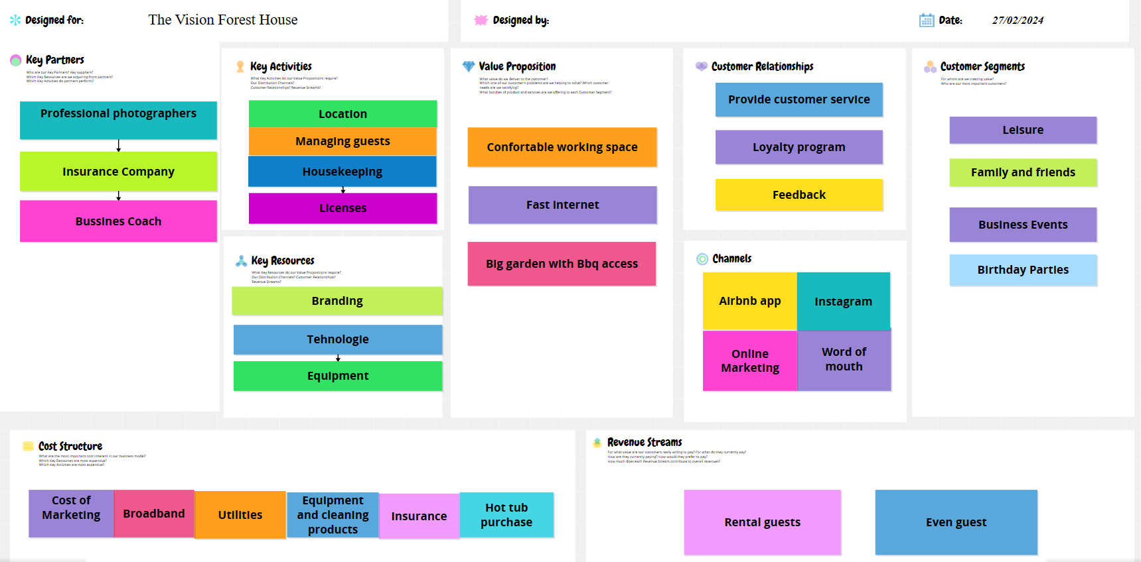

Appendix 2
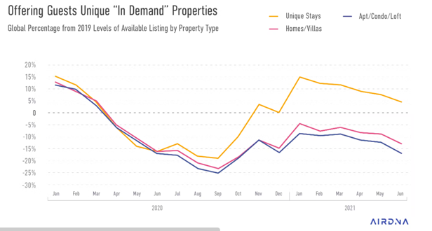

Appendix 3
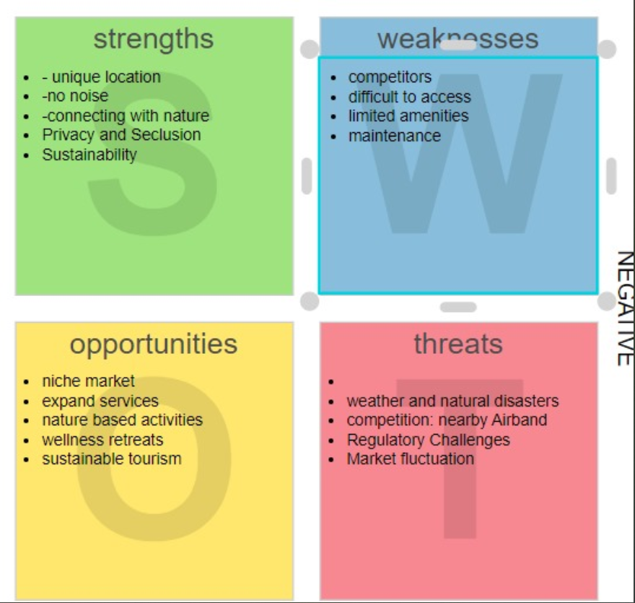

Appendix 4
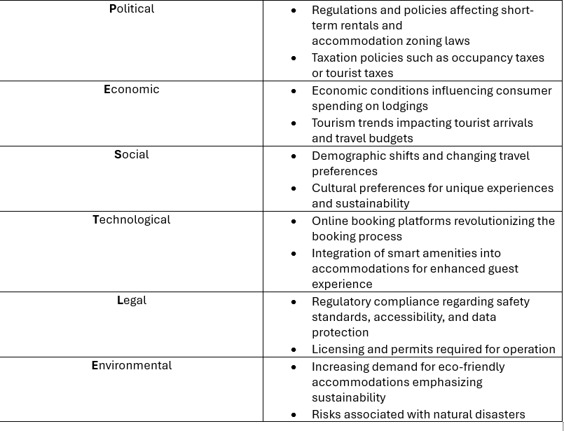

Presentation


