Natesha Natoya Lewis-Campbell (2134545)
[Email address]
2134545
Module: International Meeting Management BMIH6007
Tutor: Kathyrn Flynn
Planning and delivering an international meeting/event
Mrs Natesha Lewis-Campbell
Executive Summary
Celebrating the Year of Croeso, a costume party is the event idea to get tourist to know more about the Welch Culture. This event is about Wales so its based in Wales. The event will be taken place at the red dragon hall; this is a function room that provides almost everything that is needed to host this event. Being that it is a costume party, a prize for best dress will happened at the end of the event. This will boost ticket sales. All costumes are based on the colours of the Welch flags as this is about knowing more about their culture. Tickets will be available via the social media platform; this is where most of the marketing will be done. Social media is trending now, and majority of the population uses social media in their daily lives. To ensure this event is a success, a vast amount of research will be done on Wales, to find the key points on how to introduce the culture to outsiders.

Contents
Introduction 3
Main Body 3
The Event Cycle 3
Event Concept 4
Event Operations 6
Event Budget 7
CONCLUSION 9
Appendix 10
Reference list 12

Introduction
The event that was chosen is a costume party representing the year of Croeso. This event was chosen to help everyone who visited Wales to understand a little more about the Wales culture and the best time to put this event on was the Croeso event. The party will take place at the “Red Dragon Hall”, (see appendix 1) which is located on the Top floor of a building (choose your venue 2025). This place was chosen because it had all the decorations on the walls already built in to show all their customers about the culture of Wales. As this was a part of what was planned for this event, this location was perfect. The owner of the location was thrilled about hosting the costume party, representing the year of Croeso because they felt that people needed to know more about Wales culture. In this report, Croeso will be explained and the reason for the celebration. There will also be a breakdown of the process and planning of this event, the food, music, costumes and all the experience that was gain planning this event. Looking at industry trends and cultural considerations, it’s clear how social media has been great with marketing. To analyse these trends and what its effect are on the event planning business, a Pestle analysis will be explain on a table.

Main Body

The Event Cycle
Event cycle is a system that goes through deriving ideas, style, or taste from a broad and diverse sources. This is from theory to bringing alive the actual event. This cycle has 5 stages, they are, the reason for the event, planning, execution, monitoring and closure (outsourced 2024).
Planning an event requires lots of details and experience. First a theme is needed, which this event is based on the year of Croeso (F.Dolben 2024). The plan is get tourist to know more about the Wales culture and enjoy the beauty of the country. A costume party is the theme and the colours of the welch flag (see appendix 2) is the colour scheme, just to guide our guest into understanding what we are trying to achieve. Location is also the key to a great event. The location that was chosen has everything to boost this event and its built with a few historical designs that goes well with the theme. Dancers will be there as a part of the entertainment, along with a DJ. Music and DJ also comes with the location. Catering staff, to provide variety of welch food for the guest.
Decoration will be but only half of what is required will be needed, since the venue that was chosen has most of the decoration already built in, this means only a small amount of decoration is needed to help with getting to look that was planned together. Security is needed for this event, the location comes with its own, but we still have to get extra security just for safety. A few extra staff is needed for helping through out the event, dress in a uniformed based outfit, just to provide extra support. Drinks are sold behind the bar at the location; we take 20% stake at the end of the event if everything goes well. There will be a prize of £500 for best dress at the end of the night, this will boost the sales on the tickets. At the end of the event, a clean up duty is not needed as the location takes care of this.
The internal stakeholders are the staff that is there for support, the 2 event planners and the company that is providing the loan. Everything will be written as a agreement for each stakeholder to be away of exactly what is to be done on the night of the event.

Event Concept
This event is about celebrating the year of croeso in a costume party form. The reason for it being a costume party, is to encourage people to learn more about Wales in a fun way and to attract the younger generation to understand culture and concept. This way there will be more exposure on the welch culture. A prize for best dress is included to boost the marketing sales and get all the guest to be more creative and also creative a buzz for attendance. The event will also take place in the Year of Croeso week, this will also boost the sales. Tickets are £150, they are available on the website via the Instagram page. Social media will play a big part in our marketing process. The event will last up to 6 hours giving our guest enough time enjoy the party. The arts council of Wales will also provide a few pieces of art to help with the décor of the hall. Performers are from a company call Night out (Night out 2025), they provide entertainment for Welch events.
Aims and objectives
The overall aim of this event is to get national and international travellers to learn more about the welch culture. “aims related to the overall event is important for every Host” (Carmarthshire 2023). Eighty percent of the world population loves to have a good time and most people love to compete for something. This is why at this event, there is competition for best dress. This will also bring the community together and bring more exposure to the location that is being used. This event has no serious threat to the environment as all rubbish will be dispose of correctly and its an indoor event so 90% of everything will be controlled.
Objectives of this event is the financial cost, the marketing process and the participants. Financially it is important to set a budget for your event, this budget helps to provide a breakdown of how this budget will spend and the profits at the end. Knowing how to work around your budget is good management skills.
The marketing process is how the sales of the tickets will be sold. In this generation, social media is the main form of marketing. an Instagram page was created with the website link for purchasing the tickets. Tickets will also be sold at the location, as its already a up and running business. Due to more exposure for the location, this is free marketing for this event. One of the most popular DJ in the west midlands has offered free publicity on this event because the idea has spark lots of interest with some music producers. They are also a few online platforms, that provides free marketing for up coming businesses, this a way to generate some leads to via the social media page. In and around Wales, poster will be going up in shops, restaurants and local pubs to increase exposure. Night out will also advertise the event for free because one of their acts will be performing. The video explains how to manage the marketing process (Youtube 2024). Knowing how to market your business help with the success of the business. According to (M.Cakaloglu 2020) “customers will buy products from well known brand, for easy distribution”.
Participant who attends events, they attend with an open mind to understand what the event is about and to gather their experience. Without their good feedback, your event can result in a failure. It is important to know what you are advertising, so participant is able to understand your goals.

Event Operations
According to (Bladen et al.,2011) “in order to deliver a successful event, the event manager must consider all its elements and determine the resources, skills and equipment needed to gain success”. Bladen was trying to explain that, without all the tools needed to carry out the event, may result in failure or profit loss.
Planning an event requires funding and in order to get funding, a business plan is required. This video explains why business plan is needed for a successful outcome (Youtube 2024). With this business plan, you will be able to apply for funding. The funding circle provides short term loans to businesses (Funding circle 2025). Once the loan is secured, then is time for the venue. It is important to be smart about how you organise your budget. A venue that provides most on the list for a good price is a smart move. Research is important when it comes to finding a good venue ( C.Neville 2023), ensure you check previous event to get an idea of the success rate. Most venue provides a number of things that is needed to carry out the event. Music, Dj, decoration, security, marketing, drinks, and clean up after the event. The venue also included seating, lights and toilet facilities, everything under one roof. All these are included in the price for the venue, which may work out cheaper for the host of the event. More decoration is needed to add to what the venue already has, this will add more fun and excitement to the event and also more party vibes (Captivate events 2016), this company provides all décor for events. Having staff at the event to help around is a good idea, this way you are not on your own doing everything. Facebook is great way to find staff who want to earn a day wage. Catering is always needed at events because food is also a great way to introduce a certain culture or lifestyle. This event is about knowing and understanding more about the welch culture, so the food is catered by a welch company, who has all the experience needed (Caswell Catering 2022).
Most event has something very unique to get their guest to participate. Having a costume party with a best for best dress, is a great way to get everyone to the extra mile with their costume design, as the prize is £500. See appendix 3 for costume ideas.

Event Budget
The budget for this event is £25,000. This business loan will come from the funding circle; they provide loan to small businesses for short period of time. Their repayments are done in instalments because they understand how business work sometimes. They have a flexi pay card to help with spreading the cost. When you clear your balance in one instalment, then there is no fee. Repaying the loan in the first instalment after the event, will help in making more profit because there is no fees. The table below explain all the expenses concerning the event.
ITEMS | BUDGET
Venue | 5000
Catering | 4100
Entertainment | 500
Prize Money | 500
Staff | 300
Marketing | 1500
Extra Security | 200
Extra Decoration | 2000

Tickets are sold at £150 per guest and with your ticket, you are automatically entered into the best dress competition. Tickets are available at the door at £210 for those who have turned up without a ticket. In an article, it explains how to reduce on your event budget. “to minimise performance fee, minimise the performers time” (Special event galore 2018). At the end of the event, the venue has agreed to pay the event manager a 20% fee from the sales from the bar if everything has been sold. They are online help that will guide in the budgeting of the event, to ease the work load and make things easier (Equal money 2011)

Industry Trends
What is trending now is Artificial Intelligence and the rapid growth in the use of social media and its advances. Almost 80% of the population uses social media and the 50% uses artificial intelligence. With this number growing, social media has been used to market the event, and Artificial Intelligence was used to create content to market the event on social media, the video explains how AI is trending (Youtube 2025). With these two trends, the event will be a success if these trends are used correctly and tickets get sold. In a news article they speak on how social media has taken over the world and what are the positives of it (T. Ferne 2025). To analyse these trends a Pestle, analyse will be conducted in the table below. When explaining Pestle Analysis, each area should be explained how changes affect the current situation (Grapevine 2018).
PESTLE ANALYSIS | THE EFFECT
Political | Government polices might change
Economic | The economic growth may affect costumers’ income and expenditure
Social | Customers behaviour pattern, might be an issue
Technological | Any error in technology, may result slow market
Legal | Certain laws might affect plans moving forward
Environmental Factors | How is this event affecting the environment

The event is based on the culture of the welch. At the year of Croeso, the aim to get tourist to understand more about the welch. As a host of any event, its important to understand the culture of what you are hosting and the background behind it. The video explains a few details about the welch culture (YouTube 2025). Conducting proper research on the culture, will also help in planning the event. Speaking to the locals, attend local events and trying local dishes, will help with marketing the event.

CONCLUSION
To conclude this report, the event will be taken place in Wales, celebrating the Year of Croeso. The aim is getting tourist to understand the culture of Wales and what it has to offer. It a costume party and everyone should have their costume made in the colour of the Welch flag. This will boost sale of the tickets, as there will be a prize for best dress at the end of the night. All stakeholders have been informed of all decisions that affects them by letter headed email. Budget has been sorted, and saving has been made where necessary. Everything was carefully researched on the year of Croeso, so that the event will be a success. A pestle analysis was conducted to analyse the issues that may cause the event to fail or discontinued.

Appendix
1.
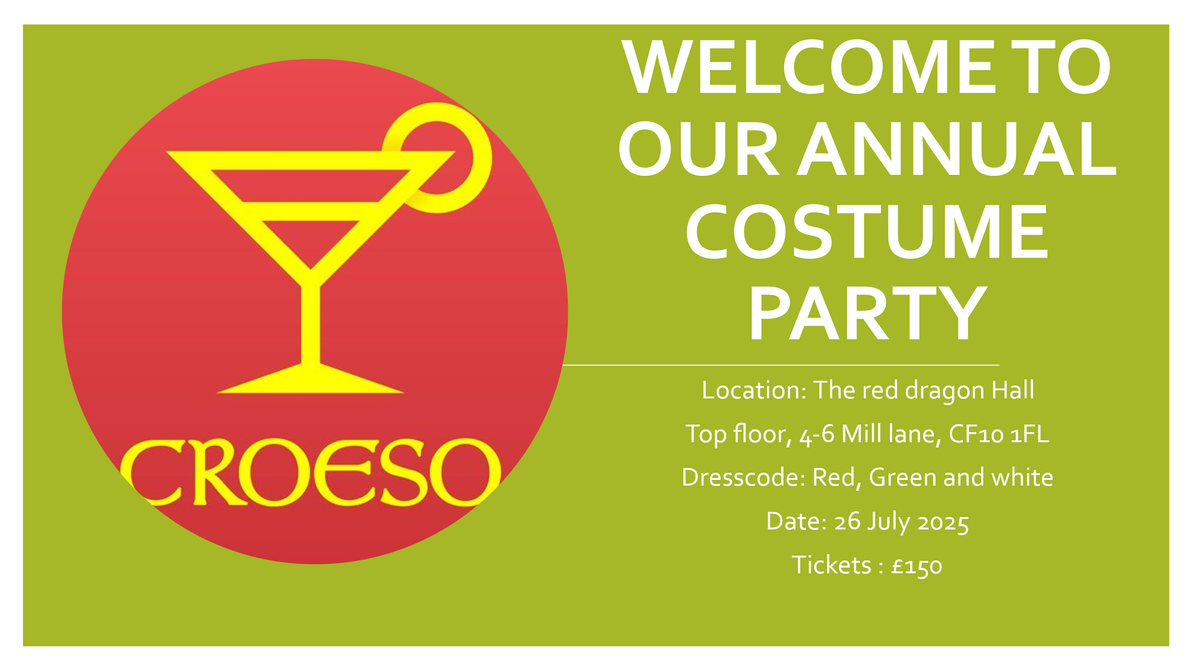

2.


Appendix 3.

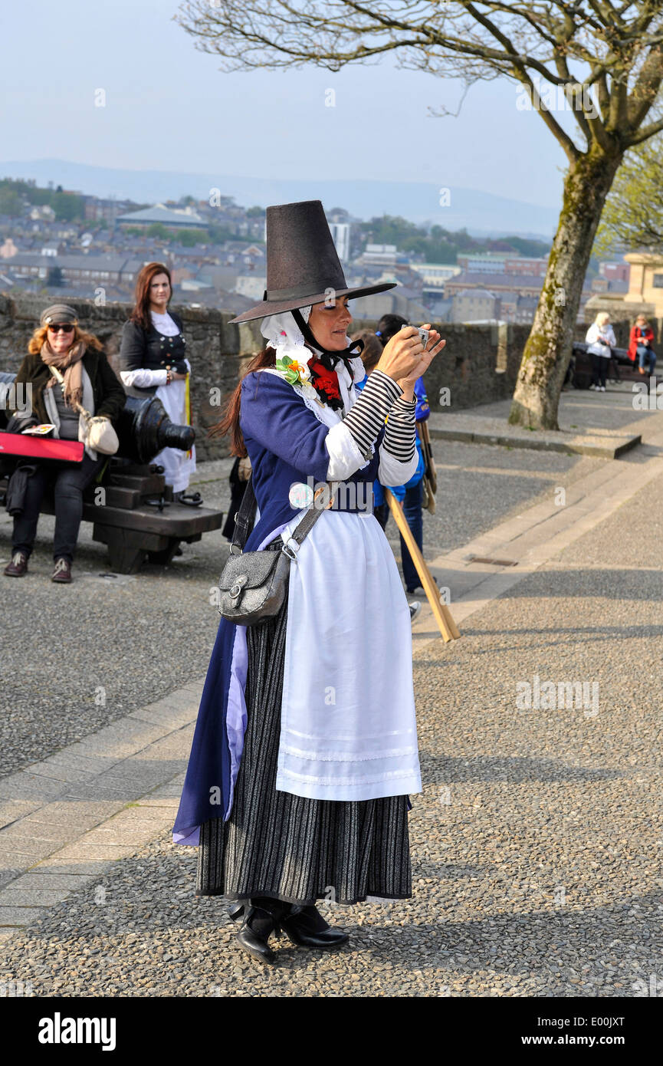

Reference list
Alamy.com. (2025). women costume. [online] Available at: https://c8.alamy.com/comp/E00JXT/welsh-woman-in-traditional-costume-attending-the-six-celtic-nations-E00JXT.jpg [Accessed 11 Jun. 2025].
Bladen, C. (2012). Events management : an introduction. London ; New York, Ny: Routledge.
Captivate Events. (2016). Captivate Event Styling. [online] Available at: https://www.captivateeventstyling.com/ [Accessed 10 Jun. 2025].
Caswellcatering.co.uk. (2022). \r\n Caterers in Swansea and South Wales | Caswell Catering\r\n. [online] Available at: https://www.caswellcatering.co.uk/ [Accessed 11 Jun. 2025].
Dolben, F. (2024). 2025 marks the Year of Croeso – in Wales. [online] Gogledd Ddwyrain Cymru - North East Wales. Available at: https://www.northeastwales.wales/2025-marks-the-year-of-croeso-in-wales/ [Accessed 9 Jun. 2025].
Ferne, T. (2025). Where is the social internet taking us? [online] Bbc.co.uk. Available at: https://www.bbc.co.uk/rd/articles/2025-06-social-media-change-issues-problems-report [Accessed 12 Jun. 2025].
Fundingcircle.com. (2025). Fast, Affordable Small Business Finance | Funding Circle. [online] Available at: https://www.fundingcircle.com/uk/?utm_source=bing&utm_medium=cpc&utm_campaign=Brand_Exact&utm_adgroup=1327112853593229&utm_term=the%20funding%20circle&utm_content=&mt=e&device=c&msclkid=d7854377d8e9103250492b30250d221c [Accessed 10 Jun. 2025].
Grapevine (2018). PESTLE – issues effecting UK events. [online] Grapevine Event Management. Available at: https://grapevineeventmanagement.co.uk/news/2018/10/3/pestle-issues-effecting-uk-events [Accessed 11 Jun. 2025].
HubSpot Marketing (2025). 6 Marketing Trends You Need to Know in 2025. [online] YouTube. Available at: https://www.youtube.com/watch?v=0sXYuIHPVik [Accessed 11 Jun. 2025].
image (2020). [online] Wp.com. Available at: https://i0.wp.com/advergize.com/wp-content/uploads/PESTLE.png?fit=1440%2C1001&ssl=1.
image (2025). welch flag. [online] Pixabay.com. Available at: https://cdn.pixabay.com/photo/2017/06/17/13/29/welsh-flag-2412265_1280.jpg [Accessed 9 Jun. 2025].
Leaders Talk (2024). Marketing Management | Core Concepts with examples in 14 min. [online] YouTube. Available at: https://www.youtube.com/watch?v=65MQnEMf-uI [Accessed 10 Jun. 2025].
Mısra Çakaloğlu (2020). Marketing Innovations in Industry 4.0 and Their Impacts on Events Marketing. Advances in marketing, customer relationship management, and e-services book series, pp.33–52. doi:https://doi.org/10.4018/978-1-7998-4954-4.ch003.
Money, E. (2011). our expense management platform. [online] Equal Money. Available at: equalsmoney.com [Accessed 12 Jun. 2025].
Neville, C. (2023). 9 Tips for Choosing an Event Venue. [online] Events.com. Available at: https://events.com/blog/9-tips-for-choosing-an-event-venue/ [Accessed 10 Jun. 2025].
out, N. (2025). Booking A Show For Your Community. [online] Nightout.org.uk. Available at: https://www.nightout.org.uk/Promoter/Booking-A-Show-For-Your-Community/ [Accessed 9 Jun. 2025].
Outsourced Events (2024). What are the 5 Stages of Event Management. [online] website. Available at: https://www.outsourcedevents.com/knowledge-insights/2024/what-are-the-5-stages-of-event-management [Accessed 8 Jun. 2025].
Reduce the Financial Impact of Entertainment on Event Budgets. (2018). Special Events Galore, 18(8), pp.1–1. doi:https://doi.org/10.1002/speg.30892.
Sara Davies (2024). What is a business plan and do I need one? | The 6 Minute Entrepreneur | Sara Davies. [online] YouTube. Available at: https://www.youtube.com/watch?v=OrI2yEHcp2o [Accessed 10 Jun. 2025].
United Kingdom Explorers (2025). What Is The Culture Of Wales? - United Kingdom Explorers. [online] YouTube. Available at: https://www.youtube.com/watch?v=Wlk5mokJorw [Accessed 12 Jun. 2025].
venue, choose your (2025). Barbara’s Bier Haus Cardiff Venue Hire | Corporate Event & Private Parties. [online] Chooseyourvenue.com. Available at: https://www.chooseyourvenue.com/venues/barbaras-bier-haus-cardiff [Accessed 9 Jun. 2025].
www.carmarthenshire.gov.wales. (2023). Establishing aims and objectives. [online] Available at: https://www.carmarthenshire.gov.wales/home/business/organising-events/community-toolkit/establishing-aims-and-objectives/ [Accessed 10 Jun. 2025].

