我的宠物
fy anifailiaid anwes
my pets

Vocabulary

中文 | Pinyin | Welsh | English
鱼 | yú | pysgodyn  pysgod | a fish  fish
鸟 | niǎo | aderyn  adar | a bird  birds
狗 | ɡǒu | ci  cŵn | a dog  dogs
猫 | māo | cath  cathod | a cat  cats
胖 | pàng | tew | fat
大 | dà | mawr | big
小 | xiǎo | bach | small
可爱 | kěài | ciwt | cute
聪明 | cōngming | clyfar | clever
漂亮 | piàoliang | pert | pretty

* colour code for tones: first tone (blue), second tone (yellow), third tone (green), fourth tone (red), neutral tone (grey）
12 zodiac

属相 | Pinyin | Welsh | English
鼠 | shǔ | llygoden | rat
牛 | niú | ych | ox
虎 | hǔ | teigr | tiger
兔 | tù | cwningen | rabbit
龙 | lóng | draig | dragon
蛇 | shé | neidr | snake
马 | mǎ | ceffyl | horse
羊 | yáng | dafad | sheep
猴 | hóu | mwnci | monkey
鸡 | jī | ceiliog | rooster
狗 | gǒu | ci | dog
猪 | zhū | mochyn | pig

sentence builder 1a
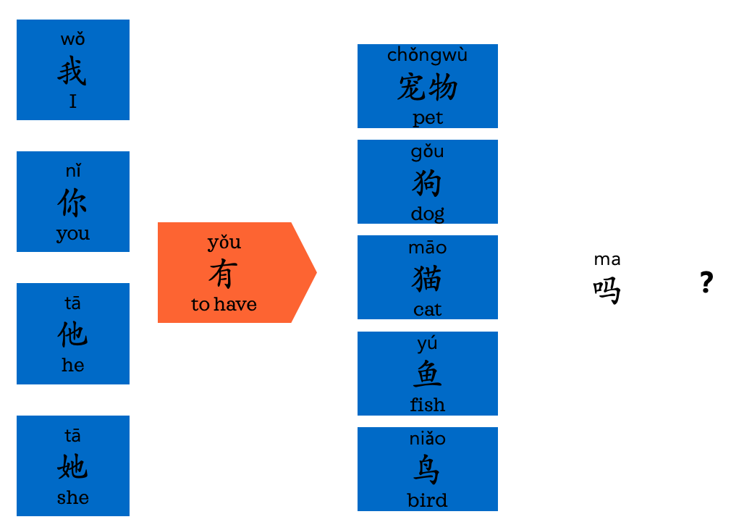

sentence builder 1b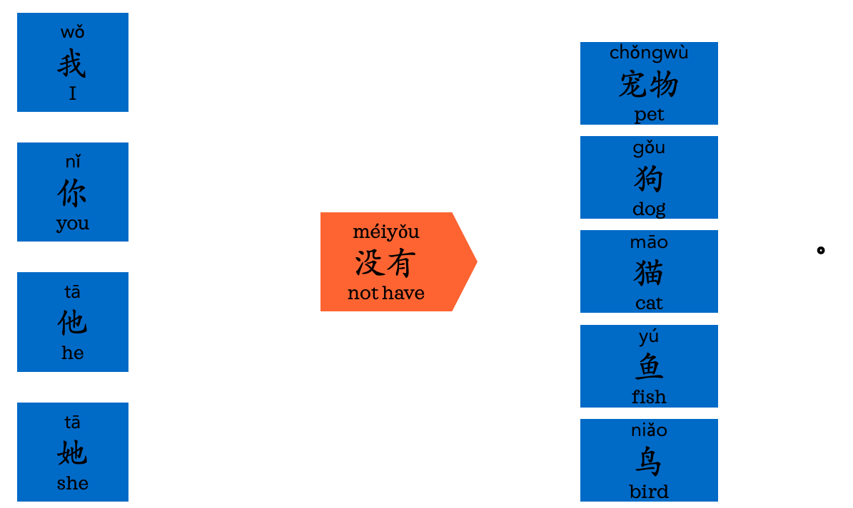

sentence builder 1c
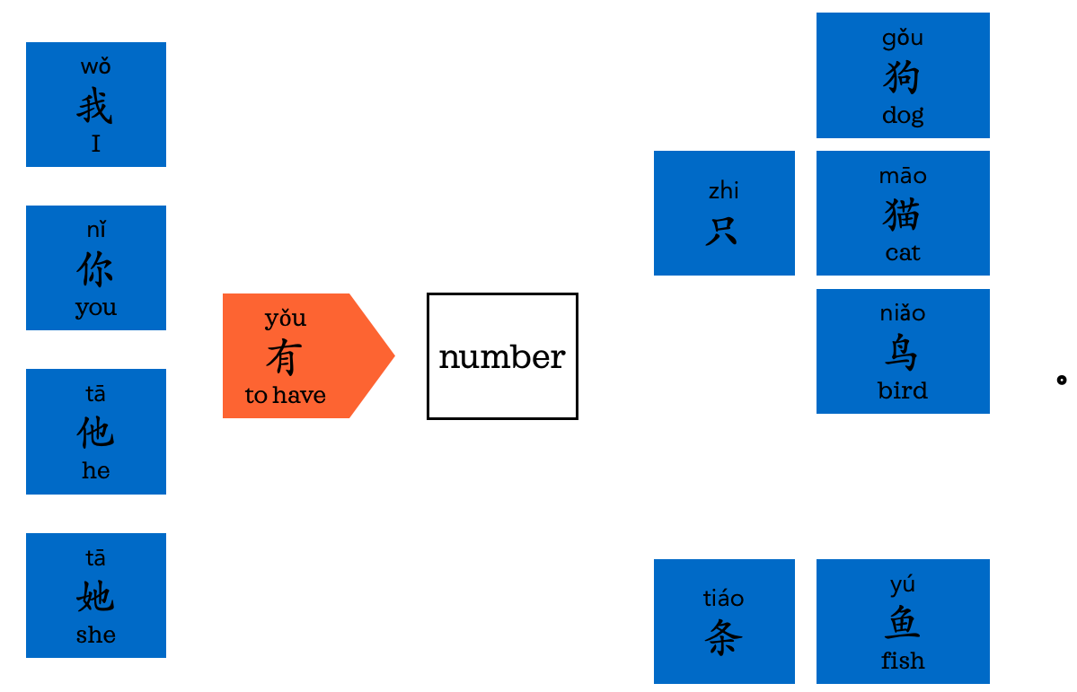

sentence builder 2a
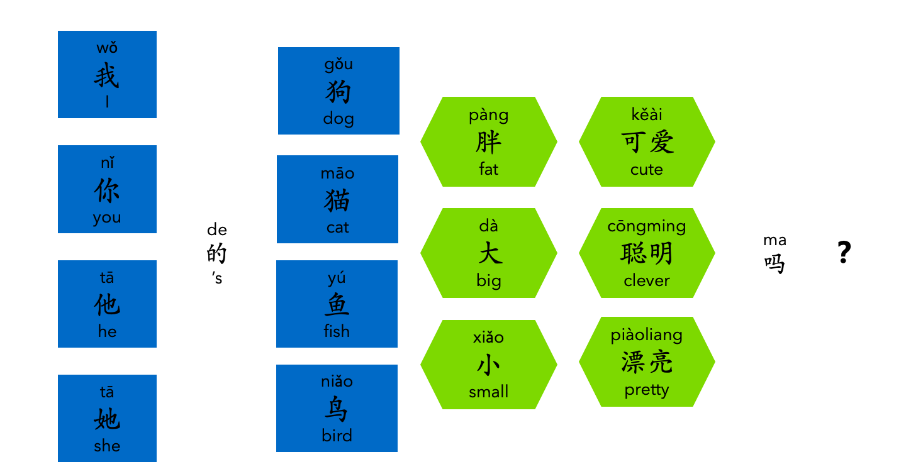

sentence builder 2b

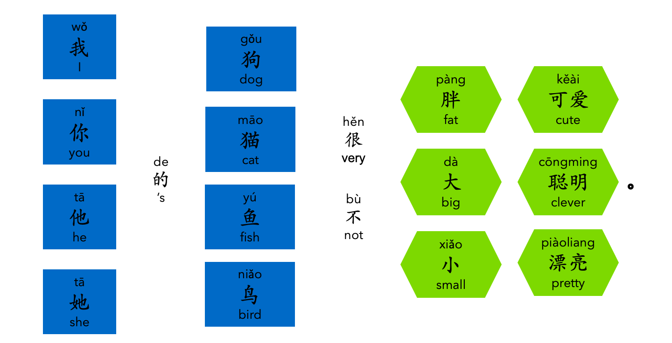

不 bù pronounces bú when folllowed by a fourth tone word.

sentence builder 3a and 3b



