Utilising the Entrecomp Framework, critically evaluate your own creativity and enterprise skills and consider how you might be able to develop the creative and enterprising skills of primary learners through your own pedagogy.

By utilising the Entrecomp Framework, this assignment will critically evaluate my creativity and enterprise skills whilst further considering how these skills can be developed within the primary classroom. Creativity has become an integral aspect of teaching and learning as this has become a skill required for learners within the workplace (Cropley, 2001; Hargreaves, 2012; World Economic Forum, 2015; Donaldson, 2015). Cowley (2005), Cropley (2001; 2012) and Education Scotland (2013) state that providing opportunity to enhance creativity in every aspect of the curriculum will provide benefits to both learners and practitioners. Such benefits have been identified in several different countries across the world which include making learning engaging, interesting and relevant (ibid). Fumuto et al., (2012) comply with this perspective on creativity by conveying that learners are likely to develop their well-being and self-esteem when engaged in these activities.

However, the term creativity has been regarded as a term difficult to define. In consequence, the speculation of the definition used to define creativity has inhibited the support provided to practitioners to become precise in their understanding of creativity (Maley and Bolitho, 2015; Claxon, Lucas and Spencer, 2013; Wilson, 2015). The National Advisory Committee on Creative and Cultural Education (NACCE, 1999) and Boden (2004) and Robinson (TED, 2007) challenges to define creativity by defining creativity as an imaginative approach in which requires learners to produce products that are both original and of value. The process of imagination allows individuals to think beyond the obvious and produce products that are unique (Craft, 2000). Maley (2003, cited in Maley and Bolitho, 2015, p.434) and Mohammed (2018) state the core characteristics that define a creative individual are: to be able to think imaginatively, plan and carry out something new and worthy, ask questions, construct knowledge, being active and experimenting. To put this differently, research suggests that creativity is an attribute that is possessed by every individual (Nichols, 1972, cited in Cropley, 2001, p. 10; Boden, 2004; Education Scotland, 2013; Savage and Fautley, 2007). NACCE (1999) agrees with this as it has been suggested that creativity is a general function in everyone but will contrast in the amount possessed which have been categorised as big C and little c (Craft, 2000). Therefore, De Bono (2016) and Seeling (2012) and the Guardian (2019) connote that learners can foster creativity through education.

NACCE (1999) and Education Scotland (2019) underline that it is the responsibility of the practitioners to recognise and plan opportunities to encourage creativity of the learners within their classroom. In order for this to be achieved, practitioners are required to be aware of which skills should be taught and should adapt their pedagogical approach to foster creativity (Eisenberger and Armeli, 1997, cited in Cropley, 2001, p. 97). As recognised by Craft (2005, cited in Desailly, 2015, p.18), creativity is most likely to progress when practitioners teach for creativity and teach creatively simultaneously. Kinsella, Faultey and Wallace (2017) affirm that teaching creatively involves the pedagogical approach to teaching while refining the creative competencies of the learner. This suggests that practitioners are required to support the creative development of learners by providing essential skills that allows learners to build on prior knowledge to adapt objects to improve the quality of education (Beetlestone, 1998; Craft and Hall, 2015; Desailly, 2015). In effect, recent research suggests that creativity can be developed within a number of areas of learning and experiences (Craft and Hall, 2015; Savage and Fautley, 2007; Cowley, 2005; The Guardian, 2019). As outlined by NACCE (1999), creativity is a generic aspect to education. Yet, Desailly (2015) and Hodder Education (2014), disclose that practitioners view creativity as an aspect of the arts alone, hence, practitioners believe that they are not competent enough to teach creatively or teach for creativity. A number of theorists such as Csikszentmihalyi (1997) and Gardner (1983, cited in Cropley, 2001, p.16) remark that creativity can only be used in particular areas of the curriculum such as art or science and challenge the view that creativity is fostered by every individual. Seeling (2012) complies with this and underlines that creativity is a skill in which has been influenced by their personal knowledge and understanding. For this reason, NACCE (1999) insinuates that teaching creativity may be considered an aspect difficult to teach for those in which do not obtain creativity.

Due to no universal agreement to define creativity, for the purpose of this writing, the definition I will be moving forward with states that “creativity is a process which generates ideas that have value to the individual” (Education Scotland, 2013, p.3). This requires learners to overcome problems by using their imagination, learning from their mistakes and exploring possible solutions in all areas of the curriculum (ibid.). As indicated by Boden (2004), the final product produced by the learner may be of value and original to the individual, but this product may be known to the practitioner. Craft (2000) contends this as she reports that originality comes as a consequence of being original to the world as well as the individual. Accordingly, if the learners’ efforts are ignored, it may be perceived that the practitioner does not appreciate their contribution and may consequence in the learners not wanting to contribute or participate in the near future (Desailly, 2015; Jeffrey and Woods, 2009). Therefore, Cropley (2001), Thorne (2007) and Fumuto et al. (2012) recognise the importance of a positive learning environment as the right conditions will foster their engagement to contribute to ideas and will have an impact on their final products. This is fundamental as creativity is dependent on the willingness and ability to share their creativity (Cowley, 2005; Thorne, 2007).
In order to assist the development of entrepreneurship competences across the world, the publication of the Entrecomp Framework has been released in order to enrich the connections with the world of both education and work (Bacigalupo, et al., 2016). This framework consists of three interconnected competences (ideas and opportunities, resources and into action) with each having an additional five competences within (ibid.). In effect, with utilising a range of skills required within the framework, this provides practitioners and end users an outline of how to use this framework in order to aid their skills effectively for future purposes. However, in the United Kingdom, the term enterprise education is primarily used as an alternative to entrepreneurship. The purpose of this differentiation has been considered in order to focus on the personal development of skills and attributes in comparison to providing learners the procedures to become self-employed (Lackéus, 2015). As defined by Kneale (2015), enterprise outlines the opportunities to take an idea further by combining their skills. Examples of these skills include flexibility, self-confidence, vision, organisation, communication and creativity and innovation (ibid.). These skills are essential as Bridge and O’Neil (2013) and Kelly et al. (2014) emphasise that enterprise skills allow individuals to make one’s choices than is not predetermined which will provide them the foundations to build upon their ideas. In any case, Bacigalupo et al. (2016) questions the reliability of the framework as this has not been adapted or tested within real settings. Subsequently, evaluating my skills accurately were found difficult as although this framework identifies competencies for education and work, some aspects of the Entrecomp Framework are not applicable to teaching. At the same time, this framework requires individuals to assess their skills by ‘best fit’ which does not provide an accurate result and provided further difficulties to draw upon solutions to optimise this thread.
Following evaluating my skills against the competencies, a general self-assessment of each competence within the framework has been displayed in appendix one. By utilising the eight level progression steps, I will further evaluate my creative and enterprise skills with a focus to the following competences; creativity and motivation and perseverance. In consequences to evaluating my creative competencies, I believe that I require to improve my creativity skills and confidence in order to deliver an effective pedagogical approach to teaching that is of benefit to the learners. As identified by Desailly (2015) and Kinsella, Fautley and Wallace (2017) it is mandatory for practitioners to advance their own skills and confidence prior to developing the skills of others. Corresponding, when evaluating my skills to progress the first thread within the creative competence, I would categorise myself being at a foundation level of level two as I believe that I able to explore different objects and use them in alternative ways. As seen within appendix two, I am able to think of alternative solutions for a function of a shoe by activating my divergent thinking by considering the different components that are used to create a shoe. Similarly, during Professional Teaching Experience (PTE), I overcame my functional fixedness by enhancing the learner’s knowledge and understanding of the different types of angles by using a table as an alternative method to the traditional approach of using their mathematic books which worked effectively (see appendix three and four). Therefore, the framework initiates that in order to enhance this thread, I require to take risks (Bacigalupo et al., 2016). Feedback complements such view as it outlines that my planning during PTE is very structured and as a student teacher, I am afraid to deviate from a pre-established plan which is an area in which I require to improve on (see appendix five).

Fisher and Williams (2004), Craft, Cremin and Ballard (2008) and Desailly (2015) identify that creativity requires a balance between structure and freedom as too much structure can intervene with creativity. In this case, Loughran (2006) suggests that in order to improve on by curiosity and openness, I require to understand and discover new ways of learning by implementing teaching procedures that are unfamiliar to develop my application of risks. Education Scotland (2013) coincides with this view by identifying that creativity is unpredictable, thus, practitioners should deviate from plans to take advantage of a situation raised by the learner, allowing them to address different skills from the curriculum. However, Desailly (2015) states that the practitioner will require sufficient subject knowledge on all areas of the curriculum in order to teach confidently and flexibly which will be very time consuming. Taking risks is one of several barriers to creativity as Kimbell (2000) and Cowley (2005) note that individuals are less likely to take a risk that have a possibility of failure. In effect, Fisher and Williams (2006) suggest that if every outcome is seen to be successful, all possibilities for creativity will be reduced as creativity requires an element of risk in order to be original.

Alternatively, Wilson (2015) identifies that the element of risk taking can be beyond physical and can be identified as psychological or emotional. Beetlestone (1998), Cropley (2001) and Jeffrey and Woods (2009) thereby acknowledge that a positive learning environment is required in order to experiment new skills in new surroundings to enhance the risks taken by the individual. This can be obtained by building positive relationships and trust between practitioners and learners (Kimbell, 2000; Thorne, 2007). When a positive learning environment is present, Csikszentmihalyi (1997;2009) and Churchill Dower (2005, cited in Craft, Cremin and Ballard, 2008, p.78) assert that the level of engagement and elements of risks by the individual will increase when they feel safe and confident. This has been agreed by Jamison (1993, cited in Cropley, 2001, p. 59) and Loughran (2006) who underlines that a strong worth and self-confidence is a requirement in order to be creative. The importance to address these barriers has been reflected within Maslow’s hierarchy of needs (1970, cited in Underdown, 2006, p.4). Within his diagram, the skills of creativity and self-actualization have been located at the top of the diagram which implied that these will only be met when my additional basic needs have been considered. Levers (1997, cited in Pound, 2009, p.34) adheres to this as he suggests that individuals are likely to participate when they have a positive self-esteem. Therefore, with all points considered, in order to be competent in this thread, I will foster a positive learning environment and relationships with the learners in order to build upon my confidence to encourage myself to trial and error a number of different approaches in a range of different situations, contexts and circumstances of which may be determined by the learners.

The second thread identified on the framework is to develop ideas. I believe that this is one the threads I perform to a great extent and will classify my skills at an intermediate level of level three. By using the framework as a function, I believe that I can refine different techniques to overcome solutions by using resources in different ways. During a lecture within university, I along with my peers were able to experiment with different techniques of creating a ‘Rube Goldberg Machine’ (Rube Goldberg, 2018). The purpose of this activity was to complete the task in the most complicated way in order to reach the outcome of popping a balloon (ibid.). Despite our efforts, we were unsuccessful to generate an effective solution to pop the balloon. However, this activity allowed us as a team to identify the functions required in order to achieve the overall outcome which provided value to the final product. By making further alterations to the product, we as a group could have developed the value of the end product but this was unsuccessful due to time constraints. This has been considered an important aspect to teaching and learning as encouraging practitioners to evaluate their practices and promotes practitioners to test new ideas is essential for creativity (Carr and Kemmins, 1986; McNiff, 2013; Mills, 2014). For this reason, when considering the fourth thread within the Entrecomp Framework, I would consider myself working competently within level three and consider a number of aspects of level four. Hence, in order to expand on my ideas and value of end products, the framework suggests that I require to test the value of my end products with users and tailor the products to reach success (Bacigalupo et al., 2016).

The third thread highlighted within the creative competence requires to conduct an assessment against defining problems. As evidenced in appendix six, I believe that I can contribute to group discussions which are aimed to define open-ended problems and will therefore categories my skills as level three. The proposed open-ended problem during this task was to create a purposeful product to reduce all possibilities for an egg to break when released from height. After identifying several solutions to the problem, the group concluded that a parachute will be used. Although the solution to the problem was successful to meet its purpose, I found this task very challenging and as a result I could have contributed to a greater extent by using my skills that are my areas of strength in order to adapt the product further. In order to enhance defining problems, the framework exclaims that I require to re-frame problems by contributing and applying my skills to enhance the final product (Bacigalupo et al., 2016). By enhancing my skills to re-frame problems, I will solve problems that arise by seeing situations with new perspectives with persistence and determination to complete the overall outcome (McNamara, 2012). I believe that this is something I am unable to achieve and require further development in order to improve my creativity.

Defining problems has been considered an important aspect to creativity as Penaluna (2019) enforces that individuals require to view things differently to be creative as a learner with one idea will not adapt for change. Firstly, Lockton et al. (2019) regards that reforming problems can be enhanced through metaphorical thinking. This process is a cognitive strategy which requires individuals to combine two elements of something familiar to create something unfamiliar to generate new ideas to help us understand the world in a different perspective (ibid.; Casakin, 2007; Tomitch, 2018). Therefore, it has been considered that metaphors are primarily used during the stages of development to reframe problems which can be exercised through enjoyable or in real-life situations (Linsey et al., 2008). Lockton et al. (2019) initiates that this technique will not only enhance my thinking skills but also expand my vocabulary with confidence as it has been highlighted that there is no right answer. However, Fetterman et al. (2015) challenge the method of metaphorical thinking as this method often invites confusion, especially when homonyms are spoken.

Consequently, De Bono (2016) recognised that confusion is a factor in which effects learners’ thinking and produced an alternative solution to expand my thinking to reframe problems; the six thinking hats. Effectively, this approach allows individuals to evaluate problems by considering six different perspective as each coloured hat represents different thinking roles; white, red, purple, yellow, green and blue (see appendix seven) (ibid; Desailly, 2015; Mohammed, 2018). However, learners should not associate themselves competent in one aspect (De Bono, 2016). This allows individuals to understand that there is no correct answer when completing problem solving tasks but required to think differently to overcome issues (Kivunja, 2015). Although De Bono (1992, cited in ibid., p. 382; 2016) acknowledges that this as a simple technique to generate different perspectives to generate solutions, he suggests that the simplistic methods are considered the most effectively used to outline our next steps. Constructive approaches to develop the skill to reframe problems is important to allow individuals to generate ideas and to evaluate their products by working alongside others (Cowley, 2005; Education Scotland, 2013). Desailly (2015) synthesises with this approach as she underlines that collaboration allows learners to generate additional ideas and take bigger risks by expressing their beliefs to other peers. Nevertheless, Aithal, Shailashreee and Suresh Kumar (2016) and Education Scotland (2013) assert that this technique can be very time consuming as individuals will contrast in views and therefore identifying the best solution to the identified problem may be difficult. Donaldson (2015) considers the importance of reframing problems within the four curricular purposes as he addresses that learners are required to think creatively to re-frame problems. For this reason, in order to improve on the third strand of the creative competence, I believe that I will be more effective to develop the six thinking hats in comparison to the use of my metaphorical thinking. This is because De Bono’s thinking hats provided a clear structure which can be implemented within a classroom which underlines what is required of the learners which have been found effective when observed during PTE (De Bono, 1992, cited in Kivunja, 2015, p. 382).

Lastly, the final thread within the competence of creativity is innovation. On reflection, I believe that this is my weakest thread within the creative competence working within the proficiency of level one. As illustrated in appendix eight, I believe that I can find innovative products as I proposed the idea ‘what if every classroom was a mobile classroom’ during a university lecture. Developing this strand will require me to discover how these innovative products have transformed society and will therefore foster my knowledge on what products are innovative and which products are new to me (Bacigalupo et al., 2016). Although this has been identified as an area of weakness, by fixating my time to further extend the two threads previously discussed, I will enhance my innovation by developing products that are original. As conveyed by the World Economic Forum (2015), these threads are aspects of innovative skills which are important today and are required in order to live in a world of change. Nevertheless, I believe that this thread may be considered from the perspective of individuals within the world of work in comparison to educational purposes. As identified during the expert levels of proficiency, this identifies individuals that are entrepreneurs.

Alongside creativity, the competence of motivation and perseverance has been explored. As conveyed by Fryer (1996, cited in Beetelstone, 1998, p.59), Richtnér and Löfsten (2014), Aguilar (2018) and Abramson and Braverman-Schmidt (2018), resilience complements creatively by reinforcing that creative individuals are those who are willing to work hard and are persistent. When appraising my skills against the framework, I believe that I am currently working towards level two. This is because I am very driven to achieve a goal which has been evidenced when participating in the Duke of Edinburgh Bronze Award (see appendix nine). Although I found this very difficult at times, I persisted and worked hard to complete the challenge prior to and during the exhibition. Therefore, in order to enhance this competence, I require to overcome simple conflicting situations. Developing motivation and perseverance can be achieved by using a framework called Habits of Mind (Costa, 2008). Employing these sixteen characteristics is believed by Costa and Kallick (2008) to be beneficial as each Habit of Mind will allow individuals to overcome problems. By becoming familiar with these characteristics, it has been suggested that I will increase my ability to overcome a number of circumstances and encourage learners to become dependent in their own learning when such opportunity is provided (ibid.). American Psychological Association (2020) express’ that I can heighten my persistence by recognising the aspects of the outcome that I can alter and enhance my positive attitude on all outcomes. Furthermore, the Personal Resilience Development Framework (see appendix ten) identifies this in a simplistic manner and claims that individuals are required to govern responses to people, events and oneself (Mowbray, 2014). Unlike the Entrecomp Framework, it is clear to see that each competence is required to develop resilience.

During the second course of the assignment, I will consider how the learners’ creativity and enterprise skills may be enhanced within the classroom with a particular focus to divergent thinking. This component to creativity has been defined as the process of thought in which is used by the individuals to generate several ideas to possible solutions (ibid.; Fumoto, 2012; Wilson, 2015). Although divergent thinking has been considered as a generic skill (Williams, 1980, cited in Baer, 2014, p.8), Guilford (1968) concedes that there are four main components which contribute to creativity which are fluency, flexibility, originality and elaboration. Having such ability to reflect upon a number of ideas to solve problems has been considered an important aspect to creativity. Penaluna (2019) enforces that individuals require to view things differently in order to be creative, as a learner with one idea will not adapt for change. However, Silvia et al. (2008) challenge such view of the importance of divergent thinking by underlining that this component for creativity is not considered valuable for outcomes that have been designed in order to make a difference to the world. As Weisberg (2006, cited in Baer, 2016, p.110) asserts, divergent thinking fails to fulfil its promises as it has been evidenced that this process is not required for all creative outcomes.

The chosen method to foster the learners divergent thinking within the classroom is through the use of an escape room. This strategy has been defined as the process in which students are required to complete problems to successfully escape a room in the time provided (Nicholoson, 2015, cited in López-Pernas et al., 2019, p.1; Beghetto, 2019). Dacey and Conklin (2013) complements with this view as they disclose that creativity requires working under pressure to accelerate learners to elaborate on a given topic. Desailly (2015) conveys that this often comes as a result of the constraints of the curriculum and result practitioners to reduce the time allocated for creativity. Opposingly, Bilton and Cummings (2010), Isbell and Raines (2013) and Desailly (2015) challenges this and state that creativity is a steady process, one in which requires time in order for learners to investigate and discuss to see new concepts. As suggested by Thorne (2007), learners will often experience a mental block which interferes with their thinking process and will require to take a break. Therefore, with all aspects considered, the escape room will commence in the enhanced continuous provision area with groups rotating daily. I believe that this method will be effective as it will allow leaners to consolidate their learning by applying their skills to tasks which can be assessed through observations (Cornerstones, 2020). By providing learners a day to complete the task, this will encourage learners to think of alternative solutions as Sandford’s research reports that walking will boost the learner’s creativity in comparison to sitting, hence, learners will have the freedom to interact with this activity at their own accord (Wong, 2014).

Positively, the proposal of an escape room will foster problem-solving strategies, teamwork, communication and leadership by encouraging learners to work collaboratively in a group to solve the problems provided (López-Pernas et al., 2019). This activity can promote the use of child-led or teacher-initiated tasks by variating the producers of the escape room. Having a balanced curriculum has been considered an important aspect to creativity as Craft and Jeffrey (2004) recognise that this will develop ownership, relevance and control which is required for innovation. Nevertheless, Cropley (2001), Isbell and Raines (2013) and Desailly (2015) recognise that practitioners are required to consider the environment in which creativity is encouraged as the environment can impact on the quality produced by learners. Thus, the environment should consider the availability of resources and support, the disparity of risks and rewards (Copley, 2001). López-Pernas et al. (2019) declares that providing support to individuals during this activity will be fundamental as it has been suggested that differentiating this activity can be challenging. Effectively, Kroski (2019) and Csikszentmihalyi (1997; 2009) assert that when individuals are presented with an environment which fosters an element of challenge and an element of interest that is manageable, they are likely to become in a mental state as referred to as ‘flow.’ This has been defined to be a term used to describe when learners are immersed in an activity which may enhance the learners’ performance and skill development (ibid.). Therefore, it may be encouraged that the learners work in groups in order to complete this challenge. Vygotsky (1978) and Craft and Jeffery (2004) maintain the view that learners will support each other through this task as a result of a more knowledgeable other providing guidance when necessarily.

In addition to this, prior to conducting this activity, it may be considered that learners acquire the skills required for the escape room. As the escape room encourages learners to use objects in different ways, the learners will undertake activities to develop their functional fixedness. Functional fixedness is one of many components which inhibits the innovation of learners which occurs when an object is only seen via its traditional use, negatively affecting their use of divergent thinking (Munoz-Rubke, 2018). Psychologists estimate that this aspect affects older individuals in comparison to the younger generation, hence, providing opportunities to overcome functional fitness is critical to educate learners to see alternative solutions to situations (Patrick and Ahamed, 2014, cited in Munoz-Rubke et al., 2018. p.12). The use of activities with more than one applicable answer is prevalent in the work of Von Oech (2002). He mentions that learners should be encouraged to consider more than one idea as this provides us further possibilities to reach an outcome that learners may be trying to discover. Modelling such behaviour as a practitioner has been identified as a fundamental aspect by Wilson (2009) and Kinsella, Fautley and Wallace (2017) who state that learners require imitation from the practitioner in order to expand upon the creativity of the learners. Penaluna (2019) synthesises with this view as he declares that learners are required to be modelled such skills in order for them to convert roles with the practitioner which can be achieved as a consequence of this being an area of strength. From this, Eisenberger and Armeli (1997, cited in Cropley, 2001, p. 97) underline that I will be able to foster creativity of the learners by identifying what requires to be taught and which methods are effective in order to enhance the learners’ creativity.

The first activity used prior to the escape room will be the ‘Dunker candle task’ which will require learners to work within small groups to attach the candle to the wall in a way that the wax will not drip to the ground (Pritchard, 2014). One solution that may be used to overcome the problem will require learners to overcome their functional fixedness by removing the matches from the box to use the box differently to its traditional use to collect the wax (ibid.). Evaluating the learners’ ability is critical prior to the activity in order to differentiate the task accordingly (López-Pernas et al., 2019). The intensity of this challenge can be differentiated by positioning the matches inside or outside the box. When the matches are positioned outside the box, the learners will be required to consider alternative uses for the objects which may be difficult to identify when the matches are inside the box (Pritchard, 2014). Contrastingly, as creativity is not governed by rules, the learners may commence this activity differently to the practitioner (Education Scotland, 2013). Therefore, it is recommended that the practitioner acknowledges this and provide the learners autonomy to complete the task (ibid.). Hence, when support is required by the learners, it is recommended that the practitioner facilitates the learning by providing questions in comparison to statements as this method allows learners to develop their thinking skills independently (Lucus, 2001, cited in Desailly, 2015, p.88; Claxton, 2002, cited in Desailly, 2015, p.100). Furthermore, alternative activities within all areas of the curriculum can be considered to enhance the learners’ functional fixedness. Examples of these include encouraging learners to find alternative solutions of measuring equipment in the classroom instead of a tape measure for numeracy and mathematics, and by using different materials to create a drawing in design and technology.

Assessing the overall outcome of a creative product has been recognised as a complicated function but one in which is essential in order for effective teaching and to assess individuals’ performance (Black and Wiliam, 1998; Donaldson, 2015). This may consider the practitioner questioning the learners about their approach, general observations or the learners conducting a self/peer assessment (Education Scotland, 2013). However, in previous years it has been noted that a traditional scoring system was used in order to assign points for infrequent responses but have been deemed ineffective (Torrance, 1966; Wallach & Kogan, 1965, cited in Silvia et al., 2008, p. 69). With this considered, Spenser, Lucas and Claxton (2012) published a framework to develop creativity which can be used to assess the creativity of the learners within the classroom with comprise five habits; inquisitive, persistence, imagination, collaboration and discipline with a total of fifteen sub-habits of creativity within (ibid.). Nonetheless, as previously noted, for the course of this assignment, the products produced by the learners are to be of value to them and not the practitioner. Therefore, peer and self- assessment strategies will be encouraged throughout each activity. Thereby, Hattie (2012) and Thorne (2007) remark that learners will suggest alternative ideas to each other or solutions to their problems which will enable the learners to identify their strengths and weaknesses on their products.

To conclude, creativity and enterprise is an extensive aspect to society as the World Economic Forum (2015) proclaims that creativity is the third greatest skill required for employment. Griffin (2019, p.10) conforms with this view as he notes that it is creativity that “life has come to develop its current form, will develop new forms, new futures.” In other terms, he reports that we as individuals require to recognise creativity as this is one of the reasons why beings are on earth today (ibid.). However, Wilson (2015) declares that the definition of creativity will evolve as a result of political, social and economic factors. Consequently, this will provide such difficulties to practitioners as the current curriculum does not provide opportunity for a range of alternative solutions such as creativity and problem-solving to be used within teaching (TED, 2007; The Guardian, 2019). Similarly, although creativity has been valued by practitioners, Robinson (TED, 2007) and Desailly (2015) assert that this is an aspect within education that is considered the least important. This may come as a result of creativity not being a mandatory requirement for practitioners to achieve within the qualified teaching standards (Kimbell, 2000; Barnes, 2015). Therefore, I synthesise with the view of the Arts in Education in the Schools of Wales and suggest that the educational system requires to enhance the use of creativity within schools (Donaldson, 2015). Although the Welsh curriculum purposes for 2020 highlights that learners will develop as “enterprising, creative contributors,” by equipping learners the skills required for future employment, I believe that a fifth purpose is required in order to reinforce creativity effectively (ibid., p. 29). As emphasised by Education Scotland (2019), learners require to be adaptable and innovative to changeable circumstances which can be constructed through enterprising activities. Providing such opportunity is essential as Palmer (2006) announces that the rise in technology will effusively eradicate creativity within learners.

Reference List:

Abramson, T. and Braverman-Schmidt, P. (2018) ‘Resilience and Creativity: Tools to Living Life to its Fullest’, Innovation in Aging, 2 (1), p. 166. DOI: 10.1093/geroni/ igy023.599.

Aguilar, E. (2018) ‘Emotional Resilience: The Missing Ingredient’, Education Leadership, 75(8), p. 24-30. Available at: http://www.ascd.org/publications/educational-leadership/may18/vol75/num08/Emotional-Resilience@-The-Missing-Ingredient.aspx (Accessed: 29th December 2019).

Aithal, P. S., Shailashree, V. T. and Suresh Kumar, P.M. (2016) ‘Factors and Elemental Analysis of Six Thinking Hats Technique Using ABCD Framework’, International Journal of Advanced Trends in Engineering and Technology, 1(1), p. 85-95. Available at: https://www.academia.edu/30895057/FACTORS_and_ELEMENTAL_ANALYSIS_OF_SIX_THINKING_HATS_TECHNIQUE_USING_ABCD_FRAMEWORK (Accessed: 29th December 2019).

American Psychological Association (2020) The Road to Resilience: 10 Ways to Build Resilience. Available at: https://www.apa.org/helpcenter/road-resilience (Accessed: 4th January 2020).

Bacigalupo et al., M. (2016) Entrecomp: The Entrepreneurship Competence Framework. Available at: https://publications.jrc.ec.europa.eu/repository/bitstream/JRC101581/lfna27939enn.pdf (Accessed: 10th December 2019).

Baer, J. (2014) Creativity and Divergent Thinking: A Task-Specific Approach. New Jersey: Broadway.

Baer, J. (2016) Domain Specificity of Creativity. London: Elsevier.

Barnes, J. (2015) Cross-Curricular Learning 3-14. 3rd edn. London: Sage.

Beetlestone, F. (1998) Creative Children, Imaginative Teaching. Buckingham: Open University Press.

Beghetto, R. A. (2019) Beautiful Risks: Having the Courage to Teach and Learn Creatively. London: Rowman and Littlefield.

Bilton, C. and Cummings, S. (2010) Creative Strategy: Reconnecting Business and Innovation. Sussex: A John Wiley and Sons.
Black, P. and Wiliam, D. (1998) Inside the Black Box: Raising Standards Through Classroom Assessment. London: Department of Education and Professional Studies.

Borden, M. A. (2004) The Creative Mind Myths and Mechanisms. 2nd edn. London: Routledge.

Bridge, S. and O’Neil, K. (2013) Understanding Enterprise: Entrepreneurship and Small Businesses. 4th edn. Hampshire: Palgrave Macmillan.

Carr, W. and Kemmis, S. (1986) Becoming Critical: Education, Knowledge and Action Research. Oxon: Deakin University Press.

Casakin, H. (2007) ‘Metaphors in Design Problem Solving: Implications of Creativity’, International Journal of Design, 1(2), p. 21-33. Available at: https://www.researchgate.net/publication/256503979_Metaphors_in_Design_Problem-Solving_Implications_for_Creativity (Accessed: 29th December 2019).

Cornerstones (2020) The Importance of Continuous Provision in the Early Years. Available at: https://cornerstoneseducation.co.uk/continuous-provision-early-years/ (Accessed: 29th December 2019).

Costa, A. L. (2008) ‘Describing the Habits of Mind’ in Costa, L. A. and Kallick, B. (ed.) Learning and Leading with Habits of Mind: 16 Essential Characteristics for Success. Virginia: Association for Supervision and Curriculum Development.

Costa, L. A. and Kallick, B. (2008) Learning and Leading with Habits of Mind: 16 Essential Characteristics for Success. Virginia: Association for Supervision and Curriculum Development.

Cowley, S. (2005) Letting the Buggers Be Creative. London: Continuum International Publishing Group.

Craft, A. (2000) Creativity Across the Primary Curriculum. Abingdon: Routledge.

Craft, A. and Hall, E. (2015) ‘Changes in the Landscape for Creativity in Education’ in Wilson, A. (ed.) Creativity in Primary Education. 3rd edn. London: Sage.

Craft, A. and Jeffrey B. (2004) Teaching Creatively and Teaching for Creativity: Distinction and Relationship’, Educational Studies, 30(1), p. 77-87. Available at: https://oro.open.ac.uk/425/2/CT-TFC-Final-Ed_Studies.pdf (Accessed: 3rd January 2020).

Craft, A., Cremin, T. and Burnard, P. (2008) Creative Learning 3-11 and How We Document It. Staffordshire: Trentham Books Limited.

Cropley, A. (2001) Creativity in Education and Learning. London: Kogan Page.

Cropley, A. (2012) ‘Creativity and Education: An Australian Perspective’, The International Journal of Creativity and Problem Solving, 22(1), p.9-25. Available at: https://s3.amazonaws.com/academia.edu.documents/32875834/Creativity_and_Education.pdf?response-content-disposition=inline%3B%20filename%3DCreativity_and_education_An_Australian_p.pdf&X-Amz-Algorithm=AWS4-HMAC-SHA256&X-Amz-Credential=AKIAIWOWYYGZ2Y53UL3A%2F20191230%2Fus-east-1%2Fs3%2Faws4_request&X-Amz-Date=20191230T114702Z&X-Amz-Expires=3600&X-Amz-SignedHeaders=host&X-Amz-Signature=aa3fe9ce6e4608064f26d484087b27b69160ecb29b4a4157edd37fe5e73b84fd (Accessed: 27th December 2019).

Csikszentmihalyi, M. (1997) Finding Flow: The Psychology of the Engagement with Everyday Life. New York: Basic Books.

Csikszentmihalyi, M. (2009) The Bestselling Classic on ‘Flow’: Key to Unlocking Meaning, Creativity, Peak Performance, and True Happiness. New York: Harper Collins Publishers.

Dacey, J. and Conklin, W. (2013) Creativity and the Standards. California: Shell Education.

De Bono, E. (2016) Six Thinking Hats. London: Penguin.

Desailly, Creativity in the Primary Classroom. 2nd edn. London: Sage.

Donaldson, G. (2015) Successful Futures: Independent Review of Curriculum and Assessment Arrangements in Wales. Cardiff: Welsh Government.

Education Scotland (2013) Creativity Across Learning 3-18. Available at: https://education.gov.scot/improvement/Documents/cre39-impact-report.pdf (Accessed: 27th December 2019).

Education Scotland (2019) Career Education Standard 3-18: Learning Resource 5: Introduction to Creative Skills: Why is Creativity Important to Employers. Available at: https://education.gov.scot/improvement/Documents/dyw41-intro-to-creativity-skills18.pdf (Accessed: 27th December 2019).

Fetterman, A.K. et al. (2015) ‘The Scope and Consequences of Metaphoric Thinking: Using Individual Differences in Metaphor Usage to Understand How Metaphor Functions’, Journal of Personal and Social Psychology, 110 (3), p. 458. DOI: 10.1037/pspp0000067.

Fisher, R. and Williams, M. (2004) Unlocking Creativity: A Teacher’s Guide to Creativity Across the Curriculum. London: David Fulton Publishers.

Fumuto, H. et al. (2012) Young Children’s Creative Thinking. London: Sage.

Griffin, J. (2019) The State of Creativity: The Future of 3D Printing, 4D Printing and Augmented Reality. Cheltenham: Edward Elgar Publishing.

Guilford, J. P. (1968) Intelligence, Creativity and Their Educational Implications. California: Robert A Knapp.

Hargreaves, D. J. (2012) What Do We Mean by Creativity and Creative Thinking? In Young Children’s Creative Thinking. London: Sage.

Hattie, J. (2012) Visible Learning for Teachers: Maximizing impact on Learning. London: Routledge.

Hodder Education (2014) 22 Promote Creativity and Creative Learning in Young Children: Unit CYPOP 7. Available at: https://www.hoddereducation.co.uk/getmedia/17883c9c-3cf8-4c1a-9a58-8de37f5ed2a1/CHAPTER-22.aspx (Accessed: 22nd December 2019).

Isbell, R. and Raines, S. C. (2013) Creativity and the Arts with Young Children. 3rd edn. USA: Wadsworth.

Jeffrey, B. and Woods, P. (2009) Creative Learning in the Primary School. London: Routledge.
Kelly, S. et al. (2014) ‘Enterprise Skills and Training Needs of Postgraduate Research Students’, Education and Training, 56(8/9), p. 745-763. DOI:10.1108/ET-05-2014-0052.

Kimbell, R. (2000) ‘Creativity, Risk and the Curriculum’, Journal of Design and Education, 5(1), p.3-4. Available at: https://www.google.com/url?sa=t&rct=j&q=&esrc=s&source=web&cd=11&cad=rja&uact=8&ved=2ahUKEwiXtuSk2OTmAhUWRxUIHcmxCaUQFjAKegQIChAH&url=https%3A%2F%2Fojs.lboro.ac.uk%2FJDTE%2Farticle%2Fview%2F416%2F393&usg=AOvVaw1168htVyDfaZLX1Bv6MBtW (Accessed: 29th December 2019).

Kinsella, V., Fautley, M. And Wallace, S. (2017) Creativity: Getting it Right in a Week. St Albans: Critical Publishing.

Kivunja, C. (2015) ‘Using De Bono’s Six Thinking Hats Model to Teach Critical Thinking and Problem-Solving Skills Essential for Success in the 21st Century Economy’, Creative Education, 6(03), p. 380-391. Available at: https://www.researchgate.net/publication/273658852_Using_De_Bono's_Six_Thinking_Hats_Model_to_Teach_Critical_Thinking_and_Problem_Solving_Skills_Essential_for_Success_in_the_21st_Century_Economy (Accessed: 2nd January 2020).

Kneale, P. (2015) ‘Raising Student Awareness of Enterprise Skills: Accredited and Non-Accredited Routes’, Planet, 21(1), p. 39-42. Available at: https://www.tandfonline.com/doi/full/10.11120/plan.2009.00210039 (Accessed: 29th December 2019).

Kroski, E. (2019) Escape Room and Other Immersive Experience in the Library. Chicago: ALA Editions.

Lackéus, M. (2015) Entrepreneurship in Education: What, Why, When, How. Available at: https://www.oecd.org/cfe/leed/BGP_Entrepreneurship-in-Education.pdf (Accessed: 29th December 2019).

Linsey, J. et al. (2008) ‘Analogies and Metaphors in Creative Design’, International Journal of Engineering Education, 2, p. 283-294. Available at: https://www.researchgate.net/publication/228349219_Analogies_and_Metaphors_in_Creative_Design (Accessed: 29th December 2019).

Lockton, D. et al. (2019) New Metaphors: A Creative Toolkit for Generating Ideas and Reframing Problems. United States: Carnegie Mellon University.

López-Pernas, S. et al. (2019) ‘Examining the Use of an Educational Escape Room for Teaching Programming in Higher Education Setting’, 7, p. 31723-31737. Available at: https://www.researchgate.net/publication/331512413_Examining_the_use_of_an_educational_escape_room_for_teaching_programming_in_a_higher_education_setting (Accessed: 6th January 2019).

Loughran, J. (2006) Developing a Pedagogy of Teacher Education: Understanding Teaching and Learning about Teaching. Oxon: Routledge.

Lucas, B., Claxon, G. and Spencer, E. (2013) ‘Progression in Student Creativity in School: First Steps Towards New Forms of Formative Assessment’, OECD Education Working Papers, 86, p. 1-45. Available at: https://www.oecd.org/education/ceri/5k4dp59msdwk.pdf (Accessed 26th December 2019).

Maley, A. and Bolitho, R. (2015) ‘Creativity’, ELT Journal, 69 (4), p. 434-436. Available at: https://academic-oup-com.ezproxy.uwtsd.ac.uk/eltj/article/69/4/434/630596 (Accessed: 24th December 2019).
McNamara, C. (2012) ‘Basic Guidelines to Reframing – to Seeing Things Differently’ [blog]. 2nd February. Available at: https://managementhelp.org/blogs/personal-and-professional-coaching/2012/02/02/basic-guidelines-to-reframing-to-seeing-things-differently/ (Accessed: 3rd January 2020).
McNiff, J. (2013) Action Research: Principles and Practice. 3rd edn. New York: Routledge.

Mills, G. E. (2014) Action Research: A Guide for the Teacher Researcher. 5th edn. London: Pearson Education Limited.

Mohammed, R. (2018) Creative Learning in the Early Years: Nurturing the Characteristics of Creativity. Oxon: Routledge.

Mowbray, D. (2014) Strengthen Personal Resilience. Available at: (Accessed: 29th December 2019).

Munoz-Rubke, F. et al. (2018) ‘Functional Fixedness in Tool Use: Learning Modality, Limitations and individual Differences’, Elsevier, 190, p. 11-26. Available at: https://www.sciencedirect.com/science/article/abs/pii/S0001691818301793 (Accessed: 29th December 2019).

National Advisory Committee on Creative and Cultural Education (1999) All Our Futures: Creativity, Culture and Education. London: DfEE.
Palmer, S. (2006) Toxic Childhood How the Modern World is Damaging Our Children and What We Can Do About it. Orion: London.
Penaluna, A. (2019) Interviewed by Cerian Evans for Assignment ECAD6011, 19th November.
Pound, L. (2009) How Children Learn 3: Contemporary Thinking and Theorists. London: MA Education.

Pritchard, D. (2014) ‘Re-evaluating the Epistemic Situationist Challenge to Virtue Epistemology’, in A Fairweather and Flanagan (eds), Naturalizing Epistemic Virtue. Cambridge University Press, p. 143-154. Available at: https://www.research.ed.ac.uk/portal/files/17515435/SituationismVE.pdf (Accessed: 4th January 2020).

Richtnér, A. and Löfsen, H. (2014) ‘Managing in Turbulence: How the Capacity for Resilience Influences Creativity’, R&D Management, 44(2), p. 137-151. DOI: 10.1111/radm.1250.

Rube Goldberg (2018) Who Was Rube Goldberg. Available at: https://www.rubegoldberg.com/rube-the-artist/ (Accessed: 30th December 2019).

Savage, J. and Fautley, M. (2007) Creativity in Secondary Education. Exeter: Learning Matters Ltd.
Seeling, T. (2012) Ingenious: A Crash Course on Creativity. London: Hay House UK Ltd.
Silvia, P. J. et al. (2008) ‘Assessing Creativity with Divergent Thinking Tasks: Exploring the Relability and Vlidity of New Subjective Scoring Methods’, Psychology of Aesthetics, Creativity and the Arts, 2, p. 68-85. Available at: https://pdfs.semanticscholar.org/742f/b67a72414ba0ab4cee4ec67c5e793a3e7e0b.pdf (Accessed: 31st December 2019).

Spencer, E., Lucas, B. and Claxton, G. (2012). Progression in Creativity: developing new forms of assessment – Final Research Report. Newcastle: CCE

TED (2007) Do Schools Kill Creativity? Sir Ken Robinson. [video]. Available at: https://www.youtube.com/watch?v=iG9CE55wbtY (Accessed: 19th December 2019).

The Guardian (2019) ‘The Guardian View on Creativity in Schools: A Missing Ingredient’, The Guardian, 18th October. Available at: https://www.theguardian.com/commentisfree/2019/oct/18/the-guardian-view-on-creativity-in-schools-a-missing-ingredient (Accessed 2nd January, 2020).

Thorne, K. (2007) Essential Creativity in the Classroom: Inspiring Kids. London: Routledge.

Tomitsch, M. (2018) Design. Think. Make. Break. Repeat: A Handbook of Methods. London: Laurence King Publishing.

Torrance, E.P. (1966) The Torrance Test of Creative Thinking: Norms-Technical Manual. Research Edition. Verbal Tests, Forms A and B. Figural Tests, Forms A and B. Princeton: Princeton: Personnel Press.

Underdown, A. (2006) Young Children’s Health and Well-being. New York: Mcgraw-hill Education.

Von Oech, R. (2002) Expect the Unexpected (or You Won’t Find It): A Creativity Tool Based on the Ancient Wisdom of Heraclitus. San Francisco: Berrett-Koehler Publisher.

Vygotsky, L. (1978) Mind in Society. Cambridge: Harvard University Press.

Wilson, A. (2009) Creativity in Primary Education. 2nd edn. London: Sage.
Wilson, A. (2015) Creativity in Primary Education, 3rd edn. London: Sage.
Wong, M. (2014) ‘Stanford Study Finds Walking Improves Creativity’, Stanford News, 24th April. Available at: https://news.stanford.edu/2014/04/24/walking-vs-sitting-042414/ (Accessed: 29th December 2019).

World Economic Forum (2015) New Vision for Education: Unlocking the Potential of Technology. Switzerland: World Economic Forum. Available at: http://www3.weforum.org/docs/WEFUSA_NewVisionforEducation_Report2015.pdf (Accessed: 20th December 2019).

Appendix:

Appendix 1 – Evaluating each competency within the Entrecomp Framework

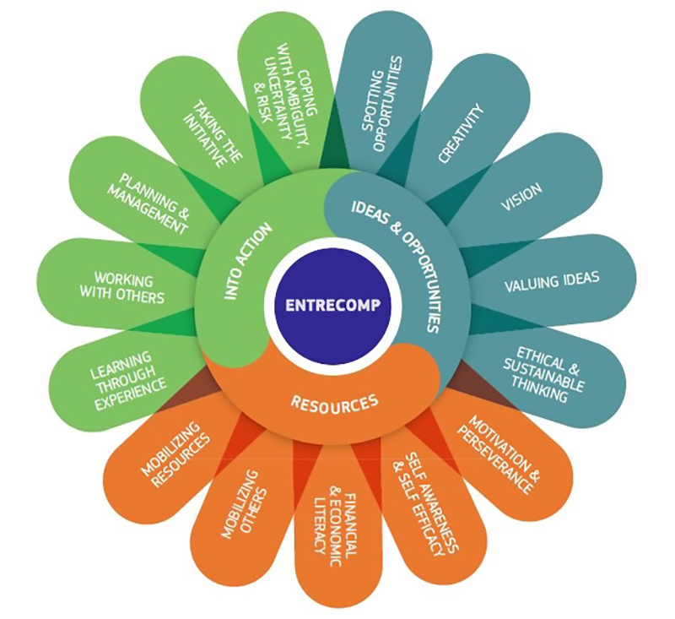
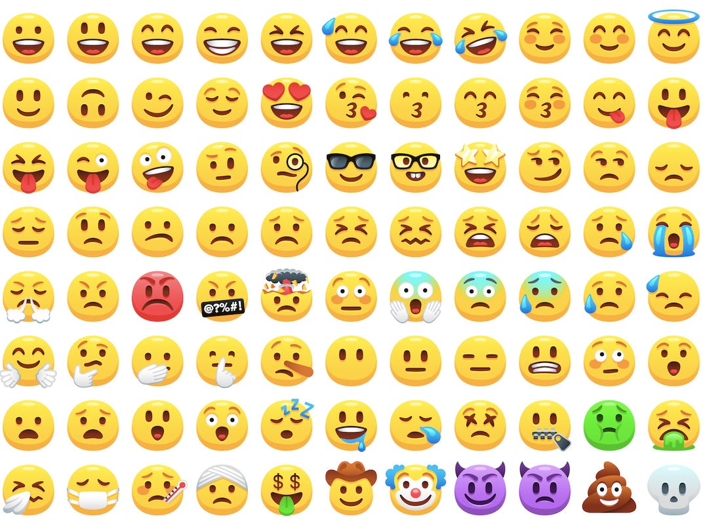
Source: https://www.eee-platform.eu/the-entrecomp-competence-framework/ (Accessed: 15th December 2019).
Appendix 2 – Using divergent thinking to show how many uses there are for a shoe.


ECAD6011 – Tom Cox Thinking like a 5-year-old 8th October 2019
Plant pot
Laces: bobble
Money box
Jewellery holder

Hammer
Microphone
Phone holder
Sponge
Gloves
Sole: gum shield
Pillow

Appendix 3 – A refelction on the mathematics lesson which allowed me to overcome my functional fixedness by allowing the learners to use a table in comparison to their books.

Model Beirniadau Wedi Adfyfyrio (BWA)

Assisted Reflective Conclusions (ARC) Model
Dyddiad/Date: 08/03/18
Digwyddiad critigol (Ffocws)/Critical incident (focus): Identifying angles

Profiad/ Experience

Teimladau/  Feelings  Beth yw eich teimladau ynghylch y profiad?  What are your feelings regarding the experience? | - This activity required learners to identify the different angles; acute, obtuse, right, straight, reflex and full.  - I believe that this lesson went well as the learners seemed engaged and on task throughout the lesson.  - This lesson was very different to previous lessons and required learners to use the tables as their mathematic books.  - Although the learners were rather loud at times, it was a pleasure to see that learners who often find it difficult to concentrate during this lesson.
Cofio a Deall/  Remember and Understand  Can you list the aspects of the learning experience that went well?  What were the elements of the  learning experience that were disappointing? | - Replacing their books with a table worked well as all the learners were engaged in the tasks. At first, the leaners were hesitant to write on the table but after giving them the permission to do so, it works effectively.  - Learners were able to correct any errors they had made and worked in mixed abilities to complete the task.  - Some learners were distracted by the pens and used them to draw in comparison to participating in the activity.
Gwerthuso a dadansoddi/  Evaluate and analyse  What will you keep the same to ensure effective teaching and learning in the future?  What was the cause of the most important disappointing element? | - For the future lessons and activities, I will continue to use resources in alternative ways as it was evident that the learners were engaged in this activity in comparison to working out questions provided within the textbook.  - Allowing the learners to work in differentiated groups worked effectively as the learners of higher ability supported those of lower ability.  - Allow the learners to peer assess each other’s work in groups.  - I believe that the groupings were too big and therefore this resulted in a number of learnings using the pens to draw.
Casgliadau a chamau gweithredu/  Conclusions and actions  What are your possible solutions to the disappointing issues identified?  What will you do next? | Future targets:  - use a timer to challenge the learners to complete the task in the time provided.  - Reduce the number of learners in a group from 6 to 4.  - Continue to use resources in alternative ways.
Y profiad newydd / Transformed experience

Appendix 4 – A photograph to illustrates how a table was used to teach the different types of angles in comparison to the traditional method of their textbooks.

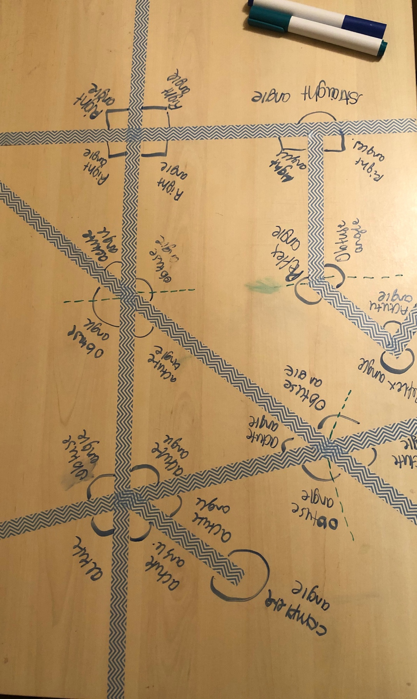

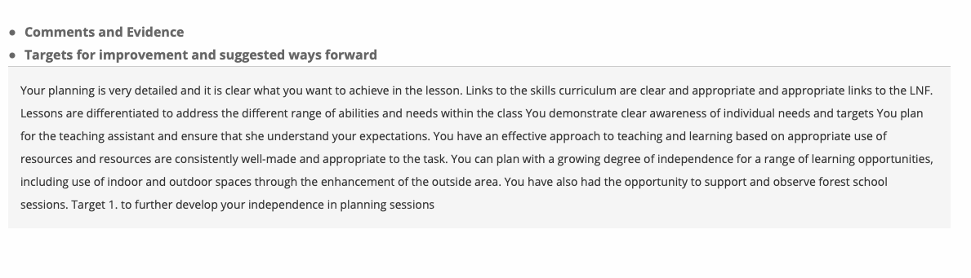
Appendix 5 – Feedback during my second professional teaching experience.
Appendix 6 – The final product produced for the egg challenge and a video to illustrate its success.
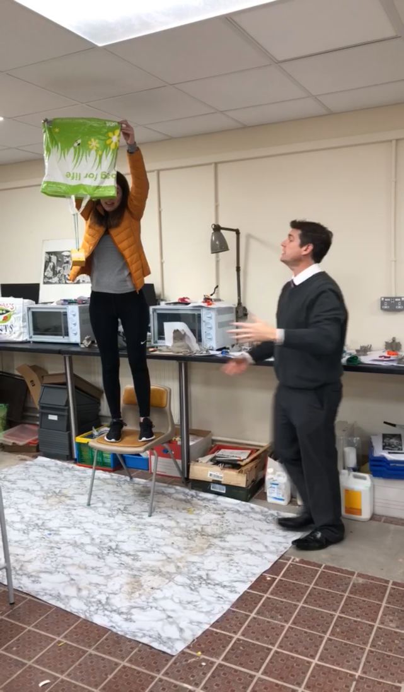

Video available:



Appendix 7 – De Bono’s thinking hats.

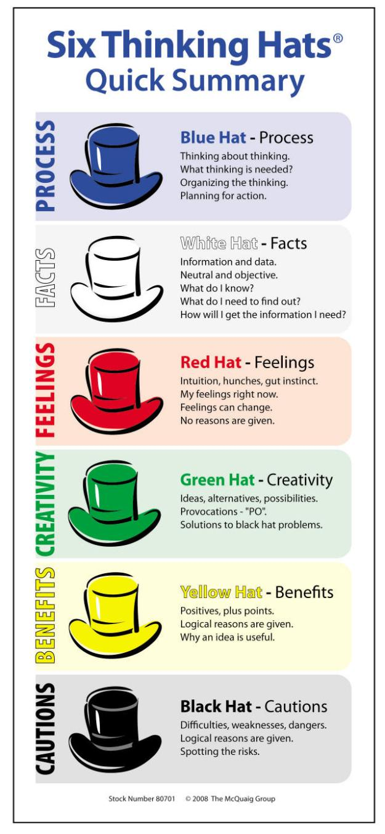

Source: https://highlandliteracy.com/reading-2/de-bonos-six-hats/ (Accessed: 19th December 2019).

Appendix 8 – Idea proposal – ‘What if every classroom was a mobile classroom?’

Allows the learners to decide their learning as anything is possible. The voice of the child has become a focal aspect in education today.
May provide opportunity for learners to participate in first-hand experiences.

Opportunity for learning to take place indoors and outdoors and several destinations of their choice.

Sources:
https://www.shutterstock.com/search/school+bus+clipart (Accessed: 10th November 2019).


What if every classroom was a mobile classroom?

This may consequence in a number of aspects in the curriculum to be achieved which may entice cross-curricular learning.

Once a week, the learners will be provided the opportunity to be taught beyond the four classroom walls.
Research advocates that outdoor learning and educational visits provides both benefits to learners and practitioners. This includes a rise in the learners’ health and well-being, their motivation and engagement and a rise in the learners’ concentration levels.

Appendix 9 – Photographs taken during Duke of Edinburgh.
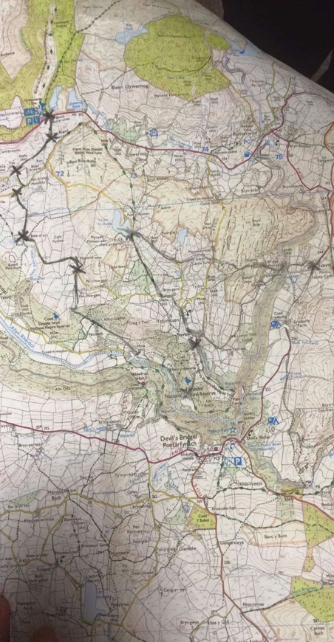
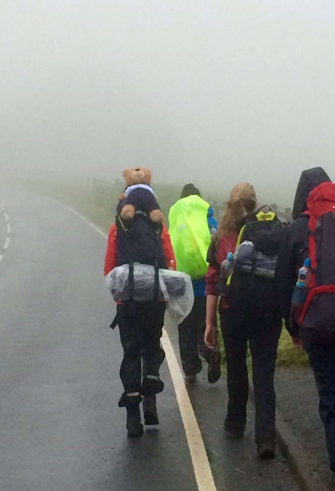
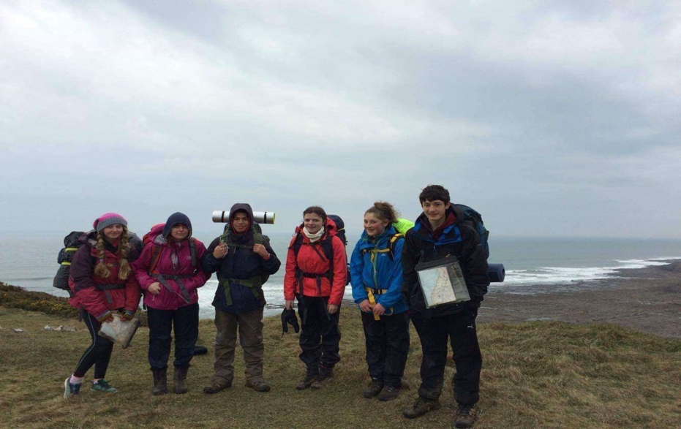

Appendix 10 – The Personal Resilience Framework.

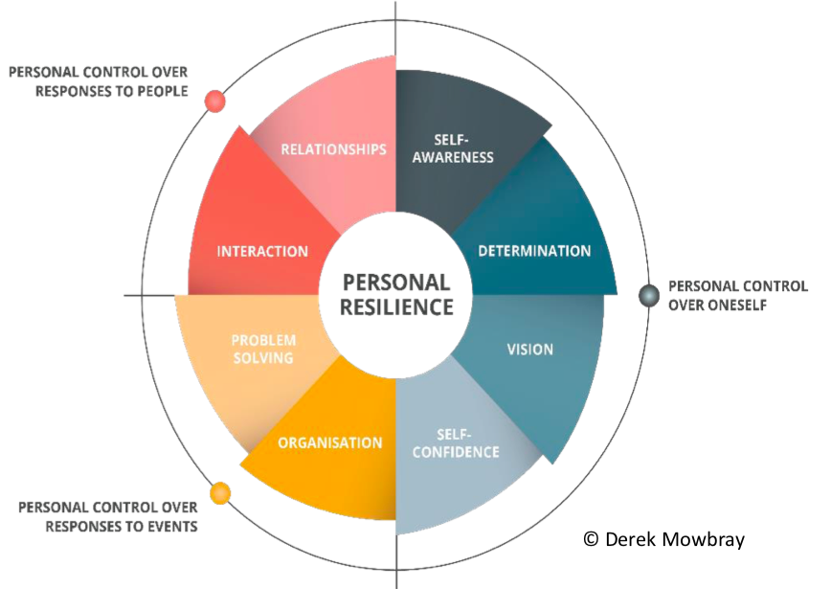

Source: https://www.ficm.ac.uk/sites/default/files/strengthening_personal_resilience_ficm.pdf (Accessed: 29th December 2019).

