ACMA4008 – Engineering Design Project

Drill Press Main Sliding Unit
University of Wales. Trinity Saint David
Barry Phillips Student ID:2014949

Contents

Introduction 2
Technical report of current design 3
Redesign Specifications. 4
The Re-Design 5
Manufacturing of new design 6
The discussion 6
Conclusion 7
References 8

WORD COUNT: 1536 (Excluding References)

Introduction

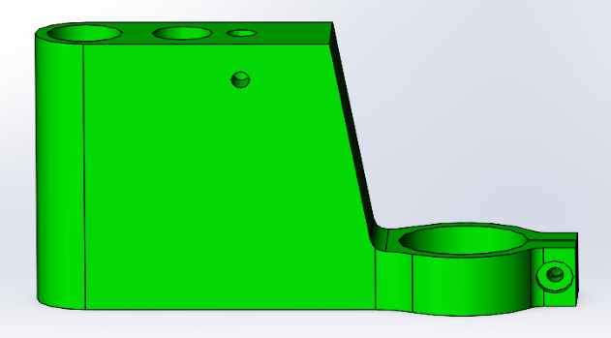
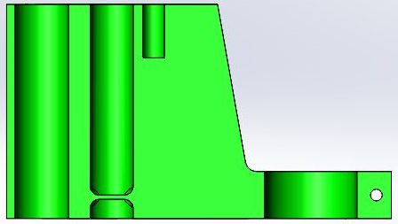
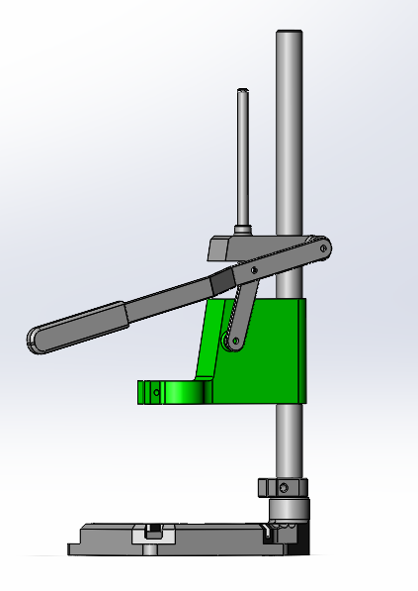
Figure 2. Drill Press Main Sliding Unit
Figure 3. Cross Sectional View of the Drill Press Main Sliding Unit
Figure 1. Drill Press Full Assembly

This assessment’s purpose is to consult with a manufacturer of the above drill press stand, with the purpose of possibly redesigning the drill press main sliding unit.
The company has the aim of producing 1000 units per week of the above press, our intention is to enable them to make a profit by improving the design of the drill press main sliding unit.
To enable us to re-design the part we first need to understand what a drill press is and to evaluate the original design.
A drill press can also be known by other names including a pedestal drill. They are commonly used to hold a drill in place whilst performing certain operations like countersinking or Counter-boring and tapping. Drill presses are available in various shapes and sizes, from floor to table mounted. Drill presses offer more precision work compared to a standalone drill. (transparencymarketresearch, 2019)

Technical report of current design

The original design was analysed, and the following conclusions were made.
Customer needs.
To best understand the customer needs we can use the kano model for customer satisfaction.
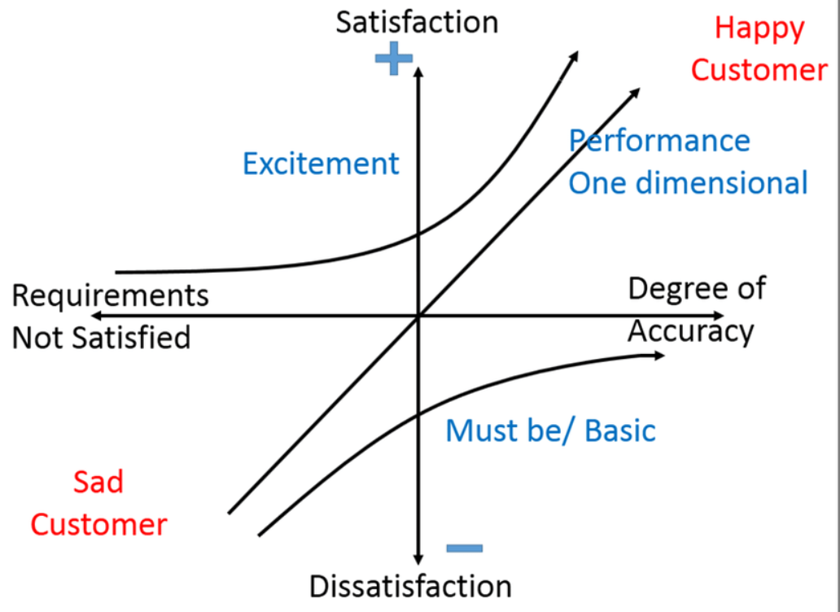
Figure 4. Kano model of customer satisfaction (Solanki, 2018)
- Basic needs. The Customer`s would expect the following but won’t necessarily ask for them. They need the drill press stand to be sturdy, light for portability and long lasting they would need these features to stay competitive, If the stand was made without these features, you would not stay competitive, and the customer would most likely look elsewhere.
- Performance needs. With an increase in investment, you will improve customer satisfaction, if you can add more functions to the stand without too much added cost, the customer will most likely choose your product over the competitor.
- Excitement needs. Adding a feature to the drill press stand that if this was not there the customer would not notice, however the fact they are there would make the customer want this over any other product on the market.
Functional and aesthetic requirements.
- The design has 3 Holes present in the main sliding unit. Each has its own purpose the 1st is to allow suitable movement between the main pillar and the sliding unit. The 2nd hole is equipped with a piece of metal to support a spring to allow for a controlled return of the part whilst in operation. The 3rd hole is for stability to ensure the part does not twist or turn in operation. The drill press has an attachment to allow a drill with a collar up to 43mm which is standard to most drill sizes.
- The aesthetic appearance of the part shows a bulky design with square edges. Its actual appearance is a different colour to the rest of the unit.
Serviceability and ethical considerations.
Due to its bulky design, there is not much that would need servicing on the part, although applying lubrication to the main shaft could prove a little tricky. Also, as this is one component if something breaks then the whole part would need to be replaced. However, the stand itself comes in many different parts which does allow swapping one faulty part for another.

Codes of practice
- If this is to be sold to members of the public or trade alike, then this would need to follow the Provision and use of work equipment regulations 1998 act (PUWER).
- The stand although very basic in design will be holding a power tool. And if the power tool does not have an emergency stop the stand should be able to be equipped with one, to conform to PUWER requirements. (HSE, 1998)

Redesign Specifications.
Now the original design has been analysed and the decision was made to re-design the drill press main sliding unit.
- To meet the basic needs of the customer they would expect a drill press stand to be light and sturdy. The new design will weigh less than the original and will have a cleaner futuristic design. A good design method is an open looking design. If something is as transparent as possible then there is no fear of hidden components.
- Less material to reduce production costs.
- All parts to remain open to either allow easier maintenance or to give the appearance of easier serviceability.
- Viewing leading competitor prices and designs.

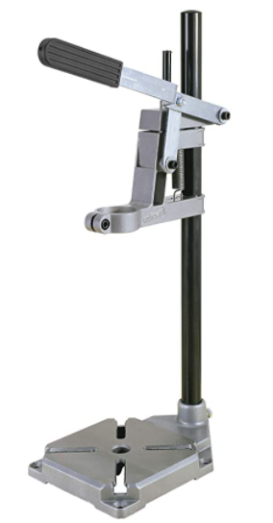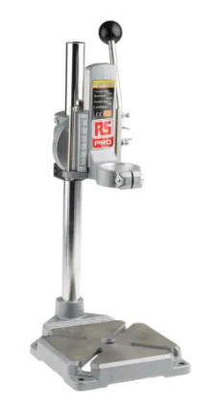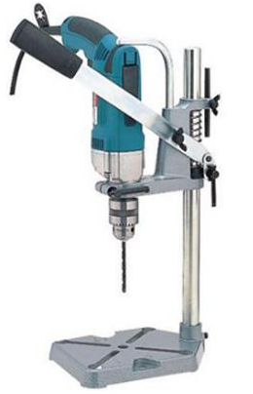
(Amazon.co.uk, 2022) (RsOnline, n.d.) (Tools, 2022)
Figure 5. Wolfcraft £29.49 Figure 6. RS PRO £66.33 Figure 7. Makita £99.99
The three leading brands are various prices, however each of their designs are similar. Each are showing a smaller drill press sliding unit. Some with and some without springs.

The Re-Design

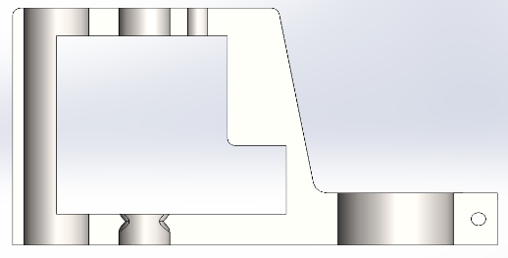
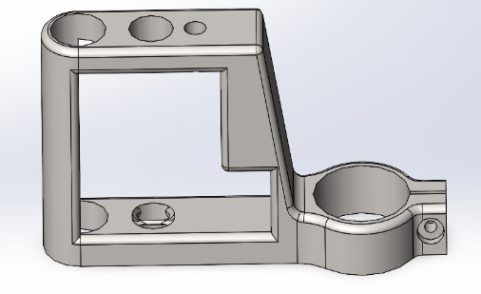
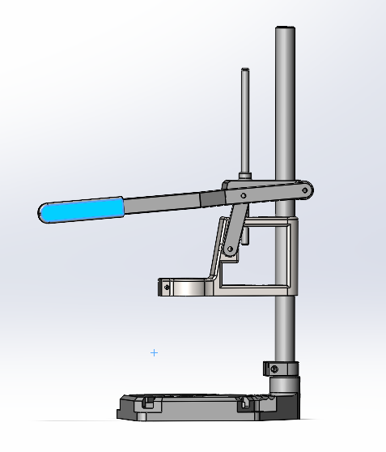
Figure 10. Cross Sectional View of the New Drill Press Main Sliding Unit.
Figure 9. New Drill Press Main Sliding Unit.
Figure 8. New Drill Press Full Assembly.

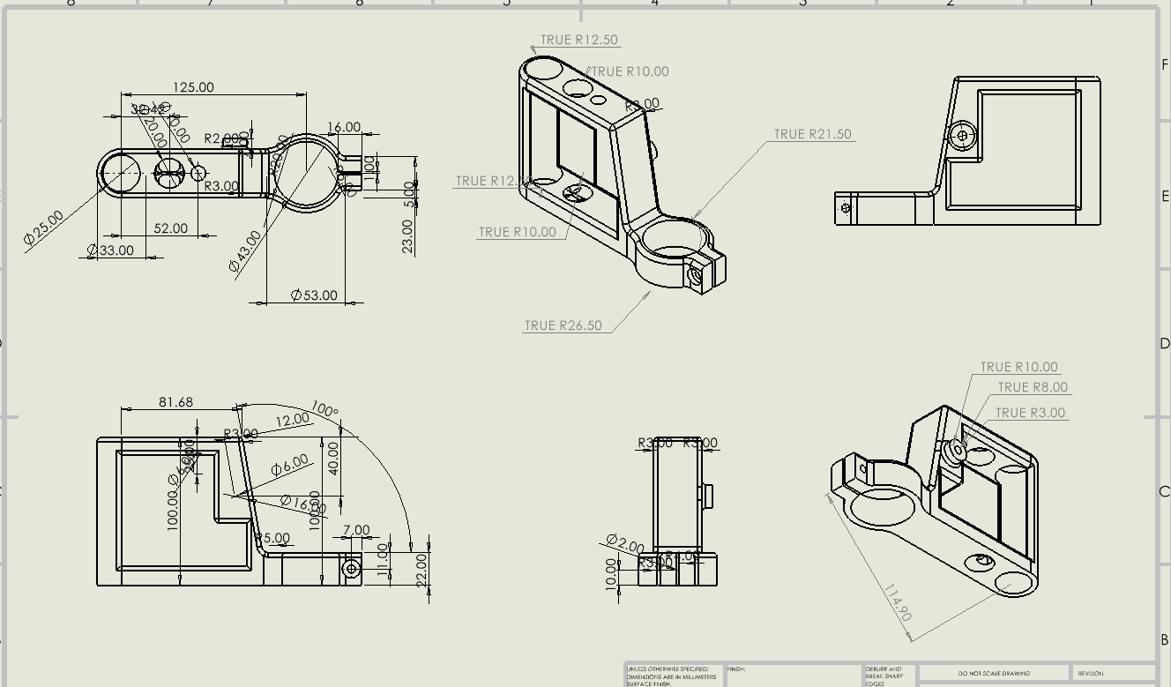
Figure 11. Solid works Design of new part.
The new design has kept the basis of the original design. The 3 holes in the sliding unit remain, as their functions are vital to the performance of the machine. The collar to hold the drill remains the same with the ability to hold a drill with a collar up to 43 mm.
The hole which is designed to accommodate a spring is now more visible allowing the ability to weld a new piece should this snap. The hollow design has the following benefits.
- A futuristic feel to the product giving a clean aesthetic appearance.
- The ability to attach an emergency brake to the main shaft without impeding the performance of the stand to conform with PUWAR regulations.
- A clear view of the main shaft to allow for easier lubrication.
- Less material used in the manufacturing process.
- Less surface area to aid cooling if the product is to be cast.

The table below shows the difference between the two designs.
 | Mass (g) | Volume (mm³) | Surface Area (mm²)
Old Design | 283.81 | 283808.88 | 56573.92
New Design | 148.02 | 148020.81 | 43506.75
Difference | 135.79 | 135788.07 | 13067.17
% Difference | 48% Lighter | 48% Less Volume | 23% Less Surface Area
Figure 12. Table comparing Mass, Volume and surface area of the Drill press sliding units.

Manufacturing of new design
This product as shown in figures 5-7 is not a high-end priced product so we need to keep manufacturing costs down to the minimum, with this and the requirements of 1000 units a week in mind are we better off moving towards die casting or a machined polymer or composite component.

The discussion
Metal. If we were to use a metal, then die casting would most likely be the better option. Normally the method for costing castings is the weight made by the amount of energy used, so by choosing a part where the material has been removed as in the re-design, it will now be 48% Cheaper than previously mentioned. Other options such as extrusion, or forging would most likely need to make 2 separate parts due to the collar to attach the drill, which would then require joining or welding together. Die casting from a single mould will allow for consistent quality at a relatively low cost as you would only need to have one bespoke die, which typically can cost around £1000 (Edmo, 2020), and can normally last up to 80,000 uses. However diecasting lead time can be slow and would not be ideal for high melting metals such as steel so aluminium would be the idea choice however would then lose the strength required. Die casting products once cooled often shrink and normally will need parts trimming off at the end.

3D printing has taken the production world by storm over the last decade, and we can now laser print using direct metal laser sintering, in this process we use metal powder to print an object such as our sliding unit in metal. However, you can also 3D print in polycarbonate which boasts a higher tensile strength than steel. 3D printing can take anywhere from 1 – 12 Hrs to make a part, so to make 1000 a week we would need to be making 6 an Hour to keep up with demand. Even with the best printers on market today we would need 6 Printers. Which would dramatically increase costs.
Injection moulding is very similar to die casting, both require a mould, both require you to liquify the material. You can have plastic or Metal injection moulding. Plastic reduces the need for the raw ingredient of metal, has quicker cooling time and can be made stronger with additives. However, does not have the same aesthetics as metal. The MIM produces much cleaner parts reducing or eliminating the need to trim off the edges. However, the sintering will again cause shrinkage. A MIM mould should last around 150,000 shots so will last almost 3 years.

Conclusion
Based on these discussions we have decided to produce using injection plastic moulding with the aim of having a strong plastic product. Once 3D printers evolve, we will be in a better position to move our production over to these as we are already using plastic polymers.
In line with the assignment brief we are only looking at the sliding drill press unit, however if we were looking at the whole drill stand, we might benefit by using the Lucas component appraisal chart to see if we could remove parts from the stand to make a more design efficient product.
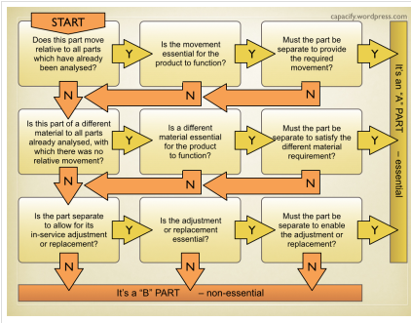
Figure 13. (Lucas, 1991)

References
Amazon.co.uk, 2022. https://www.amazon.co.uk/Wolfcraft-3406301-3406301-Drill-Stand/dp/B00PLSIHBK?th=1. [Online]
Available at: https://www.amazon.co.uk/Wolfcraft-3406301-3406301-Drill-Stand/dp/B00PLSIHBK?th=1
[Accessed 16 02 2022].
Edmo, 2020. How much does casting die cost, s.l.: www.edmolimited.co.uk.
HSE, 1998. Provision and Use of Work Equipment Regulations 1998 (PUWER), s.l.: https://www.hse.gov.uk/work-equipment-machinery/puwer.htm.
Lucas, 1991. The Lucas Manufacturing Systems Handbook, Solihull: Lucas Engineering & Systems Ltd.
RsOnline, n.d. https://uk.rs-online.com/web/p/drill-stands/1625355. [Online]
Available at: https://uk.rs-online.com/web/p/drill-stands/1625355
[Accessed 16 02 2022].
Solanki, M., 2018. Review of QFD and Kano model for customer satisfaction. s.l.:s.n.
Tools, M., 2022. Miles Tool & Machine. [Online]
Available at: https://www.mtmc.co.uk/product.aspx?ProductID=41006&source=googlebase
transparencymarketresearch, 2019. Drill-presses-market. [Online]
Available at: https://www.transparencymarketresearch.com/drill-presses-market.html
[Accessed 10 02 2022].

