

Kingston Place, Portsmouth

Name: Hortenzia Bodor
Student ID: 2233649
Module Code: LCBB4002
Module Name: Community Engagement
Lecturer: Nadeem Mirza

Table of Contents

Introduction 1
Kingston Prison redevelopment 2
1. Background 2
2. The project 4
3. Lessons learnt 8
Conclusion 9
References 10

Introduction

Human interactions and collaboration serve as the basic foundations of our civilization’s achievement, as facilitating our ability to develop, advance, and build complex social networks. These have played a crucial role in overcoming obstacles throughout the course of history and will remain essential for the development of a sustainable and connected future.
Living inside a community promotes a collective sense of connection, assistance, and shared wellbeing. Belonging to a community gives individuals emotional and social happiness, mitigates sentiments of isolation, and improves personal development via collective interactions and cooperation.
The issue of housing affordability has significant importance for the city of Portsmouth. A big portion of the population faces challenges in meeting their housing requirements within the free market and therefore select for affordable housing options, through either the Council or using another registered provider.
In this study I would like to provide a comprehensive description of a redevelopment housing project in Portsmouth, highlighting its ambitious nature. I will examine the primary goals of the project, the underlying architectural principles, the environmental factors considered, and the strategies for community integration.

Kingston Prison redevelopment

1. Background

Portsmouth, located on the south coast of England, is a vibrant maritime city with a rich history. Known for its historic dockyard, Portsmouth offers a blend of cultural attractions, waterfront activities, and a lively city centre. The dockyard, which is still a major source of employment, date back to 1496, when the town was already a naval base. Portsmouth’s population now is estimated at 252.389 residents. (2023)
Housing is a necessity and problem for a growing population city, like Portsmouth.
Kingston Prison was constructed in 1877 in the Victorian radial design. During World War II, the prison structures served as both a juvenile detention facility and a police station. In 1965, the death penalty for homicide was lifted and Kingston began holding exclusively those serving life sentences. Kingston Prison was the only prison in England and Wales to have a facility specifically for life-sentenced elderly male prisoners. The prison has been home to many famous inmates, including EastEnders actor Leslie Grntham, who played Den Watts on the show, and the M25 three; Raphael George Rowe, Michael George Davis, and Randolph Egbert Johnson, who were sentenced to life imprisonment at the Old Bailey in March 1990. In 2003, however, Her Majesty's Chief Inspector of Prisons found the facility for elderly prisoners to be "unacceptable." According to the report, the unit lacked adequate ventilation, electrical outlets, and natural light. Immediately following the release of this report, the elderly prison unit was relocated to HMP Norwich. In April 2012, the prison contained approximately 800 category C inmates out of a total population of approximately 900. On January 10, 2013, it was announced that the HMP Kingston would close, and the institution would be shut down on March 28, 2013. For decades, the only way to reside within the walls of Kingston Prison was to have committed some of the most horrific crimes imaginable. However, today, ten years after the closure of the notorious prison in Milton, Portsmouth, there has been a substantial increase in the number of people attempting to reside there.
The prison has been converted into luxurious one-, two-, and three-bedroom residences and renamed Old Portsmouth Gaol. People now pay to live in the former cells that once housed some of Britain's infamous murderers.

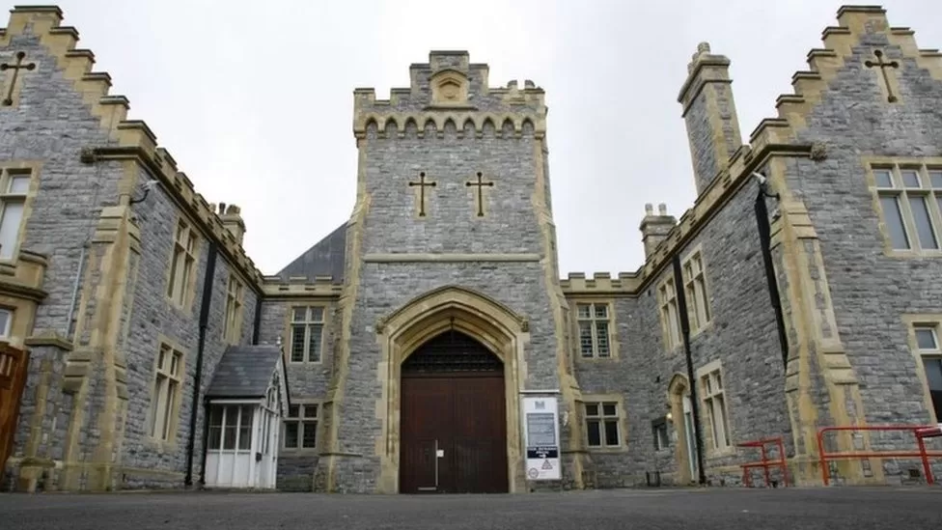

(Figure 1, BBC-2019)

2. The project

Following the closing of the penitentiary in 2014, the Department of Justice sold the facility to City & Country. In 2015, the intentions of converting the prison into apartments were made public. The proposal included 267 apartments. The public supported a museum with 28% of the vote and housing with 21% of the vote, according to the results of previous public meetings. There will be 347 parking spaces in the proposed development, and 183 of the new apartments will be designated as affordable housing. The Portsmouth City Council required the construction of affordable housing on the site. This initiative is a collaboration between affordable housing provider Vivid Homes and developers City and Country.
This project provided numerous benefits to individuals and the community, including the delivery of 267 new homes to contribute to Portsmouth's housing needs, the creation of jobs during the demolition and construction phases, additional investments from new residents and employees, and the redevelopment of a well-known place, to boost the location's overview and investment confidence. Moreover, contributes to sustainable urban development by optimising land use and fostering environmentally friendly design, thus improving the overall quality of life for the residents.

The target stakeholders in this project includes:

1. the residents, they are the main beneficiaries, because they will live in these apartments
2. the local community, the neighbourhood thus are directly affected, and their opinion need to be taken is consideration
3. the local authority, by approving, regulating, and supporting the project through policies, permits, and funding
4. the organisations that are responsible for the housing project's design, financing, and construction.
5. investors, who provide financial support or invest in the housing project (Vivid Homes in partnership with Drew Smith Ltd)
6. architects and planners, the professionals responsible for designing the housing project and ensuring its compatibility with the surrounding urban landscape (in this case Grant Associates)
7. environmental and sustainability professionals, who address the housing project's environmental impact and sustainability aspects
8. utility providers, who are responsible for providing the housing project with essential services such as water, electricity, and drainage systems
9. local leaders and organisations, representing community interests and advocating for the success and positive impact of the project
10. real estate agencies, responsible for marketing and selling the homes
11. public and media, who have an interest in understanding the housing project's impact and development

Deputations

Mr. L. Nicholas, Chair of the Baffins Neighbourhood Forum, and a local resident, brought up objections, including the following:

- although residents were invited to share their ideas for the site's use, this proposal was for the applicant's financial gain.
- the design continued to give the development a prison-like appearance and was unnecessary for the site.
- the adverse effects on local infrastructure, such as GP availability and school places, which were overwhelmed.
- environmental and parking considerations

Councillor Sanders, as the Baffins ward councillor read the written submission of fellow Baffins ward councillor Lynne Stagg, whose points included:

- no social housing had been included when it should have included 30 percent of the project.
- if this was due to sustainability concerns, why had the land been bought in the first place?
- there will be additional transport issues.
- the original prison building is in Victorian style, but the new structures are flat cubes with poor design and materials, and the roofing differ from the surrounding roof styles.

Councillor Sanders said the following:

- the project misjudged the impact on the local community and did not compensate for it sufficiently.
- these are all flats while there is a need for family homes too.

The application for the redevelopment of a former prison was submitted in January 2016. The proposed redevelopment included the partial demolition and conversion of existing buildings to create 73 apartments and commercial units’ class A1 and class A3. Additionally, the plan involved the construction of five blocks ranging from three to seven stories, to serve 157 homes. The proposal additionally included the partial demolition of the prison wall, the creation of new vehicle accesses to Milton Road and St Mary's Road, the provision of car parking facilities, and the implementation of associated gardening and other necessary works.
One of the most difficult planning challenges to overcome was the classification of Grade II for the major prison building, surrounding wall, engineers' workshop, and gatehouse. Several key factors were considered when evaluating this application. These factors included the necessity of a prison, the viability of the proposed site for residential development, the potential impact on neighbouring properties, the effect on heritage assets, the feasibility and achievability of the proposal, the public advantages associated with the proposal, and the consequences for the local highway network. The project included the restoration of a neglected historical place with the intention of effectively meeting the housing requirements and long-term objectives at both the local and broader levels. The proposed development includes the utilisation of an empty site for an extended period, with the objective of restoring the surrounding neighbourhood and significantly assisting the city's affordable housing objectives.

The proposal comprises of two main components: the redevelopment of the central prison building and gatehouse into 73 new homes, and the construction of five new houses ranging in height from three to seven stories and providing 157 new homes.
The proposed 230 apartments include 7 studios (all within renovated structures), 83 one-bedroom apartments (39 as part of the renovation and 44 new construction), 120 two-bedroom apartments (19 renovated and 101 new construction), and 20 three-bedroom apartments (8 renovated and 12 new construction).
The proposed construction materials included similar building elements to reflect match the original structure without threatening current structures.
Before submitting the proposal to the Council, significant community consultation, site visits from all interested parties, public meetings, online surveys, and application preparation were conducted. The developer's design team has modified the proposal in response to feedback from the community, Council officers, and the Design Review Panel's feedback.
This application resulted in the conclusion that the site has no future potential for its initial purpose or other comparable uses. It has been decided that there are significant public advantages associated with the proposal to compensate for the less-than-substantial damage identified, such as pollution, high walls creating shadows on close homes, increased traffic, overcrowded schools, and general practitioners. Residents were more concerned with the infrastructure and air quality.
Rod Bailey of Godwit Road noted, 'We already have an extremely congested highway network. Evening traffic north of the Milton bridge is backed up not only to the penitentiary but also beyond the roundabout on weekdays. (Portsmouth-2019)
Concerned that they would lose access to affordable housing, if they vote with a no, councillors voted in favour of the plans.
In 2019, despite the residents' pleas, the project was approved. Respecting the building's history while establishing a contemporary, comfortable environment, an effective plan was created. In addition, full engagement with the Portsmouth City Council and numerous public consultations were included.
The council approved a £49 million plan for the project, that includes 347 parking spaces, a store, and a restaurant.
The developers City and Country collaborated with Vivid Homes, who delivers a substantial amount of affordable housing on this site. James Butler, 30, one of the development’s first residents said: “It was the best of both worlds – both old and new at the same time.” (Portsmouth-2022)
Today, HMP Kingston has been transformed into modern apartments while retaining its original features.
Martin Merrett, director of Bernards Estate Agents, who has been supervising the sale of the apartments, noted that the structure has become "quite special." He added, " it’s created a lot of interest and is a bit of a talking point around the town - we've not really had any issues selling the apartments.”

3. Lessons learnt

The lessons that can be learned from this project cover a wider range of topics.

- the restoration of the original building design and the integration of historic and new build features demand the implementation of precise project management.
- the encouraging of community engagement has been identified to positively impact residents’ happiness and develop a sense of connection. However, it is crucial to acknowledge that local communities have certain rights that local authorities are required to protect and respect.
- adopting a flexible design makes it possible to meet the needs and preferences of future residents.
- effective communication between all parties prevents confusion and disagreements.
- the importance of quality construction plays a significant role in the long-term performance and reputation of a housing development, as it guarantees its durability and safety.

Conclusion

The provision of housing is universally recognised as a fundamental human right, and it frequently represents the most significant asset for individuals.
Ensuring that all residents have a safe, accessible, and affordable place to call home is vital to Portsmouth’s future.
The conclusion of the HMP Kingston project represents not only the physical realisation of the prison's redevelopment, in addition to cement and stones, but also the realisation of a goal. Through careful planning, innovative design and redesign, dedication, and collective effort, an empty and unused site has been transformed into an enjoyable place to live. The path from concept to the realisation was not without challenges, but each one was mastered with perseverance and creativity. It would have been a disgrace and a waste for the community if the city had left this Victorian style building unoccupied and abandoned; housing is always necessary. In addition to structures, the result is the effectiveness of collaboration, the significance of sustainable procedures, and the creation of a place that future generations will call home.

References

About My Area. (2015) Crowds Descend on Kingston Prison
Available at:
https://www.aboutmyarea.co.uk/Hampshire/Portsmouth/PO6/News/Local-News/288166-Crowds-Descend-on-Kingston-Prison [Accessed: 22 July 2023].

BBC News. (2019) Kingston Prison in Portsmouth to become 267 flats.
Available at:
https://www.bbc.co.uk/news/uk-england-hampshire-47318984 [Accessed: 29 July 2023].

Broom, C. (2022) ‘How Kingston Prison became the residential development Old Portsmouth Gaol’, The News, Portsmouth, 8th Oct.
Available at:
https://www.portsmouth.co.uk/news/people/how-kingston-prison-became-the-residential-development-old-portsmouth-gaol-3872409 [Accessed: 28 July 2023].

Directorate Of Environment & Transport. (2016) Planning Committee 6 July 2016
Available at:
https://democracy.portsmouth.gov.uk/documents/s11581/Planning%20Committee%20Report%206%20July%202016.pdf [Accessed: 20 July 2023].

Dye, E. (2022) ‘Now that's a 'forever home'! Grade II-listed 19th Century lifers' prison which locked up serial killers, a Nazi war criminal and Eastenders 'Dirty Den' actor is converted into 64 apartments going for up to £325,000’, Mail Online, 14th Oct.
Available at:
https://www.dailymail.co.uk/news/article-11315027/HMP-Kingston-prison-locked-serial-killers-converted-luxury-apartments.html [Accessed: 14 July 2023].

Grant Associates. (2019) Planning success for former HM Prison Kingston site.
Available at:
https://grant-associates.pr.co/171731-planning-success-for-former-hm-prison-kingston-site
[Accessed: 20 July 2023].

Lemmer, R. (2021) ‘Work begins on 260 homes in Kingston Prison site in Portsmouth’, The News, Portsmouth, 17th Jan.
Available at:
https://www.portsmouth.co.uk/news/people/work-begins-on-260-homes-in-kingston-prison-site-in-portsmouth-1378325 [Accessed: 25 July 2023].

Vivid Homes. (2023) Kingston Prison.
Available at:
https://www.vividhomes.co.uk/about-us/more-homes/developments/kingston-prison [Accessed: 18 July 2023].

Vivid Homes. (2020) Construction of new affordable homes starts at Kingston Prison site.
Available at:
https://www.vividhomes.co.uk/news/construction-of-new-affordable-homes-kingston-prison-site [Accessed: 18 July 2023].

Willshaw, T. (2016) ‘Pros and no cons: unlocking new homes at Kingston Prison’, Planning matters, Lichfield, 7th Oct. 2016
Available at:
https://lichfields.uk/blog/2016/october/7/pros-and-no-cons-unlocking-new-homes-at-kingston-prison/ [Accessed: 26 July 2023].

