Name | Naqash Asif
Student number | 2407608
Module | Introduction to Health and Social Care
Module code | LCHS4003
Programme | Certificate of Higher Education Skills for the Workplace (Health & Social Care)
Lecturer’s name | Deniel Haruna
Assignment title | Component 1- Portfolio – Two Tasks
Submission Date | 23rd February 2026


Community Mental Health Services
Community Mental Health Services (CMHS) are local programs help adults aged 18 and older manage their mental health at home. These services bring a team of experts including nurses, doctors, and social workers. This team supports you with much more than just medical treatment; they also offer practical help with finding housing, keeping a job, improving your physical health, and providing professional counselling. This program keeps you independent, stable and comfortable in your own familiar surroundings
Historical Change in Mental Health Care
For much of the 20th century, mental health care was provided in large hospitals, far from patient’s homes. Change began in the 1930s, when basic mental health support became available, though it remained limited and large institutions. By 1959, patients leaving hospital began to receive support through emerging community services. The real transformation occurred between the 1960s and 1980s, when new laws were introduced, old hospitals closed and care shifted into the community. In the 1990s, accessible support made it easier for people to find help, while the National Service Framework of 1999 established expert teams to raise standards nationwide. Since 2019, funding has increased and care has become more coordinated through the NHS Long Term Plan, with Integrated Care Systems linked across the health system to keep people safely at home.
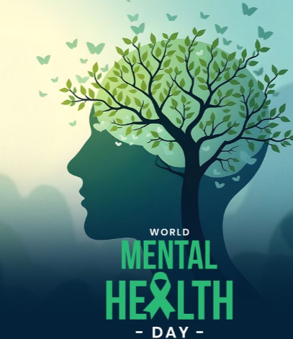

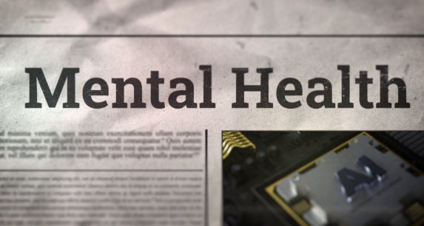

Current Functioning of the Service
Today, CMHS supports people’s mental health. Teams of specialists provide care to individual needs, offering urgent support, home visits, medication management, and therapy. The service is designed to help people recover, remain independent, and feel well, while working alongside social services, housing providers and employment support. Care is inspected by the Care Quality Commission
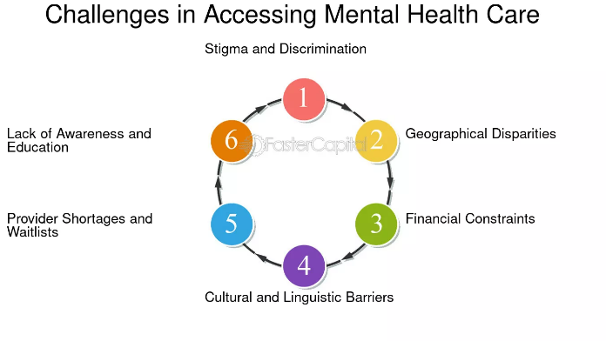

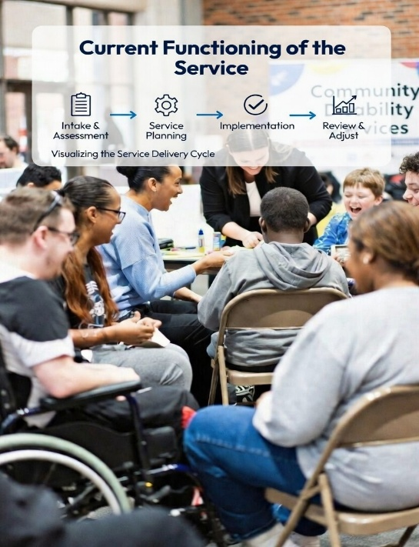

Challenges Faced by the Service
Despite its importance, CMHS faces significant challenges. One major issue is waiting times. Patients often wait weeks between their first and second appointments, with a delay. Some wait over two years, and report worsening mental health during this period. Staff shortages and rising demand make delays even more severe. Another challenge lies in funding and resource disparities. Although mental health accounts for 23% of the overall disease burden, it receives less than 15% of NHS funding. This imbalance leads to staff shortages, increased stress, limited capacity, and uneven care across regions.



Partnership, Communication, and Record Keeping
Partnership working is central to CMHS. Nurses, doctors, social workers, families, councils, charities, and health teams collaborate to provide efficient care, ensuring that both medical and basic needs are met. Clear communication between staff, service users and families reduces errors, builds trust and ensures care is tailored to everyone. Reliable record keeping further strengthens the service by documenting care plans and preferences, supporting continuity, protecting patients and staff, and ensuring safe, informed decision-making.
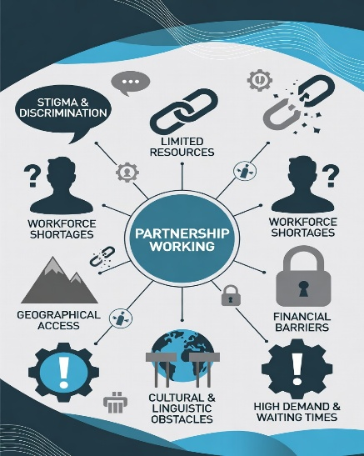

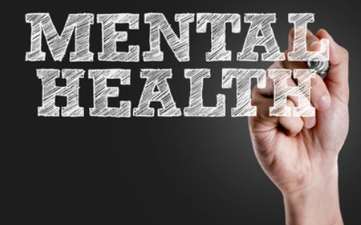

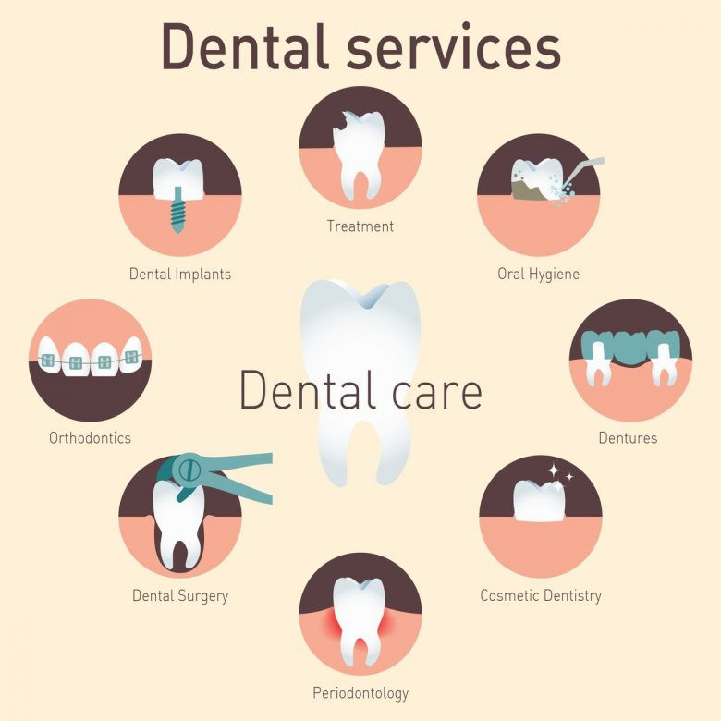
Task 2: Title: The Origins, Current Functioning and Significance of NHS Dentistry Services in Enhancing Quality of Life

Millions of people in the UK use NHS dental care, which is an important part of the National Health Service. This essay examines the history of NHS dentistry, the current operations and importance in supporting the lives. An important factor of the health and social care system in the UK is dentistry services. This essay discovers the history of NHS dentistry, how it operates today and how it helps people.
NHS dentistry of the National Health Service began on 5 July 1948 after the National Health Service Act 1946. This was reduced from the 1942 Beveridge Report, which proposed a welfare system for problems after World War II, such as poverty and disease, by providing free healthcare. Before World War II, many people could not afford dental treatment, this led to high rates, extractions and tooth loss.
When NHS dentistry started the demand for treatment because so many people had dental care requirements. In the first nine months over million artificial teeth were offered to patients, million teeth extracted and million filled, as people got free care for the first time. Most dentists 83% by November 1948 joined under Each item have a separate fee. system means patients pay for each treatment or service separately. Charges were introduced early in 951. Careful review of how things are working now In England, NHS dentists and private dentists work together care for people’s teeth. NHS dental care includes fillings, tooth removal and emergency treatment. The NHS pays for part of the cost and patients usually pay a small amount. Some people don’t have to pay, such as children, pregnant women and those who earn little.
Lot of people still struggle to pay and get dental appointments. Problem got worse after COVID-19. NHS work because of less money and confusing rules make it hard for some people. In some areas patients had to travel long distances for treatment and face waiting times, sometimes waiting months. Then people go to private dentists and sometimes borrow money. In the UK around 10% of people have tried doing their own dental work. 34% of those people got plugged out tooth themselves. They pay dentists more when they handle issues, like gum disease or bad tooth decay. "Making Life Better" NHS dentistry helps people fixes problems with teeth and gums, which makes eating and speaking easier. Bad teeth and gums can cause a lot of issues, like pain, infections and even make it hard to eat. When those who get their teeth fixed say they feel better. This includes older people who do not have much money, experiencing homelessness, people in prison and kids in care. Even with some exceptions in place, it's still harder to get dental care. These groups still struggle to get the care, even though that care helps them with daily life, social activities keep dental problems from ending up in the hospital. The new payments for 2026 help kids and those who are at higher danger. This reduces emergency room visits caused by dental issues.
NHS dentistry since 1948 always has challenges. But it remained important for people's health because it gives of easy access to treatment and care. UK dentistry has changed from private to a key part of the NHS. The service tries to put patients first but still had issues like tough to get an appointment proper funding. For dental care to work well, you must keep investing money in it. Also, good communication and teamwork are important.

Harvard style references
Task 1: Community Mental Health Services (CMHS)
- NHS England (2023) Community mental health services. Available at: https://www.nhs.uk/mental-health/services/community-mental-health-services/ (Accessed: 23 February 2026).
- Department of Health and Social Care (2019) The NHS Long Term Plan. London: DHSC. Available at: https://www.longtermplan.nhs.uk/ (Accessed: 23 February 2026).
- Mind (2022) Community mental health teams (CMHTs). Available at: https://www.mind.org.uk/information-support/guides-to-support-and-services/nhs-services/community-mental-health-teams/ (Accessed: 23 February 2026).

Task 2: NHS Dentistry Services
- NHS England (2023) NHS dental services explained. Available at: https://www.nhs.uk/nhs-services/dentists/ (Accessed: 23 February 2026).
- British Dental Association (2022) The state of dentistry in the UK. London: BDA. Available at: https://www.bda.org/ (Accessed: 23 February 2026).
- Department of Health and Social Care (2021) Integration and innovation: working together to improve health and social care. London: DHSC. Available at: https://www.gov.uk/government/publications/health-and-care-bill-factsheets (Accessed: 23 February 2026).

