PART A (UNDERSTANDING) (due date: February 25th 2019, 3pm)

A1. What is a variable and why are they important in writing programs?

A variable is a storage area in a program created by a programmer in which data can be assigned and stored inside. The variable is assigned a name, it can be called anything (not starting with a number or containing any special characters) but it is good practice to call it something related to its intended use [1].

The variable can be called upon anywhere in the program depending if it is global (defined before the program, after the libraries) or local (defined inside a function).
The data inside the variable can be changed by either the user or the program. This is the opposite of a constant which is also defined locally or globally but has a fixed value.

The data type expected to be assigned and stored to a variable must be declared for the variable. The data types are:

Int = Whole number
Float = Number with 6 decimal places
Char = Single character (e.g the letter ‘p’ or ‘a’)

The use of variables is important for writing programs because it allows the data to be manipulated by the user or the program whilst making sense to the programmer. If data was being manipulated without the use of a variable, and the programmer had data changing, without being fully aware of what the data doing, it would get very confusing.

A2. Explain why the for-loop can also be referred to as a counting-loop and give an example of when you would use it.

The for-loop can also be referred to as a counting-loop because the programmer places a condition on the for-loop, stating how many times the loop will run for. This is done by first creating a counter variable as an integer (int “i” is commonly used for this). Then create the condition (i=0; i<=4; i++) for example.

The steps taken by the program are as follows:

- if i is equal to 0, and i is less than equal to 4, and add 1 to i,
- if this is true
- run the loop.
- If this is false
- End the loop

By adjusting the value of i<=4, the number of cycles of the loop can be stated.
A time where a for-loop comes in handy is when using arrays. By using a for-loop to change to the next element within an array when obtaining data to be stored within it. This allows the programmer to only have to type the code to obtain the data, and assign it to the array, once. Then use a counter to incrementally change to the next element in the array. This saves time and makes the program look much neater.

For an example of an array in use, see section B, exercise 3.

A3. Explain what an array is, what their features are, and give an example of when you would use one.

An array allows multiple values of the same data type, to be stored in a single variable. An array is created by defining a variable and then including square brackets after the variable name [ ]. Inside the square brackets, the programmer specifies how many memory spaces will be allocated to this array [1]. For example this could look like (int myarray [5];).
(Note that because computers like to count from 0, 5 memory spaces in an array will be assigned from 0-4 and not 1-5.)

As with variables, arrays can be int, float, char or string. Arrays can also become multi-dimensional by having two or more index [ ] [ ] locations assigned to them. This becomes useful when displaying tables of information or coordinates.

For an example of an array in use see section B, exercise 3.

PART B (IMPLEMENTATION) (due date: February 25th 2019, 3pm)
The following exercises become increasingly more challenging. You don't need to complete all the exercises to pass this assignment. Marks will be awarded for attempting the exercises – a partial solution will still gain marks.

For each exercise below:

- Identify specific problems in completing the exercise.
  - You may also constrain a problem (simplify it) to produce a simpler solution that may act as a stepping stone to solving the real problem
- Write a clear analysis of the solutions (the thought process behind them) – what logical stages are required. You could use a flowchart or pseudocode.
- Show a C code listing with annotations
- Show testing (screenshots) that clearly demonstrate that the solutions work under all circumstances.

Exercise 1:
Show how variables can contain different types of values by declaring three variables that contain a name, a measure of height (e.g. 1.81cm) and a person's age (e.g. 32). Input these values and display them on the screen.d

The specific problems with setting up this programme are collecting information from the user and then displaying them on the screen once all inputs have been entered.

- Setup programme library
- Declare variables: name = char[10], height = float, age = int
- Prompt user to input name
- Collect string
- Prompt user to input height
- Collect float to 2 decimal places
- Prompt user to input age
- Collect int
- Display collected information onscreen with description to user
- End program

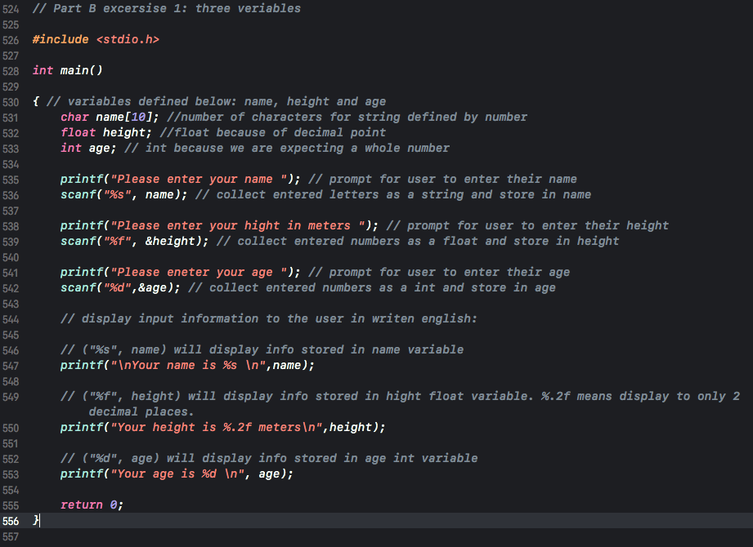

The first test of the programme with expected values entered by the user.
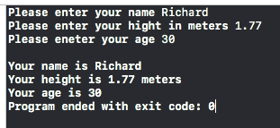

Second test shows height entered to more than 2 decimal places. Programme output to only two decimal places to user.
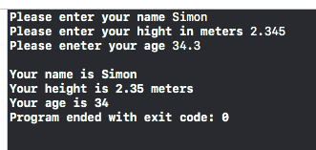
To limit the user inputting floats and integers of ridiculous numbers a while loop can be added to set parameters to re-prompt the user to input a correct value.

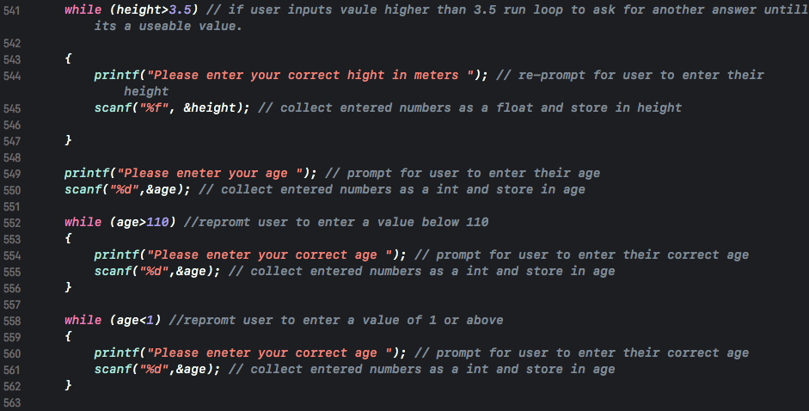

For the age part, if a value of over 3.5 is entered the while loop will run and “please enter your correct height in meters” will be printed on the screen. This will repeat until a value of under 3.5 is entered. The same with the age section but this time there are two while loops. The first loop will run if a value over 110 has been entered resulting in the message “Please enter your correct age” being displayed to the user. The second loop will run displaying the same message if a value of less than 1 is entered.

Results when entering a number above 3.5 in height section.
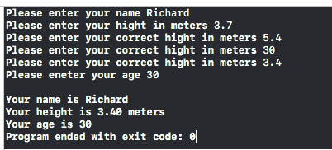

Results entering above the age range. User prompted to enter correct age. Program continue only when number enter between 1 and 110.
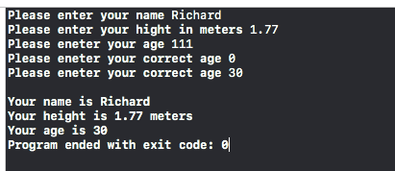

Results entering value with a decimal point below the age range.
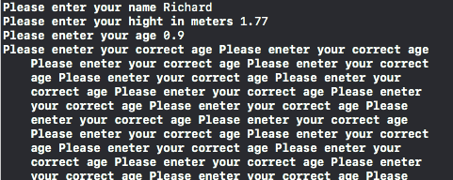

With the user entering a float value of 0.9 it has sent the while loop into an infinite loop. Scanf, can not use a number of an incorrect data type, which sends it into this loop. To combat this the following command can be added “scanf("%*[^\n]\n");” [2]. This stops the loop reading nothing and going into an infinity loop. It tells the loop to discard the input.

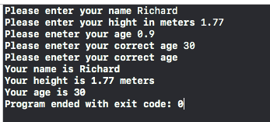

Below is a screenshot of the programme with annotations:

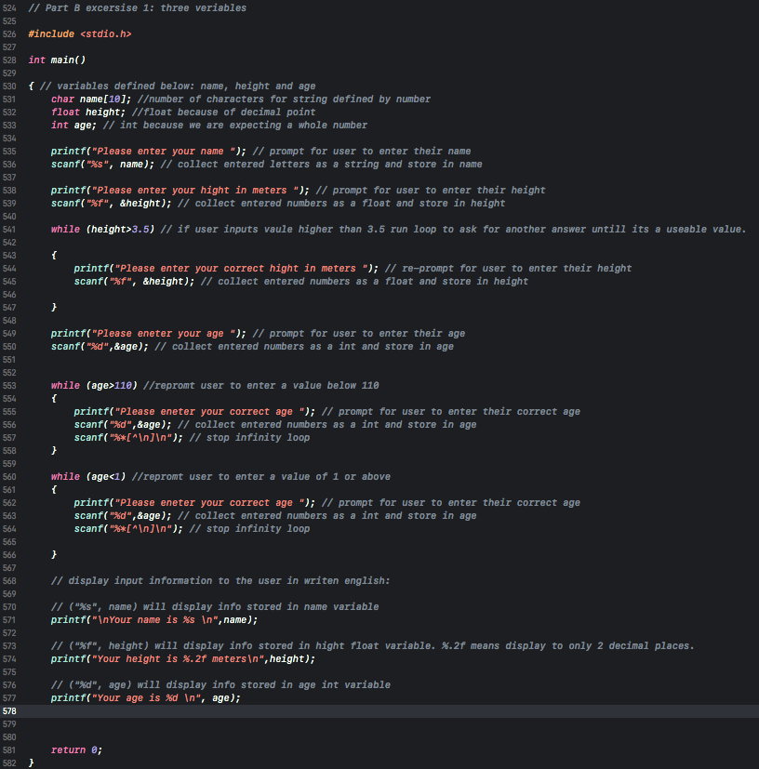

Code Below:

// Part B excersise 1: three veriables

#include <stdio.h>

int main()

{
char name[10];
float height;
int age;

printf("Please enter your name ");
scanf("%s", name);

printf("Please enter your hight in meters ");
scanf("%f", &height);

while (height>3.5)

{
printf("Please enter your correct hight in meters ");
scanf("%f", &height);

}

printf("Please eneter your age ");
scanf("%d",&age);

while (age>110)
{
printf("Please eneter your correct age ");
scanf("%d",&age);
scanf("%*[^\n]\n");
}

while (age<1)
{
printf("Please eneter your correct age ");
scanf("%d",&age);
scanf("%*[^\n]\n");

}

printf("\nYour name is %s \n",name);
printf("Your height is %.2f meters\n",height);
printf("Your age is %d \n", age);

return 0;
}

Exercise 2:
Question:

Allow the user to enter the dimensions of shapes shown below (Figure 1), then calculate the area of the blue shaded part. Note: The triangular area in the centre is empty.

Figure 1 Calculate Shaded Area
Note:
Area of circle is given by $A=πr^{2}$
Area of triangle is given by $A=\frac{\left(b×h\right)}{2}$

Answer:

The specific problems with setting up this programme are collecting input data from user. Then using math functions to simulate the given equations and then output data to user.

- Set up programme library
- Define constant (PI = 3.141)
- Define variables: radius, bvalue, hvalue, circlearea, trianglearea, totalarea
- Prompt user to input Radius value
- Prompt user to input value h
- Prompt user to input value b
- Calculate area of circle
- Calculate area of triangle
- Subtract area of triangle from area of circle
- Display results to user

There is no squared math function in C language, so to get the correct answer, the radius squared will have to become radius times by radius.

Below is a screenshot of the programme with annotations:
:
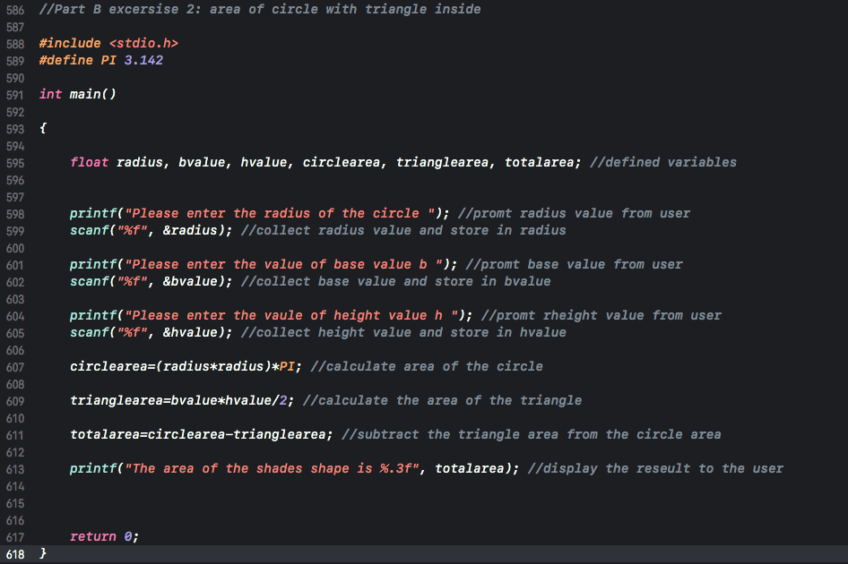

Test screen shot inserting floating values.
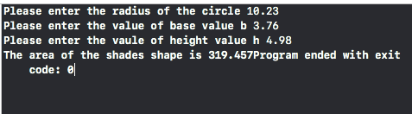

Code below:

//Part B excersise 2: area of circle with triangle inside

#include <stdio.h>
#define PI 3.142

int main()

{
float radius, bvalue, hvalue, circlearea, trianglearea, totalarea;

printf("Please enter the radius of the circle ");
scanf("%f", &radius);

printf("Please enter the value of base value b ");
scanf("%f", &bvalue);

printf("Please enter the vaule of height value h ");
scanf("%f", &hvalue);

circlearea=(radius*radius)*PI;
trianglearea=bvalue*hvalue/2;
totalarea=circlearea-trianglearea;

printf("The area of the shades shape is %.3f", totalarea);

return 0;
}
Exercise 3:
Question:
Write a program that allows the user to enter the price of 5 products into an array. Once all the prices are entered calculate the total price, and then calculate the total price plus 20% VAT.

Answer:

The specific problems with setting up this programme are creating an array to store the prices entered by the user. A counter (for-loop) to automatically move to the next storage location in the array (otherwise the entered information will keep on overwriting the stored price values). Setting up the loop to only run the same amount of times as the number of storage locations in the array.
The maths on how to calculate the VAT. Divide the total by 100 (gives 1% value) and times by the percentage (20) and add the original total onto this.

- Setup programme library
- Setup an array to hold 5 sets of floating numbers
- Declare variable “int i” to use as counter
- Set up for loop to collect price information from the user and store in array
- Declare variables for array data to be assigned to
- Assign data from array to variables
- Set up loop to add variables together
- Display total to the user
- Calculate VAT at 20% and add it to the total
- Display total with added VAT to the user

Below is a screenshot of the programme with annotations:

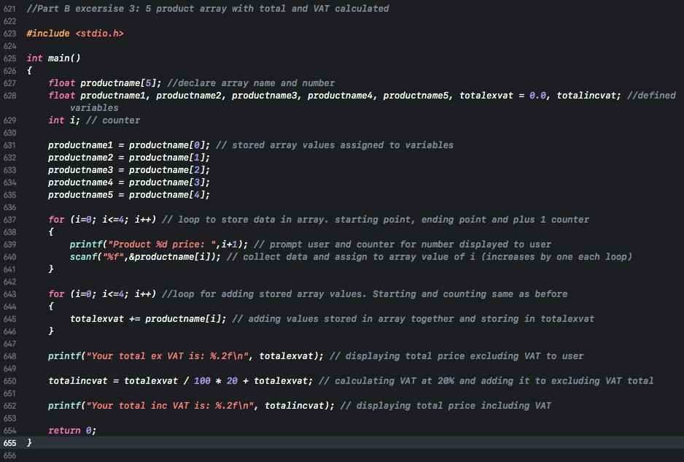

Below is a very simple test that is very easy to do mentally to see if the programme is working.
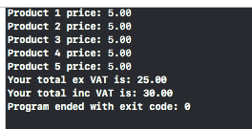

Below is another simulation with the correct results.
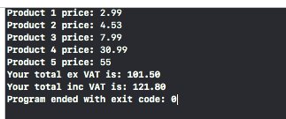

Below, a real-life test to work out the VAT on a laser CNC machine. Inserting only one value to see how the programme will run. Results are correct.
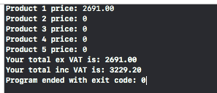

Below a test with no values added. Results are expected.
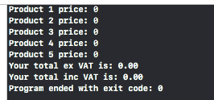

Below, inserting one price for product three and zero for the others.
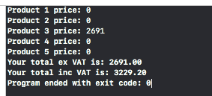

Code below:

//Part B excersise 3: 5 product array with total and VAT calculated

#include <stdio.h>

int main()
{
float productname[5];
float productname1, productname2, productname3, productname4, productname5, totalexvat = 0.0, totalincvat;
int i;

productname1 = productname[0];
productname2 = productname[1];
productname3 = productname[2];
productname4 = productname[3];
productname5 = productname[4];

for (i=0; i<=4; i++) // loop to store data in array. starting point, ending point and plus 1 counter
{
printf("Product %d price: ",i+1);
scanf("%f",&productname[i]);
}

for (i=0; i<=4; i++) //loop for adding stored array values. Starting and counting same as before
{
totalexvat += productname[i];
}

printf("Your total ex VAT is: %.2f\n", totalexvat);
totalincvat = totalexvat / 100 * 20 + totalexvat;
printf("Your total inc VAT is: %.2f\n", totalincvat);

return 0;
}

Exercise 4:
Question:
Build a fruit machine game which represents the 3 reels of symbols using numbers ranging from 1 to 5. Allow the user to have as many goes as they like (the numbers are chosen randomly each time).

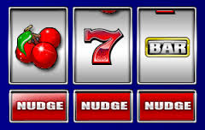

The value of 5 will be treated as the “Jackpot” symbol. The scoring will be as follows:

- Any three of the same numbers (excluding fives) will pay a bonus of 20 points e.g.
4 4 4
3 3 3
1 1 1, etc.

- Any combination of two fives will pay out 100 points e.g.
5 5 3
5 4 5
5 5 1, etc.

- Three fives pay out the big jackpot of 2000 points.

The points the player has scored should be displayed and the player should be asked if they wish to make another spin. It could look something like this:

Non-cumulative score version Cumulative score version
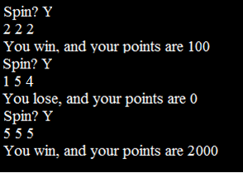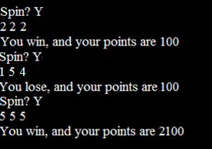

Answer:

The specific problems with setting up this programme are generating three random numbers that are different from each other and are completely unpredictable, ranging between 1 and 5. Creating a yes/no function to end the code when the user wants to. Unlimited amount of game plays and showing the user their score total.

- Set up function libraries and main
- Set up a random number generator using rand
- Use srand (time(NULL)) to generate truly random number using time clock as its parameter
- Set up wheel variables for counter wheels; wheel1, wheel2, wheel3
- Generate a random number between 1 and 5 to store in each wheel variable
- Set up winning conditions with if, else if and else
- All the same number = 20 points
- Two fives = 100 points
- Three fives = 2000 points
- None of those = 0 points
- Create variable for score and send and accumulate results
- Display results to user
- Ask user if they want to play again
- Create a yes or no scenario using a do while loop
- Create variable for playagain
- Keep running program unless play again is storing y from the user
- End program

Below is a screenshot of the programme with annotations:
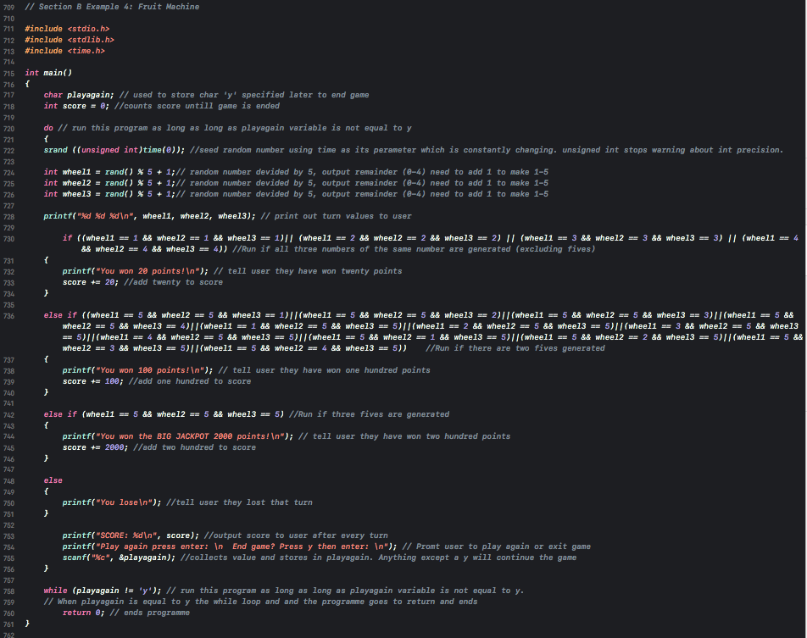

By adding an or || in between each condition it is possible to have multiple condition in statement [1]. This is important because before knowing this many else if statements were used to complete the same task taking up lots of space and looking bulky.

Below is the code for the fruit machine:

// Section B Example 4: Fruit Machine

#include <stdio.h>
#include <stdlib.h>
#include <time.h>

int main()
{
char playagain;
int score = 0;

do
{
srand ((unsigned int)time(0));

int wheel1 = rand() % 5 + 1
int wheel2 = rand() % 5 + 1
int wheel3 = rand() % 5 + 1

printf("%d %d %d\n", wheel1, wheel2, wheel3);

if ((wheel1 == 1 && wheel2 == 1 && wheel3 == 1)|| (wheel1 == 2 && wheel2 == 2 && wheel3 == 2) || (wheel1 == 3 && wheel2 == 3 && wheel3 == 3) || (wheel1 == 4 && wheel2 == 4 && wheel3 == 4))
{
printf("You won 20 points!\n");
score += 20;
}

else if ((wheel1 == 5 && wheel2 == 5 && wheel3 == 1)||(wheel1 == 5 && wheel2 == 5 && wheel3 == 2)||(wheel1 == 5 && wheel2 == 5 && wheel3 == 3)||(wheel1 == 5 && wheel2 == 5 && wheel3 == 4)||(wheel1 == 1 && wheel2 == 5 && wheel3 == 5)||(wheel1 == 2 && wheel2 == 5 && wheel3 == 5)||(wheel1 == 3 && wheel2 == 5 && wheel3 == 5)||(wheel1 == 4 && wheel2 == 5 && wheel3 == 5)||(wheel1 == 5 && wheel2 == 1 && wheel3 == 5)||(wheel1 == 5 && wheel2 == 2 && wheel3 == 5)||(wheel1 == 5 && wheel2 == 3 && wheel3 == 5)||(wheel1 == 5 && wheel2 == 4 && wheel3 == 5))

{
printf("You won 100 points!\n");
score += 100;
}

else if (wheel1 == 5 && wheel2 == 5 && wheel3 == 5)
{
printf("You won the BIG JACKPOT 2000 points!\n");
score += 2000;
}

else
{
printf("You lose\n");
}
printf("SCORE: %d\n", score);
printf("Play again press enter: \n End game? Press y then enter: \n");
scanf("%c", &playagain);
}

while (playagain != 'y');
return 0;
}

Works Cited

[1] | M. McGrath, C Programming in easy steps, Southam , 2002-2004.
[2] | "Infinite loop when assigning a float to an integer," [Online]. Available: https://stackoverflow.com/questions/20593961/infinite-loop-when-assigning-a-float-to-an-integer. [Accessed 21 Feb 2019].

