Ieuan Jones

Data Analysis and Visualisation

Table of Contents
Abstract 2
Question 1 3
Mean, Median and Mode 3
Range, Variance and Standard Deviation 5
Potential Outliers 6
Question 2 7
75th Percentile 7
The implications 8
Question 3 10
Correlation Coefficient 10
Strengths and Direction of the Relationship 10
Recommendations for Improvement 11
Question 4 12
Hypotheses 12
Null Hypothesis 12
Alternative Hypothesis 12
T-Test 13
Implications 13
Question 5 14
Visualisation of product categories 14
Scatter Plot 15
References 17
Appendices 18

Abstract
I will be analysing sales data collected from different stores ranging from urban and rural located stores. The categories of the stores will be, Electronics, Home Goods and Apparel, by gathering and analysing this data I will be able to give advice to increase performance of the stores and help them make good business decisions relating to the results I have gathered.

Question 1

Mean, Median and Mode
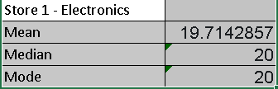
With the results I’ve gathered for Store 1, the mean, median, and mode are all close together. This could suggest that the distribution of sales is most likely not influenced by outliers and the distribution of sales is pretty much symmetrical or centred around the mean. Unlike the other stores, store 1 has a mode which could suggest that store 1 is more consistent with sales compared to the other stores. The highest and lowest value is close to equal both ways from the mean, as the lowest value is 12 and highest is 20 there is roughly an 8 difference.

c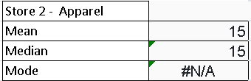
With the results I have gathered from Store 2, the mean and the median are identical but like every store besides store 1 there is no mode because there’s no reoccurring values. This could also be because the dataset is too small to identify the mode.

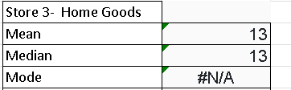

These results are similar to store 2. This might suggest that the distribution doesn’t vary much and stays centered around the mean. Which looking at the data the data tells me that the sales are centered around the mean as the highest and lowest data is 5 above and below the mean
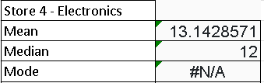
These results are similar to store 2 and store 3. The difference between store 4 though is that there is an imbalance to the distribution, the median is 12, the lowest point is 5 and the highest is 22, this is a big difference this could suggest that as the week goes on people tend to spend more money.

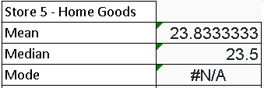
The results from store 5 are better than the results of any store this could be because store 5 sells home goods and in an urban area there will be a lot of houses and apartments compared to everything else people need home goods.

Range, Variance and Standard Deviation
Store 1
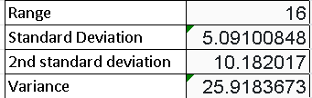
Store 2
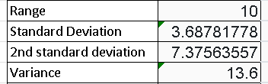
Store 3
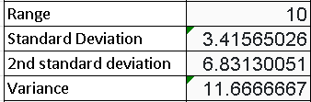
Store 4
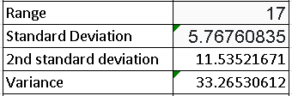
Store 5
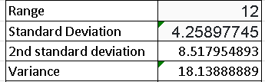
A larger range would show that there is a larger variety because the range is calculated by taking the smallest number away from the biggest one. Meaning the larger the number the smaller the smallest number is and the bigger the biggest number is. The standard deviation is used to test for variability in the data as a second test for more accurate results, its calculated but the amount of variation in a set of values, the 2nd standard deviation is the first standard deviation times 2. The 2nd standard deviation could be used to find values outside this range and identifying them as outliers. The variance is used to measure how spread out the values are from each other, the greater the variance is a give away that the variability is greater.

Potential Outliers
Store 1
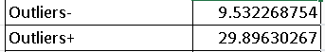
Store 2
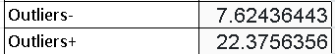
Store 3
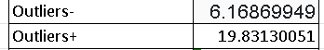
Store 4
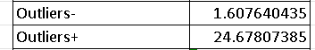
Store 5
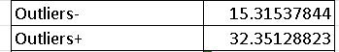
The outliers can impact the overall analysis because they could affect certain values such as the mean, median, range, variance. These are important values, and we need to distinguish the outliers to get more accurate results.

Question 2

75th Percentile
Store 1
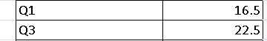
Store 1 has 2 days where they perform better than the 75th percentile and 2 days that perform under the 25th percentile.
Store 2
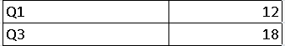
Store 2 has 1 day that performs both above the 75th percentile and below the 25th percentile.
Store 3
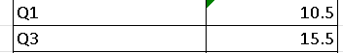
Store 3 has 2 days that perform below the 25th percentile and 2 days that perform above the 75th percentile.
Store 4
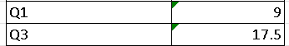
Store 4 has 2 days below the 25th percentile and 2 above the 75th percentile.
Store 5
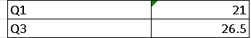
Store 5 has 2 days below the 25th percentile and 2 above the 75th percentile.
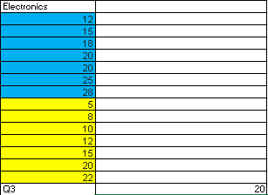
This shows the 75th percentile of both stores that sell electronics and you can clearly see store 1 is marginally better than store 4 as they have more days in the 75th percentile and their sales per day are higher than store 4s. This means store 1 performed better than store 4 considering the 75th percentile was 20.

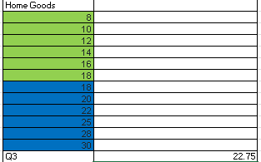
This shows the 75th percentile of both stores that cell Home Goods, there is a drastic difference between both stores as store 3s highest day is store 5s lowest day, this means store 5 outperformed store 3 as there are more days in the 75th percentile and they have sold more money’s worth of items.
There is no comparison in which store performed better than the 75th percentile in Apparel as there was only one store that sold that product.

The implications
The 75th percentile stands as a way to see which stores are consistently performing high and could be used as benchmarks for other stores to use their successful sales strategies, The stores that are performing higher than the upper quartile in their area could possibly be studied by the stores that are not performing as well as them to implement factors of what their doing into their own store to improve productivity and overall sales performance. This could also be used to find stores that are consistently performing above the 75th percentile which may be spending money on advertising which would justify their expenses to enhance their success. On the other hand, underperforming stores may need to do the same to increase performance. The 75th percentile is a good way to find benchmarks and marketing techniques for certain stores to progress more.

Question 3

Correlation Coefficient
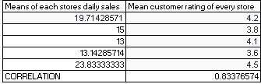
I couldn’t work out the Correlation coefficient for each store as the daily sales didn’t vary, so I done the correlation coefficient of all the stores combined which made these results.
The results provided this graph.
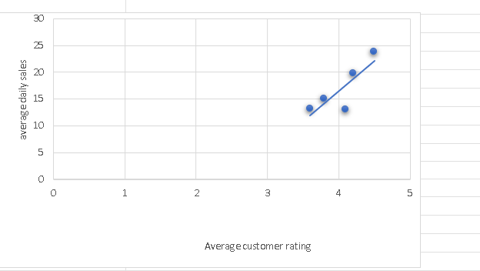

Strengths and Direction of the Relationship
The Strength of the Correlation coefficient is close to one which suggests a strong linear relationship, The direction of Correlation Coefficient is greater than one it signifies that as one variable increase so does the other so as the daily sales increase so does the customer rating.

Recommendations for Improvement
The recommendations for improvement are that if the customer rating is low and the daily sales decreases as the customer rating gets lower take customer feedback into account and change the sales methods and become a better store for the customer as the customer is what is buying your products, so if the customer isn’t happy their going to spend less money.

Question 4

Hypotheses

Null Hypothesis
Null Hypothesis - There isn’t a big difference in daily sales between rural and urban.

Alternative Hypothesis
Alternative Hypothesis - There is a big difference in daily sales between rural and urban.

T-Test
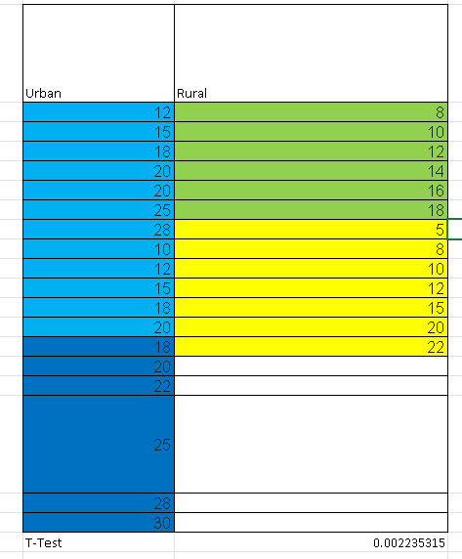
To calculate the degrees of freedom I need to add the sample sizes of each group and take away 2, this means that the degrees of freedom will equal 18+13-2= 29. The degrees of freedom are 29. The P value and the T-statistic is 0.002235315.

Implications
The T-Test value would suggest to me that there is a statistically significant difference between the Urban and Rural areas. My hypothesis was correct.

Question 5

Visualisation of product categories
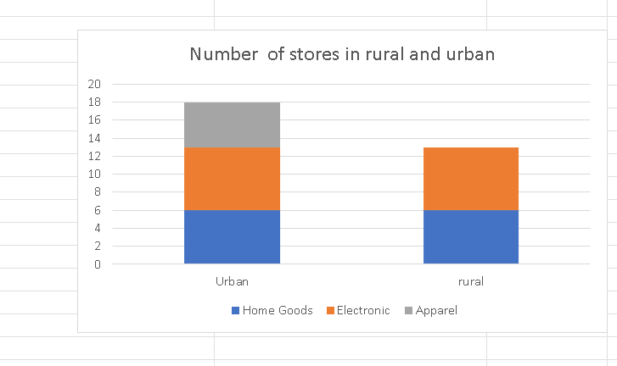
There are more home goods sales in an urban location due to there being more households, there would be more sales for electronics in an urban area due to people working from home a lot compared to a rural area where people work on farms and ranches. There would be no apparel store in a rural area due to them not caring about designer clothes due to them working on farms, there could also be no apparel stores in a rural area due to them being more needed in urban areas considering the population difference between the 2.

Scatter Plot
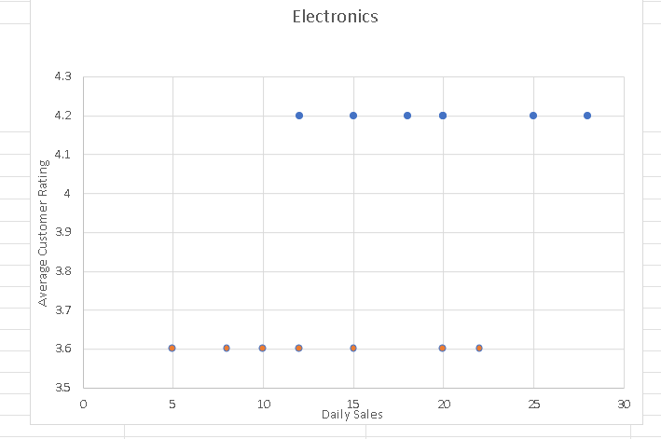
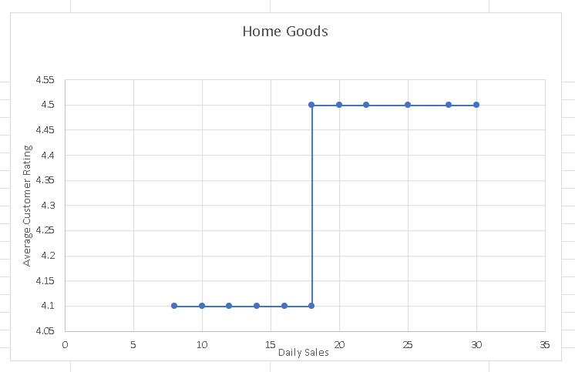
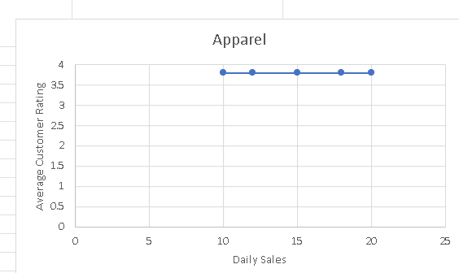

References
There are no sources in the current document.

Appendices

