Andrei Agopian (1905498)

Andrei Alexandru Agopian 1905498
Personal Reflection on Role Play and Career Development
BMSW4005 Term 3 Group 3 Lecturer: Mary March

1. The Journey So Far

It was nothing outright planned, and if I am to be honest, planning in the sense of driving yourself towards an end goal, is never a happy ending. I remember back to what must be almost 20 years ago, a neighbour I had: an old Bulgarian lady who fancied herself something of a clairvoyant/fortune teller/psychic/whatever made up profession you want, who one day grabbed my sleeve and said “you won’t stay here long, your future is America”. Everyone, myself included, thought she was beyond eccentric, to put it mildly. I said, “thank you and have a lovely day” and went about my business.
Fast forward to a few years ago when the memory of that incident creped up from my past and gave me pause: I had left Romania when I was 18 for Italy and from there headed to the UK when I was 22. Maybe the old lady meant English speaking country and not the US, maybe it makes sense. Although she also predicted a very successful romantic life for me, where I’d always be torn between loving two women and that never came to fruition. The point is that my actions weren’t deliberate, there was no clear vision for myself.

2. The Tale of Two Managers

As part of my Professional Career Development course in university we had a role play exercise which consisted of a job interview. Both I as well as my colleague Yeray were applying for jobs of our choosing and then acting as the hiring party too. Sounds like a simple and straightforward task and on top of that we both had our fair share of job interviews in our careers, however this time it felt different. From the onset, the days prior I started panicking and was anxiously looking for as much information as possible on the topic. Far from me to understand the reason behind it at the time, but I put on a suit, grabbed the 100 pages of information I had printed out, and started the video conference with the same determination I would walk into a real situation. The feedback we received was good on both sides, however, despite being just an exercise, when Yeray said “we will call you in a few weeks and let you know”, it made my heart sink a little.
To reiterate, the professor’s feedback was positive and academically we met the criteria, but the experience had more weight to it than I had imagined. Looking back and piecing the puzzle, I understand why that is now. I applied for a human resource manager position and when later I interviewed my colleague, I was acting the job I had applied for. It is crucial to add here that compared to my previous mindset, in the last 3 to 5 years my actions have been powered by a lot more intent, a lot more focus on the future, and a lot more clarity. And my dream job now would be HR manager in a Fortune 500 company. Reflecting on this role play, I see how for those 20-30 minutes I was living out my dream (Barney, J., 1995).

3. The Method

Earlier I said that having an objective was not something that was familiar to me during my formation, and a great loss. I now have friends from Scandinavian countries, much younger than I am, and they seem to have their whole life mapped out (Stern, M., 2015). Clear and specific goals, ability to gauge their progress, grounded in reality and limited by time (Bjerke, M. and Renger, R., 2017). I guess I completely misunderstood what Stephen Covey was trying to say with “if you strike the tree in your back yard 5 times a day, it will eventually fall” (Covey, S., 1989) and with the same token ignoring Einstein’s quote that “insanity is doing the same thing over and over again and expecting a different result” (Robinson, A., 2016). Self-evaluating, I can deduce that I have the drive, the desire and the willingness to do the work, but my axe isn’t sharp enough. The only way forward is by enhancing my knowledge, be that on an academic level or from a skill perspective.
An interesting topic we looked at in my PCD course was learning styles: the means by which each individual collects, stores and uses information. They are memorized using the VARK acronym. V stands for visual, A for auditory, R for reading and writing, and K for kinaesthetic. To a certain degree, we al learn using all the styles, however a certain one has a higher success rate for each of us. Looking more in-depth, a visual learner is a person that assimilates information better when it’s translated into symbols, charts, diagrams, and can see all the pieces of the puzzle at once. Might be confused with photographic memory, however studies have shown that visual learners are stimulated less by a PowerPoint presentation and pictures, thus the suggestion was made to change visual to graphic to better encompass the meaning. The auditory or aural students have a higher information assimilation rate when they’re spoken to. Again, a common misconception in their case is that these people are better at retaining word for word what they hear (Baird, M., Monson, M., 1992). Although it might be true to some extent, a defining trait is their ability to respond better to acronyms and a recommendation for a professor/trainer is to encourage them to express in their own words what they have heard. Another style of learning is read/write, a category which is defined by a predilection for written text. People who fall in this category, though well-spoken, are also avid readers and thrive when taking notes. Their ability to learn is strengthened when they’re presented with interesting information outside the curriculum’s main focal point. The letter K in the acronym stands for kinaesthetic: people who learn by doing. They see the most gain when what they are taught is easily transferable to another activity (García, P., Schiaffino, S., Amandi, A., 2008).

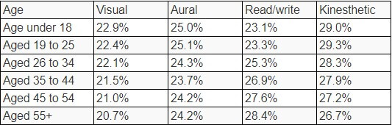
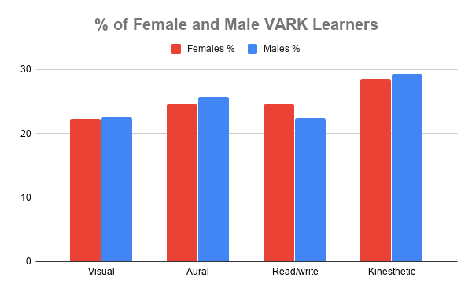

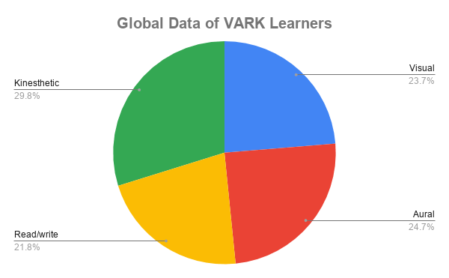
Graphics and statistics courtesy of tutorcruncher.com

Reflecting on my academic path, I cannot define myself as falling into one of these categories exclusively. And I am not the only one: many people fall on a spectrum and some of the learning styles are suitable to different types of information. From the visual side, I can say that I do much better when I can see the whole picture, rather than a step by step progression to it. Much like an aural student, I see value in acronyms as a memory aid, and to strengthen my absorption rate, I often use notes and enjoy doing my own research by reading, same as someone who would be defined by the read/write section. And to all this, I have a strong side of kinaesthesia: even if I am well-informed on a topic, and I take notes, listen to other people, it’s only when I am able to attach a physical activity to it that I fully retain it. A good example of this would be conducting a PowerPoint presentation. What cemented my ability to perform this task was that throughout this academic year I was confronted with numerous situations where I had to transfer the knowledge gained from various sources to a physical presentation. Another parallel I can draw is with term one and two – in class courses – and this third one which was internet based: I can see a slight drop in performance that can be attributed to the lack of human interaction and auditory stimuli.

4. The Tools

To aid me in my search for clarity I resorted to the use of a personal development plan. A personal development plan sets out short, medium, and long-term goals for an individual using SMART goals. In the hope to emulate more the Scandinavian people, one such plan was created in the first term of the academic year, alongside one created by my manager in work and a third was designed in term three. As we are all aware, the world came to a stand-still during the Covid19 pandemic and that had a certain impact on my plans as well, with many things getting delayed and other goals introduced. When it comes to work, the goals were based on trainings that I had to complete related to my job, alongside a year long course called Essential Skills for Supervisors and Managers, but due to the implications the virus had on most businesses, these were lost. All the goals were luckily replaced with the opportunity offered by the Institute of Strategic Risk Management to complete a level 4 and 5 diplomas with them on a live webinar. I followed both levels and decided to do the test for level 5 which I successfully passed. Despite this small victory, I still feel that compared to pre-lockdown I have lost the momentum and struggle to get back on track. In a sense, I lost a little bit of confidence in my abilities.
To remediate this, I had to do a SWOT analysis on myself. SWOT is an acronym for strengths, weaknesses, opportunities and threats and is a tool used in business management, more so in starting a new business or venture. It paints a clear picture of where you or your business stand in relation to the external factors. For me, it was an answer to the question “where do I stand in relation to my long-term goals?” (Lloyd, D., Boyd, W., Exter, K., Luke, H., 2014)
- Strengths: determination, diligence, endurance, adaptability
- Weaknesses: age, financial situation, tendency to procrastinate
- Opportunities: exposure to management environment through my network, ability to change locations due to the nature of the company I work for (Marriott)
- Threats: Covid19, Brexit, potential recession and unstable economic climate
Another tool we were given to improve ourselves in university was the Johari window, a four-quadrant diagram meant to elevate one’s understanding of his capabilities and relation to others. Used in the work environment, it highlights the difference between how we think we are seen by others and how they actually see us. It’s a trust-building and communication-enhancing activity aimed at improving productivity and efficiency (Johari, A., Looi, C., Hung, D., Bopry, J., Koh, T., 2004). On a personal level, it has the effect of boosting self-esteem or toning down high-spirited individuals, whilst reducing what is referred to as “the blind spot”, a quadrant that defines things that we don’t know, but others know about us. My experience with this tool is limited at this specific quadrant. As part of a role play exercise we had to do in a course, I was pleasantly surprised to see how much some of my colleagues and professor appreciated my work as an observer. I was tasked with providing feedback on their interactions and filling out a form and it was unexpected how much they thanked me for it.

5. The Destination

As I go through the lines above and try to conclude my reflection, it is still a daunting task to come up with a clear perspective of what will the world of employment look like in the future, even less of what will be expected of me. Will my direct competitors be robots? What I do know is that once you shift your mentality from taking it one day at a time, waiting to see what happens, to focusing on a clear purpose, you can plan a lot better. Going back to my opening statement, is not enough to cut the tree, you must have a clear objective for the type of furniture you will be making out of the planks you obtain from it. And once more, referring to something I said earlier, focusing on goals might lead to an empty life if you do not enjoy the steps you take to get to them. Every new technique you learn, every new book you read, every job you start, they’re all part of what makes you, you. And they should all be enjoyed in their own right. Rather than asking whether you set the bar too high or too low, perhaps is better to ask whether you will enjoy the journey.
When it comes to me, I enjoy learning and I will always do. Putting myself in new scenarios, be that academically or workwise, it will forever be a smart move.

6. References

Baird, M. and Monson, M., 1992. Distance education: Meeting diverse learners' needs in a changing world. New Directions for Teaching and Learning, 1992(51), pp.65-76.
Barney, J., 1995. Looking inside for competitive advantage. Academy of Management Perspectives, 9(4), pp.49-61.
Bjerke, M. and Renger, R., 2017. Being smart about writing SMART objectives. Evaluation and Program Planning, 61, pp.125-127.
Brzustowski, T., 2008. The Way Ahead. Ottawa [Ont.]: University of Ottawa Press.
Covey, S., 1989. The Seven Habits Of Highly Effective People. New York: Simon & Schuster.
García, P., Schiaffino, S. and Amandi, A., 2008. An enhanced Bayesian model to detect students’ learning styles in Web-based courses. Journal of Computer Assisted Learning, 24(4), pp.305-315.
Johari, A., Looi, C., Hung, D., Bopry, J. and Koh, T., 2004. Singapore's learning sciences lab: Seeking transformations in ICT-Enabled Pedagogy. Educational Technology Research and Development, 52(4), pp.91-99.
Lloyd, D., Boyd, W., den Exter, K. and Luke, H., 2014. Improving Conservation Community Group Effectiveness Using Mind Mapping and Action Research. Conservation and Society, 12(1), p.43.
Robinson, A., 2016. Einstein. Palazzo Editions LTD.
Stern, M., 2015. Centring the Marginal: Leonardo Lisi on Scandinavian Modernism. Scandinavian Studies, 87(2), pp.281-291.

7. Appendix

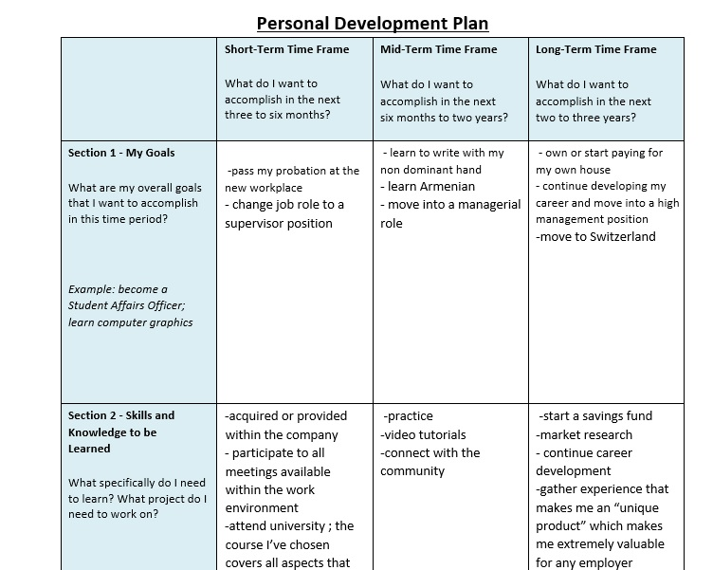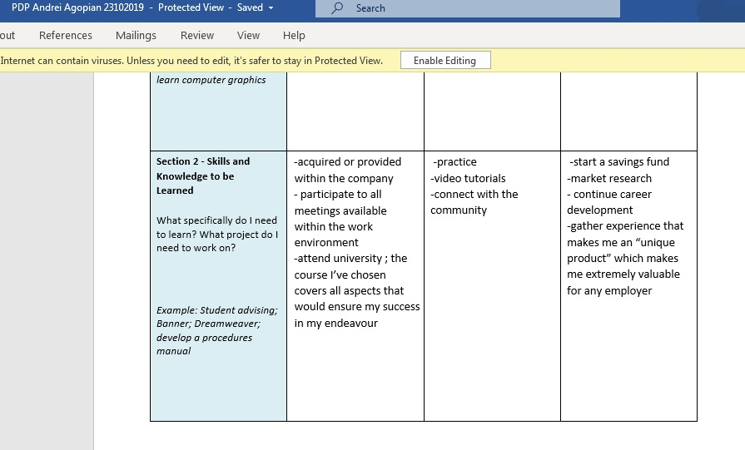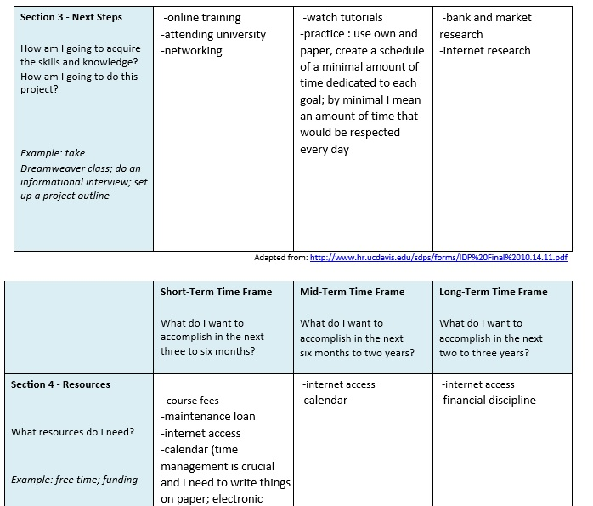ThetThe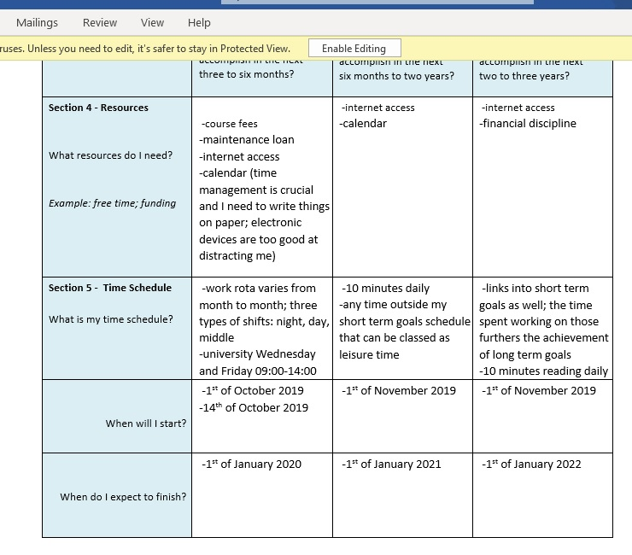
The old PDP above

