Marketing Essentials
BMIH4005
Marketing Plan
Student ID: 2022840
Word count: 1368 words
Lecture’s name: Scott James

Contents
Introduction 3
Situation Analysis 3
5 'C's 3
-Company: SWOT analysis (Micro analysis) 3
-Customers: Segmentation and Targeting/ Customer profile’s’ 4
-Competitors: Perceptual positioning map, Bowmans strategy clock 4
-Collaborators: Demonstrate an awareness of your organisations B2B Relationships, Partnerships, Franchises. 5
-Climate: PESTLE (Macro analysis) 5
-Marketing Mix 6
Objectives 6
Strategy 6
Tactics 7
Research 7
Action 7
Communication 7
Evaluation 8
Action 8
Conclusion 9
References 11
Appendix 13

List of Figures
Figure 1 Gross Revenue 5
Figure 2 Customer Profile 6
Figure 3 Competitors 7
Figure 4: Communication Strategies 10
Figure 5 KPIs for Holiday Inn 11

Introduction
With the help of this marketing plan, the Holiday Inn brand will be promoted, and its market presence will be strengthened. The plan includes the marketing division and senior executives managing the hotel chain's marketing initiatives. This paper uses several important frameworks and theories to create a successful marketing strategy. The SOSTAC model, will offer an organised method for assessing the state of the market, setting goals, developing strategies, and putting plans into action. The paper also uses Ansoff's matrix to investigate market penetration, market development, product development, and diversification strategy growth potential.

Situation Analysis

5 'C's

- SWOT analysis (Micro analysis)
The Holiday Inn's internal strengths and weaknesses as well as the exterior opportunities and threats it confronts are assessed using the SWOT analysis. Holiday Inn's strengths include a well-known brand name, a sizable global hotel network, strong client loyalty, and effective operations (Lim, 2020) (Figure 1). Older facilities, a lack of distinctiveness from rivals, or potential service gaps could all be considered weaknesses. Emerging markets, expanding travel trends, or technological improvements can all present opportunities (Rafahat, 2022). Threats could be caused by ferocious competition, shifting economic conditions, or changes in consumer preferences. Holiday Inn will be able to utilise strengths, rectify weaknesses, capitalise on opportunities, and manage dangers by analysing these characteristics.
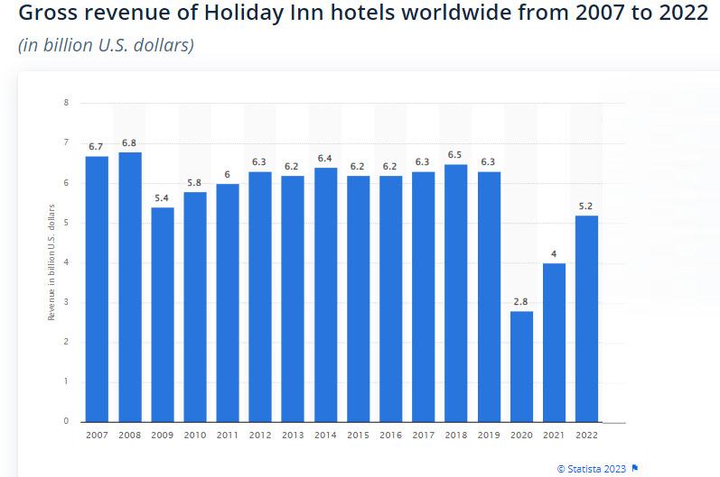
Figure 1 Gross Revenue

-Customers
To successfully reach and engage the target audience, segmenting and targeting customers is essential. To categorise its clientele into separate groups, Holiday Inn can employ segmentation characteristics including demographics, psychographics, and behaviors (Gede, 2022). Understanding each segment's requirements, preferences, and driving forces enables Holiday Inn to modify its marketing plans and deliver individualised services (Kumar et al., 2022). Using tools like SimilarWeb, consumer profiling can offer useful insights about online behavior, preferences, rival analysis, and customer feedback.
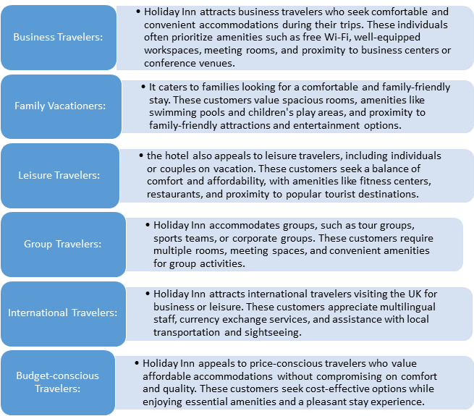
Figure 2 Customer Profile

-Competitors
A visual depiction that aids in analysing how customers rank various brands in relation to one another is called a perceptual positioning map (Hu, and Trivedi, 2020). Given Holiday Inn impressions of pricing and elegance, the following is an example of a perceptual positioning map for Holiday Inn and its rivals (Marriott, Four Seasons, Hilton, and Hyatt). This assists in understanding competitor strategies and positioning, enabling Holiday Inn to develop its own unique value proposition.

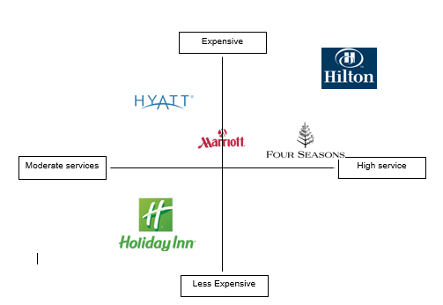
Figure 3 Competitors

-Collaborators
The alliances, partnerships, and franchises of Holiday Inn are essential to its success. Bookings and income streams can be improved by identifying and cultivating strong B2B connections with travel agencies, tour operators, corporate clients, and event planners (Butters, and Hubbard, 2021). Partnerships with vehicle rental agencies, airlines, and loyalty programs can add value for customers and raise brand recognition (Tošić, Tucović, and Tošić, 2021).

-Climate: PEST (Macro analysis)
The British government's taxes on travel and hotel companies, along with political tensions with the EU, impact Holiday Inn. Economic factors include the rising GDP rate in the UK, while trade value affects the hotel industry (Rafahat, 2022). Socially, demographic changes and a growing demand for sustainable services and unique hotel experiences are observed. Technologically, the high digitalisation rate and adoption of AI shape the practices of the British hotel industry.

-Marketing Mix
Developing efficient marketing strategies requires analysing the marketing mix, which consists of the 4Ps (Product, Price, Place, and Promotion). Evaluation of the product offerings, including available amenities, room kinds, and supplemental services, aids in locating potential areas for innovation or enhancement (Rafahat, 2022). Market dynamics, rival pricing, and customer perceptions of value should all be considered in pricing plans. The best possible reach and accessibility are ensured by evaluating both online and offline distribution channels (Kulakhmetova et al., 2020). Advertising, public relations, and digital marketing are examples of promotion strategies that aid in raising awareness and luring clients.

Objectives
The key objectives of Holiday Inn are as follows;
- To increase income and brand awareness among target groups via digital marketing strategies by the end of 2024.
- To improve website traffic and enhance customer engagement via different promotional discounts by the mid of 2024.
- To grow sales to about 15% and execute sustainable marketing strategies by the end of this year.

Strategy
The well-known hotel chain Holiday Inn provides its customers with outstanding value and enduring impressions (Rafahat, 2022). Holiday Inn is a popular option for budget-conscious tourists since it provides reasonably priced lodging without sacrificing quality. The company recognises the value of serving a wide spectrum of customers and devotes a lot of resources to improving the guest experience, especially for wealthy clients. Holiday Inn places a priority on providing excellent customer service and aims to go above and beyond what is expected of them by giving each visitor individualised attention throughout their stay. By utilising technology, such as smartphone apps and online booking platforms (Permata et al., 2023), Holiday Inn streamlines procedures and makes sure that every aspect of its customers' stays is easy and pleasant. Holiday Inn continues to set the bar for hospitality and is a well-known option for travelers all over the world thanks to its continuous commitment to offering outstanding value, first-rate customer service, and embracing technological innovations.

Tactics
Holiday Inn uses the RACE framework (Research, Action, Communication, and Evaluation) as well as Communications Mix to use different communication methods to solve the challenges highlighted in the situational analysis and accomplish the objectives.

Research
Holiday Inn will carry out research to learn more about client preferences, behavior, and feedback to enhance communications. Analysing the hotel's present communication strategies, social media presence, email marketing effectiveness, and SimilarWeb outcomes are part of this. Holiday Inn can improve its communication methods by analysing its strengths, flaws, and missed chances.

Action
Holiday Inn will make efforts to enhance its messaging in response to the research's findings. To do this, the hotel website needs to be redesigned to improve user experience. Content might also need to be optimised for search engine exposure, and customer-centric messaging might need to be implemented across all communication channels (Neethling, 2022). Holiday Inn will also spend money on employee training to ensure consistent and efficient guest communication.

Communication
To reach its target audience and increase interaction, Holiday Inn will use a variety of communication strategies. This comprises:

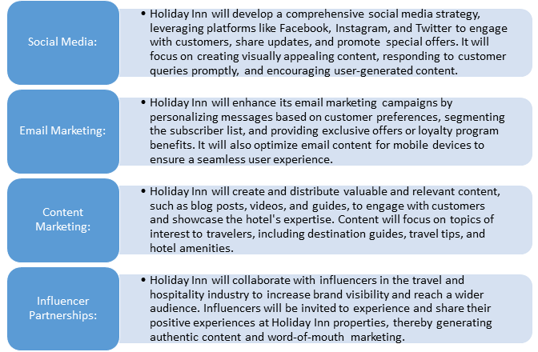
Figure 4: Communication Strategies

Evaluation
Holiday Inn will routinely monitor and evaluate crucial indicators including website traffic, social media engagement, email open rates, click-through rates, and conversions to gauge the success of the communication strategies (Rafahat, 2022). Holiday Inn may discover areas that need improvement and make data-driven decisions to optimise its communication efforts by monitoring these KPIs.

Action
The seasonality and precise timing of marketing activities are considered by the Schedule. To capitalise on the busiest travel period, when potential customers are most likely to be making travel plans, TV advertising, for instance, is arranged from March to August. As well, the radio promotional code has been scheduled for November to match up with exclusive holiday deals and discounts. For instance, PPC (Pay-Per-Click) advertising is planned for November to increase traffic right away and provide leads throughout a certain campaign or promotion.

Control
There will be several measures and Key Performance Indicators (KPIs) used to assess the marketing plan for Holiday Inn. These include more sales, favorable brand perceptions, more profits, higher website traffic and conversion rates, and higher social media engagement (Rafahat, 2022). Holiday Inn may evaluate the effectiveness of its marketing strategy, pinpoint areas for improvement, and make data-driven decisions to enhance future marketing efforts by monitoring these indicators and KPIs. The way these would be measured is shown in chart below:
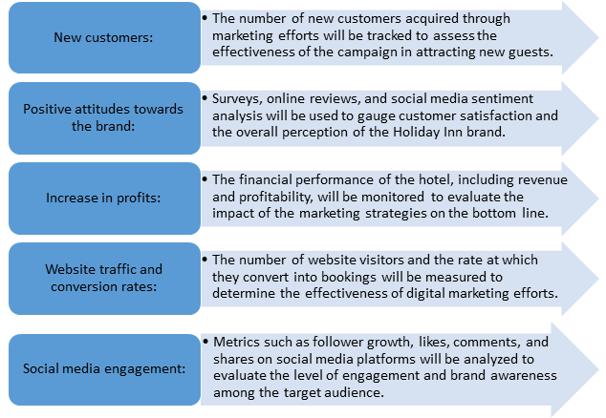
Figure 5 KPIs for Holiday Inn

Conclusion
The main goals of Holiday Inn's marketing strategy are to offer customers exceptional value, improve the guest experience, and use technology wisely. Holiday Inn seeks to raise brand recognition, draw in new clients, and boost profitability through a customer-centric strategy, individualised service, and use of digital marketing channels. Holiday Inn will be able to assess the effectiveness of its marketing initiatives and make the required adjustments to meet its goals by focusing on new customer acquisition, good brand attitudes, higher earnings, website traffic, and social media engagement. Holiday Inn is in an excellent position to succeed in the cutthroat hospitality sector thanks to its unwavering dedication to providing value and outstanding experiences.

References
Butters¹, R.A. and Hubbard, T.N., 2021. Industry structure, segmentation and quality competition in the US hotel industry.
Gede, K.A.D., 2022. The Front Office Job Description and Requirement Stay in Holiday Inn Resort Baruna Bali During Covid-19 (Doctoral dissertation, Universitas Pendidikan Ganesha).
Holiday Inn, 2023. About us [Online] Available at < https://www.ihg.com/holidayinn/hotels/us/en/reservation> [Accessed on 10th June 2023].
Holiday Inn, 2023a. Nothing feels like being there in person. [Online] Available at < https://www.ihg.com/holidayinn/content/us/en/exp/main> [Accessed on 10th June 2023].
Holiday Inn, 2023b. Great Moments Await. [Online] Available at < https://www.ihg.com/holidayinn/content/us/en/deals/hotel-offers> [Accessed on 10th June 2023].
Hu, F., and Trivedi, R. H., 2020. Mapping hotel brand positioning and competitive landscapes by text-mining user-generated content. International Journal of Hospitality Management, 84, 102317.
Kulakhmetova, G., Aktymbayeva, A., Assipova, Z., Baoleer, B. and Koshkimbayeva, U., 2022. Current Problems In The Tourism And Hotel Industry Taking The World's Tourist Cities As An Example. GeoJournal of Tourism and Geosites, 43(3), pp.841-849.
Kumar, M., Jindal, M.K. and Kumar, M., 2022. A systematic survey on CAPTCHA recognition: types, creation and breaking techniques. Archives of Computational Methods in Engineering, 29(2), pp.1107-1136.
Lim, M. C., 2020. Internship Report Holiday Inn Resorts Kandooma Maldives.
Neethling, J., 2022. The competition principle as criterion for ascertaining wrongfulness in the competitive struggle. Journal of South African Law, 2022(3).
Permata, R.R., Ramli, T.S., Priowirjanto, E.S. and Utama, B., 2023. Identifying, Preventing and Overcoming Trademark Bullying in Indonesia. Journal of Intellectual Property Rights (JIPR), 27(6), pp.389-396.
Rafahat, M., 2022. Service Strategy of Hotel Holiday Inn (Doctoral dissertation, Sonargaon University (SU)).
Statista, 2023. Gross domestic product (GDP) growth rate in the United Kingdom 2028. [Online] Available at < https://www.statista.com/statistics/263613/gross-domestic-product-gdp-growth-rate-in-the-united-kingdom/> [Accessed on 10th June 2023].
Statista. 2023. Gross revenue of Holiday Inn hotels worldwide from 2007 to 2022 [Online]. Available at: https://www.statista.com/statistics/223345/holiday-inn-hotels-revenue/
Tošić, V., Tucović, M. and Tošić, T., 2021. Loyalty programs in hospitality on the example of hotel Holiday Inn Suschevsky. Turističko poslovanje, (28), pp.39-46.

Appendix


