

PROTECTING AND SUPPORTING FAMILIES IN HEALTH AND CARE (BMHP5021)

Component 2: An examination and analysis of how the 'Early Help' system is signposted to UK families by their local authority website

Student name: DANIELA RIOS RENDON
Student number: 2429798

TABLE OF CONTENTS
1. INTRODUCTION 3
2. EARLY HELP: POLICY CONTEXT AND WEBSITE EVALUATION 4
2.1 The Early Help System 4
2.2 Multi-Agency Working 4
2.3 Evaluation of Local Authority Websites 5
2.4 Comparative Analysis 9
3. CONCLUSION 10
4. RECOMMENDATIONS 11
REFERENCES 12

INTRODUCTION

Early Help is the co-ordinated help provided to children, young people and families at the earliest point of need, prior to any statutory interventions (Department for Education (DfE), 2022). This approach is fundamentally included within the Early Help System Guide (2022) as an integral part of safeguarding partnerships, as well as being part of a continuum of support that includes child protection.
This support needs to be delivered collectively and collaboratively, through multi-agency safeguarding arrangements, as outlined in Working Together to Safeguard Children 2026 (Department for Education, 2026). The Early Help approach is founded on prevention. Frost, Abbott and Race (2015) show how early identification and intervention lowers the likelihood of children going into statutory care.
These priorities are detailed in the Early Help System Guide (2022) and consist of building resilient communities, better early identification, better whole-family working and a better local workforce. These priorities are achieved as a result of safeguarding partnerships between the statutory and voluntary agencies (Research in Practice, 2022).
This report takes a look at the communications of the Early Help offer to families across three websites: Leeds City Council, Tower Hamlets Council and Norfolk County Council. These are three different authorities, a large northern city, an inner London borough and a rural county. The depth of navigation within each site, accessibility of language, provision of contact and domain coherence are assessed against each site and a comparative analysis and recommendation carried out.

EARLY HELP: POLICY CONTEXT AND WEBSITE EVALUATION

The Early Help System

Early Help is defined in the Early Help System Guide (Department for Education, 2022) as a system wide process of helping families before issues become entrenched. Early Help is not statutory safeguarding and is offered on a voluntary basis with the consent of the family. The targeted area inspections carried out jointly by Ofsted (2023) revealed great variation in the way that services were set up and that in some areas there was a lack of clear pathways between Early Help and statutory social care, leading to delays for families.
Through the Supporting Families programme between 2012 and 2025 there have been greater than 858,000 effective family outcomes achieved, a third of children in care have come out of care in supported families (Department for Education 2025). Working Together 2026 (Department for Education 2026) include Early Help as part of the broader 'Family Help' framework which challenges the rigid threshold approach that was criticised by Devaney (2019). This is supported by the House of Commons Library (2026) telling us that the total is 2.4 billion pounds to 2028/29, through the Families First Partnership Programme.

Multi-Agency Working

Multi-agency working is the term used to refer to the joint working of practitioners from the health, education, social care and police sectors in supporting children and families (NSPCC Learning, 2023). Working Together 2026 (Department for Education, 2026) places a statutory responsibility on three safeguarding partners (local authorities, Integrated Care Boards and police) to develop, publish and independently review their multi-agency arrangements. The guidance also specifies that education providers and voluntary organisations be included, emphasising inter-disciplinary working (Department for Education, 2026). Communication failures between agencies were a cause of harm and was mentioned in the Laming Report (2003) following the death of Victoria Climbie. Silo working continues, as demonstrated by Ball and McManus (2024) who conclude that if effective multi-agency working is needed to happen, it must become part of daily practice and be reviewed regularly. Ofsted (2023) found that in areas where coordination was good, families were provided with a consistent service, whereas, in areas where it was poor, services were fragmented. The Local Government Association (2023) sees Family Hubs as the key to multi-agency Early Help delivery. The Centre for Social Justice (2024) warned of varying provision between areas as a result of local autonomy.

Evaluation of Local Authority Websites

Four criteria were used for the assessment of each web site: number of clicks from the homepage to the Early Help content (navigation depth), written language level/direction (language accessibility), provision of contact (phone, e-mail, online contact form) and location of Early Help information on the web (domain coherence).

Leeds City Council (www.leeds.gov.uk)

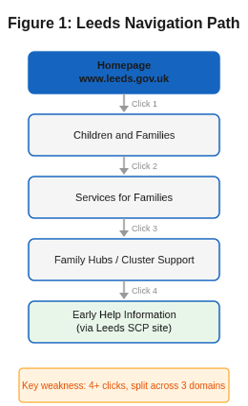
Leeds uses the path "Children and Families" to direct families to the path "Services for Families" and then on to the Family Hubs, cluster support and financial assistance (Leeds City Council, 2025). The route takes 4 clicks, and more detailed information about Early help is kept on a separate Leeds Safeguarding Children Partnership domain as illustrated in Figure 1. The website details the cluster model, which is the basis for the 22 locality-based partnerships of schools, health and social care that coordinate Early Help, launched in April 2025 (7 new Family Hubs). In 2022, Ofsted judged Leeds to be “Outstanding” (Ofsted, 2022). The council adopts a language that is accessible to families, with a focus on getting the right conversation, at the right time, with the right person for Early Help. The following are methods of contact: Family Information Service (0113 378 9700) and email. Fragmentation of information is the big problem. The content is shared in three different settings: the main council website, the Leeds Safeguarding Children Partnership site and Leeds for Learning. Families are forced to switch between these platforms to get an entire picture. There is also a statement on the Leeds for Learning Early Help page that the service is "currently under review" which does not enhance confidence. There is no translation information on the website other than a separate page service to an interpreting service, which can cause extra difficulties for families who do not speak English as a first language in a linguistically diverse city.

Figure 1: Leeds City Council website navigation path to Early Help (Source: www.leeds.gov.uk, accessed August 2026)

Tower Hamlets Council (www.towerhamlets.gov.uk)

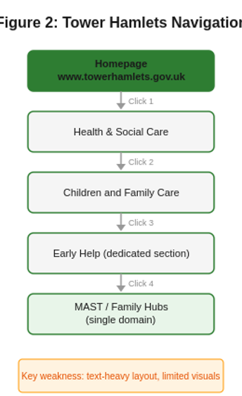
Tower Hamlets has a dedicated section on Early Help within 'Health and social care' and sub navigation to 'Family Hubs', children and family centres and family guidance (Tower Hamlets Council, 2025). The Multi-Agency Safeguarding Hub (MAST) is a multi-agency approach with staff from the social care sector, early help practitioners, health professionals, police, housing sector and the voluntary sector directly reflecting the multi-agency model in Working Together 2026 (Department for Education, 2026), and it is a single Front Door. A direct telephone number is provided (0207 364 5006) and there is also an on-line enquiry form. In 2025 the council was rated “Outstanding” by Ofsted and Early Help was recognised as a strength within the council. An Early Help Strategy 2025-2028 has been launched in October 2025, with family consultation. Family leaflets which cover the procedure are available to download.

Figure 2: Tower Hamlets Council website navigation path to Early Help (Source: www.towerhamlets.gov.uk, accessed August 2026)

The majority of Early Help information sits in one council domain as illustrated in figure 2, which means the amount of navigating between domains is minimised. Twelve Children and Family Centres and four Family Hubs are identified and have clear service information. The website's main weak aspect is its visual design. The dominant local government model is text-heavy, lacks visual hierarchy and demands multiple clicks through crowded menu bars to arrive at the information that can be accessed. This is a challenge for low digital literacy families and in crisis situations, even if the content is good.

Norfolk County Council (www.norfolk.gov.uk)

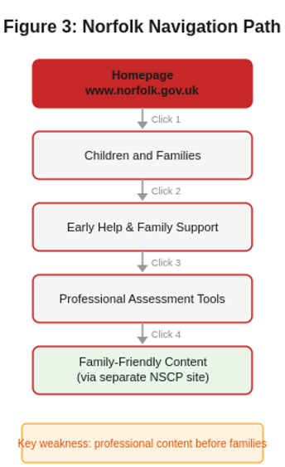
Norfolk's Early Help information is integrated into ‘Children and Families' and is sign-posted to other services on an ‘Early Help and Family Support' page (Norfolk County Council, 2025). Early Childhood and Family Services (ECFS) is provided through the services of Action for Children and includes group activities, home visits and parenting classes for children aged 0-5. Phone (0344 800 8020) and email contact are provided. The Norfolk County Council (2023) EROA report estimated that Norfolk received 6 million pounds in funding for Family Hubs and Start for Life. The website is built to be linked to Just One Norfolk, a NHS platform linking health and social care signposting.

Figure 3: Norfolk County Council website navigation path to Early Help (Source: www.norfolk.gov.uk, accessed August 2026)

As illustrated in figure 3, Norfolk's navigation takes families through professional-facing content before getting to family facing information. The main page for Early help puts a strong focus on assessment form upload and registration processes and does not provide readily available guidance. There is a layer of Norfolk Safeguarding Children Partnership practice guidance, which is hosted separately. This practitioner-based approach is a big problem for one of the less connected rural counties. The provision for children aged 5-19 (ECFS) is not as apparent as the provision for children aged 0-5.

Comparative Analysis

All three councils have implemented a Family Hub model and offer phone, email or online contact as appropriate in line with Working Together 2026 (Department for Education, 2026) and the Early Help System Guide (Department for Education, 2022). The results of the evaluation of the four criteria are summarised in the table below. Navigation: It takes 4+ clicks on 3 domains to reach Leeds.
Tower Hamlets needs 4 clicks to achieve within one domain. Norfolk needs 4 clicks, family behind professional tools. Language: Leeds and Tower Hamlets write for families. Norfolk has a professional-facing communication style as its default. Contact: All three have phone, email and online access. Tower Hamlets is strongest in terms of single point model (MAST). Domain coherence: Tower Hamlets maintains information for a single domain. Leeds is divided in three platforms. Norfolk is divided between the council site and NSCP. The deciding factor is audience. Tower Hamlets and Leeds use language for families, with Norfolk using practitioner language. This was recognised as a barrier to effective Early Help delivery by Ofsted (2023). The Department for Education's (2024) Supporting Families report emphasized the need for a ‘one front door’ approach, which Tower Hamlets does well with MAST. The MAST model also conveys multi-agency partnership working to families, including a list of the professionals who make up the integrated team (Tower Hamlets Council, 2025), explicitly aligned to Working Together 2026 requirements (Department for Education, 2026).

CONCLUSION

This report looked at family communication of the Early Help offer in Leeds, Tower Hamlets and Norfolk by analysing their websites. Multi-agency safeguarding partnerships underpin the Family Help framework and Early Help is an integral part of Working Together 2026 (Department for Education, 2026), supporting the Early Help system as coordinated, multi-agency responses are needed before issues escalate. The most effective Early Help information is provided in Tower Hamlets. Strategic clarity is reflected in its Front door in MAST, single domain website, downloadable family leaflets and Early Help Strategy 2025-2028, and was indicated by its Ofsted rating in 2025 which is Outstanding. Leeds has a full package offer yet disperses information over three platforms. Norfolk has good integration of health signposting for Just One Norfolk, although there is a focus on information for professionals rather than families.

RECOMMENDATIONS

Secondly, Norfolk should redesign their Early Help web pages so that they start with content for the families, with the contact numbers and service description and accessible language above the practitioner assessment tools. This falls under the Department for Education guidance (2024) “one front door”. Secondly, Early Help information should be brought together onto the main council website, this will eliminate the need for families to go to the main council site, the Leeds Safeguarding Children Partnership and Leeds for Learning to get the full picture. Third, all three councils should ensure that they have early accessible documents outlining Early Help and what to expect and how to access support in the form of a downloadable leaflet, similar to that found in Tower Hamlets. This helps to overcome the digital literacy barriers highlighted in the Centre for Social Justice (2024) review of Family Hub provision. Fourth, all authorities should user test content on the website with families who have accessed Early Help. The Early Help System Guide (DfE, 2022) and Working Together 2026 (DfE, 2026) prioritise family involvement in the design of services, which should also apply to information online.

REFERENCES

Ball, E. and McManus, M. (2024) 'Multi-agency safeguarding: From everyone's responsibility to a collective responsibility', Journal of Community Safety and Well-Being, 9(4), pp. 1-12.
Centre for Social Justice (2024) Family Hubs: An interim review. London: Centre for Social Justice.
Department for Education (2022) Early Help System Guide. London: HM Government. Available at: https://assets.publishing.service.gov.uk/media/628de13be90e071f5f7e1bd2/Early_Help_System_Guide.pdf (Accessed: 7 August 2026).
Department for Education (2024) Supporting Families: A foundation for family help. Annual report of the Supporting Families programme 2023-2024. London: HM Government.
Department for Education (2025) Supporting Families: Whole family working. Annual report of the Supporting Families programme 2024 to 2025. London: HM Government.
Department for Education (2026) Working Together to Safeguard Children 2026: A guide to multi-agency working to help, protect and promote the welfare of children. London: HM Government.
Devaney, J. (2019) 'The trouble with thresholds: rationing as a rational choice in child and family social work', Child and Family Social Work, 24(4), pp. 458-464.
Frost, N., Abbott, S. and Race, T. (2015) Family Support: Prevention, Early Intervention and Early Help. Cambridge: Polity Press.
House of Commons Library (2026) Children's services in local authorities. Research Briefing CDP-2026-0018. London: House of Commons.
Laming, H. (2003) The Victoria Climbie Inquiry: Report. London: The Stationery Office.
Leeds City Council (2025) New family hubs launched in Leeds to boost support for those in need of early help. Available at: https://news.leeds.gov.uk/news/new-family-hubs-launched-in-leeds (Accessed: 6 August 2026).
Local Government Association (2023) Family Hubs and Early Help: An overview. London: LGA.
Norfolk County Council (2023) Norfolk to benefit from new Family Hubs and Start for Life funding. Available at: https://www.norfolk.gov.uk/44268 (Accessed: 4 August 2026).
NSPCC Learning (2023) Early help and early intervention. Available at: https://learning.nspcc.org.uk/safeguarding-child-protection/early-help-and-early-intervention (Accessed: 2 August 2026).
Ofsted (2022) Inspection of Leeds City Council children's services. Manchester: Ofsted.
Ofsted (2023) Joint targeted area inspection of the multi-agency response to children and families who need help. Manchester: Ofsted.
Research in Practice (2022) What is early help? Concepts, policy directions and multi-agency perspectives. Manchester: Research in Practice.
Tower Hamlets Council (2025) Tower Hamlets launches ambitious strategy to support families. Available at: https://www.towerhamlets.gov.uk/News_events/2025/October/Tower-Hamlets-launches-ambitious-strategy-to-support-families.aspx (Accessed: 1 August 2026).

