Preschool Stage: Transitions in a variety of aspects.
Polyana Pavanello - 1811822
Dr. Gulnar Ali

BMHP4003_PSY

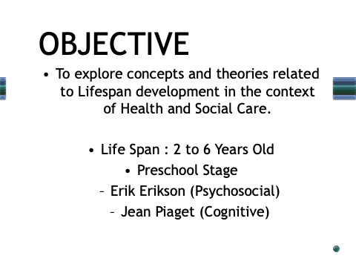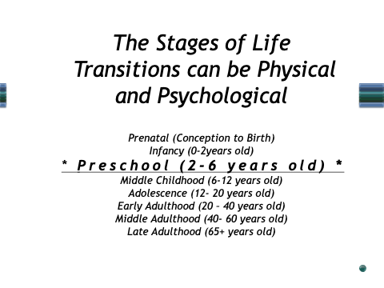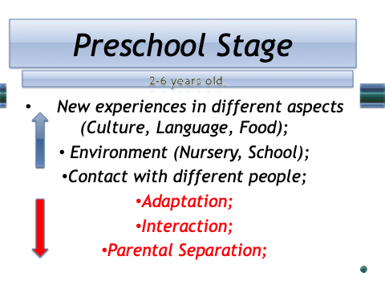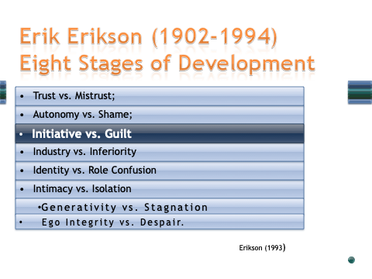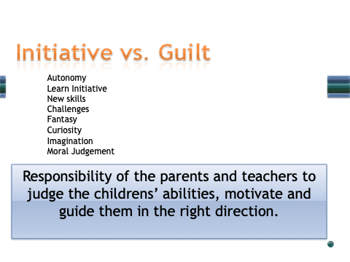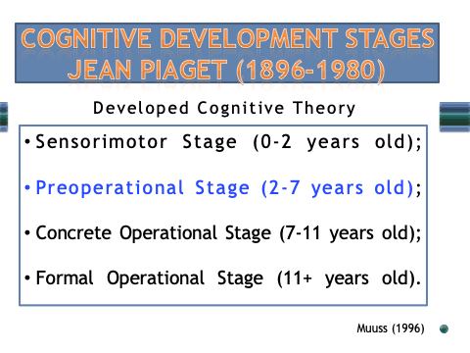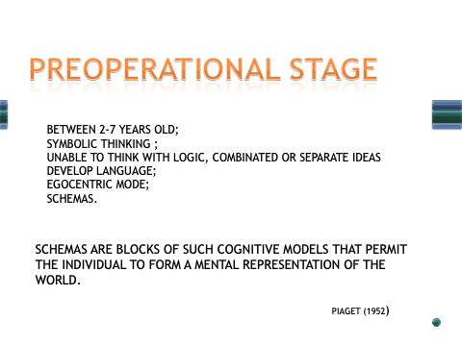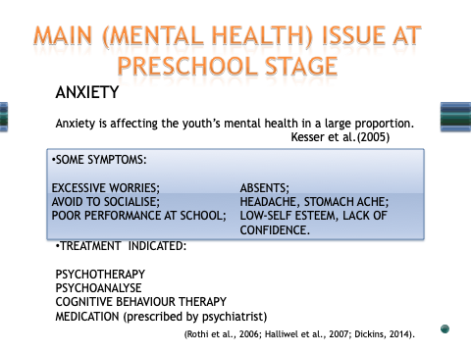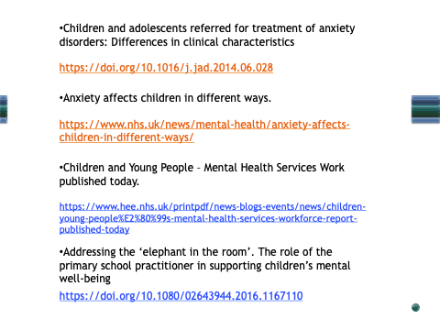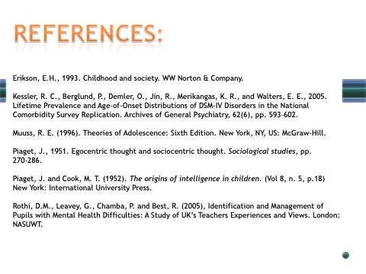

Table of Contents

Preschool Stage – Transitions in a variety of aspects. 10
1.INTRODUCTION 10
2. PRESCHOOL STAGE 10
3. ERIK ERIKSON – INITIATIVE vs. GUILT (3 to 6 years old) 11
4. JEAN PIAGET – PREOPERATIONAL STAGE (2 to 7 years old) 11
5. CONCLUSION 12
6. REFERENCES 13

Preschool Stage – Transitions in a variety of aspects.

1.INTRODUCTION

Through diverse research, in a behavioral context, it was proven that individual presents changes in their lives that can occur from conception to death and that these can be determined by numerous factors. Life has been divided into several stages. These studies are based on both physical and psychological changes and stability, as people get older. These concerns have led numerous interests in development to answer questions about what kind of changes can occur across the lifespan, the change that happens between childhood and adulthood in the own experience as social, historical context and in the relationship with others. People's lives are influenced by their experiences and some situations become difficulties issues by transitions sometimes bringing uncertainty confronting their understanding of some subjects in life perspectives.
The option for Preschool Stage is to understand some points about behavior in this phase, as they are creating understanding about how the 'world works' to them. It is essential to give them support for a good and health formation and possibilities of success next steps in their lives.

2. PRESCHOOL STAGE

The stages of life encompass transitions in a variety of aspects. The individuals present those stages during their existence: Pre-Natal, Infancy, Preschool, Middle Childhood, Adolescence, Early Adulthood, Middle Adulthood, and Late Adulthood.
Preschool: In this stage, the child is between two to six and years old. This phase is decisive in the learning process as they to start sharing new experiences with others, they start to have contact with different people, as staff, other children, new languages, culture, food in a new environment. At the same time, they are leaving home and parents going to the nursery or school, they find a new place as the children attend this part of their life at school. So it is the responsibility of the parents, cares, and teachers to judge their abilities, motivate and guide them in the right direction. The Preschool ages are crucial time during which child development occurs the fastest. All developments as Physical, Psychosocial and Personality Structure will probably develop in the same direction in the further age rather changing direction. In this period child begins to gain their value judgments following a cultural structure.
For this assignment was applied the theories of two important names on the subject to relate what happens in this stage of life, their meaning and their considerations. There is Erik H. Erikson through their concepts in Psychosocial Development Theory and Jean Piaget in Cognitive Theory aspects. They studied about stages in life and their techniques are still well accepted in the actually in educational segment and therapies.

3. ERIK ERIKSON – INITIATIVE vs. GUILT (3 to 6 years old)

According to Erikson's theories, people experience a conflict that becomes a differential to their process of development. When individuals successfully deal with the conflict they present psychological strengths that will serve them well for the next step in their lives. If they fail, there is a possibility of not development in the essential skills for a strong sense of self. If the children have success in this precious stage, they can act independently, developing ambition and direction. Erikson (1993).
The third stage of Erikson's theory Initiative vs. Guilt describes that at the end of the third year of the children a sense of autonomy is highlighted and begins to face the task confronting every child to learn initiative without too much guilt. It is a positive step; the children are in contact with the world's challenges, taking on responsibilities, learning new skills, and feeling purposeful. Erikson (1950). In this stage, the family can contribute to teaching children by example their capacities and direction, through their adults' tasks. Children become more aware, self-observation, self-guidance, self-punishment and they can change their attitudes to their initial failures. According to Erikson (1963) and Batra (2013), 'a necessary part of every act and man needs a sense of initiative that is a necessary part of every act for whatever he learns and does. From fruit gathering to a system of an enterprise'. For Erikson (1950, 1959) children utilize play as a mode to learn about themselves and their environment. With objective to identify a problem, the therapist needs to continue playing repeating some actions bringing comfort to the child and is encouraged to come up with a name for the problem and asked to draw a picture of the problem. It is an example of the strategies used for them.

4. JEAN PIAGET – PREOPERATIONAL STAGE (2 to 7 years old)

Cognitive Development reflects an increase in children's thoughts. Their development is determined by biological maturation and interaction with the environment and can be found in individual differences. Piaget (1952). As Muuss (1996) cites, according to Piaget, the Stages of Cognitive development are the: Sensorimotor Stage, Preoperational Stage, Concrete Operational Stage, and Formal Operational Stage.
The Preoperational Stage happens between the age of two and seven years old. During this period children think at a symbolic level without exploring cognitive operations. They are unable to think with logic or transform, combine or separate ideas. Children become aware of object permanence and start through schemas to explore situations in a different context. Schemas are blocks of such cognitive models that permit the individual to form a mental representation of the world. Piaget (1952, p.7). Piaget (1951, 1952), defined schema as "a cohesive, repeatable action sequence possessing component actions that are tightly interconnected and governed by a core meaning." According to Wadsworth (2004), a schema is a set of elements filed in the brain, telling an individual how to react to stimuli or information. Piaget (1972/1999), describes that schemas tend to be simpler; especially those used by infants and as a child gets older, their schemas become more elaborate. Human development is the product of on-going transactions between person and environment. How do children interact at school? Why do some children have difficulty with some adaptations as parental separation for example or to following rules? Does the emotional health of children bring an impact on adult lives and their relationships? The excess of information, activities, new technologies, games, social media influencing interpersonal relationships and behaviors amongst young people? Modern society, big companies, behavior studies, schools, parents are often seeking for better strategies to understand how are the lives and what impact the way they see the world and interact on it and in the most case they still use this theories or moderns theories based in those two renowned concepts. Their theories are used in some therapeutic techniques for treatment of diverse issues as anxiety.

5. CONCLUSION

Through diverse research related to the theories of development, the variations in stages contribute with vast knowledge and more perception of how behavior change through age, influenced by environment and determined for numerous factors.
Early stages require more attention in life. One individual that receives a good formation in early stages brings health and balance to the forward phases. It is necessary for a better understanding of the importance of help children to gain knowledge thought the connections that they make though family, school, and community in general modes.

6. REFERENCES

Batra, S., 2013. The psychosocial development of children: Implications for education and society—Erik Erikson in context. Contemporary Education Dialogue, 10(2), pp.249-278.

Erikson, E.H., 1950. Growth and crises of the" healthy personality".
Erikson, E.H., 1959. Identity and the life cycle: Selected papers.
Erikson, E.H., 1963. Youth: Change and challenge. Basic books.
Erikson, E.H., 1993. Childhood and society. WW Norton & Company.
Logan, R.D., 1986. A reconceptualization of Erikson's theory: The repetition of existential and instrumental themes. Human Development, 29(3), pp.125-136.
Muuss, R. E. (1996). Theories of Adolescence: Sixth Edition. New York, NY, US: McGraw-Hill.
Piaget, J. (1936). Origins of intelligence in the child. London: Routledge & Kegan Paul.
Piaget, J. (1951). Egocentric thought and sociocentric thought. J. Piaget, Sociological studies, 270-286.
Piaget, J., & Cook, M. T. (1952). The origins of intelligence in children. New York, NY: International University Press.
Piaget, J., 1972. The epistemology of interdisciplinary relationships. Interdisciplinarity: Problems of teaching and research in universities, pp.127-139.
Piaget, J. (1999). Intellectual evolution from adolescence to adulthood. In R, E. Muuss & H, D. Porton (Eds.). Adolescent behavior and society: A book of readings (Fifth Edition) (pp. 66-73). New York: McGraw-Hill. (Reprinted from Human Development, 15, pp. 1-12, 1972.)
Wadswort, B.J. (2004). Piaget's Theory of Cognitive and Affective Development. U.S.: Pearson.

