ART DECO
Session 3 –Digital

Use Adobe Illustrator to create Art Deco motifs.
Use symmetry to reflect, transform and rotate shapes – MONOCHROME

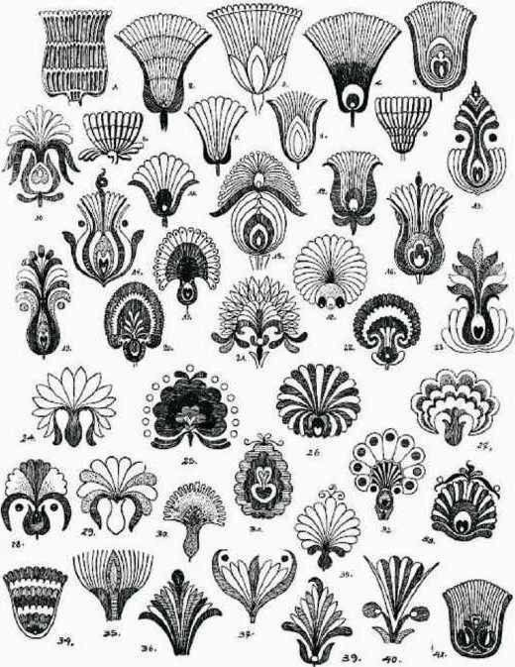

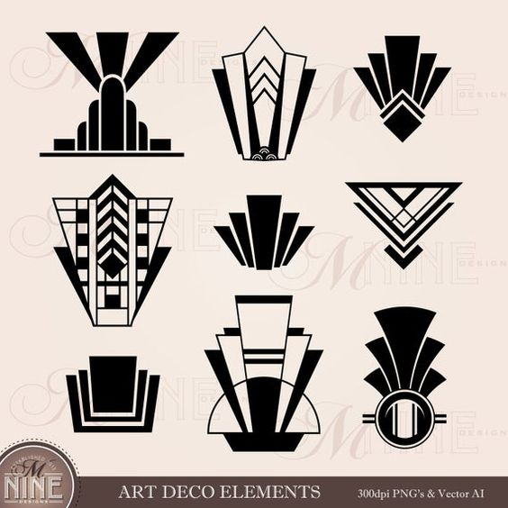

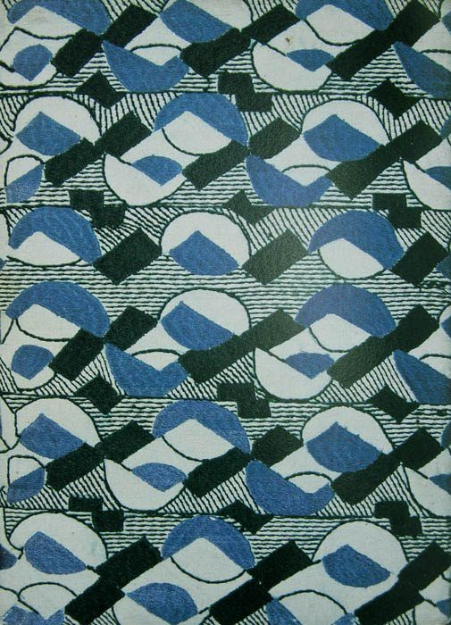

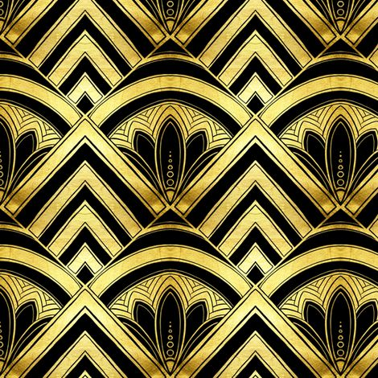

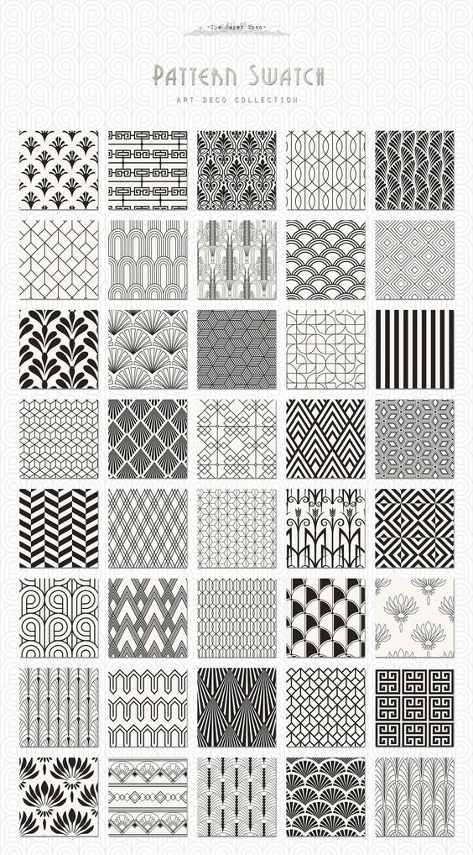

- Create a NEW > FILE > A3 in Adobe Illustrator
- Show > Grid
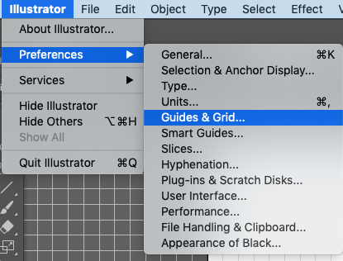
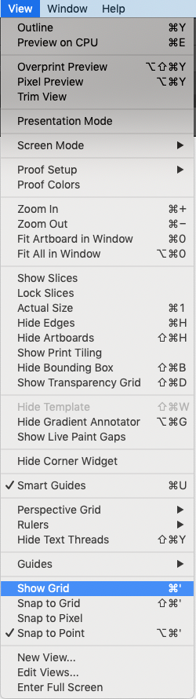

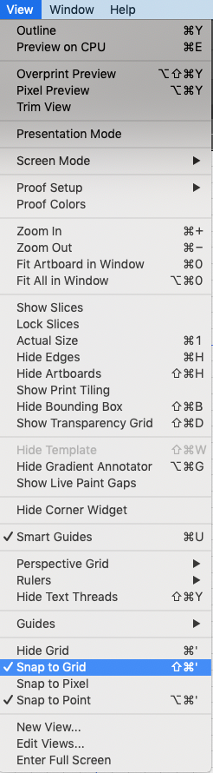

- Create guides



- Use the Pen Tool in Black, both stroke and fill to create ‘half of the motif.
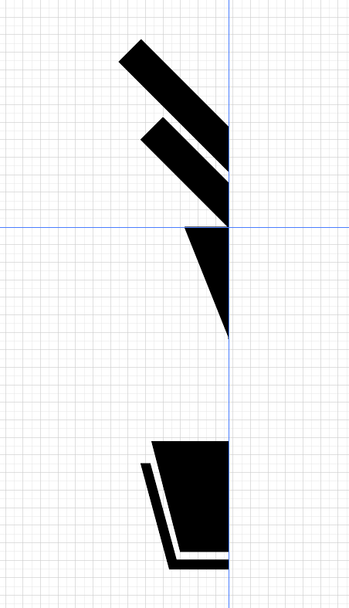

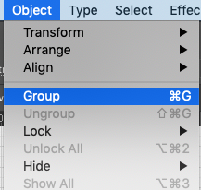
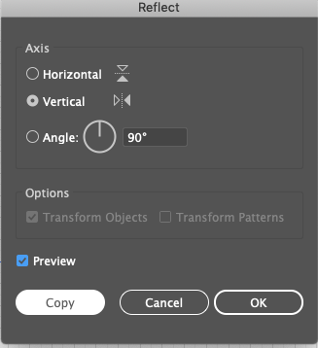
- Group the objects, then Transform > REFLECT > Save as > Illustrator or .psd files to adapt in either programme.

Effects for Arcs >>>


