Steel & Concrete Frame Construction

Construction Materials – ACBA4016

By Joseph Lewis (2414282)
Contents
- Introduction
- Material Choice
- Ease of Adaptation
- Advantages and Disadvantages
- Reference Page

Introduction

As part of my research into steel and concrete frame construction I have developed two detailed case studies on habitable steel and concrete frame buildings from around the world. In this report I will go into the detail of how both buildings were constructed and what factors were considered in the planning process such as environment and climate. I will discuss the impact that both construction materials had in the production process to the community and environment and how adaptable these buildings are dependent on their shape and design. The two buildings I have chosen to do this are:
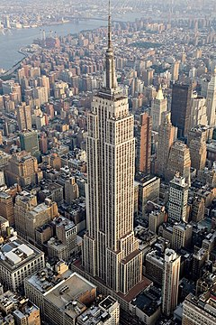
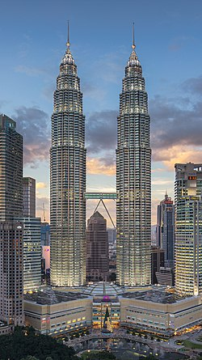

Petronas Towers, Kuala Lumpur Empire State Building, New York
Concrete Frame Construction Steel Frame Construction
Completed in 1996 Completed in 1931

Petronas Towers, Kuala Lumpur

The Petronas Towers in Kuala Lumpur stand as the world’s tallest twin skyscrapers and were the worlds tallest buildings from when they were finished in 1996 until 2004. Officially opened in 1999, the buildings stand at 1,483 feet and have 88 floors each. The design of the building is recognized in Malaysian culture and features motifs of Islamic art.

The buildings are built primarily in concrete and feature a tube in tube design which incorporates a reinforced concrete central core with an outer system of high strength, reinforced concrete columns with stainless steel for improved structure and a glass façade to finish. Because of the incredible size and weight of the buildings, the Petronas Towers sit on a large concrete raft foundation with 104 deep driven piles below. These are some of the deepest piles ever driven for a foundation and reach depths of up to 120 meters before reaching bedrock. This was needed because of the discovery of soft soil on the site.

The twin towers are recognizable for having a two-story sky bridge connecting the two buildings. This is located at the 41st and 42nd floors. It is the world’s highest sky bridge and spans the distance of 58m between the buildings.

Empire State Building, New York
The Empire State Building in New York is one of the world’s most recognizable skyscrapers and stands in the heart of the city. Completed in 1931, just 13 months after construction started, the building stood as the world’s tallest building from its completion to 1970. The Empire State Building was the first building to be more than 100 stories’ tall, reaching a total of 1,454 feet.

The building is an example of art deco architecture with a steelwork skeleton and concrete floors. Limestone panels cover the exterior of the building with stainless steel accents and windows. The design of the building was very simple and repetitive for construction workers which allowed the building to be completed in such a short time frame. Prefabricated materials and precise coordination were also a major factor in this.

The Empire State Building’s foundation extends down 102 feet below ground level and consists of a complex structure of concrete and steel beams. The site had a very high-water table and therefore required a carefully engineered foundation to combat this. Once the foundation was complete, steel started being erected at the building and went at an astonishing rate of 4 ½ stories per week.

Material Choice
Both buildings in this case study encountered many factors in the design process for the materials that were used in their construction. In this part of the case study, I will explain the reasons behind why the materials were chosen for each building and relate them to factors such as durability, strength and climatic conditions. I will also explain the impact that each material had on the local community and environment when being produced for the buildings.

Petronas Towers
In the design process of the Petronas Towers, many factors were considered for the use of building materials on the project. For example, before construction of the towers started, poor ground conditions were discovered from test boreholes. This brought up many challenges when designing the foundation and the buildings themselves. The boreholes discovered that the ground on the site was very soft and effectively sat in the center of a large cliff face below ground. This meant that the entire site had to be moved to find more stable ground. But deep concrete piles could be used with a large raft foundation to adequately support the building. This type of foundation also helped to prevent ground settlement below the site and further improved the buildings stability.

The climate and environmental conditions of Kuala Lumpur was also another major factor in the designing process of the buildings. The city can achieve tropical weather all year round including high temperatures, frequent rainfall and winds. Because of this, steel wasn’t deemed as a durable material due to corrosion and wouldn’t have as good structural integrity. Therefore, concrete was seen as a stronger and more durable material to resist the forces that were being put on the building. Malaysia is also a common country for seismic activity, the use of reinforced concrete throughout the structures has provided additional strength and stability for withstanding these forces. Although there is stainless steel incorporated within the construction of the Petronas Towers, concrete remained the main structural element of the towers. The steelwork does however allow for flexibility within the structures and can further help to combat the effects of seismic activity.

The Petronas Towers had a profound impact on the community and environment of Kuala Lumpur. Because of the incredible amount of concrete that was used in the building, new sustainable practices of using the material were discovered and helped to reduce material usage and improve efficiency. The construction of the towers helped to develop the city and provided durable and long-lasting infrastructure. Furthermore, the economy grew because of the development of the twin towers.

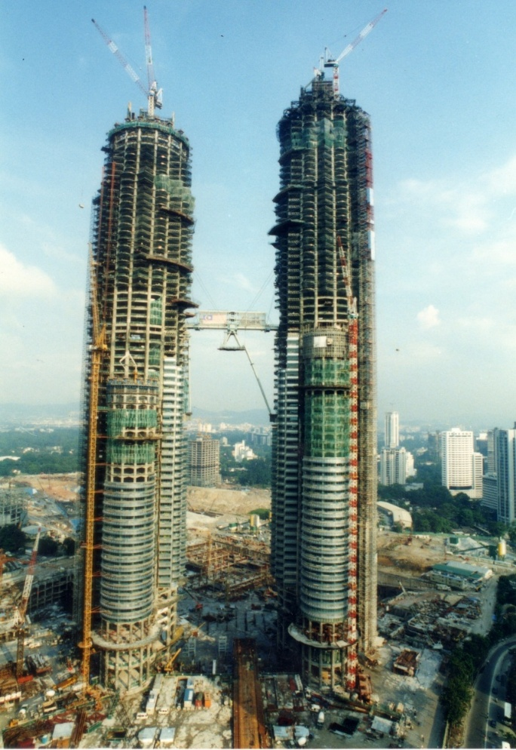

Figure 1 – Petronas Towers Under Construction (Expatgo, 2016)

Empire State Building

When the Empire State Building was constructed in 1931, it was seen as an incredible feat of engineering because of the size and speed of the construction and many factors were considered when during the design process.

At the time of construction of the Empire State Building, the United States was in the middle of the Great Depression. This posed many issues for the designers and planners of the building. But, as the building was completed in just over 13 months, under budget and ahead of schedule, the building became a sign of resilience and effectively put thousands of people to work during a difficult period for the country. Around 3,500 people were employed to work on the construction of the building, all working effectively together because of the meticulous planning of the project.

Material costs were also another major factor in the construction of the building. Because of the economic downturn, materials costs were low and helped to keep the cost under budget, further helping the economy of the country. Because of the low cost of the materials, it didn’t take long for the building to start making money and has since attracted millions of tourists every year.

The climatic conditions of New York were also a major factor in designing the building. New York can experience very cold weather and snow during winter months, therefore large amounts of concrete would have been harder to set in these conditions during construction. Although New York is not prone to seismic activity, the Empire State Building is heavily designed to be able to withstand it. Deep foundations reaching depths of 102 meters anchored to the bedrock provide a stable foundation for the building and the steelwork and concrete together provide significant resistance vibrations.

Steel was seen and proved to be a much quicker method of construction for the building thus helping to keep the project ahead of schedule. Therefore, the workforce was more readily available to the project and were very highly skilled to achieve completion of the project in the timescale.

The Empire State Building has had a profound impact on the local community and environment of New York since its construction. It was the first building of its kind to be built in such a quick timeframe and effectively paved the way for the construction of skyscrapers in New York and the United States in general.

Ease of Adaptation
Both buildings mentioned in this case study were designed in a way so that their construction was as easy as possible and so that there was a potential for multiple uses for the building. For example, the Petronas Towers was designed with a flexible structural design meaning that it has lots of open floor space with no columns interrupting. This means that many different layouts could be incorporated for each of the building. The building provides an example of this as the towers are part of a complex that houses many commercial, residential and recreational spaces. This shows the buildings ability to adapt to many different uses.

The Empire State Building was also designed with adaptability in mind. For example, the steel beams used in the building were all prefabricated and of a modular nature. Therefore, it can allow a potential for vertical expansion or modification. This prefabricated steel frame also contributed to the ease of assembly of the building as all steel was made off site and transported and fixed on site. The Empire State Building’s steel design also allowed it to have multiple uses. For example, most of the building is office space but there are also many floors that house observation decks for tourists.

Below is a table representing the advantages and disadvantages of steel and concrete frame construction

Steel
Advantages | Disadvantages
Strength & Durability – Steel can withstand significant stresses and is incredibly strong | Cost – Initial material cost is often higher than that of concrete
Ease of Fabrication – Can be prefabricated off site and transported for erection on site | Thermal Conductivity – Steel is more prone to temperature fluctuations and can lead to higher energy costs for the building because it conducts heat
High Strength to Weight Ratio – Allows the creation of lightweight yet robust buildings | Maintenance – Steel can rust or corrode if not treated properly and will need regular maintenance
Adaptability – Ideal for buildings that require a flexible floor plan and can accommodate future modifications | Fire Resistance – Steel requires an intumescent coating to be deemed fireproof which can add to the cost of the project
Speed of Construction – Due to prefabrication, it is more efficient and requires less time to erect on site

Concrete
Advantages | Disadvantages
Fire Resistance – Concrete provides a high level of safety in the event of a fire | Weight – Concrete is much heavier than steel and can impact design of foundations for a building
Material Availability – Concrete is usually more locally sourced and can be more readily available | Longer Construction Time – Concrete takes time to set once laid which can add time to a construction project
Sound Insulation – Concrete naturally exhibits good sound insulation | Weather Dependent – Concrete must have the correct weather conditions to be able to set effectively
Thermal Mass – Concrete can absorb and release heat slowly resulting in less reliance on heating and cooling systems | Cracking – Concrete can crack over time due to thermal shrinkage and expansion
Versatility – Concrete can be molded into many different shapes and is an extremely malleable material

References
Construction Physics, (2022). Building Fast and Slow, Part 1: The Empire State Building and the World Trade Center. (Online)
Available at: https://www.construction-physics.com/p/building-fast-and-slow-the-empire
(Accessed 19th March 2025)

Designing Buildings Wiki, (2023). Petronas Twin Towers. (Online)
Available at: https://www.designingbuildings.co.uk/wiki/Petronas_Twin_Towers
(Accessed 19th March 2025)

Call Me Construction, (2025). What Materials Were Used to Build the Petronas Towers? (Online)
Available at: https://callmeconstruction.com/building/what-materials-were-used-to-build-the-petronas-towers/
(Accessed 18th March 2025)

Missouri University of Science and Technology, (1998). Foundation Design and Performance of the World’s Tallest Building, Petronas Towers. (Online)
Available at: https://scholarsmine.mst.edu/cgi/viewcontent.cgi?article=1831&context=icchge
(Accessed 18th March 2025)

Research Gate, (2018). Structural Systems of Petronas Twin Towers. (Online)
Available at: https://www.researchgate.net/publication/326624649_Structural_Systems_of_Petronas_Twin_Towers
(Accessed 19th March 2025)

Design Asia Magazine, (2023). Petronas Towers: A Towering Architectural Triumph. (Online)
Available at: https://designasiamagazine.com/petronas-towers-a-towering-architectural-triumph/
(Accessed 19th March 2025)

History 101, (2025) History of the Empire State building. (Online)
Available at: https://www.history101.nyc/places/empire-state-building
(Accessed 20th March 2025)

What it Costs, (2025). How Much Did the Empire State Building Cost to Build. (Online)
Available at: https://www.whatitcosts.com/empire-state-building-cost-build/
(Accessed 20th March 2025)

ESBNYC, (2025). Energy Efficiency & Sustainability | Empire State Building. (Online)
Available at: https://www.esbnyc.com/about/sustainability
(Accessed 20th March 2025)

DesignWithAjay, (2024). Navigating the Pros and Cons of Steel Frame vs Concrete Frame Construction. (Online)
Available at: https://www.designwithajay.com/post/navigating-the-pros-and-cons-of-steel-frame-vs-concrete-frame-construction
(Accessed 21st March 2025)

BuildingsDB, (2025). Empire State Building. (Online)
Available at: https://buildingsdb.com/NY/new-york/empire-state-building/
(Accessed 21st March 2025)

