

Student Name: Vrushabh Rakeshbhai Patel
Student ID: 2528085
Programme: Master of Business Administration
Module Name: International Business Concepts
Module Code: LCMB7034
Lecturer’s Name: Gladius Kulothungan
Word count: 5437

Assignment Title: International Market Entry Strategy: A Critical Evaluation of Starbucks’ Proposed Expansion into Bangladesh

Table of Contents
1. Introduction 3
2. Section 1 – International Market Entry Analysis 3
2.1 Organisational Classification and Global Strategy 3
2.1.1 Strategic Categorisation: Bartlett and Ghoshal’s Model 4
2.1.2 Global Configuration, Competitive Advantage and Value Creation 5
2.2 Macro-Environmental Appraisal and Market Attractiveness 6
2.2.1 Political Environment 6
2.2.2 Economic Environment 7
2.2.3 Legal and Regulatory Environment 9
2.2.4 Cultural Environment 11
2.2.5 Integrated Market Attractiveness 12
2.2.6 Dunning’s Eclectic Paradigm (OLI) 13
2.3 Entry Mode Strategy and Strategic Synthesis 14
2.3.1 Historical Entry Modes Used by Starbucks 14
2.3.2 Strategic Fit of Entry Modes for Bangladesh 16
2.3.3 Recommended Entry Mode: Strategic Licensing Partnership 17
2.3.4 Risk, Resource Commitment and Control 17
2.3.5 Implementation Strategy 18
2.3.6 Conclusion and Final Recommendation 18
3. Section 2: Reflective Account Based on Gibbs' Reflective Cycle 19
4. Conclusion 21
5. References 23

Introduction

Figure 1: Starbucks Corporation
Source: (Starbucks, 2024)
International market entrance is complicated because multinational businesses (MNCs) must balance firm-specific skills with host market political, economic, legal, and cultural factors (Hamdat et al., 2024). Starbucks Corporation, with a globally known brand name, an international presence and an ever growing asset light international expansion strategy, is characterized by immense room for growth in developing nations. By June 2026, more than 41,000 company-operated and licensed stores were run by Starbucks throughout the world using their locally skilled partners to achieve international expansion (Starbucks, 2024). This study aims at making a critical evaluation of the expansion of Starbucks to Bangladesh where there have been no major operations as of 1 June 2026. Although Bangladesh shows potential on account of the population size, urbanization and café culture but challenges such as high levels of inflation, economic instability, complex regulations and strong tea drinking culture exists.

Section 1 – International Market Entry Analysis

Organisational Classification and Global Strategy
Starbucks’ global strategy balances worldwide brand integration with local responsiveness, enabling international growth while adapting operations to diverse market environments.

Strategic Categorisation: Bartlett and Ghoshal’s Model
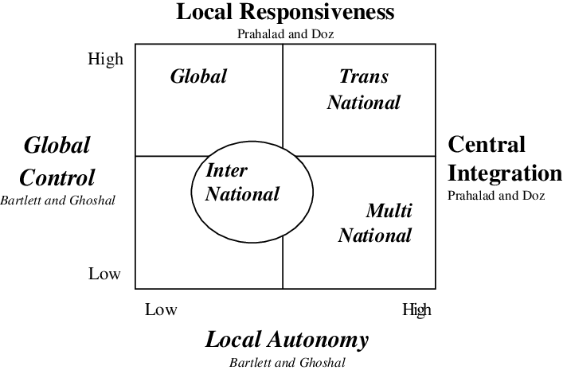
Figure 2: Bartlett and Ghoshal’s Model
Source: (Lehmann, 2024)
According to Bartlett and Ghoshal (1989), international strategies are based on global integration and local responsiveness. Types of internationalization include international, global, multinational, and transnational (Lehmann, 2024). International strategies imply transferring parent company capabilities overseas but with little adaptation, global strategies are focused on standardization and efficiency, multinational strategies concentrate on local adaptation, and transnational strategies try to achieve global efficiency, local responsiveness, and worldwide transference of knowledge (Nosova, 2023).

Starbucks is best described as multinational, but a global approach is clear. Its worldwide brand identity, coffee quality, shop experience, employe training, and digital environment are integrated. Starbucks applies a uniform brand image, high-quality coffee, unified shop, thorough training for employees, and digital environment around the world (Nissa, Amalia, and Novelia Muzallifah, 2026). It customizes products, shops, advertising, and partnership according to the peculiarities of each location, but it does not impose one unified solution (Nissa, Amalia, and Novelia Muzallifah, 2026). The company customizes Asian products and processes to meet local needs and preserve its overall brand image.
It is worth noting that the transnational strategy creates a strategic contradiction. Standardization can lead to losing cultural relevance, and excessive localization can damage the global strategy of Starbucks and make its work more difficult. Therefore, Starbucks attempts to standardize the general strategy and localize its implementation, using the local experience to achieve economies of scale and preserve brand equity (Nissa, Amalia, and Novelia Muzallifah, 2026).
Local partners become increasingly important in implementing the above strategy. Starbucks predicts that 90% of its future international growth will be generated by the existing experienced licensees (Woods, 2026). Therefore, transnational strategy allows explaining how Starbucks combines global competitive advantages and host-country responsiveness.

Global Configuration, Competitive Advantage and Value Creation
Starbucks demonstrates highly diversified geography with the number of more than 40,000 stores globally by 2025, which highlights the degree of internationalization of this company. According to Statista, there were almost 23,000 international stores operating for Starbucks in 2025, which shows that overseas stores outnumbered North American ones and accounted for about 56% of the global network (Islas, 2026). Such geography creates the competitive advantage of Starbucks as it helps to spread brand, organizational know-how, and experience working with customers around heterogeneous geographies. For example, Starbucks' significant presence in China, Japan, South Korea, and India gives access to the fast-growing consumer market in Asia and experience in adapting the way coffee drinking is perceived depending on cultural specifics (Korosteleva, 2026).
Geographical diversification helps Starbucks to create value because of economies of scale, high brand recognition, and knowledge of local markets. In 2025, Starbucks reported revenues higher than US$37.2 billion, which was the record revenue for the company (Starbucks, 2025). However, the geographical diversification is accompanied by the strategic risks due to the high exposure of the company to major markets where it operates such as the USA and China. For this reason, increased reliance on the licensed stores and local partners becomes strategically crucial for the company because it helps to expand geographically with lower capital outlay while retaining control of brand assets (Nwabekee et al., 2024).

Macro-Environmental Appraisal and Market Attractiveness
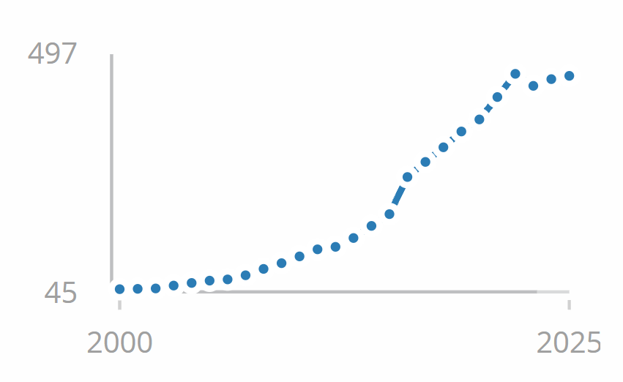
Figure 3: Bangladesh GDP
Source: (World bank open data, 2021)
Starbucks views Bangladesh as an exciting but extremely risky emerging market. The factors that determine whether or not Bangladesh is an ideal emerging market for Starbucks cannot be determined through mere demographics; the key issue is whether or not Bangladesh is politically stable, economically prosperous, compliant with the law, and culturally ready to support the premium experience concept. According to the data provided by World Bank Open Data (2021), the population of Bangladesh as of 2025 was about 175.7 million, with GDP estimated at US$456.3 billion, GDP per capita at US$2,597, and inflation rate of 8.8%. Thus, the current analysis will focus on the political, economic, legal, and cultural aspects relevant to Starbucks' market entry strategy, and then apply the findings using Dunning’s OLI approach.

Political Environment
Starbucks' market debut in Bangladesh depends on political stability, investor trust, regulatory predictability, property agreements, and company continuity (Abu, 2025). After the political disturbances that occurred in 2024 following the change of government, instability was seen to arise. The newly elected government of Prime Minister Tarique Rahman won at least 212 out of 299 seats of the parliamentary elections held in 12 February 2026 indicating that the trend is towards normalcy (Bureau, 2026).

According to Starbucks, these are factors that can bring about investments. The policies of the new government include improved international business environment, economic reforms, and improvement in employment and investment (Corgnier, 2025). This is relevant in the case of Starbucks because the company will require long-term leases, credible suppliers, and labor laws. Continued stability in politics is an assurance of reduced uncertainties that might come with the operation of the stores physically.
However, the situation in politics is relatively risky. It can happen that the situation can change overnight as was witnessed recently. The GDP of Bangladesh grew at a slower pace than before to 3.7% in FY2025 due to output disruption as a result of political disturbances, poor governance, weaknesses in the financial system and delayed reforms (News On AIR, 2026). In order to attract foreign direct investment, IMF suggests improvements in governance and transparency.
Starbucks has a strategic problem. Political stability makes Bangladesh more appealing, but institutional problems enhance the hazards of a high-commitment fully owned investment. Political unrest may impact store access, supply chains, customer spending, and imported goods (Krykavskyy et al., 2023). Therefore, Starbucks should first enter with little investments and partnerships, enabling local knowledge to alleviate institutional uncertainties while maintaining brand and quality control.
Due to political and economic uncertainties, private investment remained low, and FY2026 growth was predicted at 2.5% (World Bank, 2025). Thus, Bangladesh's political climate is improving yet unpredictable. Such a scenario calls for a gradual approach for entry in Dhaka, as opposed to expansion countrywide by Starbucks.

Economic Environment
There is a strange case of economic opportunity at hand, where Starbucks has the advantage of a large customer base and a growing coffee industry environment, but constraints like low disposable income levels, inflation, and currency issues limit the spending on premiums. The population of Bangladesh in 2025 was 175.7 million, with a GDP of US$456.3 billion and per capita GDP of US$2,597. GDP growth has slowed down to 3.5%, while consumer inflation has been high, at 8.8%. According to the world bank open data (2021), the aforementioned information indicates that there might not be correlation between the market size and demand.
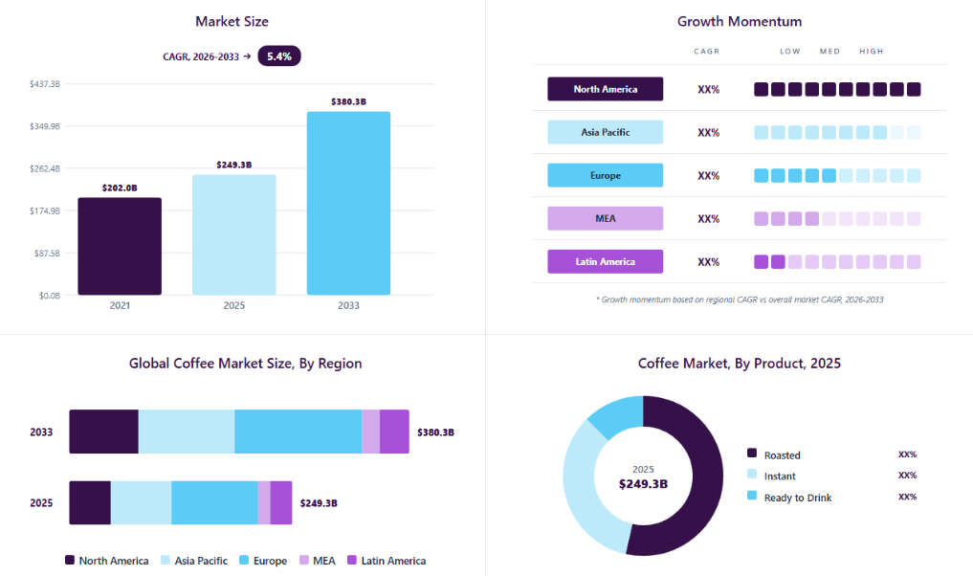
Figure 4: Coffee Market
Source: (Grand View Research, 2024)
The broader coffee industry nevertheless provides a positive structural signal. According to Grand View Research (2024), the worldwide market of coffee will have an annual growth rate (CAGR) of 5.4%, with the value of the market increasing from US$249.3 billion in 2025 to US$380.3 billion by 2033. The most relevant market segment for this venture is the Asia-Pacific coffee market, worth US$68.1 billion in 2025 and growing annually by 5.9% until 2033 (Grand View Research, 2026). While there is considerable demand in the region, the relatively low income level in Bangladesh and the cultural dominance of tea pose restrictions on market development.
Inflation constitutes the primary threat to the profit margins of the venture. High inflation within the range of 5–6% would lower disposable incomes, making consumption of premium coffee products discretionary (Transcend CU, 2022). Hence, Starbucks will be facing a decline in customers and price sensitivity. The strategic choice will be to maintain its premium pricing, maintaining both profitability and branding or lower prices in order to increase access and challenge the perception of premiumness of Starbucks. In this situation, tiered pricing, reduction of portion sizes, and locally-sourced foods are preferred to widespread discounts.
The risk of high costs increases with the use of foreign currencies. Thus, in April 2026, the total foreign exchange reserves of the country amounted to US$35.1 billion, showing increased external liquidity compared to earlier in the fiscal year (Bangladesh Bank, 2021). However, Starbucks will still be prone to depreciation of the taka, as coffee, equipment, and technologies will still be costly. At the same time, procurement of milk, baked goods, packaging, and some additives locally could contribute to cost resilience, whereas coffee quality is monitored globally (Raimondo, 2022).
Starbucks should target wealthy urban customers rather than the general market based on purchasing power limitations. Dhaka professionals, foreign businesses, institutions of higher education, and upper middle-class families appear to be a better target market than the entire country. According to Grand View Research (2024), B2C channels will account for 62.5% of worldwide coffee-market revenues in 2025 owing to premiumization, specialty coffees, and changing lifestyles. The above factors support Starbucks’ experience-centric approach, especially urban youth.
Also examine economic development and shop economics. Sales density is essential to meet rent, staffing, equipment, and quality expenses. In Bangladesh, location appears to matter more than the size of the market, owing to comparatively low levels of income (Swazan and Das, 2022). Higher transaction values may be observed in premium areas in Dhaka, although high real estate prices could hurt margins. A unit economic evaluation through a trial operation is recommended before expansion. Engaging local suppliers may add to stability and minimize landing costs and currency risk. Instead of pursuing new locations, Starbucks should observe metrics such as transaction value, repeat visits, gross margin, and revenue adjusted for inflation. It allows the company to grow according to purchasing power, not overly optimistic population projections.
Bangladesh provides an appealing yet limited commercial landscape. There are long-term opportunities owing to a substantial population and positive trends in Asia-Pacific coffee production. Still, slow growth, 6.25% inflation, and low GDP per capita make it imprudent to develop a mass market.

Legal and Regulatory Environment
Bangladesh provides a relatively open legal environment for foreign investment, but regulatory complexity remains a significant consideration for Starbucks because its proposed operations would combine foreign investment, food retailing, imported inputs and local employment. The Bangladesh Investment Development Authority (BIDA) allows for 100% foreign ownership in most cases, while the Foreign Private Investment (Promotion and Protection) Act 1980 protects all qualified foreign investments (LegalSeba, 2020). BIDA provides One Stop Services that help register a company, process an employment permit and complete other related processes. Starbucks will not have to find a Bangladeshi equity partner by law; thus, all cooperation will have to rely on local expertise and risk management.
As for the issue of regulation, it is necessary to mention that Starbucks' reputation depends on the quality of the product, so adherence to the food-safety regulation will be of particular importance. All food enterprises have to follow BFSA regulations regarding contamination, food additives, advertisements, and obligations of food businesses (BFSA, n.d.). BFSA introduced a draft packaging-foods labeling regulation in January 2026 which means that food safety regulation in Bangladesh is currently changing (Tao, 2026). Starbucks will have to have strict supplier verification, hygiene control, staff education, and traceability system exceeding the local requirements.
Taxes and customs affect entrance economics. BIDA validates foreign investors' repatriation of invested capital, earnings, dividends, and authorised royalty, franchise, and technical-know-how fees, while Bangladesh's National Board of Revenue handles VAT, income-tax, and customs (Wahab, 2022). Starbucks' imported coffee beans, equipment, and technology may incur customs fees and taxes. Locally sourcing milk, bread items, packaging, and selected ingredients would reduce costs and maintain coffee quality.
Employee regulations add duties. The Bangladesh Labour Act 2006 regulates pay, working conditions, health, safety, and employment relationships (Iqbal et al., 2023). A normal number of working hours should be eight hours in a day and 48 hours in a week, with overtime and breaks regulated through statutes. Local agreements, payroll systems, restrictions on working hours, and safety regulations will be necessary for the business.
The trademarks and the image of Starbucks present significant ownership benefits, which explains the need for IP laws. In Bangladesh, the Department of Patents, Designs and Trademarks implements the Trade Marks Act 2009, the Patent Act 2023, and the Industrial Design Act 2023 (Uddin & Arafat Hossen, 2025). It is recommended that Starbucks register its trademarks before entering the market, as well as include strong IP protection into licensing agreements. Even though Bangladesh provides a favorable atmosphere for investments, it possesses a complicated legislative framework.

Cultural Environment
Starbucks faces cultural differences but also opportunities in Bangladesh. First of all, the country is traditionally associated with tea drinking and not with coffee drinking contrary to Western countries. Tea drinking in Bangladesh is associated with hospitality, socialization, and daily life routine, therefore, just branding will hardly be able to replace this cultural phenomenon (Bodkin, 2023). It was estimated that there is a ratio of consumption of 90 cups of tea per one cup of coffee (The Daily Star, 2026). Thus, there is a challenge of introducing a new brand and creating its demand in a cultural environment.
The cultural environment changes especially among young urban population and generation Z when there is an increasing popularity of café visits and specialty coffee because of cosmopolitan lifestyle, global brands, modern consumer behavior on the social networks. However, in spite of that tea is still prevailing in this country, Euromonitor (2026) notes that changing lifestyle and a younger consumer make the hot drinks market to develop in Bangladesh. Starbucks can concentrate on a new market niche development and not try to change the whole market.
It is worth mentioning that café culture of Dhaka is very important since there is an increased usage of cafés for meetings, communication, education, and even remote work not only for coffee drinks purchase (Yos Sudarso, Kusnadi, and Ary Purwatiningsih, 2026). It is connected to the concept of "third place" implemented in Starbucks in the whole world since the café is seen as a place where people can be with each other but not at home or workplace.
However, taste adjustment is necessary. Making the Western food too standardized risks driving away cultures and preventing acceptance. Starbucks could keep its global image yet provide locally relevant food and beverages including tea-based beverages, appropriate flavors, and sweetened products (Shenoy, 2026). This methodology conforms to the transnational strategy paradigm whereby global brand equity and quality standards are maintained and market adaptation is done taking into consideration the local tastes. The feasibility of this methodology is proven by some examples from Asia like that of Starbucks in different locations. In India, Starbucks adopted a joint venture in which they collaborated with 50% each in the form of Tata (Tata Consumer Products, 2024). In 2026, Starbucks signed a joint venture with Boyu Capital, keeping its 40% stake, while 60% belongs to the local partner (Starbucks, 2024a).
Importantly, these instances show that cultural adaptability does not involve forsaking global standardisation. The local partner and local consumers affect the choice of products and marketing techniques. As a result, Bangladesh poses a moderate to high cultural risk but has great potential in the long run (Hossain et al., 2025). A pilot project in Dhaka, locally customized menu, and culturally appropriate marketing will narrow down the cultural distance and help Starbucks evaluate the growth of the coffee culture there.

Integrated Market Attractiveness
According to the findings of the study, Bangladesh appears to be a conditionally attractive market for Starbucks but not an immediately scalable one. The large population base and the growing coffee market in the region provide future potential for growth, although macro-economic conditions and cultural differences limit near-term attractiveness. Hence, the market attractiveness is dependent on Starbucks’ ability to target the right demographic and minimize financial risks.
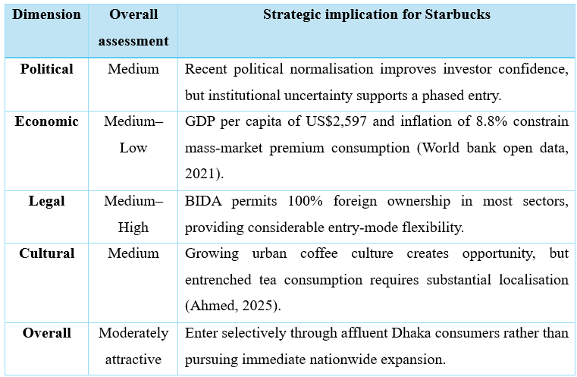
Crucially, however, the key opportunity is in demand generation for the future rather than market size at the current point in time. For this reason, it is important for Starbucks to consider Bangladesh as a strategic expansion opportunity that requires a light asset approach, a locally responsive approach, and an evidence-driven approach to market entry (Quadir et al., 2024). Conducting a small pilot study in Dhaka can help determine willingness to pay, repeat purchases, and profit margin before committing further investments.

Dunning’s Eclectic Paradigm (OLI)
The eclectic paradigm proposed by Dunning, which is more frequently termed the OLI paradigm, helps explain why companies engage in international business when there are three factors present: ownership (O), location (L), and internalization (I) (Chen, 2019). It is not just a matter of analyzing the three factors individually but rather of matching the firm-specific advantages of Starbucks with the local market characteristics of Bangladesh.
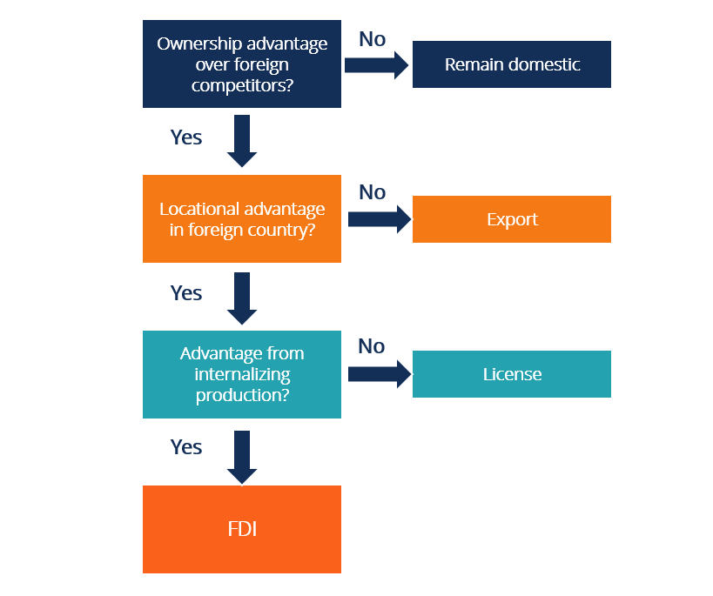
Figure 5: Dunning’s Eclectic Paradigm (OLI)
Source: (CFI, 2022)
Ownership Advantages
Ownership advantages include resources and competences that give a company a competitive advantage over local as well as foreign competitors (Zander, 2015). The resources that provide Starbucks with a competitive advantage include its global brand name, trademark, its proprietary business processes, coffee know-how, logistics capabilities, online platforms, and its international experience. It helps to reduce consumer uncertainty and allows delivering a premium product in Bangladesh. Experience in operating in culturally diverse Asian countries like India and China aids in localizing and managing relations (AHMAD, 2026). Nevertheless, ownership advantages are unable to overcome the demand risk associated with a particular country as brand awareness is not enough when consumers have purchasing power limitations and limited coffee consumption.
Location Advantages
Location advantages arise from host-country characteristics that make operating within that market economically or strategically attractive (Cuervo-Cazurra, de Holan and Sanz, 2014). The population of 175.7 million people, growing urban consumption habits, and rising interest in café culture in Bangladesh speak about its long-term prospects (World Bank Open Data, 2021). Besides, the density of business organizations, institutions, and wealthy consumers in Dhaka make it especially attractive. The country provides cheaper labor force and cheaper costs of doing business compared to many developed countries. With GDP per capita of $2,597 and inflation at 8.8%, the country lacks discretionary income (World Bank Open Data, 2021).
Internalisation Advantages
Benefits of internalization come from coordinating activities within the firm rather than from using external market transactions (Chen, 2019). Due to its key features, Starbucks needs to take care of the brand standards, intellectual property rights, the quality of coffee, recipes, staff training, technologies and the customers’ experience. However, an experienced Bangladeshi partner can help in acquiring property, recruiting staff, selective sourcing, logistics and handling with the authorities in order to minimize the risk of investment and institutional risks. Selective internalization is the means that creates the right balance between control and flexibility. Therefore, the OLI approach implies strategic licensing or partnership entry.

Entry Mode Strategy and Strategic Synthesis
Entry mode strategy is the corporate structure of a firm to enter and operate in the foreign country and affects resource allocation, control and risk (Divrik, 2023). Starbucks needs to find a way to balance brand standards, risk in finance, politics and operation while remaining flexible.

Historical Entry Modes Used by Starbucks
Starbucks' multi-mode internationalisation approach has considered market attractiveness, institutional requirements, and the balance between control and resource commitment (Azriuddin, 2020). No single entry style can enhance control, limit risk, and give deep local knowledge, making this flexibility crucial.

Figure 6: Historical Entry Modes
Source: (Self-created)
Wholly Owned Operations
Starbucks opts for company-owned and wholly-owned stores in situations where greater control over brand standards, customer service experience, staffing issues, and operations procedures becomes imperative. Increased control ensures protection of the Starbucks brand and increases store-level sales (George, 2023). This, however, involves considerable financial investment and puts the company at risk regarding property issues, labor issues, political considerations, and changes in the level of demand. Thus, this strategy works best in markets with stable demands. In a volatile market like that of Bangladesh, a capital-intensive and wholly-owned strategy would increase the risk level.
Licensing
Licensing reduces Starbucks' financial commitment by transferring investment and selected operational responsibilities to local partners. The network of FY2025 for Starbucks includes 21,514 company-operated stores and 19,476 licensed stores, which constitute 47.5% of all the company's stores (GlobalData, 2021). Licensing enables Starbucks to obtain license fees and access to local knowledge, property network, and cash flows. Reduced control, however, may lead to quality and reputational risks. These risks are managed by Starbucks through contractual provisions, training, and auditing.
Joint Ventures
Joint Ventures take advantage of Starbucks’ global capabilities combined with local strengths. In India, the 50:50 joint venture with Tata gave Starbucks a chance to use Tata’s local market knowledge and infrastructure as well as deliver the brand and coffee experience of Starbucks (Tata Consumer Products, 2024). According to Kang (2025), Tata Starbucks has more than 497 stores in 81 Indian cities. In addition, Starbucks opened the retail joint venture with Boyu Capital in China where Starbucks owned 40% share of the business and retained its intellectual property (Starbucks, 2026). Such examples demonstrate a new direction for the company in terms of relying on local knowledge and avoiding financial risks. Therefore, the pattern of Starbucks' development became more focused on partnership worldwide and especially in developing countries.

Strategic Fit of Entry Modes for Bangladesh
The entry mode for Starbucks should take into account the level of political risk, financial involvement, control, cultural adaptation, and strategy. A wholly owned subsidiary is a form of entry which provides the most control yet carries the greatest risks. It means that Starbucks would have to build its own premises, buy equipment, hire employees and build the supply chain which makes Starbucks susceptible to economic risks associated with Bangladesh. World Bank Open Data (2021) states that the GDP per capita is equal to $2,597 and projected inflation for 2025 is 8.8%.
A joint venture (JV) addresses Bangladesh's cultural and institutional distance better. A skilled local partner might provide property knowledge, supplier ties, recruiting skills, and customer preferences. The 50:50 partnership between Tata and Starbucks in India proves the potential benefits of local expertise for enhancing Starbucks' global brand (Tata Consumer Products, 2024). Nonetheless, JVs are resource-intensive and involve shared-control problems, namely price wars, disagreements concerning future development and reinvestments, etc. In Bangladesh, foreign firms are allowed 100% foreign shareholding in most sectors, and thus, Starbucks does not necessarily need an equity partner locally (Invest Bangladesh, 2026).
Strategic licensing appears the most suitable solution. Strategic licensing reduces costs, transfers real estate and business risks to the local partner and provides market knowledge (Jiang, Aulakh, and Pan, 2008). Indeed, Bangladesh's emergent coffee/tea culture is an important factor that allows Starbucks to benefit from localization without substantial fixed costs.

Crucially, strategic licensing is consistent with Starbucks' 2026 asset-light strategy for international expansion, whereby 90% of international expansion will be executed by experienced licensees (Starbucks, 2026a).
However, insufficient quality control may make pure licensing inefficient. Starbucks should create a strategic licensing strategy with severe brand, coffee, training, technology, and customer experience constraints. This partnership offers Bangladesh the lowest financial/political risks and strategic control compared to fully owned investments and typical JVs.

Recommended Entry Mode: Strategic Licensing Partnership
Starbucks should enter Bangladesh by an exclusive strategic license arrangement with an established local operator, not franchising. Starbucks' brand, intellectual property rights, coffee expertise, and operational systems provide it significant Ownership capabilities, according to the OLI framework. The nation has selective Location capabilities because to its vast population and emerging urban café culture, but inflation and buying power limits it.
Starbucks should manage brand identity, intellectual property rights, coffee, quality, store designs, training, technology and customer experience standards (Tan, 2025). Property acquisition, personnel recruitment, local logistics, chosen procurement and day to day business operations should fall under the responsibility of the Bangladeshi partner. It is done to protect the Starbucks intangible resources by using local capabilities.
The strategic licensing route is better than the wholly owned route in terms of cost of investment and reduced risk of politics, currency fluctuation and demand risks. Since Bangladesh allows full foreign ownership of companies in most industries, Starbucks does not have to share any ownership rights to enter in the market making it better than joint ventures (Kreston Global, 2021a).
The advice supports Starbucks' 2026 asset-light strategy, which expects 90% of worldwide expansion via experienced licensees (Starbucks, 2026a). Thus, strategic licensing best balances control, flexibility, local responsiveness, and risk-adjusted resource commitment.

Risk, Resource Commitment and Control
The result of comparative analysis reveals that strategic licensing represents the most favorable choice for risk-adjusted fit for the company’s expansion into Bangladesh market. Fully-owned business model allows for maximum control by the management but involves significant costs and carries high risks associated with politics, finance, and operation. Joint venture improves local knowledge base and spreads risk, but the shared ownership may cause problems related to corporate governance (Hargrave, 2024). Licensing involves minimum costs and offers flexibility while utilizing the power of local knowledge base. While the level of management control in the case of licensing is lower than in the case of fully-owned business models, the company can protect its core values through contract provisions and training programs.
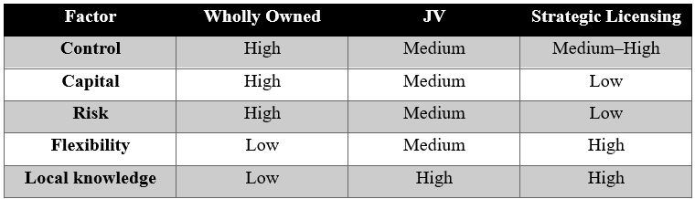

Implementation Strategy
The recommended entry should be implemented progressively.
Phase 1 – Pilot: Starbucks should open around 3-5 stores in premium locations in Dhaka. At this stage, the focus is on validation and not growth.
Phase 2 – Evaluation: Starbucks should evaluate various parameters such as average ticket size, frequency of purchases, customer satisfaction, gross profit margin, store level profit margins, and efficiency in supply chain (Bajpai, 2023).
Phase 3 – Controlled Growth: Once certain benchmarks are met, the company can proceed towards growth of about 10-15 stores in Dhaka and select secondary cities.
Phase 4 – Equity Option: In about three years from now, Starbucks can explore the option of equity ownership if sustainability in the market is proven and there are positive changes in the political economy of the country.

Conclusion and Final Recommendation
Strategic licensing is a viable entry route for the firm in entering Bangladesh without resorting to wholly-owned subsidiaries and traditional joint ventures. In this way, risks are minimized while maintaining full control over core operations. Gradual entry into the city of Dhaka will provide an opportunity for assessing market demand and handling cultural differences.

Section 2: Reflective Account Based on Gibbs' Reflective Cycle
Gibbs' Reflective Cycle is a reflective cycle developed by Gibbs in 1988, which provides a way to evaluate experiences and learning. There are six steps in the process of reflection: description, feelings, evaluation, analysis, conclusions and action plan (Dutta, 2023). It makes people analyze events, learn their importance and ways to improve future actions.
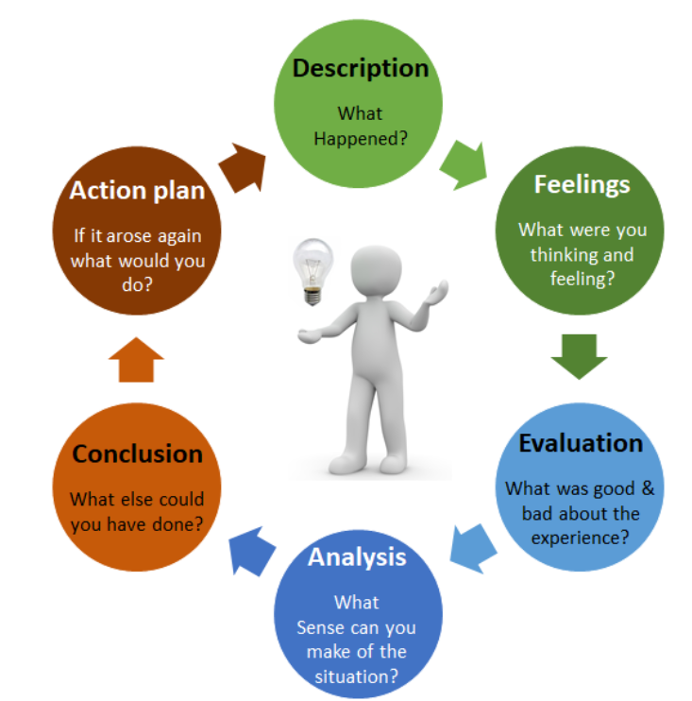
Figure 7: Gibbs’ Reflective Cycle
Source: (Dutta, 2023)
Description
This assessment began with an examination of the brief in order to understand the necessary theories, evidence and word count structure. In this case, Starbucks has been chosen as the multinational firm and Bangladesh as the market for expansion. The secondary research involved a study of academic literature, reports by Starbucks, government documents, World Bank and IMF databases and market studies. Next, I examined the international business strategy of Starbucks according to Bartlett and Ghoshal’s model, analyzed the political, economic, legal and cultural environment of Bangladesh and used Dunning’s OLI framework. Finally, I made a comparison of entry modes and a strategic decision for licensing based on the above factors of risk, control and resource commitment.
Feelings
Initially, I felt confused about how to undertake this assessment considering the fact that not only description of Starbucks and Bangladesh was required but also the application of different theories in relation to current market situation. My initial challenge in this assessment was in choosing an appropriate entry mode as all of the different options carry different amount of risks, control and investments. During the research process, my confidence grew as I got more clear understanding of what is going on strategically. Though I first assumed that a big population in Bangladesh could be a market opportunity, the examination of GDP per capita, inflation and purchasing power changed my perception.
Evaluation
The research process was successful in terms of combining the use of scholarly literature and secondary contemporary literature in order to connect theoretical concepts to practical decision making in international business. Secondary sources included the literature published by such international organizations as the World Bank and the International Monetary Fund, national governments and Starbucks. Academic sources provided the theoretical concepts. It is important to triangulate the sources, because none of them would be sufficient in analyzing the complex situation in the business environment (Vivek, Nanthagopan, and Piriyatharshan, 2023). Bartlett and Ghoshal's (1989) model and Dunning's (1988) OLI paradigm helped in the transformation of the descriptive data into the strategic evaluation. However, there was a lack of comprehensive and trustworthy information about Bangladesh's customers who prefer high-end coffee products and their purchasing power. Thus, some results could only be analyzed carefully rather than predicted.
Analysis
The analysis stage demonstrated that effective international-business research requires synthesising evidence rather than treating environmental factors independently. According to the paradigm proposed by Bartlett and Ghoshal (1989), Starbucks should balance its global integration and local responsiveness in order to explain why it needs to follow its global branding standards in addition to the product and marketing adaptations tailored specifically for Bangladesh. According to Dunning's (1988) OLI paradigm, mere ownership advantages are not enough to internationalize; it is necessary to consider other aspects (Dunning, 2001).
The analysis also challenged the assumption made at the beginning of the assignment that the large population of Bangladesh implied a highly attractive market environment for the firm. Economic information reveals that purchasing power, inflation, and price elasticity are more important factors for Starbucks than the population per se (Kazaz, Webster, and Yu, 2025). Hence, the recommendation was revised into a staged licensing partnership approach focused on the city of Dhaka.
Conclusion
The assignment revealed the necessity of thorough research, theory application, and evidence-based judgement in conducting international business analysis. It turned out that the market size should not be the only criterion for assessing international attractiveness, as it should be accompanied by firm-specific resources, purchasing power, cultural distance, the regulatory framework and risks. Application of the frameworks suggested by Bartlett and Ghoshal (1989) and Dunning (1988) made it easier to bridge the gap between theory and practice. Overall, the research experience increased my analytical skills and made me understand the importance of questioning assumptions and providing realistic recommendations despite the uncertainty of international environment.
Action Plan
The upcoming case analyses will utilize a systematic research methodology and source matrix to check the validity, relevance, and publication dates. The analysis will focus on using more primary sources and industry information, such as information about customers and competitors. The research will give priority to comparing strategic alternatives and testing the proposals in the context of changing economic and political situations. The theories will be used at the initial stage of the research for deeper analysis, not for organization of discussion.

Conclusion
Starbucks' Bangladesh market is conditionally appealing but strategically problematic, according to the report. The company's brand name, knowledge of coffee making, technology and ability to provide excellent customer service experience are easily transferable, whereas large population size, urbanization, and emergence of cafe culture indicate potential. Nevertheless, mass marketing is limited because of lack of purchasing power, inflation, currency risks, political instability and high level of tea consumption. Application of OLI theory suggests that there are great ownership advantages, some location and internalization advantages. In consideration of brand name, intellectual property, quality control and control of training procedures, strategic licensing in partnership with an experienced local player is recommended.

References
Abu, T. (2025). Political instability and consumer behavior: A comparative study of Turkish and Bangladeshi markets. Izu.edu.tr, [online] pp.1–134. Available at: https://openaccess.izu.edu.tr/entities/publication/19cbd069-4b7d-4918-bcb5-97d6ab329a4e [Accessed 9 Aug. 2026].
AHMAD, N.R. (2026). AI-enabled public governance in developing states: Service delivery gains, accountability risks, and a practical risk-based regulatory model. Lex localis - Journal of Local Self-Government, [online] pp.99–117. doi:10.52152/wja5db40.
Ahmed, S. (2025). Weaving coffee shops as third spaces: Enriching Colombian coffee culture and enhancing social connectivity. [online] Ohiolink.edu. Available at: https://rave.ohiolink.edu/etdc/view?acc_num=ucin174765204134411 [Accessed 9 Aug. 2026].
Azriuddin, M. (2020). (PDF) 📄 becoming an international brand: A case study of Starbucks. [online] ResearchGate. Available at: https://www.researchgate.net/publication/338772671_Becoming_an_International_Brand_A_Case_Study_of_Starbucks [Accessed 9 Aug. 2026].
Bajpai, P. (2023). Starbucks as an example of the value chain model. [online] Investopedia. Available at: https://www.investopedia.com/articles/investing/103114/starbucks-example-value-chain-model.asp [Accessed 9 Aug. 2026].
Bangladesh Bank (2021). Bangladesh Bank. [online] Bb.org.bd. Available at: https://www.bb.org.bd/en/index.php/econdata/intreserve [Accessed 9 Aug. 2026].
Bodkin, M. (2023). Grounds for a “third place”: The “Starbucks experience,” sirens, and space - ProQuest. [online] www.proquest.com. Available at: https://search.proquest.com/openview/171f093c02a06b144d5eea1212f5b69a/1?pq-origsite=gscholar&cbl=18750&diss=y [Accessed 9 Aug. 2026].
Bureau, T.H. (2026). Bangladesh election results highlights: ‘Yes’ triumphs in Bangladesh referendum with 60% turnout. [online] The Hindu. Available at: https://www.thehindu.com/news/international/bangladesh-elections-live-results-updates-thursday-february-12-2026/article70622357.ece [Accessed 9 Aug. 2026].
CFI (2022). Eclectic paradigm. [online] Corporate Finance Institute. Available at: https://corporatefinanceinstitute.com/resources/management/eclectic-paradigm/ [Accessed 9 Aug. 2026].
Chen, J. (2019). Eclectic paradigm: Definition, example, advantages. [online] Investopedia. Available at: https://www.investopedia.com/terms/e/eclecticparadigm.asp [Accessed 9 Aug. 2026].
Corgnier, J. (2025). Comparative analysis of BNP Paribas” approaches to energy sustainability, security, and costs in France and South Africa. [online] Uct.ac.za. Available at: https://open.uct.ac.za/items/e4acb0b6-fe72-4cf5-be90-c3e10712bb52 [Accessed 9 Aug. 2026].
Cuervo-Cazurra, Á., de Holan, P.M. and Sanz, L. (2014). Location advantage: Emergent and guided co-evolutions. Journal of Business Research, 67(4), pp.508–515. doi:10.1016/j.jbusres.2013.11.007.
Divrik, B. (2023). International market entry strategies. [online] ResearchGate. Available at: https://www.researchgate.net/publication/373742576_International_Market_Entry_Strategies [Accessed 9 Aug. 2026].
Dunning, J.H. (2001). The eclectic (OLI) paradigm of international production: Past, present and future. International Journal of the Economics of Business, [online] 8(2), pp.173–190. doi:https://doi.org/10.1080/13571510110051441.
Dutta, S. (2023). Gibbs” reflective cycle (adapted from Gibbs, 1988). [online] ResearchGate. Available at: https://www.researchgate.net/figure/Gibbs-reflective-cycle-Adapted-from-Gibbs-1988_fig1_371536633 [Accessed 9 Aug. 2026].
Euromonitor (2026). Euromonitor international. [online] Euromonitor. Available at: https://lp.euromonitor.com/hot-drinks-in-bangladesh/report?utm_source=chatgpt.com [Accessed 9 Aug. 2026].
George, A. (2023). A Cooperative Business Analysis of Starbucks Corporation & reflection by principal financial investigator. Honors Theses. [online] Available at: https://digitalcommons.coastal.edu/honors-theses/464/ [Accessed 9 Aug. 2026].
GlobalData (2021). Starbucks Corp Analysis & Company Information - GlobalData. [online] Globaldata.com. Available at: https://www.globaldata.com/company-profile/starbucks-corp/analysis/ [Accessed 9 Aug. 2026].
Grand View Research (2024). Coffee market size, share & trends analysis report, 2030. [online] www.grandviewresearch.com. Available at: https://www.grandviewresearch.com/industry-analysis/coffee-market [Accessed 9 Aug. 2026].
Hamdat, A., B, C., Samalam, A.G., Susanto, S.E. and Rizal, M. (2024). Strategic management in multinational enterprises: A literature analysis. Vifada Management and Digital Business, [online] 1(2), pp.39–55. doi:10.70184/13tna293.
Hargrave , M. (2024). Joint venture (JV): What is it and why do companies form one? [online] Investopedia. Available at: https://www.investopedia.com/terms/j/jointventure.asp [Accessed 9 Aug. 2026].
Hossain, Md.N., Howladar, M.F., Ahammed, S., Haque, M.R., Khan, M.I., Hasan, M., Chowdhury, T.R. and Hosain, A. (2025). Application of multi-indexing approach within a GIS framework to investigate the quality and contamination of ground water in Barisal sadar, Bangladesh. Heliyon, [online] 11(3), p.e42262. doi:10.1016/j.heliyon.2025.e42262.
Invest Bangladesh (2026). [online] Available at: https://investbangladesh.gov.bd/land-opportunities? [Accessed 2026].
Iqbal, H., Shaharia Nawshad, Mahmud, M., Nath, P. and Baith Ullah Bayath (2023). An overview of Bangladesh labour act, 2006 &amp; Bangladesh EPZ labour act, 2019. [online] Available at: https://www.researchgate.net/publication/376989400_An_Overview_of_Bangladesh_Labour_Act_2006_Bangladesh_EPZ_Labour_Act_2019 [Accessed 9 Aug. 2026].
Islas, L. (2026). How many Starbucks stores does it have worldwide? [online] Revista Merca2.0. Available at: https://www.merca20.com/how-many-starbucks-stores-does-it-have-worldwide/ [Accessed 9 Aug. 2026].
Jiang, M.S., Aulakh, P.S. and Pan, Y. (2008). Licensing duration in foreign markets: A real options perspective. Journal of International Business Studies, 40(4), pp.559–577. doi:10.1057/jibs.2008.71.
Kang, Y. (2025). Starbucks Coffee Company and Tata Starbucks re-affirm coffee leadership and announce a farmer support partnership (FSP) to strengthen the coffee value chain from bean to cup : Starbucks stories Asia. [online] Starbucks Stories Asia. Available at: https://stories.starbucks.com/asia/stories/2025/starbucks-coffee-company-and-tata-starbucks-re-affirm-coffee-leadership-and-announce-a-farmer-support-partnership-fsp/ [Accessed 9 Aug. 2026].
Kazaz, B., Webster, S. and Yu, H. (2025). Inflationary effects on consumer purchase behavior and pricing. [online] doi:10.2139/ssrn.5859082.
Korosteleva, N. (2026). Strategic approaches of international coffee chains in the central Asian market. Coffee Science, [online] 21, pp.1–14. doi:10.25186/.v21i.2409.
Kreston Global. (2021a). Doing business in Bangladesh - Kreston Global. [online] Available at: https://www.kreston.com/doing-business-in/bangladesh/ [Accessed 9 Aug. 2026].
Krykavskyy, Y., Shandrivska, O. and Pawłyszyn, I. (2023). A study of macroeconomic and geopolitical influences and security risks in supply chains in times of disrup. LogForum, 19(3), pp.423–441. doi:10.17270/j.log.2023.855.
LegalSeba (2020). Laws governing foreign investment in Bangladesh - A comprehensive guide. [online] LegalSeba - Articles. Available at: https://legalseba.com/bd-articles/laws-governing-foreign-investment-in-bangladesh-a-detailed-guide/ [Accessed 9 Aug. 2026].
Lehmann, H. (2024). Figure 2.1 . global business strategies of multinational firms: The... [online] ResearchGate. Available at: https://www.researchgate.net/figure/Global-business-strategies-of-multinational-firms-the-Bartlett-and-Ghoshal-and-Prahalad_fig1_226078133 [Accessed 9 Aug. 2026].
Mordor Intelligence (2026). Asia Pacific Coffee Market size, share, trends, growth | 2022 - 27. [online] www.mordorintelligence.com. Available at: https://www.mordorintelligence.com/industry-reports/asia-pacific-coffee-market [Accessed 9 Aug. 2026].
News On AIR (2026). Bangladesh: IMF warns against unsecured support to weak banks | akashvani news. [online] Newsonair.gov.in. Available at: https://newsonair.gov.in/bangladesh-imf-warns-against-unsecured-support-to-weak-banks/ [Accessed 9 Aug. 2026].
Nissa, S.F., Amalia, N.D. and Novelia Muzallifah (2026). Global Marketing Strategy and competitive advantage: Starbucks international expansion performance. Journal of Economic Studies, [online] 1(4), pp.373–380. doi:10.66618/q2580920.
Nosova, O. (2023). Strategies for achieving global competitiveness of transnational companies. Proceedings of London International Conferences, (8), pp.66–81. doi:10.31039/plic.2023.8.170.
Nwabekee, S., Abdul-Azeez, O.Y., Ebele, E. and Ignatius, T. (2024). Brand management and market expansion in emerging economies: A comparative analysis. International Journal of Management & Entrepreneurship Research, [online] 6(9), pp.2913–2939. doi:10.51594/ijmer.v6i9.1531.
Quadir, P., Ansar, T.B., Dembo, S.A., Zaheen, T. and Raisa, K.A. (2024). Navigating the Bangladeshi market: Unlocking market entry opportunities for STARBUCKS. Business perspective review, 5(2), pp.37–48. doi:10.38157/bpr.v5i2.604.
Raimondo, E. (2022). Coffee industry market strategies in developing countries. [online] Webthesis. Available at: https://webthesis.biblio.polito.it/25630/ [Accessed 9 Aug. 2026].
Shenoy, B.R. (2026). How Starbucks adapts to local tastes. [online] Medium. The Heritage Pub. Available at: https://medium.com/the-heritage-pub/how-starbucks-adapts-to-local-tastes-b33d95247695 [Accessed 9 Aug. 2026].
Starbucks (2024a). Starbucks and Boyu Capital finalize joint venture to accelerate long term growth in China. [online] Starbucks.com. Available at: https://investor.starbucks.com/news/financial-releases/news-details/2026/Starbucks-and-Boyu-Capital-Finalize-Joint-Venture-to-Accelerate-Long-Term-Growth-in-China/default.aspx? [Accessed 9 Aug. 2026].
Starbucks (2024b). Starbucks corporation - IR home. [online] Starbucks.com. Available at: https://investor.starbucks.com/ir-home/default.aspx [Accessed 9 Aug. 2026].
Starbucks (2025). Starbucks reports Q4 and full fiscal year 2025 results. [online] Starbucks.com. Available at: https://investor.starbucks.com/news/financial-releases/news-details/2025/Starbucks-Reports-Q4-and-Full-Fiscal-Year-2025-Results/default.aspx [Accessed 9 Aug. 2026].
Starbucks (2026a). Coffee and human connection are a global ritual - and growth opportunity. [online] About Starbucks. Available at: https://about.starbucks.com/press/2026/coffee-and-human-connection-are-a-global-ritual-and-growth-opportunity/ [Accessed 9 Aug. 2026].
Starbucks (2026b). Starbucks and Boyu Capital finalize joint venture to accelerate long term growth in China. [online] About Starbucks. Available at: https://about.starbucks.com/press/2026/starbucks-and-boyu-capital-finalize-joint-venture-to-accelerate-long-term-growth-in-china/ [Accessed 9 Aug. 2026].
Swazan, I.S. and Das, D. (2022). Bangladesh’s emergence as a ready-made garment export leader: An examination of the competitive advantages of the garment industry. International Journal of Global Business and Competitiveness, 17(2). doi:10.1007/s42943-022-00049-9.
Tan, Y. (2025). Research on the synergistic mechanism of Starbucks” product innovation strategy and consumer experience management. Academic Conferences Series, [online] 12(1). doi:10.62381/acs.aems2025.14.
Tao, L. (2026). Bangladesh consults on safe food (packaged food labeling) regulations 2026, introducing front-of-pack labeling. [online] ChemLinked. Available at: https://food.chemlinked.com/news/food-news/bangladesh-consults-on-draft-safe-food-packaged-food-labeling-regulations-2026-introducing-front-of-pack-labeling [Accessed 9 Aug. 2026].
Tata Consumer Products (2024). Tata Starbucks | tata consumer products. [online] www.tataconsumer.com. Available at: https://www.tataconsumer.com/brands/out-of-home-retail/tata-starbucks [Accessed 9 Aug. 2026].
The Daily Star (2026). Café culture, youth, and the future of coffee in Bangladesh. [online] The Daily Star. Available at: https://www.thedailystar.net/lifestyle/news/cafe-culture-youth-and-the-future-coffee-bangladesh-3887416? [Accessed 9 Aug. 2026].
Transcend CU (2022). How inflation affects your budget and savings | transcend CU. [online] Transcendcu.com. Available at: https://www.transcendcu.com/rising-costs-how-inflation-affects-your-budget-and-savings [Accessed 9 Aug. 2026].
Uddin, J. and Arafat Hossen (2025). Intellectual Property Rights, TRIPS and SDGs in Bangladesh. Trends in intellectual property research., 3(2). doi:10.69971/tipr.3.2.2025.60.
Vivek, R., Nanthagopan, Y. and Piriyatharshan, S. (2023). Beyond methods: Theoretical underpinnings of triangulation in qualitative and multi-method studies.” SEEU Review, 18(2), pp.105–122. doi:10.2478/seeur-2023-0088.
Wahab, L. (2022). A tax primer for foreign investors in Bangladesh: Incentives, TP, DTAs, repatriation. [online] A. Wahab & Co. Available at: https://www.awahabco.com/post/a-tax-primer-for-foreign-investors-in-bangladesh-incentives-tp-dtas-repatriation [Accessed 9 Aug. 2026].
Woods, D. (2026). Starbucks’ next chapter. [online] Global Coffee Report. Available at: https://www.gcrmag.com/starbucks-next-chapter/ [Accessed 9 Aug. 2026].
World Bank (2025). Global economic prospects. [online] World Bank. Available at: https://www.worldbank.org/en/publication/global-economic-prospects [Accessed 9 Aug. 2026].
World bank open data. (2021b). [online] World Bank Open Data. Available at: https://data.worldbank.org/country/bangladesh? [Accessed 9 Aug. 2026].
Yos Sudarso, Kusnadi Kusnadi and Ary Purwatiningsih (2026). The impact of cafes on the socialisation patterns and social interaction of young people in the digital era. Jurnal Civics Media Kajian Kewarganegaraan, [online] 23(1), pp.316–330. doi:10.21831/jc.v23i1.92873.
Zander, I. (2015). Firm-specific advantage - an overview | ScienceDirect topics. [online] Sciencedirect.com. Available at: https://www.sciencedirect.com/topics/social-sciences/firm-specific-advantage [Accessed 9 Aug. 2026].

