ECIE4003

Additional Needs in Context

Portfolio

Student Number: 2317729
Rae Blick

Element 1

Poster – Outlining good practice in terms of supporting learners with a specific learning need
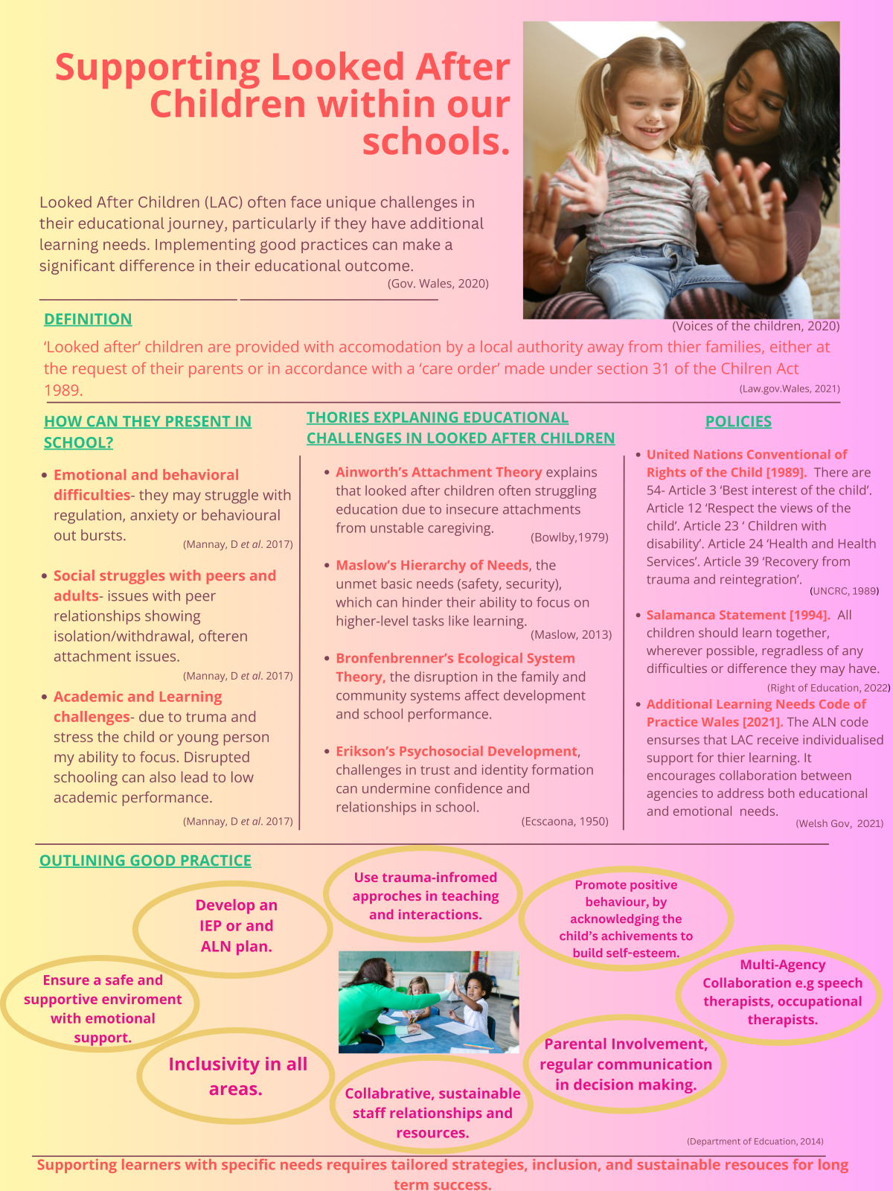

References
Barnes, M. (no date) Classics in the history of psychology -- A. H. Maslow (1943) a theory of human motivation. Available at: https://psychclassics.yorku.ca/Maslow/motivation.htm (Accessed: 29 September 2024).
By, Guy-Evans, O., et al. (2024) Bronfenbrenner’s ecological systems theory, Simply Psychology. Available at: https://www.simplypsychology.org/bronfenbrenner.html (Accessed: 30 September 2024).
By, McLeod, S., et al. (2024) Erikson’s stages of development, Simply Psychology. Available at: https://www.simplypsychology.org/erik-erikson.html (Accessed: 29 September 2024).
Department of Education. for (2024) Send code of practice: 0 to 25 Years, GOV.UK. Available at: https://www.gov.uk/government/publications/send-code-of-practice-0-to-25 (Accessed: 29 September 2024).
Escalona, S. (1951) ‘Childhood and society. Erik H. Erikson. New York: Norton, 1950, Science, 113(2931), pp. 253–253. doi:10.1126/science.113.2931.253.
Macdonald, A. (n.d.). An integrated approach to improving educational outcomes for looked after children in Wales An integrated approach to improving educational outcomes for looked after children in Wales Background and Context. (2020) Available at: https://www.gov.wales/sites/default/files/publications/2020-07/integrated-approach-improving-educational-outcomes-looked-after-children.pdf. (Accessed: 26 September 2024).
Making a difference. Available at: https://www.gov.wales/sites/default/files/publications/2018-11/making-a-difference-a-guide-for-the-designated-person-for-looked-after-children-in-schools.pdf (Accessed: 29 September 2024).
Mannay, D et al. (2017) The consequences of being labelled ‘looked‐after’: Exploring the educational experiences of looked‐after children and young people in Wale. British Educational Research Journal, 43(4), pp.683-699.
Maslow, A. (2013) A Theory of Human Motivation. Connecticut: Martino Fine Books
PDA Education Support Assistance . (2024) PDA Education Support Assistance (Level 6) | Glasgow Clyde College. Available at: https://www.glasgowclyde.ac.uk/courses/578-pda-education-support-assistance-level-6/4138 (Accessed: 28 October 2024).
Responsibilities in respect of children (2021) Responsibilities in respect of children | Law Wales. Available at: https://law.gov.wales/responsibilities-respect-children (Accessed: 26 September 2024).
Social Services and well-being (Wales) act 2014. Available at: https://www.gov.wales/sites/default/files/publications/2019-05/part-6-code-of-practice-looked-after-and-accommodated-children.pdf (Accessed: 27 September 2024).
UNICEF (2021) A summary of the UN Convention on the Rights of the Child. Available at: https://www.unicef.org.uk/wp-content/uploads/2019/10/UNCRC_summary-1_1.pdf (Accessed: 26 September 2024).

Element 2
Essay - Explore the wide and complex spectrum of additional needs
In this essay I shall explore the complexity of Additional Needs. There are two approaches that influence management, education, and care for disability: The Medical Model and The Social Model (Scope, 2022). I will offer contrasting perspectives on how disabilities are perceived and managed. I will aim to highlight the advantages of The Social Model in schools, and link the relationship between legislation, policies, and good school practice. I shall also refer to relevant educational theories, such as those of Maslow (1943) and Skinner (1976).
There is no single definition of Additional Needs. Additional Needs relate to the diversity of individuals within society. It includes a wide range of challenges like vision, hearing impairment, chronic health conditions, or learning difficulties (Karr et al.2022). It can refer to disabilities, disorders, difficult home lives, or behavioural problems. Within educational settings, it encompasses the learner’s social, academic, or physical distinctions from their peers. Whether a student should be 'statemented', is governed by specific criteria outlined in legislation (Education Act, 1996). It has been suggested that there are ‘three conceptions of additional needs include personal, school-based, or environmental factors, non-recognition of underlying factors, or the overlook of self and society’ (Hyman et al.2020, p.1). All children have individual learning needs influenced by various factors, and these additional support needs challenge medical thinking (Paulsrud and Nilholm, 2023). These needs are not limited to specific categories and should be recognised as the right of children to have their personal requirements met (Department of Education, 2015).
The Medical Model is based on the following principles. ‘An impairment, deficiency, or problem located within an individual. It is therefore up to medical science to try and cure or prevent disability’ (Lawson and Beckett, 2021). For example, a person diagnosed with diabetes would be prescribed insulin to manage their blood sugar levels. The main goal being, management of the physical issue, rather than addressing factors like lifestyle or emotional well-being (Wade and Halligan, 2004). The Medical Model has always defined how society supports children with various needs (Lawson and Beckett, 2021), and societies attitudes have shaped the medical model, but this approach has overlooked disabled people's engagement throughout history. Physical rehabilitation is crucial, and medical treatment for impairment remains a necessity (Andrews et al., 2022), but critics argue that it lacks focus on the experience of disabled individuals and reduces people to their impairments. The model's narrow focus perpetuates stigma and low self-esteem. Being labelled as different, can lead to exclusion and limited opportunities (Zaks, 2023). Some believe that the medical model arose due to advances in medical technology and medicine. However, it has been used since Roman times (Mandilara et al, 2023). In conclusion, policymakers and service providers may claim that they comply with the social model of disability, but it is likely that many rely on the medical model, consequently excluding disabled people from full and equal participation in society.
In stark contrast, the Social Model suggests that social and environmental barriers create disability, thereby focusing on changing the environment, rather than rehabilitating the individual (Khayatzadeh-Mahani et al. 2020), reinforcing inclusivity as a fundamental right that needs to be forcefully pursued (Equality Act, 2010). The Social Model aims to identify the barriers within society that excludes individuals, and advocates for social inclusion. This model focuses on social justice, empowerment, and the need for societal change. Schools operate the social model to ensure inclusion for all (Shakespeare, 2006). It challenges non-impaired educators to reflect on their role in creating and perpetuating disability as a problem (Hyman, et al 2020). Many schools adopt the social model, helping to create an inclusive environment that promotes optimal learning and growth by considering additional needs. By including social and environmental influences, schools can better address this issue and provide more comprehensive solutions. A more holistic approach can better meet the needs of individuals who are struggling. Maslow's Hierarchy of Needs (1943) provides a framework for understanding and prioritising the students' needs. It emphasises the importance of meeting basic physiological and safety needs before addressing higher-level needs such as belongingness, esteem, and self-actualisation. By creating an environment within schools, where learners feel included, they will ultimately improve as learners and will become more motivated to achieve higher levels of learning and personal development. Skinner's operant conditional Theory (1938) offers valuable suggestions for addressing challenging behaviours in the classroom. By analysing the precursors, behaviours, and consequences, educators can develop proactive strategies to promote positive behaviour and reduce negative behaviours. Incorporating these principles into educational settings promote a more holistic approach to addressing students' additional needs.
The social model emphasises the need for systemic change in education to ensure equal access and participation for learners with diverse needs. This has implications for policy changes that support and validate students with learning differences. It aims to cater to the specific needs of each learner, while encouraging self-respect and building positive connections. Involving the student in decision-making, can boost participation and add to their general state of wellbeing. Ultimately, it benefits all learners by promoting understanding and admiration for the distinctive differences of everyone. With changing perceptions of additional needs, this model supports inclusivity, diversity, and empowerment, with the ultimate aim of establishing a nurturing and supportive learning atmosphere (Shakespeare, 2006).
School staff must aim to embrace the diversity in human characteristics and learning styles. For example, a learner who has dyslexia could find it challenging to read, the school can provide accessible materials, like audiobooks or voice-to-text- software and use group work where students can contribute in different ways. (E.g., discussing ideas rather than only reading or writing). Additional Needs are regularly mentioned in both legislation, like the ‘Equality Act 2010’, and educational policies, such as the ‘Special Educational Needs and Disability (SEND) Code of Practice 2015’. Schools that adopt the social model are committed to ensuring that their students have equal access to the curriculum and enjoy the social benefits of a personalised and effective learning environment (Barnes & Mercer, 2010). It can begin to remove the various barriers that hinder the learner's participation and ensure equitable access to education (Barnes and Mercer, 2010)
Additional needs are wide ranging and require a multi-faceted approach in supporting each individual. The Medical and Social models of disability offer contrasting views on how disability is perceived and managed, with the social model being more aligned with modern inclusive practices. Flexibility in adopting strategies, interventions, and teaching methods is essential for addressing diverse learners' needs. Personalised learning plans support success in inclusive environments, while differentiated instruction and resources are valuable. Ultimately, learning is a deeply personal journey for every student. It is a search for understanding and meaning, an exploration of knowledge that is intrinsically linked to individual experiences. It is the duty of educators to nurture this journey, to guide and support their learners as they navigate the vast terrain of knowledge.

References
Allan, J. & Youdell, D (2020) Ghostings, materialisations and flows in Britain's special educational needs and disability assemblage. The Education Assemblage. [HTML]
Andrews, E. E. et al. (2022). The evolution of disability language: Choosing terms to describe disability. Disability and health journal. [HTML]https://doi.org/10.1016/j.dhjo.2022.101328
Barnes, C.M. and S (1999) Exploring disability: a sociological introduction. 1st edn. Cambridge: Polity Press:
Department of Education (2015) Special educational needs and disability code of practice: 0 to 25 years. Statutory guidance for organisations which work with and support children and young people who have special educational needs or disabilities. Available at: https://assets.publishing.service.gov.uk/media/5a7dcb85ed915d2ac884d995/SEND_Code_of_Practice_January_2015.pdf (Accessed: 29 September 2024).
Education Act 1996. Available at: https://www.legislation.gov.uk/ukpga/1996/56/contents (Accessed: 8 October 2024).
Hoff. P, Maatz.A and Vetter. J,S (2020) Diagnosis as dialogue: historical and current perspectives , Dialogues in Clinical Neuroscience, 22:1, 27-35, DOI: 10.31887/DCNS.2020.22.1/phoff : https://doi.org/10.31887/DCNS.2020.22.1/phof
Hyman, S.L. et al (2020). Identification, evaluation, and management of children with autism spectrum disorder. Paediatrics, 145(1). [HTML]
Karr, V., Hayes, A. and Hayford, S. (2020) Inclusion of Children with Learning Difficulties in Literacy and Numeracy in Ghana: A Literature Review, International Journal of Disability, Development and Education, 69(5), pp. 1522–1536. DOI: 10.1080/1034912X.2020.1792419.
Khayatzadeh-Mahani, A et al. (2020) Prioritising barriers and solutions to improve employment for persons with developmental disabilities, Disability and Rehabilitation, 42:19, 2696-2706, DOI: 10.1080/09638288.2019.1570356
Lawson, A and Beckett, A. E (2021) The social and human rights models of disability: towards a complementarity thesis, The International Journal of Human Rights, 25(2), pp. 348-379. DOI: 10.1080/13642987.2020.1783533
Maslow, A. (2013) A Theory of Human Motivation. Connecticut: Martino Fine Books
Mandilara, P et al. (2003) A History of Medical Liability: From Ancient Times to Today. Cureus vol. 15(7). Available at https://pmc.ncbi.nlm.nih.gov/articles/PMC10408696/ (Accessed: 8 October 2024).
Paulsrud, D. & Nilholm, C. (2023). Teaching for inclusion–a review of research on the cooperation between regular teachers and special educators in the work with students in need of special support. International Journal of Inclusive Education. tandfonline.com https://www.tandfonline.com/doi/pdf/10.1080/13603116.2020.1846799 (Accessed: 13 October 2024).
Scope (2022) The Social Model of Disability. Available at: https://www.scope.org.uk/about-us/social-model-of-disability/ (Accessed: 9 October 2024).

Shakespeare, T. (2017) Disability: The Basics. 1st edn. London: Routledge.
Skinner, B.F. (1976) About Behaviourism. New Jersey: Random House
UK Government (updated 2016) Definition of disability under the Equality Act. Available
at athttps://www.gov.uk/definition-of-disability-under-equality-act-2010 (Accessed: 30
September 2024).

Wade, D.T and Halligan, P.W (2004) Do biomedical models of illness make for good healthcare systems? BMJ (Clinical research ed.) vol. 329,7479: 1398-401. DOI:10.1136/bmj.329.7479.1398
Waltz, M and Schippers, A (2021) Politically disabled: barriers and facilitating factors affecting people with disabilities in political life within the European Union, Disability & Society, 36:4, 517-540, DOI: 10.1080/09687599.2020.1751075 To lin: https://doi.org/10.1080/09687599.2020.1751075
Zaks, Z. (2023) Changing the medical model of disability to the normalisation model of disability: clarifying the past to create a new future direction’, Disability & Society, pp. 1–28. DOI: 10.1080/09687599.2023.2255926.

Element 3
Explore and summarise the additional learning needs of a pupil using a person centred planning approach.
(Based upon Section 1C IDP : Profile (About me)
and
2A IDP : Description of the child or young person’s additional learning needs (ALN))

Section 1C: Profile (About me)
My name is J, I’m 6 years old and I really like my school. I'm in the LRC and like being around people I feel comfortable and safe with. These are a things that are important to me and for me:
• What is important to the learner?
- I like spending time playing with my friends.
- Greeting everyone in the morning makes me feel more settled when I first arrive.
- I really like dancing to music.
- Consistently seeing Mummy and Daddy. ‘ I don’t live with Mummy and Daddy, so seeing them makes me feel better’.
- Access to the sensory room, when I feel restless and anxious.

• What is important for the learner?
- Routine- I like to know how my day is going to look.
- A multi-sensory and total communication approach to learning.
- Warning when things may need to change in my daily timetable. These changes can be communicated verbally as well as visual alerts.
- Safe and secure home environment and family time, by offering family engagement programs and encouraging parent involvement.

• What is working and should be built on?
- I am happy when I have supported contact with my family.
- My communication and speech has improved. To have continued support from the O.T speech and language program.
- I am becoming more comfortable and making an effort to communicate verbally with friends. Help me by encouraging me to have more social interactions and having more confidence in conversations with people.

• What is not working and needs to change?
- I don’t like it when plans change i.e the school routine and contact with my parents. I need to be given time to process change and transitions- use a timer and now and next cues.
- I struggle to communicate my needs through speech, gesture or sign.
- NDT assessment is taking a long time.

Section 2A: Description of the child or young person’s additional learning needs (ALN)
Cognition and Learning

Communication and Interaction
- J is currently assessed as 3 years behind her chronological age. She exhibits a profile of social communication difficulties that impact on her skills in the following; speech and language, attention and play, social interaction and sensory regulation. Her attention to activities, even those of her own choice is fleeting and does not use toys/ items for their planned function.

- J can become overwhelmed by noises and busy environments along with social interaction. Jane will show signs of restlessness and frustration by rocking herself or displacing objects around her.

- J has limited speech and is reliant on gestures to familiar adults, however she has recently started to progress with her verbal communication since being placed in the LRC.

- J exhibits some autistic traits and is undergoing an NDT assessment.

Sensory and/or Physical

Behaviour, Emotional and social development

Element 4
Discuss the potential support provided to your chosen pupil (utilising the key principles, approaches and policies that guide inclusive practice).
Based upon Section 2B IDP : Description and delivery of the child or young person’s additional learning provision (ALP)

- Section 2B1: Description and delivery of the child or young person’s additional learning provision (ALP)
2B1.1) Intended outcome:  These outcomes should be SMART (Specific, Measurable, Achievable, Realistic,  Timebound). | Will be able to sit in assembly, in the main hall for 5 minutes by the end of the Autumn term.
2B1.2) ALP to be provided:  This should include how often (daily, weekly); the type of support; who provides the support. The description of the Additional Learning Provision (ALP) should be very clear and precise, the above could then be split into smaller goals and targets. |  | 2B1.3) Should the ALP be provided in Welsh? | 2B1.4) Organisation/  Service to provide the ALP, (e.g. NHS, Inclusion Service, Specialist Teacher, etc.): | 2B1.5) Start date: | 2B1.6) End / Review date:
- A fidget toy which is chosen by the learner to take into assembly.  - For the adult to have on their person, noise cancelling headphones, should it be required.  - Sitting in close proximity to a familiar adult whilst in assembly.  - A 5 minute sand timer to take into assembly, which the adult will have on them. |  | No | Gelliswick school staff,  or a familiar adult working in school. | September 2024 | Mid- December  2024
2B1.7) Rationale for the ALP listed above:  If there is a difference of opinion it should be recorded here e.g. a difference of opinion between the child, child’s parent or young  person and professionals. The section could explain how different opinions have been taken into consideration before a particular decision was reached. |  | No
Section 2B2: Description and delivery of the child or young person’s additional learning provision (ALP)
2B2.1) Intended outcome:  These outcomes should be SMART (Specific, Measurable, Achievable, Realistic,  Timebound). | Once a week she will work with a small group of 3, to engage and contribute to the group learning task, for 10 minutes during Literacy, by the end of the Autumn term.
2B2.2) ALP to be provided:  This should include how often (daily, weekly); the type of support; who provides the support. The description of the Additional Learning Provision (ALP) should be very clear and precise, the above could then be split into smaller goals and targets. |  | 2B2.3) Should the ALP be provided in Welsh? | 2B2.4) Organisation/  Service to provide the ALP, (e.g. NHS, Inclusion Service, Specialist Teacher, etc.): | 2B2.5) Start date: | 2B2.6) End / Review date:
- Provide a visual now and next timetable so that she is aware of the learning task that needs to be completed..  - Is able to sit next to the adult who is carrying out the learning task.  - Being given a designated task/ job within the group.  - To have a 10 minute sand timer within sight. |  | No | Gelliswick school staff,  The class teacher/ LSA or a familiar adult working in the school. | September 2024 | Mid- December 2024
2B2.7) Rationale for the ALP listed above:  If there is a difference of opinion it should be recorded here e.g. a difference of opinion between the child, child’s parent or young  person and professionals. The section could explain how different opinions have been taken into consideration before a particular decision was reached. |  | No
Section 2B3: Description and delivery of the child or young person’s additional learning provision (ALP)
2B3.1) Intended outcome:  These outcomes should be SMART (Specific, Measurable, Achievable, Realistic,  Timebound). | Will be able to smoothly transition from arriving at school, putting their belongings away and starting their chosen settling in activity. Then, put away activity (with support, if required) on request, to sit on the carpet for morning registration by the end of the Autumn term.
2B3.2) ALP to be provided:  This should include how often (daily, weekly); the type of support; who provides the support. The description of the Additional Learning Provision (ALP) should be very clear and precise, the above could then be split into smaller goals and targets. |  | 2B3.3) Should the ALP be provided in Welsh? | 2B3.4) Organisation/  Service to provide the ALP, (e.g. NHS, Inclusion Service, Specialist Teacher, etc.): | 2B3.5) Start date: | 2B3.6) End / Review date:
- Being met on arrival by a familiar member of school staff.  - Have a calming starter activity task chosen by her to have each morning when she arrives in school.  - A visual timetable to understand the sequence of activities.  - Use consistent cues and prompts to indicate it’s time to sit on the carpet for registration. |  | No | Gelliswick school staff  or a familiar adult. | September 2024 | Mid- December 2024
2B3.7) Rationale for the ALP listed above:  If there is a difference of opinion it should be recorded here e.g. a difference of opinion between the child, child’s parent or young  person and professionals. The section could explain how different opinions have been taken into consideration before a particular decision was reached. |  | No
Section 2B4: Description and delivery of the child or young person’s additional learning provision (ALP)
2B4.1) Intended outcome:  These outcomes should be SMART (Specific, Measurable, Achievable, Realistic,  Timebound). | Will be able to use 20 simple signs to communicate my wants and needs- food/ more/help/playtime/dinner by the end of Autumn term.
2B4.2) ALP to be provided:  This should include how often (daily, weekly); the type of support; who provides the support. The description of the Additional Learning Provision (ALP) should be very clear and precise, the above could then be split into smaller goals and targets. |  | 2B4.3) Should the ALP be provided in Welsh? | 2B4.4) Organisation/  Service to provide the ALP, (e.g. NHS, Inclusion Service, Specialist Teacher, etc.): | 2B4.5) Start date: | 2B4.6) End / Review date:
- Provide language and speech models. (e.g ‘b’ is ball) supplemented with a sign.  - Use visual supports alongside spoken language e.g objects of reference and sign to support daily routine.  - simplify language and avoid long instruction.  - Provide opportunities to initiate communication/interaction into the school day. |  | No | O.T speech and Language, Gelliswick school staff,  The class teacher/ LSA or a familiar adult. | September 2024 | Mid- December 2024
2B4.7) Rationale for the ALP listed above:  If there is a difference of opinion it should be recorded here e.g. a difference of opinion between the child, child’s parent or young  person and professionals. The section could explain how different opinions have been taken into consideration before a particular decision was reached. |  | No

