Critical analysis of management theories relevant to the work place
Submission date 3/5/19
Syeda Savannah Davies
1710300

Executive summary
This report has been compiled in order to critically evaluate the difference in management theories and models used in current places of work. It will include research into the pros and cons of the models in today’s society. The researcher will discuss and evaluate the impact certain management theory’s have on the organisation and its employees.
The authors chosen organisation of research management theories is Marie curie nursing services; the research should identify the performance of managers and employees. It will look at the impact of the authors own beliefs against the organisations attitudes, values and beliefs and how this can affect or influence the employees performance within a business. Research will then identify are value led organisations more successful.

Contents page
- Cover page

- Executive summary

- Contents

- Terms of reference/ procedure

5, 6, 7, 8, 9, 10, 11, 12, 13, 14 Findings

15. Conclusion/ recommendations

16, 17, Reference list

Terms of reference
Marie curie nursing services have requested a report on the 3/5/19 from Syeda savannah Davies to research and critically evaluate management issues within the organisation, it will look closely at the attitudes behaviours of the managers and the performance of the employees, The researcher will therefore need to offer solutions and recommendations to overcome any identified barriers in the organisation to help meet its objectives and meet the needs of its employees.

Procedure
In this report the researcher will identify, discuss and research the impact of management theory’s within a chosen organisation, the researcher will source the evidence from a gathering of textbooks, journals, university library resources, online journals, moodle and professional websites.

Findings
Critical thinking means, don’t accept things that you see here or are told before asking questions. Critical thinkers ask for evidence and good reason before they can evaluate and make a decision. It is important to ask and answer questions systematically to make a credible story. Critical thinking can however be seen as negative and destructive, when being used for academic purpose the aim is to researcher deeper into what is being said, investigate the relevance, look at the strengths and weaknesses of an argument, is it appropriate, give reasons and draw conclusions, this research should then find the closest possible truth.
Questions that are often asked in critical thinking, what, who, when, where, how, what if, why, and what next, when you are able to achieve an answer from systematically questioning it can then be pieced together for study in the form of the description, analysis and evaluation.
Stephen Toulmin recognised that intelligent and realistic arguments usually follow six parts. These are his terms to describe each section.
- Data 2. Claim 3. Warrants 4. Qualifiers 5. Rebuttals 6.Backing.
Toulmin’s model can be used for analysing arguments, as this was its original purpose; however it might be used in study as a basis for structure and organization.
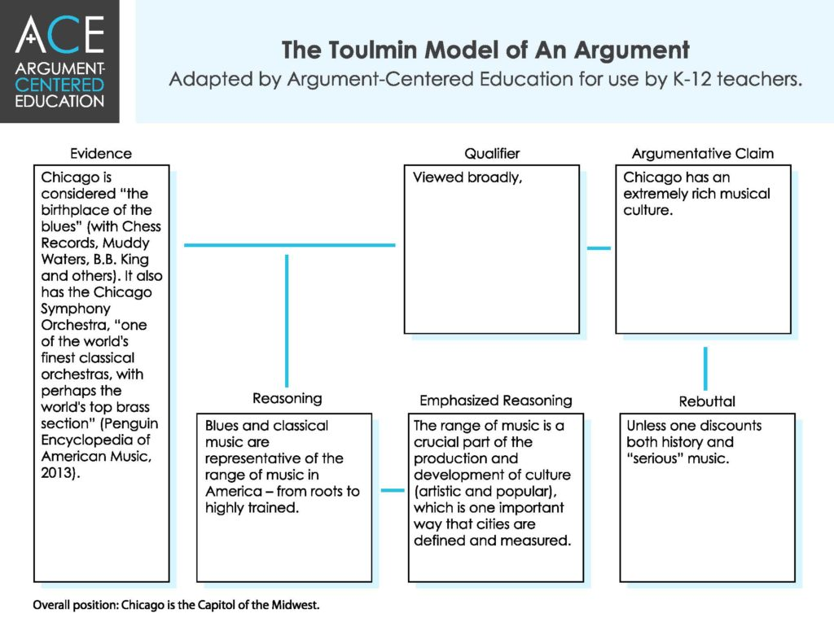
Management theory is a gathering of ideas that set out general guide lines on how to manage an organization. Management theories identify how managers and supervisors relate to their employees and the organization in the way of meeting its aims and objectives. It shows ways of implementing effective means to achieve the goals set and looks at how to motivate employees to perform to the best of their abilities.
Management Theories Originated from the mass production and the Industrial Revolution, it brought about new requirements for managing large groups of employees and manage the manufacturing processes. When organisations began to grow in size and production, business owners increasingly relied upon managers to run the daily operations of their organisation. Before the Industrial Revolution, very few organizations and militaries required any theories for management. It was only the result of expanding industry that the practice of management became a major theoretical consideration in the study of business. Managers are vital for organisations they are motivated, responsible for making decisions, allocating resources or negotiating deals. Management theories have been developed and used since they became a standard part of business practices and while some older theories still hold relevant, new theories are continuously being developed to keep up with current trends in organisations. As we are aware the workplace has transformed dramatically overtime and from when the first management theories were conceived, therefore modern management is not a one-size-fits-all practice, it is better to research a deeper understanding of management theories and their applications.

There are four main classifications for management theories
- Scientific management
- Classical Management Theory
- Behavioural Management Theory
- Modern Management Theory

These four classifications represent a different time in the evolution for management theories. Each of these categories usually further involves multiple sub-theories. Max weber, Henry Fail and Fredrick Taylor have all researched and published their thoughts and uses of classical management theory. However these classical theorise don’t work in all organisations, face book and Google are very different organisations compared to the mass production industry’s that were around in this era that research was carried out in. Classical Management Theory focuses more on the execution and maximizing production, this doesn’t apply to large online organisations as they are not mass producing a tangible product. Google do however participate in Behavioural Management Theory as it focuses on human elements and a social environment they push decision-making authority away from managers and delegate it to individuals or teams. Google believes this increases autonomy, offers more learning and growth opportunities, and allows teams to self-organize and make their own decisions. The employees find this empowering. Elton Mayo (The Hawthorne studies) - recognised that employees have social needs as well as physical needs, and managers need a mix of managerial skills that include human relations skills. Modern Management Theory builds on the previous two theories, while incorporating modern scientific methods.

Steven.R. coveys research in to the 7 habits of a highly effective people is a modern management theory that looks at an individual’s attitude towards their own goals and objectives.
“Habit 1: Be Proactive
Habit 2: Begin with the End in Mind
Habit 3: Put First Things First
Habit 4: Think Win/Win
Habit 5: Seek First to Understand, Then to Be Understood
Habit 6: Synergise
Habit 7: Sharpen the Saw”

Frederick.w.taylor stated that scientific management is the systematic training of workers in “the one best practice” rather than allowing them personal discretion in their tasks. Their workload is evenly shared between the workers and management with management performing the science and instruction and the workers performing the labor, but each group is organized with the jobs that best suit their skills set.

Selecting a management theory that is effective for an organisation can be tricky, it is vital to consider all the factors as each theory provides valuable insight into what managerial requirements you are looking for in your organisation. Not all models or theories will work for an organization; multiple modern organizations apply a combination of theories to achieve organisational success. This has led to the creation of newer models with less structured hierarchies. Unlike face book and Google smaller businesses are less rigidly hierarchical and operate with minimal staff. Therefore you have to select a management theory that is sustainable, especially if business resources are limited.

The Bartel AMO theory (2004) suggests employees perform well and use their own discretion when they have the ability, appropriate skills and knowledge and are motivated either by reward, recognition, training or flexible working hours, they have to be given opportunities, to demonstrate their skills and voice their knowledge, expertise and ideas.

The organisation HSBC uses this theory as they provide a wide range of support to help employees improve their skill set and achieve their professional career goals. HSBC recognise that acknowledging employees talents, choosing diversity in their staff choices and offering rewards is the foundation of their success, the organisation is committed to helping develop employees personal and professional skills in order to bring out their strengths which in turn contributes to the overall success of the organisation.
The authors chosen organisation Marie curie nursing service incorporates the Douglas McGregor management theory style.
Marie curies organisation is charity that offer help and support to patients and their families living with a terminal illness. They offer nursing staff to patients in their own homes to help achieve the best quality of life, and support to keep the patience independence and dignity for as long as possible. The nurses and staff are trained in treating and managing pain, with medicines, therapies and other specialist approaches, whilst providing emotional support when they need it most.

Theory X and Y was created in the 1960s, by a social psychologist Douglas McGregor he developed two contrasting theories that explained how a managers' beliefs about what motivates their employees can affect their management style. They are labelled Theory X and Theory Y.
Carson 2005 states that McGregor’s theory is influenced by Maslow’s theory of needs, according to Maslow theory X only covered lower order needs and theory Y covered the higher needs, the only disadvantage to this is that once the lower level of needs have been met, they are no longer required. His book identified manager’s characteristics in managing employees with theory X and theory Y. His beliefs where those managers in the theory X category found employees to be dissatisfied, lazy and unmotivated, they were found to need more control and crave purpose. However McGregor states that managers in theory Y believed that employees where self disciplined, self driven, happy and have a sense of direction and purpose.
Theory X and Y have been served as a bench mark in relationship management in the 20th century. These theories continue to be important even today in many different organisations.

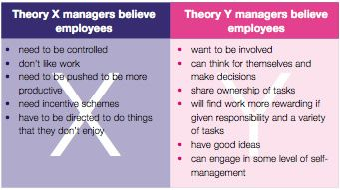
frontlinemanagementexperts.wordpress.com
Douglas McGregor believes theory Y hold more validity than theory X, very few organisations currently use theory X as it requires more controlled supervision and monitoring which is time consuming for companies. When people lack motivation, they are less productive and more likely to leave increasing company costs of finding replacements. However theory Y is more widely used in organisations as more managers are encouraging employees to take the lead and use their own initiative and become self motivated to meet the company’s objectives. The disadvantages of using theory Y is that you cannot create a working environment that suites every one, as individuals have varying learning styles and are motivated by different rewards. Theory X also has its flaws as staff can be punished for not meeting targets i.e. suspension, no bonus, pay dock. This could have a drastic affect on how an employee feels about the employer and can permanently damage their psychological contract between them, making production decline further, however having received feedback on performance may encourage staff to make more of an effort.

Theory x is also visible in a positive attitude when looking at Marie curies incentive schemes; these are used to motivate and reward their employees. Annual leave entitlement of at least 25 days (excluding bank holidays), rising to 28 days after five years’ service and 31 days after 10 years’ service.

Life assurance Members of the pension scheme while employed at Marie Curie could be eligible for life assurance.

Help getting to work with interest-free loans on rail season tickets, new bikes and satnav systems.

Computer loan After six months you’ll be eligible to apply for an interest free loan to buy a computer.

Continuing education External training that’s relevant to your career, they offer financial support. Study leave may also be granted in some circumstances.
- flexible working
- employee self service to update personal details and book annual leave
- roaming working
- introduce a friend scheme
- free Will–writing service
A psychological contract emphasises the relationship between employers and workers is more than just a transaction regulated by a legal contract. As in any relationship, both parties have informal expectations of each other that – although unwritten – can significantly affect the length and quality of their relationship and production.

Marie curie believes nothing is more important than a strong productive team that are confident in their role. They have dedicated Clinical Nurse Mangers in each area of the Region ensure ring that all staff are clear about their own roles and responsibilities and have appropriate support. These managers are responsible for regularly reviewing performance and identifying on-going training and development needs via Marie Curie’s Personal Performance Review and Development (PPRD) process. Individual training plans ensure that skills and competency levels required to deliver the services are maintained and developed. They believe putting in a reward system of yearly bonuses, giving opportunities of promotions and supporting staff with their own individual PDP increases productivity and motivation in the organisation, leaving the employees feeling that they are an integral part of the team and satisfied in their current job role. They feel that if the effort is recognised and we can see the benefit of their work they are more inclined to get behind your way of thinking. With nearly half of the employees being client facing they need to have happy confident staff that are happy to help, if staff believe that Marie curie invest in their future, this will show in their work performance. Regular monthly meetings are also an opportunity to thank staff, recognise and appreciate them for their hard work, listen to their ideas and offer feedback; this helps the employees to feel valued. This all falls in to the category of theory Y however Marie curie do use theory X in their management style it is not because staff are lazy or unmotivated it because the NHS takes a different approach to management as they must ensure that staff have the appropriate skills and knowledge they need to carry out their roles safely and effectively. Very few sectors find it is it as important that employees know how to keep themselves and their patients safe. And as a result of this, statutory and mandatory training will be found in every NHS organisation, department and workplace, with ongoing supervision and strict guidelines to be followed, it is not a lack of trust in their employees, these guidelines are there to protect staff. Marie curie offers all staff an employee handbook that contains all of their policies and procedures, these may appear constricting but these are the guidelines set out for nursing.

Marie curie nursing services attitudes values and beliefs

Values are stable long-lasting beliefs about what is important to a person. They become standards by which people order their lives and make their choices. A belief will develop into a value when the person's commitment to it grows and they see it as being important.

Beliefs and attitudes

The charity strives to provide a better life for people and their families living with a terminal illness by ensuring that families and patients

Are listened to Supported Are seen as individuals

Values Always compassionate Connecting and empathising with people starting with the person's needs, respecting them and treating them with dignity Supporting people's choices and decisions

Making things happen Being clear and straightforward Listening so that we can understand and do the right thing prepared to speak up and challenge on people's behalf

Leading in our field Building on our unique skills, expertise and experience sharing, innovating and partnering Always seeking to improve in everything we do

People at our heart Valuing every individual all views and expectations are heard and respected Bringing people together and building relationships

THE BARRETT MODEL
The Seven Levels Model describes the evolutionary development of human consciousness it was developed in 1996–1997. The two aspects to the model, the Seven Levels of Consciousness® Model and the Seven Stages of Psychological Development Model, They believe that we operate at levels of consciousness and that we grow in stages these seven stages of psychological development.

Values are a reflection of what is important to us. They are a way of describing our individual and collective motivations. Together with beliefs, they are the causal factors that drive our decision-making and motivation to grow. They show who we are, what you hold dear, what upsets you and what underlies your decisions are all connected to your values. The values that you hold dear now are a reflection of our current needs and our unmet needs from the past. Often some of our values change priority as we move through the different stages of psychological development; other values stay the same. Values can be positive or potentially limiting.
The author has undertaken the Barrett values test online and the results are as follows.
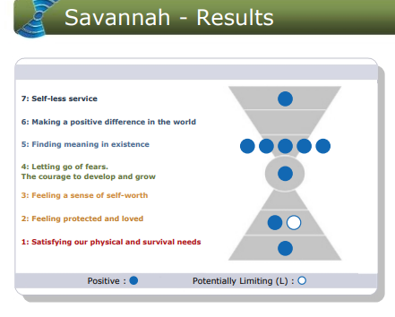

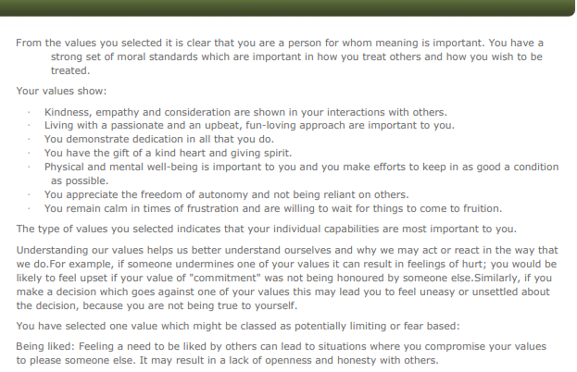

The author has found that many of their personal values and beliefs are in line with Marie curies, having empathy and showing kindness towards patients is essential, the author is currently employed by Marie curie, having now understood how their own beliefs and values has improved their self awareness and understanding of how happy they are with their current role. Sharing the same values are the basis of a relationship and it makes seeing the company’s vision and objectives far easier. It gives life meaningful significance; in turn this improves self motivation, strengthens the physiological contract and makes us more aware of our conscious choices. Knowing our own values makes us more tolerant of others, this helps improve overall team work within the organisation.

Conclusion
The author concludes that the Douglas McGregor theory works effectively within Marie curies organisation, however having to follow such strict rules and regulations can have a negative impact on their employees as they sometimes feel restricted and not trusted leading to low staff morale at time this is why the incentive schemes have been put in to place, to reward the staff for their hard work. Putting people first is one of Marie curies strongest values, this means there patients and employees are always their main focus, making them a great organisation to work for; they value the input of staff, leaving them feeling a sense of significance and purpose in their role. They have created a positive, safe and healthy environment for employees to work in, this has increase morale, improved employees work-life balance and, in turn has positively affected the organisation as a whole and produced a happy, healthy workforce, which intern has prevented long term absence saving the organisation money. The author has found that everyone has different values, beliefs and preferences and what one believes in, and what you may see as acceptable or desirable is an essential part of who you are. It affects the way in which you respond to people and organisations, if you share a value or belief that interests you it will create a positive attitude with those that also feel the same and less warmly to people who have different attitudes values and beliefs. Professional relationships you develop with people are more likely to last if you can support and understand their vision.
Recommendations
The author recommends that Marie curie may benefit from incorporating some of Maslow’s hierarchy of needs theory as there is not much scope for higher promotions; this can have a negative impact if employees feel they cannot grow and improve. They could also try job rotation as this is not currently used within the organisation, it would give staff a chance to use and improve their skill set and help to keep them engaged and motivated.

Reference list
1. Cottrell, S. (2005) Critical thinking skills Basingstoke: Palgrave Macmillan
2. Cottrell, S. (2008) the study skills handbook. Basingstoke: Palgrave Macmillan
3. http://www.selfawareness.org.uk (accessed 10/4/19)
4. https://www.mariecurie.org.uk (accessed 11/4/19)
a. Marie curie intranet.
b. Marie curies policy’s and procedure booklet.
5. Armstrong ,m. (2016) Armstrong’s handbook of management and leadership for HR : developing effective people skills for better leadership and management.https://www-dawsonera-com.ezproxy.uwtsd.ac.uk/readonline (accessed 30.04.19)
6. https://www.virtual-college.co.uk/news/healthcare/2018 (accessed 11/4/19)
7. Murton et al (2010) unlocking human resource management, London: Hodder Education p181
8. ARMSTRONG, M. & BARON, A. (2004) Managing performance: performance management in action. London: Chartered Institute of Personnel & Development
9. https://academics.umw.edu/speaking/resources/handouts/toulmin-argument-model (accessed 14/4/19)
10. GILLEN, T. (2007) Performance management and appraisal, CIPD toolkit, 2nd ed. London: Chartered Institute of Personnel & Development
11. https://www.virtual-college.co.uk/news/healthcare/2018/11/importance-of-mandatory-and-statutory-training-in-the-nhs (accessed 13/4/19)
12. Read more: http://www.businessdictionary.com/definition/management-theory.html (accessed 15/4.19)
13. https://smallbusiness.chron.com/management-theories-concepts-workplace-17693.html (accessed 14/4/19)
14. https://www.inc.com/marcel-schwantes/googles-insane-approach-to-management-could-transform-your-company.html (accessed 16/4/19)
15. Steven R, Covey 1st edition (2016)
16. Paul Grise (2002) Management knowlege, : palgrave mcmillan.
17. https://www.hsbc.com/careers/life-at-hsbc/career-development (accessed 1/5/19)
18. Paul Griseri (2002) management knowledge, Great Britain: Palgrave
19. Carson, C.M. (2005). A historical view of Douglas McGregor’s Theory Y, Management Decision, 43(3), PP. 450-460.
20. Maslow, A. H. (1987). Motivation and personality (3rd ed.). Delhi, India: Pearson Education.
21. Frontlinemanagementexperts.wordpress.com (accessed 29/04/19)
22. Carolyn Wiley, (1977) “what motivates employees according to over 40 years of motivation surveys”, international journal of manpower, vol. 18 issue: 3, pp.263-280
23. Armstrong, M. (2016) Armstrong’s Handbook of management and leadership for HR. 4th ED.
24.www.cipd.co.uk/knowledge/fundamentals/relations/employees/psychological-factsheet (accessed 1/5/19)
25. Barrett values centre https://www.valuescentre.com
26. https://www.mariecurie.org.uk/jobs/working-for-marie-curie (accessed 2/5/19)
27. https://www.bartleby.com/essay/How-My-Own-Values-Beliefs-and-Personal-P3CQMJFJVJ (accessed 27/4/19)

