University of Wales Saint Trinity David

Kamrul Ahmed
Effective Team Working and Communication
Anupam Mazumdar
BMSK4002-LON)

Table of contents

- Introduction
- Communication
- Verbal communication
- None verbal communication
- Written communication
- Body languages
- Eye contact
- Shannon weaver model communication
- Berol’s module communication
- Things need to improve with communication within the work place
- Conclusions/summaries
- References

Introduction
In this assignment the purpose is to talk about the experience within the work place it can be mine or a friend of mine, but I will talk about my own experience in my work place. Some of the things I will be talking about are the following communication, verbal communication, none verbal communication and many more that just few of the things I will be talking about in my work place, but I will mention them later on this assignment.

Communication within my work place
Communication is when I exchange information verbal, or none verbal communication within the company where I work for such as Indian Restaurant and during the working hours work where I exchange information from one colleague to another colleagues of mine at my work place. In my work place where I used communication, none verbal communication, verbal communication, body languages, eye contact to communicate with them so that I may understand them better and co-operate with each other while we at work, these are the few things that I am going to talk about in this assignment. In my work place work place I used communication, none verbal, eye contact to talk to customers or consumers or to my colleagues in order to understand better and get to work better and also as I said I used communication to talk to customers or consumers to make them happy about the service and how was the foods and are the happy with it. Also, there are many ways to communicate such social media for example Facebook, because lots of people used social media to talk to their families and friends.
The ability to communicate effectively with families, friends, colleagues and staff and no matter what industry you work in weather is a restaurant or company. Workers in the digital age must know how to effectively convey and receive messages in person as well as via phone, email, and social media.

Verbal communication
Verbal communication is created through languages, also effective verbal communication involves accurate interpretation of others like sharing information between two people such as speech. The individuals work for a company or a restaurant for should effectively use verbal communication that employs to understand well spoken words rather than mumbling words, or well as ensuring that the speech, stress and tone of your voice which the words is expressed as appropriate to say it in front of other people. Many companies, restaurant use their memos way to communicate with consumers and workers, but as large company manages to use verbal communication better at resolving problems or conflict. You need to be use strong verbal communication if you want to or able to able to apply for a big company in the future. A good verbal communication with each other and you could be able to tell how one was doing and you can tell that person to or how to improve on his/her verbal communication.

None-verbal Communication
Your none-verbal communication cues the way you listen, talk, look, move, reacted to tell the other person you’re communicating with whether you care, if you’re being truthful, and how well you’re listening to that person. If you want to become a better with communication but not just your body languages to others as well yourself. Key success in both personal and professional lies in your ability to communicate with others, not just using words your none-verbal cues or the body languages that speaks the loudest. Your facial expressions, gestures, tone of voice and eye contact are important for the place you work for because its powerful communication tools that you can use during work time. This built a trust and draw you towards other people, by improving how you can understand you none-verbal communication and how can you express really means and connect with others better.
None-verbal often carries out more information than a speech and has a great impact on understand and trust. To learn none-verbal signals you also need to present yourself as well, you have none-standards body’s languages, for example if you on autism spectrum or physically disability, you have found way to avoided it or correcting misunderstanding.
None-verbal communication for an example….
- Facial express
- Body movement/body languages/posture
- Eye contact/Touch

Written communication
Written communication involves any types of messages that use written words for example sending an Email, text, or letters to anyone. Written communication is so important and most effective for any types of business whether its retails or a restaurant because you still need to use written communication whoever you may be and it’s important for your business. Some of the various forms of communication used for businesses operation such memos. There are two types of communication such as oral communication and written communication.
Written communicating through writing is essential in the modern world because we use this for the business and there are many ways to communicate through social media even for the businesses. The fact that, written communication is the most common form of business communications because you can use it for your business such as retails or restaurant.
The information has changed the ways we communicate with each other and placed an increasing importance on written of oral’s and written communications.
Written communication that are used in the business’s operations including….
- Memos
- Reporters
- Emails

Advantage and disadvantage for any types of businesses weather is a restaurant or retails.
Some of the advantages of written communication….
- No need for the personal contacts, you can Email a colleague to work overtime instead of face to face
- Save money on distances calls by sending an Email or message to that person
- Written proof-provides written proofs in case of disagreement or debate between you and another person
Here are some of the disadvantage of written communication are….
- Lack of secrecy because if you write on the paper, anyone can see it or read it
- Delay in communication, this may take a while to get to expected receiver
- Cost, if the sender and the receiver are sitting near each other, they will spend some money on the paper, foods and internet services
Some of the various of written communication, the advantage to the business owners and how they can avoid being lack of written communication or oral communication, this is good for any types of businesses because soon they know what to avoid and what to follow in the future.

Body languages
The body languages are the way we move around and use our postures and feeling like for example our hands, legs and body to communicate through our body languages movements. Body languages also refers as none-verbal communications that we use to communicate, these none-verbal communications make signals make ups a huge parts impacts of daily communication. For an example our face facial expressions to our body movements and the things we don’t say or convey volumes of information.
Our body languages also use of physical behaviour expressions and to communicate none-verbal, which often done instinctively rather than consciously, which you may not be aware of it when you interact with others, yet despite that you continuing to give and to receive wordless signals. Even though you may not be talking louds or gestures you make or how fast you speak or how you sit that doesn’t matter because you still communicating none-verbally even if you are silent.
The body languages has two different things like for example if use one thing and your body languages say another or something entirely different things, like you are being dishonest and say yes while shaking your head meaning no, you’re not interesting.
Some of various forms of body languages including the following ….
- Happiness
- Sadness
- Confused
Some of the body languages mistakes….
- Looking down
- Slouching
- Distraction

Eye contact
Eye contact is when people are looking at each other’s eye at the same time while talking to each other. We as human being use eye contact is a form of communicating and none-verbally, where it has large influence on our social behaviours. This was in mid 1960s from the West, often to define as meaningful and important because this was consider as being respectful and confidence in the 1960s, but in the modern days as todays we use as to communicate with other people and to respect the people we meet. Nowadays people use eye contact during an interview or other things like for example if you in school your teacher will use eye contact to talk to the pupils.
Eye contact is so important because you use it more often with your friends, families, teachers and many more, for example if you go to an job interview he/she has to use eye contact and the person who may be doing the interview that person will look at your eye contact to see how well you do during an interview. You may think that eye contact is not important then let me I assure you it is but not just eye contact even facial expressions which provide social and emotionally information with people without being consciously doing so, to check your eyes or faces for positives or negative signs for example it could be your mood. Overall, I think eye contact is important for your life because you may not know when to use it or as I said you can use it during an interview.

Shannon weaver model communication
The Shannon weaver model communication was developed during the 1948. This model of Shannon was designed and to developed effective communication between the sender and the receiver and to find out the factors of affecting communication was noise, but they want to develop to improve the technical communication but unfortunately didn’t go how they wanted to but instead applied in the field of communication. This type of model deals with the various concepts like for example information sources, transmitter, noise, channel, place of destination, encoded, decoded and the receiver. As you can see on the chart how they are lay out to see how the message go through to another person and how they received.
Sender: is the discoverer of messages and information sources
Encoder: is the transmitter that converts the messages into signals
Note: the person who sends the messages into converted into signals like waves or binary data which compactable to transmit the messages through satellite or cables.
Receiver: is the aims of the messages from the sender
Noise: is the messages are transferred from the encoder to decoder through a channel, during this process the messages will be distracted by physical noise like horn sounds for example.
This is telling us that the model is clearly dealing with external noises which affect the messages and signal from the external sources, for example if there were any problems with the network where you cannot send any types of messages or Email.
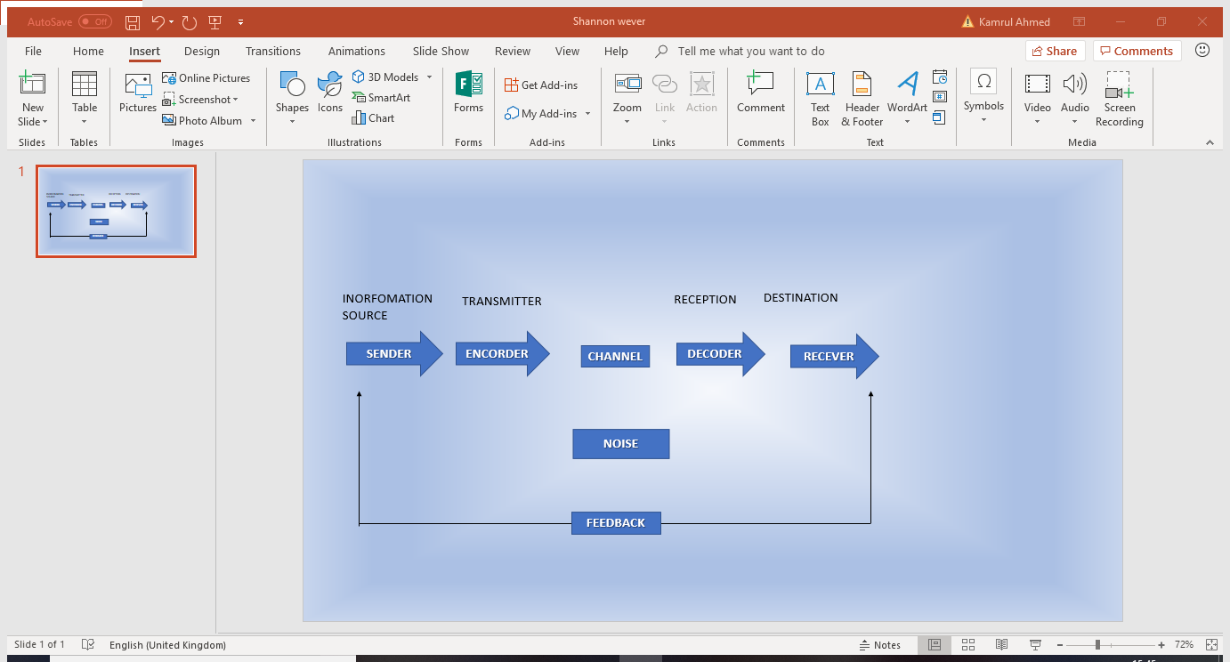
This is a Shannon weaver communication model

Seven elements of communications
- Sender
- Ideas
- Encoding
- channel
- Receiver
- Decoding
- Feed back

Berol’s model communication
This model was designed in 1960s. Berol sender message, channel-receiver (SMCR) model of communication from the Shannon Weaver Model of communication in 1949. David described the factors affecting the individual’s components in the communication making more efficient. Model focuses on the encoding and decoding which happens to before the sender sends the messages and before the receiver received the messages. Berol’s model communication has four components to describe the communication process, there are the sender, message, channel, and receiver and each of this component is affected by many factors.



Things need to improve with communication within the work place
Well things I need to improve is team working because I don’t use team working while I am working because I like to do things my way so therefore, I was being naïve not working in a team while I am at work. Of course, I need to improve that so therefore past for weeks I became good at working as team and manging somehow. Now is that my team working is improving which makes me happy because that the only thing I needed to improve during my hours of work, now that out of the way I can relax because I achieved the one thing needed to be improved which I have done now.

Conclusions/summaries
This is inconclusions of this assessment are the following for example introduction, communication, none-verbal communication, verbal-communication, written communication, body languages, eye contact, Shannon weaver model communication, Berol’s model communication also conclusions and references. References is there because we need to know where we got the information from. Just to summaries of all the things I that did in this assessment and the information where I got them from.

References
You will find all this online if you click the web below you…
https://www.thebalancecareers.com/communication-skills-list-2063779
https://study.com/academy/lesson/what-is-written-communication-in-business-definition-types-examples.html
https://www.verywellmind.com/understand-body-language-and-facial-expressions-4147228
available (online2018) at
https://en.wikipedia.org/wiki/Eye_contact
https://www.communicationtheory.org/shannon-and-weaver-model-of-communication/
https://www.businesstopia.net/communication/berlo-model-communication

