REPORT ON DESIGN AND IMPLEMENTATION OF SMART HOME ENERGY SOLUTION FOR HOME
Name: Said Ahmed, ID Number: P150856, Programme: BSc (Hons) Computing Portfolio, Assignment Title: Internet of Things – Smart Cities Applications
Lecturer: Dr Mabrouka Abuhmida, Internal Verifier: Prof John Rees, Module: Smart and connected devices 2, Submission Deadline: 13/12/2019
ABSTRACT
This report presents the design and implementation of smart energy solution for home, it identifies the proper solution for the smart home, explained in brief about smart home with smart energy as well, it mentioned about internet of things that now is the popular technology in the world. It explains how the smart energy is useful and will be needed in the future to be installed to each house in the world together with the design and result according of the design used.

INTRODUCTION
The aim of this report is to research Internet of Things based on Smart energy solutions for the home and its simulation or practical development of a demonstrator, so this will include and explain three different types of sensors and outlines briefly how would be useful for the monitoring task of each sensor in a saving energy.
Also, to explain the design and implementation of Smart home energy by using the Arduino equipment, including temperature, motion and light sensor for the design and build a typical IoT monitoring system for the wireless sensor network. This includes the documentation for the choice of components, an explanation of the design, with the results obtained.

INTERNET OF THINGS (IoT)
The future of communication and computing represents by revolution of technology of the Internet of Things, and IoT makes the fastest growth of innovational technologies to the world of technology, connected a lot of devices already and more of different devices will be connecting in the coming days, this system link with the computer devices that either human or mechanical objects with the understanding to transfer data through the system network without needing human to human or interaction of computer.
The one biggest development of the Internet of Things is creating the information world and physical world together [1]. Sensors is the most important things to bridge gap between information world and physical world, sensors works to collect data from environment, creating information raising awareness for context [1]. That helps the changes of the environment to be monitored, and if needed can make some responses for the related things [1].
The author from this paper, tried to explain the general meaning of Internet of Things by designing and implement different sensor for the smart energy that based on energy saving at home, that sensor helps to communicates with the devices through the internet for the purpose of the best solution of saving energy and reduce the cost.

SMART HOME
The author explained Smart Home is to create the surrounding environment of the home fully automated and comfortable by linking sensors, electronic devices and home appliances through either wireless or wired connection [2]. The device of Smart home such as smart home sensors that’s used to monitor indoor and outdoor environment, for example humidity and temperature, smoke detectors, motion and light sensor, and many more. The other device includes door locks, TV sets and IP camera [2]. Over a total smart home solution that involves all devices of smart home, customers will be provided with a helpful guide information on how ease to use and makes to them useful for the daily smart home routine [2].
Other source explained the problem in a smart home is the user can how connect remotely and get the access to a control network of smart home [3]. But this can be solved by uses of one of the two method, either a service of web-based for the data sharing with the special management station through the Internet by the remote site or the second one can be a programming application to the mobile cellular for monitoring the all wireless sensors network devices attached through the network [3].
At the future, Smart home will be everywhere, and each house will be connected, this will make the house much safer and easy to monitor or track and know what’s going on. But thing can make Smart home more convenient is to use the renewable energy such as solar panel for solar energy, that can make a home a self-sustaining by programming using own energy and use extra in case of needed.

SMART ENERGY
The author mentioned a smart energy in a smart meter technology is an intelligent device that optimize, records, and communicate automatically. As well communicates with the control system and remote Utility Monitoring and improves its tariff with the demand and fluctuating supply [4]. Some of the benefits is helps reduce emissions and to save money, it gives the good management of the energy use, the energy bill read is the actually the energy used [4], so for the smart energy the meter play a huge rule for the monitoring the customer usage and gives a peace of mind as well.
Also, the author looked in smart lighting for the smart energy with the sensors built on it and communication system that adjusts automatically its luminance for the dimmers and time set and it also cohesive with the system of smart Building Energy Management for data optimization and exchange [4]. The way controlled is remotely through wireless control unit and through the system of smart energy management. The single remote control has the ability to control different wireless or wired LED lights by switching them on and off, dimming, time set up and changing the warmth of the glow [4]. The researcher also mentioned “The global smart lighting market size is expected to achieve a value of USD 19.47 Billion by 2022” [4]. “The Compound Annual Growth Rate (CAGR) is expected to achieve 27.1% and 71.3%, respectively, this between 2016 and 2022 [4]”. These figures prove the consumer demand on smart energy in to smart lighting is increasing day by day.
On the design of Smart energy at home the author mentioned of temperature , so to track the temperature at the house need to have smart home heat monitoring , the function of this is to allow the IoT technology do its works, and reduce human work effort to switch on and off the heater when needed instead the smart heat will ensure the temperature level of the house are always optimal when the owner around and no need to continue heating on while the owner not in instead will turn off automatically, for this will make house at standard temperature without going too cold or too heat and at the same time when the temperature on standard mode the heater will stay off for the energy saving.

SMART ENERGY SOLUTION
The world living now is everything depends on energy and a lot of device are on electronics and needs energy to operate. The author tried below to explain a possible solution according of his design of energy saving at home:

ADJUST OF HUMAN BEHAVIOUR FOR EVERYDAY LIVING
By moving to a Smart home will help saving energy in a big step, everything will be smart and energy efficient such as at the kitchen, toilet, living room, rooms and entire house. Everyday home energy [5] will be monitored and will figure out which device use much electricity which use less and will have a good control of the energy in general especially temperature when the winter or summer period arrived.

REDUCE THE COST OF WATER USAGE
Water is everything in our life, must come with the possible ways of protecting it, when it comes for the household usage most of the European countries need water heating that contribute a lot on an energy consumption. To choose the best smart water heater [6]will help a lot saving energy because will reduce the cost of water heating while no one use it and reduce the level of consumption of the energy.
Also, to install smart water tap, the tap will sense and allow water on when the hand of user near it and stop when not, this make smart and good functionality of the motion sensor and will help a lot to save energy.

REPLACE LGHT BULB
Light bulb is the other thing consume more electricity, in order to make everything smart this should be replaced with the new smart light bulb that use lighting sensor on it. Some of the smart bulb can detect motion and switched automatically on when an object near it and off when nothing near it, and this light is perfect for outdoor when the night times come. Also, for the other smart bulb light can control by setting time slot with detect motion as well for what time the user needs to turn it on and off.
Smart bulb can control by using programmed app or voice, that can turn on and off, can adjust the brightness and even sometimes can change the colour.

INSTALL SMART THERMOSTAT
This will help to balance the house temperature and help reduce energy cost for heating and cooling and makes the house comfy. Can control by using an application or actual device through the Internet, this smart technology not cheap but can save and worth the future energy at home.

DESIGN THE BEST IoT SOLUTION SYSTEM TO THE HOUSE
When the user decides to implement the new system of saving energy and make everything smart on his house, the first thing to consider is the whole system design how will be going to work, this includes:
- What kind of devices needed to install and what for?
- How that devices will help to save energy?
- Which ways the user can use to monitor and control the entire system?
- Is the system will be benefit for the environment as well? If yes how the environment will get beneficially?
- What kind of energy the system will use? Should consider more on renewable energy for the best energy saving.
- Is the design system will being secure from any vulnerabilities of attacking?
So, when the user manages to answer all these questions, will come out with the best smart energy solution that can bring huge advantage to the environment and saving his own money for the bills as well.

SMART SECURITY
The biggest important point for an IoT technology system is the security, as the author design based more on smart home energy, that makes him to use different type of sensors and security will helps for protect assets or connected devices against any attack. when the attacker finds vulnerabilities area through the system that can be easily to bring down the entire system and cost more as the user think. The author investigated couples of ways for the attacking protection of its design, such as:
- Router, this is the first part on a smart home, connected different devices to the IoT and manages them to operates, and when creating a strong encrypted password that will help to stop the home network to be attacked
- To check the smart home devices that used sensor on it regularly for the updated, that will help to make them secure.
- Application performance indicator (API) security is vital to protect the integrity of information being sent from the devices connected to the Internet to back-end systems and guarantee only allowed devices, apps and developers communicate by APIs
- The Security gateways works as an in-between the network and IoT devices, security gateways have got more power on processing, capabilities and memory than the devices of IoT themselves, which gives them the power to implement features such a network firewalls to make sure attackers cannot able to access the IoT devices they connect.
By implementing a best security will ensure the entire system stayed safe through the network and all device attached through it and will give a user a clean safety monitoring and control his system without a network interruption failure from any source of an attacks.

SENSORS
The author provides and explain the three sensors used on his research of design of smart home energy solution for the useful on monitoring task: below are each sensors explanation according of the research and design of the author provided

MH-SENSOR (LIGHT SENSOR) – FLYING FISH
According of the design an author focused on saving energy from light used at home, the light sensor function on automatic detect the dark and bright. It will switch on when it is dark and off the light and will work together with the motion sensor or ultrasonic sensor, at the same time will either be coding for set up time, from what time to what time should be on and what time to what time should be off. The user will not feel stress when he think about his home light but the light sensor will do a job for him because that is the life of the future world, everything will be smart and connected to the internet and will help save a billion of money on energy.

ULTRASONIC SENSOR HC-SR04/MOTION SENSOR
This focus on control the measure of the distance from 2cm to 400cm, is designed not affected by a sunlight or any black material example of that is sharp rangefinders. The author use this sensor on his design instead of motion sensor and coded for the use of motion of the distance object dictated, so when ultrasonic detect motion of the measure distance the light will turn on and no motion the light will go off. At somehow, this sensor works together with the light sensor for the light energy saving and will help the user reduce the energy bills incase when going out and forget switched off the light but automatically the light will go off because of no motion detected.

DHT 11 SENSOR WITH HIGH LEVEL TRIGER RELAY
DHT sensor is used on measure humidity and temperature, this sensor can measure humidity from the range 20% to 90% and temperature from of 0°C to 50°C with an accurateness of ±1°C and ±1%. The author mentioned this sensor for the smart home with the temperature measure of the hot and cold on the design project also with the high level trigger relay, the relay will work to trigger voltage between ground and signal input and is design when the temperature is low will automatic trigger the heater and switched on while when reach up the set up temperature will automatic switched off. This will save a lot of energy used by heater for temperature control because will function according the home temperature environment and the temperature will stay on standard not to go low oh high.
In the world of IoT technology, sensor play a huge rule to balance the everyday life and save a lot of energy and money. The author will explain below how his design worked and maintain to come out with the solution of smart home energy with benefit of the user and environment in general.

DESIGN AND IMPLEMANTATION
The Smart Home energy solution the author designed to reduce and save energy consumption at home is used the Internet of Thing with three different sensors on it. The author did the design from the approach area he chooses by using the available Arduino equipment, sensors and actuators, design and build a typical IoT monitoring system of a Wireless Sensor monitoring Network.
Below is the summary of implementation and design of this project:

DESIGN
The author tried to show and explained about the design choose for the project of smart home energy, below is the drawing sketch of the house that show different areas with the light sensor and temperature sensor for control the light and heat temperature as well. The author main aim is the solution of reduce energy, so when turn the dark the outside light will automatic switch on according of the motion detected and distance in cm programmed will go off automatic in the morning and wont switched on even the motion detect because set up only for the dark. And inside light some of the light the author design when is come dark will switch on according of the motion detected some will trigger the detection of the motion as soon when any object near it for the distance programmed, this will function under the light and motion sensor. The other sensor the author used is a temperature sensor, this will help to maintain the house temperature when it come cold and hot, so will adjust and as soon the temperature goes low the heater will automatically switch on to the temperature programmed. The author to balance the temperature used relay for trigger the temperature and temperature sensor for reading the accurate temperature.
Another thing, the author design the website for monitoring station of the daily energy used in a house, when the temperature is on standard and light is on or off the user will get notification from the website and will help to monitor if any fault happen in the entire system and this communication will work through wireless communication network (Wi-Fi).
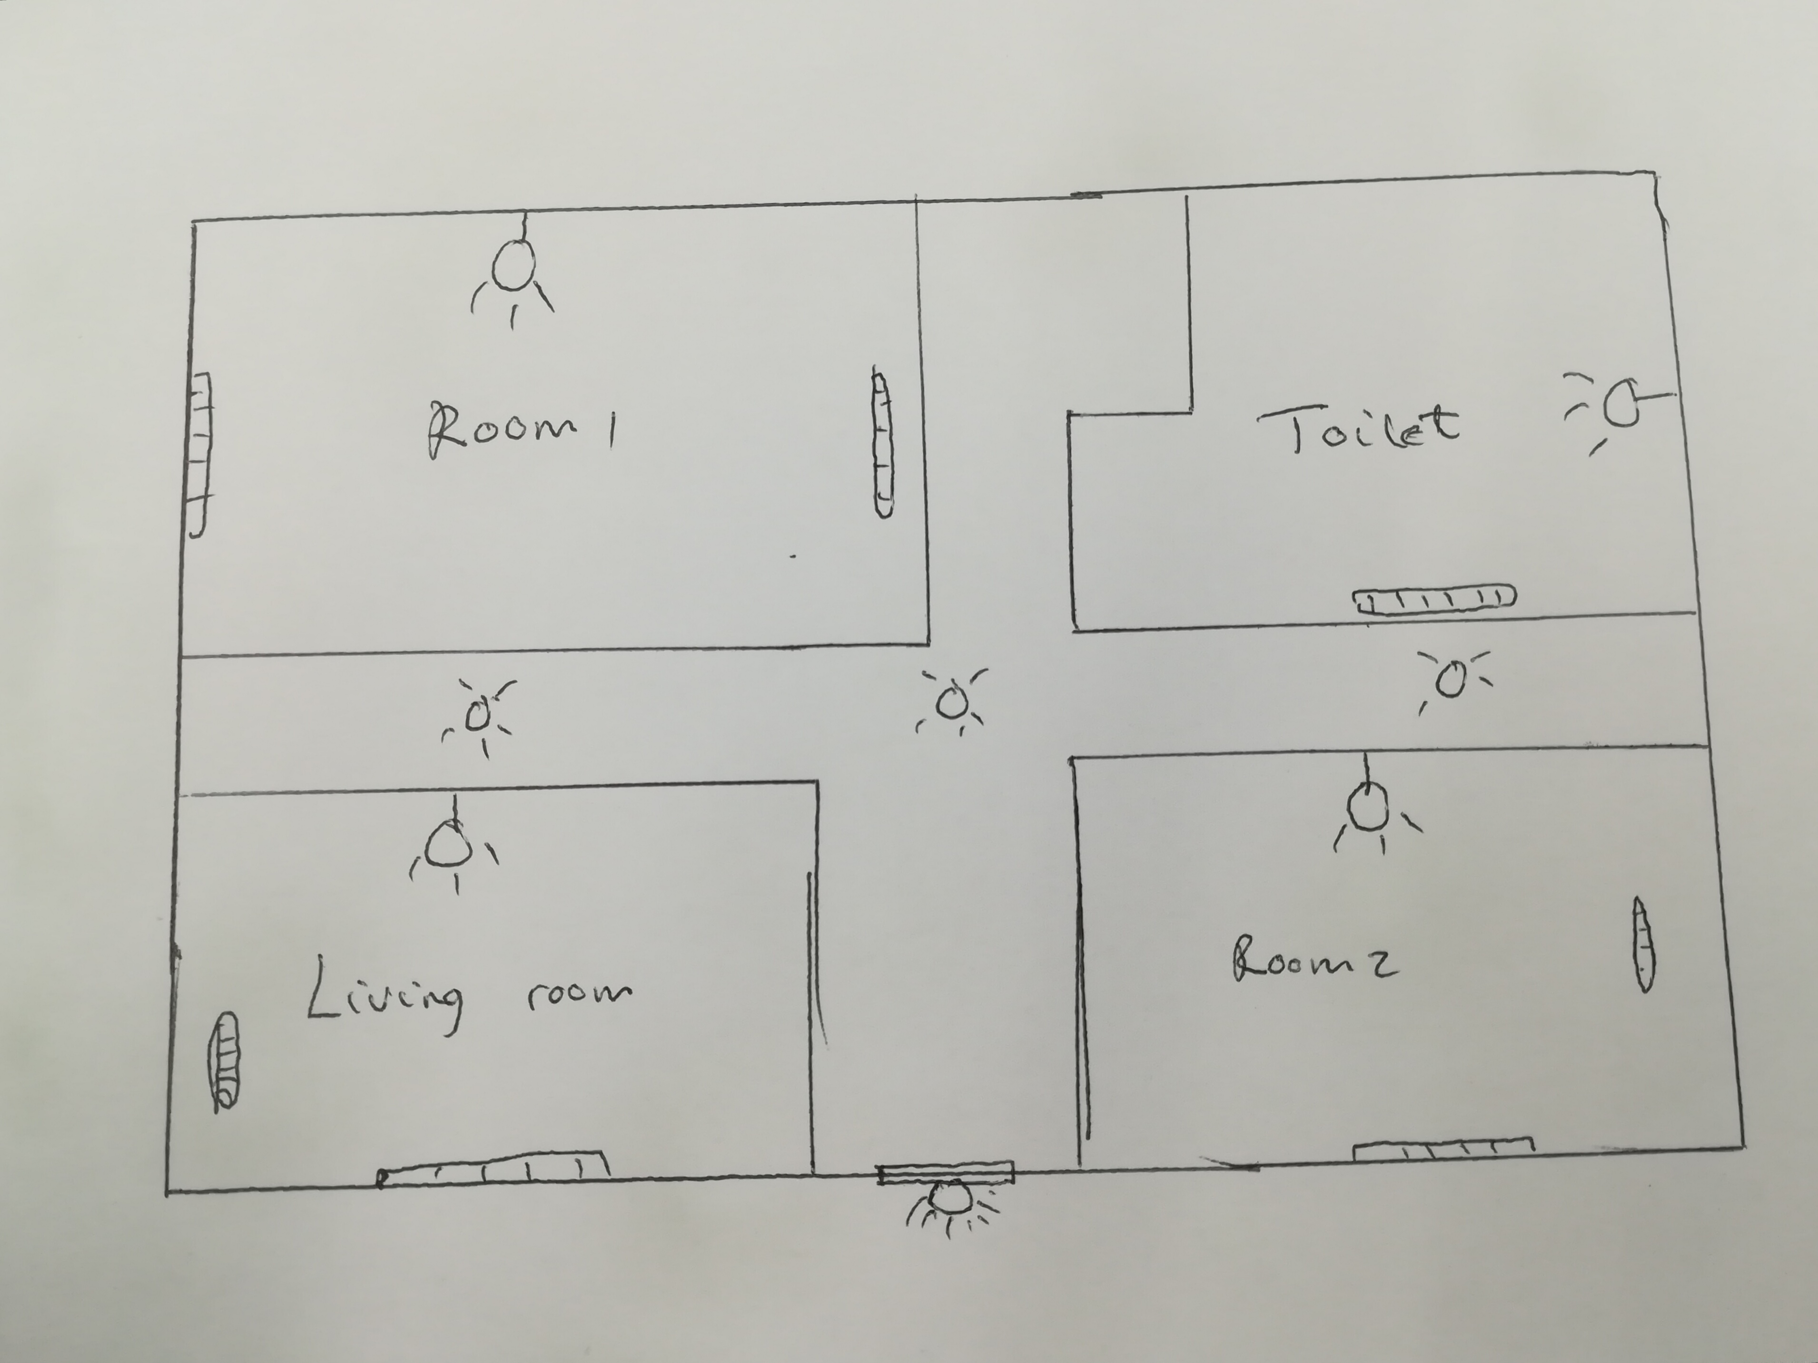
Figure 1 Smart house sketch

IMPLEMENTATION
The author implement is project on Arduino by suing Arduino kit provided, and build the entire system of smart home by the help of the coding to the Arduino application, the author used Arduino Wifi ESP8256 module and wires connected on each through bradboard with the desirable pin for the sensor used together with the RGB LED for the light connection.

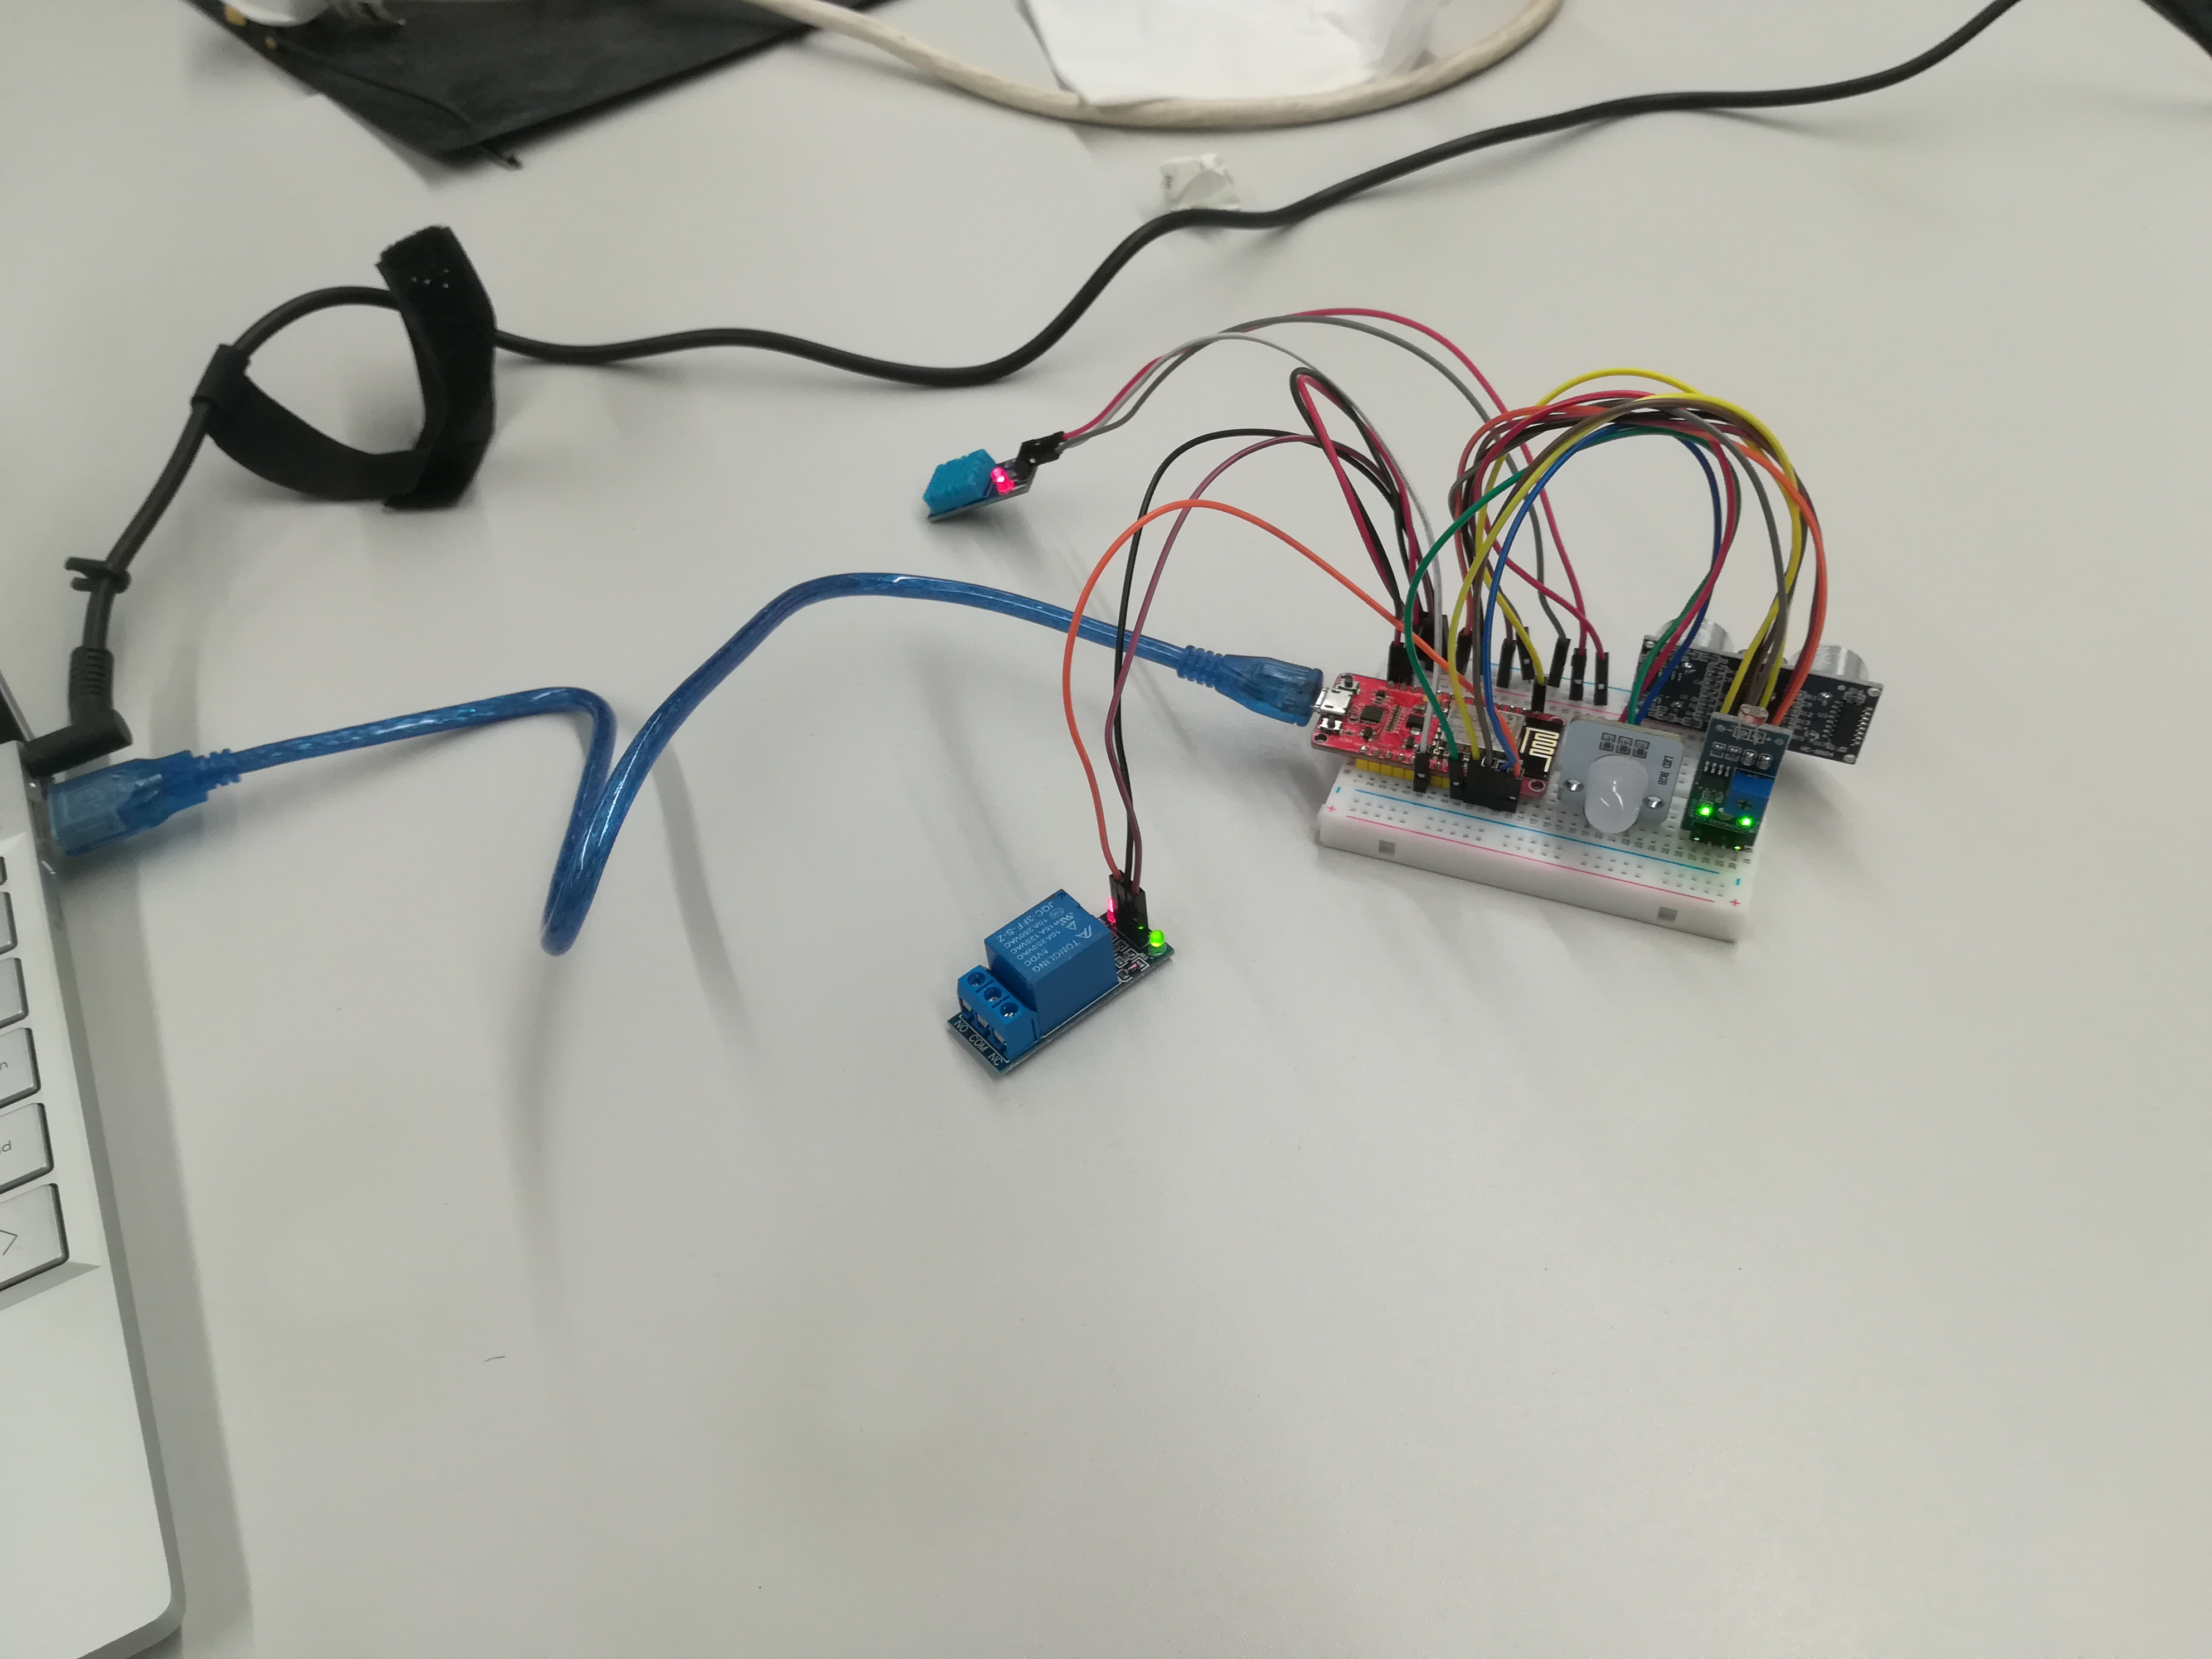
Figure 2 The smart home energy station - Arduino

RESULTS
Finally. The author managed to make the project worked, with testing through the website created that showed the heater when it on or off, and the light that used lighting sensor and motion when is on and off as well.
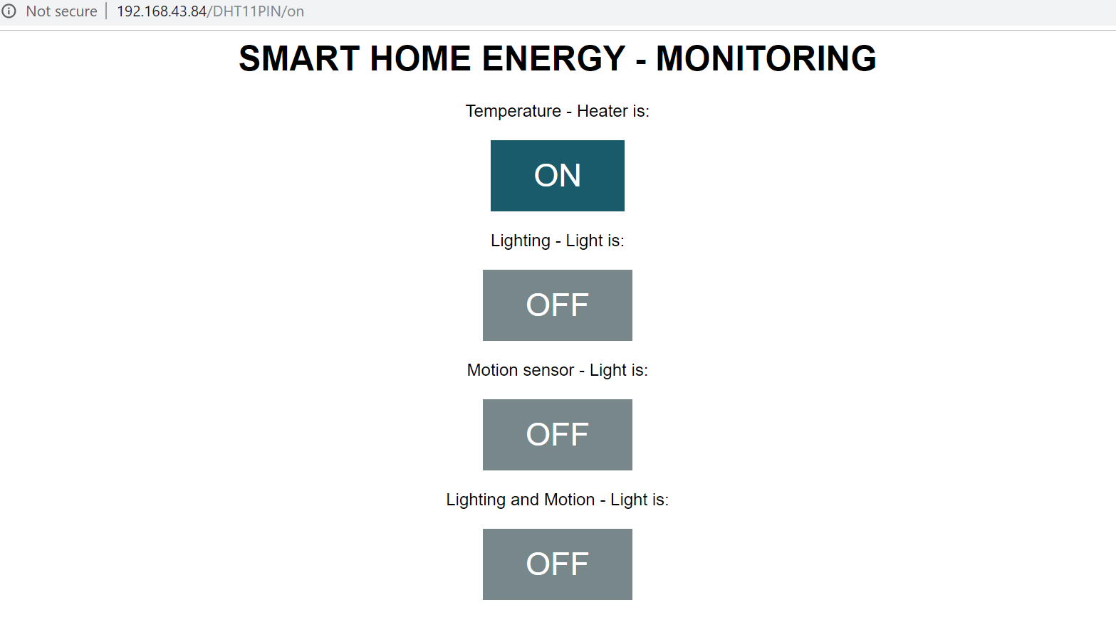
Figure 3 smart home energy monitoring website

CONCLUSION & RECOMMENDATION
This report has outlined and explained about smart home energy solution, also mentioned the researched performed into different sectors, such IoT, how the smart energy is important and what the solution for the smart energy. Showed the design and implementation of the author performed together with the result on it.
To recommend on this the author should focus more on designing the lighting sensor with set up timer on it and do more research for the best and useful report.

References

[1] | N. W. Lu Tan, "Future internet: The Internet of Things," in ICACTE, Chengdu, China, 2010.
[2] | J.-Y. H. S. K. S.-H. K. J.-H. K. J. C. Sehoon Kim, "Restful Design and Implementation of Smart Appliances for Smart Home," in IEEE, Bali, Indonesia, 2014.
[3] | H.-J. L. Mingfu Li, "Design and Implementation of Smart Home Control Systems Based on Wireless Sensor Networks and Power Line Communications," IEEE Transactions on Industrial Electronics, vol. 62, no. 7, pp. 4430 - 4442, 2015.
[4] | F. M. Bhutta, "Application of smart energy technologies in building sector — future prospects," in International Conference on Energy Conservation and Efficiency (ICECE), Lahore, Pakistan, 2017.
[5] | J.-h. L. Dae-man Han, "Smart home energy management system using IEEE 802.15.4 and zigbee," IEEE Transactions on Consumer Electronics, vol. 56, no. 3, pp. 1403 - 1410, 2010.
[6] | M. A. T. P. Cameron Dean Whitehouse, "Smart water heater system, method and computer readable media," University of Virginia Licensing and Ventures Group, Virginia, 2015.

