
learning in the digital era
Assignment 1

Module Code: ACCA 4025
Student Name: Delia Deliu Alexandrina
Student ID: 2509861
Group No: 2
Lecturer's Name: Koushik Modak
Submission Deadline: 21* November
Table of Contents
Introduction 1
. IEEE Referencing & written summary on essential academic and employment skills 2
Essential Skills for Study and Employment 3
REFLECTION 4
2 Collaborative Teamwork and Professional Academic poster 5
‘Life is a Team Sport’ 6
3 Automatic Referencing tool 6
Digital Portfolio 7
Conclusion 7

Introduction

This work explores the important connection between academic success and career readiness, emphasizing the essential transferable skills necessary for effective study and employment today. While discipline-specific knowledge is crucial, skills such as communication, problem-solving, collaboration, and self-management are highlighted as key enablers for applying learning, adapting to technological changes, and collaborating with others. Drawing from scholarly works, including Cottrell (2024) and Gallagher (2022), it argues that effective study skills—like organization and time management—are directly related not only to academic achievement but also to preparing for professional demands. The rapid pace of change underscores the need for future professionals to be adaptable, engage in critical thinking, and commit to lifelong learning. The forthcoming discussion elaborates on these core skills, focusing on their significance within the Information Technology sector.

1. IEEE Referencing & written summary on essential academic and employment skills

Essential Skills for Study and Employment
Education and job success today relies on fundamental abilities such as computer literacy, problem-solving, collaboration, communication, and self-management. While academic knowledge is essential, these transferable skills empower individuals to apply their learning, adapt to change, and work with others effectively.

Developing effective study skills, including organization, time management, and self-reflection, is essential for academic success and motivation, as emphasized by Cottrell (2024). [1] These skills contribute not only to improved academic performance but also equip students for future careers, where skills like meeting deadlines and workload management are vital. Gallagher (2022) supports this notion by stating that employability hinges on a balance of academic and personal skills, with employers seeking candidates who demonstrate independent thinking, clear communication, and collaborative abilities. [2]

Adaptability and critical thinking are crucial skills for the future workforce, as highlighted by Fajaryati et al. (2020). Employers seek individuals who can creatively solve problems, collaborate effectively, and commit to lifelong learning in an evolving technological landscape. [3]

My chosen field of information technology (IT) requires essential abilities such as effective communication, critical thinking, and problem-solving skills, which are vital for system design and software debugging. Time management and self-discipline enable me to handle multiple tasks and meet project deadlines. Additionally, digital literacy, the ability to comprehend and utilize technology, serves as the foundation of all IT work. By honing these skills, I am not only improving my academic performance but also preparing for long-term career advancement in the IT sector. [4]These abilities will facilitate collaboration, adaptation to technological advancements, and significant contributions to industry in the future.

[1] S. Cottrell, The Study Skills Handbook,, London: Bloomsbury Academic, 2024. [2] K. Gallagher, Essential Study and Employment Skills for Business and ManagementStudents, Oxford: Oxford: Oxford University Press, 2022. [3] B. B. M. A. a. W. W. N. Fajaryati, “The Employability Skills Needed to Face the Demands of Work in the Future,” Open Engineering, vol. 10, p. 595 to 603, 2020. [4] “National Careers Service,” Department for Education (DfE, London, 2025. REFLECTION 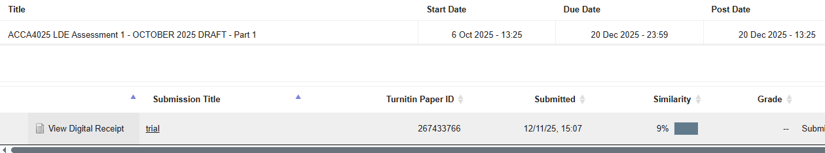 My similarity score of 9% shows that my work is highly original, mostly because I utilize my own language, with only a little amount of overlap in important terms and phrases. This result demonstrates my dedication to academic honesty and appropriate referencing. I am aware that there is room for improvement, particularly in the area of summarizing difficult concepts while maintaining their intended meanings in upcoming tasks. Additionally, I want to make sure that all references are properly credited. I would give myself an approximate score of 88% based on the Generic Assessment Criteria, indicating high-level performance with good understanding, Although I am aware that I could do better, particularly in terms of my academic writing style, I think my work shows a great deal of effort, creativity, and interest in the subject. 2 Collaborative Teamwork and Professional Academic poster 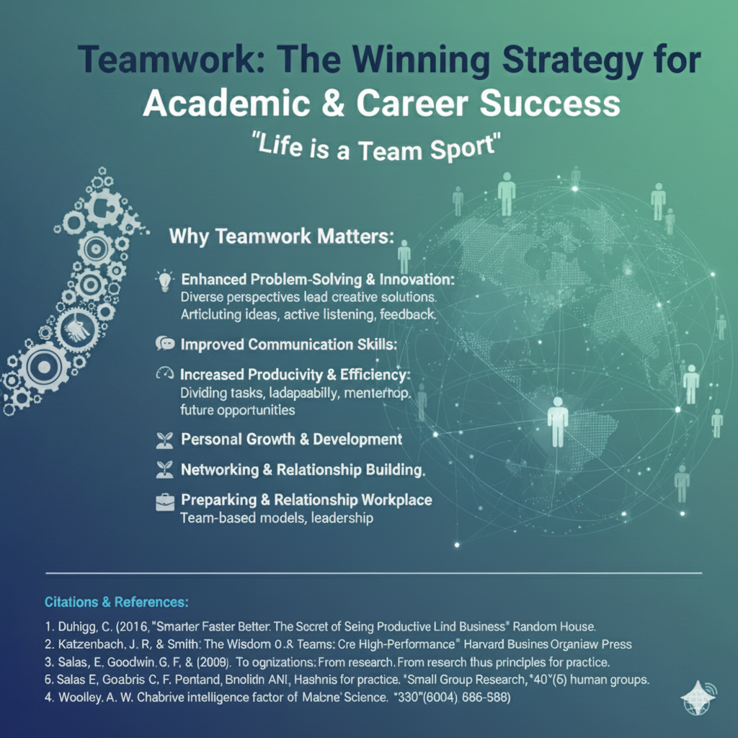 poster.png (1024×1024) ‘Life is a Team Sport’ 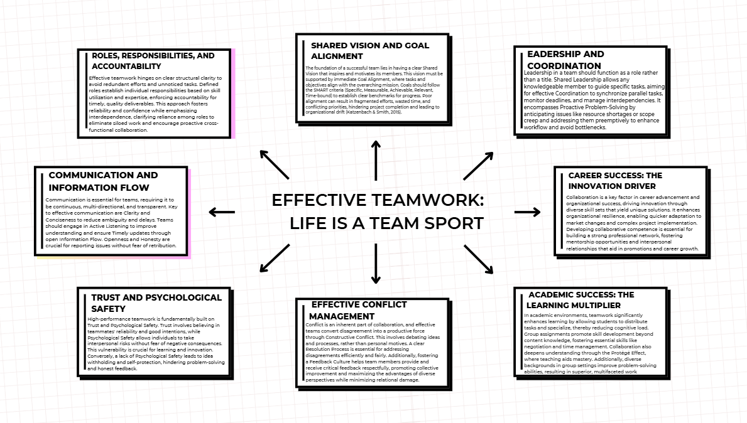 Black and White Simple Modern Mind Map - Brainstorm 3 Automatic Referencing tool The Norming Stage The transition into the Norming stage is a critical developmental milestone for any team, particularly for virtual teams where communication challenges may arise [1]. This phase follows the Storming stage, during which team members begin to resolve their conflicts and develop a mutual understanding of each other's abilities and weaknesses [2]. During the Norming stage, the team establishes its identity, clarifies leadership roles, defines individual member responsibilities, and reinforces commitment to shared goals [2]. However, this newfound harmony can be fragile if teams do not embed mechanisms for constructive disagreement and accountability [1] For virtual teams to enhance their performance during the Norming phase, they must confront the dysfunctions highlighted in Patrick Lencioni's model: specifically, Lack of Commitment and Avoidance of Accountability [3]. Given the geographical spread of team members and the inability of leaders to directly observe performance, these issues can be exacerbated. Effective navigation of this stage requires team members to engage in open, constructive feedback [4]. Radical Candor, a concept introduced by Kim Scott, is seen as an effective framework for fostering this necessary environment [5]. This methodology encourages team members to challenge one another directly while also showing personal care, helping to steer clear of two detrimental communication pitfalls: Ruinous Empathy (showing care while avoiding direct challenges) and Obnoxious Aggression (challenging directly without personal regard) [5]. Utilizing Radical Candor can cultivate deep trust within the team, thus enabling higher performance and reinforcing commitment and accountability as the team progresses from the Norming stage [5]. The practical application of this philosophy is illustrated through feedback sessions, such as discussions around an individual's SWOT analysis aimed at defining roles [6]. Key strategies ensure this feedback is constructive and beneficial, including focusing the conversation on outcomes and asking inquisitive questions that stimulate critical thinking and dialogue [4]. It is also essential to maintain a holistic and supportive approach, emphasizing that feedback is intended for collective improvement and reinforcing team commitment [5]. Through these collaborative efforts to define roles, team members can address questions regarding the interrelation of strengths and weaknesses among peers (e.g., are their weaknesses your strengths?). This engagement not only validates individual contributions but also helps establish a shared team identity—perhaps even assigning a team name—and lays down the essential norms required for successful teamwork [6]. Ultimately, the efficacy of these practices relies heavily on the appreciation of each member's input and the transparent application of Radical Candor [4]. 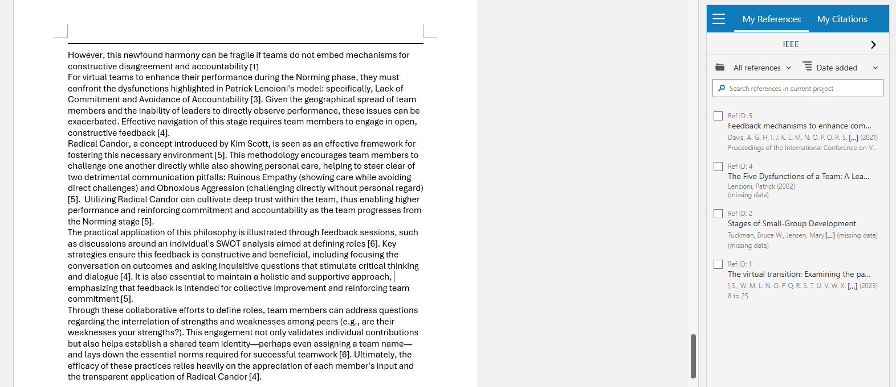 Digital Portfolio https://sites.google.com/view/delia-deliu/home 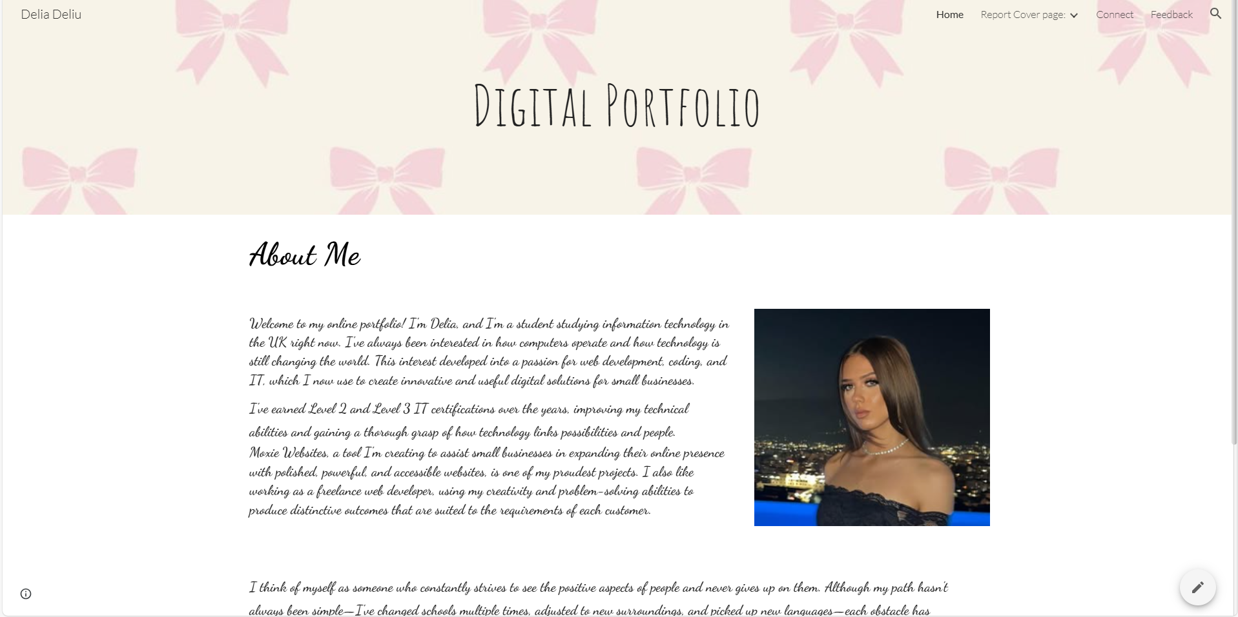 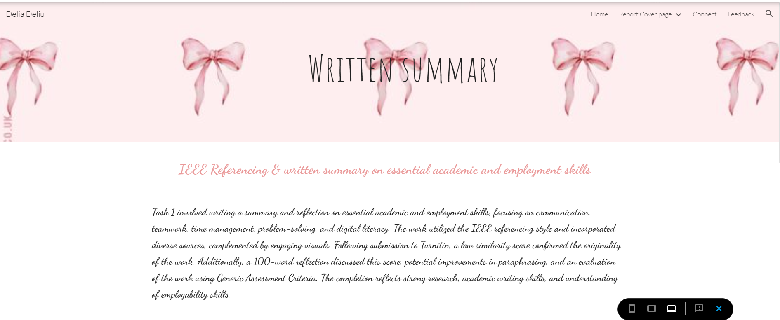 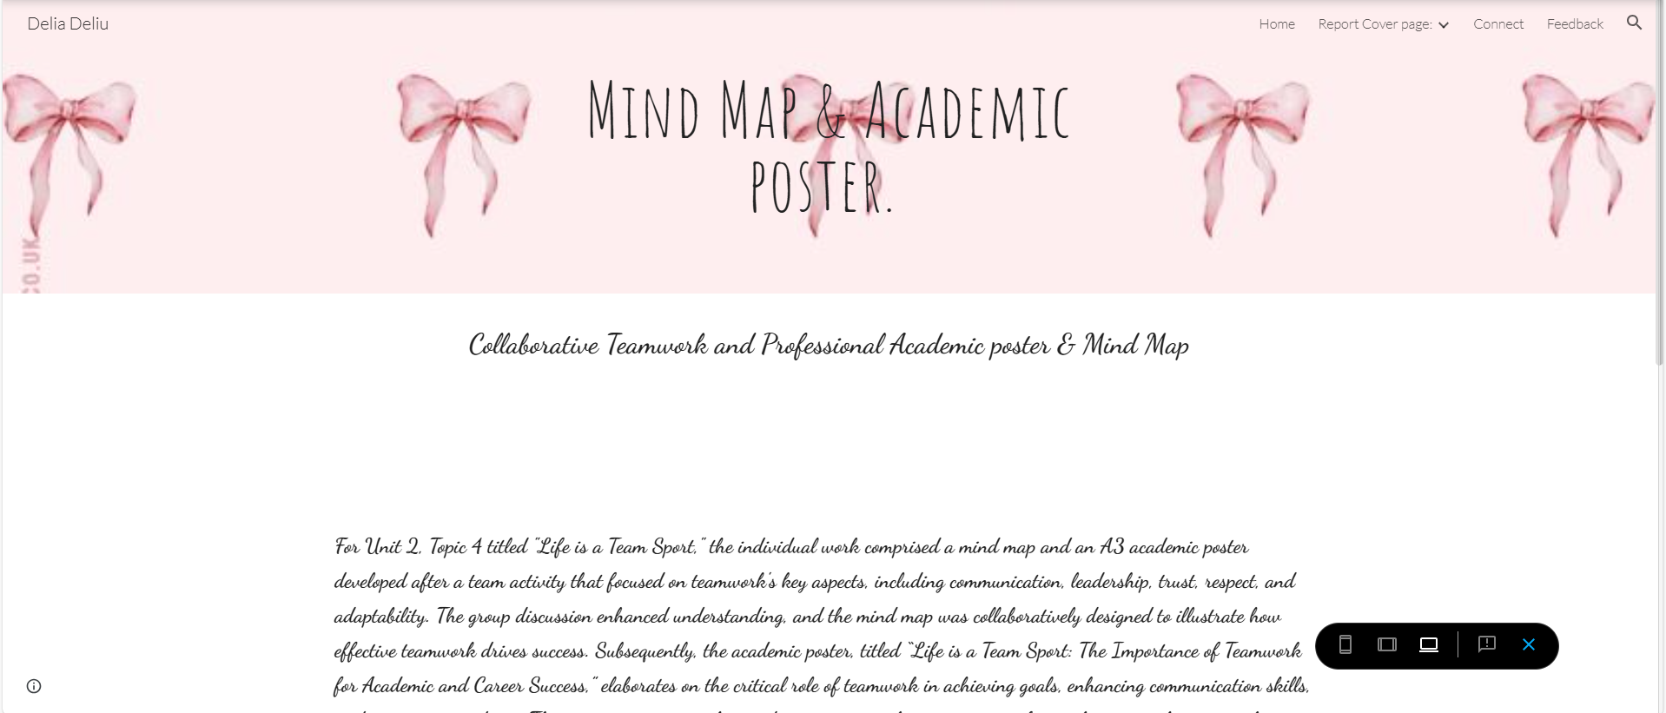 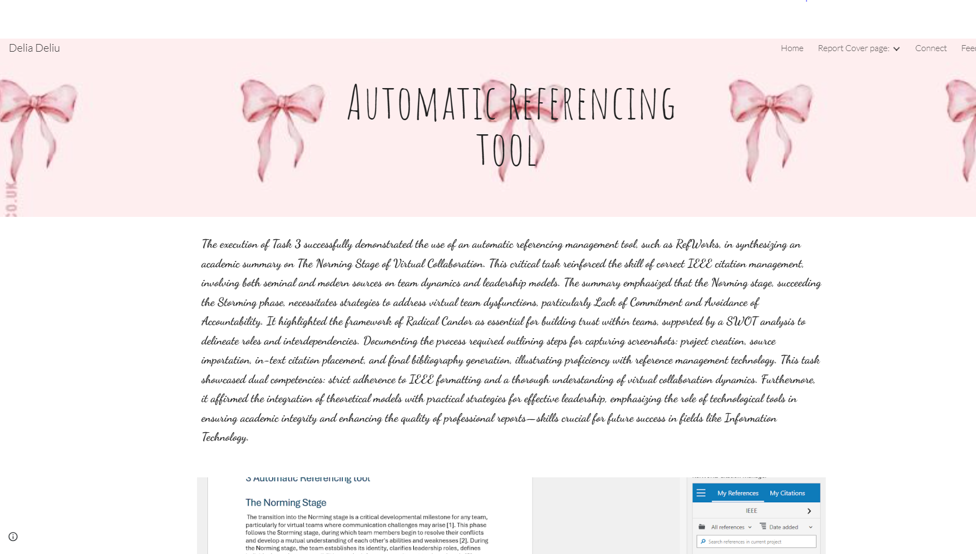 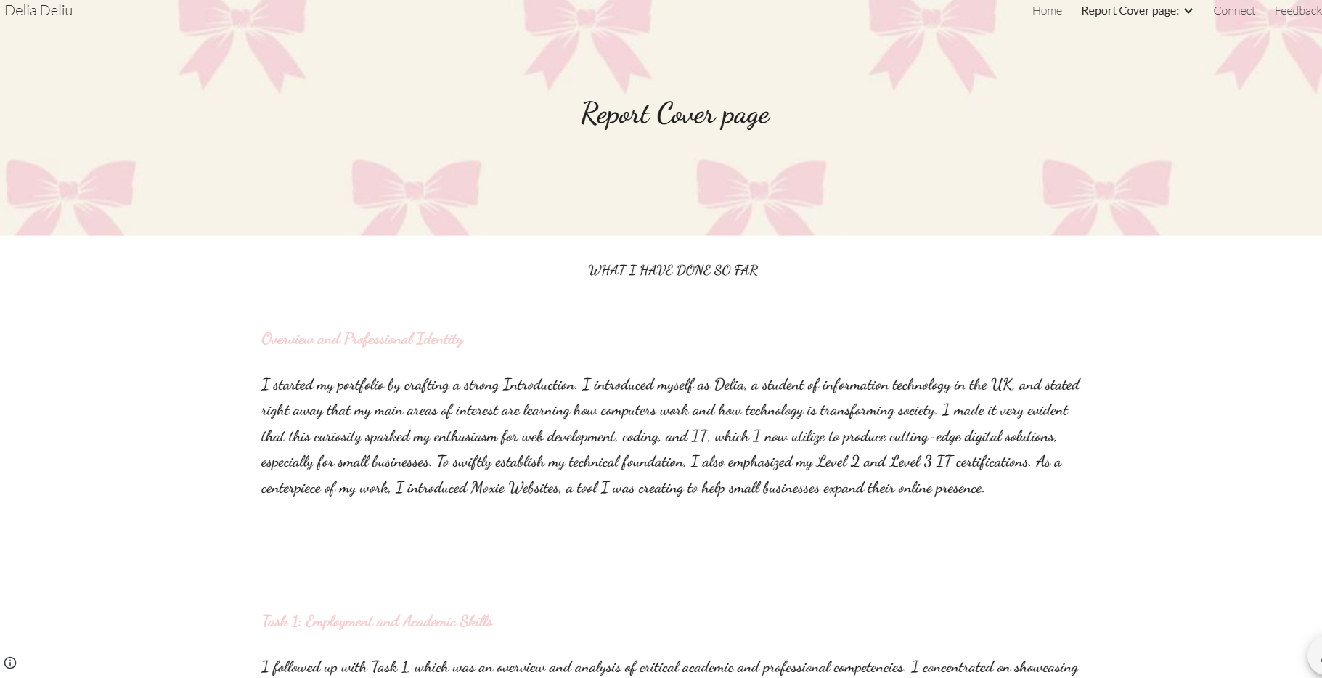 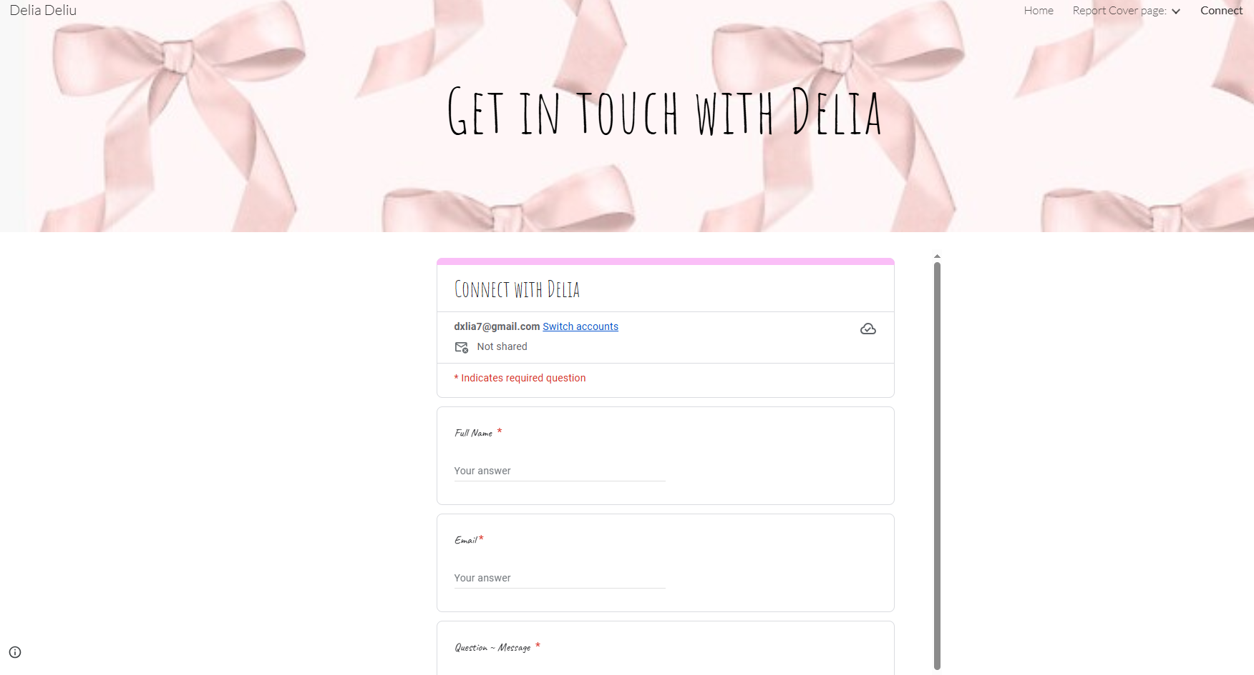 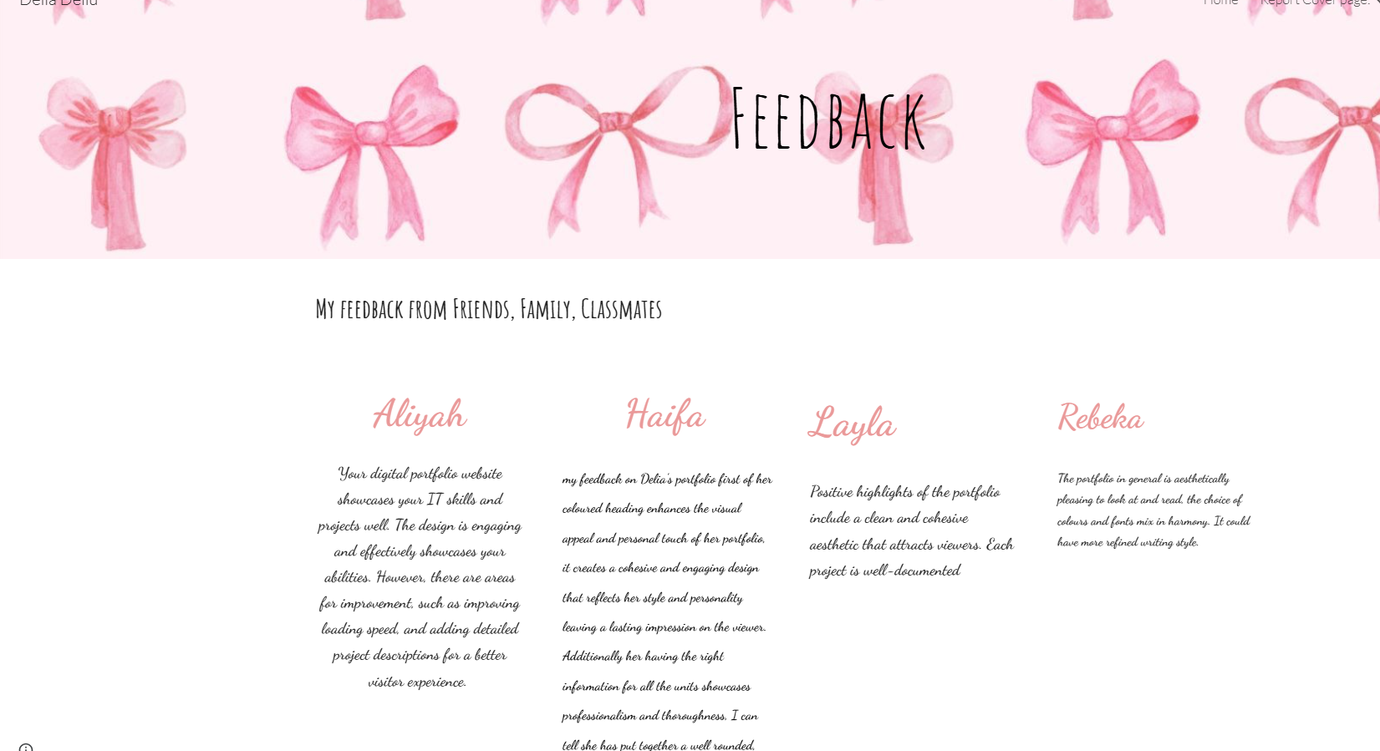 CONCLUSION The analysis highlights that success in education and employment is reliant on a mix of academic knowledge and soft skills, particularly in the IT sector where digital literacy, critical thinking, and communication are important. Time management and self-discipline are also vital for meeting deadlines and ensuring reliability. The reflective conclusion emphasizes academic honesty, backed by a low similarity score and a self-assessment estimating performance at 88%, while recognizing the need for improvement in writing and summarization skills. Overall, the work underscores the importance of intentional skill development for academic success and career growth.

