Report - Hilton

Student name: Andreea Violeta Panciu
Student ID Number: 2214991
Module Title: Sustainable Hospitality & Tourism Management
Module code: BMIH5006
Lecturer’s Name : Lisa – Marie Bassler
Date : 03 June 2024

Table of Contents
1 Introduction 3
2 Discussion 3
2.1 Evaluating Actions to Promote Sustainable Practices 3
2.2 Evaluating Benefits and Challenges Associated With Integrating Sustainability Into Day-To-Day Operations 8
2.3 Future Of the Hotel and Hospitality Industry 11
2.3.1 Community-based establishments 11
2.3.2 A circular economy 11
2.3.3 Conservation of water 12
3 Conclusion 12
4 References 13

Introduction
According to British Business Bank (2024), despite the existence of multiple huge hotel organisations, the hospitality sector in the United Kingdom consists of around 35,000 small bed and breakfasts and guesthouses. Small accommodation firms play a crucial role in helping the United Kingdom reach its goal of reaching net zero carbon emissions by 2050. This is because the hospitality industry is responsible for as much as 15% of the country's greenhouse gas emissions. The organisations are working on sustainability practices and are likely to reduce carbon emissions and get a green key certificate to become responsible towards society. However, A prominent global hospitality enterprise with more than 100-year history, Hilton has welcomed over 3 billion guests, committed to achieving its founding vision of illuminating the world through hospitality and compassion. The company have established a reputation for excellence, integrity, and innovation among our owners and visitors. Hilton is prepared to extend unparalleled service to its customers, regardless of destination (Hilton, 2024).

Discussion

Evaluating Actions to Promote Sustainable Practices
Mbasera, Du Plessis and Saayman (2016) mentioned, the hospitality sector in the tourism business has substantial negative environmental effects, including elevated energy consumption, added pressure on waste management systems, and contamination of soil, water, and air. The long-term consequences of these detrimental environmental effects, particularly those related to global climate change, are uncertain. Consequently, there is an increasing demand for the establishment of carbon-neutral hotels in different areas and the adoption of eco-friendly measures in the hospitality sector.
From Hilton's working practices, it is captured that Hilton management is playing a significant role in eco-friendly practices as the organisation is taking different initiatives to provide services to their customers that are eco-friendly. Hilton leaders and developers are crucial stakeholders in the advancement of a more sustainable future for the hospitality industry. Hilton developed Sustainable Design Checklists for its partners to streamline the process of making educated judgements regarding sustainability. The several instances where the company may incorporate energy efficiency and sustainable features into hotels, whether it is during the design, construction, restoration, or conversion processes. What are the benefits and challenges associated with integrating sustainability into their daily (Hilton, 2024a).

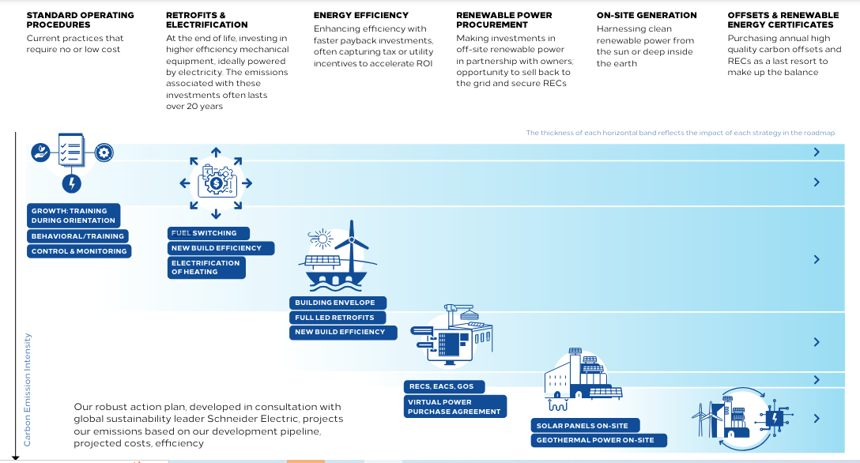
Figure 1: Roadmap to Reduce Carbon Emission (Source: Hilton, 2024b).

To become sustainable and move towards eco-friendly practices, the Hilton Industry leader designed a long-term goal which started in the year 2019, and will be completed in the year 2030. The management started controlling the current operations at the start, and to move towards improvement, they focused on training and monitoring activities. Furthermore, the company's comprehensive action plan, established in collaboration with Schneider Electric, a renowned global leader in sustainability, forecasts emissions based on the future development pipeline, anticipated expenses, and efficiency. This helps management to design sustainability strategies smoothly and offer services to customers that are up to standard as well as environment friendly (Hilton, 2024b).
From the analysis, it is revealed that Hilton is taking different steps to achieve its goal of carbon-free practices. The emissions reduction strategy follows a step-by-step approach. The management took the firsr step by making operational changes that require minimal resources to implement. Then, leaders focus on investing in energy efficiency efforts that have a substantial effect. In the following stage, the goal is to carry out energy-efficient upgrades and electrification measures while also acquiring renewable energy from external sources and replacing equipment that has reached the end of its useful life. The last stages of the roadmap focus on producing renewable electricity on-site and, as a final step, obtaining renewable energy certificates (RECs) and carbon offsets to compensate for any remaining unavoidable emissions. By implementing this cascade method, the entity has been able to make well-informed judgements and has helped us build a clear plan to reduce emissions intensity by 75% for managed properties and 56% across our franchised portfolio by 2030 (Hilton, 2020a). The actions of the organisation do play significantly in the sustainability of the business and do impact positively on consumer behavior.
On the other hand, one major challenge for hospitality leaders is to manage water and food wastage. Leaders of Hilton are constantly looking for ways to reduce unnecessary waste in our supply chain and operations. To accomplish the 2030 goals and develop a more sustainable hospitality sector, it is imperative to decrease food waste, engage in recycling practices, and eradicate the use of single-use plastics.
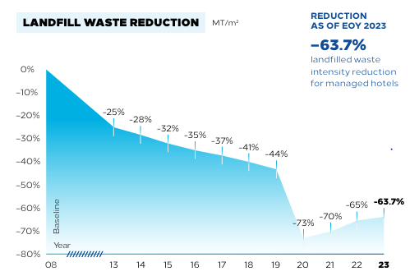
Figure 2: Hilton Action Towards Water Reduction (Source: Hilton, 2024c).
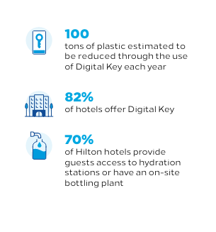
Figure 3: Hilton Operations and Sustainability (Source: Hilton, 2024c).
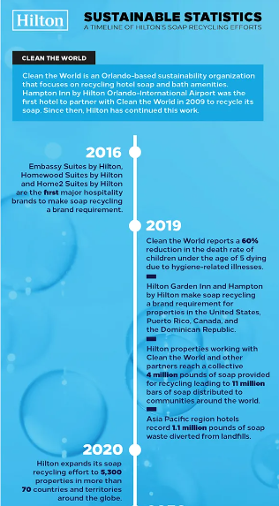
Figure 4: Hilton Sustainable Statistics (Source: Hilton Stories, 2019).

Hilton also announced the successful completion of its 2019 Clean the World Challenge. The goal of the challenge was to gather a sufficient amount of soap by Global Handwashing Day for the purpose of sterilising and recycling it into 2 million new bars of soap for communities in need. Over the previous ten years, Hilton establishments have successfully redirected 4 million pounds of waste away from landfills. The current market leader is enhancing its standards by partnering with non-governmental organisations (NGOs) such as Clean the Globe. For further sustainable practices, by the end of 2023, Hilton locations were required to switch to larger-sized shampoo, conditioner, and soap products, thereby getting rid of small single-use bottles and reducing the use of soap bars. In addition, the hotels contributed more than 3.1 million new bars to communities facing hardship and repurposed over 330,000 pounds of soap for sanitisation. Through this transition, the entity has successfully reduced the usage of disposable plastic by visitors across properties and supported the hotels in their efforts to minimise waste sent to landfills by emphasising the recycling of large amenity bottles (Hilton, 2024c; Hilton Stories, 2019).

Evaluating Benefits and Challenges Associated With Integrating Sustainability Into Day-To-Day Operations
There are multiple advantages and benefits which firms get if they work eco-friendly as the approach is promoted to work with sustainability. Along with the benefits, changes in practices are itself a challenge which experts face while promoting eco-friendly practices. The hospitality industry has energy costs that exceed £1.3 billion per year and releases more than eight million tonnes of carbon dioxide yearly, which is a major challenge for UK industry leaders (British Business Bank, 2024). Hilton leaders are dedicated to making a positive impact on the world, and the organisation take its obligations seriously. The actions are taken to eliminate challenges regarding carbon emissions and further provide benefits to the company as customers are likely to prefer firms who provide envoirnment friendly practices and care for the community. Also, the action will impact positively on the brand image. Leaders are dedicated to setting a standard for the durability and liveliness of the places where visitors live, work, and travel, ensuring their preservation for future generations (Hilton Corporate Responsibility, 2018).
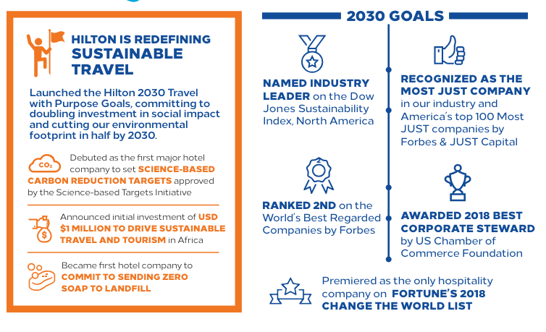
Figure 5: Hilton Sustainability Goals for 2030 (Source: Hilton Corporate Responsibility, 2018).

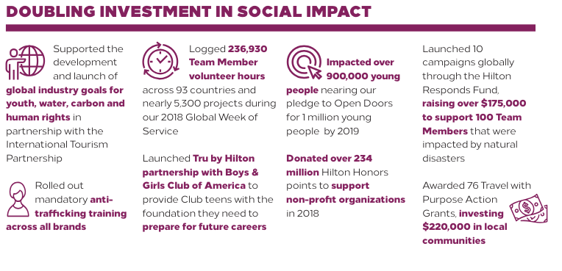
Figure 6: Investment for Sustainability (Source: Hilton Corporate Responsibility, 2018).
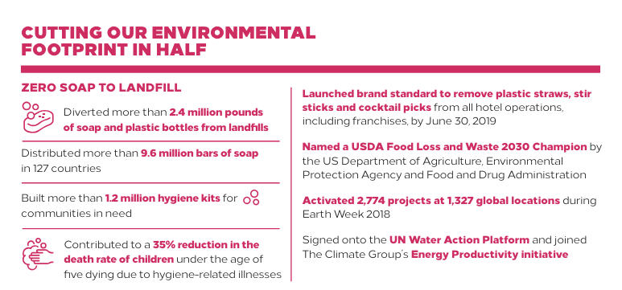
Figure 7: Cutting Environment Footprint (Source: Hilton Corporate Responsibility, 2018).

Management is proud to be the pioneering hotel firm that has set science-based targets to decrease carbon emissions in alignment with the Paris Climate Agreement. Additionally, the company have committed to eliminating the disposal of hotel soap in landfills. The action has been taken for inclusive growth as this will double through the implementation of programmes that support women, youth, veterans, refugees, and those with disabilities on a global scale. This will fully exploit the economic advantages of travel and tourism. This aligns with the dedication to promoting the 2030 Agenda for Sustainable Development set by the United Nations. This year, the company have received recognition for our outstanding commitment to communities, as demonstrated by the selection as the Industry Leader on the Dow Jones Sustainability Index North America. The company has been recognised by Forbes as the Most JUST Company in the hotel industry. This made Hilton's first appearance as the only hospitality company on Fortune's Change the World List. The US Chamber of Commerce Foundation awarded the Best Corporate Steward award in 2018. Each morning, leaders wake up with the goal of inspiring others, and this makes them energised and optimistic because Hilton leaders know that, together with the 400,000 Hilton Team Members, developers, proprietors, partners, guests, and communities, they are actively making a positive impact on our world. These actions integrate sustainability into day-to-day operations and further make the company a market leader (Hilton Corporate Responsibility, 2018).

Future Of the Hotel and Hospitality Industry
According to Yusoff et al. (2018), the concept of "sustainable development" was first articulated in the 1972 report titled "The Limits of Growth" (Gunilla, 2013). The Brundtland Report (1987) and the World Commission on Environment and Development (WCED) (1989) made later references to it (Borim-de-Souza et al., 2015). In the latter, it was described as "ongoing progress without sacrificing future requirements" (Barkemeyer et al. 2014). The Brundtland study encompasses two essential concepts: The first is related to the needs of the poor, while the second pertains to the limitations of the environment that prevent it from meeting future demands (Barkemeyer et al., 2014). Sustainable operations are considered in the industry because they promote the growth of business and society together (Yusoff et al. 2018).

Community-based establishments
The action for the future is taken because it is important for the growth of the community. Sustainability in the hospitality industry extends beyond the boundaries of the business. Local communities play a crucial role in promoting sustainability since hospitality businesses actively engage in sourcing products and services from nearby providers. This not only provides advantages to local producers and artisans, but it also reduces the environmental impact caused by transportation. Hotels are integrating the fundamental characteristics of the town into the guest experience, encompassing locally influenced cuisine and meticulously constructed amenities. Establishments are increasingly adopting local sourcing, which promotes deeper community relationships and provides a mutually advantageous situation for the hotel and its surrounding area (BNU, 2024).

A circular economy
Hospitality businesses are reassessing waste management practices as they shift towards adopting a circular economy. Recycling programmes, waste reduction schemes, and material repurposing are increasingly common practices, showcasing a commitment to minimising the environmental footprint. The industry's investment in creative solutions demonstrates that sustainability may be associated with exclusivity and luxury. The main emphasis is on the reuse of materials, where discarded items are transformed into upcycled decorations and amenities. The hotel brand Locke has made it a priority to employ recycled construction-site materials in the design of their buildings, reflecting their ethos. Within the supply chain, firms engage in partnerships with suppliers who are committed to employing environmentally conscious packaging and delivery methods, thereby furthering sustainable practices. This thorough approach demonstrates a dedication to minimising the environmental consequences at each phase of the operations process (BNU, 2024).

Conservation of water
Water is a limited and necessary resource that is a primary focus for promoting sustainable practices in the hospitality industry. This demonstrates the hospitality industry's recognition of this issue by allocating resources to water conservation efforts, advocating for appropriate usage, and adopting water-saving technologies. Visitor guestrooms in hotels contribute to 30% of the total water use. Guests are becoming more inclined towards hotels that prioritise water efficiency while maintaining comfort. The integration of smart technologies and visitor education on water conservation measures facilitates the holistic approach to sustainable water management. Hotels are implementing water-conservation methods, such as advanced irrigation systems and low-flow fixtures, to decrease water usage. An example of this is the IHG Green Engage programme. Hotels are actively contributing to the greater effort of preserving this vital resource for future generations by investing in local water conservation projects in addition to their internal activities (BNU, 2024).
On the other hand, changes can be observed through Hilton practices as leaders also set goals for 2030 to promote sustainability in future. Sustainable practices are needed to save the environment.

Conclusion
It is concluded that in the UK, hospitality and hotel industry leaders are working to promote sustainable operations. They do face challenges because of the negative environmental impact because there are legal bindings as well and consumers are less likely to prefer firms who do not consider communities. Hilton has been taking the initiative for a decade to achieve the sustainability goal as it will positively impact the growth of business and community.

References
Barkemeyer, R., Holt, D., Preuss, L. and Tsang, S., 2014. What happened to the ‘development’in sustainable development? Business guidelines two decades after Brundtland. Sustainable development, 22(1), pp.15-32.
BNU. 2024. Comment: Sustainable Hospitality: Nurturing a Greener Future. [Online] Available at <https://www.bucks.ac.uk/news/comment-sustainable-hospitality-nurturing-greener-future>[Accessed on 24th t May 2024].
Borim-de-Souza, R., Balbinot, Z., Travis, E.F., Munck, L. and Takahashi, A.R.W., 2015. Sustainable development and sustainability as study objects for comparative management theory: proposing styles of reasoning for an unknown metropole. Cross Cultural Management, 22(2), pp.201-235.
British Business Bank. 2024. Becoming a sustainable hotel, B&B, or guest house. [Online] Available at <https://www.british-business-bank.co.uk/business-guidance/guidance-articles/sustainability/sustainable-accommodation-hotel> [Accessed on 21st May 2024].
Gunilla, A., 2013. Sustainability and SMEs: The next steps. In Sustainable Entrepreneurship: Business Success through Sustainability (pp. 265-268). Berlin, Heidelberg: Springer Berlin Heidelberg.
Hilton Corporate Responsibility, 2018. Travel With Purpose. [Online] Available at https://cr.hilton.com/wp-content/uploads/2019/03/Hilton-Corporate-Responsibility-2018-2.pdf [Accessed on 23rd May 2024].
Hilton Stories. 2019. Hilton Marks Global Handwashing Day by Expanding Soap Recycling Effort Around the World. [Online] Available at <https://stories.hilton.com/releases/hilton-bolsters-soap-recycling-efforts-for-global-handwashing-day> [Accessed on 23rd May 2024].
Hilton, 2024. Welcome to Hilton. [Online] Available at https://www.hilton.com/en/corporate/> [Accessed on 21st May 2024].
Hilton. 2024a. Environmental Impact. [Online] Available at <https://esg.hilton.com/environment/#green-hotels> [Accessed on 21st May 2024].
Hilton. 2024b. Roadmap to Reduce Carbon Emission Intensity. [Online] Available at <https://esg.hilton.com/wp-content/uploads/sites/4/2024/05/Hilton-Roadmap-to-Emissions-Reductions-ADA.pdf> [Accessed on 21st May 2024].
Mbasera, M., Du Plessis, E., Saayman, M. and Kruger, M., 2016. Environmentally-friendly practices in hotels. Acta Commercii, 16(1), pp.1-8.
Yusoff, T., Wahab, S.A., Latiff, A.S., Osman, S.I., Zawawi, N.F. and Fazal, S.A., 2018. Sustainable growth in SMEs: A review from the Malaysian perspective. J. Mgmt. & Sustainability, 8, p.43.

