

Reasearch in Action
Portfolio of Competencies

ECPS5016

[
]

[
]

]

I confirm that I have not used any AI tools in the research and creation of this assignment. I confirm that I have not presented any AI generated materials as my own work. I confirm I have copies of my drafts, notes, and other resources I used, which I may be asked to provide in evidence

Research in Action was a module that initially pushed me outside of my comfort zone because of the amount of independent learning, collaboration, and professional research skills involved. Although I was interested in developing my understanding of psychological research methods, I initially lacked confidence in my ability to contribute effectively within a research-focused group project. Throughout the module, I worked closely with my lab partner Harry to design and develop our research materials, including the ethics form, proposal form, participant documents, and data collection materials. This required regular discussions to ensure consistency throughout the project and to collaboratively refine decisions regarding the study design and methodology. Although some sections were initially completed individually, we regularly reviewed each other’s work, discussed feedback, and refined sections together to improve the overall quality and consistency of the project. Over time, engaging with these processes increased both my confidence and understanding of how psychological research is conducted within ethical and professional frameworks. Collaborative communication and teamwork are important aspects of successful group research projects (Tuckman, 1965). This reflective piece will apply Gibbs’ Reflective Cycle (Gibbs, 1988) to evaluate my experiences across the module, including the development of practical research skills, collaborative working, responding to feedback, and my overall personal and academic growth.
One of the main tasks completed throughout the module was the development of our research proposal and ethics documentation. Initially, I underestimated the level of detail and professionalism required when preparing research materials for ethical approval. As we progressed through the proposal and ethics forms, I became more aware of the importance of participant wellbeing, confidentiality, informed consent, and ensuring that all research procedures were clearly justified and ethically appropriate. These principles are central to ethical psychological research and participant protection (British Psychological Society [BPS], 2021). Receiving feedback from Katie throughout this process was particularly valuable, as it highlighted areas that lacked clarity and required further development. Although I sometimes found the number of revisions frustrating and time-consuming, responding to feedback helped improve both the quality of the project and my understanding of ethical research practice. Ethical review processes are designed to ensure research is conducted responsibly and with appropriate consideration of participant welfare (Smith, 2015). Working collaboratively with Harry throughout these revisions also highlighted the importance of communication and consistency within group research projects, particularly when multiple documents needed to align with one another.
Another important aspect of the module was learning how to prepare materials for participant recruitment and data collection. This included developing participant information sheets, consent forms, debrief forms, and creating study materials through platforms such as EMS and Qualtrics. Prior to this module, I had limited understanding of the amount of preparation required before data collection can ethically take place. Through completing these tasks, I developed a greater appreciation for the importance of clarity, organisation, and consistency within psychological research, which are essential for producing reliable and ethically appropriate research materials (Breakwell et al., 2021). For example, ensuring that the information provided within the consent form matched the ethics application and debrief materials required careful attention to detail and regular checking between documents. Although Harry initially completed some sections independently, we regularly discussed the wording and structure together to ensure all materials remained consistent and professionally presented. This process also improved my confidence in using digital research platforms and strengthened my understanding of the practical skills required when preparing psychological research studies. Digital research platforms such as Qualtrics are increasingly common within psychological research and require both technical and organisational skills from researchers (Evans & Mathur, 2018).
Reflecting on the module as a whole, I believe one of the most significant skills I developed was the ability to respond constructively to feedback and use it to improve my work. Initially, receiving large amounts of feedback on documents such as the ethics form and proposal form felt overwhelming, particularly when multiple revisions were required before sections were considered suitable. However, as the module progressed, I began to recognise that feedback was an essential part of the research process and contributed to producing more accurate, ethical, and professional research materials. Constructive feedback is recognised as an important contributor to both academic development and reflective learning (Hattie & Timperley, 2007). Gibbs’ Reflective Cycle (1988) emphasises the importance of evaluating experiences to support future learning and development, which became increasingly relevant throughout this module. Discussing feedback with Harry also helped us identify inconsistencies between sections and collaboratively refine areas that required improvement. This process strengthened my ability to critically evaluate my own work rather than viewing feedback as purely negative criticism. In addition, it highlighted the importance of communication, adaptability, and attention to detail within both academic research and future professional practice, which are considered important transferable skills within higher education and employment settings (Cottrell, 2019).
Overall, the Research in Action module provided me with valuable insight into the practical, ethical, and collaborative processes involved in psychological research. Although I initially lacked confidence in my ability to contribute effectively within a research-focused group project, the experience gradually improved both my confidence and understanding of professional research practice. Developing research materials, responding to feedback, and collaboratively refining documents with Harry helped strengthen my organisational, communication, and critical thinking skills. The module also increased my awareness of the importance of consistency, ethical responsibility, and professionalism within psychological research. As a result, I now feel more prepared to approach future research projects with greater confidence and understanding.
In future research projects, I would aim to improve my confidence earlier within the research process by engaging more proactively with feedback and trusting my own academic judgement. I would also aim to develop stronger time management strategies when completing large amounts of documentation, particularly when multiple forms and revisions are required simultaneously. In addition, I would continue developing my understanding of ethical research practice and digital research platforms, as these are important skills within both academic psychology and future professional settings. Developing reflective practice and professional skills is an important aspect of becoming an effective researcher and practitioner (Kolb, 1984). Finally, I would continue using collaborative discussions and consistency checking throughout group work, as I found these strategies particularly helpful in improving the quality and professionalism of the final project.

Competency 1
Ethics form completion

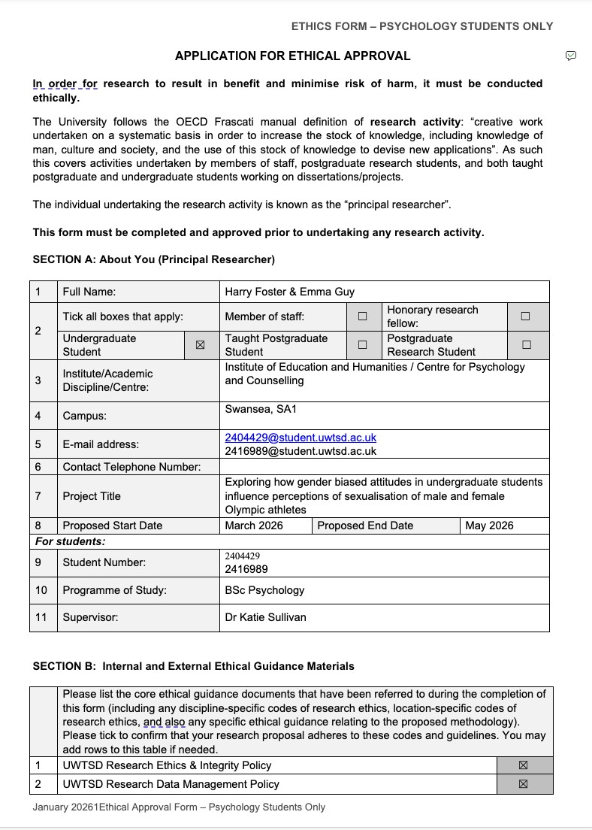
Figure 1. Ethics application form
This screenshot shows the development of the ethics application completed throughout the module. Reviewing feedback and refining sections collaboratively improved my understanding of ethical responsibility, professional research standards, and the importance of consistency across research documents.

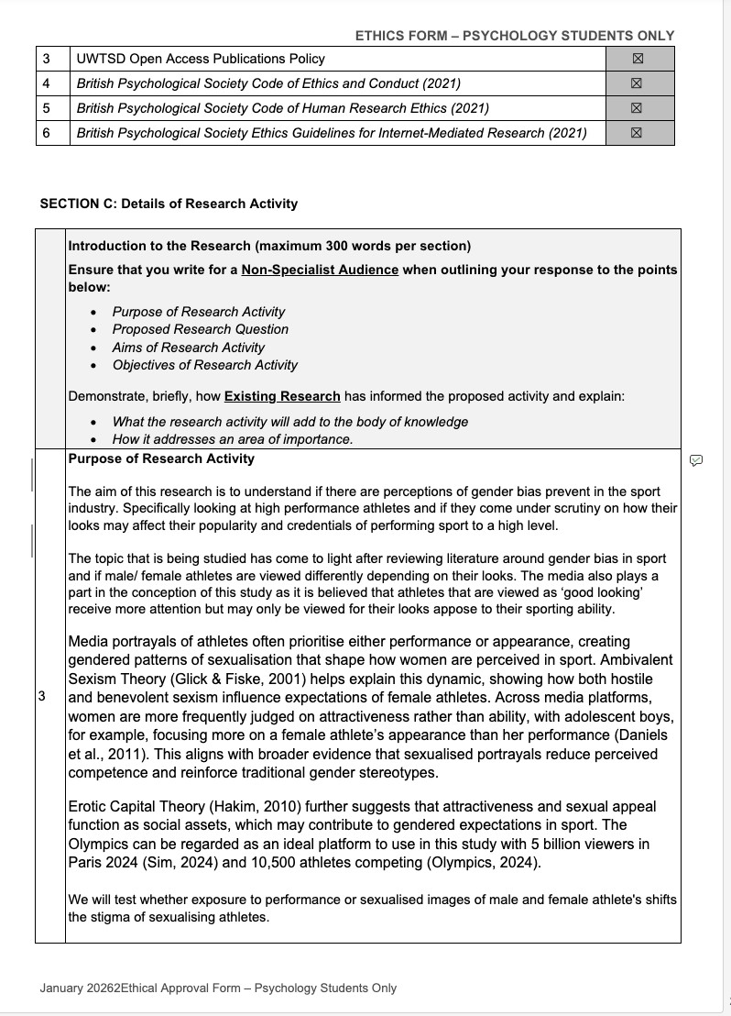
Figure 2. research and ethical guidance

This section demonstrates the development of the research and integration of psychological literature into ethics application. Reviewing journal articles and discussing the content collaboratively helped improve the clarity, consistency and academic quality of the proposed study.
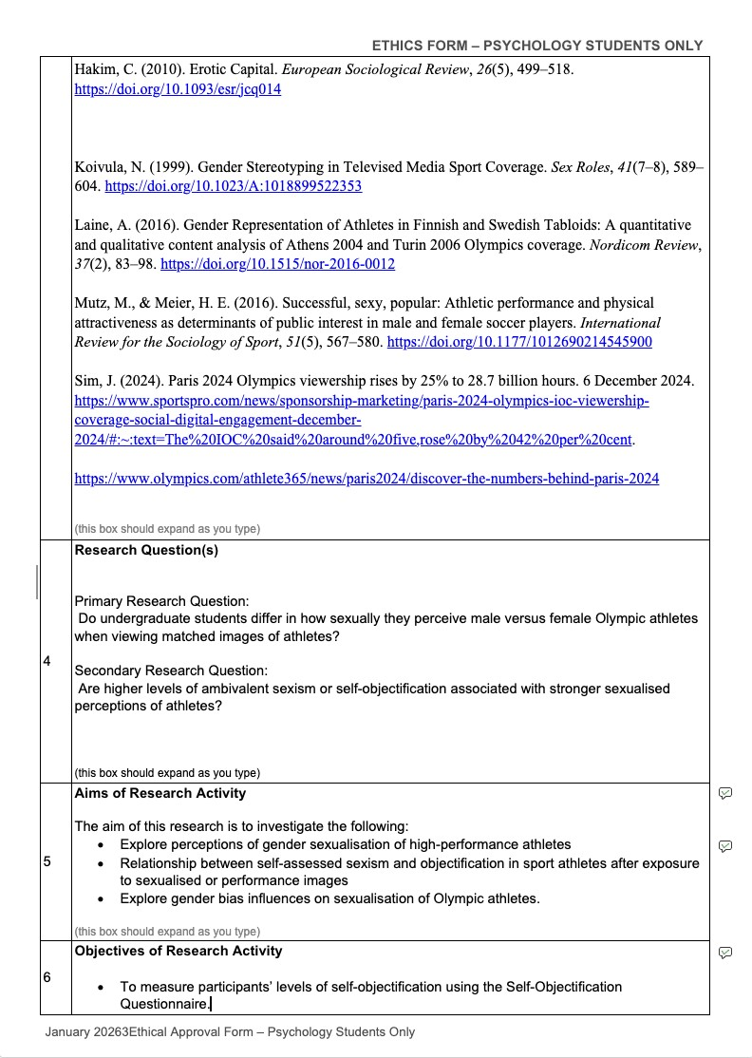
Figure 3. research questions
This section demonstrates the development of the research questions, aims and objectives used throughout the study. Collaborative discussions and reviewing relevant literature helped refine the overall direction of the project, improve consistency across research documents and strengthen the proposed methodology.
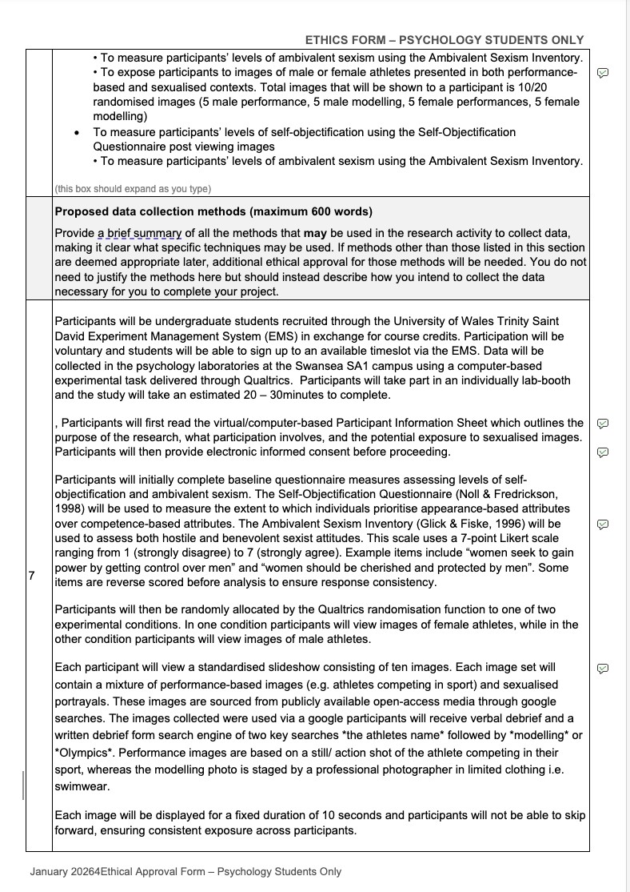
Figure 4. data collection methods.

This section demonstrates the development of the study methodology, participant procedures and data collection materials. Reviewing feedback, and refining the procedures collaboratively, improved the clarity, consistency and ethical suitability of the proposed research while also strengthening my understanding of how psychological studies are prepared prior to data collection.
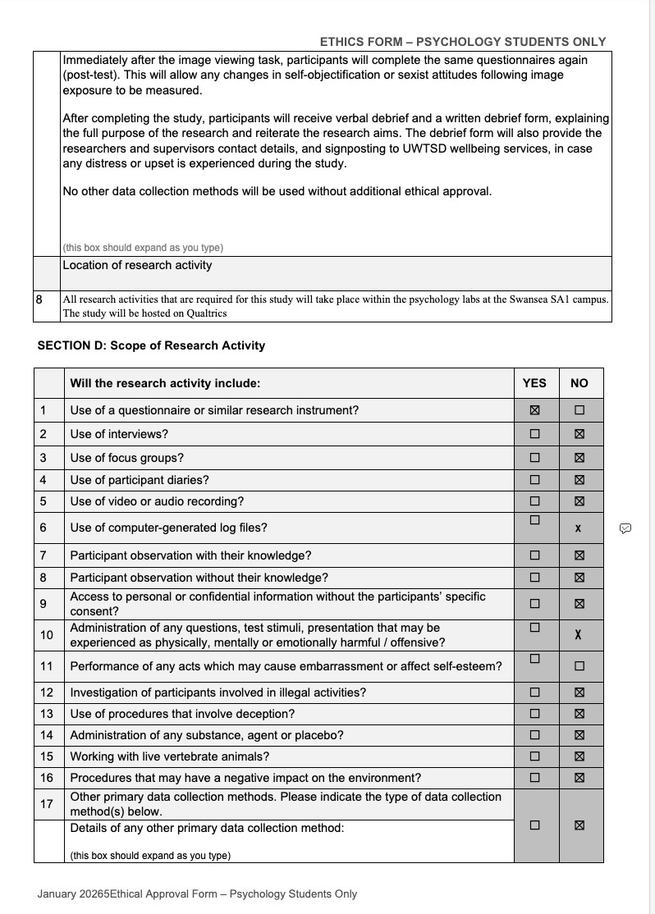
Participant procedures and research scope
This section demonstrates the development of the participant procedures and ethical considerations included within the study. Regularly reviewing the research materials and responding to feedback improved consistency across documents and strengthened my understanding of ethical responsibility, participant wellbeing, and professional research practice.

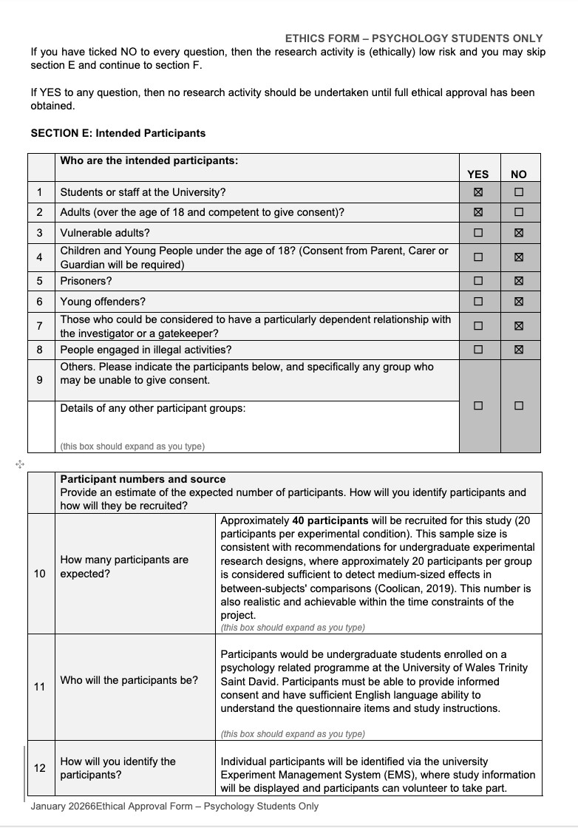
Figure 6. Participant recruitment and sampling procedures
This section demonstrates the development of the participant recruitment procedures and sampling strategy used within the study. Reviewing feedback and discussing methodological decisions collaboratively improved my understanding of participant selection, ethical recruitment, and the importance of justifying sample sizes within psychological research.

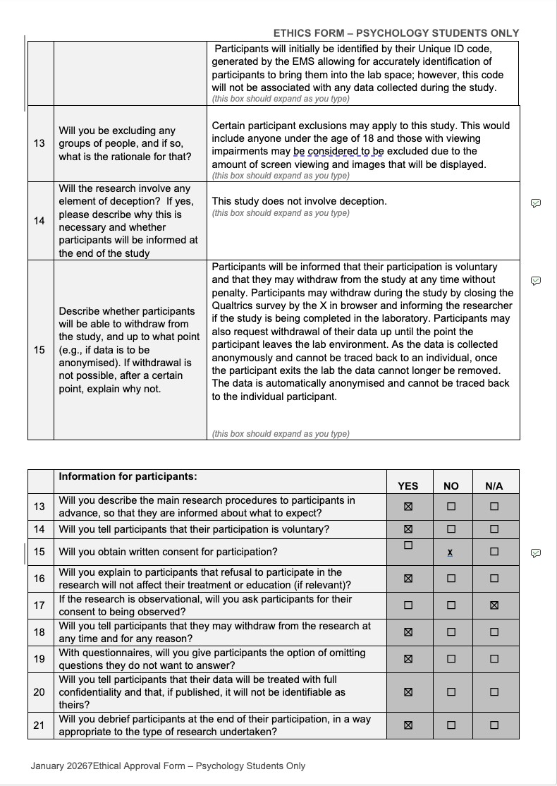
Figure 7. Participant rights and ethical protections
This section demonstrates the development of the ethical safeguards and participant protections included within the study. Completing these sections improved my understanding of informed consent, confidentiality, withdrawal rights, and the responsibilities involved in conducting ethical psychological research with human participants.

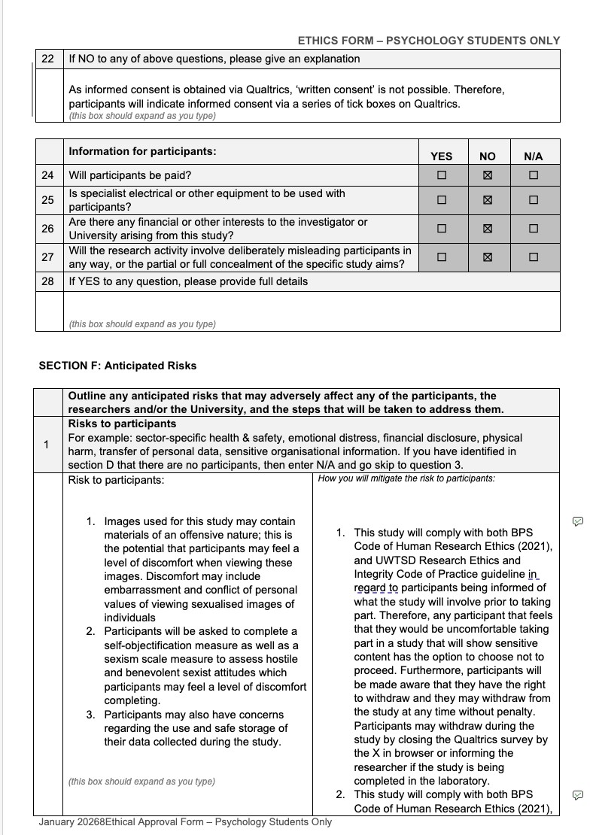
Figure 8. Anticipated risks and ethical risk management
This section demonstrates the identification of potential participant risks and the development of procedures designed to minimise harm and protect participant wellbeing. Reviewing ethical guidance and discussing appropriate safeguards collaboratively improved my understanding of risk management and ethical responsibility within psychological research.

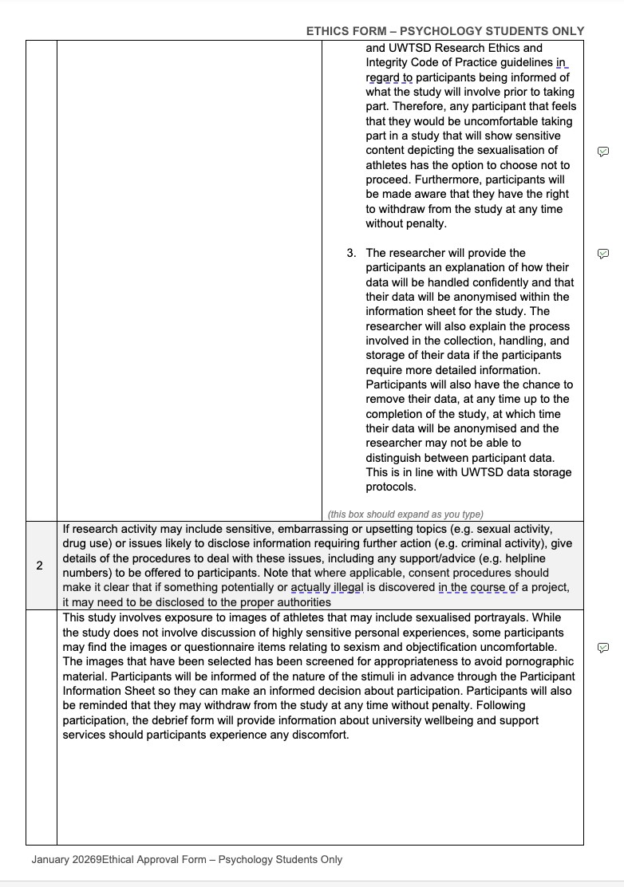
Figure 9. Managing sensitive research topics and participant wellbeing
This section demonstrates the ethical considerations involved when researching potentially sensitive topics, including sexualisation and sexism within sport media. Reviewing ethical guidance and refining participant safeguards collaboratively improved my understanding of how psychological research must balance research aims with participant wellbeing and protection from harm.

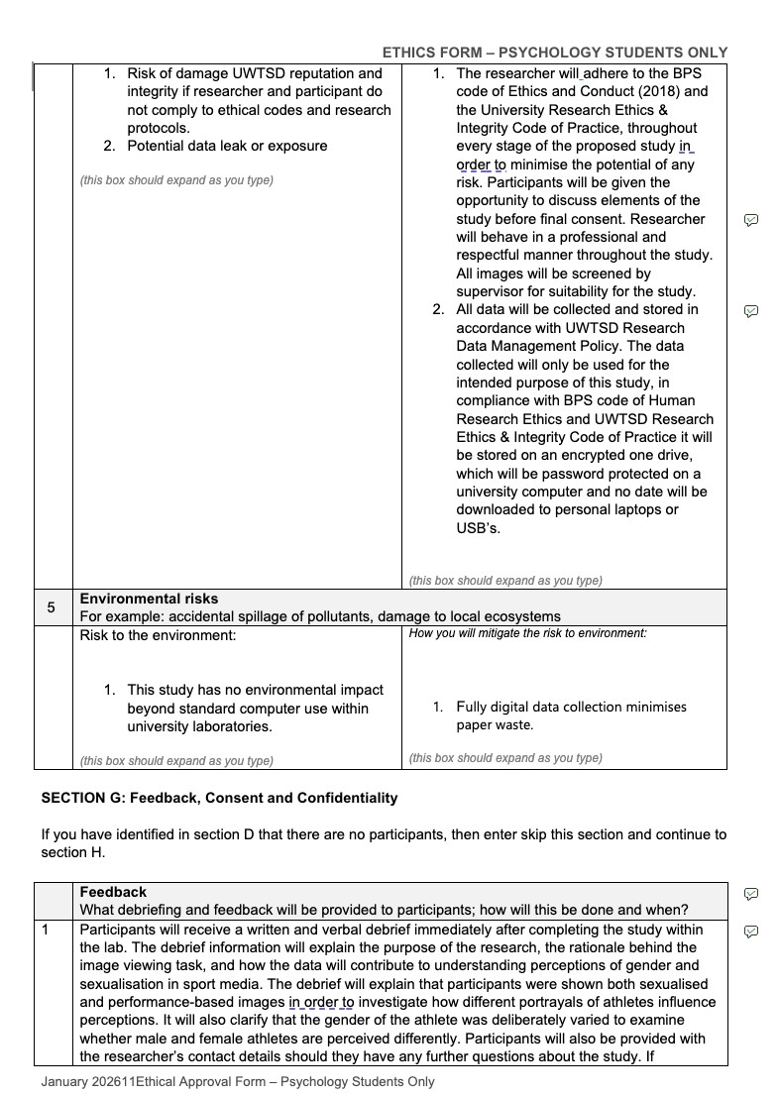
Figure 10. Institutional risk management and participant feedback procedures
This section demonstrates the development of procedures relating to confidentiality, data protection, and participant debriefing. Reviewing ethical guidance and refining these procedures collaboratively improved my understanding of professional responsibility, secure data handling, and the importance of maintaining transparency throughout psychological research.

Figure 11. Institutional responsibilities and participant debriefing procedures
This section demonstrates the development of procedures relating to professional conduct, data protection, participant debriefing, and ethical responsibility within the proposed study. Completing these sections improved my understanding of confidentiality, participant support, and the importance of maintaining professional standards throughout psychological research.

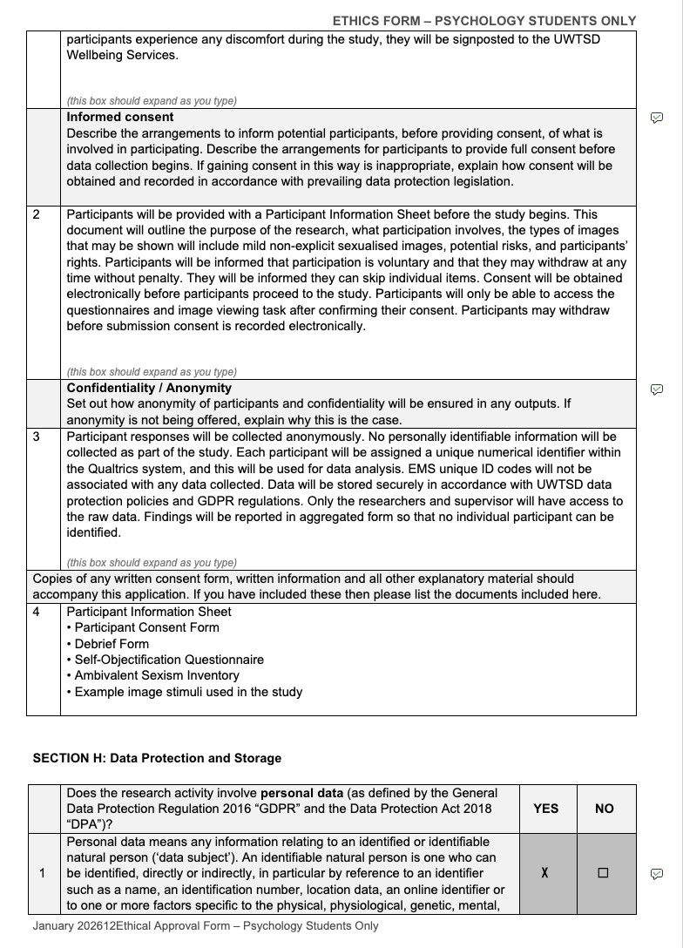
Figure 12. Informed consent, confidentiality, and data protection procedures
This section demonstrates the ethical procedures developed to protect participant wellbeing, informed consent, anonymity, and confidentiality throughout the study. Completing these sections improved my understanding of GDPR requirements, participant rights, and the importance of ensuring that psychological research is conducted in a secure, transparent, and ethically responsible manner.

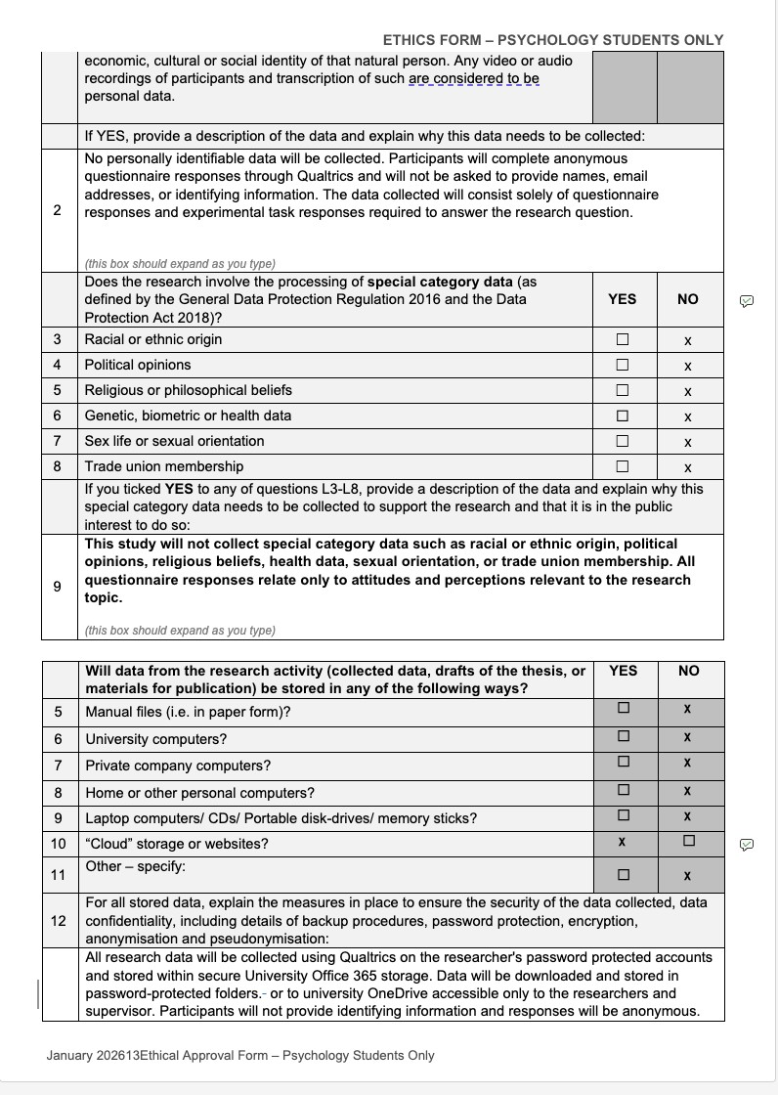
Figure 13. Data protection, anonymity, and secure data storage procedures
This section outlines the procedures developed to ensure participant anonymity, compliance with GDPR regulations, and secure handling of research data throughout the study. Completing this section increased my understanding of ethical data management within psychological research, including the importance of confidentiality, restricted data access, and secure digital storage procedures.

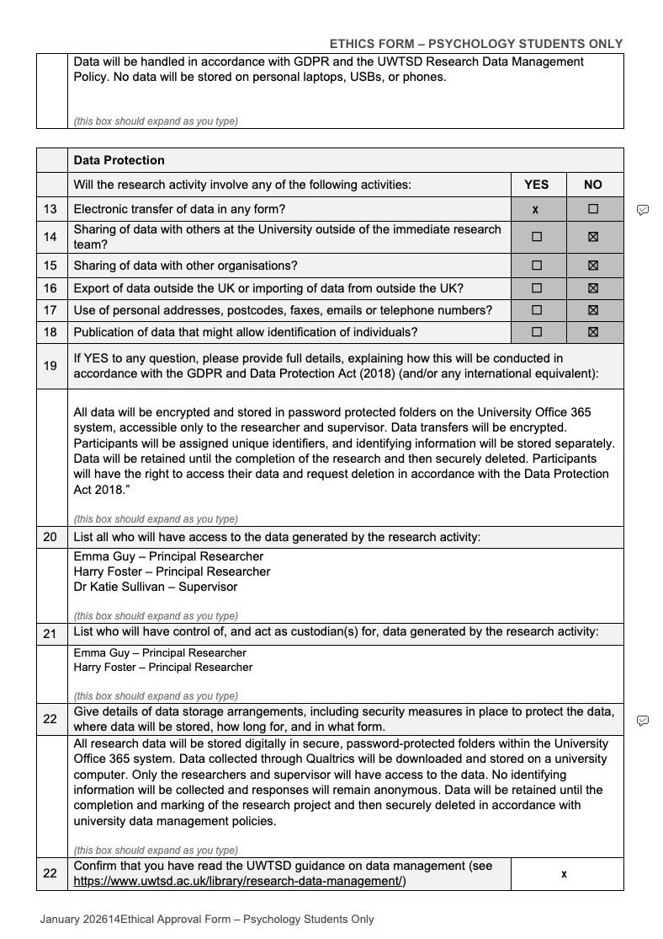
Figure 14. GDPR compliance and secure electronic data management procedures
This section outlines the procedures implemented to ensure GDPR compliance, encrypted electronic data storage, and restricted access to research data throughout the project. Completing this section improved my understanding of professional data management responsibilities within psychological research, including secure storage procedures, participant confidentiality, and ethical handling of digitally collected data.

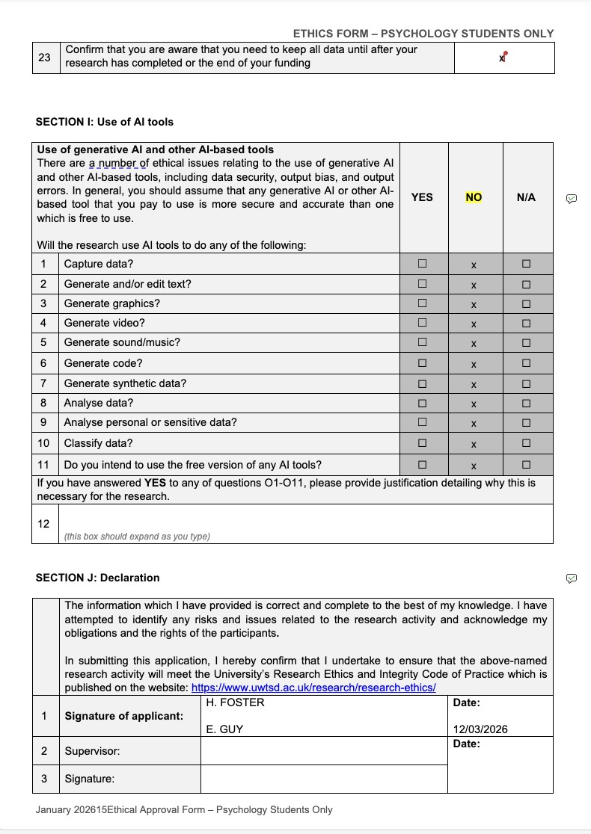
Figure 15. Consideration of AI use and final ethical declaration
This section demonstrates consideration of ethical responsibilities relating to the use of AI tools within research, alongside the final researcher declaration confirming adherence to university and BPS ethical guidelines. Completing the declaration process reinforced the importance of accountability, transparency, and professional responsibility when conducting psychological research.

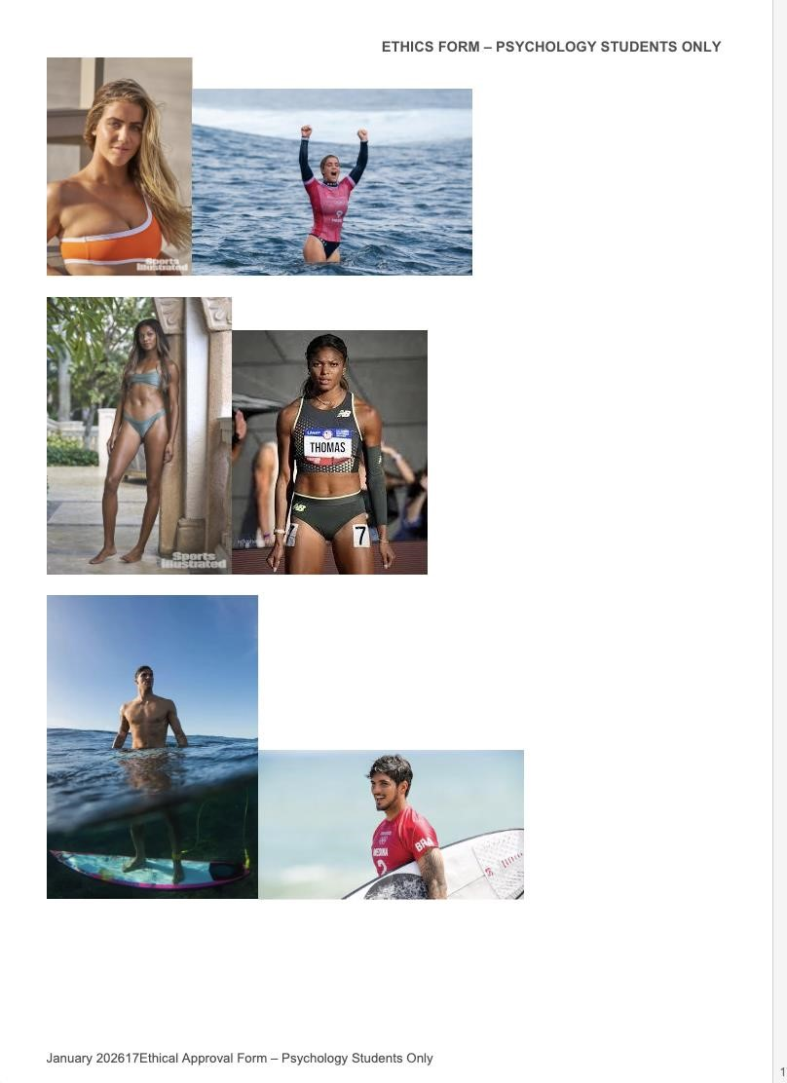
Figure 16. Example image stimuli used within the study
This figure presents examples of the performance-based and sexualised athlete images selected for use within the experimental task. Although Harry initially sourced many of the images, we worked collaboratively to review and discuss the suitability, consistency, and appropriateness of the stimuli to ensure they reflected the aims of the study while remaining ethically appropriate for participant exposure.





Competency 2
Proposal form completion

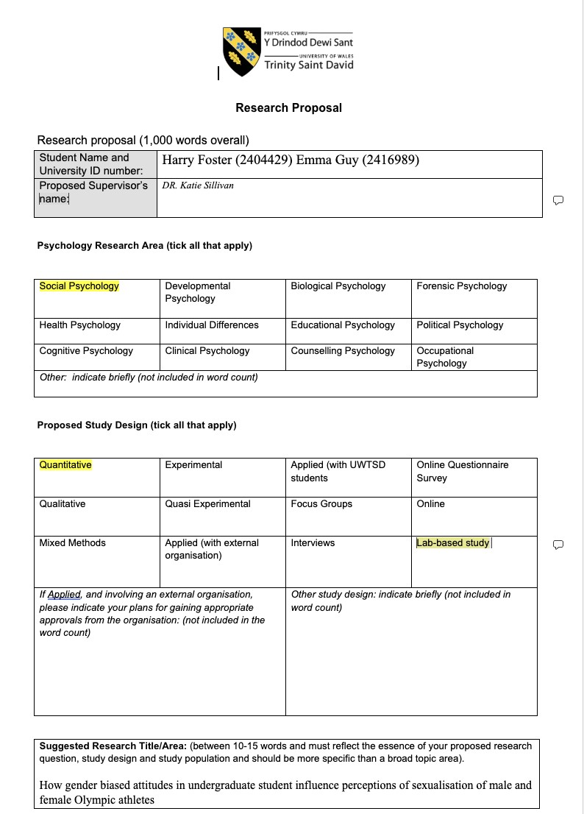
Figure 1. Initial research proposal outlining study design and research area
This figure presents the initial research proposal form used to outline the proposed study topic, research area, and methodological approach. Completing this proposal required collaborative discussion regarding the aims, design, and feasibility of the project, helping to establish a clear foundation for the later development of the ethics application and data collection materials.

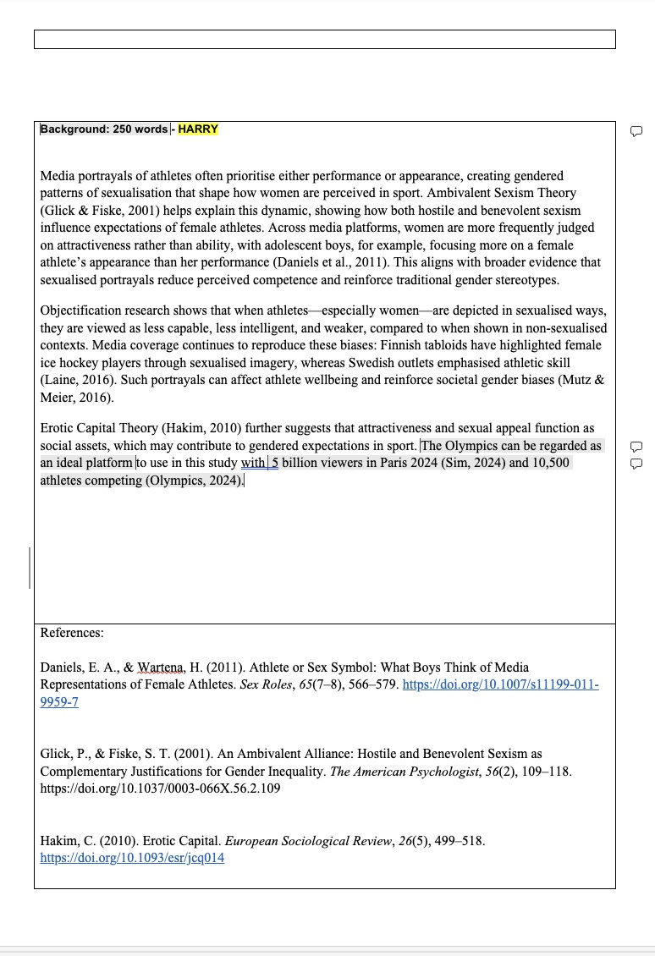
Figure 2. Development of the literature background for the research proposal
This figure presents the background literature section developed for the research proposal, outlining theoretical and empirical research relating to gender bias, sexualisation, and perceptions of athletes within sport media. Although Harry initially drafted this section, we discussed the literature together and reviewed the content collaboratively to ensure consistency with the overall aims, methodology, and ethical considerations of the study.

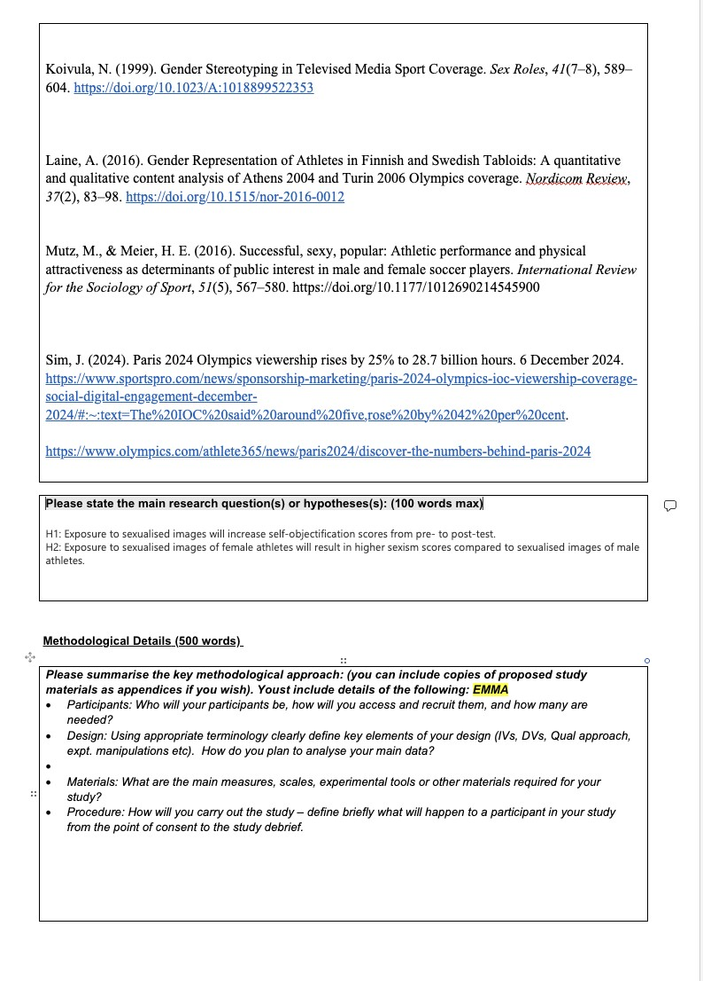
Figure 3. Development of the study hypotheses and methodological planning
This figure shows the development of the study hypotheses and the initial methodological planning section of the proposal. Completing this section required consideration of the relationship between the research aims, variables, and experimental design to ensure the proposed study was both measurable and appropriate for quantitative analysis.

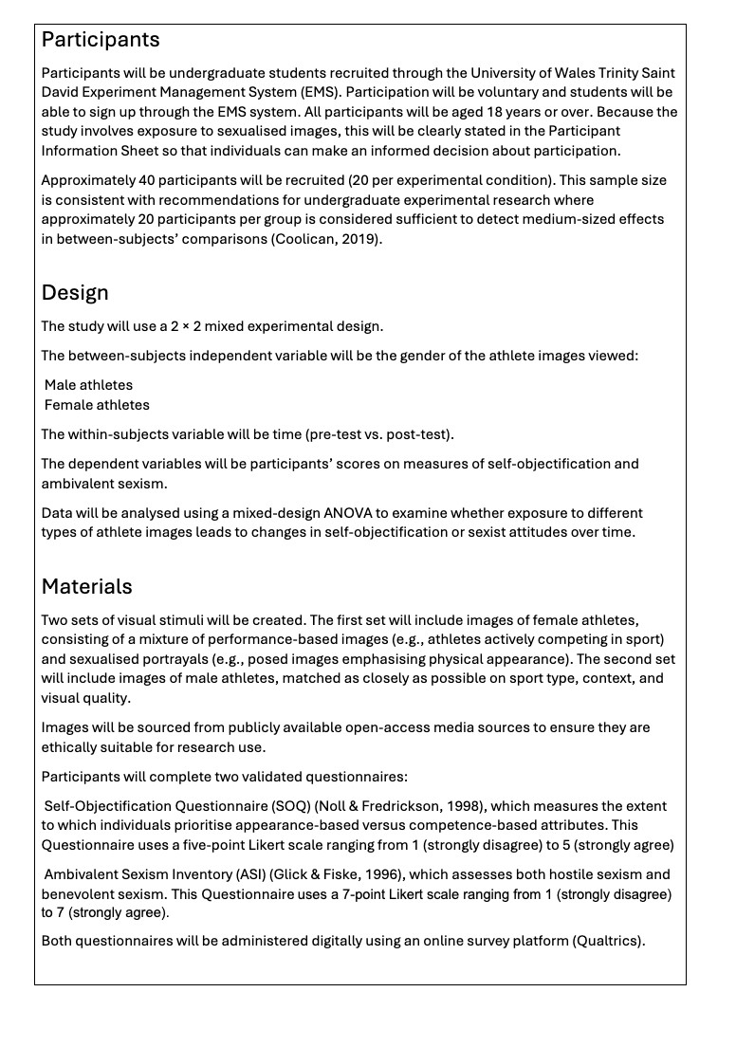

Figure 6. Selection of study materials and psychological measures
This section outlines the visual stimuli and questionnaire measures selected for the study, including the Self-Objectification Questionnaire and Ambivalent Sexism Inventory. Developing this section required collaborative discussion to ensure that the materials were appropriate, ethically suitable, and consistent with the aims of the research project.

Figure 5. Experimental design and planned statistical analysis
This figure presents the experimental design of the study, including the independent and dependent variables and the proposed mixed-design ANOVA analysis. Completing this section helped develop my understanding of quantitative research design, operationalisation of variables, and the relationship between research questions and statistical analysis procedures.

Figure 4. Participant recruitment and sampling procedures
This section outlines the proposed participant recruitment strategy and sampling procedures for the study. Developing this section improved my understanding of participant inclusion criteria, ethical recruitment through EMS, and the importance of justifying sample size within undergraduate experimental research.

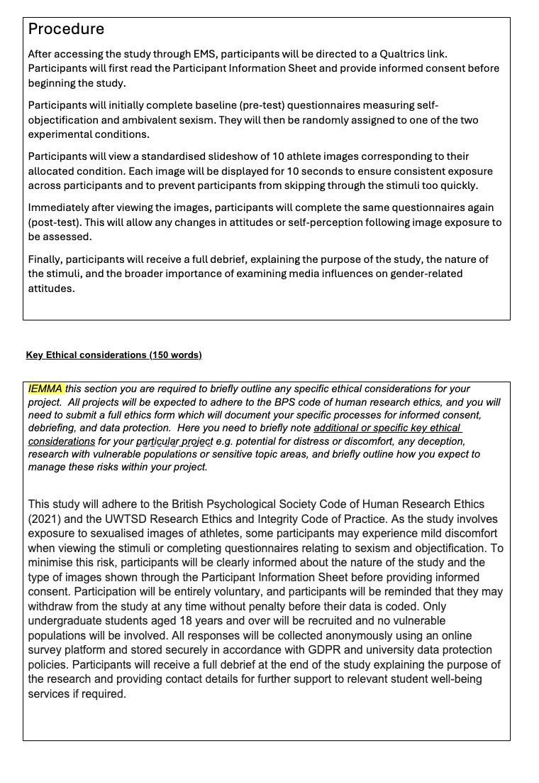
Figure 8. Key ethical considerations within the research proposal
This section outlines the key ethical considerations relevant to the proposed study, including participant wellbeing, informed consent, confidentiality, and the handling of sensitive image stimuli. Completing this section reinforced the importance of integrating ethical thinking throughout the research planning process rather than viewing ethics as a separate stage of the project.

Figure 7. Development of the experimental procedure
This figure outlines the step-by-step procedure participants would complete during the study, from informed consent through to debriefing. Writing this section improved my understanding of how to structure a clear and standardised experimental procedure while ensuring consistency across participants and adherence to ethical guidelines.

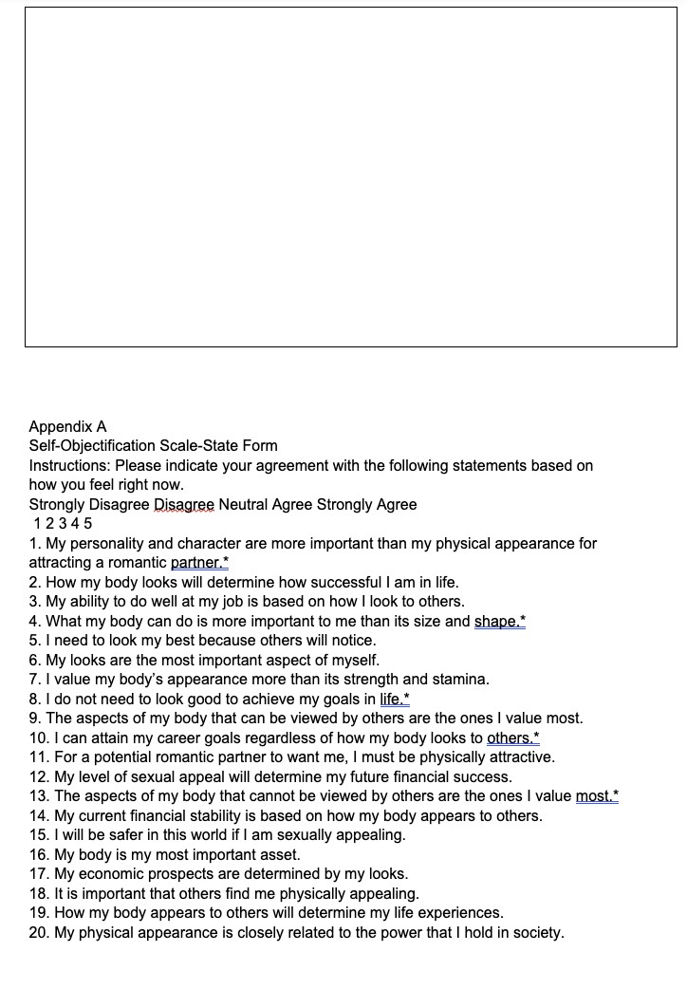
Figure 9. Selection of questionnaire materials included within the proposal appendices
This figure presents example questionnaire materials included within the proposal appendices. Reviewing and discussing these measures collaboratively helped ensure that the selected scales were appropriate for measuring the constructs relevant to the research aims and proposed hypotheses.

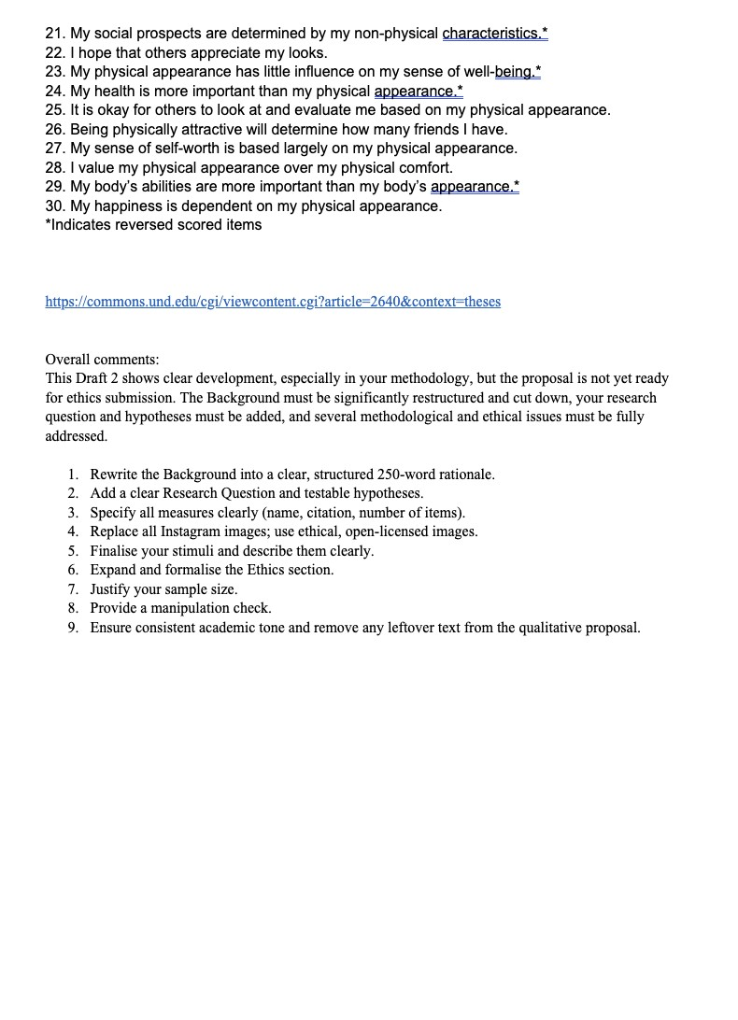
Figure 10. Reflection on formative feedback provided for the proposal draft
This figure presents formative feedback received on the initial proposal draft. Reviewing this feedback helped identify areas requiring further development, particularly regarding methodological clarity, ethical justification, and refinement of the research rationale. Responding to feedback throughout the module contributed to improvements in both my academic writing and critical reflection skills.

References
Breakwell, G. M., Smith, J. A., & Wright, D. B. (2021). Research methods in psychology (6th ed.). Sage.
British Psychological Society. (2021). Code of human research ethics. British Psychological Society.
Cottrell, S. (2019). The study skills handbook (5th ed.). Red Globe Press.
Evans, J. R., & Mathur, A. (2018). The value of online surveys. Internet Research, 28(4), 854–887. https://doi.org/10.1108/IntR-03-2018-0089
Gibbs, G. (1988). Learning by doing: A guide to teaching and learning methods. Oxford Polytechnic.
Hattie, J., & Timperley, H. (2007). The power of feedback. Review of Educational Research, 77(1), 81–112. https://doi.org/10.3102/003465430298487
Kolb, D. A. (1984). Experiential learning: Experience as the source of learning and development. Prentice Hall.
Smith, J. A. (2015). Qualitative psychology: A practical guide to research methods (3rd ed.). Sage.
Tuckman, B. W. (1965). Developmental sequence in small groups. Psychological Bulletin, 63(6), 384–399. https://doi.org/10.1037/h0022100

