UWTSD
WISA



Engineering Problem
Engineering Design ACHA4001

Daniel Jack Briggs
2312568
11/10/25

Contents
1 Introduction 1
1.1 Justification 1
1.2 Aims 1
1.3 Objectives 1
2 Background 2
3 Research 3
4 Materials 3
5 Designs 4
6 Process 5
7 CAD 6
8 Technical Drawings 7
9 Design Justification 8
10 Conclusion and Further Work 8
11 References 9

Figure 1 (The original design of the anodization tank from the assignment brief). 2
Figure 2 (Design 1). 4
Figure 3 (Design 2). 4
Figure 4 (Design 3). 5
Figure 5 (CAD image of the tank). 6
Figure 6 (CAD image of the lid). 6
Figure 7 (CAD image of the tank and lid). 6
Figure 8 (This technical drawing is of the base of the tank.) 7
Figure 9 (This technical drawing is of the lid of the tank.) 7

Table 1 (Shows the comparison of different materials.) 3
Table 2 (Components Bought for the Product). (https://www.screwfix.com/) 8

Introduction

Justification
To show an understanding of the design process used in the manufacturing industry and to show the ability to take regulations into account.

Aims
The aim of this technical report is to provide a basic understanding of the processes of carrying out a design project.

Objectives
Design three different products for an OEM (Original Equipment Manufacturer).
Discuss the material used in the final product and why the material was used.
Discuss the final product design and justify why that design was chosen.
Discuss the process used to create the final product.

Background
In this assignment the class was given a task to redesign the lid to an anodization tank from the perspective of a OEM (Original Equipment Manufacturer).
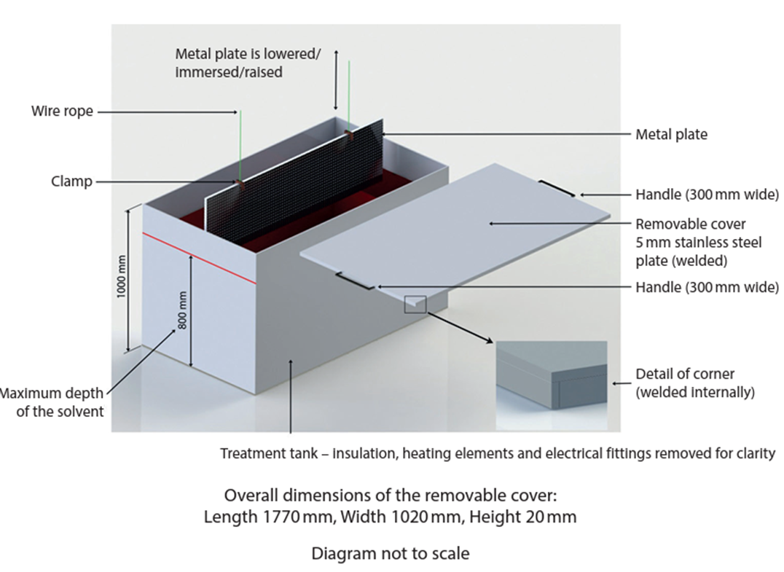
Figure 1 (The original design of the anodization tank from the assignment brief).
The customer requirements are:
• Must be safe to operate
• Operated by a single person
• The tank dimensions and material must remain the same, but modifications can be made
• The tank lid can be altered as the designer sees fit
• There must be clearance from above to allow the aluminium parts to be lowered into the tank

Research
Sulfuric acid is a chemical used in multiple industrial processes and research because of its corrosive and oxidization properties.
30% concentration of sulfuric acid represents the optimal concentration balance between the relative use of the acid and health and safety. This means sulfuric acid is valuable for technical applications such as the anodization process used in vehicle manufacturing.
Legislation and regulations that must be considered are:
“The Poisons Act 1972(Explosives Precursors) (Amendment) Regulations 2018 made sulfuric acid a regulated explosive precursor when concentrated above 15%” GOV.UK. (2023). So, this makes the Chemical a highly restricted product.
“Control of Substances Hazardous to Health (COSHH) Regulations 2002” Health and Safety Executive (2024). This is another regulation to be considered because of how workers will work with the chemical.

Materials

Table 1 (Shows the comparison of different materials.)
Materials | Weight | Dimensions | Cost
Stainless steel  Original Part | 73.3KG | 1770x1020x5mm | £102.62
Polypropylene | 16.5KG | 1770x1035x10mm | £24.92
PTFE | 40.3KG | 1770x1035x10mm | £410.66
Titanium | 41.4KG | 1770x1035x5mm | £421.45

For this product, I have chosen to use Polypropylene because it is a strong plastic that can take a battering and is sulfuric acid resistant. Also because the customer required a single-person operation instead of a two-person operation, so this meant the product's weight also had to be reduced and polypropylene is the lightest and cheapest material to use for the product. This will also fall under the “Health and Safety Executive Manual Handling at Work Act 1992” Health and Safety Executive (2020). which is 25kg for a Male and 16kg for a Female for a single-person operation as recommended. Polystyrene is also recyclable, meaning the product can be recycled after its industrial lifespan is up (polypropylene's industrial lifespan is estimated at 20 -30 years).

Designs
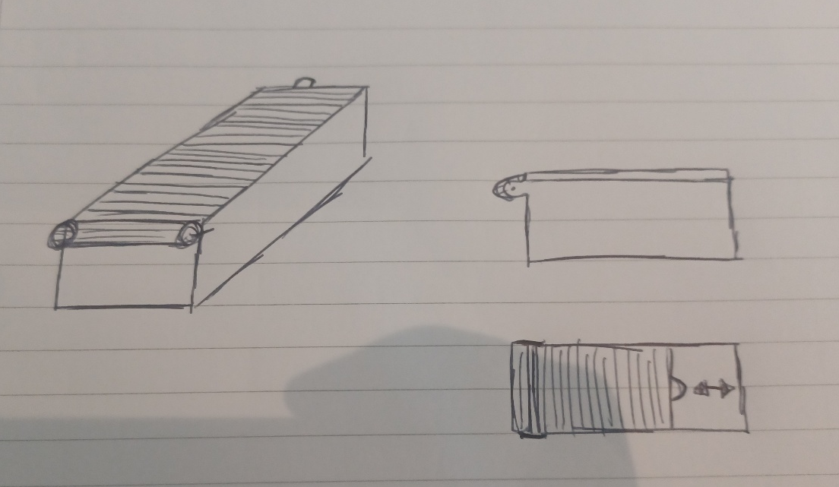
Figure 2 (Design 1).
Design 1 shows a rail door system that rolls forwards and backwards along a rail. The reason why I didn’t use this design is due to the materials that would be needed to be used would degrade rapidly due to the sulfuric acid.
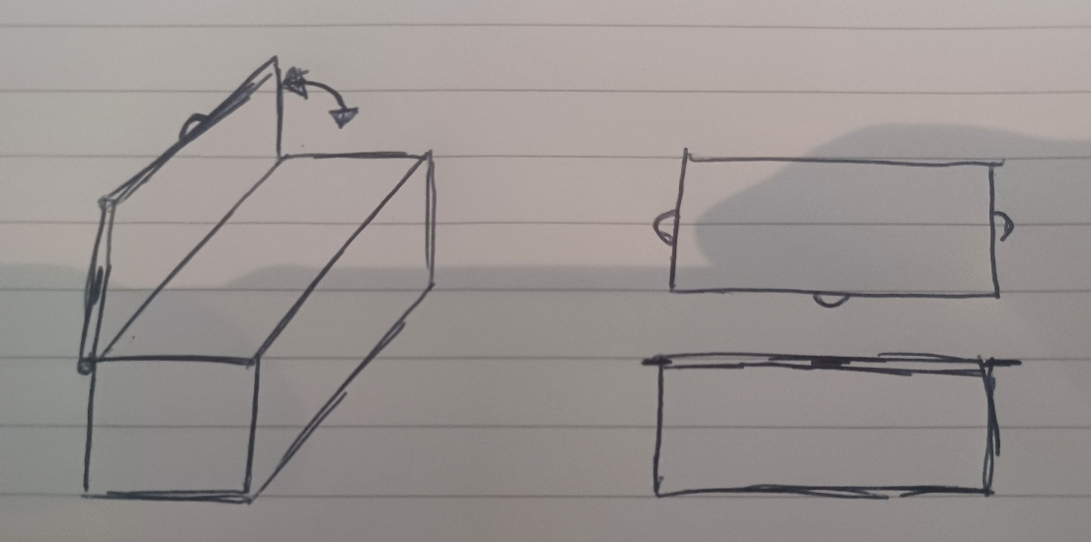
Figure 3 (Design 2).
Design 2 shows a hinge lid that will work, but the operator would lean over the tank and put themselves in danger, so I chose not to use this design.
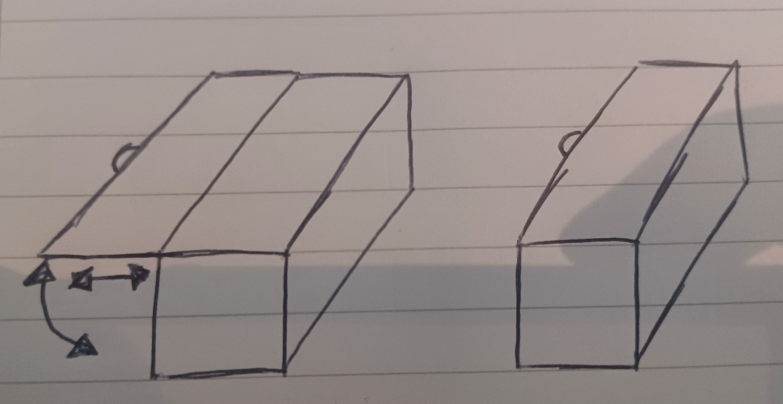
Figure 4 (Design 3).
Design 3 shows a tuckaway lid. This is the design I chose to use as my product because it's simple and it keeps the operator safe.

Process
The process to manufacture the lid for the anodization tank will be injection moulding at 10 mm wall thickness. The reason for injection moulding is that the lid of the Tank can be produced in one large component instead of multiple components (the handle will be made on the lid as one part and the side runners and back stop will also be made as one piece). Injection moulding is also cost-effective when producing high numbers of the same product, which will be the best option for the product's manufacturing because the customer will need dozens of anodization tank lids to replace the tank lids that are currently in use.

CAD
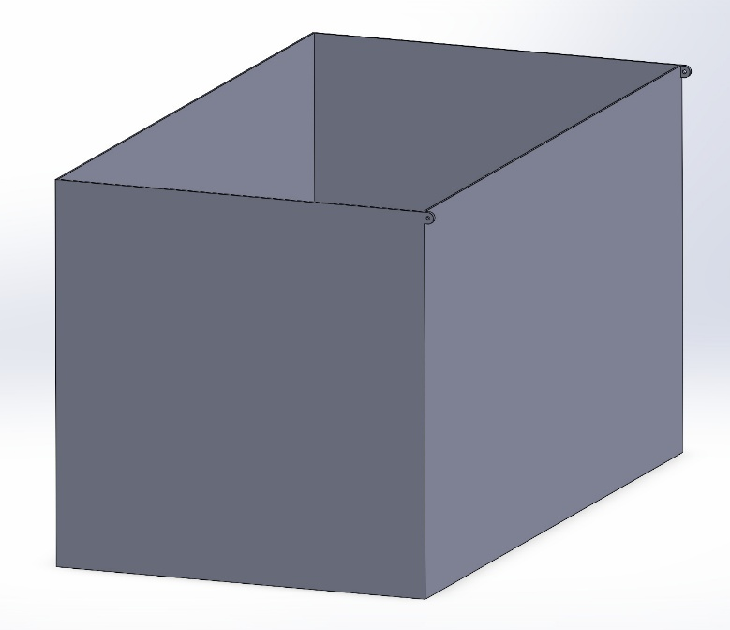
Figure 5 (CAD image of the tank).
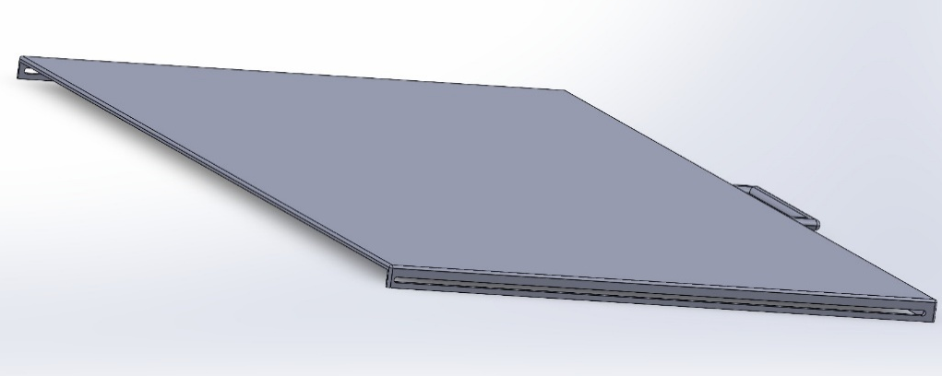
Figure 6 (CAD image of the lid).
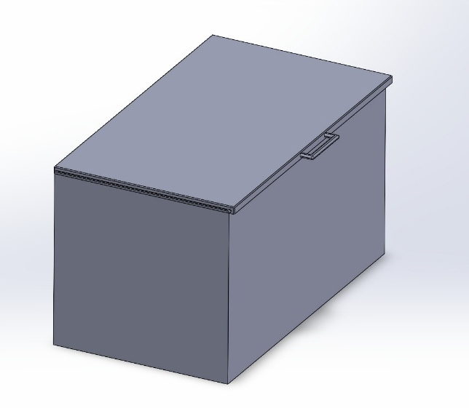
Figure 7 (CAD image of the tank and lid).

Technical Drawings
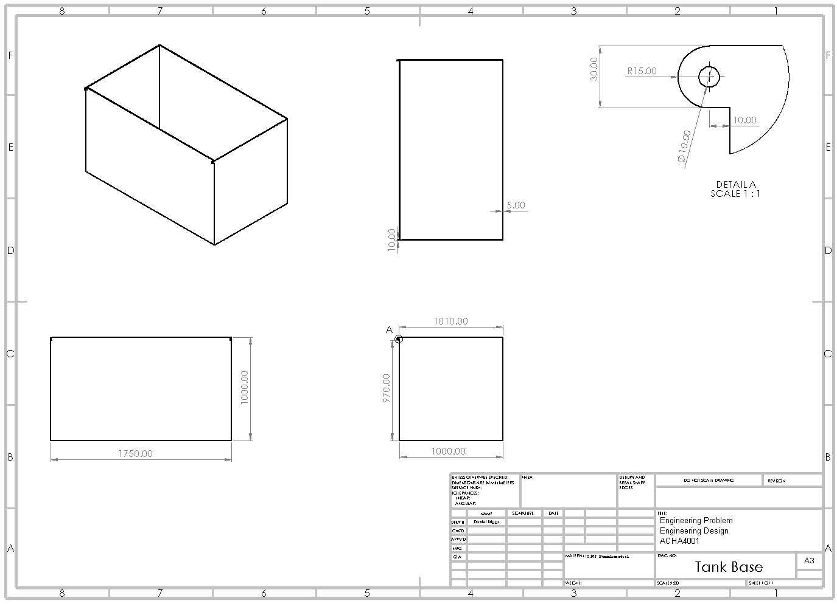
Figure 8 (This technical drawing is of the base of the tank.)
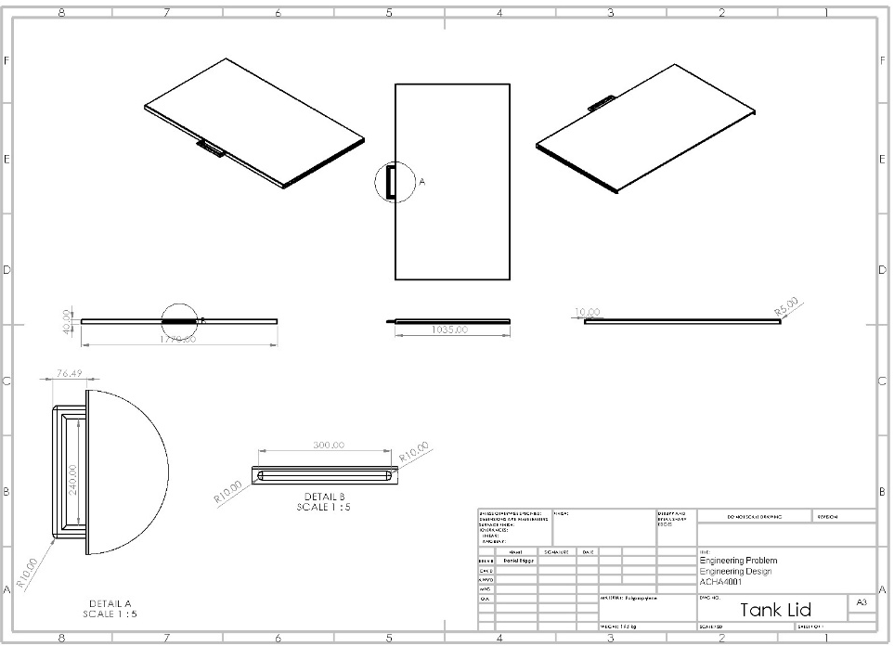
Figure 9 (This technical drawing is of the lid of the tank.)

Design Justification
The reason for the final product design is to keep the product simple to create and operate the product. With the minimal number of parts because “the best part is no part”, said by Elon Musk, Michael Jolley (2022). and keeping it simple to operate means there are fewer parts to go wrong because “if it can go wrong, it will go wrong”, Murphy’s Law.
The lid will be held on the tank by two M10 stainless steel nuts and bolts
Table 2 (Components Bought for the Product). (https://www.screwfix.com/)
Product Name | Cost
Easyfix A2 Stainless Steel Set Screws M10 x 40mm 10 Pack | £6.49
Easyfix A2 Stainless Steel Nylon Lock Nuts M10 100 Pack | £20.99

This product will have a 12-month maintenance schedule to keep track of wear and tear and any accidental damage. This means that the product is cheap to produce, in turn making the product affordable to replace the lid and will recycle the old product. I expect the lifespan of this product to last about 4-5 years taking into consideration of wear and tear.

Conclusion and Further Work
This product will meet all the minimum design requirements from the customer while keeping it as cheap as possible. Next time I could also consider rollers within the track. In turn this would reduce the wear and tear on the rail track lid, extending the life expectancy for the lid. I would also spend more time on the CAD model and make the model open, close and fold away just like the real product would.

References

Alliance Chemical. (2021). Sulfuric Acid 30% - Industrial Chemical Solutions | CAS... [online] Available at: https://alliancechemical.com/products/sulfuric-acid-30

King, M.J., Moats, M. and Davenport, W.G. (2013). Sulfuric acid manufacture : analysis, control and optimization. Oxford: Elsevier.

GOV.UK. (2023). Licensing for home users of poisons and explosive precursors. [online] Available at: https://www.gov.uk/government/publications/licensing-for-home-users-of-explosives-precursors/licensing-for-home-users-of-poisons-and-explosive-precursors.

Health and Safety Executive (2024). Control of Substances Hazardous to Health (COSHH) - Health and Safety Topics in Cleaning. [online] Hse.gov.uk. Available at: https://www.hse.gov.uk/cleaning/topics/coshh.htm

FOW Mould. (2023). How to Choose from Best 5 Chemical Resistant Plastic - Immould. [online] Available at: https://www.immould.com/chemical-resistant-plastic/.

Health and Safety Executive (2020). Health and Safety Executive Manual handling at work A brief guide. [online] Available at: https://www.hse.gov.uk/pubns/INDG143.pdf.

Michael Jolley (2022). Elon Musk explains the SpaceX philosophy on lean manufacturing and design - Starship. [online] YouTube. Available at: https://www.youtube.com/watch?v=CoKsF3HRGnI

