

MODULE: MARKETING MANAGEMENT
MODULE CODE: LCMB7001
ASSESSMENT 1

Assignment Title: Marketing Management - Assignment 1
Student Name: Drashti Sorathiya
Student ID: 2240378
Lecturer Name: Tushara Balendran
Submission Date: 22/12/2023

Table of Contents
1. Introduction 4
2. Communication 5
2.1. Communication Model & Diagram: 5
3. Customer Journey Mapping Theory 7
3.1. Overview 7
3.2. Customer Journey Mapping Theory in the Context of Starbucks: 9
4. Integrated Marketing Communication Theory: 10
4.1. Recommendations for New Promotional Strategies for Starbucks 11
5. Stages in the Customer Journey Map: 13
5.1. Customer Journey Stages 13
5.2. Starbucks Customer Journey Touchpoints: 13
5.3. Starbucks Customer Journey Map: 15
6. Communication Channels: 18
6.1. Omnichannel Marketing: 18
7. Stakeholder Expectations at Starbucks 20
7.1. Stakeholder Theory: 20
7.2. Meeting Starbucks Stakeholder Expectations for Long-Term Success: 21
8. Conclusion 23
References 24
Appendixes 26
Appendix 1: Starbucks Drive Thru Customer Journey: 26
Appendix 2: Starbucks Pick Up Customer Journey Map: 27
Appendix 3: Starbucks Walk-In Customer Journey Map: 27
Appendix-4: Starbucks System Map: 28

List of Figures
Figure 1: Marketing Communication Model 6
Figure 2: Customer Journey Mapping Theory 8
Figure 3: Integrated Marketing Communication Model 10
Figure 4: Omnichannel Marketing 19

Introduction
A paradigm shift has been observed in the dynamic area of ​​customer satisfaction, which focuses on moving away from a traditional emphasis on touchpoints and towards an in-depth analysis of the customer journey from beginning to end (Kuehnl, 2019). This achievement highlights the understanding that customer satisfaction levels are not limited to personal interactions but are the result of their entire relationship with the brand.
The importance of this change cannot be overstated. Traditional approaches run the risk of overlooking the nuances of a long-term customer journey because they are so focused on touchpoint optimization. It can be a distraction, and this insight forces companies to rethink the strategies for maximizing customer satisfaction.
Develop sophisticated marketing strategies, which are essential to increase customer satisfaction in today’s marketing environment. These strategies explore customer experience, engagement, and brand loyalty in addition to traditional promotions. By combining new channels, companies can build holistic relationships with their customers that go beyond the limits of discrete networks (Tueanrat, 2021).
Starbucks, an internationally recognized chain of coffee shops, has been chosen as the subject of this study. Starbucks, best known for its recognizable green logo and presence in many countries, is a testament to the power of successful marketing to influence customers’ perceptions.
Starbucks has a diverse customer base that spans many different demographics. Starbucks attracts people looking for more than just a cup of coffee, from professionals hosting informal events to college students looking for a quiet place to study. Starbucks is a popular destination for a wide variety of people due to its welcoming atmosphere and food catering to different tastes and food demands Starbucks' emphasis on total experience is a notable factor that has a huge impact on its business model (Micheaux, 2019). Starbucks presents itself as a "third place"—a place separate from home and work where guests can relax, mingle, and develop a sense of community—in addition to serving good coffee, Starbucks has it great impact in maintaining the warm and inviting atmosphere that markets its brand.

As the research progresses, Starbucks will be used as a canvas to understand how an important retail player uses creative marketing strategies to navigate the complex world of customer satisfaction. The Starbucks case provides valuable insights into the opportunities and challenges facing the super brand as well as their applicability and effectiveness in shifting marketing strategies to the long-term goal of customer satisfaction.

Communication
The process of conveying and exchanging ideas, thoughts, feelings, or data between people, groups, or entities through spoken or written language, gestures, symbols, images, sounds, or even technology is known as communication. In order to provide understanding and convey meaning, it emphasizes nonverbal as well as verbal signals, such as tone, body language, and context. Successful message encoding and decoding, mutual comprehension encouragement, and the ability for participants to exchange information, feelings, and intentions are all components of effective communication. It serves as the cornerstone for interpersonal communication, teamwork, and the spread of knowledge in a variety of social, cultural, and technological contexts (Luo, 2022).

Communication Model & Diagram:
The process of exchanging both verbal and nonverbal messages is called communication. It's an ongoing process. A message is a prerequisite for communication. The recipient needs to receive this message via some sort of media. It is imperative that the recipient understand this communication in the same terms that the sender intended. He has a deadline by which to respond. Communication is therefore a two-way process, and it is incomplete if the recipient does not provide the sender with feedback regarding how well he understood the message.

- Context: The setting in which communication occurs has an impact. This context could be social, historical, cultural, or physical. Every communication starts with background information. The message that is communicated within a context is chosen by the sender.
- Sender/Encoder: The sender of the message is also known as the encoder. A sender uses symbols to communicate a message and elicit the necessary response, such as words or graphic or visual aids. As an illustration, consider a training manager guiding a new group of hires through their training. The sender could be a person, a team, or an institution. The sender's opinions, experiences, background, methodology, abilities, and knowledge all greatly influence the message. Determining whether the recipient will understand the message in the same terms as the sender depends on the verbal and nonverbal symbols used (Putra, 2022).

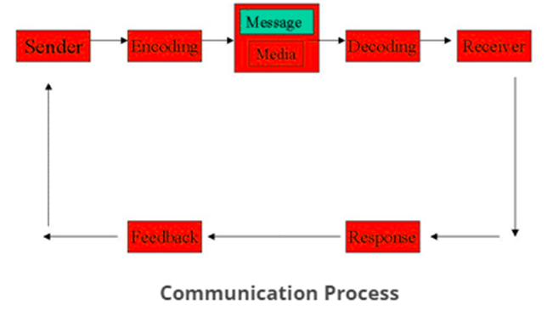
Figure 1: Marketing Communication Model

- Message: The main idea that the sender wishes to convey is the message. It's a signal that makes the receiver react. Deciding on the message to be communicated is the first step in the communication process. It is important to confirm that the message's primary goal is understood (Blakeman, 2023).

- Medium: A medium is a way to communicate or send a message. In order to ensure that the intended recipients receive the message, the sender must select an appropriate medium. Selecting the right communication channel is crucial to the message's effectiveness and the recipient's accurate interpretation of it. The characteristics of communication influence the choice of communication medium. For example, an oral medium is selected when the recipient must provide immediate feedback in order to clear up any misunderstandings, whereas a written medium is used when a message needs to be delivered to a small group of people.
- Recipient/ Decoder: The individual for whom the message is meant, aimed, or targeted is known as the recipient or decoder. The recipient's level of responsiveness to the message, the encoder's dependence on the decoder, and other factors all affect how much the decoder comprehends the message (Sari, 2023).
- Feedback: The primary element of the communication process is feedback, which enables the sender to assess the message's effectiveness. It assists the sender in verifying that the decoder correctly interpreted the message. Feedback can be expressed verbally or nonverbally, such as by sighs, smiles, or other nonverbal cues. It can also be written down in the form of reports, memos, etc.

Customer Journey Mapping Theory

Overview
The Customer Journey Mapping (CJM) theory has become a useful framework in modern business strategies for understanding and optimizing the complex path of a customer's interaction with a brand. This theoretical framework guides to view the comprehensive customer experience beyond the traditional methods of analyzing specific touchpoints (Hollebeek, 2020).
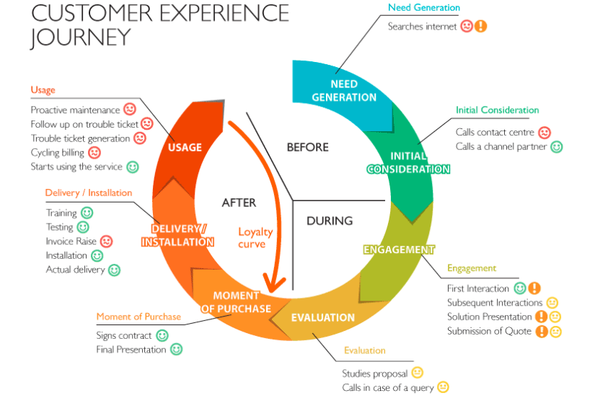
Figure 2: Customer Journey Mapping Theory
The customer journey map involves the creation of visual representations of a customer journey describing every stage of a customer with which the customer interacts with a specific product, service or brand extending beyond the purchase point including stages like first impression, pre-purchase thoughts, actual action, post-engagement experience and potential moments. The customer journey map helps us to gain a comprehensive understanding of the customer experience at all touchpoints (Rana, 2022).
A key component of the customer journey map it does not have a linear view of customer interaction rather it provides a comprehensive, thorough review of the dynamic customer journey identifying that customer experiences are connected and adaptable. The visualization in the customer journey map helps to identify the patterns, behaviors and critical touchpoints.

Customer Journey Mapping Theory in the Context of Starbucks:
Starbucks a globally recognized company is deeply rooted in retail and services and understands the customer journey fully. The customer journey in the perspective of Starbucks does not solely present touchpoint analytics or depict customer interactions like online purchases, rather it provides a holistic approach to the customer journey experiences including pre-purchase thoughts, experiences in-store, post-purchases interactions at the store or online purchase and moments after purchase (Anayiotos, 2021). The other customer journey maps like a drive-thru, pick-up purchase and walk-in are attached in (Appendix 1,2, and 3).
Starbucks is globally recognized for its unmatchable products and offerings. Utilizing the customer journey map can help the company to improve its business operations. The different stages of the customer journey and illustration enable Starbucks to deeply analyze the different touch points of the customer journey. This approach also aids the company to streamline its operations and procedures keeping in view the customer pre-purchase thoughts and post-purchase thoughts, improving customer satisfaction and hindering all obstacles in the way of company success and development (Klink, 2020).
Moreover, the different components in the customer journey map create new innovative opportunities for the company. Starbucks can take new ideas from the customer journey map because, at each touchpoint, there is a comprehensive customer experience detailing its thoughts, pain points and desires, this can help the company to think of new innovative and creative ideas to improve their services according to customer desires (Siebert, 2020). Taking this example into account, customers at Starbucks not only demand a flavorful cappuccino cup but also look for a cosy, attractive ambience where they can feel relaxed and enjoy their cup, in this context, Starbucks can utilize this idea and create an attractive yet relaxing ambience but not comprising over its quality.

Businesses need to realize that moving in a fast-paced environment without developing smooth interactions with their customers is a matter of risk. Thus, they should analyze each point of their customer journey carefully. In this perspective, a thorough customer journey experience can help Starbucks to develop and retain long-lasting relationships with its customers. By analyzing each point carefully of the customer journey, the company can identify issues and problems causing hindrances to reach their target audience, this approach will also improve customer interactions with the company (El-Barkouky, 2023).

Integrated Marketing Communication Theory:
Integrated Marketing Communication (IMC) is a framework that comprises different communication methods like sales promotion, direct marketing, public relations and others. This framework allows businesses to establish smooth communication with their targeted audiences. Businesses can choose their communication method depending on their target audience and business requirements (Blakeman, 2023).
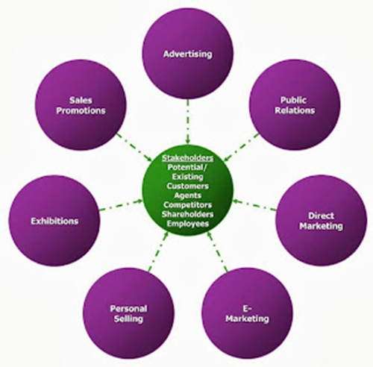
Figure 3: Integrated Marketing Communication Model
To strengthen Starbuck's brand identity, the implication of IMC tools is crucial. The company can utilize different tools of IMC to interact with their customers, delivering their message without any obstacles.

Recommendations for New Promotional Strategies for Starbucks
- Digital Engagement through social media:
Starbucks can use Social Media platforms like Twitter, Instagram and Facebook to interact with their audience. The company can utilize social media platforms and conveys its messages to customers by posting captivating content including pictures, videos and user-generated advertisements. The IMC aspect in this regard is consistency which the brand represents across its all-online channels by aligning its marketing message with digital media content (Krizanova, 2019).
- Mobile App Integration:
The development and integration of mobile applications in Starbucks's business strategies will allow a smooth and seamless flow of communication with their customers. Using Starbucks' mobile application will make their customers convenient. It will allow them to order, select, purchase and pay online using their smartphones. From the perspective of the IMC approach, the development of mobile application will strengthen the customer-centric approach and create convenience for customers, thus elevating the customer experience journey (PETCHJUMRUS, 2019).
- In-Store Promotions and Merchandising:
Another example through which Starbucks can attracts their customers is through in-store promotions. The company can often create and run in-store promotions on its various items like seasonal drinks or beverages. Starbucks can also introduce different merchandising items like mugs, tumblers and other accessories in limited-time offers. The in-store promotions at Starbucks will add value and contribution to the digital campaigns held by the company because they create consistency in attracting their customers towards stores. Moreover, the offering of different merchandise items like mugs helps to attract customers improving the overall brand experience (Novianti, 2022).
- Public Relations and Community Engagement:
Customers nowadays are more concerned about ethical and sustainable business practices customers are the focal points which urge companies to adapt and execute sustainable policies and procedures in their business operations. In this regard, Starbucks will engage in different corporate social responsibility activities like ethical sourcing and community support initiatives. The initiatives taken by Starbucks for delivering and showing their concerns for corporate social responsibilities and ethical practices will be delivered through media press releases, social media and by pasting in-door posters. This approach will raise brand concerns aligning these strategies with the company’s values.
- Traditional Advertising:
Not only this, Starbucks can still employ the traditional marketing advertising approach. The company will make advertisements and can also use print media to reach a large pool of people. These traditional approaches will add more contribution to the digital ones, assuring a broader range of audience and strengthening the brand's main message (Rivandi, 2021).

Stages in the Customer Journey Map:

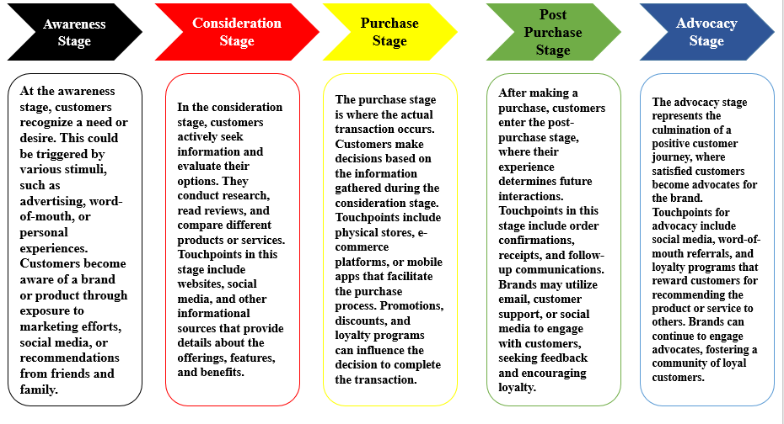
Customer Journey Stages

Starbucks Customer Journey Touchpoints:
- Pre-Purchase Stage:
People first become aware of their needs or desires during the pre-purchase phase of the consumer journey. Starbucks uses a variety of touchpoints to skillfully engage potential customers during this stage. Starbucks uses social media platforms as effective tools because they provide a venue for showcasing new products, sharing interesting content, and interacting with customers. An important source of information about the wide variety of coffee options, specials, and the whole Starbucks experience is the official Starbucks website. The Starbucks mobile app also acts as a handy pre-purchase touchpoint, letting customers browse the menu, find nearby locations, and even personalize their orders prior to visiting the actual store.
- Purchase Stage:
The primary transaction takes place during the purchase stage, and Starbucks uses a range of touchpoints to improve this experience. Starbucks locations themselves serve as the main points of contact and are thoughtfully furnished to create a warm environment. The design, furnishings, and scent all enhance the pleasing sensory experience. Beyond the pre-purchase phase, the mobile app plays a crucial role in the purchasing process by enabling users to use the "Mobile Order & Pay" function to place and pay for orders ahead of time. Starbucks offers discounts and freebies as part of their loyalty program, which is integrated into the checkout process. This encourages customers to make repeat purchases and builds customer loyalty (El-Barkouky, 2023).
- Post-Purchase Stage:
The phase that follows a purchase is crucial for retaining and promoting customers. Starbucks uses well-placed touchpoints to guarantee a satisfying experience after the sale. Customers frequently communicate with businesses via email, where they can get updates on new products, personalized offers, and order confirmations (Basaran, 2022). Members of the Starbucks Rewards program continue to earn points for every transaction, which they can then use to make future purchases. Starbucks encourages customers to share their experiences on social media, which helps to create a sense of community. Social media is still important. In addition to enabling transactions, the Starbucks app serves as a post-purchase touchpoint by letting users track rewards, get tailored recommendations, and leave reviews.

Starbucks Customer Journey Map:
Starbucks Customer Persona:
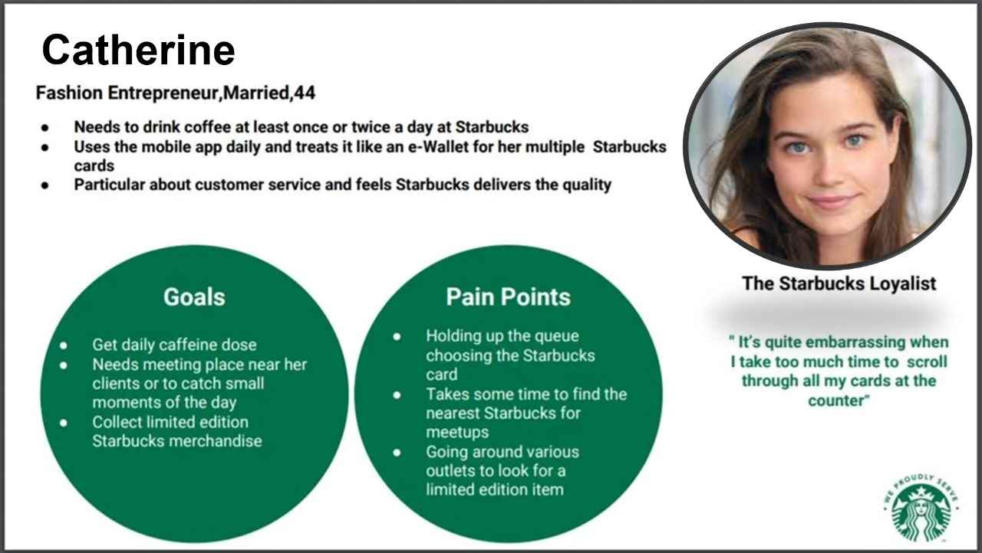
Source: Created by myself using Microsoft PowerPoint

Starbucks Customer Journey Map:
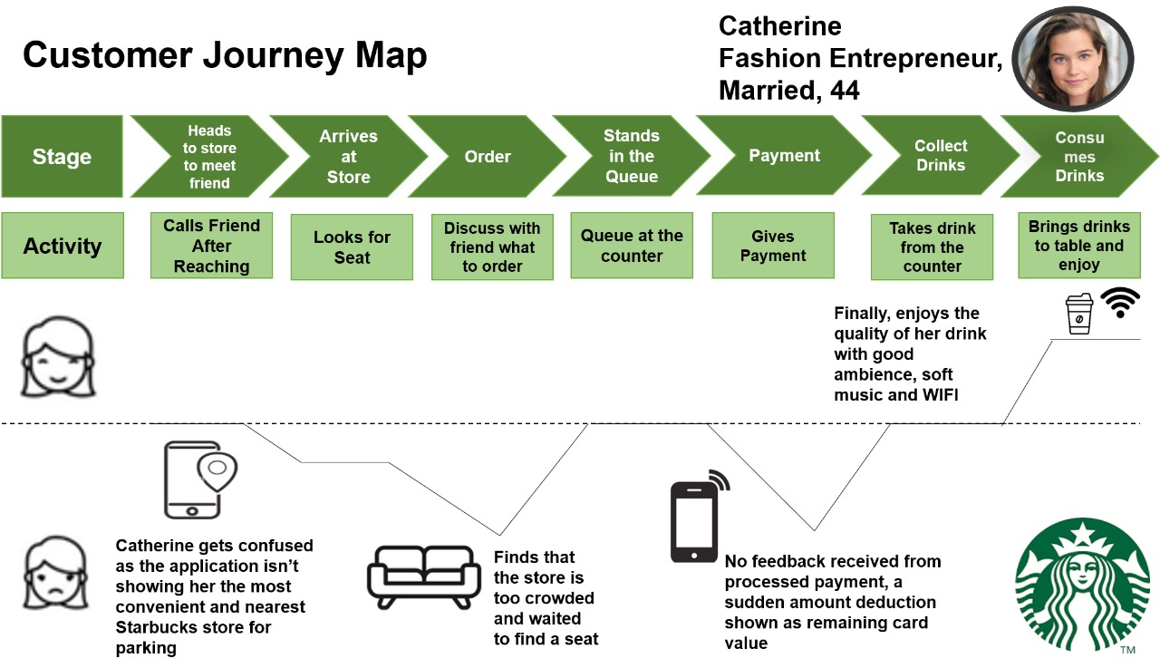
Source: Created by myself using Microsoft PowerPoint

Starbucks Customer Journey Map – (Strengths & Weaknesses):
- Heading to the Store to Meet Friend:
- Strengths: The initial stage involves a proactive activity of calling a friend, showing effective communication. However, the weakness lies in the feeling of uncertainty regarding the nearest Starbucks with parking, indicating a potential lack of clear information on the app.
- Opportunities for Improvement: Enhancing the app's functionality to provide clearer information about the nearest Starbucks with parking can improve the user experience.
- Arriving at the Store:
- Strengths: Catherine actively engages in finding a seat upon arrival, demonstrating a commitment to enjoying her Starbucks experience. However, the weakness lies in her unexpected wait due to crowdedness.
- Opportunities for Improvement: Starbucks could explore ways to manage and communicate store crowding, perhaps through the app or other digital channels, to set realistic expectations for customers.
- Deciding on the Order:
- Strengths: Catherine engages in a social activity by discussing her order with a friend, aligning with the social aspect of Starbucks. This stage indicates effective communication and collaboration.
- Opportunities for Improvement: No specific weaknesses are evident in this stage; however, maintaining a streamlined and user-friendly ordering process is crucial.
- Queuing:
- Strengths: Queuing at the counter is a common part of the Starbucks experience, and it aligns with the typical customer journey. This is a routine activity, and there are no apparent weaknesses.
- Opportunities for Improvement: Continuous monitoring and optimization of queue management to minimize waiting times can enhance customer satisfaction.
- Payment:
- Strengths: Catherine successfully completes the payment, but the weakness lies in the time taken to select cards and the lack of immediate feedback on processed payments.
- Opportunities for Improvement: Streamlining the payment process and providing instant payment confirmation can improve efficiency and enhance the overall experience.
- Collecting Drinks:
- Strengths: The standard activity of collecting drinks at the counter is a routine part of the Starbucks journey, with no apparent weaknesses.
- Opportunities for Improvement: Ensuring prompt and accurate order fulfillment contributes to a positive customer experience.
- Consuming Drinks:
- Strengths: Catherine enjoys her drink in a pleasant environment with soft music and free WIFI, showcasing the positive aspects of the Starbucks ambiance.
- Opportunities for Improvement: Maintaining the quality of the Starbucks environment and addressing any potential issues, such as seating availability, can enhance the overall customer experience.
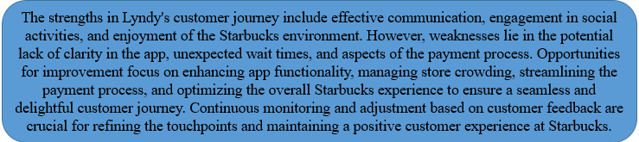
Overall Analysis:

Communication Channels:

Omnichannel Marketing:
Omnichannel marketing theory represents a strategic approach where a company can seamlessly integrate its multiple communication channels to create and design a unified coherent experience for its customers. The purpose behind this is to provide a smooth, consistent and interconnected journey across different touchpoints like online platforms, social media platforms, mobile applications and physical stores. In the context of Starbucks, the implication of Omni channel marketing stands as an effective strategy to improve the overall customer experience of Starbucks (Nguyen, 2022).
- Digital and Physical Platforms:
Starbucks can integrate its communication channels by exploiting the coaction between digital and physical platforms. First of all, Starbucks can ensure a smooth and seamless transition between its mobile application and in-store experience. For example, customers using the mobile application should feel like they are ordering their items in the physical store of Starbucks, in other words, the experience should be seamlessly integrating the mobile application procedure with in-store visits, allowing customers to have a swift, hassle-free yet smooth experience. This correlation correspondence improves a sense of continuity, ensuring that the customer journey is not disturbed by any transition between the physical and digital touchpoints (Cai, 2023).
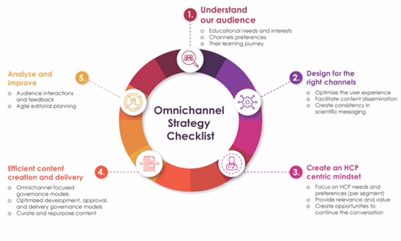
Figure 4: Omnichannel Marketing
- Social Media and In-Store Experience:
Additionally, Starbucks can utilize social media channels to accompany its in-store experience. By utilizing social media platforms like Facebook, Instagram and Twitter, Starbucks can engage with its audience by sharing captivating content and launching promotional campaigns. The integration of social media platforms with in-store ambience will help Starbucks to create a harmonized brand presence (Baron, 2023). For instance, a new beverage launched can be promoted on both platforms i.e. on social media and in-store. The campaign can be run on social media by uploading attractive visuals and in stores, it can be showcased by appealing posters, thus creating a cohesive customer experience.
- Loyalty Programs:
The loyalty programs across different channels are another approach for Starbucks to follow Omni channel marketing. Making sure that rewards earned by a customer through a mobile application are seamlessly applicable to in-store visits will encourage customers to engage continuously across that platform. This cohesive loyalty program adds value and contributes more to the unified customer experience, reinforcing the idea that every interaction with the company irrespective of the medium contributes to an increased level of commitment for customers from Starbucks (Basaran, 2022).
- Data Analytics:
The most modern use of technology Data Analytics plays a pivotal role in Omnichannel marketing. By using data analytics, the company can understand and analyze their customer’s behavior across different channels. Insights derived from this approach will help Starbucks to create personalized marketing strategies and product recommendations. For instance, data gathered from data analytics for a specific customer shows that he/she orders the same beverage every time, the company can now make a personalized discount or offer to him, or every time he purchases the product. This will have a dual benefit, the customer will regularly and consistently engage with the brand and the brand can easily generate profit from this approach (Blakeman, 2023).

Stakeholder Expectations at Starbucks

Stakeholder Theory:
Stakeholder Theory is a management and business tool that sets forth that organizations must consider the interests and expectations of their stakeholders, not solely shareholders. Stakeholders circumscribe a broad-spectrum including customers, employees, investors, suppliers, communities and another group of people. The theory focuses that success and sustainability are interlinked with their ability to manage and meet the diverse needs and expectations of all business stakeholders (Freeman, 2023).

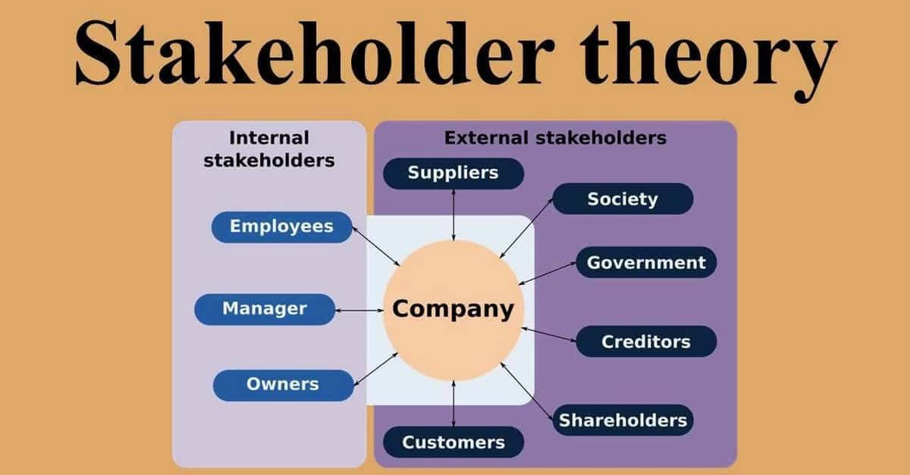

Meeting Starbucks Stakeholder Expectations for Long-Term Success:
The Stakeholder theory aligns with the giant global coffeehouse chain Starbucks contributing to its long-term success. The sophisticated nature of stakeholders ranging from customers taking a cup of coffee to employees contributes to the overall success of the company (Bridoux, 2022). Furthermore, it is connected to the business's everyday operations, and investors' desire for financial gains necessitates a thorough approach to stakeholder management. The Starbucks System Map showing the company’s stakeholders is attached in (Appendix-4).
- Customer Expectations:
Customers are important to the success of Starbucks. The promenade extends to serving premium beverages and offers a relaxed, relaxed and accommodating atmosphere. By providing great value with ethical sourcing, offering a wide variety of food options, and creating a comfortable, welcoming environment, Starbucks has succeeded in this. In addition to encouraging customer loyalty, it also recognizes and exceeds customer expectations and encourages positive feedback. (Li, 2022).

- Employee Expectations:
The number of employees has a significant impact on Starbucks’ business efficiency. Positive and encouraging work environments are created to meet employee needs, such as providing fair wages and opportunities for career advancement. The company’s commitment to providing health care, educational support and other benefits to its employees is in line with the principles of stakeholder theory, which believes employees are the true assets of the business and are ultimately responsible for its success responsibility for they are equal (Ji, 2023)
- Investor Expectations:
Investors benefit from the long-term success of Starbucks through higher and stronger net worth. If Starbucks can meet the demands of its investors, it has the potential to attract and retain capital. This includes robust economic growth, creating effective governance, providing business options and environmentally friendly practices They provide investors who are looking into the company’s sound practices and finances profitability and consistency with the project’s transparent financial reporting and its policies on sustainable-ethical business practices (Basaran, 2022).
- Community and Social Expectations:
Starbucks emphasizes that meeting local expectations is important in global engagement with communities. These values ​​extend beyond social practices, community engagement, and environmental sustainability. Initiatives such as the Starbucks Global Farmer Fund, and the company’s commitment to reducing its environmental footprint through eco-friendly practices, demonstrate the company’s passion for meeting social and community expectations and various solutions (Olobia, 2023)

Conclusion
In conclusion, the study examines the complexities of marketing, customer satisfaction and stakeholder management at Starbucks to provide valuable insights for competitive success. The exploration of new strategies such as Omnichannel marketing emphasizes the need for a dynamic approach to customer engagement across multiple channels. Starbucks puts customer satisfaction first, using principles such as customer journey mapping and customer relationship management to improve communication through data analytics, personalized loyalty programs and a commitment to delivering a seamless Omnichannel experience (Blakeman, 2023).
Alignment with stakeholder theory emphasizes the firm’s commitment to ethical, sustainable and socially responsible practices. As Starbucks addresses the dynamic global business environment, its commitment to a customer-centric, innovative and inclusive approach positions the brand for sustainable success in a competitive environment.

References
Anayiotos, C., 2021. How Iconic Communication affects the brand loyalty in cafeterias via brand experience and moments of truth: The case of Starbucks. Journal of Business Management.
Baron, O., Chen, X. and Li, Y., 2023. Omnichannel services: The false premise and operational remedies. Management Science, 69(2), pp.865-884.
Basaran, U., 2022. Customer Experience Management in the Digital Marketing Era: An Omnichannel Retailing Strategy. Handbook of Research on Interdisciplinary Reflections of Contemporary Experiential Marketing Practices. IGI Global, pp. 351-382.
Blakeman, R., 2023. Integrated marketing communication: creative strategy from idea to implementation:Rowman & Littlefield.
Bridoux, F. and Stoelhorst, J.W., 2022. Stakeholder theory, strategy, and organization: Past, present, and future. Strategic Organization, 20(4), pp.797-809.
Cai, Y.J. and Choi, T.M., 2023. Omni-channel marketing strategy in the digital platform era. Journal of Business Research, 168, p.114197.
El-Barkouky, H. E. E. M., 2023. The customer journey: the ongoing cycle of customer experience, value co-creation and customer engagement. Journal of Business Management.
Freeman, R. E., 2023. The politics of stakeholder theory: Some future directions. R. Edward Freeman’s Selected Works on Stakeholder Theory and Business Ethics. Springer International Publishing, pp. 119-132.
Hollebeek, L.D., Clark, M.K., Andreassen, T.W., Sigurdsson, V. and Smith, D., 2020. Virtual reality through the customer journey: Framework and propositions. Journal of Retailing and Consumer Services, 55, p.102056.
Ji, Y., Lee, W.S. and Moon, J., 2023. Café Food Safety and Its Impacts on Intention to Reuse and Switch Cafés during the COVID-19 Pandemic: The Case of Starbucks. International journal of environmental research and public health, 20(3), p.2625.
Klink, R.R., Zhang, J.Q. and Athaide, G.A., 2020. Designing a customer experience management course. Journal of Marketing Education, 42(2), pp.157-169.
Krizanova, A., Lăzăroiu, G., Gajanova, L., Kliestikova, J., Nadanyiova, M. and Moravcikova, D., 2019. The effectiveness of marketing communication and importance of its evaluation in an online environment. Sustainability, 11(24), p.7016.
Kuehnl, C., Jozic, D. and Homburg, C., 2019. Effective customer journey design: consumers’ conception, measurement, and consequences. Journal of the Academy of Marketing Science, 47, pp.551-568.
Li, X., 2022. The discursive construction of corporate identity in the corporate social responsibility reports: A case study of Starbucks. Frontiers in Psychology, 13, p.940541.
Luo, X., Chen, H.H. and Guo, Q., 2022. Semantic communications: Overview, open issues, and future research directions. IEEE Wireless Communications, 29(1), pp.210-219.
Micheaux, A. and Bosio, B., 2019. Customer journey mapping as a new way to teach data-driven marketing as a service. Journal of Marketing Education, 41(2), pp.127-140.
Nguyen, A., McClelland, R., Hoang Thuan, N. and Hoang, T.G., 2022. Omnichannel marketing: Structured review, synthesis, and future directions. The International Review of Retail, Distribution and Consumer Research, 32(3), pp.221-265.
Novianti, W., Rahmah, E.H. and Sumitra, T.P., 2022. INFORMATION TECHNOLOGY FOR MARKETING COMMUNICATION. Journal of Innovation, 2(1), pp.22-31.
Olobia, L., 2023. Environmental Sustainability Through Corporate Social Responsibility. American Journal of Development Studies , 1(2), pp. 1-4.
PETCHJUMRUS, B. and Piriyakul, I., 2019. INTEGRATED MARKETING COMMUNICATION FACTORS AFFECTING BUYING DECISION OF CONSUMERS STARBUCK COFFEE IN BANGKOK METROPOLIS.
Putra, R. and Ali, H., 2022. Organizational behavior determination and decision making: analysis of skills, motivation and communication (literature review of human resource management). Dinasti International Journal of Digital Business Management, 3(3), pp.420-431.
Rana, J., Gaur, L., Singh, G., Awan, U. and Rasheed, M.I., 2022. Reinforcing customer journey through artificial intelligence: a review and research agenda. International Journal of Emerging Markets, 17(7), pp.1738-1758.
Rivandi, R., 2021. Integrated Marketing Communication And Coffee Shop Consumer Purchase Decision In Surakara City. International Journal of Economics, Business and Accounting Research (IJEBAR) , 5(2).
Sari, A.R., Razali, G., Manda, D., Rukmana, A.Y. and Pitono, P., 2023. The Impact Of Work Communication And Discipline On Employee Performance. Journal of Economics and Business Management, 2(3), pp.09-22.
Siebert, A., Gopaldas, A., Lindridge, A. and Simões, C., 2020. Customer experience journeys: Loyalty loops versus involvement spirals. Journal of Marketing, 84(4), pp.45-66.
Tueanrat, Y., Papagiannidis, S. and Alamanos, E., 2021. Going on a journey: A review of the customer journey literature. Journal of Business Research, 125, pp.336-353.

Appendixes

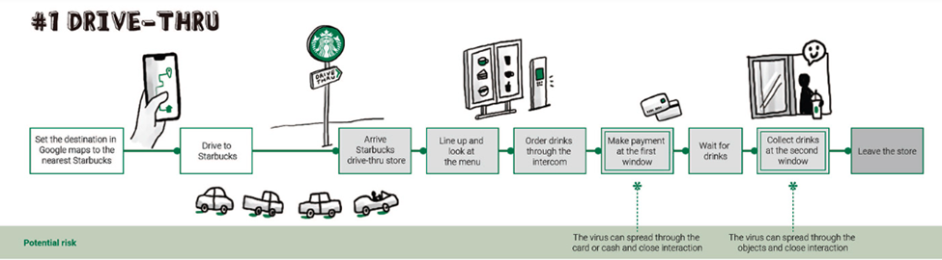
Appendix 1: Starbucks Drive Thru Customer Journey:

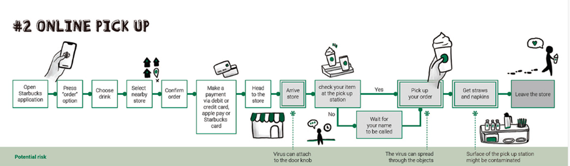
Appendix 2: Starbucks Pick Up Customer Journey Map:

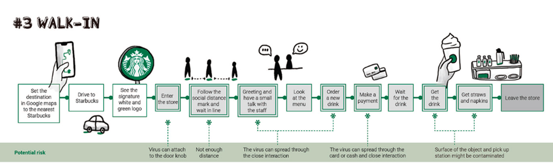
Appendix 3: Starbucks Walk-In Customer Journey Map:

Appendix-4: Starbucks System Map:


