Cosmina Andrei
ID:1809878
Marketing Fundamentals Analysis and Evaluation

Processes and stages of marketing including the role of the marketing mix
1)The marketing process could be explained and related to your chosen company.
I choose Coca-cola company.
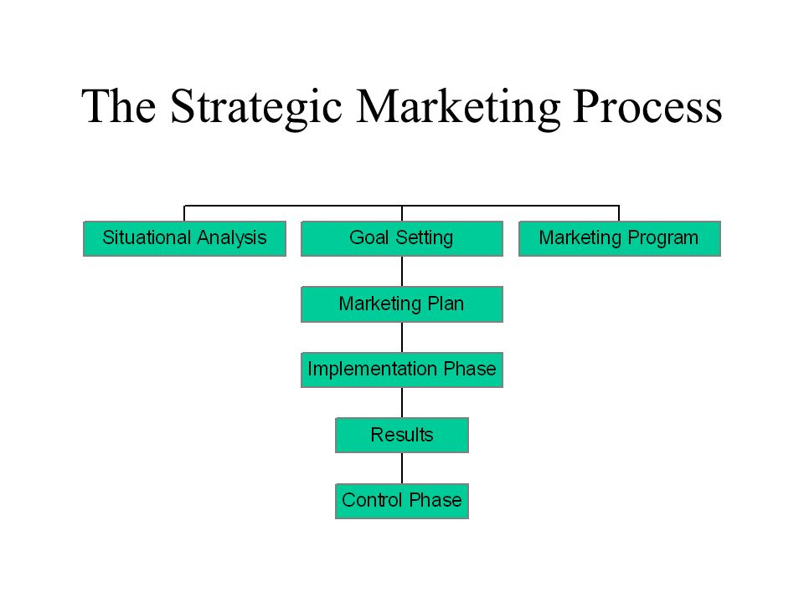
Accessed online: https://www.mbaskool.coml

The marketing process could be explained as:
Marketing is the management process responsible for identifying, anticipating and satisfying consumers ‘requirements profitably. Is the process of planning and executing the pricing, promotion, and distribution of goods and services to create exchanges that satisfy individual and organisational goal.

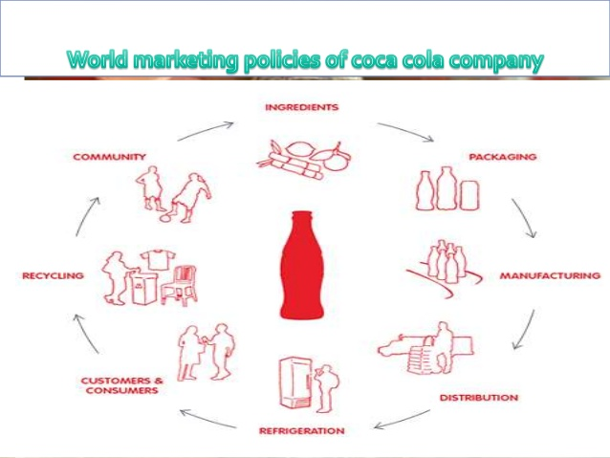
Accessed online:www.coca-cola.com#

Coca cola’s products are improving and adapting to consumer’s needs, for example, Coca cola has created Coca cola diet, coca cola zero.
Coca-cola has improving by buy out other products, extend sponsorship, improve on healthy products, expand on contracts with companies. Coca-cola is adapting to new demands, offer quality products. Coca-cola mission: ‘to refresh the world, in mind, body and spirit’, to inspire moments of optimism and happiness.
Coca cola improve the people lifestyle and developed a set of goals, which everyone in the company is working hard to achieve the best results and satisfied the consumers.
The team is working hard to achieve this result and the performance by profit maximising return to shareholders, take responsibilities seriously, offer a great place where people can work positively and do their best at work. That will enable the company to have a positive feedback and keep the consumers loyal. Coca cola satisfy people’s desires and needs, improve people’s loyalty, responsible and highly effective, adapting to new and values people, effective communication, learning together and improve the relationships and that help to grow together.accesed online(https://mpk732t22016clusterb.g/
Coca cola value the team, their passion for work, integrity, collaboration, innovation and offer quality.
2)Provide a definition of the Macro environment or Pestle factors and relate these external forces to your chosen company stating whether each force is favourable or un favourable and why SWOT analysis could also be related to the company.
Macro analysis: UK government restricted the carbonated drinks from primary school, improve children health and educated for a better lifestyle.
Coca-Cola beverages being a non-alcoholic industry fall under the Food and Drug Administration.
Economic: coca cola increasing in the interest rates may affect the company for further investment, as the higher.
Social: as the inflation rate grow higher, to buy power of customers is a big threat for Coca -Cola Company. People follow are pursuing healthier lifestyles, and Coca Cola is facing a big threat of this. The company is improving the education about lifestyle and incorporate Diet coke, Zero sugar, juice drinks and sports drinks.
Technological: grateful to the new technology of medical, Coca Cola make the products to look more attractive and that help to sell and gain consumers.accesed online: https://www.coca-cola.co.u.pdf
Micro analysis: Suppliers
Coca cola Company know their suppliers as partners who give them system with materials, including ingredients, packaging and machinery and other goods who help to sell more and adapt to consumers’ needs.
Customers:
Coca cola have a big international chain of retailers and restaurants and small independent businesses. They are working together and all win from that, is helping each other and that help to improve and grow their company.
Coca cola have many consumers, people drink also at their best time, sharing with friends, and enjoy together the drink.
Competitors: Pepsi, both try to have a good price for consumers, packaging attractive and promotions.
Public: Coca cola is promotive an attractive and positive image of the products, their publicity is attractive for consumers and have lots activities.
Intermediaries: organizations, wholesalers.
I think the public is a favourable force and that help to maintain the brand because Coca cola is promoting a positively image, people are buying their product, are enjoying with family, with people they love and that give the best for company.The competitors force is unfavourable because , the competitors try to make a better price, more attractive products with good taste and good price and that will low Coca cola’s sale.
Also, Coca cola is a strong name and that make people to trust and buy their products and be loyal.
Swot analysis could also be related to the company because that help to improve their business, to learn from mistakes and develop their knowledge.
Coca cola strengths is to have a strong name and brand, many consumers appreciated their products, and that help the company to have a good sale and maintain at this position long time.accesed online(https://marketprocessuwecom/
Coca cola weaknesses is the company is still focusing on selling coke, fanta sprite and other carbonated drinks, undiversified product portfolio.
Opportunities: Consumption of bottled water, increasing demand for healthy food and beverages.
Threats: Coca cola changes in consumer tastes, reduce the sugar, water scarcity, strong dollar, legal requirements to disclose negative information on product label, saturated carbonated drinks market.
Segmentation, targeting and positioning could be explained and related to Coca cola

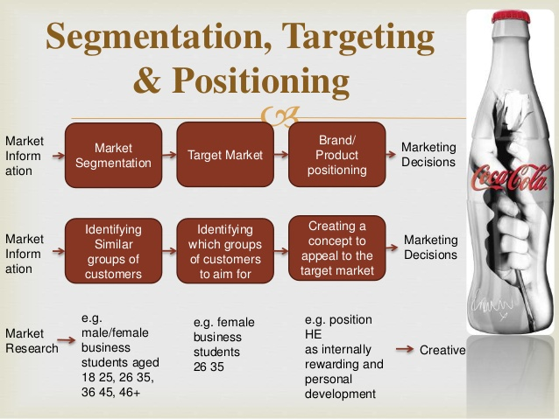
Accessed online(https://www.marketing9coca-cola/)
Coca cola is one of long-term sustainable development, is a strong name and most of the consumers are young. Coca cola have famous people to make them publicity and gain consumers. Coca cola is recognized by everyone in the world. When people talk about Coca cola , they have memories, association and connection with other people.
.
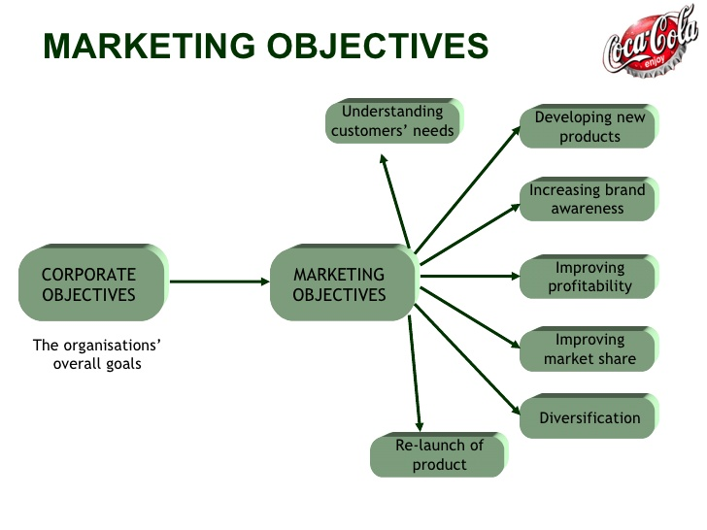
Accessed online:( https://www.slideshare.n-coca-cola)
The marketing mix strategies of Coca cola:
Coca cola is a strong name and recognized all around the world.
The Coca cola ‘strategy is product: give the best for customers, respond to their needs, respect and value them. Price: Have a reasonable price, the consumers can afford to buy and enjoy it , promotion: Coca cola is promoting positively the product , consumers are buying and are loyal , have a positively image and place , coca cola is around all the world and recognised by people and trust this company,

The role of marketing in creating value for customers: Definition of marketing concept.
The marketing concept is the philosophy that firms should analyse the needs of their customers and then make decision to satisfy those needs, better that the competion.
Coca cola’ marketing concept is sustainble growth of the company, keeping peace and ensure future presence.
. Branding .A brand can be a company ,that has a voice and personality of their own.

Coca cola is a brand and the advantage are to be a strong name and people are trusting their products and that help to have loyal consumers.(accessed online https://www.marketing91.com/-coca-cola/)
Coca cola create also new products, zero sugar, diet and that respond to people’s needs. Coca cola respect people suggestion and value their opinion. That make them favourable products on marketing,
Stakeholders engagement and their impact on the marketing activities of an organisation
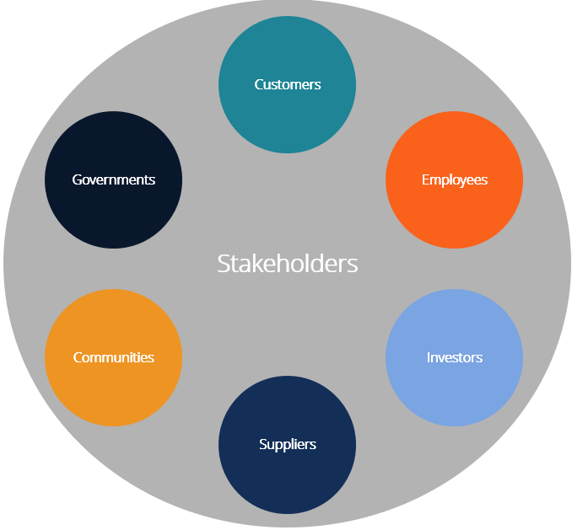
Stakeholders is a party that has an interest in a company and can affect or be affected by the business. Stakeholders of coca cola company include employees, managers and owners and external is customers, suppliers.
The Coca cola team and the employees are working all together to offer good products to consumers and that help to gain loyal consumers. It is important they effective communication, because are giving a positive attitude and trust to consumers.

Task 1b

In my project I wrote about coca cola company. I used website to develop my knowledge and have a better understanding of this company. I understand from my research how important is the team to work together and support each other, to have a safe and positively environment and that enable you to give the best at work.
I believe it is very important for consumers what they receive, and their needs to be respected and valued, the consumers will feel appreciated and will be loyal to the company.
People are enjoying drinking coca cola with people they love; they are sharing memories together. I understand is a strong name and recognised all around the world and has a positive impact in people’s life.
This Project enable to know more about the company, they are marketing, strategy and have a better understanding of their business and how they maintain this company.
To give your best for cosnumers is the best way to maintain the brand and feel appreciated.

References:
https://www.marketing91.com/marketing-strategy-of-coca-cola/
https://www.coca-cola.co.uk/content/dam/journey/gb/en/hidden/PDFs/2019/Coca-Cola-Business-and-Sustainability-Report.pdf

https://marketprocessuwe.wordpress.com/
https://www.slideshare.net/kabchi/about-coca-cola

