Presentation Notes (Virgin Atlantic Delta)
26th, June, 2019
Akbor Ali 1709535
Marie Pitson
During the year 2012, America’s Delta Air lines purchased a 49 percent stake in Virgin Atlantic. At the time, Singapore Airlines owned near half the company, a sum of £224m was paid to acquire the stake, ending the twelve-year investment of the Asian airline. As recent as 2018 Virgin and Delta Airlines have signed an agreement with Air France-KLM, which will see Virgin Atlantic sell a further 31 percent stake leaving the Virgin group with a 20 percent share. With the majority now owned by Delta Airlines, there are possibilities of an organisational culture clash as these organisations merge. The term “Organisation culture” refers to the values and beliefs of an organisation, first introduced by Edgar Schein.
The culture at Virgin Atlantic and the leadership tactics of Sir Richard Branson has redefined the way things are done. Sir Branson says “There’s no magic formula for great company culture. The key is just to treat your staff how you would like to be treated”. Modelled from his personal values and beliefs, Sir Branson has created an organisational culture where employees are positive and motivated. With the merger between majority stake holder Delta and Air France-KLM, Virgin Atlantic’s organisational culture could clash with the values and beliefs of Delta Air lines and its organisational culture. Delta Airlines say “Our people are the foundation of our success. Over the last 5 years, we’ve shared more than $5.5 billion in profits with our employees and have raised pay by almost 25% since 2015, it’s our philosophy our people share in our success”. This is a philosophy that may course conflict.
Conflict between these airlines can stem from the way each company adopts each other’s culture. These large organisations will have a complex structure where each will have its own culture and ways of doing what they do, different policies, values, beliefs and attitudes on both sides can create a cultural divide where conflict can arise and impact the overall organisation. As an example: Virgin Atlantic employees are rewarded with benefits such as, access to a range of deals across the Virgin family from discounts on Virgin Trains, Virgin Experience Days, Virgin Media, Eurostar and cinema tickets as means of a supplement to their salary, but may not be happy with the pay structure that they are offered in contrast to the employees at Delta Airlines as Delta shares its profits with its staff. This can lead to possible employee strikes causing disruptions to service, effecting its customers and the airlines operations. The true test will be how these organisations synchronise its employees in the working environment and avoid a possible culture clash. Delta Airlines is not without its critics and these critiques are from within its work force. According to Delta’s flight attendants and the ramp workers, Delta has capped the number of hours part-time employees can work and does not provide adequate health insurance, these grievances raised is to address issues and are part of a union contract, but Delta will not recognize the union. According to Carlson, Delta is probably one of the most anti-union companies in the world. This behaviour contradicts Delta’s philosophy of “Our people are the foundation of our success”.
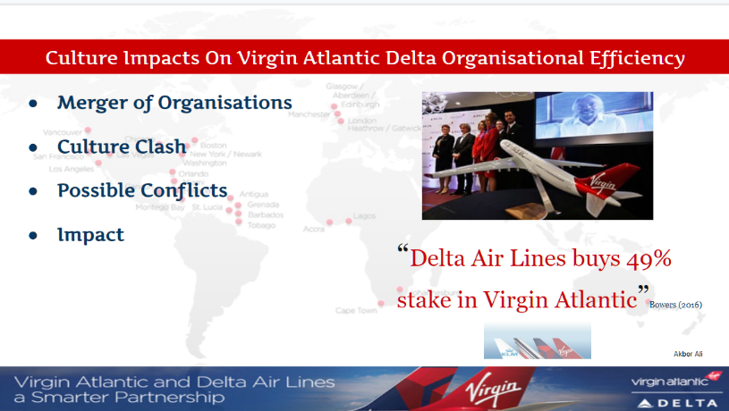
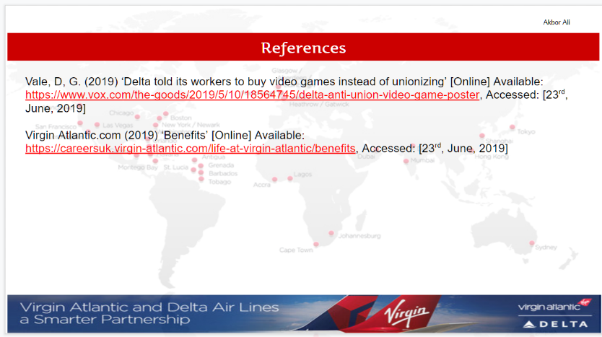
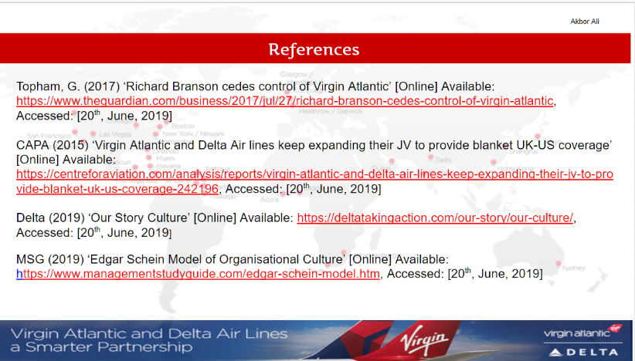
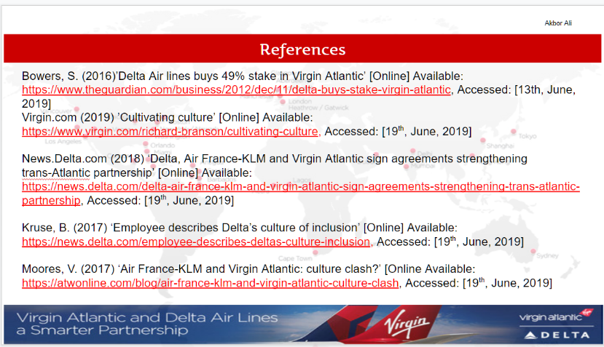
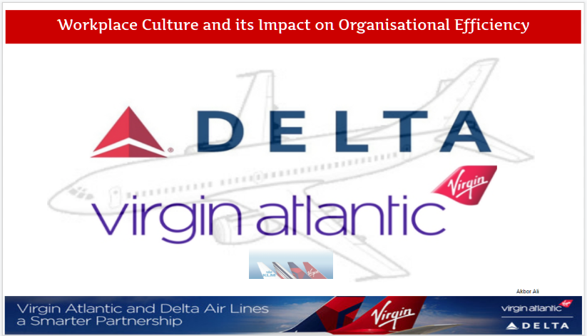
Virgin Atlantic is expected to retain its independence in the United Kingdom which will allow it to fly under its Virgin brand and Sir Branson will remain as its chairman, he has said “this independence should provide a fantastic opportunity to extend our network and create a stronger customer champion, as well as being extremely beneficial to our people and the Virgin Atlantic brand”. The impact that this has on its people and the organisation is critical, due to the positivity of Sir Branson and the knowledge that he still remains as the chairman. The merger of these giants continues to grow, and their trans-Atlantic venture expand over markets outside the more competitive routes of London Heathrow, New York and Los Angeles. With the feed all parties bring to the partnership, routes that would be unviable on a standalone basis are becoming promising. As with the impact of culture within these organisations, it’s a shared pattern of values and beliefs that when aligned can bring efficiency to Virgin Atlantic and its new partners. Delta’s chief executive Richard Anderson has said “To be associated with a great business leader and a great business brand like Virgin, is truly humbling for us at Delta," adding that Delta and Virgin cultures would "mesh well together". This alliance can be positive to Virgin Atlantic and its new partners, as it will boost revenues as well as increase its long haul network that will see it increase its already sharp focus on the part of the world that is included in its name - the Atlantic.
Reference
Bowers, S. (2016)’Delta Air lines buys 49% stake in Virgin Atlantic’ [Online] Available: https://www.theguardian.com/business/2012/dec/11/delta-buys-stake-virgin-atlantic, Accessed: [13th, June, 2019]
CAPA (2015) ‘Virgin Atlantic and Delta Air lines keep expanding their JV to provide blanket UK-US coverage’ [Online] Available: https://centreforaviation.com/analysis/reports/virgin-atlantic-and-delta-air-lines-keep-expanding-their-jv-to-provide-blanket-uk-us-coverage-242196, Accessed: [20th, June, 2019]
Delta (2019) ‘Our Story Culture’ [Online] Available: https://deltatakingaction.com/our-story/our-culture/, Accessed: [20th, June, 2019]
Kruse, B. (2017) ‘Employee describes Delta’s culture of inclusion’ [Online] Available: https://news.delta.com/employee-describes-deltas-culture-inclusion, Accessed: [19th, June, 2019]
Moores, V. (2017) ‘Air France-KLM and Virgin Atlantic: culture clash?’ [Online Available: https://atwonline.com/blog/air-france-klm-and-virgin-atlantic-culture-clash, Accessed: [19th, June, 2019]
MSG (2019) ‘Edgar Schein Model of Organisational Culture’ [Online] Available: https://www.managementstudyguide.com/edgar-schein-model.htm, Accessed: [20th, June, 2019]
News.Delta.com (2018) ‘Delta, Air France-KLM and Virgin Atlantic sign agreements strengthening trans-Atlantic partnership’ [Online] Available: https://news.delta.com/delta-air-france-klm-and-virgin-atlantic-sign-agreements-strengthening-trans-atlantic-partnership, Accessed: [19th, June, 2019]
Topham, G. (2017) ‘Richard Branson cedes control of Virgin Atlantic’ [Online] Available: https://www.theguardian.com/business/2017/jul/27/richard-branson-cedes-control-of-virgin-atlantic, Accessed: [20th, June, 2019]
Vale, D, G. (2019) ‘Delta told its workers to buy video games instead of unionizing’ [Online] Available: https://www.vox.com/the-goods/2019/5/10/18564745/delta-anti-union-video-game-poster, Accessed: [23rd, June, 2019]
Virgin Atlantic.com (2019) ‘Benefits’ [Online] Available: https://careersuk.virgin-atlantic.com/life-at-virgin-atlantic/benefits, Accessed: [23rd, June, 2019]
Virgin.com (2019) ’Cultivating culture’ [Online] Available: https://www.virgin.com/richard-branson/cultivating-culture, Accessed: [19th, June, 2019]

