Programme: Master of Business Administration
Modul: Human Capital Management
Module Code: LCMB7023
Assignment Title: Assessment Component 1: Individual Report
Student Name: Jayraj Nathabhai Keshvala
ID: 2614288
Word Count: 2598
Date of Submission:

LCMB7023 HUMAN CAPITAL MANAGEMENT -- Component 1

Table of Contents
Introduction 3
TASK A: Designing Innovative Working Practices 4
1.1 Critical Evaluation of Traditional Work Design and Contemporary Innovative Working Practices 4
1.2 Recommended Innovative Working Practices for NHSX 8
TASK B: Breeding an Environment Where Talent May Grow 11
2.1 Designing a strategic talent ecosystem for developing and performing with high potential 11
2.2 Comprehensive Talent Growth Strategy for NexSpace Health Systems 16
2.3 Measuring the Effectiveness of the Talent Growth Strategy 17
TASK C: Reflective Report 18
Description 18
Feelings 18
Evaluation 18
Analysis 19
Conclusion 19
Action Plan 19
Conclusion 20
Reference list 21

Introduction
NexSpace Health Systems (NHSX) is a healthcare technology organisation expanding rapidly with ~600 employees across the UK, India, and the UAE. The company focuses on developing AI-enabled digital health solutions while facing challenges of innovation, talent retention, collaboration, and workforce wellbeing. This report evaluates innovative work practices and structures a strategic talent ecosystem to recommend improved HR capability development.

TASK A: Designing Innovative Working Practices

1.1 Critical Evaluation of Traditional Work Design and Contemporary Innovative Working Practices
Considering the internal challenges of NHSX, work design must integrate strategies to support autonomy, collaboration, agility, and technology mediation while reducing the effects of control-oriented hierarchy. The strategic definition of Foot and Hook (2008) describes future plans, including working processes and an approach for long-term focus. It is essential for NHSC to operate with 600 employees in the UK–India–UAE work culture while supporting innovation and maintaining coordination with accountability.
Dimension | Traditional Hierarchical Work Design | HPWS | HIWS
Core logic | Authoritative and controlling system with vertical decision-making | Integrated HR practices for maximised performance with capability | Empowered employee participation with shared decision-making
Decision-making | Centralised with substantial managerial authorities | Responsibility delegation and performance-oriented | Decentralised system with strong employee involvement
Employee role | Task execution | Performance-focused training and skill development | Active contributors to problem-solving and decision-making
NHSX relevance | Governance and accountability reinforcing delayed decision-making | Potential improvement of AI-technical capability through training, recruitment, and performance management | Most suited to support creativity with knowledge sharing and participation
Key limitation | Slow innovation | Intensified workload | Time-consuming and ineffective with participation-oriented interference
Table 1: Comparative evaluation of work-design approaches
(Source: Influenced by Parker and Knight, 2024; Fragoso et al., 2022; Kilroy et al., 2023)
Therefore, traditional hierarchy needs to be surpassed with strategies of accountability, participatory decision-making, and regulatory oversight. However, the inconsistency of retained hierarchy structure can interfere with knowledge-intensive AI environments, leading to turnover. Nonetheless, HPWS can improve performance integration with capability, while HIWS can address the fundamental issue of employee participation (Fragoso et al., 2022; Kilroy et al., 2023). Hence, a hybrid architecture is essential, with a strategic governance system to sustain operational innovation with an engaged team base.
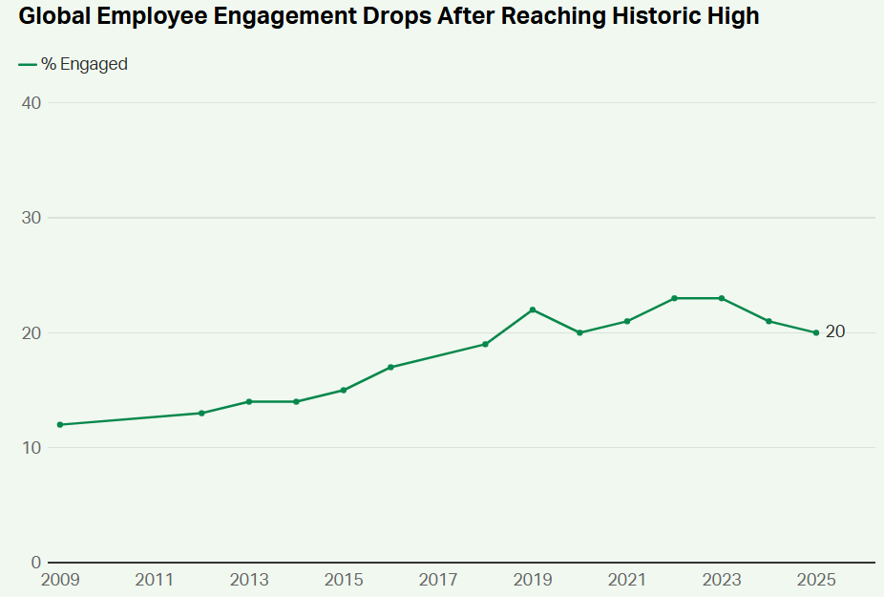
Figure 1: Global employee engagement rate
(Source: Gallup, 2026)
Considering the innovation challenge of NHSX, Agile working systems can improve outcomes with organised iterative delivery, rapid feedback, and cross-functional expertise leading to adaptation beyond rigid functional boundaries. However, Prasodjo (2025) argued that an agile working culture without a governance system reduces the efficiency of the working system while increasing ambiguity. Hence, agile autonomy with cybersecurity, regulatory boundaries, and clinical systems are essential. As suggested by Khan (2025), hybrid and flexible working systems have dual effects on innovation development and empowerment disruptions, with complex collaboration efficiency. CIPD (2025) report indicated that 74% of UK organisations implemented hybrid working practices, while 91% promote flexible working conditions to support innovation and maximise performance. However, employer descriptions highlight complexities in managing hybrid teams. Nonetheless, structured flexibility can be integrated in NHSX to synchronise employee innovation, retention and outcome-based performance management.
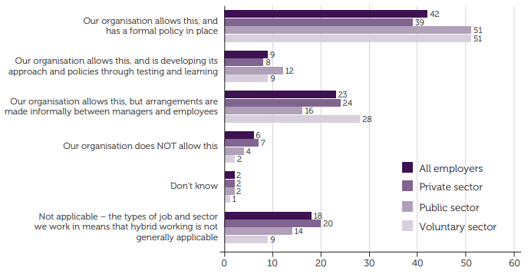
Figure 2: Hybrid working approach implementation
(Source: CIPD, 2025)
Following Tuckman’s team development model can support the potential cross-functional, agile teams.
Stage | NHSX application | Management requirement
Forming | Established team purpose with AI, clinical, product, and software specialists | Clarification of objectives, roles and decisions
Storming | Conflicting professional priorities with innovation, clinical safety and commercial speed | Constructive team management with diverse opinions
Norming | Team expectations with shared protocol and communication routines | Collaboration norms and accountability
Performing | Coordinated team with trust and autonomy | Eliminated barriers and performance management
Table 2: Implementing Tuckman’s team development model
(Source: Influenced by Zirar et al., 2025)
Therefore, this application can support a dynamic project environment and facilitate cross-functional collaboration. Moreover, applying Sociotechnical Systems Theory, it can be argued that identifying collaboration platforms without redesigned AI tools can reduce the work system. The PERFORM model shows the need to balance purpose and values with flexibility, empowerment, optimal productivity, recognition and appreciation, morale and relationships, and communication.

1.2 Recommended Innovative Working Practices for NHSX
NHSX can be recommended to adopt an integrated Connected-Empowered-Agile-Digital work model to support a participatory work culture with clinical, regulatory and cybersecurity controls.
Practice | Recommendations | Integrated effect and theoretical integration
Cross-functional collaboration | To establish an AI-clinical-product squad to integrate software-mediated data cybersecurity and UX expertise. UK innovation success with cross-functional configuration achieves 34% (Government of UK, 2026). | HIWS ensures efficient problem-solving with knowledge enhancement, while HPWS improves skill alignment with performance and outcomes. Tuckman and PERFORM strategies control operational conflict through coordinated practices and team development.
Hybrid and flexible working | Synchronous work mediated with structured hybrid working increases collaboration for UK-India–UAE collocation. 91% perceived fairness in the work environment compared to 73% reported working under determined leadership arrangement show potential positive results for the former, while formal plans lower burnout by 29% (Gallup, 2026). | Participation and flexibility are achieved with HIWS and agile working, while Sociotechnical Systems theory ensures work alignment with technology and social interaction. Hence, coordination and collaboration must reside simultaneously at NHSX.
Employee autonomy | To deliver decision-making to employees over task execution, experimentation,tion and workflows while maintaining central control over data protection, clinical safety, and cybersecurity. | HIWS empowerment is essential to ensure effective decentralised execution. Autonomy-within-boundaries can be achieved with strategic empowerment without weakening healthcare accountability.
Agile project teams | Short innovation cycles with retrospection and experimentation aided by HRP and Build-buy talent planning supporting innovation. | Improved responsiveness with an agile approach can be limited by skill shortages (Mageed, 2025). NHSX needs to build strategic capabilities with skill training.
Digital collaboration technologies | Deployment of an integrated workspace for project management, knowledge repository, AI-supported retrieval and asynchronous communication. | Combined optimisation of technology and people by applying Sociotechnical theory. 38% of organisations report collaboration technology integration with a cross-functional approach. Digital tools combined with asynchronous-first rules and documentation will protect outcomes.
Table 3: Recommendations with evidence
(Source: Self-developed)
A transparent and fair HR governance framework can be achieved with CEAD architecture. Additionally, ACAS Code of Practice can be used to protect innovation and crave culture with fair procedures and an appropriate approach to maintain consistency while providing employee opportunities addressing disciplinary and grievance cases (Policy and Guide, 2023). Hence, team autonomy can be enriched with collaborative practice and with formal resolution of issues.
Innovative practices are used to improve performance at NHSX while accelerating decisions and strengthening cross-functional knowledge sharing with facilitative experimentation. Nonetheless, increased employee autonomy and engagement can reduce discordant practices.

TASK B: Breeding an Environment Where Talent May Grow

2.1 Designing a strategic talent ecosystem for developing and performing with high potential
Rising above the limiting hierarchical structure: a strategic talent ecosystem, developed with the following theoretical foundation, can contribute to enhancing creativity and retention of the 600-strong workforce of NHSX.
Learning Organisation: Senge
Disciplines | Contribution to talent acceleration ecosystem
Systems thinking (Addresses employee wellbeing) | - Designing targeted KPIs by integrating metrics such as cognitive recovery time and retention with financial performance to address burnout caused by rigorous productivity standards
Personal mastery (Addresses limitations of hierarchical structure) | - Allocating 15% individual autonomy  - Encouraging employees to acquire new skills, allowing them to take up lateral projects to collaborate with remote international teams
Mental models (Addresses slowed innovation and decision-making) | - Examining project failure without blaming employees  - Allowing autonomous decision-making  - Fostering continuous learning
Shared vision (Addresses weakened collaboration and knowledge-sharing) | - Co-developing strategic goals for teams scattered across the UK, UAE, India  - Enabling cross-team problem-solving
Team learning (Addresses stagnant innovation) | - Cross-border project team development and facilitating collaboration  - Developing an internal digital knowledge-sharing platform
Table 4: Five disciplines of Senge contributing to talent ecosystem development
(Source: Adapted from Havens, 2025)
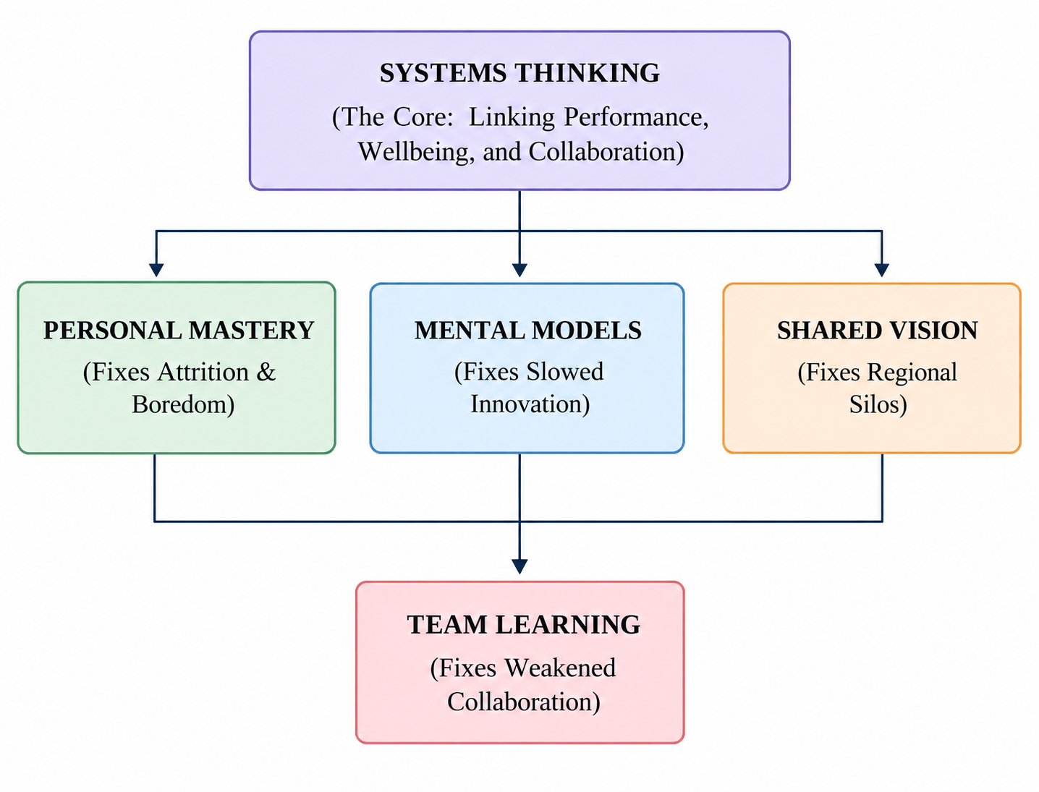
Figure 3: Five disciplines of Senge to create an improved talent ecosystem
(Source: Self-developed)
- Growth Mindset: Dweck
Focusing on micro-behaviours of teams and individuals, this concept can be applied to transform a hierarchical outlook: to view failed experiments as learning opportunities, consider obstacles as drivers of professional growth, regard the success of other team members as a blueprint for success, and deem continuous learning as a metric of successful performance (Chew et al. 2024).
- Psychological Safety: Edmondson
Edmondson’s psychological safety will contribute to enhancing inter-team trust, decoupling failure from blame (McCausland, 2023). Employees are encouraged to ask unusual questions in both team meetings and anonymous digital suggestion platforms. Employees should be given autonomy to express concerns whenever their work pressure becomes unrealistic. The Performance-Safety matrix presented below can contribute to developing a desired talent development ecosystem for NHSX.
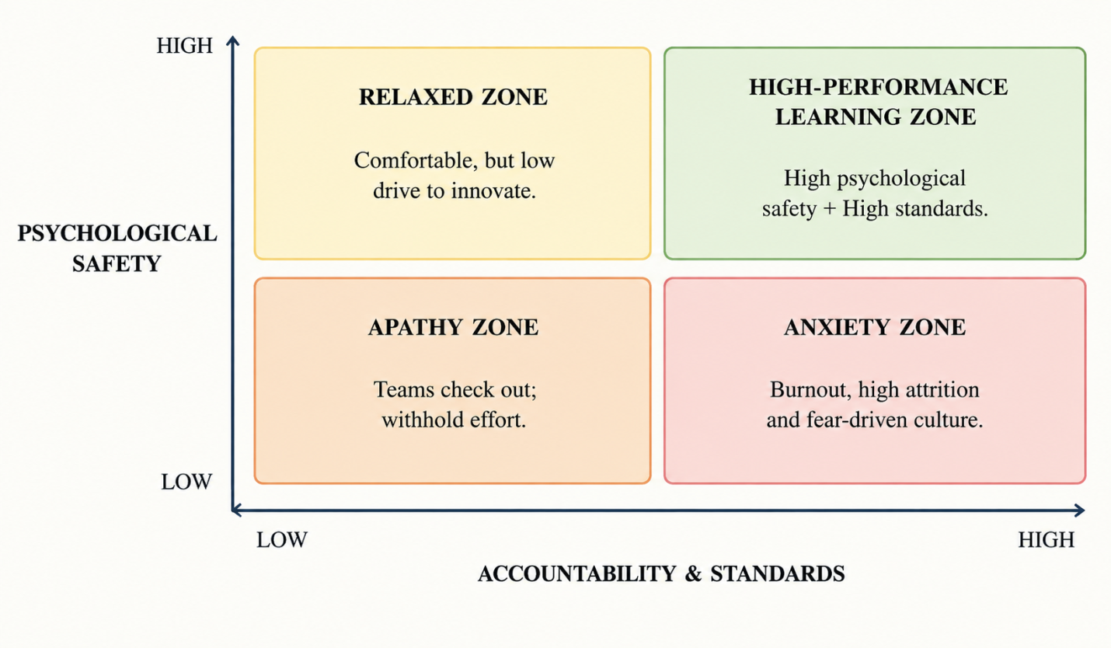
Figure 4: Blueprint for psychological safety of employees at NHSX
(Source: Self-developed)
- Talent Management Frameworks
Supported by agile governance talent management frameworks, NHSX can implement a dynamic capability framework that rewards and incentivizes strategic agility, links career pathways to skill-based employee competencies, and provides career advancement opportunities based on cross-border performance metrics. NHSX can also implement incentive and reward standards focused on employees' wellbeing, such as introducing mandatory cognitive rest days and mental health tracking and counselling sessions. In 2026, strategic focus on employee wellbeing and mental health helped to reduce 15-20% voluntary attrition rate (JRG Partners, 2026).

- Job Crafting Theory
Crafting segmentation | Suggested future ecosystem
Task crafting (to increase creativity) | Allowing flexibility in alternate job scope within team members and sequence of tasks and aligning tasks with individualised employee strengths
Relational crafting (to accelerate knowledge transfer) | Encouraging employees to expand professional relationships with cross-border team members to share insights and learn
Cognitive crafting (to increase ) | Guiding employees to discover the greater social value of allocated tasks to drive innovativeness in performance
Table 5: Applying job crafting theory to improve talent management
(Source: Adapted from Demerouti et al. 2024)
- Self-Determination Theory
NHSX should create a curiosity-driven ecosystem where employees feel motivated to pursue innovative ideas (McAnally and Hagger, 2024).
Autonomy- This is critical to overcome slowed decision-making and burnout, as employees are given free choice to execute their tasks, encouraging spontaneous creativity.
Competence- Linking clear pathways for career growth and encouraging experiments without blaming employees encourages employees to take strategic risks and fosters an innovative workplace culture.
Relatedness- Encouraging employees to reach out to cross-border team members to resolve problems foster spontaneous knowledge-sharing.
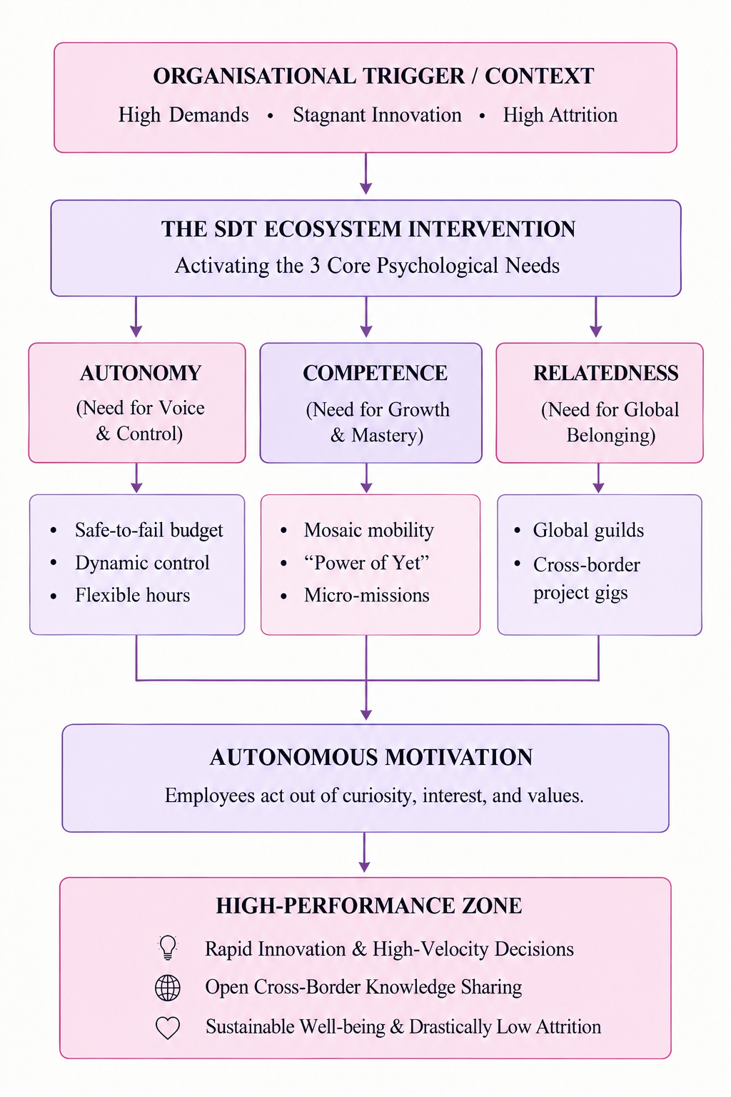
Figure 5: Ecosystem developed with SDT
(Source: Self-developed)
- Employee Experience (EX)
From recruitment to retention, each stage of employee experience should be documented digitally in the individualised employee profiles. Psychological safety should be embedded into day-to-day routine as well as experimental tasks. Integration of Slack (13% of global enterprise market) or Microsoft Teams (37% of enterprise messaging market) makes the employee experience of digital collaboration easier (SQ Magazine, 2026). Digital tools should be integrated to track the workload of high-potential employees; high-demand projects should be assigned only after ensuring they are given mandatory cognitive rest days.

2.2 Comprehensive Talent Growth Strategy for NexSpace Health Systems
Talent growth strategy | Strategic blueprint
Continuous Learning and Capability Development | - Establishing a capability development program, supported by AI, agile methodologies in healthcare technologies, and online peer-to-peer mentoring
Career Development and Internal Mobility | - Implementing individualised career advancement plans  - Giving opportunities to participate in cross-border projects to rapidly advance career  - Linking career pathways with definitive metrics without any bias
Psychological Safety and Growth-Oriented Culture | - Conducting post-project reviews with professional counselors  - Distinguish errors from failures  - Developmental feedback
Employee Autonomy | - Skill-based and flexible task allocation  - Employee-led project execution
Wellbeing and Sustainable High Performance | - Establishing KPIs to identify burnout  - Realistic work hours, schedules, and workload  - Constructive feedback channel
Employee Experience and Talent Retention | - Career advancement support  - Providing autonomy and psychological safety  - Offering proactive managerial support
Table 6: Talent growth strategy for NHSX
(Source: Adapted from McAnally and Hagger, 2024; Madhumithaa et al., 2025)

2.3 Measuring the Effectiveness of the Talent Growth Strategy
A real-time talent management dashboard, with KPIs, will be instrumental in mapping out the effectiveness of the growth strategy.
Measurable metrics | KPI | Measurement
Capability building | - Knowledge Retention Rate  - Task accuracy rate | - Quizzes  - Measuring output quality
Employee retention | - Employee Retention Rate | - Regular assessment of workforce stability trends
Innovation | - Experimentation rate  - Creative output rate | - Number of ideas submitted per employee per quarter
Psychological safety | - Psychological Safety Index  - Retention and Absenteeism Rate | - Conducting regular employee surveys
Autonomy | - Employee Engagement Survey score | - Conducting surveys on autonomy
Wellbeing | - Net Promoter Score | - Conducting surveys to assess satisfaction
Table 7: Assessment of talent growth strategy at NHSX
(Source: Self-developed)

TASK C: Reflective Report

Description
HRM processes can be supported by AI as a decision-support tool that can be particularly useful in workforce planning, recruitment, skill gap identification, and task allocation. Chukwuka and Dibie (2024) suggested that recruitment, learning,g and performance management can use AI applications to support HRM and innovations that emphasise the need for managerial capability and human oversight (AI as a Strategic Tool). I had applied AI to analyse employee performance at NHSX, along with its planning of workforce requirements and task allocation to maintain capability (Reflective Analysis)

Feelings
Initially, I considered AI as an efficient support mechanism with objective oversight due to its ability to compare skills, assess performance indicators,tors and control workload requirements. Nonetheless, I needed to apply it cautiously to follow the AI recommendations while allocating tasks to highly skilled employees with specific consideration of workload pressure and potential burnout. Nonetheless, task allocation based on skill level can often result in overlooking the potential development opportunities (Morandini et al., 2023). It also highlights that human-centred judgement is essential to be integrated into data-driven optimisation. (AI as Strategic tool)

Evaluation
AI application has structured my research on human resource management through team performance analysis, identifying gaps during workforce planning and capability matching for allocating jobs based on set skill sets. However, the integration lacks support to interpret motivation, learning curves, emotional wellbeing, and individual circumstances. (Reflective analysis)
This limitation is important as it affects AI-oriented employment strategies, including recruitment, promotion, task allocation, and performance evaluation. Hence, human interpretation is essential. Through this experience, I have learned that AI augmentation is not replacing managerial judgement. Nonetheless, transparency, fairness, privacy, empathy, and accountability are essential in ethical HR practices. (AI as Strategic Tool)

Analysis
I incorporated AI on several occasions, such as analysing team performance, where AI quickly assessed massive datasets and identified possible burnout risks. Similarly, I incorporated AI in workforce planning, and it quickly identified gaps compared against industry benchmarks. In furtherance, I relied on AI for capability matching for allocating jobs, comparing individualised skill sets (AI as a strategic tool).
I noticed that applying AI has both advantages and limitations; although it can tally skill sets to allocate jobs or identify burnout trends, it cannot assess emotional intelligence; subsequently, it lacks intuitiveness in human nature and critical thinking ability (Reflective analysis).

Conclusion
Overall, it can be assumed that the incorporation of AI as a decision-support tool in HRM requires a delicate balance between unlocking technological efficiency and hindering critical thinking ability. While data-centric decision-making is precise and instantaneous, it can fail to incorporate human elements, such as intuition (AI as a strategic tool).

Action Plan
I intend to increase awareness about psychological safety by going through industry case studies and enrolling in short courses on how to implement Senge’s learning organisation framework in real-life work talent acceleration ecosystem design (Havens, 2025). To gain a better understanding of how technology can transform design, I will enrol in particular online courses such as HR analytics or digital workforce to improve employability scope. I intend to learn how AI can be integrated to address high attrition rates and conduct skill gap analysis (Personalised Action Plan).

Conclusion
The discussion above present’s strategic pathways to develop an innovative workplace practice for NHSX and suggests a roadmap to building a talent growth ecosystem. The integration of technology within the proposed KPIs will help the HR team of NHSX to identify retention risks, lagging innovative inputs, and capability gaps in real-time.

Reference list
Chew, Y.C. and Mohamed Zainal, S.R., (2024). A sustainable collaborative talent management through collaborative intelligence mindset theory: A systematic review. Sage Open, 14(2), p.21582440241261851. https://doi.org/10.1177/21582440241261851
Chukwuka, E.J. and Dibie, K.E., (2024). Strategic role of artificial intelligence (AI) on human resource management (HR) employee performance evaluation function. International Journal of Entrepreneurship and Business Innovation, 7(2), pp.269-282.
CIPD (2025). Flexible and hybrid working practices in 2025. [Online]. Available at: https://www.cipd.org/en/knowledge/reports/flexible-hybrid-working/ Accessed on: 23/09/2026]
Demerouti, E., Roth, C., Ebner, K., Soucek, R. and Moser, K., (2024). Toward a better understanding of self‐regulation promoting interventions: When performance management and job crafting meet. Human Resource Management, 63(5), pp.849-867. DOI: 10.1002/hrm.22236
Foot, M. and Hook, C. (2008). Introducing human resource management. Pearson Education.
Fragoso, P., Chambel, M.J. and Castanheira, F., (2022). High-performance work systems (HPWS) and individual performance: The mediating role of commitment. Military Psychology, 34(4), pp.469-483.
Gallup (2026). How to Manage Hybrid and Remote Teams: A Gallup Strategic Guide. [Online]. Available at: https://www.gallup.com/workplace/316313/understanding-and-managing-remote-workers.aspx Accessed on: 26/09/2026]
Gallup (2026). State of the Global Workplace 2026. [Online]. Available at: https://www.gallup.com/workplace/349484/state-of-the-global-workplace.aspx Accessed on: 25/09/2026]
Government of UK (2026). UK innovation survey 2025: report. [Online]. Available at: https://www.gov.uk/government/statistics/uk-innovation-survey-2025-report/uk-innovation-survey-2025-report Accessed on: 24/09/2026]
Havens, S., (2025). An Integrated Framework Combining Kotter, Albrecht, and Senge for Sustainable Organizational Transformation. https://papers.ssrn.com/sol3/Delivery.cfm?abstractid=5216097
JRG Partners (2026). Employee Retention Statistics 2026: What the Data Says About Keeping Talent.. [Online]. Available at: https://www.jrgpartners.com/employee-retention-statistics-2026-what-data-says-about-keeping-talent/ [Accessed on: 24/09/2026].
Khan, M.A., (2025). Examining the influence of organizational structure and leadership on innovation in hybrid work settings: the mediating role of organizational culture in enhancing team collaboration and innovation outcomes. Journal of Intercultural Management, 17(1), pp.31-70.
Kilroy, S., Fu, N., Bosak, J., Hayes, R. and Schaufeli, W., (2023). Reducing day‐level emotional exhaustion: The complementary role of high involvement work systems and engaging leadership. Human Resource Management Journal, 33(4), pp.846-867.
Madhumithaa, N., Sharma, A., Adabala, S.K., Siddiqui, S. and Kothinti, R.R., (2025). Leveraging AI for personalized employee development: A new era in human resource management. Advances in Consumer Research, 2, pp.134-141. https://acr-journal.com/article/leveraging-ai-for-personalized-employee-development-a-new-era-in-human-resource-management-885/
Mageed, I.A., (2025). Issues and challenges in transforming management practices through agility. Systemic analytics, 3(2), pp.91-111.
McAnally, K. and Hagger, M.S., (2024). Self-determination theory and workplace outcomes: A conceptual review and future research directions. Behavioral sciences, 14(6), p.428. https://doi.org/10.3390/bs14060428
McCausland, T., (2023). Creating psychological safety in the workplace. Research-Technology Management, 66(2), pp.56-58. https://doi.org/10.1080/08956308.2023.2164439
Morandini, S., Fraboni, F., De Angelis, M., Puzzo, G., Giusino, D. and Pietrantoni, L., (2023). The impact of artificial intelligence on workers’ skills: Upskilling and reskilling in organisations. Informing Science, 26, pp.39-68.
Parker, S.K. and Knight, C., (2024). The SMART model of work design: A higher order structure to help see the wood from the trees. Human Resource Management, 63(2), pp.265-291.
Policy, C.S.I. and Guide, N.J.C., (2023). Employee Investigations Policy. policy.
Prasodjo, T., (2025). Agile Governance in the digital age: A qualitative study of its effectiveness and implementation challenges. Golden Ratio of Social Science and Education, 5(1), pp.01-10.
SQ Magazine (2026). Slack Statistics 2026: DAU, Revenue, Market Share & Enterprise Adoption. [Online]. Available at: https://sqmagazine.co.uk/slack-statistics/ [Accessed on: 24/09/2026].
Zirar, A., Muhammad, N., Upadhyay, A., Kumar, A. and Garza-Reyes, J.A., (2025). Exploring lean team development from the Tuckman’s model perspective. Production Planning & Control, 36(4), pp.442-463.

