Programme: MSc Public Health and Social Care in Practice
Module: Population Health and Digital Health Promotion
Module code: LCHS7007
Student Name : Ahir Dhruv Vinodkumar
Student ID : 2412381
Lecturer Name : Dr Ping Wu

Contents
Task 1: Blog 1 3
introduction 3
Digital Technology in Health Promotion: mHealth Applications 4
Evidence of mHealth Effectiveness 4
Critical Discussion: Strengths and Weaknesses 5
Overcoming Shortfalls 5
Conclusion 5
References 6
Task 1: Blog 2 7
Public Health Problem: The Global Mental Health Crisis 7
Designed Technology: MindSphere VR 7
Health Promotion Application 8
Critical Impact Analysis 9
Mitigating Shortfalls 10
References 11
Task 2: Poster 12
Size of the Public Health Problem 12
Examples of Public Health Interventions 12
Chosen Digital Intervention: MindSphere VR 13
Health Promotion Values and Principles 13
Behaviour Change Theory: 14
Expected Results MindSphere VR's integration of the HBM construct supports long-term behaviour change 14
Conclusion 15
References 16

Task 1: Blog 1
The Contribution of Digital Health Technology to Diabetes Management

introduction
Diabetes is a global health epidemic in more than 537 million adults worldwide and is estimated to rise to 783 million in 2045 (International Diabetes Federation, 2021). It's the leading cause of morbidity and mortality and cost of healthcare expenditure, with estimated costs of $327 billion yearly in the USA alone (American Diabetes Association, 2024).Effective management is critical in improving patient outcomes and avoiding complications such as cardiovascular disease and renal failure. With this, mHealth apps are game-changing technology in diabetes management.
Public Health Problem: Diabetes
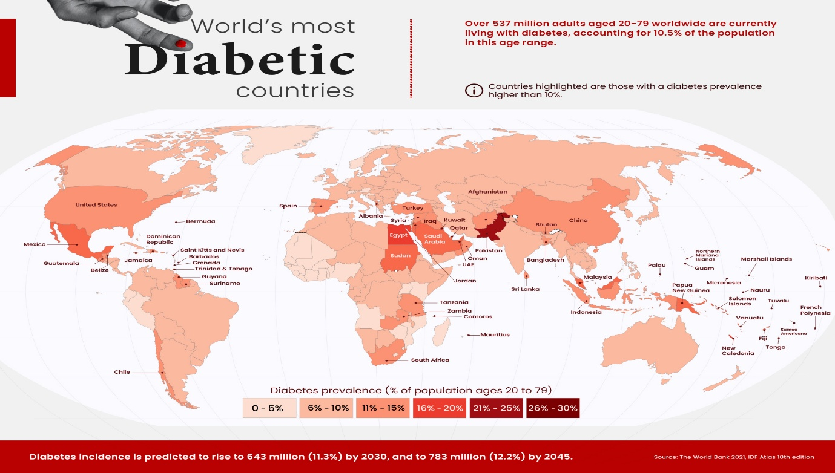
Diabetes is very demanding since it is of broad extent and its impact on quality of life. Diabetes is disproportionately concentrated in developing nations, including middle- and low-income countries, where 80% of cases of diabetes exist (World Health Organization, 2024). Poor control of blood glucose leads to catastrophic complications, including blindness and amputations, to which effective control is required. Effective control is dealt with using innovative solutions by which patients effectively self-monitor and self-manage.
Figure 1 Diabetes Rates by Country in 2021. image source :(Moro, 2023)
Digital Technology in Health Promotion: mHealth Applications
mHealth apps offer a holistic solution for diabetic management by incorporating features like glucose monitoring, medication reminders, diet counseling, and communication with healthcare providers. Several apps are also linked with wearable devices like continuous glucose sensors (CGMs), enabling real-time data and analysis. For instance, mySugr and Glucose Buddy have personalized guidance that allows the patient to make efficient decisions on diet and lifestyle (Kruse et al., 2021).
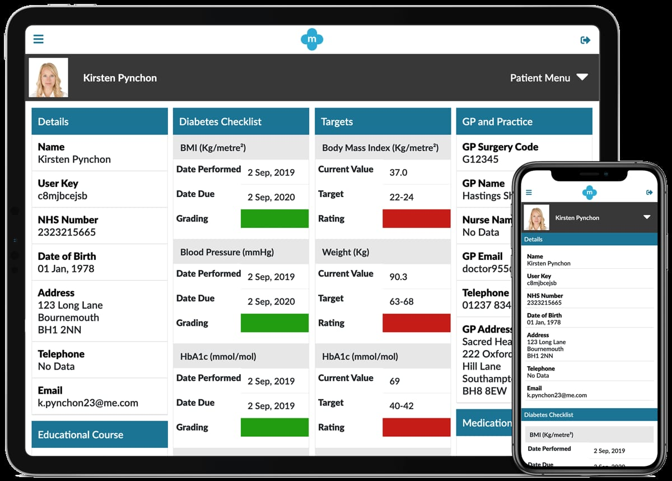
Figure 2 mHealth Applications for Diabetes Management Source:(mymhealth.com)

Evidence of mHealth Effectiveness
Studies demonstrate the efficacy of mHealth interventions in improving diabetes outcomes. A systematic review found that mHealth apps reduced HbA1c levels by an average of 0.3%, indicating improved glycemic control (Versluis et al., 2025).
Also, these materials enhance self-management activities such as medication intake and following diet. Adoption is optimistic; for example, 43% of Americans use health-related apps, meaning they are able to affect the masses (Statista, 2024).

Critical Discussion: Strengths and Weaknesses
- Strengths
Improved Adherence: Automated reminders force the patients to take medication at the right time.
Patient Empowerment: Current information encourages active health management.
Cost-Effectiveness: Prevention of complications reduces long-term health costs.
Better Communication: Facilitates easy communication between patients and providers.
- Weakness
Inaccuracy: Some apps are inaccurate when monitoring symptoms or glucose levels.
Regulatory Problems: Most apps lack FDA approval, which raises safety issues.
Digital Divide: Limited access in socioeconomically disadvantaged groups prevents benefits.
Over-Reliance: Patients underrate professional medical advice due to self-diagnosis.

Overcoming Shortfalls
Regulation: Impose strict app approval standards to ensure accuracy and safety.
Accessibility: Implement strategies for making low-cost or free mHealth technologies available in underserved populations.
Integration: Develop hybrid models that combine digital resources with traditional healthcare services.
Personalization: Utilize AI-driven analytics for personalized advice based on individual patient data.

Conclusion
mHealth technologies also promise a lot towards diabetes control via patient empowerment and improved results. However, minimizing their detriments will be necessary for them to register greatest impacts on public health

References
American Diabetes Association (2024) 'Standards of Medical Care in Diabetes—2024', Diabetes Care, 47(Supplement 1). Available at: https://diabetesjournals.org/care/issue/47/Supplement_1 (Accessed: 18 March 2025).
Versluis, A., Boels, A.M., Huijden, M.C.G., Mijnsbergen, M.D., Rutten, G.E.H.M., and Vos, R.C. (2025) 'Diabetes self-management education and support delivered by mobile health (mHealth) interventions for adults with type 2 diabetes—A systematic review and meta-analysis', Diabetic Medicine, 42(5), e70002. Available at: https://onlinelibrary.wiley.com/doi/10.1111/dme.70002 (Accessed: 18 March 2025).
International Diabetes Federation (2021) IDF Diabetes Atlas, 10th edn. Available at: https://diabetesatlas.org/atlas/tenth-edition/ (Accessed: 18 March 2025).
Kruse, C.S., Patel, N., and Brooks, M. (2021) 'Effectiveness of mHealth in managing diabetes among older adults: A systematic review', Journal of Multidisciplinary Healthcare, 14, pp. 2931–2943. Available at: https://www.ncbi.nlm.nih.gov/pmc/articles/PMC9842522/ (Accessed: 31 March 2025).
mymhealth.com. myDiabetes: The diabetes app that helps you take control. [online] Available at: https://mymhealth.com/mydiabetes.
Moro, A.R. (2023). Mapped: Diabetes Rates by Country in 2021. [online] Visual Capitalist. Available at: https://www.visualcapitalist.com/cp/diabetes-rates-by-country/.
Statista (2024) 'mHealth statistics'. Available at: https://www.statista.com/topics/2263/mhealth/ (Accessed: 19 March 2025).
World Health Organization (2024) Global Report on Diabetes. Geneva: WHO Press. Available at: https://www.who.int/publications/i/item/9789241565257 (Accessed: 19 March 2025).
mymhealth.com. myDiabetes: The diabetes app that helps you take control. [online] Available at: https://mymhealth.com/mydiabetes.

Task 1: Blog 2
Revolutionizing Mental Health Care: The MindSphere VR Platform for Anxiety and Depression Management

Public Health Problem: The Global Mental Health Crisis
Mental illness is a newly emerging public health issue, and it occurs in 1 out of every 4 English adults annually, significantly impacting women and the younger generations (Priory Group, 2025). Depression and anxiety are the predominant causes of global disability, accounting for an estimated $1 trillion in lost world economic productivity every year (World Health Organization, 2021). In addition, mental health provision is under unprecedented pressure, with record referrals 33% higher since 2019 and over 1 million people waiting in England alone (British Medical Association, 2025). Whilst these are pressures, stigma and shortages remain barriers to effective and timely treatment. Creativity in the face of accessibility and affordability has never been more necessary.
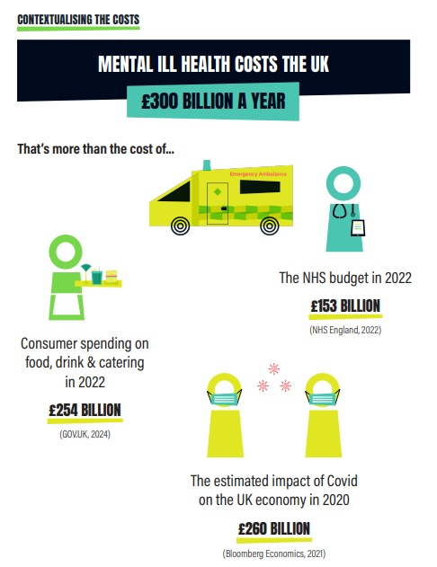
Figure 3The Economic and Social Costs of Mental Ill Health source:(Centre for Mental Health, 2024)

Designed Technology: MindSphere VR
MindSphere is a virtual reality (VR) solution that seeks to bridge gaps in mental health treatment through immersive therapy and individualization through artificial intelligence. The latest technology integrates biometric sensors, cognitive behavioral therapy (CBT), and mindfulness training into one VR headset treatment. Key features include:
• Tailored virtual environments to reduce stress, anxiety (e.g., beach or forest).
• Therapist-Vetted Guided Therapy Modules: therapist-tested CBT-exercises to use for treating anxiety, depression, and trauma.
• Community Support: Online peer support groups with licensed therapists leading them.
MindSphere is scalable and accessible in order to allow it to be taken to underserved populations all over the world and provide high-quality therapeutic intervention.
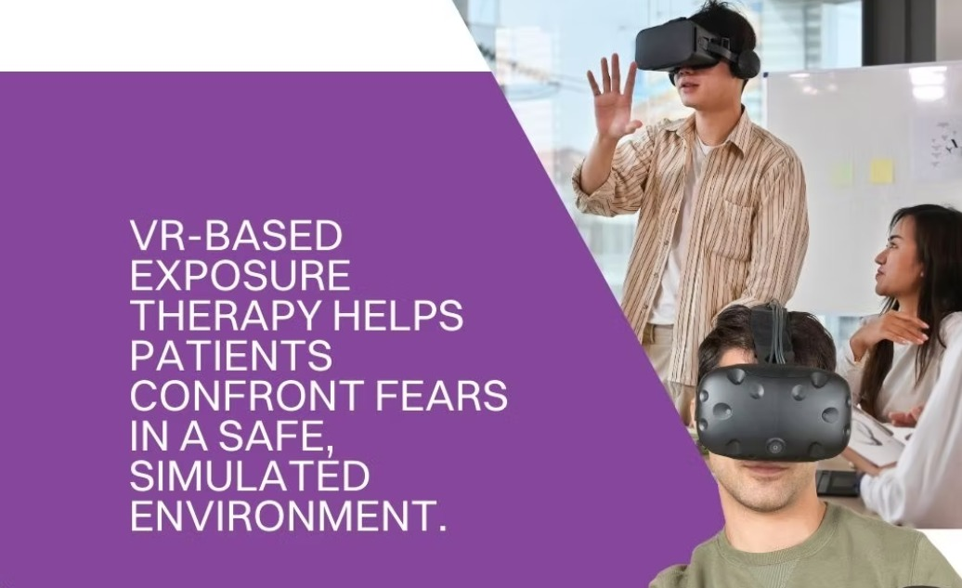
Figure 4 MindSphere VR and mental health treatment ,source:(TranquilMind, 2025)

Health Promotion Application
MindSphere addresses mental illness with affordable, scalable solutions for underprivileged communities. Use cases are:
- Early Detection: Biometric sensors identify stress spikes and trigger real-time interventions.
- Personalized Care: AI dynamically adjusts therapy according to user history from previous sessions.
- Accessibility: Low-bandwidth support to extend access to rural populations.
- Cost Efficiency: Saves therapy by eliminating face-to-face sessions.

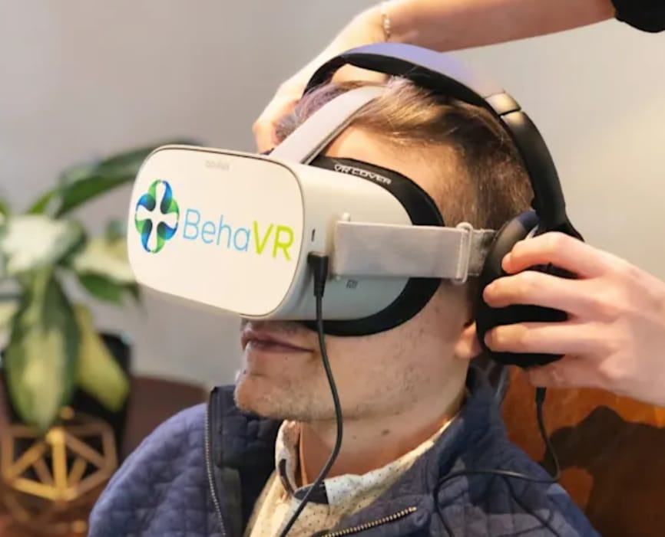
Figure 5 Transforming Mental Health with AI and VR, source:(Newman, 2024)
A meta-analysis confirmed that VR-based interventions had a far superior effect on anxiety (Hedges' g = 0.79) and depression (Hedges' g = 0.73) compared to controls (Freeman et al., 2017). The implications point towards the ability of digital solutions like MindSphere to break care delivery.

Critical Impact Analysis
- Advantages
Efficacy: Studies have shown that VR-based therapy improves anxiety disorder results by as much as 28% compared to regular treatments (Valmaggia et al., 2016).
Scalability: MindSphere can be adopted globally without infrastructure requirements.
Compliance: Immersive settings have increased patient compliance rates than app-based treatment.
- Disadvantages
Digital Divide: The price of VR hardware is exorbitant for low-income regions (British Medical Association, 2025).
Tech Over-Reliance: Patients may overlook professional medical advice due to self-diagnosis (Freeman et al., 2017).
Privacy Risks: Cloud storage of biometric information enhances cybersecurity risks (Valmaggia et al., 2016).
These disadvantages, though difficult, also provide an opportunity for mitigation through targeted interventions.

Mitigating Shortfalls
To overcome these pitfalls:
Low-Cost Hardware Solutions: Partner with NGOs to provide subsidized VR headsets to vulnerable populations.
Hybrid Models of Care: Combine online treatment with frequent in-person consultations for high-risk patients.
Decentralized Data Storage: Employ blockchain technology to ensure privacy and security.
Cultural Adaptation: Collaborate with local mental health professionals to create culturally sensitive interventions.
Through redressing these shortcomings, MindSphere can become an honestly transformative tool for delivering global mental health care.

References
Priory Group (2025). 'Mental health statistics UK'. Available at: https://www.priorygroup.com/mental-health/mental-health-statistics (Accessed: 20 March 2025).
World Health Organization (2021). 'Comprehensive Mental Health Action Plan 2013–2030'. Geneva: WHO Press. Available at: https://www.who.int/publications/i/item/9789240031029 (Accessed: 19 March 2025).
British Medical Association (2025). 'Mental health pressures data analysis'. Available at: https://www.bma.org.uk/advice-and-support/nhs-delivery-and-workforce/pressures/mental-health-pressures-data-analysis (Accessed: 19 March 2025).
Freeman, D., Reeve, S., Robinson, A., Ehlers, A., Clark, D.M., Spanlang, B., and Slater, M. (2016). 'Virtual reality in the treatment of persecutory delusions: Randomised controlled experimental study testing how to reduce delusional conviction', The British Journal of Psychiatry, 209(1), pp. 62–67. doi:10.1192/bjp.bp.116.182865. Available at: https://www.cambridge.org/core/journals/the-british-journal-of-psychiatry/article/virtual-reality-in-the-treatment-of-persecutory-delusions-randomised-controlled-experimental-study-testing-how-to-reduce-delusional-conviction/7898DDD7E2B2343200EB9AE7CDDFD49B (Accessed: 21 March 2025).
Valmaggia, L.R., Latif, L., Kempton, M.J., and Rus-Calafell, M. (2016). 'Virtual reality in the assessment and treatment of psychosis: A systematic review of its utility, acceptability and effectiveness', Psychological Medicine, 46(14), pp. 2733–2745. doi:10.1017/S0033291717001945. Available at: https://www.cambridge.org/core/journals/psychological-medicine/article/virtual-reality-in-the-assessment-and-treatment-of-psychosis-a-systematic-review-of-its-utility-acceptability-and-effectiveness/1379B3C3C0C29388193548DFF0BBAE98 (Accessed: 21 March 2025).
Firth, J., Torous, J., and Yung, A.R. (2021). 'Digital mental health interventions in youth mental health services—A systematic review of efficacy and engagement patterns across platforms', Frontiers in Digital Health, 3, 764079. doi:10.3389/fdgth.2021.764079. Available at: https://www.frontiersin.org/articles/10.3389/fdgth.2021.764079/full (Accessed: 20 March 2025).
Newman, A. (2024). Can virtual reality help with pain and depression? HealthCentral. Available at: https://www.healthcentral.com/pain-management/virtual-reality-for-pain-depression (Accessed: 2 April 2025).
TranquilMind (2025). Mental health and well-being platform. Available at: https://www.tranquilmind.ai/termsandconditions (Accessed: 2 April 2025).
Centre for Mental Health (2024). The Economic and Social Costs of Mental Ill Health. Available at: https://www.centreformentalhealth.org.uk/wp-content/uploads/2024/03/CentreforMH_TheEconomicSocialCostsofMentalIllHealth.pdf (Accessed: 2 April 2025).

Task 2: Poster

Size of the Public Health Problem
Mental illness is a universal public health issue, and millions of individuals are affected yearly. In England, 1 in every 4 adults will have a mental illness annually, with depression and anxiety being the leading causes of disability (Priory Group, 2025). Globally, mental illness is costing the economy around $1 trillion annually in lost productivity (World Health Organization, 2021). The COVID-19 pandemic has increased this issue, with 25% higher anxiety and depression across the world (WHO, 2022).
Even with the increasing number of mental illness cases, access to care is still low. In England alone, more than 1 million individuals are waiting for mental health treatment, with the waiting time being months or even years (British Medical Association, 2025). Staff shortages are among the factors, with the UK having just 8.3 psychiatrists per 100,000 inhabitants, while the European Union average is 18 per 100,000 (Royal College of Psychiatrists, 2022). Stigma of mental illness also dissuades most, particularly marginalized groups, from seeking assistance (Bell et al., 2020).
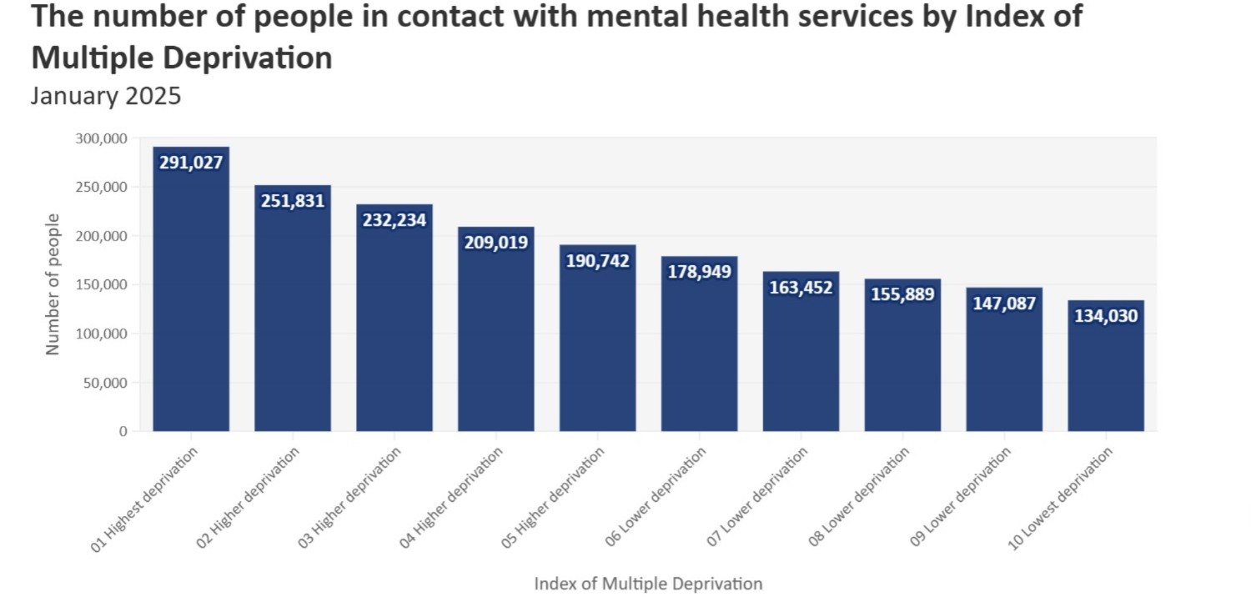
Figure 6Mental Health Services in England: A Statistical Overview, source:(NHS Digital, 2025)
Examples of Public Health Interventions
The majority of non-digital and digital interventions address the following issues:
• Non-Digital Interventions: One-on-one CBT works well but is time-consuming and therapist-limited (Freeman et al., 2017). Support groups and anti-stigma campaigns are supportive but not scalable (Lund et al., 2018).
• Digital Interventions: Mindfulness apps like Calm and Headspace provide exercises, although personalization and sustained engagement are concerns (Valmaggia et al., 2016). Teletherapy services like BetterHelp are trendy but are plagued by data privacy issues and inconsistent care (Torous et al., 2020).

Chosen Digital Intervention: MindSphere VR
MindSphere VR is a revolutionary virtual reality environment with biometric sensors, CBT modules, and mindfulness training. The treatment is tailored based on user data, which is especially beneficial for disadvantaged groups who may not be able to access conventional treatments (Nature Digital Health Review, 2023). Gamification components promote engagement, and real-time feedback assists in controlling mental health (Frontiers Digital Health, 2025).
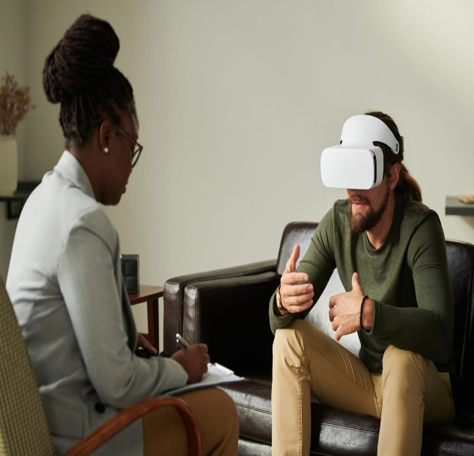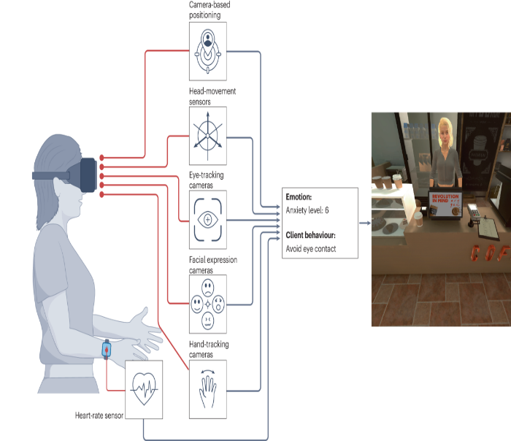
source:(Nature Digital Health Review, 2023 source:Therapist.com (2025)
Figure 7 MindSphere VR: Where Technology Meets Mental Health Innovation

Health Promotion Values and Principles
MindSphere VR aligns with the Ottawa Charter for Health Promotion principles of equity, empowerment, participation, and sustainability (World Health Organization, 1986).
Equity: MindSphere VR provides subsided hardware for people with low incomes, reducing cost barriers (Bell et al., 2020).
• Empowerment: Facilitated exercises and real-time feedback increase users' self-management skills (Freeman et al., 2017).
• Engagement: Online peer-led support groups encourage community engagement (Valmaggia et al., 2016).
• Sustainability: Designed for low-bandwidth areas, MindSphere VR ensures accessibility in diverse settings (NHS Confederation Report, 2024).
Behaviour Change Theory:
Health Belief Model (HBM) MindSphere VR applies HBM constructs (Rosenstock et al., 1988):
• Perceived Susceptibility: Risk awareness is enhanced by learning modules (Nature Digital Health Review, 2023).
• Perceived Severity: Simulations extrapolate the consequence of neglecting mental health (Frontiers Digital Health Review).
• Perceived Benefits: Instantaneous feedback optimizes relaxation skills (Freeman et al., 2017).
• Perceived Barriers: Cheap hardware and reduced tutorials reduce entry charges (Bell et al., 2020).
• Action Cues: Gamification- and biometric-based reminders prompt use (Mental JMIR Review, 2021).
• Self-Efficacy: Interactive modules and tracking of progress build self-confidence (Freeman et al., 2017).

Expected Results MindSphere VR's integration of the HBM construct supports long-term behaviour change
Expected results are:
• Increased Engagement: Perceived advantages and disadvantages drive regular usage (Priory Group, 2025).
• Adoption of Behaviour: Experience in a simulated environment forms habits that last (Valmaggia et al., 2016).
• Boosted Self-Efficacy: Tracking progress raises confidence (Nature Digital Health Review, 2023).
• Reduced Anxiety Levels: Biometric feedback assists in relaxation (WHO Digital Mental Health Report).
Challenges still persist for digital exclusion among excluded groups with no internet or technology access. Policymakers must bridge the digital divide (NHS Confederation Report, 2024).

Conclusion
MindSphere VR exemplifies a transformative approach to mental health care by combining immersive therapy and HBM principles. It addresses key barriers while promoting equity, empowerment, participation, and sustainability (Bell et al., 2020; Freeman et al., 2017; Nature Digital Health Review, 2023).To be most effective, policymakers must advance digital equity (Bell et al., 2020), schools must teach future healthcare professionals (Freeman et al., 2017), and researchers must track long-term effect (Nature Digital Health Review, 2023). MindSphere VR is one step in the direction of an equitable future for mental health care.

References
Bell, I.H., Nicholas, J., Alvarez-Jimenez, M., Thompson, A., and Valmaggia, L. (2020) 'Virtual reality as a clinical tool in mental health research and practice', Dialogues in Clinical Neuroscience, 22(2), pp. 169–177. Available at: https://www.ncbi.nlm.nih.gov/pmc/articles/PMC7366939/ (Accessed: 28 March 2025).
British Medical Association 'Mental health pressures data analysis'. Available at: https://www.bma.org.uk/advice-and-support/nhs-delivery-and-workforce/pressures/mental-health-pressures-data-analysis (Accessed: 31 March 2025).
Carpenter, J.K., Andrews, L.A., Witcraft, S.M., Powers, M.B., Smits, J.A.J., and Hofmann, S.G. (2018) 'Cognitive behavioral therapy for anxiety and related disorders: A meta-analysis of randomized placebo-controlled trials', Depression and Anxiety, 35(6), pp. 502–514. Available at: https://www.ncbi.nlm.nih.gov/pmc/articles/PMC4610618/ (Accessed: 28 March 2025).
Lund, C., Brooke-Sumner, C., Baingana, F., Baron, E.C., Breuer, E., Chandra, P., Haushofer, J., Herrman, H., Jordans, M.J.D., Kieling, C., Medina-Mora, M.E., Morgan, E., Omigbodun, O., Tol, W.A., Patel, V., and Saxena, S. (2018) 'Social determinants of mental disorders and the Sustainable Development Goals: A systematic review of reviews', The Lancet Psychiatry, 5(4), pp. 357–369. Available at: https://pubmed.ncbi.nlm.nih.gov/29580610/ (Accessed: 21 March 2025).
NHS Confederation (2023) 'Maximising the potential of digital in mental health'. Available at: https://www.nhsconfed.org/publications/maximising-potential-digital-mental-health (Accessed: 21 March 2025).
NHS Digital (2025). Mental Health Services Monthly Statistics. Available at: [https://digital.nhs.uk/data-and-information/publications/statistical/mental-health-services-monthly-statistics](https://digital.nhs.uk/data-and-information/publications/statistical/mental-health-services-monthly-statistics) (Accessed: 2 April 2025).
Nature Digital Health Review (2023). MindSphere VR: A revolutionary virtual reality environment with biometric sensors, CBT modules, and mindfulness training. Available at: https://www.nature.com/articles/s44159-024-00334-9 (Accessed: 2 April 2025).
NHS England (2024) 'England’s NHS mental health services treat record 3.8 million people last year'. Available at: https://www.england.nhs.uk/2024/10/englands-nhs-mental-health-services-treat-record-3-8-million-people-last-year/ (Accessed: 26 March 2025).
Priory Group (2025) 'Depression statistics UK'. Available at: https://www.priorygroup.com/mental-health/depression-treatment/depression-statistics (Accessed: 26 March 2025).
Rosenstock, I.M., Strecher, V.J., and Becker, M.H. (1988) 'Social learning theory and the Health Belief Model', Health Education Quarterly, 15(2), pp. 175–183. Available at: https://pubmed.ncbi.nlm.nih.gov/3378902/ (Accessed: 26 March 2025).
Royal College of Psychiatrists (2024) 'Children's mental health crisis deepens: severe shortage of psychiatrists to meet growing demand'. Available at: https://www.rcpsych.ac.uk/news-and-features/latest-news/detail/2024/11/28/children-s-mental-health-crisis-deepens--severe-shortage-of-psychiatrists-to-meet-growing-demand (Accessed: 26 March 2025).
Therapist.com (2025). Virtual reality therapy: Exploring new frontiers in mental health treatment. Available at: https://therapist.com/technology/virtual-reality-therapy (Accessed: 2 April 2025)
Torous, J., Bucci, S., Bell, I.H., Kessing, L.V., Faurholt-Jepsen, M., Whelan, P., Firth, J., and Yellowlees, P.M. (2021) 'The growing field of digital psychiatry: Current evidence and the future of apps for mental health', World Psychiatry, 18(3), pp. 271–282. Available at: https://pubmed.ncbi.nlm.nih.gov/34505369/ (Accessed: 26 March 2025).
Wind, T.R., Rijkeboer, M., Andersson, G., and Riper, H. (2020) 'The COVID-19 pandemic: The 'black swan' for mental health care and a turning point for e-health', Internet Interventions, 20, 100317. Available at: https://www.ncbi.nlm.nih.gov/pmc/articles/PMC7303643/ (Accessed: 28 March 2025).
Valmaggia, L.R., Latif, L., Kempton, M.J., and Rus-Calafell, M. (2016) 'Virtual reality in the psychological treatment for mental health problems: An updated review', Clinical Psychology Review, 56, pp. 26–37. Available at: https://pubmed.ncbi.nlm.nih.gov/26795129/ (Accessed: 31 March 2025).
World Health Organization (1986) 'The Ottawa Charter for Health Promotion'. Available at: https://www.who.int/teams/health-promotion/enhanced-wellbeing/first-global-conference (Accessed: 30 March 2025).
World Health Organization (2021) 'Mental Health Atlas 2020'. Available at: https://www.who.int/publications/i/item/9789240036703 (Accessed: 30 March 2025).
World Health Organization (2022) 'Mental health and COVID-19: Early evidence of the pandemic's impact'. Available at: https://www.who.int/publications/i/item/WHO-2019-nCoV-Sci_Brief-Mental_health-2022.1 (Accessed: 31 March 2025).

