
ACCA7027 — Cloud Engineering Principle and Practice
Name: Manthan Yagneshkumar Siddhpura
Student ID: 2524128

Contents
Abstract 4
1. Introduction 4
2. Principles of Virtualisation 4
2.1. Introduction to Containerization 5
2.2 How does the Containerization Work? 5
2.3 Docker Architecture 6
2.4 Benefits of Using Containerization Technology 8
2.5 Virtualization vs Containerization 8
3. Images and Publishing Images 10
3.1 Introduction to Docker Images 10
3.2 Difference between Docker Image and Container 10
3.3 Creating Docker Images 10
3.4 Docker Image Layers 11
3.5 Docker Registries and Docker Hub 11
3.6 Publishing Images to Docker Hub 13
4. Container Volumes 14
4.1 Introduction to Container Volumes 14
4.2 Why Persistent Storage is Required 14
4.3 How Docker Volumes Work 14
4.4 Types of Docker Storage 15
4.5 Applications of Container Volumes 16
5. Container Networking 17
5.1 Introduction of Container Networking 17
5.2 The Workings of Docker Networking 17
5.3 Different Types of Docker Networks 17
5.4 The Use Cases and Applications of Container Networking 18
6. Complete Docker Practical Demonstration 20
6.1 Introduction 20
6.2 Youtube link for all practices 20
6.3 Create HTML Web Page 20
6.4 Create Dockerfile 21
6.5 Create Docker Image 21
6.6 Run Docker Container 22
6.7 View Website in Browser 22
6.8 Create Docker Volume 23
6.9 Create Docker Network 23
6.10 Publish Docker Image 24
7. Load Balancing, Scalability and Application Gateways 26
7.1 Load Balancing 26
7.2 Scalability 26
7.3 Application Gateway 26
7.4 Why Load Balancing and Scaling Work Together 27
8. Driving Forces Behind Cloud Computing and Serverless Computing 28
8.1 Driving Forces Behind the Growth of Cloud Computing 28
8.2 Serverless Computing (Function as a Service) 28
8.3 Comparison Between Serverless Computing and Containerization 30
8.4 Benefits of Serverless Computing 31
Conclusion 31
References 32

Abstract
This report explores key cloud computing technologies, including virtualisation, containerisation, Docker, cloud scalability, load balancing, application gateways, and serverless computing. It explains how Docker images, containers, volumes, and networking support the deployment and management of applications. A practical Docker implementation is also demonstrated, covering image creation, container deployment, persistent storage, networking, and publishing an image to Docker Hub. The report concludes by comparing containerisation and serverless computing and highlighting their benefits for scalable and reliable cloud applications.

1. Introduction
Cloud computing is a way to provide computing resources and services using a network-based system [1]. It helps companies get things like computing power, storage, apps and platforms without needing to own all the equipment [1] . Cloud engineering is important because it deals with creating setting up and taking care of cloud systems that're reliable can grow and work well. These systems can change to meet the needs of businesses and their customers. This report looks at the ideas and methods in cloud engineering. It starts with virtualization and containerization especially focusing on Docker and how it helps in building putting together and sending out apps. Then it looks at ideas in cloud design like balancing workloads being able to grow and using application gateways. It also looks at how these tools can work to make apps more available and perform better. Lastly the report checks what makes companies choose cloud services like saving money and being able to change. It also looks at serverless computing using things, like AWS Lambda and Azure Functions. Compares these ways with containerization.

2. Principles of Virtualisation
Virtualisation is a technology that lets the parts of one computer or server be split into many different virtual areas [2]. These areas are called machines or VMs for short. Each VM can work on its own with its operating system and programs. Virtualisation is an idea in cloud computing because it helps share real computer resources between different tasks instead of needing a whole new server for each app [2].
A main part of virtualisation is the hypervisor. The hypervisor takes care of machines and decides how real parts like the processor, memory, storage and internet connections are given to each VM. A real computer that has the hypervisor is called the host. The virtual machines that run on it are called guest systems. This setup lets many tasks run on the real machine while keeping them apart, from each other.
Example of Shared Hardware
For example, a physical server may have power and memory to handle several different tasks. Of using separate physical servers for each task, a hypervisor can create several virtual machines on the same server. One virtual machine could run a web server another could run a database application. Another could host a different business application. Although the tasks operate independently, they share the physical central processing unit, memory, storage and network resources [2].
This approach can improve the way hardware is used because available resources can be used by tasks. It can also reduce the number of servers required which may lower infrastructure and maintenance costs. Virtual machines can also be created, configured and managed easily than separate physical machines providing greater flexibility for cloud environments.
However, virtualisation also has limitations. Virtual machines require resources than lightweight containers because each virtual machine normally includes its own operating system. If many virtual machines compete for the same physical resources the performance of the virtual machines can also be affected. In addition, the hypervisor introduces a management layer that must be properly configured and secured.
Principles and Benefits of Containerization

2.1. Introduction to Containerization
Containerization is a relatively new software technology that allows for packaging an application with the files, libraries, and dependencies and settings for the application to run [3]. The main advantage with this technology is that it allows an application to behave the same, regardless of the environment. In the last few years containerization technology has become very popular and widely used technology while developing software and in cloud computing and DevOps [3].

2.2 How does the Containerization Work?
Applications today have been containerized. They can now be delivered along with all of their dependencies as a single, unified file, named Image. A Single Image can consist of source code, run-time, binaries, configuration file, system tools etc [3].
Container Images are run on a Docker Engine to give you an instance of a deployed application [3]. A Docker Engine can be told to run numerous Images (and Containers) on many different Docker Engines working on a single Host Operating System.
The Docker Engine is in charge of the creation and running of the isolated Container Environments. When an application is being deployed with the help of Docker, developers of the application can be relaxed about additional and external software dependencies. This is because the application is completely self-contained in the Image file that enables it to run.
Docker technology uses the deployment of lightweight processes on the Host Operating System. This lightweight nature makes the processes easier to deploy and better utilizes the available processing and memory resources of the Host OS on which the deployment is taking place.

2.3 Docker Architecture
Docker client and Docker Engine make the client-server architecture in Docker. The commands sent by the Docker client are received by Docker Engine.
The Docker daemon referred to as the Docker engine performs the primary function of constructing and operating containers.
The Docker images contain all the information needed to operate the containers. The images are constructed using Docker files that provide the instructions for constructing images.
Docker allows developers to operate containers created from Docker images.
Finally, the Docker registry stores Docker images for easy access and distribution [3].
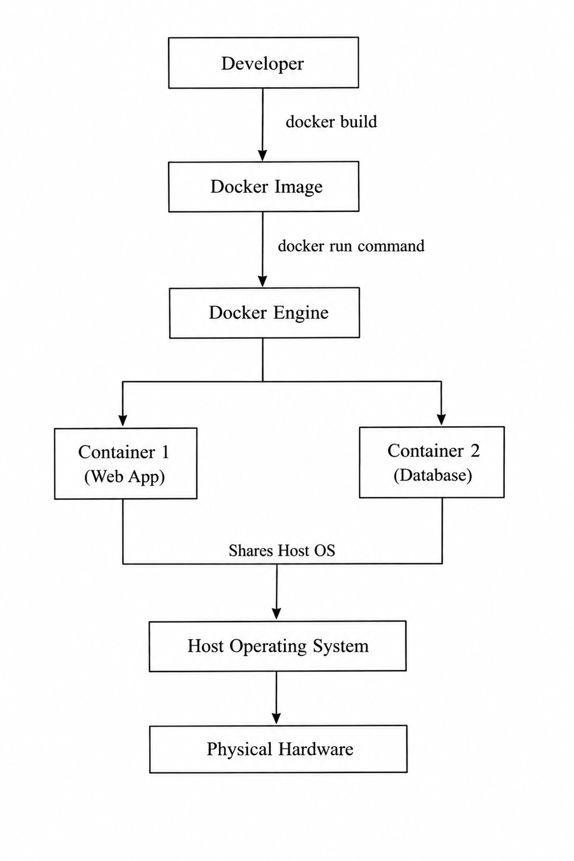
Figure 2.1: Docker Containerization Architecture

The figure above shows the basic architecture of the Docker platform. The Docker architecture can be further explained using the following components:
Docker Client | This component executes commands to operate Docker applications.
Docker Engine | This component serves as the Docker daemon that operates the Docker images and containers.
Docker Images | This component contains the information needed to operate Docker images.
Docker Registry | This component stores and distributes Docker images. The registry makes the images accessible for installation.

2.4 Benefits of Using Containerization Technology
Lightweight Deployment: Containers take up system resources like CPU, memory and storage which makes it quicker to put applications into use.
Portability: Applications work the way in different places whether it is a developers computer, a test server, a private data center or a cloud service.
Rapid Deployment: It works well with integration and deployment which makes the process of building and releasing software much faster.
Cost Efficiency: Using resources means the cost of the infrastructure and cloud hosting is lower.
Application Isolation: Every container works on its own so if one application has a problem it does not cause issues for applications.
Scalability: Containers can be increased quickly which makes them perfect, for cloud-based applications that need to manage growing amounts of work.

2.5 Virtualization vs Containerization
Virtualization | Containerization
Runs virtual machines | Runs containers
Every virtual machine requires an operating system | All containers run on the same operating system
Requires much more processing power and memory | Fewer system resources
Virtual machines take a relatively long time to start up | Containers start within a few seconds
Better operating isolation | Limited isolation
Slower portability and deployment | Better portability and deployment
Ideal for running multiple operating systems | Ideal for cloud-native applications
Table 2.1 Virtualization vs. Containerization
Containerisation is really useful because containers are not that heavy and they are easy to move. You can set up containers in places quickly. Containers work with the operating system as the computer they are on. This is different from machines which have their own operating system [4].
Containerisation is good for getting things done fast and using resources. It is great for cloud-based apps and small parts of systems.. Sometimes you need more separation or a different operating system. That is when virtual machines are better. Virtual machines are still helpful when you need things to be more independent. Containerisation works well for some things. Virtual machines are better for other things that need more separation or different operating systems. Containerisation is good for cloud-based apps. Virtual machines are good, for things that need to be separate [4].

3. Images and Publishing Images

3.1 Introduction to Docker Images
Source Code and Dependencies in Docker Images Because Docker images provide the foundation where Docker containers operate and they can run consistently regardless of the runtime environments that contain the necessary software applications, they can contain everything. Basically, the Docker images include binary format that is read only, and the complete information application must have. This includes system libraries, configuration files, runtime environments, software tools, source code, and dependent packages [5].

3.2 Difference between Docker Image and Container
A Docker image is a template only in the read-only category with a set of necessary files or codes required for running a software. Docker image has contained in it everything from the code, required Libraries, dependencies, and run-time required to run the application or software. We can consider the Docker Image to be the “blueprint of a container” which holds all the code, dependency, and software with it required for the successful running of software [5].
A Docker container is a “run time instance of the image “. Once the image is being executed from the Docker command line interface (CLI), Docker generates and creates an individual container for running that application code and all its components that have previously been packaged within that image. Similar to the images, we cannot directly change the container from outside but as compared to image, containers run on their own individual space so they will not interact with each other’s.
This individual environment gives a system stability as no single running software can affect other software or system.
We can spin multiple instances of containers from a single Docker image simultaneously.

3.3 Creating Docker Images
How the image is created Using the provided Docker file the image is built. The instructions will be read from top to bottom of the docker file and Docker will process each one in sequence. Within the instruction everything needed by the application, including base operating system, the application code, any application libraries, dependencies, environment variables, configuration values, and command which to execute when run will be defined [6].
The processing the docker file will result in the creation of a self-contained and reusable image with the applications configured and running to the specified settings that will produce the identical running application from that image wherever the image is ran [6].
Moreover, it is worth noting that the use of Docker file is not mandatory, but rather optional as developers can create images without using it, although, in practice, the utilization of this concept facilitates the process of image creation.

3.4 Docker Image Layers
When you construct a Docker image, it’s comprised of several “layers.” Each layer is just a component that will add or do something on the top of one layer and they combine to create a whole new Docker image [7].
So, basically Docker executes your Docker file one instruction at a time.
So, every time it’s being run through your Docker file, it executes each instruction and gives back a layer, which either adds to or changes what was in the previous layer. Having said that, what this brings with itself is that layers are also cacheable by Docker. Which means that the next time when you are rebuilding an image, and say for some instructions nothing has changed, they wouldn’t be run through again.
Instead they will pick from the cache, saving a lot of time [7]!
In addition to it, layers can also be reused across multiple docker images. For example, say you build multiple applications based on the same OS, say a particular Ubuntu version. The same OS layers will be shared between all these images, thereby saving on space [7]!

3.5 Docker Registries and Docker Hub
A Docker registry refers to a system for storing and distributing Docker images. In particular, it allows uploading images into the system for subsequent downloading from the system whenever needed [8].
There are two types of Docker registries:
- Public registries, which are open for everyone.
- Private registries, which require authentication before being accessed.
On the other hand, certain organizations may host private registries containing their application images for better security reasons.
Docker registries help in simplifying the application distribution process since they serve as a central place where images can be stored, viewed, searched, and distributed to other platforms securely.
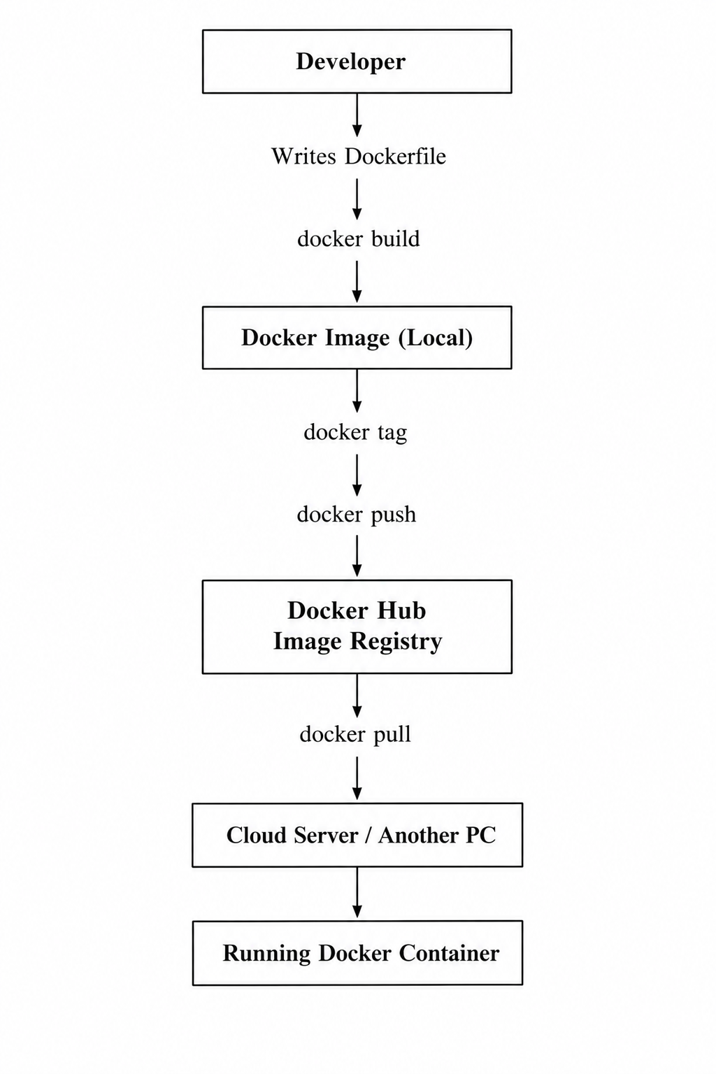
Figure 3.1: Docker Image Publishing Workflow Using Docker Hub
As displayed in figure 3.1, a Docker image is constructed from a Dockerfile and can be downloaded to the computer of the programmer, or pushed to a Docker registry, which we'll refer to as Docker Hub for convenience. From this Docker Hub, an image can be retrieved from any computer or server to implement and share the same applications on other environments.

3.6 Publishing Images to Docker Hub
Publishing Docker Images This is yet another most important step in deploying your software application on cloud instances by using Docker. Therefore, publishing basically boils down to creating an image locally under a particular name and pushing it to the Docker Hub in the first step, followed by the other systems pulling your named image and running it. Publishing a Docker image to the Docker Hub is definitely the simplest and fastest way of deploying an application. No need to ship your code with your application, install your softwares and dependancies onto the machine of your choice one after the other, instead you have an image you could simply share it with the others [6]!

4. Container Volumes

4.1 Introduction to Container Volumes
Docker containers are ephemeral by default. That means that any data is contained inside the container and it's destroyed when the container is destroyed. Most applications however require that some of the data on a container be persistent. This is especially true for databases and the storage of files since the data contained within them must be retained even when the container is deleted [9].
This is done by using Docker volumes which provide an alternate storage location for applications to use in addition to or instead of the writable layer of the container. A Docker volume is a persistent and self-contained storage area that can be mounted on a running container.
The volumes are widely used in cloud computing to store data vital to the applications while also providing the flexibility of managing storage.

4.2 Why Persistent Storage is Required
For instance, if a dockerized application that requires databases is deployed on a Docker container, then on deletion of that container the database information within the container will also be deleted, this is a major hurdle for most applications requiring use of databases. Fortunately, by using the volumes in Docker we will be able to persist the data in some other place in the computer to be able to retrieve and use when necessary. We must point out at this point that using Docker volumes is also beneficial to application developers as they can program their applications such that their applications have some storage space that they can attach to from out of the container store space, and when the container gets deleted the volumes remain intact.

4.3 How Docker Volumes Work
Most of the Docker volumes in their nature exist outside the scope of the writable layer of a specific Docker container.
It shows that the volume provided by that Docker volume can be directly accessed by the container that provides Docker volume mount point to the container, from within the Docker container. This will give you the freedom to read/write information on the Docker container.
Since the volume exists outside the container, its data can also be accessed and modified even when the Docker container is deleted.
It is also possible to share volumes among different Docker containers so as to share information when necessary.

4.4 Types of Docker Storage
There are different types of Docker storage that can be used for different purposes.
The recommended type of storage to use in Docker is the Docker Volumes that have been discussed throughout this paper.
The other types of storage that can be used include:
- Bind Mounts.: This type of mount allows users to bind files and/or folders on the Docker host and mount them on the Docker container.

- Tmpfs Mounts: The main difference is their performance, though they're extremely quick as compared to others, tmpfs mount would all data gone, if the Docker container gets terminated. Here, you can store some temporary files into the Docker host’s Random-Access Memory (RAM).

4.5 Applications of Container Volumes
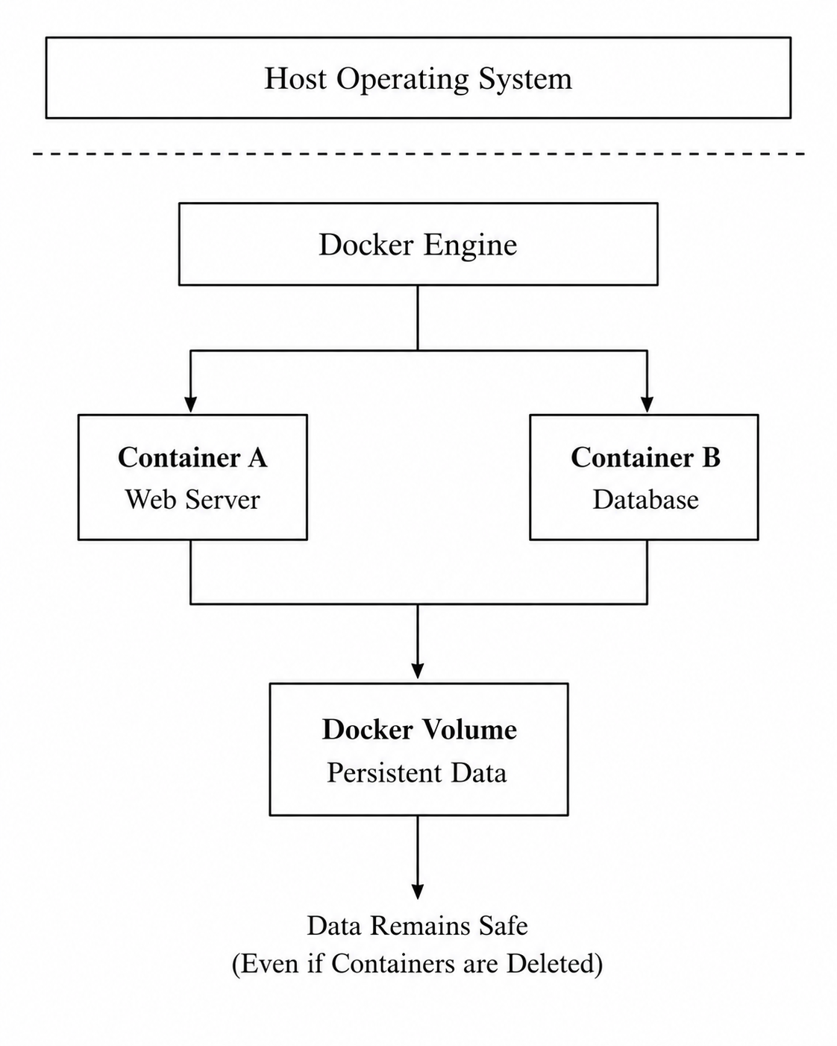
Figure 4.1: Docker Volume Architecture
It is also quite clear from Figure 4.1 that the data is stored in the Docker volume and not in the Docker container. This is because when you remove the Docker container you will still be able to retrieve the data. The data can also be mounted on other Docker containers as explained in this paper.
In cloud applications, Docker volumes are particularly useful for services such as databases because they allow important application data to remain available even when containers are stopped, removed or recreated.

5. Container Networking

5.1 Introduction of Container Networking
One of Docker’s key features is the ability to allow the communication of its containers, between the host, and to the outside world. The idea behind containers is that a single application can be split into several interconnected microservices [10].
So an application can run in, besides just web and database servers, a file server or a message server. These Docker containers need to be able to talk to each other for your application to function as expected. Using Docker networking you can share information between them in a way that they're completely isolated from other applications running on the same machine.
By assigning virtual networks to the containers, Docker allows their communication while isolating other services.
Container networking is beneficial for cloud computing and the organization of microservices.

5.2 The Workings of Docker Networking
By default, Docker containers communicate via a built virtual network, which is why upon the creation of a new container, it gains an IP address.
With Docker networking, the containers can directly communicate with each other by sending data through virtual network interfaces.
Such interfaces are connected to the host machine and resemble real computer networks, however they are entirely virtual.
Through the usage of these networks Docker has the capability to separate your containers that are running to other process taking place on the host and also permit them to communicate with one another. It is additionally attainable to set up digital systems all on your own that will let you give containers with private IP tackle that enable to communicate solely with particular services.
This is useful for the isolation of different applications.

5.3 Different Types of Docker Networks
- Bridge Networks: When we use Docker, it makes a bridge network by default. This network lets containers on the computer talk to each other. It also keeps them separate from containers on networks so they can communicate in a safe and organized way.
- Host Networks: Host networking allows a container to use the host's network stack directly, which can reduce networking overhead but provides less network isolation than a separate container network.
- Overlay Networks: An overlay network connects containers that are running on computers with Docker. It lets them talk to each other like they are on the network. We often use Docker Networks like this when we have applications that are spread across computers like with Docker Swarm and Kubernetes.
- None Networks: A none network disables networking for the container, meaning it does not have access to external networks or normal container-to-container communication. It can therefore be useful for workloads that do not require network connectivity or where network isolation is required.

5.4 The Use Cases and Applications of Container Networking
Docker networking connects services, like web servers, databases and application servers running in separate containers. It is widely used in cloud and microservice-based applications to enable communication, isolation and easy management across multiple servers.
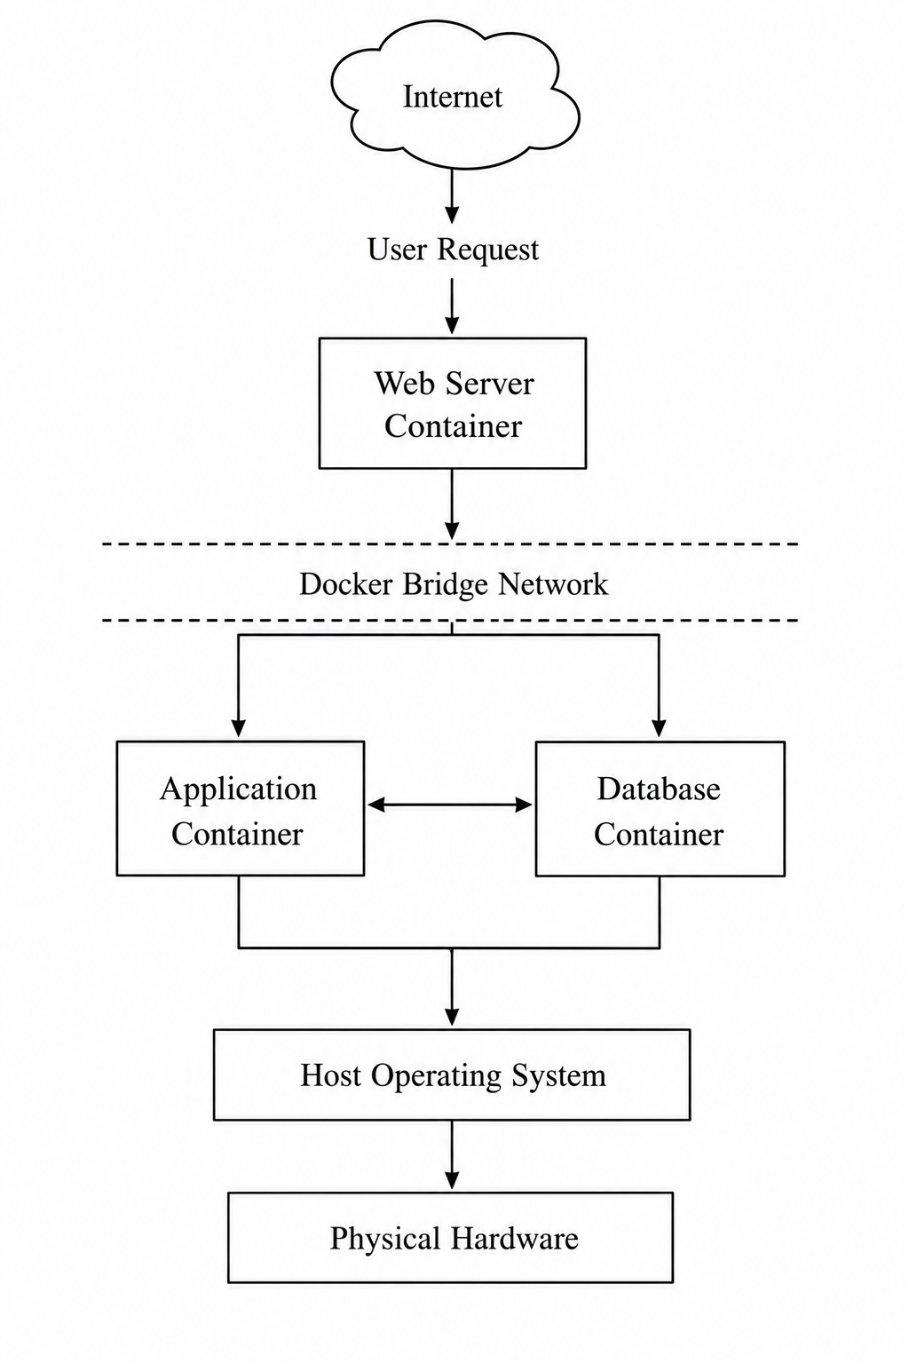
Figure 5.1: Docker Container Networking Architecture
As seen in Figure 5.1, Docker’s virtual network allows multiple containers to communicate with each other across the host machine. Thus, the web server, app server, and database server are connected with a network while being isolated from other services.
Container networking is important in cloud applications because it allows separate services, such as web applications and databases, to communicate while maintaining appropriate network isolation.

6. Complete Docker Practical Demonstration

6.1 Introduction
The main idea of this practical demonstration was to learn the concept of complete process of containerising the web application using Docker.

6.2 Youtube link for all practices
https://youtu.be/EFnB_r68Hb8?si=4QgxCPhJLjQp_U_A

6.3 Create HTML Web Page
The initial activity involved creating an HTML web page which would be later hosted in the Docker Container.
Initially a folder was created named ‘Docker Assignment’, the terminal command was used to ‘cd’ inside that folder. In that ‘Docker Assignment’ folder, by using Nano text editor the following html code was written and saved as ‘index.html’.
The content of the HTML page consisted of some text and other elements to test if the webpage was accessible from the browser. This HTML page would be deployed as the application inside the Docker Container.
This practical demonstrates the deployment of a simple web application using Docker. The process covers creating a Dockerfile, building a Docker image, running the image as a container, accessing the application through a browser, creating persistent storage with a Docker volume, configuring container networking and publishing the image to Docker Hub.
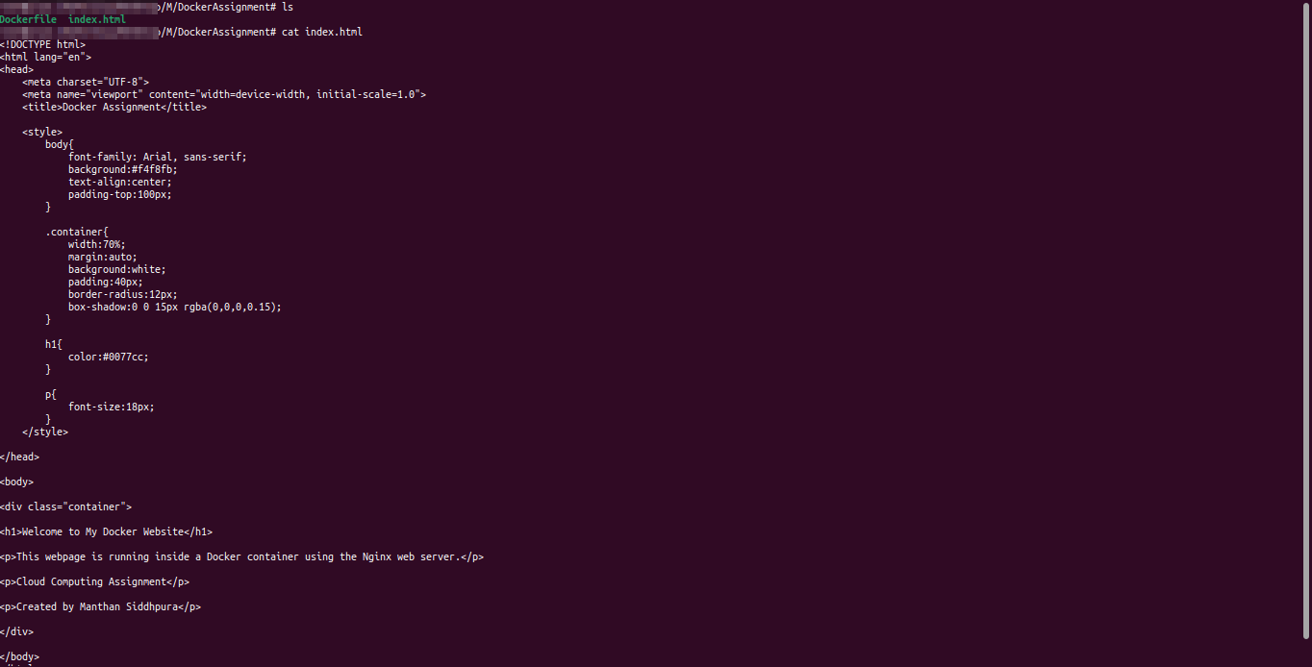Figure 6.1: Project Directory with HTML Code

6.4 Create Dockerfile
The next step was to create a Dockerfile with the help of which Docker image would be built. The Dockerfile consisted of some instructions that Docker would follow during the image creation process.The created Dockerfile is shown below.
The Dockerfile used the official Nginx image as a base image and set the application code (HTML page) as the default webserver document root.
Moreover, the Dockerfile exposed port 80 to make the webserver accessible. The Docker image would be built with the help of this file.
Figure 6.2: Dockerfile to Create Docker Image

6.5 Create Docker Image
The next step involved building the Docker image.
To do that, the build command was used.
After executing this command, Docker read and processed all the instructions mentioned in the Dockerfile and successfully built the image with tag mywebsite:v1.
This image consisted of the Nginx webserver and the HTML page deployed in the Nginx webserver.
To check if the image was successfully built, the images command was used.
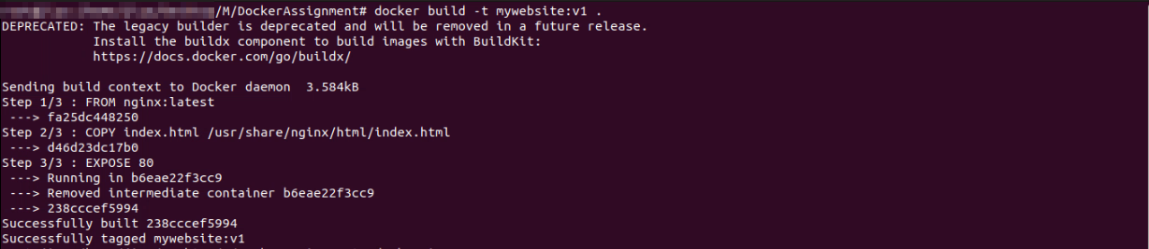Figure 6.3: Output of Successful Image Creation

6.6 Run Docker Container
The next step was to run the Docker container.
So at this point, we basically just took the docker container which we had created in the previous step and we just expose that container’s port 80 to port 8080 on our local host, and the idea was that when we just access it from localhost colon 8080 in our local browser, where we run the commands locally, we should get an html file sent back to us from a web server.
To just verify if the container got created properly we simply use the ps command.
Figure 6.4: Successfully Run Docker Container

6.7 View Website in Browser
To check if the webserver inside the Docker container was accessible or not, a browser was used.The URL mentioned below was typed in the address bar of the browser.
As seen in the below-attached image, the HTML page was successfully retrieved.
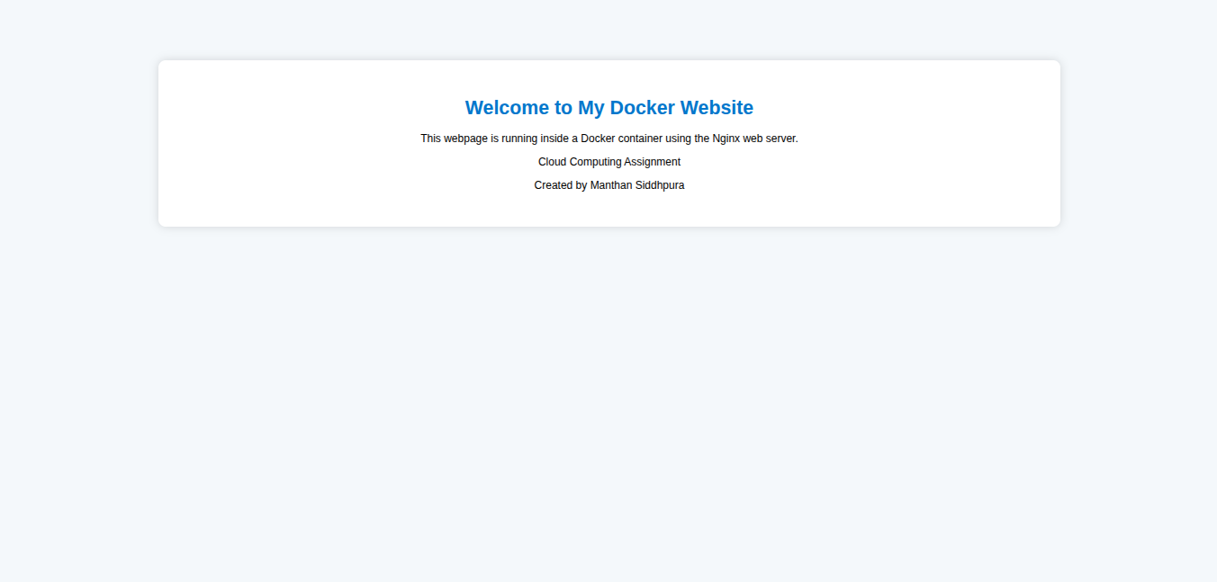Figure 6.5: Output of HTML Page Hosted in the Docker Container
This step checks if the Docker image got built successfully and whether the Docker container started up and is running. If this step succeeds, it indicates that the service had successfully been deployed inside the Docker container.

6.8 Create Docker Volume
The next step involved creating a Docker volume.First, a volume named myvolume was created.The created volume was mounted to the default webserver directory while running the Docker container.
The purpose of using Docker volume was to maintain persistent storage.Data stored in the Docker volume remained persistent even after the removal of the Docker container.
To check the created volumes, the below-attached command was used.
Figure 6.6: Creation of Docker Volume

6.9 Create Docker Network
The next step involved creating a Docker network.First, a network named mynetwork was created.The created network was attached to the webserver container. An Ubuntu container named ubuntu-client was also attached to the created network.
This helped in establishing communication between the webserver container and the Ubuntu container.To establish communication, first, the Ubuntu container was opened using the below-attached command.
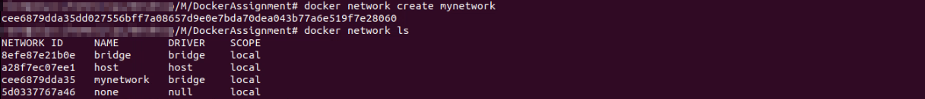Figure 6.7: Create Docker Network
Then, the client was able to communicate with the webserver container as seen in the below-attached output.
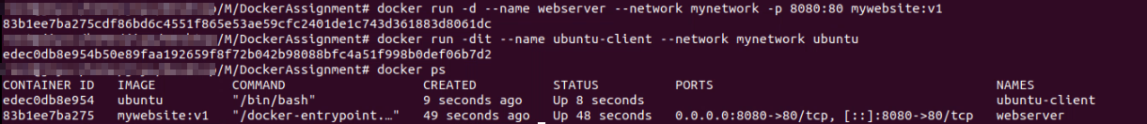Figure 6.8: Multiple Containers Attached to Docker Network

6.10 Publish Docker Image
The last step involved publishing the Docker image to Docker Hub.To do that, first, the login credentials were entered using the login command as seen below.After logging in, the tag command was used to tag the Docker image.The tagged image was pushed to Docker Hub using the push command.
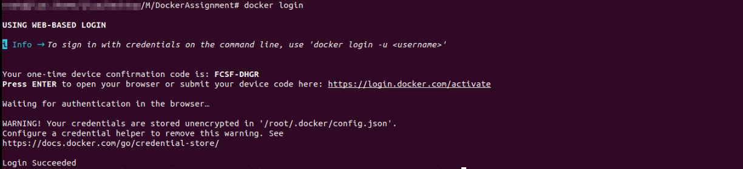Figure 6.9: Login to Docker Hub
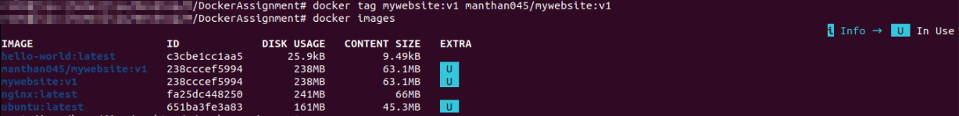Figure 6.10: Tag Image
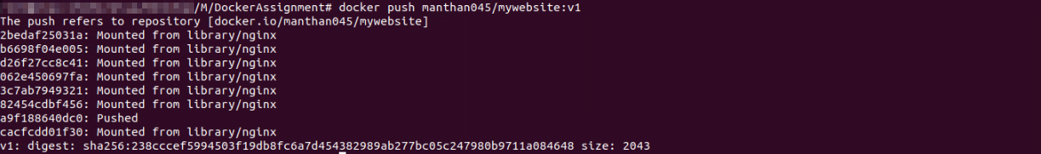Figure 6.11: Publish Image

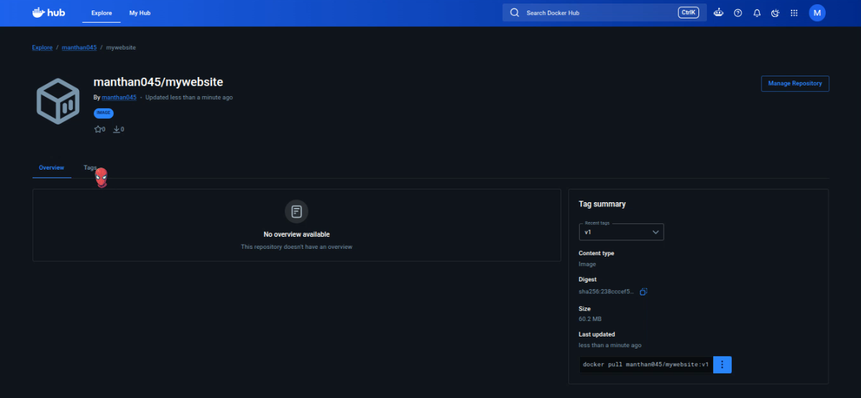Figure 6.12: Docker Hub repository page

7. Load Balancing, Scalability and Application Gateways

7.1 Load Balancing
Load balancing is a way to share work in the cloud. It helps spread out all the people using a website or application across computers. This means that no one computer gets too busy and stops working.
When a lot of people are using something in the cloud load balancing can really help. Sometimes a website or application gets a lot of visitors. Sometimes it does not. Load balancing helps because it can send people to computers. If one computer gets too busy the other computers can still work. This means that people can still use the website or application.
For example, Azure Load Balancer can share network traffic across computers. This helps cloud applications work better when a lot of people are using them. It also helps make sure that people can always use the services they need. Load balancing is very useful, for cloud applications because it helps them work well when a lot of people are using them.

7.2 Scalability
Scalability is about the ability of a cloud-based system to grow or shrink its computing power depending on changes in workload or demand. It lets companies offer resources when need rises without keeping extra physical equipment all the time.
There are two ways to scale. Vertical scaling means making an existing computing machine stronger like adding CPU, more memory or more storage. This can make a server work better but it might be limited by how much the system can handle. Horizontal scaling means adding or removing machines to spread the work across different resources. This method can offer flexibility, for apps that have changing levels of use.
Cloud computing gets a lot of help from scalability because companies can change resources based on needs. This can help keep apps running when there is a lot of demand and stop using extra resources when demand is low. Scalability helps with both flexibilities. Using resources in a smart way.

7.3 Application Gateway
An application gateway is a service that assists people who use applications and the servers that host these applications to communicate with each other. It ensures that when people access a website or an application they are able to reach the server that hosts the application. This is very useful for companies because it helps them control how people access their applications and it makes these applications more available and reliable for people who use them like the application users.
An application gateway is not the same as a load balancer. A load balancer just sends traffic to servers. An application gateway can look at the traffic and decide which server to send it to based on what the traffic is asking for. For example if someone wants to look at a website the application gateway can send them to one server that hosts the website. If someone wants to buy something it can send them to a server that handles purchases. Application gateways can also help keep applications by handling secure traffic and protecting against bad people who might try to hurt the application, which is very important, for companies that host applications.
Azure Application Gateway is a type of application gateway that helps companies manage traffic to their applications. It makes sure that people can get to these applications safely and reliably which is what companies want for their application users. If you already know about Azure Application Gateway you can use that knowledge to understand how Azure Application Gateway works and how it can help companies manage traffic to their applications like the application gateway does.

7.4 Why Load Balancing and Scaling Work Together
Load balancing and scalability go hand in hand because they deal with parts of handling changes in how much an application is used. Scalability is about how power the computers have to handle the work. Load balancing is about spreading the work across the computers that're available.
For example let us say you have an application that normally uses two computers when things are quiet. If a lot of people start using the application you can add computers to handle the extra work. Then the load balancer can send the work to all the computers so one computer does not get much to handle.
Using both load balancing and scalability helps the application work and be available when a lot of people are using it. Scalability gives you power when you need it. Load balancing makes sure that power is used in a way. So using both load balancing and scalability together gives you a way to support applications that are used more at some times, than others.

8. Driving Forces Behind Cloud Computing and Serverless Computing

8.1 Driving Forces Behind the Growth of Cloud Computing
- Cost: Cloud computing reduces the need to buy and maintain expensive hardware. Organizations only pay for the resources they use, making it a cost-effective solution.
- Flexibility: Cloud services allow users to access applications and data from anywhere with an internet connection. This makes it easy to adapt to changing business needs.
- Scalability: Cloud platforms can quickly increase or decrease resources based on demand. This helps applications handle more users without additional hardware.
- Reliability: Cloud providers use multiple data centers to ensure high availability. If one server fails, another takes over, reducing downtime.
- Fast Deployment: Cloud computing enables faster application deployment by removing the need to set up physical servers. Developers can launch applications more quickly and efficiently.

8.2 Serverless Computing (Function as a Service)
Serverless computing Serverless computing is a model in cloud computing in which developers are freed of any responsibility to manage the underlying hardware or the operating system but are only responsible for writing and executing their code. The responsibility for managing everything else, including the provisioning of resources for execution, is shouldered by the cloud provider.
Developers only have to write the codes for their applications and let the cloud provider handle the execution whenever there is a request.
AWS Lambda and Microsoft Azure Functions are popular cloud providers of Serverless.
Serverless cloud provider service options may include functions, which are used to perform a piece of code when an event triggers – for instance, a change to data stored in a data store, a new file uploaded to storage, an incoming request, or even scheduled triggers.
The functions are only active for the duration that they take to execute, and this eliminates idle resources for applications that have sporadic traffic.
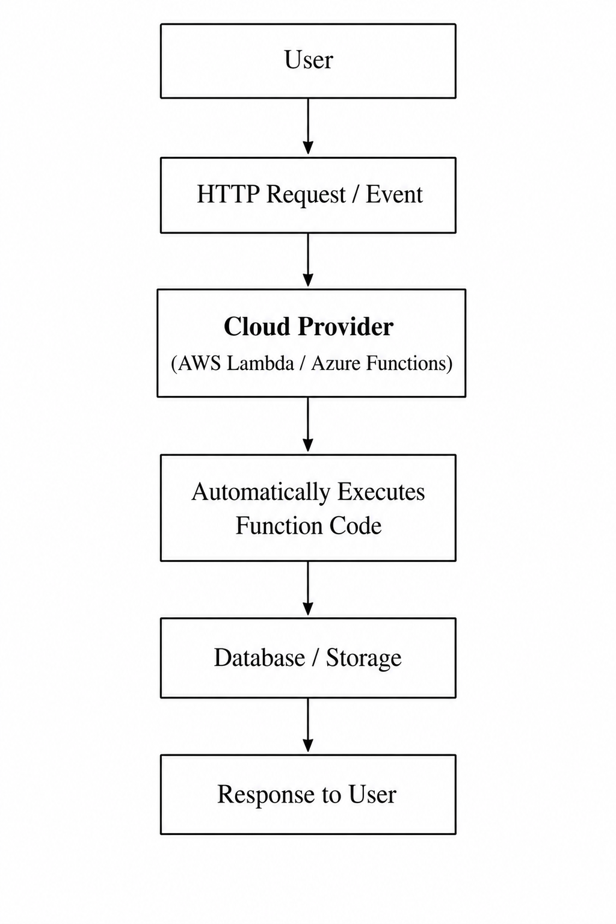
Figure 8.1: Model of Execution for Serverless Compute
From Figure 8.1, one can see that when there is a request for an action the execution of the task triggers a cloud function controlled by the provider.
The cloud provider handles the allocation of resources, execution of the required function, responding to end-users, and releasing the resource after execution.

8.3 Comparison Between Serverless Computing and Containerization
Serverless Computing and Containerization are cloud-native application development methods used to deploy applications in the cloud.
While both technologies serve a similar purpose of enabling organizations to take their applications in the cloud without having to host their own infrastructure. There are differences that could see you choose one over the other. Some of the more common differences between Containerization and Serverless Computing can be seen below.
Feature | Containerisation | Serverless Computing
InfrastructureManagement | Developers are responsible for managing containers. | The cloud provider manages the infrastructure.
Deployment Unit | Complete application is deployed as a container. | Individual functions are executed in response to a request.
Resource Allocation | Resources are allocated when a container is launched. | Resources are only allocated when functions are executed.
Cost | Containers are billed depending on their size and usage duration. | The cost is incurred when functions are executed and depends on their duration.
Startup Time | The startup time is usually a few seconds. | The startup time is often measured in milliseconds.
Best For | Long-running applications such as microservices. | Applications with events such as automation, scripts, and functions.
Table 8.1: Comparison Between Serverless Computing and Containerisation
Containerizationis best for deploying complete applications because it allows developers to manage the hosting infrastructure.

8.4 Benefits of Serverless Computing
Autoscaling: Serverless computing automatically scales resources based on application demand. This ensures smooth performance without manual intervention.
Cost: With a pay-as-you-go model, users only pay for the actual execution time of their applications. This reduces infrastructure and operating costs.
Reduced Infrastructure Management: Developers do not need to manage servers or system maintenance. The cloud provider handles the underlying infrastructure.
Faster Development: Serverless computing speeds up application development by removing server configuration tasks. Developers can focus on writing and deploying code quickly.

Conclusion
This report has evaluated several cloud technologies and their relevance to AeroLink Logistics. Virtualisation provides efficient use of shared physical resources, while containerisation offers lightweight and portable application deployment. Docker further supports this approach through images, containers, volumes and networking, as demonstrated in the practical implementation. Load balancing, horizontal scaling and application gateway services can improve the availability and performance of applications when demand changes. Serverless computing provides another deployment approach by reducing the need for direct infrastructure management and supporting flexible application execution. Overall, no single technology is suitable for every workload. AeroLink can benefit from combining these technologies according to its application, performance, scalability, security and operational requirements.

References

[1] | P. Mell and T. Grance, "The NIST Definition of Cloud Computing," National Institute of Standards and Technology, Gaithersburg,MD, 2011.
[2] | A. Bhardwaj and C. Krishna, "Virtualization in Cloud Computing: Moving from Hypervisor to Containerization—A Survey," Arabian Journal for Science and Engineering, vol. 46, no. 9, 2021.
[3] | KANE, Matthias and K. , Docker: Up & Running, 3 ed., Sebastopol, CA: O'Reilly Media, Inc., 2023.
[4] | D. Merkel, "Docker: Lightweight Linux Containers for Consistent Development and Deployment," Linux Journal, no. 239, 2024.
[5] | Docker, "What is an image?," Docker Docs, [Online]. Available: https://docs.docker.com/get-started/docker-concepts/the-basics/what-is-an-image/.
[6] | Docker, "Build, tag, and publish an image," Docker Docs, [Online]. Available: https://docs.docker.com/get-started/docker-concepts/building-images/build-tag-and-publish-an-image/.
[7] | Docker, "Understanding the image layers," Docker Docs, [Online]. Available: https://docs.docker.com/get-started/docker-concepts/building-images/understanding-image-layers/.
[8] | Docker, "What is a registry?," Docker Docs, [Online]. Available: https://docs.docker.com/get-started/docker-concepts/the-basics/what-is-a-registry/.
[9] | Docker, "Volumes," [Online]. Available: https://docs.docker.com/engine/storage/volumes/.
[10] | Docker, "Networking overview," Docker Docs, [Online]. Available: https://docs.docker.com/engine/network/.

