Amber Phillips – 1803356
Welsh language development portfolio
Link to Welsh Video: https://uowtsd-my.sharepoint.com/:v:/g/personal/1803356_student_uwtsd_ac_uk/EVG1O6M-sohMmpNY6hZzFjYBTlzqhiqrdAgn0zFu2eelOg?e=FpadNY
Lesson plan and resources
The lesson plan is focused on the whole week as session were 15 minutes long each day however the relevant context has been highlighted.

Lesson Plan Phase 1

Lesson Plan – Step 1 Cynllun Gwers – Cam 1

Student-teacher | Amber Phillips | Class: | 2P
AoLE or Subject | Welsh | Date: | 2/3/4/5
Lesson Focus: | Carrying on with the story Mae hi’n oer – forming sentences (This lesson is only 15 minutes).
Meaningful links to Curriculum | Welsh  appreciate books, stories and words around them  follow stories read to them and respond as appropriate  listen to others reading appropriate imaginative material  look at books, handling them as a reader, with or without an adult  use context to perceive the meaning of familiar words and decode new words by means of clues in pictures, letter sounds and word forms.  use appropriate language in spontaneous and structured play activities and when conveying meaning  building on previous experience, speak with confidence  Asking or answering questions.  Speaking, substituting words in familiar patterns  Read aloud their own work and other printed resources  understand the significance of the printed word and the relationship between printed symbols and sound patterns
Meaningful links to:  Cross Curricular Responsibilities | Creative development  be involved in activities that allow them to work as individuals and in groups  LLC - explain relevant details from texts.  Use the different features of texts to make meaning, e.g. pictures, charts and layout  Ethical informed citizens who - show their commitment to the sustainability of the planet and are ready to be citizens of Wales and the world.  Ambitious capable learners who - can communicate effectively in different forms and settings, using both Welsh and English
Personal Targets (Linked to QTS and identified in weekly review)
To increase the use of AFL strategies.
To use questioning throughout.
To set clear expectations for the lesson.
To develop reflection straight after the lesson. (RAG rate groups)

Learning Objectives (focus on Learning- use accessible vocabulary):
The pupils will learn to:
To further develop language skills when acting out the story ‘Mae hi’n oer.’
To confidently match the animal with its name.
To form sentences using the Artic animal and they way it moves.

Success Criteria (clearly linked to each Learning Objective and related to the process and/or product of learning) | Assessment of Pupils’ Learning  Evidence  (What have the learners to say/write/do/produce – to demonstrate learning)
I can use welsh vocabulary when acting out the story.  I can confidently match the animals to their names in Welsh.  I can from a sentence using the Artic animals name and the movement it makes. | Lollipop sticks – I will use this AFL strategy to select random learners to answer. This gives each learner a fair chance to speak and a fair chance to be heard. This also provides an opportunity for pupils to share their opinions.  Phone a friend – I will use this AFL technique if learners ae not sure of the answer. Before I tell them, they will get the chance to select one of their peers to help them.  Popcorn – I will use this strategy so learners can shout out as much as they know about the question being asked, this is a good opportunity for everybody in the class to speak.  Think, pair, share – This allows learners to talk to their peers and develops communication and discussion from the learners and helps me to access any prior knowledge off them when asking questions. This is used to initiate individual and collaborative thinking.  RAG rating – I will do this at the end of the lesson to assess what has been learnt and check what has been learnt is understood.  The use of questioning – I will use questioning throughout this lesson and my activity to develop the learner’s knowledge. This will show me learners’ prior knowledge. I will use questioning in this lesson to initiate individual thinking and collaborative thinking. Also to engage students with the learning and to assess what has been learnt this lesson.

Time | Activities/Methodology/Key Concepts  (Teacher’s Role – including key teaching points and key questions) | Pupil Tasks  (Pupils’ role -including differentiation strategies, engagement in formative assessment and homework) | Resources  (Including Health and Safety requirement)
Opening phase (with links to prior learning) | Monday - On Monday we will recap through the story. I will ask learners ‘discuss with your partner what animals were in the story?’ I will use learners to think, pair, share the answers. ‘Now discuss the way these animals moved, so how did the fox move?’  This introduction will be based on the animals and what we discussed about them last week.  Tuesday- On Tuesday I will recap with the learners the game we played last week in welsh. When one of the children had to pick up a picture of an animal. We then discussed the animal and said how it moves. I will explain to learners that this lesson we will be playing a game of snap where you pick up the card and find the word for the animal in welsh or the movement. ‘What movement goes with the fox?’ ‘Who can remember what was fox in welsh?’ I will ask questions like this to engage learners with the game.  Wednesday- On Wednesday I will introduce sentence pattens to the learners, I will explain to them what task we will be doing this lesson.  Thursday-On Thursday we will recap over the sentence patterns. I will ask learners to recap in pairs what we did in yesterday’s session. | On Monday learners will discuss in pairs the animals in the story. They will then discuss the way the animal moves.  On Tuesday learners will recap the game they played. They will then discuss the animals and how they move. They will all then listen as I explain the task we will be doing today.  On Wednesday learners will sit on the carpet and engage as I introduce sentence patterns to them in Welsh.  On Thursday learners will recap on sentence patterns.
Teaching & Core Learning | Monday – On Monday we will read back through the story to recap with learners the animal and the movement. By then end of this lesson all learners should be confident with the story and be able to use the actions for the correct. I will use my turn, your turn with the children so the pronounce the animals and the movement properly. We will use this lesson to go over the story properly to make sure all learners are confident with it.  Tuesday – On Tuesday the focus of the lesson will be to play a game of snap to improve learners Welsh oral skills. All learners will sit in a circle, I will explain that they must pick up a picture card and match it to the word picture card which is a movement of the animal. Learners will all take part in this game and I will choose random learners to answer but ensure everyone gets a turn. The idea of this lesson is for the learners to recognise and read the Welsh names and be able to pronounce them correctly. It also shows me how confident the learners are with the vocabulary from the story.  Skill: Use appropriate language in spontaneous and structured play activities and when conveying meaning.  understand the significance of the printed word and the relationship between printed symbols and sound patterns.  Wednesday – On Wednesday I will explain to the learners that we will be focusing on developing their speaking skills using sentence patterns. The learners will be sat in a circle, I will select random learners then will select a card for them to have a go at, for example, if the learner gets cadno the card will have a picture of a fox on and say rhedeg. I will ask the learners ‘Beth Dw’in weld?’ they must then use the template which says ‘mae ____ yn ______’ to create the sentence. If learners are unsure, they can phone a friend to help them. All learners are now confident with the animal’s name and movement, so should be able to form the sentence with the scaffolding. This will develop the learners oracy skills.  Skill: building on previous experience, speak with confidence  Asking or answering questions.  Speaking, substituting words in familiar patterns  Read aloud their own work and other printed resources.  Thursday – On Thursday, we will read out the story as a class with the children joining in with the actions and using the key vocabulary, then we will recap on the animals in the story. We will have a group discussion about the animals and what they all had in common. ‘Then I will ask random learners to use the sentence patterns which we practised yesterday to create sentences about the animal and the way that it moves, this will be building on the learner’s knowledge from the week. I will choose random learners to answer throughout the session and try and engage all learners. I will ask learners ‘Beth dw’in weld?’ They can use the resources to support them. Then I will show learners a picture card with the animal and the movement on which they will have to use to form a sentence. | On Monday learners will join in with my turn, your turn to help them pronounce the Welsh words properly. By the end of this session learners will be able to go through the story and the actions confidently.  On Tuesday learners will play a game of snap. All learners will sit in a circle. The learners will have to pick up a card with a picture of the artic animal on and then will have to match it with its name. (Cadno – Rhedeg).  On Wednesday learners will be focusing on sentence patterns. Random learners will be selected to try and form a sentence using the cue cards.  On Thursday learners will sit on the carpet, they will join in with the story saying the familiar verses and using the actions. The learners will tell me what they know about the animals in the story. Then the learners will answer questions asked to them and form the sentences using the cue cards to help them. They will be able to say ‘The fox is running’ – ‘mae’r cadno yn rhedeg.’ | Story  Snap cards  Lollipop sticks  Cue cards
Plenary | As this lesson is 15 minutes it does not have a plenary.

Resources
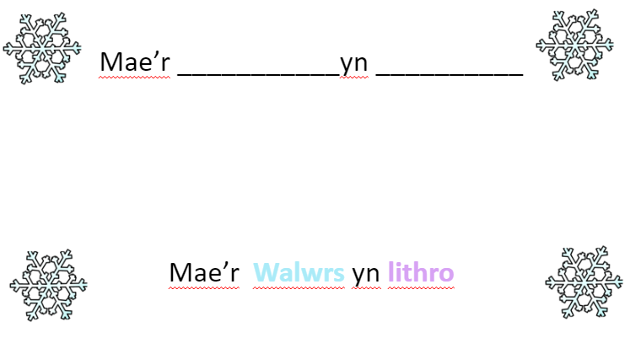
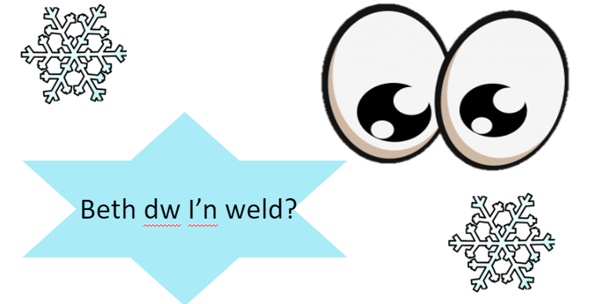

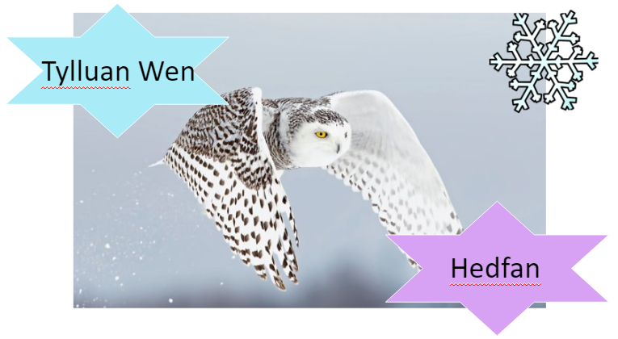

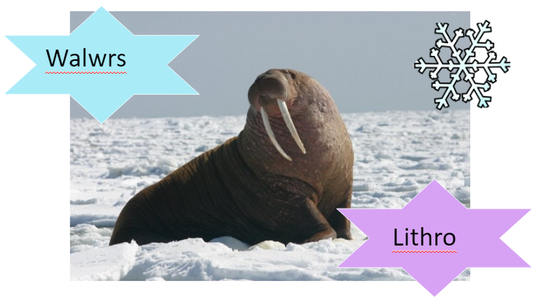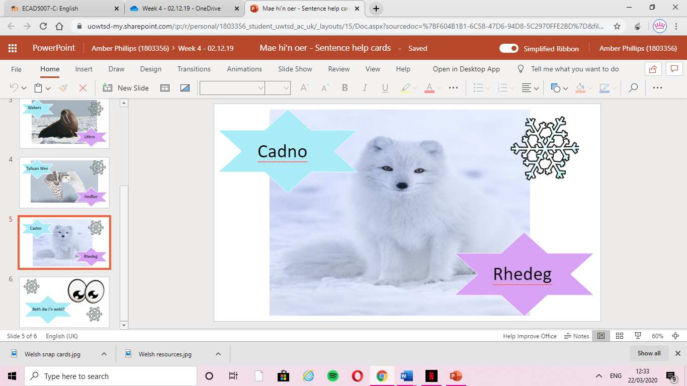

Written self-evaluation – Reflection of the week (total 1 hour)

What are your feelings regarding the experience?
Overall, my feelings regarding this experience were positive, I think learners all engaged throughout the week’s sessions and became more confident and developed their Welsh language skills by participating in activities. I taught these sessions as whole class and encouraged learners to do group-based learning to address the issue of anxiety within the classroom (Baker, 2011). The emphasis on group work is that children can learn from hearing the language used by other members of the group. In addition to this their motivation level is likely to increase from working in a group (Richards, 2006).

What aspects of the learning experience went well?
The aspects of the learning experience that went well was the planning of the sessions, when planning my lessons, I would build on learners’ previous knowledge and develop new skills from the Framework to ensure the learners were making progress each session. Estyn (2013) state that lesson plans should build effectively on children’s previous learning and ensure progression to the next stage in their learning.
Another aspect that went well was the structure of the lessons. I tried to plan fun engaging lessons. For example, we played a game of snap for Tuesdays session, where the learners had to match the movement and the animal. By planning a session like this I was also acting upon my tutors’ feedback of “using more pictures e.g a picture of a snowy owl’ (see appendix 1). One of the elements of this session that went well was that motivation was enhanced because the choice of content was high in interest to the children (Baker, 2011). This encouraged all learners to engage and participate even if they were not that confident.
Welsh language games also help children to work together in different ways and to develop important social skills, such as turn-taking. Often the motivation to win can be a valuable way of enabling less confident children to participate (Estyn, 2013).
This session also developed the learners Welsh reading skills as they had to read the movement out to the class, this allowed the learners to familiarise themselves with the way the words looked and understand the significance of the printed word and sound patterns. The Welsh Government (2008) states:
“use a growing range of appropriate vocabulary in play and structured activities and formal situations and demonstrate an understanding of prepositions within their play and structured activities”.

Another aspect that went well was throughout the week I embedded Welsh cross curricular. I did this by creating an enhanced provision planner. This is where the children would have a choice of an area, they would like to work in during Topic lessons. The Welsh Government state that children in the Foundation Phase should be free to choose their area of learning, for example going to the role play area (Welsh Government 2014). The Welsh role play area had paper masks of the animals from the story and if the children chose to work in this area, they would have to role play the story of ‘Mae hi’n oer’. Within this area there was also resources with key words on to help the learners recite the story. This encouraged the learners to use key vocabulary and increased their motivation of using the Welsh language as it was free choice of task. Estyn (2013) state the best Welsh language sessions include children using simple Welsh phrases spontaneously in role play situations. Throughout the week many of the learners chose to work in this area and role played the story out either in a pair or a group. The learners used the resources to help them re tell the story. Then at the end of the Topic lesson they presented the role play to the rest of the class.

What elements of learning experience was disappointing?
One of the elements of the learning experience that was disappointing was how long the sessions were for, as they were only fifteen minutes the lesson ideas were limited, and learners were mostly taught with a story or in circle time. This was disappointing for me as I would have liked to do a story map with the learners and developed some Welsh literacy skills based on the story. However, Cook (2008) argues that teaching a second language for as little as an hour a week can have useful effects on of other aspects of a child’s mind. This suggest that even though the Welsh sessions were short they were still having a significant impact on the children’s mind. Because of this I tried to plan Welsh into cross curricular activities such as in Topic lessons to give the children other opportunities to develop their language skills rather than just in the Welsh session.
Another element I found disappointing was my use of my own Welsh when asking the children questions. Once I re watched my lesson of the film evidence back, I realised how many opportunities I missed to ask the learners questions in Welsh. However, the reason I did not use that much Welsh when asking the learners questions was that some of them found it difficult understanding the question and repeated it back to me thinking it was the sentence starter. When doing oral tasks with the learners I used the resources to scaffold them showing them the ‘Dw’in weld…’ however, when asking the learners ‘Beth dw’in weld?’ they would answer back ‘’Beth dw’in weld’ thinking the question was the sentence starter. This was an area I could have improved on and it is clear the learners needed a bit more scaffolding for this activity.

What will you keep the same to ensure effective teaching?
The things I would keep the same to ensure effective teaching and learning would be some of the techniques I used for example, using my turn, your turn to develop the learners oracy skills, this is where I would say the word and the learners would all participate and repeat the word back.
‘learning is the process of guided participation between meditated through the direction of a more knowledgeable other. Through repeated participation in a variety of joint activities’ (Baker, 2011).
I did this to familiarise the learners with the Welsh words and phrases. I used this strategy often with the learners to ensure their pronunciation was correct. The Framework states that learners should “speak using correct pronunciation” (Welsh Government, 2008).
Another element I would keep the same to ensure effective teaching and learning would be putting the actions with the story. I allowed the learners to create their own actions to the story as it made the learning more personal to them and encouraged the children to memorise the story. The Welsh Government (2008) states “children should join in with, repeat or memorise a range of stimuli and create their own action commands”.
Furthermore, another element I would keep the same would be the use of resources and cue cards to scaffold the learners. When I received feedback off my tutor to “extend the learners language patterns to form sentences” (see appendix 2) I created resources which were picture cards with a photo of the animal on it I and the movement it made. Then created a template which said ‘Mae _____ yn ______’. This ensured effective teaching and learning as the learners would have struggled without the scaffold of the resources.
Another element I would keep the same to ensure learning would be the structure of my lessons. Most of my Welsh sessions throughout the week were practical and encouraged the learners to interact. This ensured all lessons were enjoyable and engaging for learners.
They should be encouraged to communicate their needs in Welsh and should be increasingly exposed to Welsh. Skills are developed through communicating in a range of enjoyable, practical planned activities (Estyn, 2013).
Finally, the last aspect I would keep the same would be to track learner progress after each session, I did this by using a RAG rating tracking chart. This ensured I could see what learners next steps would be and would help me to plan my next session to aid progression.

What was the cause of the most disappointing element?
The cause of the most disappointing element was the learners misunderstanding of the questions being asked in Welsh. This may have been because I did not spend enough time on this task with the learners and they were not that confident with answering questions. Some of the learners found it difficult to understand a question when being asked, however found it easier to answer due to the resources. Because of this I asked the learners a lot of questions in English to make sure they didn’t get confused. However, this was not developing the learner’s language skills to their full potential as some of the learners were not understanding the question. In addition to this, The Welsh Government (2008) state learners need to ask and answer questions to develop their Welsh language skills, this suggest the learners could have done an activity where they were the ones asking the questions to ensure they understood the difference of answering the question and asking it. Another suggestion to improve this aspect would be to spend a few sessions going over the question and sentence patterns and not moving until I was confident all learners understood.

What are the solutions and what will you do next?
The possible solution to this element would be to scaffold learners with questioning. This could be done as a paired activity when learners would be partnered up with one of their peers, I would put the lower ability with the higher to ensure they were being scaffolded throughout the task. Then one of the learners would ask the question and one would answer, then after practising the learners would swap. This could be done by creating cue cards for the learners to use to scaffold them, this would develop the learners understanding of the difference between the question and the answer and would give them good practise of asking questions themselves. This is supported by Richards ‘(2006) as he states, ‘paired activities gave learners greater opportunities to use the language and develop fluency’. To ensure the learners were fully confident with this aspect I would spend a few sessions on it with them until I was sure they were confident on this aspect. To assess the learners and know when to move on from this aspect I would use a tracking chart to RAG rate the children.
Wordcount – 1754.

References
Baker, C. (2011) Foundations of Bilingual Education and Bilingualism, 5th Edition. Clevedon: Multilingual Matters.

Cook, V.J. (2008) Second Language Learning and Language Teaching, 4th Edition. London: Hodder Education.

Estyn (2013) Welsh Language development in the Foundation Phase. Cardiff: Crown.

Richards, J.C. (2006) Communicative Language Teaching Today. Cambridge: CUP

Welsh Assembly Government (2008) Welsh Language Development in the Foundation Phase, Cardiff: WG.

Welsh Government (2014) Evaluating the Foundation Phase: Key Findings on Welsh Language (WISERD). Cardiff: Crown.

Appendix
1.
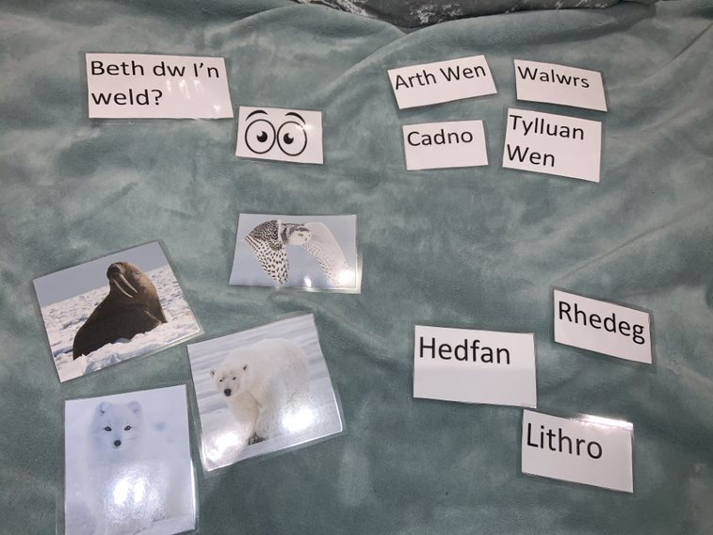
2.
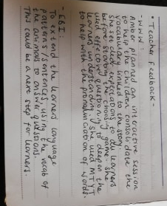
3.
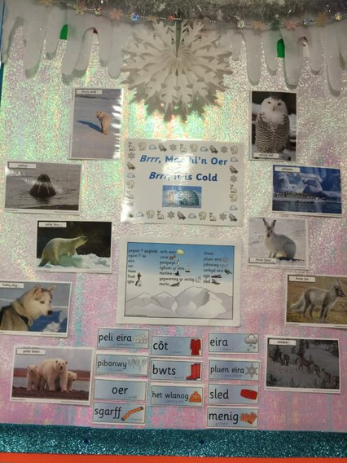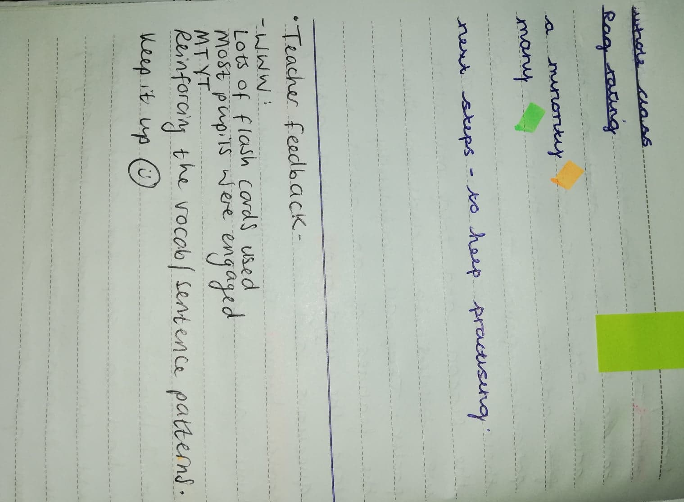
Teacher feedback from sentence patterns lesson.
Display board in the classroom of ‘Mae hi’n Oer’.

