Name | Student Number | Date | Lecturer’s Name | Your score
Theresa Gayle | 2431896 | 23.10.25 | Caroline Walsh | To be filled by the marker  ___/40
You will have 75 minutes to complete this assessment. It is divided into three sections: note-taking, paraphrasing and writing a paragraph.
---------------------------------------------------------------------------------------------------------------------
1. Take diagrammatic notes from the passage below using the space provided:

As a student you've got a lot on your plate - academic work, social life, work commitments, career plans, relationships and finances - sometimes stress can get in the way of this juggling act. When you recognise that you have become overwhelmed with stress, adopt a few strategies to help you manage your triggers more effectively. Those strategies could include exercising; you simply need to get your heart racing, for example by going for a brisk walk or a bike ride. Another suggestion is to try mindfulness, a relaxation technique originating in Buddhism. It is used by clinicians to improve patients' physical and mental health as it can significantly lower stress levels. Thirdly, why not speak to your friends and family - they know you best and care about you the most. What's more, studies suggest that socialising with a friend just once a week can reduce your stress levels and improve your mood as much as therapy or counselling. Simple time management techniques can also help you to feel more relaxed and focused. Try creating a written schedule, breaking your tasks down into manageable chunks, planning accordingly and allocating yourself time every day to relax or socialise. Finally, an obvious but often overlooked solution: get enough sleep, as no one functions at 100% when they're tired.
Adapted from: https://www.prospects.ac.uk/applying-for-university/university-life/5-ways-to-manage-student-stress

Space for your notes (max 12 marks):

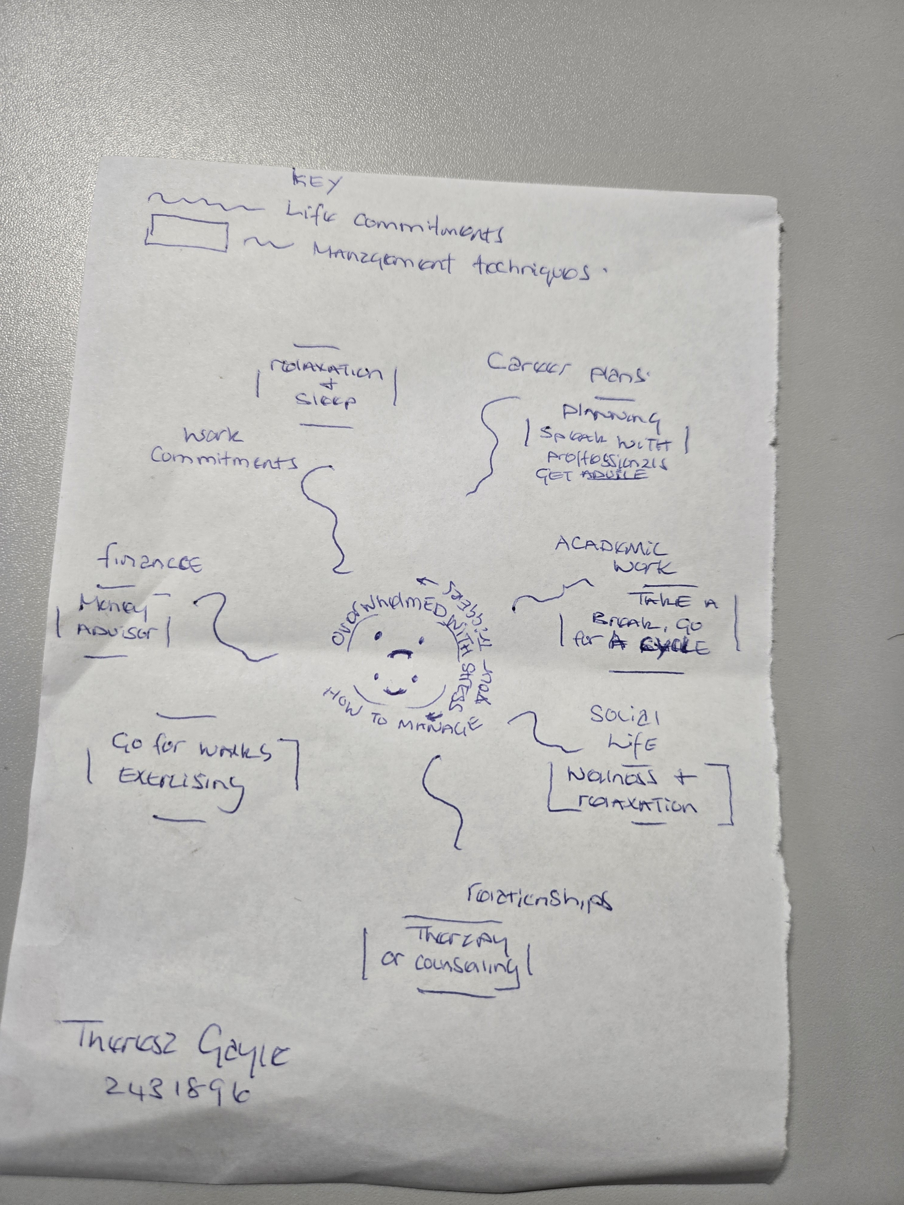

2. Paraphrase the following sentences (max 3 marks for each, max 12 marks in total):

a) Good time management techniques can help you feel more relaxed and focused.
Being relaxed and focused can help you have a good time management technique.

b) Speaking to your friends and family can significantly lower stress levels. ____________________________________________________________________________________________
Stress levels can be lowered greatly by speaking to your friends and family.

c) University life offers numerous opportunities for personal growth and development.
There are opportunities to flourish and elevate in university life.

d) Attending lectures regularly is crucial for understanding course material.

To be up to date with learning material, attending lecturers is advised.

3. Write a well-structured paragraph (8 sentences) on the following topic:

Strategies for managing a student budget and reducing costs while at university.

Your paragraph must be written in full sentences (no bullet points) and in an academic style.

(max 16 marks in total)

Strategies for managing a student budget and reducing costs while at university

Firstly, when you receive your bursaries, apply for any thing that you are entitled to such as help with council tax and rent that will help you with finances, if you are not sure ask.
Finding a part time job will also help keep costs down and help pay towards day to day living.
Catching local transport and avoiding taxis will keep cost down.
If you like to socialise, find ways of keeping the cost down, such as finding events that are free, or offer student discounts, or keep going out to one or two times a week if possible.
When you need to go food or clothes shopping, activities events etc, there are plenty of apps, such as student Beans apps that you can receive and find great discounts.
Also, music and apps such as amazon you can purchase for your academic year at half price.
There is a lot of help on line and at your university to help you save and reduce cost whilst at University.
I hope this information is informative.

