Sample question:

What is the future of glass as an art form and where do I see it progressing? What materials and tool can be used to create a whole new way of glass appreciation for the future generation.

Case study

I will be looking into how glass has changed over the years creating new techniques that will influence the glass world and how it has been changing now and what will be in the future. ( will be editing later)

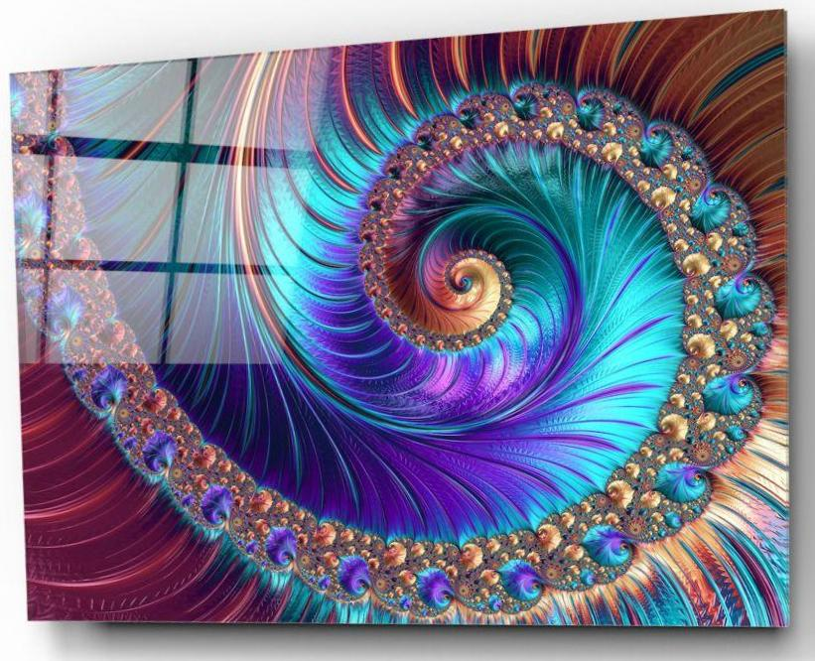
Figure 1 Swirl glass print wall art ARTRONAUTS

This piece is a very good representation of new modern technique that has been incorporated and blended into a glass art piece, This artist has been able to create a digital print using the worlds most highest quality of Durst UV printing and this has the longest fade resistant. This is a really interesting method of directly UV printing onto the surface of the glass, this method can be used to print any image and I find that this would be a nice way to have any image perhaps even family photos saved for generations instead of having the actual photo dull and fade with age.
This may be a simple concept but it has many of brilliance and I think that this could really make an impact. From what I have researched and looked into this has been inspired by Laser Photo Crystals which are images that have been engraved on a Crystal which a usual 2D, this however has no colour at all in the image unlike the UV printing technique which makes it very unique and original. This method really does show “The elegance of the glass surface” ( website 1...) the gleam of the glass really brings out the colour in glass and brings a sense of elevation to the overall piece, a normal canvas made “canvas is traditionally woven from 100% pure Flax (linen), 100% pure cotton, 100% pure jute, a mix of linen and cotton or a mix of linen and jute”( website 2).
How Artronauts create there digital UV printing actually uses a mixture of traditionally organic inks and ultraviolet light which is then used to dry or to cure the surface of the glass that has the ink design or image printed onto. This method is a much faster and even inexpensive way to create beautiful and vivid high quality custom prints that can go onto any surface. The only problems that have been noted is that it does not have a very high durability to scratches and the inks could fade slightly over time. I think that this is a very innovative, I have been coming up with different design ideas and images that could work really well using this method, the image must be vibrant and detailed .
Who created UV printing and Digital printing? UV printing was created by Michel Caza in 1990’s and Benny Landa was the one who created digital printing in 1993 his invention was called the E-Print 1000 and it was the world first digital colour printing press and still to this day he is know as the father of digital printing.
The art of using UV light to cure printing inks was another impactful point made in history and this has also made an impact in today society because “ability to fully dry the ink during the print process enabling the substrate/product to proceed to the next part of the conversion. In addition, key advantages of UV curing provide product enhancing features, such as surface protection and gloss finishes. It can also be employed for laminating, tactile finishes, screen ink finishes and many other versatile print processes where UV can immediately cure and finish the process.” ( 3)
The creators of our past have really paved the way for our future. Because this is where it started and all it took was an idea.
Theses methods from previous inventors have been redeveloped and explored upon by many company’s and artist such as the Artronauts who have been using theses techniques in there own artwork.
The Artronauts aim is to make everything around us that looks more simple and basic turn into something fun and to “ create the best living space” (Artronauts abouts 4).
The Brothers welcome everyone to be apart of this with them. Starting a “ war against boredom by using all possibilities, they thought, to made efforts on our work. Destroyed what seemed simple and built new ones instead”. They had a drive and a determination to create something you can have in your house that will change you in a way as to bring colour into your life and environment around you. Colour is found in many places and this colour can effect moods and behaviour to the point that the use of vivid colour and effect in a positive manner and “enhance memory abilities and functional ability” (Sevinc Kurt, Kelechi Kingsley Osueke Page 1 ). So, colour is a very serious matter as it is a large point in decorating people’s homes. Especially if you take colour theory into consideration and the meaning behind colours, using colours or patterns in art that bring forth good emotions and energy which could then be placed within your home and bring out those emotions in the viewer.

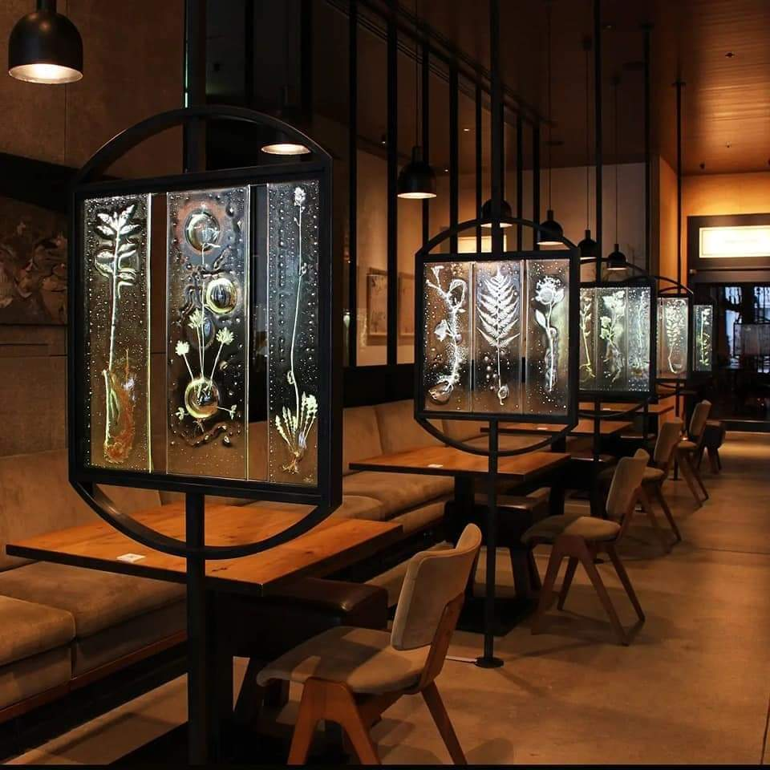
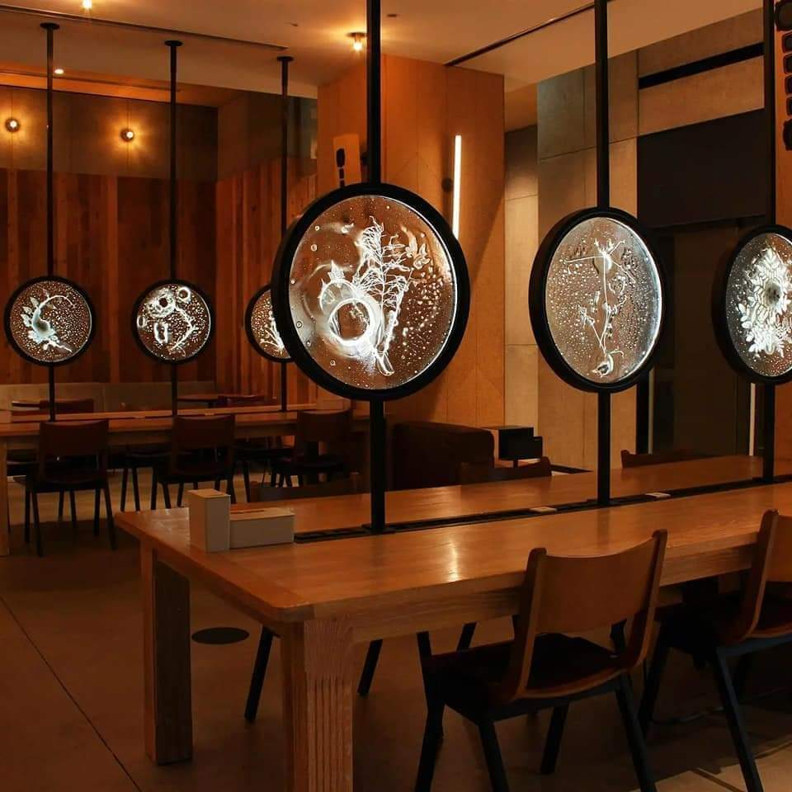

Figure 2

Rui Sasaki work create a whole new world to discover, she describes her work as intimae which can be seen depicted in her work as it is very delicate. The meaning behind theses pieces are a link to her home and herself as it creates a bond with her body and its surroundings.
She became an artist because she was looking for the meaning behind what she could see and she was looking for answers. Water is very important to her and she wished to make something out of water and she found glass as her medium of choice.
She is a concept artist and must have a bond within the creation of her pieces or she loses interest and is unable to finish, there must be a drive,
Cloudy and raining, sun and windy all of this she is very effective by, the weather effects her mood and her spirit, and she wants to change the perspective that people have of rain and bring joy as she appreciates the rain, this is one of the elements she try’s to bring into her work.

Japanese art is very young and is developing constantly but has a strong presence. I have noticed that Japanese art really does try and push the boundaries, Rui has found that glass is a tool for her to express herself something to experiment and explore. She believes glass is not “tided to the land so it is free with bond so to her it has unlimited parental” I do agree with this statement as glass is everywhere and does not just belong to one place and the material its self is very malleable and has unlimited potential.
Her pieces and installations are used as an expression she considers the entire process as a continued part of her work and the glass is the concept.
She moved to the United States from Japan, this was the time when she started to forget her home back in Japan. She states that “home is the place she can feel intimacy” (Artist Statement Rui Sasaki).
This is what she is trying to find again though her art, her path of discovery.
It was eight years till she went back home to Japan, It was only then that she has discovered that she has lost her “ intimacy” of Japan, it raised Questions to her about what is physical space and what the means to her. Noticing that though out her work she has documented the meaning of intimacy and her memories of home, I believe that as her work continues to develop going forward that she will find a greater understanding and the answers that she is missing.

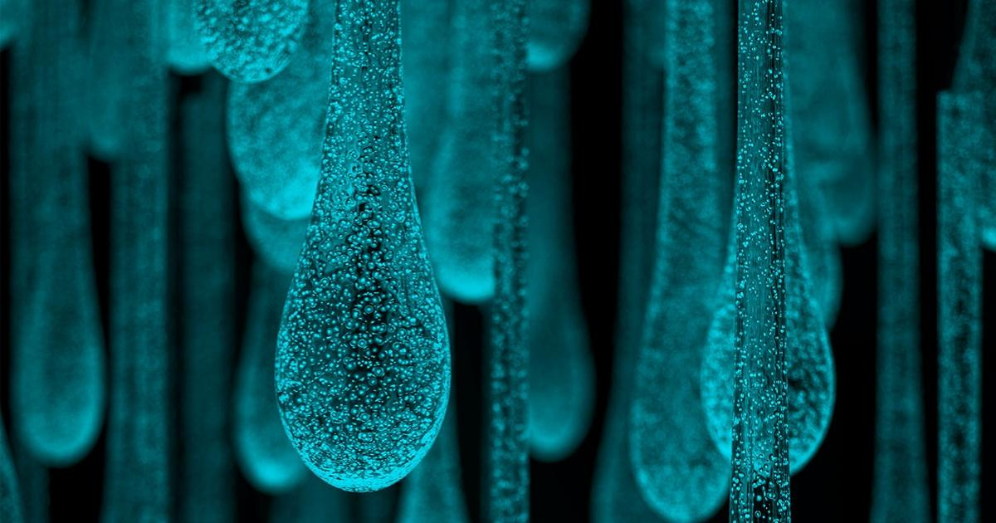
Figure 3

Using phosphorescent lights with solarium light is used in her work so when light is removed for the area surrounding her work the actual pieces glow like glow worms.
When looking into what type of phosphorescent I could to replicate this, I discovered that there was many different powders that i could infuse into glass to create this or at least a very similar effect. I will have to create a few different test to really know more on this subject. I will keep in mind the health and safety that I will have to do when using theses materials.
She considers her work interactive and ever changing, and has discovered that weather is something that has a powerful meaning to her and she feels that weather affects everyone both mentally and physically so the idea for the viewer is that you will see the changes in the glow which is to bring from appreciation of natural light changing though out the day.

Each organic material that was used to burn between the glass has been taken from places she has been that she had developed a emotional attachment towards . how she describes Intimacy is showed how she remembers her childhood though smell and touch of the plants that she choses and she find memories.
She then dry’s the plant and cuts circles of sheet glass placing the plants between and places them into the kiln, each plant has a different moisture and minimal so she constantly checks the kiln over the time. Sometimes holding the kiln at 30 hours or something it only take 20 minuets Her aim is to achieve the white ash, black as means something different to her so white ash is more desirable, black as could be considered to be connected to death, and gloom, in terms of weather storms come to mind bringing destructions while also beautiful. With some pieces She will glass blow a petri dish to place of the glass and cut down to side so only a rim is left along the edges, she does this so water can be pored into the space. Glass records memories and preserves which is why glass has been the perfect material for her to use.
I think that to create her work will be a challenge as there are so many different elements to consider, however this should allow me to find organic materials that o remember from my childhood and to find that connection as she has. Further developing my connection to the world around me, this is a very powerful meaning. Being able to appreciate what the world has to offer is important considering all the events concerning climate change so I do believe that this could have a impact on the view allowing them to really think about the world around them and the impacts that they have had on the world and the memories of places that they have form nature that will be destroyed from climate change and all the factors that come with that. The memories that are lost are like the burning of the plant, they are forgotten like and blurry like the black ash but them they come back to life and have been reborn into glass transforming into the white ash being sealing safely forever. This is a very powerful meaning as you are capturing the very essence of the plant you are using to bring the memory to life, it is symbolic in many different ways. I aim to bring this into my own creations using her methods going forward.

Bibliography
https://artronauts.co.uk/collections/glass-print-wall-art/products/northern-lights-aurora-glass-print-wall-art
https://www.jacksonsart.com/blog/2016/07/27/the-story-of-claessens-maker-of-the-worlds-finest-quality-artists-canvas/

https://www.flexotechmag.com/key-articles/20507/advantages-of-uv-inks-and-curing/
https://artronauts.co.uk/pages/about-us.

(Not done properly yet, just collecting them all here for now)

